Priapus

http://en.wikipedia.org/wiki/Priapus

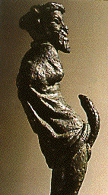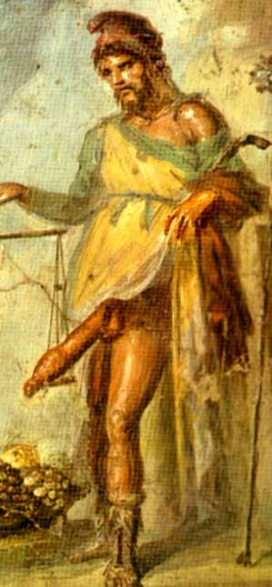

In Greek mythology, Priapus (Greek: Πρίαπος) was a minor rustic fertility god of purely phallic character, protector of livestock, fruit plants, gardens and male genitalia. (Roman equivalent: Mutinus Mutunus.)
He was a son of Aphrodite by Dionysus, Hermes, or Adonis ^{[1]}

Contents
- 1 Art
  - 1.1 Statues
- 2 In literature
- 3 Worship
- 4 Modern misconception
- 5 Priapus in popular culture
- 6 Medical terminology
- 7 References
- 8 Notes

Art
One of the most famous images of Priapus is that from the House of the Vettii in Pompeii; it is a wall fresco in which Priapus is weighing his phallus against a bag full of money and it appears that his phallus is heavier.

[] Statues
At Helicon in Boeotia, the travel-writer Pausanias pointed out a statue of Priapus that was "worth seeing"^{[2]}.
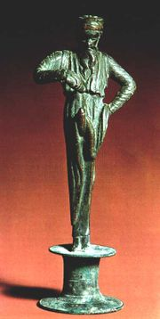
Bronze sculpture of Priapus making an offering to his phallus, House of the Vettii, Pompeii

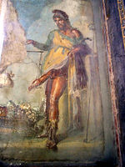
Fresco of Priapus, House of the Vettii, Pompeii.

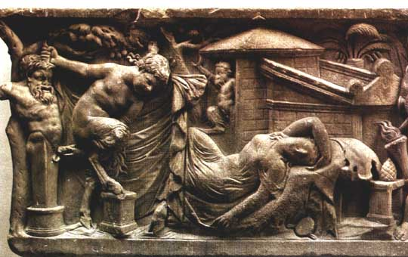
Herma of Priapus in a garden, depicted on a sarcophagus

Sculptures of Priapus with large, erect genitalia were placed in gardens and fields to guarantee an abundant crop. For the Romans, his statue was used as a scarecrow and his erect penis was thought to frighten thieves. Epigrams collected in Priapeia (treated below) show Priapus using sodomy as a threat toward transgressors of the boundaries he protected like a herm:
"I warn you, my lad, you will be sodomised; you, my girl, I shall futter; for the thief who is bearded, a third punishment remains."
"... If I do seize you . . . you shall be so stretched that you will think your anus never had any wrinkles."

[] In literature
Main article: Priapeia
The Latin collection of Priapeia shows how poets invented comic and obscene situations for him, giving him more literary prominence than he enjoyed in rites or cult, though masked phallic figures were prominent on many festive occasions, both in Greece and in the wider Roman world.
In Ovid's Fasti^{[3]}, the nymph Lotis fell into a drunk slumber at a feast, and Priapus seized this opportunity to advance upon her. With stealth he approached, and just before he could embrace her, Silenus's donkey alerted the party with "raucous braying." Lotis awoke and pushed Priapus away, but her only true escape was to be transformed into the lotus flower. To repay the donkey for spoiling his opportunity, Priapus slaughtered him. In later versions of the story, Lotis is replaced with the virginal goddess Hestia. Ovid's anecdote served to explain why donkeys were sacrificed to Priapus in the city of Lampsacus on the Hellespont, where he was worshipped among the offspring of Hermes.^{[4]}

[] Worship
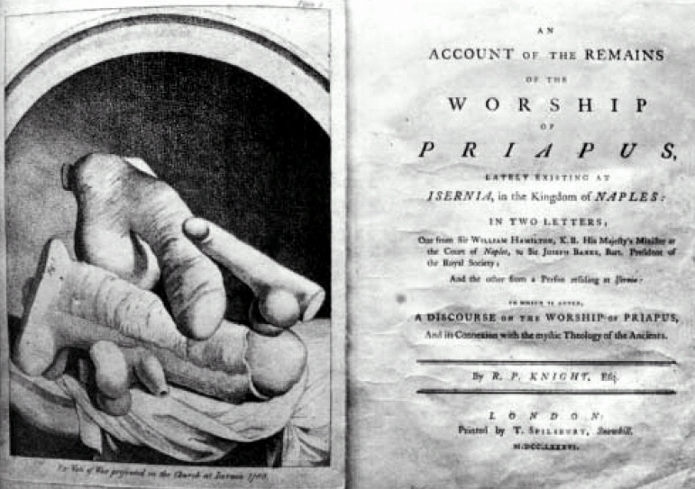

An Account of the Remains of the Worship of Priapus, (Richard Payne Knight), 1786.
Lucian (De saltatione) tells that in Bithynia Priapus was accounted a warlike god, a rustic tutor to the infant Ares. Also, Pausanias notes:
"This god is worshipped where goats and sheep pasture or there are swarms of bees; but by the people of Lampsacus he is more revered than any other god, being called by them a son of Dionysus and Aphrodite." ^{[5]}
Payne-Knight identified priapus-worship as surviving in Catholic phallic votives offered in parts of Italy in the 18th century.^{[citation needed]} Priapus is also recognized as a saint in Ecclesia Gnostica Catholica.

[] Modern misconception
Main article: Ideal beauty in the classical world
Large penises were, in the ancient world, considered barbaric and comical rather than attractive, and the same went for Priapus. His large penis ensured than no woman wanted to sleep with him, whilst his existence as a household god warned potential burglars that, if they were caught and raped (rape was a common punishment in the ancient world), the rape would be as painful as if it were done by Priapus's over-large penis.^{[citation needed]}

[] Priapus in popular culture
- In Fantasy Lover by Sherrilyn Kenyon, Priapus is responsible for cursing his half-brother, Julian of Macedon, to an existence as a sex slave trapped in an ancient scroll as an act of vengeance for fornicating with one of Priapus' sacred virgins.
- In Marvel Comics, Priapus was a super-villain leader of a cult based on sensual pleasures.
- Priapos also appears in N.F. Houck's mythology-based novel, Herald, as a son of Hermes and Aphrodite.

[] Medical terminology
The medical condition priapism gets its name from Priapus.

[] References
- Kerenyi, Karl, 1951. The Gods of the Greeks, pp 175–177.

[] Notes
- ^ According to a scholiast on Lycophron, noted by Kerenyi 1951.
- ^ Description of Greece IX.312
- ^ Fasti, 6.319ff
- ^ Hyginus, Fabulae, 160
- ^ Pausanias, Description of Greece IX.312
Retrieved from "http://en.wikipedia.org/wiki/Priapus"
Categories: Articles with unsourced statements | Fertility gods | Greek gods | Greek mythological people | Sexuality in ancient Rome
===================================================================================================================================
END

