Jordan Maxwell 1940-2022, Author, dies aged 82 - Matthew Roscoe 25 March 2022
By Matthew Roscoe • 25 March 2022 • 10:02
https://euroweeklynews.com/2022/03/25/alternative-researcher-jordan-maxwell-died/

Jordan Maxwell, pseudoniem van Russell Joseph Pine (Pensacola, 28 december 1940 – 23. maart 2022)
https://nl.wikipedia.org/wiki/Jordan_Maxwell
, is een Amerikaanse schrijver-onderzoeker, die zich bezighoudt met theologie, geheime genootschappen, etymologie en occultisme.
Maxwell wordt gezien^{[bron?]} als een grote naam binnen de wereld van 'complottheoretici' en diende als voorbeeld voor verschillende auteurs en onderzoekers binnen het gebied, onder wie Michael Tsarion en David Icke.
Maxwell was drie jaar redacteur bij Truth Seeker Magazine, maakte documentaires voor CBS TV Network en presenteerde zijn eigen radioprogramma onder de vlag van ABC.
Een van de stokpaardjes van Maxwell, naast symboliek en woordduiding, is de zogenaamde 'astro-theologie' (niet door hem bedacht), een theorie die stelt dat religies gebaseerd zijn op astronomische gebeurtenissen.
Zo zou het verhaal van Jezus (geboorte, kruisiging, wederopstanding, de twaalf apostelen), net als vele andere geloven in de wereld, gebaseerd zijn op het geloof van de zonnegod Horus. Maxwell betoogt dat al deze geloven gelijkenissen aan de cultus van Horus vertonen, hoe miniem soms ook.

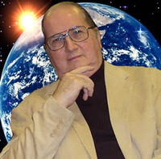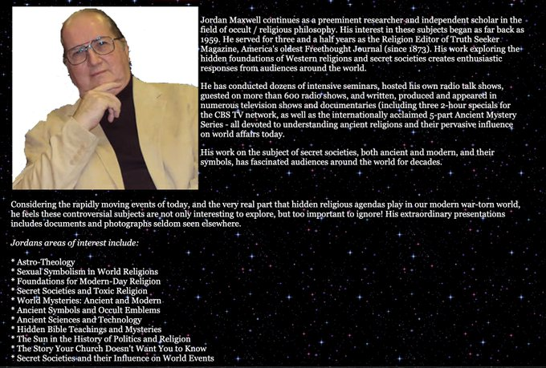

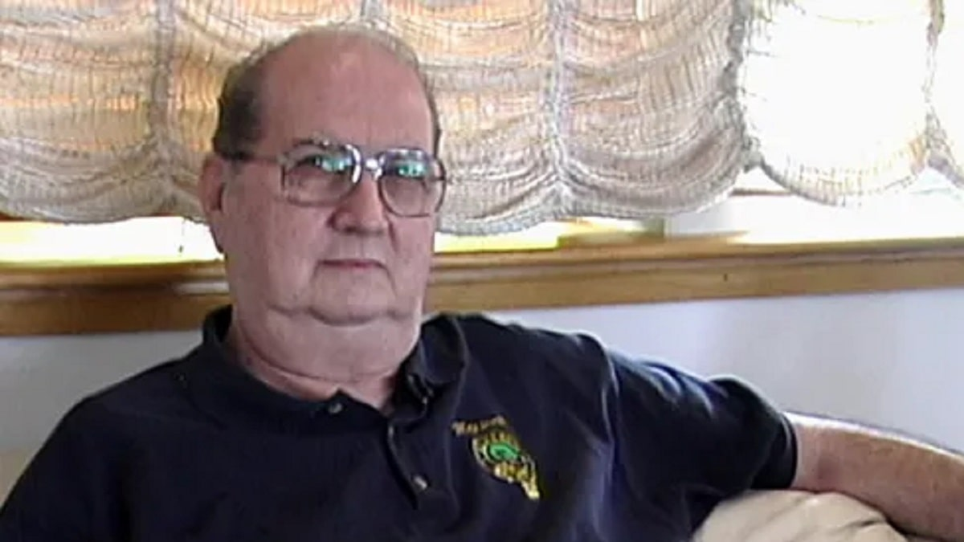
Researcher, author and alternative media icon Jordan Maxwell has died. Credit: Twitter

Researcher, author and alternative media icon Jordan Maxwell has died.
AUTHOR and alternative media icon Jordan Maxwell, who was a well-known researcher into the occult, religion and symbology, has died at the age of 82.
Maxwell was considered a preeminent researcher and independent scholar in the field of occult and religious philosophy after becoming attracted to this field in 1959 when he was a child, according to his friends.
Considered ‘the Godfather of conspiracy research’, tributes flooded social media platforms after his death was announced on Wednesday, March 23.
Infinite Fringe radio host and alternative media mainstay Billy Ray Valentine said: “RIP Jordan Maxwell. A legend. Rest Easy.”
Another Twitter user wrote: “Jordan Maxwell was one of the first people who set me down a path of research. Whatever books he would recommend reading, I ordered and read cover to cover. Thank you for all your inspiration and knowledge. RIP.”
“The Godfather of conspiracy research has crossed over. Thank you sir for enlightening the world with your wisdom,” one person said.
“Our dear friend Jordan Maxwell has passed on to a new beginning where adventures await his brilliant spirit. Thank you, Jordan for lighting our way. Your intelligence humour and courage planted seeds in our hearts. May we rise to carry on your legacy. Until we meet again,” wrote another in a touching tribute.
Luke Rudkowski said: “RIP Jordan Maxwell.”
Another shared a photo of Maxwell in his hospital bed, with the caption: “Rest in Peace Jordan Maxwell dear friend. I will continue your work on Earth. You changed my single-handedly. I will get our work to the masses with my books and one day TV series. Rest easy.”
One person wrote on Facebook: “The exceptional Jordan Maxwell has passed away. He was the first man to open my eyes to the ‘hidden world’ that surrounds us and it is immeasurable what he gifted to us all. I hope Jordan has inherited the ‘celestial’ kingdom he so very much deserves.”
“Honour to you Jordan Maxwell. Rest well my friend,” another said.
According to friends, the alternative media icon worked for three and a half years as the Religion Editor of Truth Seeker Magazine, America’s oldest Freethought Journal.
They noted that Maxwell was indulged in the religions, scripture and started exploring the hidden foundation of Western religions and secret societies creating enthusiastic responses from audiences around the world.
Controversial “conspiracy theorist,” David Icke said on Telegram: “RIP. See you on the other side brother.”
A statement released on his official Facebook account read: “It’s with great appreciation and a heavy heart to say that one of the greats of all-time Jordan Maxwell has departed the physical plane. Truly a giant in the study of the fields of religion, symbology, pattern recognition, law, secret societies and the occult. A rare breed.
“Many who knew Jordan as a friend realised that he was a deeply sensitive man who immensely cared about ‘family’ with a deep respect for his elders.
“Jordan had been in declining health but his mind was always on point and nothing gave him more pleasure than in sharing the depth of his research, knowledge and hopefully a bit of wisdom.
“Our sincere thanks for all the heavy lifting you did on behalf of all people who were free thinkers and open minds.”

^{The Ochelli Effect}
https://www.spreaker.com/user/ochelli/the-ochelli-effect-3-28-2022-jordan-maxw



Info
Farewell Legend Jordan Maxwell
The Ochelli Effect 3-28-2022 Jordan Mawell Tribute with Jeffrey Matte and Aaron Franz
With Love and Respect, The Ochelli Effect presents a Tribute to Jordan Maxwell. Jordan Maxwell (Reported on the day he was born, Russell Pine) December 28, 1940 - March 23, 2022. He is gone and shall not be forgotten.
For show notes, We have thoughts from the three voices who were LIVE on the show. Many clips of Jordan are heard during the 2-hour podcast.
-------------
- Aaron Franz -
I am indebted to Jordan Maxwell, and his generous sharing of decades of his unique research. His influence remains beyond measure. I am very lucky to have gotten to guest host his show and to have met and spoken with him.
Aaron Franz
-------------
- Jeffrey Matte -
Jordan Maxwell will be greatly missed and I am grateful for his lifelong sacrifice to teaching those who wanted to know. His dedication to learning and sharing the truth with the common man/woman while exposing underlying criminality was near super-human. I wish to celebrate this man's work by continuing to learn about our world and how it works, just as he did and the many others who do as well.
I also want to thank everyone around the world who tirelessly followed Jordan over the decades; you recognized the true value and insight this man represented when he was with us.
I am eternally grateful to Jordan, and forever in his debt for everything he taught me and shared unconditionally.
I also wish to thank Aaron and Chuck for their commitment to the truth and continued integrity in the material they choose to present.
You will be missed and I'll see you on the other side.
Jeffrey Matte
-------------
- Chuck Ochelli -
Jordan Maxwell has been a friend and teacher to me for some years. I have met and worked with many unique men in my life at different times. The unique man I knew provided me with a great portion of my reformed worldview, before and after I started speaking with him. I never thanked him enough for his work or our friendship.
Teacher, I'll see you soon.
Chuck Ochelli

Jordan Maxwell Death Cause And Wikipedia: What Happened To The Occult Books Author?

https://mixedarticle.com/jordan-maxwell-death-wikipedia

- Author: Ukesh Karki
- Published Date :March 24, 2022 05:34 AM
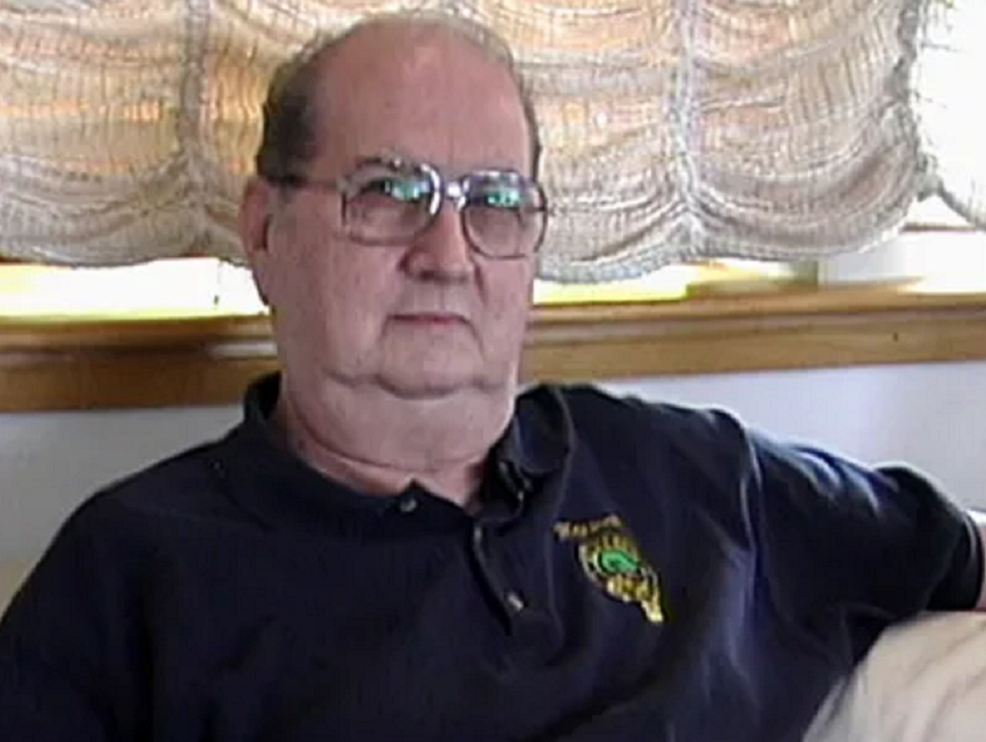

source: https://instagram.com
Table Of Content
- Jordan Maxwell Death Cause
- Jordan Maxwell Wikipedia: Who Is He?
Jordan Maxwell, an occults researcher and book author, has recently died. His sudden death has stunned his fans and followers. Let's find out more about him and his work in the occult.
With the internet getting more accessible, there is a rapid increase in the number of people who believe in the occult. This belief has given rise to people like Jordan, who claims to have witnessed such acts and sometimes give evidence to prove them.
There is no certain way to verify these beliefs because people often claim this knowledge is esoteric. No matter what, Jordan managed to have an impact on a large number of people, who will miss him.

Jordan Maxwell Death Cause
It is official that Jordan has died; however, there is a lack of answers regarding how he died. It can be expected that the sources near to him will soon report about his cause of death. He was a prominent figure for people in the occult.
His followers have taken over the internet to express their grievances and condolences to the deceased soul and family. They are also thanking him for sharing his knowledge with the rest of the world.
There is certainly discussion about the veracity of the things he has said about supernatural things and extra-terrestrial matters. He has also written books that are popular among the people who believe in these things.
His talks and matters have been expanded over various conspiracy theories. Looking at the surface, everything he did seems unconventional and superstitious, but still there people who trust him and are pursuing the path he has shown.

Jordan Maxwell Wikipedia: Who Is He?
Jordan is the researcher and author of the books that focus on the Occult. There are many claims he made that are questionable but some of them make sense in the current scenario, according to some people.
He has made claims like humans are mutating in a certain scientific manner. He has also given talks about the existence of secret societies like the Illuminati. These are only claims without any evidence backing them.
There are other claims too made by him like the existence of reptile people and so on, which he bolstered with an anecdote. He left a deep impact on many of his followers, who he inspired to follow the path he showed.
People can be for or against him but no one gainsays the fact that he was an elegant speaker who can defend his claims no matter how absurd they are. He was an explorer expanding the horizon of fields he believed were true.

============================================================================================================================================================================================

