Archetypes - Blueprints - Symbols
http://www.crystalinks.com/archetypes.html

Archetypes are creational blueprints that trigger our cellular memories. We all have cellular encoded memories that will be triggered under certain circumstances. I believe that we set those codings ourselves before we come into the physical plane to trigger at a specific point in our lives.
We do not all hold the same memories nor have the same triggers. Triggers can vary from tones, shapes, colors, digits, people, places, or events.
They can be found on the planet in crop circles, paintings, ancient hieroglyphs, various art forms, or just about anywhere.
Once the symbols triggers you - generally it has served its function - so don't look for deeer meanings or synchronicities.
Never stare at a symbol that has triggered someone else in hopes it will trigger you as well. Triggering is like a light switch that goes off in your mind. Boom! You make a connection that is beyond the physical realm.
Symbols often link with:
• Scared Geometry
• Messages From Entities Art, Writing, Pictures, Doodling
• Dreams
• Crop Circles
Suggested things to do with symbols:
• Meditate
• Sleep with the symbols under your pillow
• Trying to find someone else who connects to the same patterns
• Jewelry in the shapes of their symbols
• Paintings or sculptures
• Placing them on a computer to create holographic images

Crop Circle Archetypes
Crop formations fall into distinct categories for trigger people's memories:
Creation, Sacred Geometry, Converging Realities - weaving back into Oneness
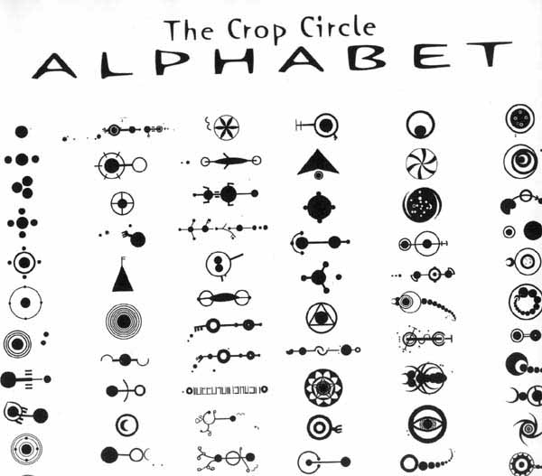
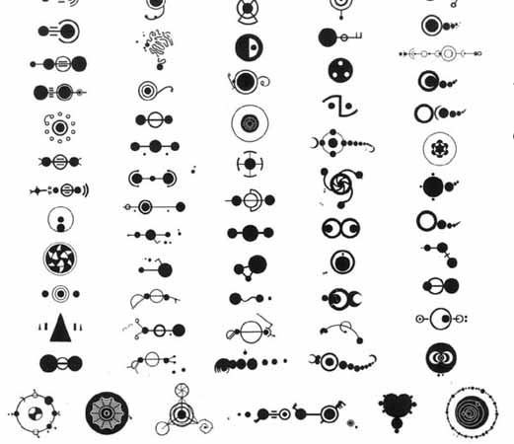
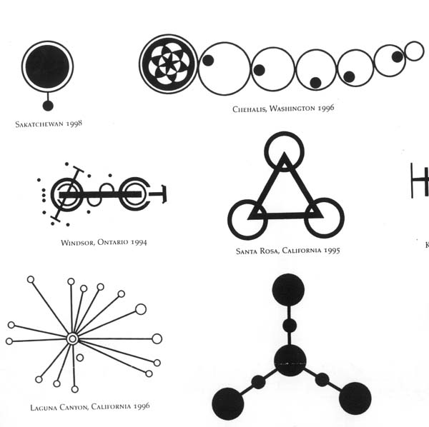
The Crop Circular

Native American Symbols

This specific design in its horizontal position represents the 'Universal Law of Free Will'. No one shall control another's physical, mental, emotional, sexual or spiritual essence. The repercussions of this violation result in decades and centuries of misplaced balance that affects the harmony of the universe and generates reincarnated souls that need to correct karma, which is needed for the continued existence of humankind. All philosophical and spiritual people may have many translations of this symbol according to their mental growth, but the result of each message will remain the same.


This design in its vertical postion represents the 'Spiritual Freedom of Humanity', the right to choose one's path in life, the right to choose between the Red Road and the Black Road, the right to choose a walk that is a steady road to higher spiritual growth or the right to choose the opposite, which would result in moral degradation for the human spirit. The representation of the adjacent road shows that there is always a choice and a chance to change.

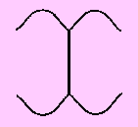
This design represents the 'Universal Change of Unci Maka' (the Earth ), or the four seasons of the Earth, as represented by the 'waniyetu' (winter), the 'wetu' (spring), the 'mdoyetu' (summer), and the 'ptanyetu'.

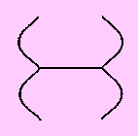
This design represents, the 'Four Stages of Physical / Emotional / Mental / Spiritual Growth of the Man and Woman', the 'bebena' (baby), the 'wikoska' (young man) and the 'wikoske' (young woman), and the 'wicahcana' (old man) and the 'winhucana' (old women). In the feminine terms it will be equal to the physical.

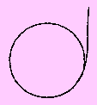
This design represents the 'Spirit of All Creation' , 'Moves With the Earth', the two-leggeds, the four-leggeds, the ones that crawl, the ones that swim, and the plants and all that grow from 'Unci Maka' (the Earth) and the spiritual walk of man.

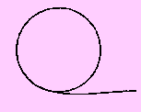
This design represents 'Strength, Happiness and Health'. There is more to this one, and we will know more later.

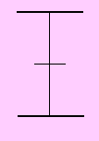
This is the symbol of the 'Universal Law of Innocence and Truth'. The upper line represents the celestial (heaven), and the bottom line represents the terrestrial (Earth). The connection between Heaven and Earth represents the creation of innocence and this is reflected by the center line. The innocence has no right or wrong, no good or bad. This results in truth.

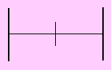
This is the symbol of 'Spiritual Protection'. The right line represents wicasa (man) and the left represents winyan (woman). The connection between the two represents the wakanyeza (the innocent children). The responsibility of the parents is to protect the children. This is the symbol of Tiwahe (family) among the Lakota and the Dakota Oyate (Nation).

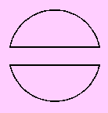
This symbol represents the 'Separation of Humankind' from the animals, plants, birds and all creation. Man thought of himself as superior, better than the animals and the other creatures. This created an extinction for many species, which equals an imbalance.

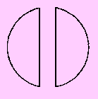
This is the symbol for the 'Spiritual Law of Equality'. No one is either above or below another. Every life form is equal to all others. We all depend on all life forms for our existence.

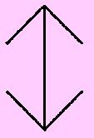
This design represents the 'Connection Between the Creator and the Human Being'. The prayers that are sent directly to the Creator are indicated by the wahinkpi pointing upwards. The Creator then sends or answers the prayers however he feels back to Maka (the Earth).

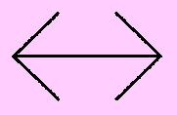
This design represents the Freedom of Choice every human being faces. The direction he chooses is either towards power or towards being a human being. The Wicahpi Oyate (The Star Nation) carry the same choices. Some of them have made the decision for power and some of them have chosen to be human beings.

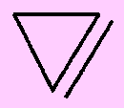
This design represents the 'Universal Law of Light, Sound and Vibration'.

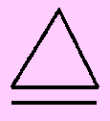
This design represents the Spiritual Gift to Humankind. It represents the power to see feeling, the power to change things through thought, and the power of intuition.

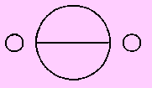
This design represents the 'Universal Law of Judgment'.

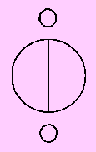
This design represents the Spiritual Law of Karma - 'What goes around comes around'.

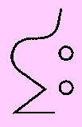
This design represents the 'Law of Nature'. The only animal that utilizes this law is the black-tailed deer. This design is a symbol that hasn't been utilized in the last 150 years.

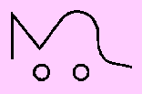
This is the spiritual 'Law of Protection', which is being direct and to the point.
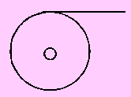
This is the spiritual 'Law of Protection', which is being direct and to the point.

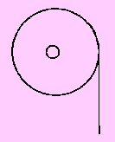
This design is used by the 'Spirit of Doctoring'. It can be used as a design for the altar to help the people with good health and to help those people to cross over. The design represents the gift to bring people back up to the level of being in balance and structuring their spiritual levels back to the understanding and balancing their physical, mental and emotional and spiritual awareness back into the Circle of Life and living in oneness with creation.

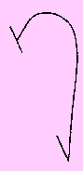
This one represents the 'Universal Law of Perception', the art of being far sighted into the realms of Universal thought and respect for mankind and all forms of life on Keya Maka (the Earth). To perceive any act that will create long term devastation that will create an imbalance within the universe.

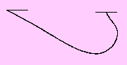
This design represents the 'Spiritual Law of Perception'. It is used to help those who need help on a spiritual and emotional level. This law helps those who ask for help and tells us not to use this spiritual law to manipulate others into our way of spiritual thought. It also requires every individual to see how his/her words and actions can create spiritual construction or spiritual destruction.

Blueprints By Nicole Torres
Email
It seems as if the blueprints have a particular frequency attached to each one. I see them three dimensionally as if I could actually walk through them and obtain information about them through actually going through them. A composition of several of these blueprints would actually make up an intelligible group of sounds ....all of them are like morphemes, a unique sound that when grouped together make up words or symbols that convey intense meanings. In one of my meditations I walked through several of these prints and realized that within each of them there existed many smaller blueprints that made up the larger ones, hence the information was of course infinite.

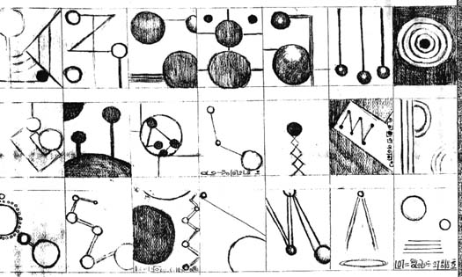

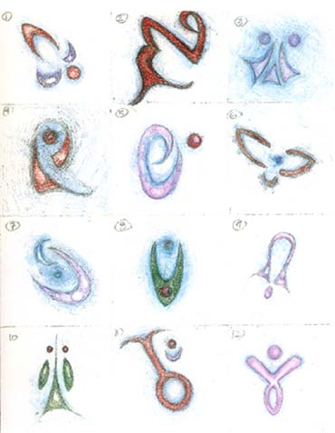

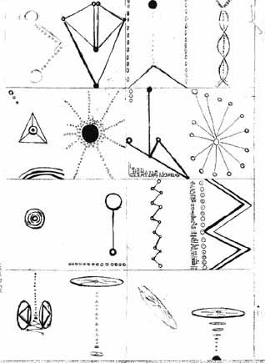

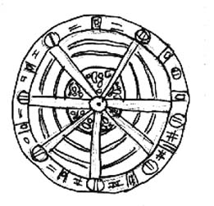

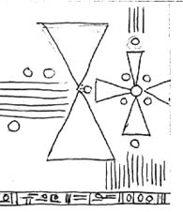

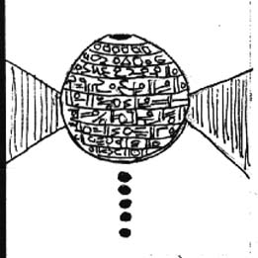

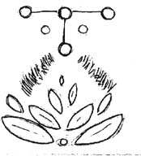

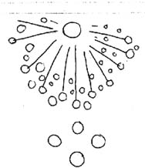

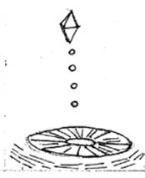

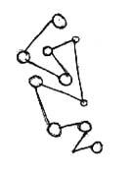

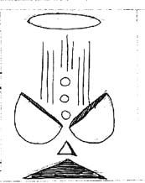

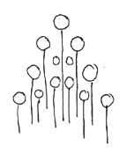

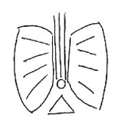

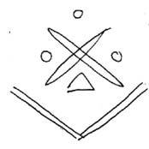

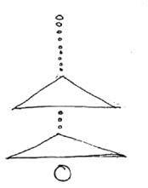

Egyptian Archetypes sent by Damion

