# Design Fundamentals Permaculture notes

quietly bring to consciousness the essential factors of passive planning. To restate the basic energy-conserving rules:

The four principles of natural farming (no cultivation, no chemical fertilizer or prepared compost, no weeding by tillage or herbicides, and no dependence on chemicals)

1. No placement without the element (plant, animal or structure) serving at least two or more functions”.

2. “Every function (water collection, fire protection) served in two or more ways.” With the foregoing rules, strategies, and criteria in mind, you can’t go far wrong in design.

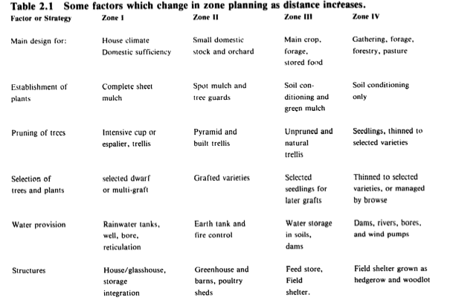

The golden rule is to develop the nearest area first, get it under control, and then expand the perimeter.

Time, like area, is a resource (as any farmer knows). Just as we can over-extend in area, so to can we in time. This is the very basis of zonation planning in permaculture; It becomes critical as a matter of time conservation, to tend to the land nearest to one, not to commute too far, and thus centralize on settlement. Very close attention should be given to the nature of activities and distance, or we may run out of tirne for control, and hence lose yield and stability.

## Sector Planning

* fire danger sector
* cold winds
* hot, salty, or dusty winds
* screening of nearby irksome views
* winter and summer sun angles and
* reflection from ponds.

With zones and sectors sketched in on the ground plan, slope analysis may proceed. High and low entries or access roads, the former for heavy cargo or mulch, the latter for fire control, can now be placed. Provision for attached glasshouse, hot air collector, reflection pond, solar pond, and shade-house should be made at all homestead sites where climatic variation is experienced. Details of these are given in following sections.

Yoeman’s – Keypoint and water harvesting research

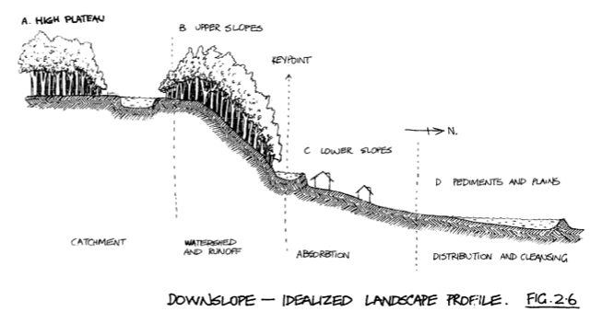

Above the keyline, particularly on rough, rocky and dry sites, there should be careful selection of dry-country permaculture needing ‘spot’ watering only for establishment. On lower sites choose plants with higher water requirements

At the dwellings, small tanks for emergency supply are needed ( 22,000 liters for a family of 5) and the dwelling sited behind the lower dams or lakes for fire protection (fire is most intense when advancing upslope). Waste water, run to a series of small pondings, provides valuable algae and nutrients for low gardens, duck food, and fish food.

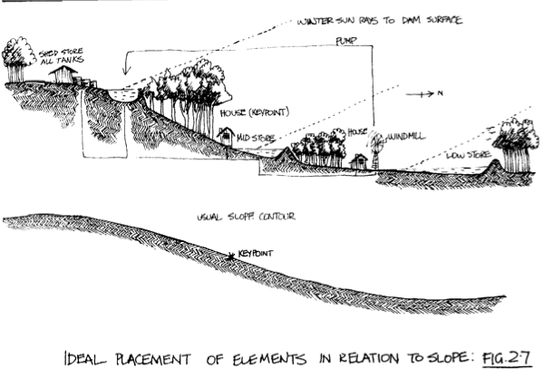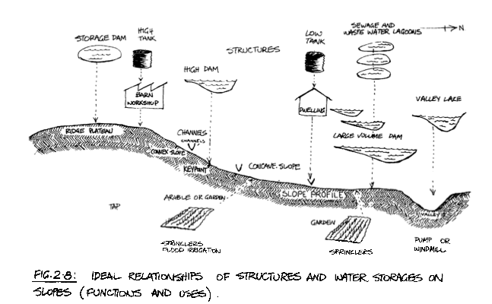

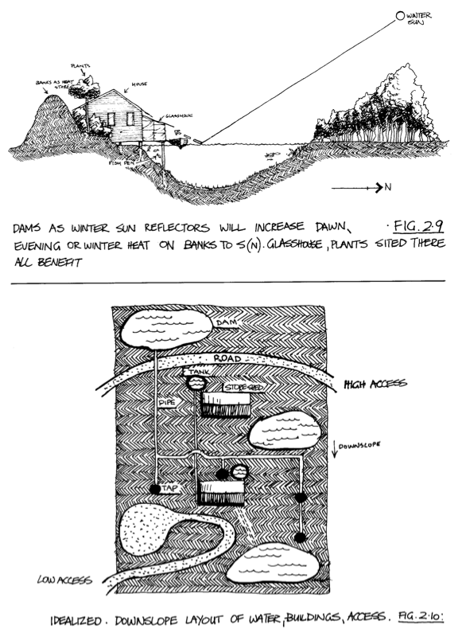

People frequently ask how much land they need for self-sufficiency. The answer is, “As much as you can control”. Any more and you lose self-sufficiency, let alone the ability to produce an excess.

But the smaller the managed annual system can become, the more is left for perennial planting and for free-range animals on forage crop. Vegetables can largely supplanr monoculture grains for human food, as tree crops can largely supplant grains for animal forage. The energy savings of both these strategies are obvious and necessary.

## Systems Establishment

It is not difficult to accommodate or design gardens that are more intensive than the natural system, and our advantage is that we can use several strategies to increase the number of plants that will fit into an area. These are: l by preventing water loss, building high shade, or hedge and trenched wall systems which reduce evaporation by wind;

l by introducing very drought-resistant species such as cacti, which have a greater resistance to drought than normal useful plants, especially as windbreak hedges; and l by using vertical, buried sheet-plastic moisture barriers between the garden and the dry soil it adjoins.

a well- occupied system resists invasion by rampant forms (such as blackbirds and blackberries), so that the initia! diversity, plus lack qf disturbance are the factors that will preserve the diversity- stability dynamism. I cannot stress too much the importance of keeping a small area fully occupied with plants,as a strategy to reduce work.

* act as trellis to plants (grape on mulberry, fig, boxthorn); 0 screen and shade plants (coffee under palms); * provide nutrients to plants (comfrey leaves for potato sets); * cross-fertilize plants (different varieties of plums and nuts); @ live in obligate relationships with plants (fungi under oaks, pines); @ reject or accept other plants (see section on companion plants); @ provide spare parts (grafts) for plants (apple, pear, nut species).

*The “edge effect” is an important factor in permaculture. It is recognized by ecologists that the interface between two ecosystems represents a third, more complex system which combines both. At interfaces species from both systems can exist and the edge also supports its own species in many cases. Gross photosynthetic production is higher at interfaces. For example, the complex systems of land/ocean interfaces-such as estuaries and coral reefs-shows the highest production per unit area, of any of the major ecosystems(Kormondy, E. J., Concepts of Ecology. Prentice Hall, New Jersey, 1959).A landscape with complex edge is interesting and beautiful; it can be considered the basis of the art of landscape design. And most certainly, increase ededge makes for a more productive landscape.(Permuculture One’, p. 29

Up to page 24

The One-Straw Revolution, by Masanobu Fukuoka, 1978.

http://zinelibrary.info/files/Permaculture,%20The%20One%20Straw%20Revolution.pdf

Almost everyone thinks that "nature" is a good thing, but few can grasp the difference between natural and unnatural.

If a single new bud is snipped off a fruit tree with a pair of scissors it may bring about disorder that cannot be undone. When growing according to the natural form, branches spread alternately from the trunk and the leaves receive sunlight uniformly. If this sequence is disrupted the branches come into conflict, lay one upon another and become tangled, and the leaves wither in the places where the sun cannot penetrate. Insect damage develops. If the tree is not pruned the following year more withered branches will appear.

Human beings with their tampering do something wrong, leave the damage unrepaired, and when the adverse results accumulate, work with all their might to correct them. When the corrective actions appear to be successful, they come to view these measures as splendid accomplishments. People do this over and over again. It is as if a fool were to stomp on and break the tiles of his roof. Then when it starts to rain and the ceiling begins to rot away, he hastily climbs up to mend the damage, rejoicing in the end that he has accomplished a miraculous solution.

It is the same with the scientist. He pores over books night and day, straining his eyes and becoming nearsighted, and if you wonder what on earth he has been working on all that time-it is to become the inventor of eyeglasses to correct nearsightedness.

Don’t buy the chipper – you will be trapped into using machines – get nature working right from the beginning. Only with right fungus environment can sticks break down naturally. Start from the beginning. Grow the mulch on-site.

The ones who see true nature are infants. They see without thinking, straight and clear. If even the names of plants are known, a mandarin orange tree of the citrus family, a pine of the pine family, nature is not seen in its true form.

An object seen in isolation from the whole is not the real thing.

whether or not humans know nature, and of whether or not nature can be known within the confines of human understanding.

if nature is left to itself, fertility increases. Organic remains of plants and animals accumulate and are decomposed on the surface by bacteria and fungi. With the movement of rainwater, the nutrients are taken deep into the soil to become food for microorganisms, earthworms, and other small animals. Plant roots reach to the lower soil strata and draw the nutrients back up to the surface.

As the green manure (*Ground cover crops such as clover, vetch, alfalfa which condition and nourish the soil*.) enriches and softens the soil, weeds and bushes grow up below the trees, and a rich cycle of regeneration is begun. There are instances in which the top four inches of soil have become enriched in less than ten years.

For the most part, a permanent green manure cover and the return of all the straw and chaff to the soil will be sufficient. To provide animal manure to help decompose the straw, I used to let ducks loose in the fields, if they are introduced as ducklings while the seedlings are still young, the ducks will grow up together with the rice. Ten ducks will supply all the manure necessary for a quarter acre and will also help to control the weeds.

Using straw, green manure, and a little poultry manure, one can get high yields without adding compost or commercial fertilizer at all.

If seeds are sown while the preceding crop is still ripening in the field, those seeds will germinate ahead of the weeds. Winter weeds sprout only after the rice has been harvested, but by that time, the winter grain already has a head start. Summer weeds sprout right after the harvest of barley and rye, but the rice is already growing strongly. Timing the seeding in such a way that there is no interval between succeeding crops gives the grain a great advantage over the weeds.

Directly after the harvest, if the whole field is covered with straw, the germination of weeds is stopped short. White clover sowed with the grain as a ground cover also helps to keep weeds under control.

If rice is sown in the autumn and left uncovered, the seeds are often eaten by mice and birds, or they sometimes rot on the ground, and so I enclose the rice seeds in

little clay pellets before sowing. Pg for more detail

Such is the yearly cycle of rice/winter-grain cultivation by the natural method. The seeding and harvesting so closely follow the natural pattern that it could be considered a natural process rather than an agricultural technique.

There is probably no easier, simpler method for growing grain. It involves little more than broadcasting seed and spreading straw, but it has taken me over thirty years to reach this simplicity.

In areas where water is not so readily available, for example, upland rice or other grains such as buck- wheat, sorghum or millet might he grown. Instead of white clover, another variety of clover, alfalfa, vetch or lupine might prove a more suitable field cover.