the Oregon Petition
31,487 American scientists have signed this petition,
including 9,029 with PhDs
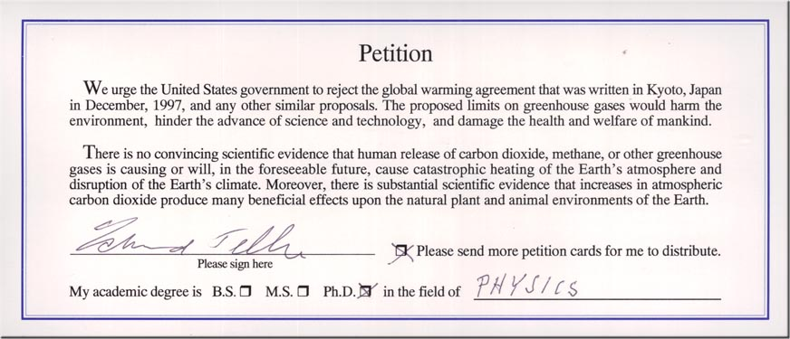
THE OREGON PETITION
31,486 scientists have signed a document called the Oregon Petition
lambasting the shoddy research behind global warming, stating quite simply that “. . . any
human contribution to climate change has not been demonstrated.”
This is not a gang of political hacks, or George Soros–funded “activists.” No, the signatories
include 3,667 atmospheric, environmental and Earth scientists; 4,796 chemists; 2,924 biologists
and agricultural scientists; 903 math and computer scientists; and 9,992 in engineering and
general science.
Of these, 9,029 have PhDs.
The petition states that there is no convincing scientific evidence that the human release of
carbon dioxide or other greenhouse gases is causing or will cause global warming.
It goes on to say that there is substantial scientific evidence demonstrating that atmospheric
carbon dioxide produces countless beneficial effects on the plant and animal populations of
Earth. (In one of Mother Nature’s most spectacular touches of environmental magic, plants
convert carbon dioxide and sunlight into oxygen—you know, the stuff we breathe.)

