Applications of neural networks

Neural networks in medicine
Artificial Neural Networks (ANN) are currently a 'hot' research area in medicine and it is believed that they will receive extensive application to biomedical systems in the next few years. At the moment, the research is mostly on modelling parts of the human body and recognising diseases from various scans (e.g. cardiograms, CAT scans, ultrasonic scans, etc.).
Neural networks are ideal in recognising diseases using scans since there is no need to provide a specific algorithm on how to identify the disease. Neural networks learn by example so the details of how to recognise the disease are not needed. What is needed is a set of examples that are representative of all the variations of the disease. The quantity of examples is not as important as the 'quantity'. The examples need to be selected very carefully if the system is to perform reliably and efficiently.
- Modelling and Diagnosing the Cardiovascular System
Neural Networks are used experimentally to model the human cardiovascular system. Diagnosis can be achieved by building a model of the cardiovascular system of an individual and comparing it with the real time physiological measurements taken from the patient. If this routine is carried out regularly, potential harmful medical conditions can be detected at an early stage and thus make the process of combating the disease much easier.
A model of an individual's cardiovascular system must mimic the relationship among physiological variables (i.e., heart rate, systolic and diastolic blood pressures, and breathing rate) at different physical activity levels. If a model is adapted to an individual, then it becomes a model of the physical condition of that individual. The simulator will have to be able to adapt to the features of any individual without the supervision of an expert. This calls for a neural network.
Another reason that justifies the use of ANN technology, is the ability of ANNs to provide sensor fusion which is the combining of values from several different sensors. Sensor fusion enables the ANNs to learn complex relationships among the individual sensor values, which would otherwise be lost if the values were individually analysed. In medical modelling and diagnosis, this implies that even though each sensor in a set may be sensitive only to a specific physiological variable, ANNs are capable of detecting complex medical conditions by fusing the data from the individual biomedical sensors.

- Electronic noses
ANNs are used experimentally to implement electronic noses. Electronic noses have several potential applications in telemedicine. Telemedicine is the practice of medicine over long distances via a communication link. The electronic nose would identify odours in the remote surgical environment. These identified odours would then be electronically transmitted to another site where an door generation system would recreate them. Because the sense of smell can be an important sense to the surgeon, telesmell would enhance telepresent surgery.
- Instant Physician
An application developed in the mid-1980s called the "instant physician" trained an autoassociative memory neural network to store a large number of medical records, each of which includes information on symptoms, diagnosis, and treatment for a particular case. After training, the net can be presented with input consisting of a set of symptoms; it will then find the full stored pattern that represents the "best" diagnosis and treatment.
Neural Networks in business
Business is a diverted field with several general areas of specialisation such as accounting or financial analysis. Almost any neural network application would fit into one business area or financial analysis.
There is some potential for using neural networks for business purposes, including resource allocation and scheduling. There is also a strong potential for using neural networks for database mining, that is, searching for patterns implicit within the explicitly stored information in databases. Most of the funded work in this area is classified as proprietary. Thus, it is not possible to report on the full extent of the work going on. Most work is applying neural networks, such as the Hopfield-Tank network for optimization and scheduling.
- Marketing
There is a marketing application which has been integrated with a neural network system. The Airline Marketing Tactician (a trademark abbreviated as AMT) is a computer system made of various intelligent technologies including expert systems. A feedforward neural network is integrated with the AMT and was trained using back-propagation to assist the marketing control of airline seat allocations. The adaptive neural approach was amenable to rule expression. Additionaly, the application's environment changed rapidly and constantly, which required a continuously adaptive solution. The system is used to monitor and recommend booking advice for each departure. Such information has a direct impact on the profitability of an airline and can provide a technological advantage for users of the system. [Hutchison & Stephens, 1987]
While it is significant that neural networks have been applied to this problem, it is also important to see that this intelligent technology can be integrated with expert systems and other approaches to make a functional system. Neural networks were used to discover the influence of undefined interactions by the various variables. While these interactions were not defined, they were used by the neural system to develop useful conclusions. It is also noteworthy to see that neural networks can influence the bottom line.

2. Credit Evaluation
The HNC company, founded by Robert Hecht-Nielsen, has developed several neural network applications. One of them is the Credit Scoring system which increase the profitability of the existing model up to 27%. The HNC neural systems were also applied to mortgage screening. A neural network automated mortgage insurance underwritting system was developed by the Nestor Company. This system was trained with 5048 applications of which 2597 were certified. The data related to property and borrower qualifications. In a conservative mode the system agreed on the underwritters on 97% of the cases. In the liberal model the system agreed 84% of the cases. This is system run on an Apollo DN3000 and used 250K memory while processing a case file in approximately 1 sec.

CoEvolution of Neural Networks for Control of Pursuit & Evasion

.

The following MPEG movie sequences illustrate behaviour generated by dynamical recurrent neural network controllers co-evolved for pursuit and evasion capabilities. From an initial population of random network designs, successful designs in each generation are selected for reproduction with recombination, mutation, and gene duplication. Selection is based on measures of how well each controller performs in a number of pursuit-evasion contests. In each contest a pursuer controller and an evader controller are pitched against each other, controlling simple ``visually guided'' 2-dimensional autonomous virtual agents. Both the pursuer and the evader have limited amounts of energy, which is used up in movement, so they have to evolve to move economically. Each contest results in a time-series of position and orientation data for the two agents.
These time-series are then fed into a custom 3-D movie generator. It is important to note that, although the chase behaviors are genuine data, the 3D structures, surface physics, and shading are all purely for illustrative effect.
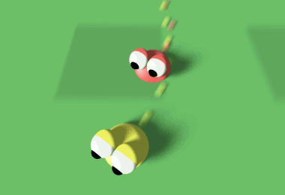

- P0 vs E0 (2.33Mb Color Mpeg). Best pursuer from generation 0 versus best evader from generation 0. Generation 0 is the initial random generation, so the behaviors shown here are produced by randomly generated recurrent dynamical neural network architectures. As can be seen, the pursuer is not very good at pursuing, and the evader is not very good at evading.

2. P200 vs E200 (2.31Mb Color Mpeg). Best pursuer from generation 200 versus best evader from generation 200. Pursuer chases evader, but soon runs out of energy, allowing the evader to escape.
3. P999 vs E999 (1.53Mb Color Mpeg). Best pursuer from generation 999 versus best evader from generation 999. Pursuer chases evader, but uses up all its energy just before the evader runs out of energy.
4. P999 vs E200 (1.34Mb Color Mpeg). Best pursuer from generation 999 versus best evader from generation 200. After a couple of close shaves, the pursuer finally catches the evader.

Learning the Distribution of Object Trajectories for Event Recognition

.
This research work is about the modelling of object behaviours using detailed, learnt statistical models. The techniques being developed will allow models of characteristic object behaviours to be learnt from the continuous observation of long image sequences. It is hoped that these models of characteristic behaviours will have a number of uses, particularly in automated surveillance and event recognition, allowing the surveillance problem to be approached from a lower level, without the need for high-level scene/behavioural knowledge. Other possible uses include the random generation of realistic looking object behaviour for use in Virtual Reality (see Radiosity for Virtual Reality Systems at Section 2.3), and long-term prediction of object behaviours to aid occlusion reasoning in object tracking.

1. The model is learnt in an unsupervised manner by tracking objects over long image sequences, and is based on a combination of a neural network implementing Vector Quantisation and a type of neuron with short-term memory capabilities. 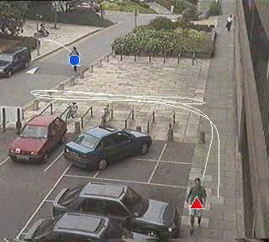  1. Learning mode |  | 2. Models of the trajectories of pedestrians have been generated and used to assess the typicality of new trajectories (allowing the identification of `incidents of interest' within the scene), predict future object trajectories, and randomly generate new trajectories. 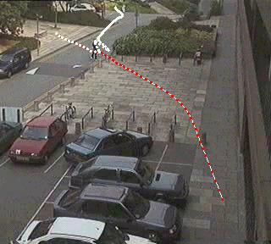  2. Predict mode

Autonomous Walker & Swimming Eel

.
(A) The research in this area involves combining biology, mechanical engineering and information technology in order to develop the techniques necessary to build a dynamically stable legged vehicle controlled by a neural network. This would incorporate command signals, sensory feedback and reflex circuitry in order to produce the desired movement.  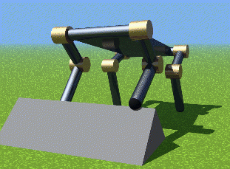  Walker |  | (B) Simulation of the swimming lamprey (eel-like sea creature), driven by a neural network.  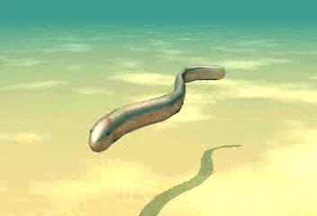  Swimming Lamprey

Robocup: Robot World Cup

The RoboCup Competition pits robots (real and virtual) against each other in a simulated soccer tournament. The aim of the RoboCup competition is to foster an interdisciplinary approach to robotics and agent-based AI by presenting a domain that requires large-scale coorperation and coordination in a dynamic, noisy, complex environment.
RoboCup has three different leagues to-date. The Small and Middle-Size Leagues involved physical robots; the Simulation League is for virtual, synthetic teams. This work focus on building softbots for the Simulation League.
Machine Learning for Robocup involves:
The training of player in the process of making the decision of whether (a) to dribble the ball; (b) to pass it on to another team-mate; (c) to shoot into the net.
The training of the goalkeeper in process of intelligent guessing of how the ball is going to be kick by the opponents. Complexities arise when one opponent decides to pass the ball to another player instead of attempting a score.
Evolution of a co-operative and perhaps unpredictable team.
Common AI methods used are variants of Neural Networks and Genetic Algorithms.

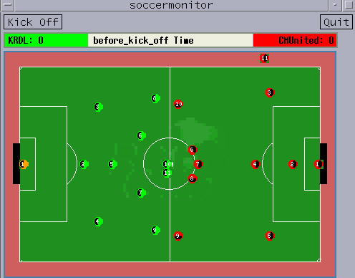
KRDL Soccer Softbots

Using HMM's for Audio-to-Visual Conversion

.
One emerging application which exploits the correlation between audio and video is speech-driven facial animation. The goal of speech-driven facial animation is to synthesize realistic video sequences from acoustic speech. Much of the previous research has implemented this audio-to-visual conversion strategy with existing techniques such as vector quantization and neural networks. Here, they examine how this conversion process can be accomplished with hidden Markov models (HMM).

(A) Tracking Demo: The parabolic contour is fit to each frame of the video sequence using a modified deformable template algorithm. The height between the two contours, and the width between the corners of the mouth can be extracted from the templates to form our visual parameter sets.  (B) Morphing Demo: Another important piece of the speech-driven facial animation system is a visual synthesis module. Here we are attempting to synthesize the word "wow" from a single image. Each frame in the video sequence is morphed from the first frame shown below. The parameters used to morph these images were obtained by hand. Tracking |  | 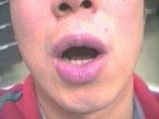  Morphing  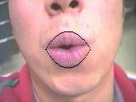

Artificial Life: Galapagos

Galapagos is a fantastic and dangerous place where up and down have no meaning, where rivers of iridescent acid and high-energy laser mines are beautiful but deadly artifacts of some other time. Through spatially twisted puzzles and bewildering cyber-landscapes, the artificial creature called Mendel struggles to survive, and you must help him.
Mendel is a synthetic organism that can sense infrared radiation and tactile stimulus. His mind is an advanced adaptive controller featuring Non-stationary Entropic Reduction Mapping -- a new form of artificial life technology developed by Anark. He can learn like your dog, he can adapt to hostile environments like a cockroach, but he can't solve the puzzles that prevent his escape from Galapagos.

Galapagos features rich, 3D texture-mapped worlds, with continuous-motion graphics and 6 degrees of freedom. Dramatic camera movement and incredible lighting effects make your passage through Galapagos breathtaking. Explosions and other chilling effects will make you fear for your synthetic friend. Active panning 3D stereo sound will draw you into the exotic worlds of Galapagos. |  | 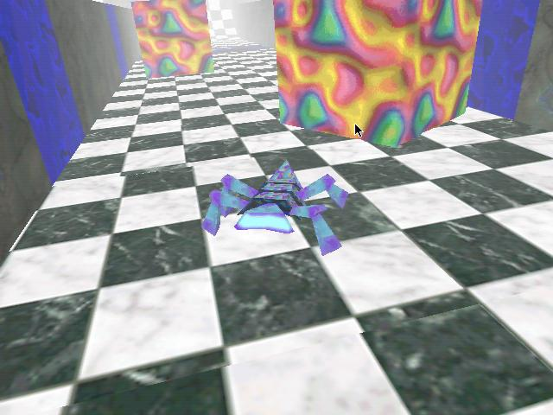  Galapagos

Speechreading (Lipreading)

.
As part of the research program Neuroinformatik the IPVR develops a neural speechreading system as part of a user interface for a workstation. The three main parts of the system include a face tracker (done by Marco Sommerau), lip modeling and speech processing (done by Michael Vogt) and the development and application of SNNS for neural network training (done by Günter Mamier).
Automatic speechreading is based on a robust lip image analysis. In this approach, no special illumination or lip make-up is used. The analysis is based on true color video images. The system allows for realtime tracking and storage of the lip region and robust off-line lip model matching. The proposed model is based on cubic outline curves. A neural classifier detects visibility of teeth edges and other attributes. At this stage of the approach the edge between the closed lips is automatically modeled if applicable, based on a neural network's decision.
To achieve high flexibility during lip-model development, a model description language has been defined and implemented. The language allows the definition of edge models (in general) based on knots and edge functions. Inner model forces stabilize the overall model shape. User defined image processing functions may be applied along the model edges. These functions and the inner forces contribute to an overall energy function. Adaptation of the model is done by gradient descent or simulated annealing like algorithms. The figure shows one configuration of the lip model, consisting of an upper lip edge and a lower lip edge. The model edges are defined by Bezier-functions. Outer control knots stabilize the position of the corners of the mouth.

 |  | 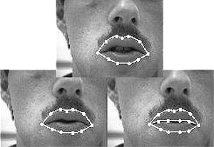  Lipread
  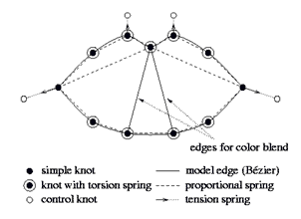
  Fig 2.8.1 The model interpreter enables a permanent measurement of model knot positions and color blends along model edges during adaptation to an utterance. The resulting parameters may be used for speech recognition tasks in further steps.

Detection and Tracking of Moving Targets

.
The moving target detection and track methods here are "track before detect" methods. They correlate sensor data versus time and location, based on the nature of actual tracks. The track statistics are "learned" based on artificial neural network (ANN) training with prior real or simulated data. Effects of different clutter backgrounds are partially compensated based on space-time-adaptive processing of the sensor inputs, and further compensated based on the ANN training. Specific processing structures are adapted to the target track statistics and sensor characteristics of interest. Fusion of data over multiple wavelengths and sensors is also supported.
Compared to conventional fixed matched filter techniques, these methods have been shown to reduce false alarm rates by up to a factor of 1000 based on simulated SBIRS data for very weak ICBM targets against cloud and nuclear backgrounds, with photon, quantization, and thermal noise, and sensor jitter included. Examples of the backgrounds, and processing results, are given below.
The methods are designed to overcome the weaknesses of other advanced track-before-detect methods, such as 3+-D (space, time, etc.) matched filtering, dynamic programming (DP), and multi-hypothesis tracking (MHT). Loosely speaking, 3+-D matched filtering requires too many filters in practice for long-term track correlation; DP cannot realistically exploit the non-Markovian nature of real tracks, and strong targets mask out weak targets; and MHT cannot support the low pre-detection thresholds required for very weak targets in high clutter. They have developed and tested versions of the above (and other) methods in their research, as well as Kalman-filter probabilistic data association (KF/PDA) methods, which they use for post-detection tracking.
Space-time-adaptive methods are used to deal with correlated, non-stationary, non-Gaussian clutter, followed by a multi-stage filter sequence and soft-thresholding units that combine current and prior sensor data, plus feed back of prior outputs, to estimate the probability of target presence. The details are optimized by adaptive "training" over very large data sets, and special methods are used to maximize the efficiency of this training.

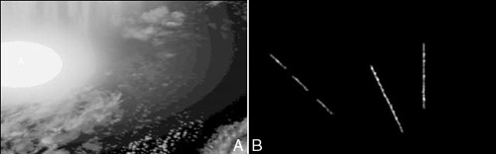
Figure 2.9 (a) Raw input backgrounds with weak targets included,
(b) Detected target sequence at the ANN processing output,
post-detection tracking not included.

2.10 | Real-time Target Identification for Security Applications

.
The system localises and tracks peoples' faces as they move through a scene. It integrates the following techniques:
- Motion detection
- Tracking people based upon motion
- Tracking faces using an appearance model
Faces are tracked robustly by integrating motion and model-based tracking.

(A) Tracking in low resolution and poor lighting conditions  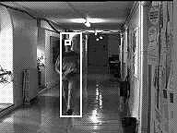  Jon |  | (B) Tracking two people simultaneously: lock is maintained on the faces despite unreliable motion-based body tracking.  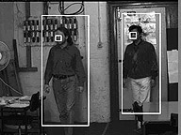  Double Tracking

2.11 | Facial Animation

.
Facial animations created using hierarchical B-spline as the underlying surface representation. Neural networks could be use for learning of each variations in the face expressions for animated sequences.
The (mask) model was created in SoftImage, and is an early prototype for the character "Mouse" in the YTV/ABC televisions series "ReBoot" (They do not use hierarchical splines for Reboot!). The original standard bicubic B-spline was imported to the "Dragon" editor and a hierarchy automatically constructed. The surface was attached to a jaw to allow it to open and close the mouth. Groups of control vertices were then moved around to created various facial expressions. Three of these expressions were chosen as key shapes, the spline surface was exported back to SoftImage, and the key shapes were interpolated to create the final animation.
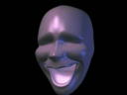  Mask | 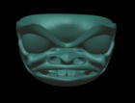  Haida

Artificial Life for Graphics, Animation, Multimedia, and Virtual Reality: Siggraph '95 Showcase

.
Some graphics researchers have begun to explore a new frontier--a world of objects of enormously greater complexity than is typically accessible through physical modeling alone--objects that are alive. The modeling and simulation of living systems for computer graphics resonates with the burgeoning field of scientific inquiry called Artificial Life. Conceptually, artificial life transcends the traditional boundaries of computer science and biological science. The natural synergy between computer graphics and artificial life can be potentially beneficial to both disciplines. As some of the demos here demonstrate, potential is becoming fulfillment.
The demos demonstrate and elucidate new models that realistically emulate a broad variety of living things--both plants and animals--from lower animals all the way up the evolutionary ladder to humans. Typically, these models inhabit virtual worlds in which they are subject to physical laws. Consequently, they often make use of physics-based modeling techniques. More significantly, however, they must also simulate many of the natural processes that uniquely characterize living systems--such as birth and death, growth, natural selection, evolution, perception, locomotion, manipulation, adaptive behavior, intelligence, and learning. The challenge is to develop sophisticated graphics models that are self-creating, self-evolving, self-controlling, and/or self-animating by simulating the natural mechanisms fundamental to life.

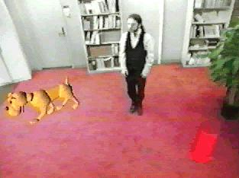  A.Dog | 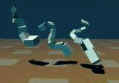  Evolved Virtual Creatures | 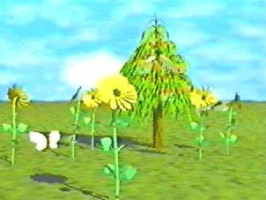  Sensor-Based Autonomous Creatures | 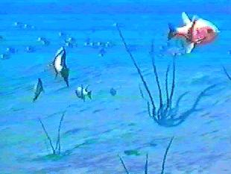  A.Fish

Creatures: The World Most Advanced Artificial Life!

.
Creatures is the most entertaining computer game you'll ever play which offers nothing to shoot, no puzzles to solve or difficult controls to master. And yet it is mesmerising entertainment.
One have to raise, teach, breed and love computer pets that are really alive. They are so alive that if it is not taken care of, they will die. Creatures features the most advanced, genuine Artificial Life software ever developed in a commercial product, technology that has blown the imaginations of scientists world-wide. This is a look into the future where new species of life emerge from ordinary home and office PCs.

Framsticks Artificial Life

.
Framsticks is a three-dimensional life simulation project. Both physical structure of creatures and their control systems are evolved. Evolutionary algorithms are used with selection, crossovers and mutations. Finite elements method is used for simulation. Both spontaneous and directed evolutions are possible.
"Antelope" attacks "Spider". The broken "Spider" becomes energy/food source.

Conclusion
The development of true Neural Networks is a fairly recent event, which has been met with success. Two of the different systems (among the many) that have been developed are: the basic feedforward Network and the Hopfield Net.
In addition to the applications featured here, other application areas include:
- Financial Analysis -- stock predictions .
- Signature Analysis -- the banks in America have taken to NNs to compare signatures with what is stored.
- Process Control Oversight -- NNs are used to advise aircraft pilots of engine problems.
- Direct Marketing -- NNs can monitor results from a test mailing and determine the most successful areas.
- Pen PC's.

