SCHOOL OF COMPUTING AND ELECTRICAL ENGINEERING DEPARTMENT OF COMPUTER SCIENCE AND ENGINEERING

BAHIR DAR UNIVERSITY IOT

AI ASSIGNMENT THREE

PREPARED BY:BEKELE HAILE
ID NO.:- ENG/R/069/2000
1, Create a complete state space representation for 8-puzzle problem, given the initial and goal state is as follows. Formalize the problem (formally).

2 | 8 | 3
1 | 6 | 4
7 |  | 5
1 | 2 | 3
8 |  | 4
7 | 6 | 5

Initial state Goal state

Solution:-
To solve this puzzle we have two possibilities these are:-
1.Breadth-first search(BFS)
BFS is a graph search algorithm that begins at the root node and explores all the neighboring nodes. Then for each of those nearest nodes, it explores their unexplored neighbor nodes, and so on, until it finds the goal.However, BFS is an uninformed search method that aims to expand and examine all nodes of a graph or combination of sequences by systematically searching through every solution. In other words, it exhaustively searches the entire graph or sequence without considering the goal until it finds it. It does not use a heuristic algorithm.
2, Depth-first search(DFS)
DFS is an algorithm for traversing or searching a tree, tree structure, or graph. One starts at the root (selecting some node as the root in the graph case) and explores as far as possible along each branch before backtracking.
Thus,let us do it the puzzle by each of them,
using Breadth-first search (BFS)
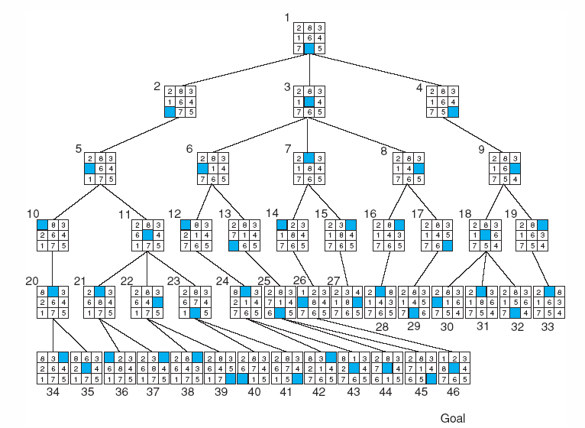
using Depth-first search (DFS)
