

Bahir Dar University

Institute of Technology

School of Computing and Electrical Engineering
Department of Computer Science and Engineering
Requirement Engineering

Requirement Document

Group Members.
Anteneh Sirak……………………………………045/2000
Mulugeta Temesgen……………………………..266/2000
Mulugeta Ayele…………………………………..267/2000
Mulugeta Muche………………………………….268/2000
Nebiyou Samuel ………………………………….279/2000

Table of Content
1. Introduction 4
1.1 The current system 4
1.2 Problem for the current system 4
1.3 System Objectives 5
1.4 Scope 5
1.5. Development phases (Activities) 5
1.6 Definitions, Acronyms, and Abbreviations 6
Chapter 2 7
2. Product prospective 8
2.2 Product Features 9
2.3 User Classes and Characteristics 9
2.4 General constraints 10
2.4.1 Operating Environment 10
2.4.2 Design and Implementation Constraints 10
Chapter 3 12
3.1 Functional User Requirements 12
3.1.2 Non-Functional User Requirements 24
Available 24
Reliability 24
Security 24
Usability 24
Flexibility 24
Scalability 25
Interoperability 25
Efficiency 25
Maintainability 25
Portability 25
3.1.2 System Requirements 25
Use Case Diagram 26
Use case description 26
Chapter 4 51
4.1 User Interfaces 51
4.2 Hardware Interfaces 60
4.3 Software Interfaces 60
4.4 Communications Interfaces 60
7. Analysis Models 60
7.1 Sequence diagram 60
7.2 Data Flow Diagram (DFD) 67
7.3 State Transition Diagram 72

Introduction
The aim of this project is to design and implement library management system for BahirDar University, which will enable users to search for books and browse information about these books as the abstract, publisher information and cost.
The database of the library based on one of the standardized systems for cataloging and classifying the books. We follow the standardization rules to assign subjects and sub-subjects codes, and to classify books under subjects and sub-subject.

1.1 The current system
it is manually system where librarian have to process every thing manually from organizing the books and place them in the right place write shelf to retrieve them for the library visitors and that is overwhelming consuming process

1.2 Problem for the current system
Retrieving books from a library is very important for many peoples. The main problem is to define whether this book is exactly what the user wants and where this book resides in the library (to go and pick).
And that with be source of some of these limitations in books searching in library
- Wasting a lot of time looking for the book in the wrong location in the library
- Use the wrong search item and ending up with the same title for more than author
- Misallocate books in the wrong section the wrong shelf
- Search process consume allot of the librarian time as well as the user and it could be overwhelming for the librarian specially if they have to deal with more than one user at the time
There is a need for designing an advanced search engine that searches a library database and returns a complete book record, including the shelf number on which the book resides.

1.3 System Objectives
- Design and implement a library database based on a standard library classification system.

- Build an advanced search that can help for the best handling of user queries, this search should handle different search types like searching by author, title, subject, format or any combination of them, or searching by ISBN, or Publisher and Publication date. The search result should contain information about the exact location of the book.

1.4 Scope
The system we are going to automate mainly has the following activities that will be covered in our project scope:-
- Maintain book information, publisher information, author information.
- Handel search request.
- Handel retrieval operations like:-.
  - List all books with specific title.
  - List all books with specific author name.
  - List all books classified under specific sub-subject.
  - List all books with any combination of title, subject and author.
  - List all books published by a certain publisher.
  - List all books published in a certain date.
  - Retrieve a book with a given ISBN.
  - List all books belong to a certain series.

1.5. Development phases (Activities)
To solve our problems in this system, we will use the following structured approach to achieve the system goals using the next steps in analysis and design phases:-
- Requirement gathering phase :-in this phase the functional and non functional requirements of the user and customer are discovered
- Analysis phase :-In this phase we want to analyses the system and tray to explain the moving data between different components of the system. And prepare
Context diagram, which it is the highest level view of the system, it contains only one process and a number of data flows and also a number of sources. It is an overview of an organizational system that shows the system boundaries, external entities that interact with the system, and the major information flows between the entities and the system.
Data flow diagram (DFD) It is a logical model of the system. These diagrams have a notification for each of the components of the system, they also have a notification for representing different level in a hierarchy of detail used to describe the system.
Sequences diagram It call interaction diagram too ;in it the transformation for the analysis requirements to the it’s final functionality in the destine stage

Use case diagram use case in a use case diagram is a visual representation of a distinct business function in a system. For example in the library system borrow book and search book are use cases
Class diagram It’s the conceptual model and its use conceptualization to visuals the basic concept of the system in the analysis stage
- Design phase :- Prepare the (ER) entity relationship diagram, which it is a data model that determines the relationships between several entities in the system.
ER to relational data model mapping.
Normalization. The normalization process takes a relation schema through
a series of tests to certify weather it satisfies a certain normal form.
User interface it is the interaction window between the user and the system
and in this phase we will develop the screen shoot of the main interface.

- Coding and implementation:- here is where the whole phases end up and real system is produced and tested.
- Database design by using SQL server
- Write code for each method that are determined in the class diagram
- Test and debugging
The model we used for the development of the system shall be spiral software process models so that we can Handel the changing requirements.
User characteristics
The BDU library librarians typically have the following personal characteristics.
- The library manager shall have at least a diploma in library system management and enough knowledge about database management system.
- Highly motivated and conscientious.
- Computer literate with minimum one 42-hour week hands on training on work station.
Product Perspective
The product user database system is completely dependent on registrar database.

General Constraints
- The BDU library System software product shall execute under windows platform.
- The BDU library System software product code shall be written in java programming language.

1.6 Definitions, Acronyms, and Abbreviations
The acronyms that are constantly used in the document include the following.
SRS – Software Requirements Specification.
UML – Unified Modelling Language
ERD – Entity Relationship Diagram
DFD – Data Flow Diagram
SD –Sequence Diagram
UC-Use Case Diagram
FR-functional requirement
NFR-non functional requirement
BF – Basic Flow
AccNo – Accession Number
CallNo – Call Number
ISBN – International Book Standard Number
DDC: Due Decimal Classification

Chapter 2

2. Product prospective
Currently there is not fully implemented system for any of the libraries in Bahirdar University. Previously volunteer IT professional, who is employed in Bahirdar University Institute of Technology. But it not sufficient to handle all cases and lacks basic features. And currently Some BDUIOT Instructors are on the process to develop sample system that can be implemented in BDUIOT and probably after some modification and simple modification.
BDU as a whole is taking training with Addis Ababa University to develop a general library system. Now we are automating the whole libraries of Bahirdar University. That has new and almost all functionalities that has high priority.
The system is completely new and it works independently with other systems. It is a large system with different subsystems that are related to get the full functionality of the system. The system defines the major components that interrelated to each other.
The components of the system are the following
- Book: - :- all the book information is maintained keep in a digital record so that it is easily available for any operation on it. All book information is registered
- User: - a subsystem to manage all users’ information in the system. In this module user (Students, Instructors, staff members, and all categories of Librarians) are registered. Their profile information is updated, deleted or viewed when ever needed.
- Accusation: - In this subsystem all the book accusation request and approval, price comparison, giving Acc No (Accession No) is given to the entire book before they are being used.
- Search:- This module allows the user of the system to dynamically search for book, periodicals, and users by using Name, Title, ID no, Call no, ISBN, Year, Subject.
- Report:- In every section of the library system many reports are generated daily, weekly, monthly, quarterly, and annually. This module allows as to dynamically generating each kind of reports.
- Catalogue: - After Acc no is given each book passes to the catalogue section to get Call No and make them ready to use in the stack, reserve, or reference.
- Periodicals and documentation:- all publishes that are published in some time interval are handled in this module. Periodicals include final graduation projects, magazine, news paper.

2.2 Product Features
The details of the function and features of the system is described in section three. Generally the overall function of the system is
- Register student.
- Register Instructors.
- Register Librarians.
- Register Staff members.
- Register Book.
- Register Periodicals and documentation.
- Search User by using his/her ID no, Name.
- Search Book by using title, author, subject, and call no, ISBN.
- Search periodical by using year, publisher, name, published date, and author.
- Update user information.
- Update book information.
- Update periodicals and documentation information.
- Generate Call no.
- Accusation request and approval handling.
- Price comparison of book form different year book of different publishers.
- Users suggest and like a book.
- Generate reports.
These are the basic and major functions of the system all the details and other functionalities are listed and briefly discussed in section three.

2.3 User Classes and Characteristics
There are different classes of user of the Bahirdar University Library system. These are Students, Instructors, Staff members, catalogue workers, stack and reserve workers, circulation workers, accusation workers.
- The users (Students, Instructors, Staff members, stack and reserve workers) shall be able read and write English to use search and suggest for a book.
- Catalogue workers shall take to library science course.
- All users shall be

2.4 General constraints

2.4.1 Operating Environment
The system shall operate in the following environment
- windows 2000, Windows XP, SP2,SP3 and more,
- Mozilla Fire Fox3.x and more, IE 8 and more, opera, chrome, safari
- The for deployment 2GB of RAM, 500 GB of hard disk

2.4.2 Design and Implementation Constraints
The Library system of Bahirdar University is very huge and vast. So that it is difficult to finish it by five Software engineers with this sort period of time. Even it is difficult to gather all requirement of the system from different stakeholders. We have limited time in the semester if some conditions are fulfilled we have planned to complete the project in summer by spending our maximum effort and working cooperatively with Instructor that started to develop Library system for BDUIOT and ICT professionals of Bahirdar university Library .
The system is expected to run on extranet. Extranet is just like Intranet but in extranet external user outside of the intranet can access the system.
Since the database is huge and need some security it is decided to use Oracle as database management system software.
As a main development language we choose to use object oriented PHP as a server side scripting language and HTML, and JavaScript, Jquery as client side scripting languages. The latest web technologies like AJAX, JSON, HTML5, and CSS3 are also used.
Due to some compatibility issues on browser especially IE we will lose some fantastic features. The system is being developed only in English languages.
The system uses Http and Https as a protocol by implementing SSL.
To achieve security we use MVC in addition to SSL so that the information and presentation is separated. Once the information and presentation is separated, customizing the system for other stakeholders or make ready for sale is simple.
2.4. After the implementation and testing we prepare user manual and full documentation about the system functionalities as a whole. So performing a single application is very easy.
The product will be supplied as-is, with the following documentation only for administrators and hrm manager.
- User manual that describe all functionalities step by step.
- Installation guide of the output software.
- Backup and restore procedure.
- System requirement document.
- Software design document.
- System architecture document.
- Software test case document.

Chapter 3

3.1 Functional User Requirements

Book (Req. ID 1xx)
Book Management
Req. ID: 100 | Source: Librarians | Priority: high
Name: | Book registration
Description: | The librarian registers new book by taking different information from the book.

Req. ID:101 | Source: Librarians | Priority: high
Name: | Delete book
Description: | The librarian will delete lost book from the book list table using the book id.

Req. ID: 102 | Source : Librarians | Priority: medium
Name: | Update book information
Description: | The librarian updates book information.

Req. ID: 103 | Source: Librarians | Priority: high
Name: | View book information
Description: | The users of the system allowed viewing all information of a book.

- Lend book

Req. ID: 110 | Source: Librarians | Priority: high
Name: | Check book type
Description: | The system should check whether the book is reserve book, reference book, or general circulation book. Unless it is in general circulation it will not lend the book.

Req. ID: 111 | Source: Librarians | Priority: high
Name: | Check user status
Description: | The system checks whether the user has finished his allowed pocket or not. If the user has finished his pocket the system will deny borrowing.
Req. ID: 112 | Source: Librarians | Priority:
Name: | Lend book
Description: | After the system checks the above requirements it will add book to the borrowed book list.

- Return book
Req. ID: 120 | Source: | Priority: high
Name: | Check return date
Description: | The system will check the return date of the book. If the return date has passed it will calculate penalty.

Req. ID: 121 | Source: | Priority: high
Name: | Calculate penalty
Description: | The system will calculate penalty cost of the user if the return date has passed. It will calculate by multiply 0.25 cents and number of return date late days.
Req. ID: 123 | Source: Librarians | Priority: high
Name: | Update user information
Description: | The system will update user information from the borrowed to return and it will increase the users pocket size.
Req. ID: 124 | Source: book file | Priority: high
Name: | Calculate book cost
Description: | If the book has lost the system will get the amount of the book from the librarian and it will calculate the book cost multiplied by 3 and the user has to pay that amount of money.

Req. ID: 122 | Source: Librarians | Priority: high
Name: | Update book information
Description: | The system will update book status from borrowed to available.
Req. ID: 125 | Source: Librarians, User | Priority: high
Name: | Return book
Description: | The system will check the return date and if it is not passed it will remove the book and the user from the borrowed book list.

Req. ID: 124 | Source: Librarians | Priority: high
Name: | Calculate book cost
Description: | If the book has lost the system will get the amount of the book from the librarian and it will calculate the book cost multiplied by 3 and the user has to pay that amount of money.

- Reserve book

Req. ID: 130 | Source: Librarians, User | Priority: high
Name: | Reserve book
Description: | The system will add the user and the book to the reserved book list.

Maintain User Info (Req. ID 2xx)
Req ID:-210 Register user
Req. ID: 211 | Source: Librarians | Priority: high
Name: | Register Student
Description: | The library manager register a student so that he/she can get service of the library and specify which no book can he/she is able to borrow at a time.
Related Req. | Req. ID: 212

Req. ID: 212 | Source: | Priority: high
Name: | Register Instructors
Description: | The library manager registers Instructors so that he/she can get service of the library.
Related Req. | Req. ID: 211

Req. ID: 213 | Source: Librarians | Priority: high
Name: | Register librarians
Description: | The library manager registers librarians (circulation managers, catalog workers, Acquisition workers, Stack and reserve workers,) with their perspective privilege so that we can give permission to each of them.

Req ID:- 220 Update User Information
Req. ID: 221 | Source: Librarians | Priority: high
Name: | Update Student Information
Description: | The library manager updates the student information whenever the student status is changed. For example when the student year increases the no of book that he/she can borrow increases. So update is required each year. In addition to this when the students graduate, some update is required.

Req. ID: 222 | Source: Librarians | Priority: high
Name: | Update Instructor Information
Description: | The library manager updates the Instructor information whenever some update is required.

Req. ID: 223 | Source: | Priority: high
Name: | Update Librarian Information
Description: | The library manager updates the Librarian’s information whenever some update is required.

Req ID :- 230 Delete User
Req. ID: 231 | Source: | Priority: high
Name: | Delete Student Information
Description: | The detail of the student record is deleted. Technically the record is stored in the log file.

Req. ID: 232 | Source: Librarians | Priority: high
Name: | Delete Instructor Information
Description: | The detail of the Instructor record is deleted. Technically the record is stored in the log file.

Req. ID: 233 | Source: Librarians | Priority: high
Name: | Delete Librarian’s Information
Description: | The detail of the Librarian’s record is deleted. Technically the record is stored in the log file.

Reports (Req. ID 3xx)
Req. ID: 300 | Source: | Priority: medium
Name: | borrowed books
Description: | The system reports the list of borrowed books in their Call No and the User types.
Related Req.

Req. ID: 310 | Source: | Priority: medium
Name: | Original and copy book
Description: | The system reports the list of original books and copy books in the library.
Related Req.

Req. ID: 320 | Source: | Priority: high
Name: | Reserved books
Description: | The system reports the reserved books to the user found in the reserved stack
Related Req:

Req. ID: 330 | Source: | Priority: low
Name: | Penalty for not returned
Description: | The system reports penalty for the user borrowed books not returned by the time (business rule returned borrowed books by 2week )
Related Req:

Req. ID: 340 | Source: | Priority: high
Name: | lost books
Description: | The system reports the lost books inside the stack
Related Req:

Req. ID: 350 | Source: | Priority: medium
Name: | new books
Description: | The system reports the new book bought by the library
Related Req:

Req. ID: 360 | Source: | Priority: medium
Name: | Transfer books from stack to reserved for the user
Description: | The system reports the books from the stack to the resaved for the user
Related Req:
Req. ID: 370 | Source: | Priority: medium
Name: | Returned books
Description: | The system reports the returned books by the bowered user
Related Req:

Req. ID: 380 | Source: | Priority: high
Name: | catalog
Description: | The system reports the catalog for the books found in the stack
Related Req:

Req. ID: 390 | Source: | Priority: high
Name: | Books transferred from one library to other library
Description: | The system reports the books that transfer form one library
Related Req:

Catalogue Management (Req. 4xx)
Req. ID: 401 | Source: Catalogue workers | Priority: medium
Name: | Assign call number
Description: | The catalogue worker searches call number of that particular book subject from DDC database and pick up the corresponding call number

Req. ID: 402 | Source: Catalogue workers | Priority: medium
Name: | Assign call letter
Description: | The catalogue worker takes the first letters from the author of the book and assigns it as call letter.

Req. ID: 403 | Source: Catalogue workers | Priority: medium
Name: | Assign shelf number
Description: | The catalogue worker enters the call number of the book; then the system assigns the book to shelf that includes call number the book n its range.

Acquisition (Req. 6xx)
Req. ID: 610 | Source: Student, Instructor | Priority: medium
Name: | Book request
Description: | Users request book to be bought by the library which they think is important to students or any other users of the library.

Req. ID: 620 | Source: Student, Instructor | Priority: medium
Name: | Book suggestion
Description: | Any users of the system suggest different items or books for the library thought the system.

Req. ID: 630 | Source: Acquisition worker | Priority: medium
Name: | Book selection
Description: | The worker in the library which is assigned to perform tasks in the acquisition area selects book from the requested or suggested books by the users in the database.

Req. ID: 640 | Source: Acquisition worker | Priority: medium
Name: | Publisher Information
Description: | The worker register, update or delete publisher’s information

Req. ID: 650 | Source: Acquisition worker | Priority: medium
Name: | Price compare
Description: | The workers compare different prices which are listed on from different publishers or companies that provide or publish books then the worker chooses the most fair price. The worker can find all the information of the publisher from the database.

Req. ID: 660 | Source: Acquisition worker | Priority: medium
Name: | Register new books
Description: | The worker registers new books which are bought by users request or users suggestions to the books catalogue with the old ones.

Req. ID: 670 | Source: Acquisition worker | Priority: medium
Name: | Assign acquisition number
Description: | The worker gives an acquisition number for the books.

Search (Req. ID 7xx)
Req. ID 710 Search Book
Req. ID: 711 | Source: User, Librarian | Priority: High
Name: | Search Book by Title
Description: | All user of the system (students, instructors, Staff members, mangers of each library, and librarians) search for a book by using the title of the book.

Req. ID: 712 | Source: User, Librarian | Priority: High
Name: | Search Book by Author
Description: | All user of the system (students, instructors, Staff members, mangers of each library, and librarians) search for a book by using the Author’s name of the book.

Req. ID: 713 | Source: User, Librarian | Priority: High
Name: | Search Book by Subject
Description: | All user of the system (students, instructors, Staff members, mangers of each library, and librarians) search for a book by using the subject of the book.

Req. ID: 714 | Source: User, Librarian | Priority: High
Name: | Search Book by call No
Description: | All user of the system (students, instructors, Staff members, mangers of each library, and librarians) search for a book by using the Call No of the book. Call No is a unique number given to each book by using internationally defined rules. The rules are documented and available in the library in four modules.

Req. ID: 715 | Source: User, Librarian | Priority: High
Name: | Search Book by ISBN
Description: | All user of the system (students, instructors, Staff members, mangers of each library, and librarians) search for a book by using the ISBN of the book. The International Standard Book Number (ISBN) is a unique numeric commercial book identifier based upon the 9-digit Standard Book Numbering (SBN) code.

Req. ID: 720 Search Users
Req. ID: 721 | Source: User, Librarian | Priority: High
Name: | Search User by Name
Description: | The librarian’s, circulation managers, and manager of the library search for a specific type of user by using his/her name.

Req. ID: 722 | Source: User, Librarian | Priority: High
Name: | Search User by ID No
Description: | The librarian’s, circulation managers, and manager of the library search for a specific type of user by using his/her ID No.

Req ID:-730 Search Periodicals
Periodicals are magazine, new paper, projects that are published at regular intervals of more than one day.
Req. ID: 731 | Source: : User, Librarian | Priority: Intermediate
Name: | Search Periodical by Title
Description: | The librarian’s, circulation managers, students, instructors, and manager of the library search for a specific periodical by specifying its category and the title of periodical. The final graduation projects is searched by using the title of the project

Req. ID: 732 | Source:: User, Librarian | Priority: Intermediate
Name: | Search Periodical by Published Date.
Description: | The librarian’s, circulation managers, students, instructors, and manager of the library search for a specific periodical by specifying its category and the date in which the periodicals is published.

Req. ID: 733 | Source: : User, Librarian | Priority: Intermediate
Name: | Search Periodical by publisher.
Description: | The librarian’s, circulation managers, students, instructors, and manager of the library search for a specific periodical specially for magazine and news paper by using the publisher of the periodical.

Req. ID: 734 | Source: : User, Librarian | Priority: Intermediate
Name: | Search Periodical by subject.
Description: | The librarian’s, circulation managers, students, instructors, and manager of the library search for a specific periodical especially for final projects by using their subject or focus area.

3.1.2 Non-Functional User Requirements

Available
The system shall be available for all the working hours of library. At least it should be available 2:00 am to 11 pm in local time in every day.

Reliability
The system should be available all hours of a day and 7 days aweek.
The system should be reliable and matured enough in giving its service. It should have a fault tolerance mechanism in which it can recover faster from problems that may occur. The system should support backup in case the original was accidentally damaged or erased.

Security
Librarians can access the system based the role they are given by the system. The system restricts librarians from accessing roles that are not allowed to them. The system should enforce librarians to enter a password more than at least 6 characters for strong password protection.

Usability
The system should be understandable by the any user who has basic computer knowledge. Any who can operate computer for some function can use the system without difficulty. Student should adapt the searching interface within 3 minutes.

Flexibility
The system should support for adding new library. When the new library is added the system should implements by adding only additional module.

Scalability
Adding too more new book and user to the system shall not degrade the system. The system can support more number of users and items.

Interoperability
The system must work by integrating with the university Registrar System.

Efficiency
The system should work any registration and updating transactions within 0.2 seconds. Searching for particular book or user must not take more than 0.9 seconds.

Maintainability
Maintaining the database of the system must not take more than 5 days. If there is query transaction crash the system should maintain within 1 working day.

Portability
The system should run on windows and Linux operating system. The system should also run on major browsers Internet Explorer, Mozilla Firefox, Opera, and Chrome. The systems shall works on different web servers like apache, zamp, mamp which can supports the system implementation language.

3.1.2 System Requirements

Use Case Diagram
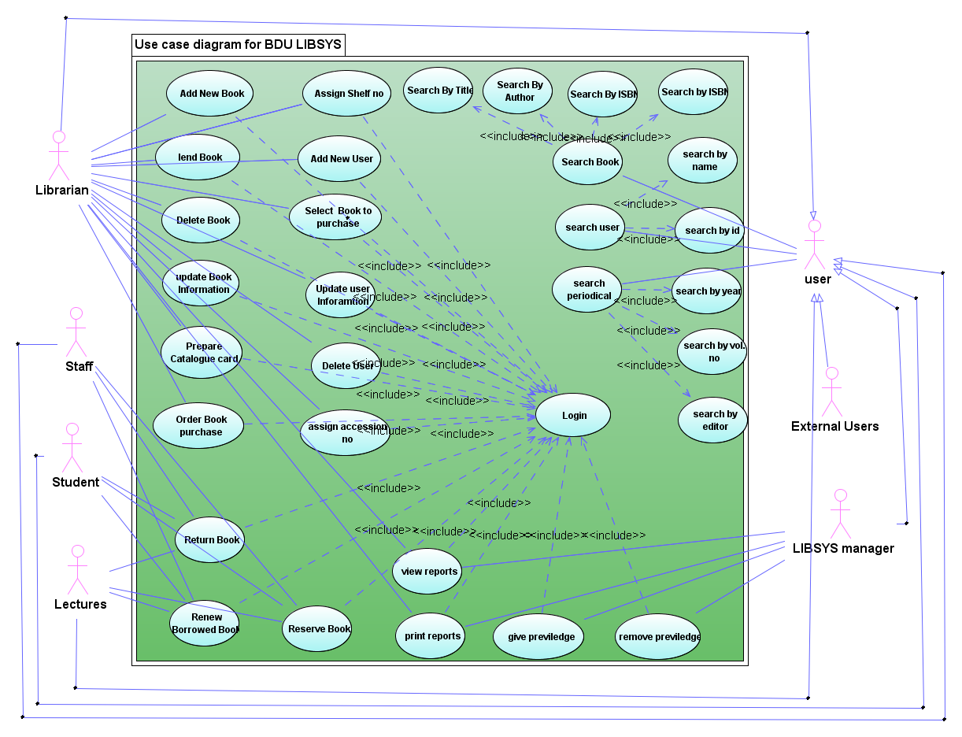

Use case description
SUC 100 Book Management
Use Case ID: | SUC-100
Use Case Name: | Book registration
Created By:
Date Created:
Updated By
Date of Update | May 21, 2011
Actors: | Primary Actors  - Acquisition Worker librarian
Description: | The librarian registers new book by taking different information from the book.
Trigger: | New books enter to the library.
Preconditions: | The librarian must be authenticated
Basic Flow: | User Action | System Response
Basic Flow: | - The librarian want to add new book  - The librarian selects register book menu.  4. The librarian enters  - title  - author  - ISBN  - accNo  - publisher  - edition  - subject  - year Published  - place  - location  - shelf Address  - joint Author  - bibliography  - index  - no. of pages  - registration date  of the book.  - The librarian click “Register” button. | 6.the system will check validation  Of the inputs  7.the system will add the book information to the book table  8. the system will display successfully registered message
Post conditions: | Book will save to the LYBSYS database.
Alternative Flows: | 6.1 the system will get the input is invalid
Alternative Flows: | 2.go to BF 4 | - The system will display error message
Exceptions:
Priority: | high
Frequency of Use: | Whenever new book is arrive to the library
Business Rules: | The book have to be registered by the acquisition worker
Special Requirements: | The page should be user friendly.  The system have to display error messages  The system have to display success message  The system has to take maximum of 2 sec. to insert the book information to the database.
Assumptions:
Notes and Issues: | The system knows which librarian has logged in so that it can manage which use is register book.

Use Case ID: | SUC-101
Use Case Name: | Delete book
Created By:
Date Created:
Updated By
Date of Update | May 21, 2011
Actors: | Primary Actors  - librarian
Description: | The librarian will delete lost book from the book list table using the book id.
Trigger: | - A book has lost.  - A book has transferred to other library
Preconditions: | The librarian must be authenticated
Basic Flow: | User Action | System Response
Basic Flow: | 1.The librarian want to delete a book  2. The librarian selects manage book menu.  6. The librarian search the book (SUC -)  8. the librarian click “delete” button  10. the librarian click “ok” button | 5.the system will display manage book window  7.the system will display the result with delete, update buttons.  9.the system will display confirmation window  11.the system will delete the book from the books table in the LIBSYS database  12.the system will display successfully deleted message  13 the system will display the search window
Post conditions: | The book will deleted from the LYBSYS database.
Alternative Flows: | 10.1 the librarian clicks “cancel” button
Alternative Flows: |  | 1.Go to BF 7.
Exceptions:
Priority: | high
Frequency of Use: | Whenever book lost
Business Rules: | The book has not to be deleted before the user pays the cost of the book if user has lost the book. Else it can be deleted without check the cost.
Special Requirements: | The page should be user friendly.  The system have to display error messages  The system have to display success message  The system has to take maximum of 2 sec. to delete the book from the LIBSYS database.
Assumptions:
Notes and Issues: | The system knows which librarian has logged in so that it can manage which use is delete book.

Use Case ID: | SUC-112
Use Case Name: | Lend book
Created By:
Date Created:
Updated By
Date of Update | May 21, 2011
Actors: | Primary Actors  - librarian  - user
Description: | After the system checks the above requirements it will add book to the borrowed book list.
Trigger: | - librarian want to lend a book
Preconditions: | The librarian must be authenticated
Basic Flow: | User Action | System Response
Basic Flow: | 1.The librarian want to lend a book  2. The librarian selects lend book menu.  4. The librarian enter the callNo of the book and user id  5. the librarian click “lend” button  8. the librarian click “ok” button | 3.the system will display lend book menu  6. the system will check book category  7. The system will display success message with returning date.
Post conditions: | The system will add the book and the user to the borrowed table in the LIBSYS database.
Alternative Flows: | 6.1 The book user want to borrow is reference or reserve book.
Alternative Flows: |  | - The system will display the book is not allowed to lend.
Alternative Flows: | 6.2 the user pocket has exceed from allowed pocket size  6.2.1 the user is lecture
Alternative Flows: |  | - The system will display you have borrowed 10 books already. You have to return the books to borrow this one message.
Alternative Flows: | - the user is 2nd year student
Alternative Flows: |  | - The system will display you have borrowed 3 books already. You have to return the books to borrow this one message.
Alternative Flows: | 6.2.3 the user is 3rd year student
Alternative Flows: |  | - The system will display you have borrowed 4 books already. You have to return the books to borrow this one message.
 | 6.2.4 the user is 4th year student
 |  | 1 The system will display you have borrowed 5 books already. You have to return the books to borrow this one message.
 | 6.2.5 the user is 5th year student
 |  | - The system will display you have borrowed 5 books already. You have to return the books to borrow this one message.
Exceptions:
Priority: | high
Frequency of Use: | Whenever the a librarian want to lend
Business Rules: | - Lectures borrow maximum of 10 books.  - 1st year students cannot get borrowing service  - 2nd year students borrow maximum of 3 books  - 3rd year students borrow maximum of 4 books  - 4th year students borrow maximum of 5 books  - 5th year students borrow maximum of 5 books
Special Requirements: | The page should be user friendly.  The system have to display error messages  The system have to display success message  The system has to take maximum of 2 sec. to save the book to the borrowed book list in the LIBSYS database.
Assumptions:
Notes and Issues: | The system knows which librarian has logged in so that it can manage which use is lending book.

Use Case ID: | SUC-125
Use Case Name: | Return book
Created By:
Date Created:
Updated By
Date of Update | May 21, 2011
Actors: | Primary Actors  - librarian  - user
Description: | The system will check the return date and if it is not passed it will remove the book and the user from the borrowed book list.
Trigger: | - user want to return book
Preconditions: | The librarian must be authenticated
Basic Flow: | User Action | System Response
Basic Flow: | 1.The user want to return a book  2. The librarian selects return book menu.  6. The librarian search the book (SUC -) from the borrowed book list by using book callNo.  8. the librarian click “return” button  11. the librarian click “ok” button | 5.the system will display return book window  7.the system will borrowed book and user in table format with return book button.  9.the system will check the penalty date.  10. the system will display confirmation message with book title, user name information.  11.the system will remove the book and user from the borrowed book table in the LIBSYS database  12.the system will display successfully returned message
Post conditions: | The book will removed from the borrowed book list table in the LYBSYS database.
Alternative Flows: | 9.1 the user has passed the return date.
Alternative Flows: | - user has pay the money  - the librarian click on “penalty cost paid” button  5.the librarian click on the “Ok” button | - system will display you have late for [currentDate-returnDate] days. You have to pay [(currentDate-returnDate)x0.25cents] Birr.  4.The system will display confirmation window.  6.the system will display successfully returned message
Exceptions:
Priority: | high
Frequency of Use: | When ever the user want to return book
Business Rules: | - Lecture can borrow a book for one semester (5 month)  - Students can borrow a book for 15 days  - If users does not return on the day penalty cost will be 0.25 cents per day
Special Requirements: | The page should be user friendly.  The system have to display error messages  The system have to display success message  The system has to take maximum of 0.1 sec. to check the penalty date and penalty cost.  The system has to take maximum of 1 sec to remove book and user from the borrowed book list in the LIBSYS database.
Assumptions:
Notes and Issues: | The system knows which librarian has logged in so that it can manage which user (Librarian) is operating the return book operation.

Use Case ID: | SUC-130
Use Case Name: | Reserve book
Created By:
Date Created:
Updated By
Date of Update | May 21, 2011
Actors: | Primary Actors  - librarian  - user
Description: | The system will add the user and the book to the reserved book list.
Trigger: | - user want to reserve book
Preconditions: | The librarian must be authenticated
Basic Flow: | User Action | System Response
Basic Flow: | 1.The user want to reserve a  book  - The librarian selects  Reserve book menu.  4. The librarian search the book (SUC -) by its callNo or title  5.the librarian enters  - Book CallNO  - User UserId  - Reserve date  6.the librarian clicks on the “reserve” button | 3.the system will display reserve book window  5.the system will display the result with a form to be filled.  9.the system will check validation  10.the system will display success message.
Post conditions: | The book and the user are add to the reserved book list in the LIBSYS
Alternative Flows: | 9.1 the user enter invalid inputs
Alternative Flows: | 2.go to BF5 | - The system will display error message
Exceptions:
Priority: | high
Frequency of Use: | Whenever a user want to reserve a book
Business Rules:
Special Requirements: | The page should be user friendly.  The system have to display error messages  The system have to display success message  The system has to take maximum of 1 sec. to add userid and book callNo for LIBSYS database.
Assumptions:
Notes and Issues: | The system knows which librarian has logged in so that it can manage which use is operating reserve book operation.

SUC 200 Manage Items
Use Case ID: | SUC-201
Use Case Name: | Manage Periodicals
Created By:
Date Created: | 6-05-2010
Updated By | Muluadam Temesgen
Date of Update | May 20, 2011
Actors: | Primary Actors  - Librarian
Description: | This use case manages periodicals
Trigger: | The librarian selects manage periodicals
Preconditions: | User or librarians should be authenticated.
Basic Flow: | User Action | System Response
Basic Flow: | - The user want to manage the periodical information  - The librarian selects the “manage “button  4. The user selects registration menu.  6. The selects the type of Periodical.  9. The user fills all the necessary fields of the form.  10. The use submits the form. | - The system will display the manage periodicals window  - The system asks the type of periodical.  - The system displays the registration form for  Periodicals.  8. The system displays the registration form for the selected type of periodical.  11. The system checks the inputs fields.
Post conditions: | The periodical will registered
Alternative Flows: | 3.4 the user selects update periodicals menu  1. the user select the update periodicals menu  2. the system will display the update periodical window  3. the user update the information what he want  4. the user submit the updates  5 the system checks the inputs  6 the system will display success message  Post condition : the system update the periodicals information  3.4 the user selects delete periodicals menu  1. the user selects the delete periodicals menu  2. the system will display the delete periodicals window  3. the user selects the periodical to delete  4. the user delete the periodical what he want  5. the system will display deleted successfully message  Post condition : the system delete the periodical  7.1 the system get invalid input  1. the system will display error message with some description  2. go to Basic course of action 3
Exceptions:
Priority: | Intermediate
Frequency of Use: | All the working time of the software
Business Rules:
Special Requirements: | The page should be user friendly.  The searching method should be user friendly and ease to use.  The system should take maximum of 2 sec. to search.  The system should take maximum of 1 sec to delete.  The system should take maximum of 2 sec to update.  The system should take maximum of 5 sec to register.
Assumptions:
Notes and Issues:

SUC 200 Manage Users
Use Case ID: | SUC-202
Use Case Name: | Manage users
Created By: | Nebiyou Samuel
Date Created: | 01/05/2011
Updated By | Muluadam Temesgen
Date of Update | May 20, 2011
Actors: | - admin  - users(students, instructors, stuffs, librarian)  - issuer
Description: | This use case describes how users of the system are managed.
Trigger: | The system needs to be legal or being managed by an admin.
Preconditions: | Admin is selected for managing the system.
Basic Flow: | User Action | System Response
Basic Flow: | - admin wants to view users or librarian info then clicks “manage” button  - The User the category of user from the selected  5. Admin selects register button.  - The user fills the all the required fields of the form.  - The user submits the form. | - The system displays user categories.  4. The system displays the selected category.  6. The system displays the registration form for the selected category of users.  - The system validates the form.  - The system checks stores the data.  - The system displays success message.  - Use case ends.
Post conditions: | The system handles the new state with what the admin sets.
Alternative Flows: | The admin selects update button.  - The system displays the update form with editable value for the selected category of users and specific user.  - Admin updates the form.  - Admin submits the form.  - The system validates the form.  - The system saves the last update information.  - se case ends.
Priority: | High
Frequency of Use: | Minimum of 1/day
Business Rules:
Special Requirements: | - Security of the system.  - The system should display errors.  The system should be integrated with other automated systems of the Library Management System.
Assumptions: | An authorized admin.
Use case Id: | SUC-330
Use Case Name: | Penalty for the borrowed
Description | In this use case users of the library system generate report for penalty of the borrowed books not returned by the time(sut=14dy&teach=6m)
Actors: | Primary Actors:  - Users.  - Librarians.  - Book
Preconditions: | Users and librarians should be authorized.
Triggers: | - Whenever the user or the librarian want to generate report
Flow of Events: | - librarians login to the system  - Librarians search what they want user to penalty.  - Users or librarians generate the penalty report.
Post condition: | The user or the librarian gets report that they want.
Alternate Flow: | None
Exceptions: | There is no exception to report other that the authorized user.
Information Requirements: | - Book callNo, AccNo,ISBN.  - Book author,Publisher. Book title  - Book status( borrowed)  - Borrowed users  - Librarians.
Assumptions: | All information seekers are authorized.
Notes and Issues: | When we are saying users it includes students, lectures, researchers, staff members.

SUC 300 Report Generation
Use case Id: | SUC-340
Use Case Name: | Lost book report
Description | In this use case users of the library system generate report for lost books in the stack and library
Actors: | Primary Actors:  - Librarians.  - Book
Preconditions: | Librarians should be authorized.
Triggers: | - Whenever the librarian want to generate report
Flow of Events: | - librarians login to the system  - Librarians search the lost books in the stack.  - Librarians generate the lost books report.
Post condition: | The user or the librarian gets report that they want.
Alternate Flow: | None
Exceptions: | There is no exception to report other that the authorized user.
Information Requirements: | - Book callNo, AccNo,ISBN.  - Book author,Publisher. Book title  - Book status( borrowed)  - Borrowed users  - Librarians.
Assumptions: | All information seekers are authorized.
Notes and Issues: | When we are saying users it includes students, lectures, researchers, staff members.

Use case Id: | SUC-350
Use Case Name: | New book report
Description | In this use case users of the library system generate report for new books in the library stack
Actors: | Primary Actors:  - Librarians.  - Book
Preconditions: | Librarians should be authorized.
Triggers: | - Whenever the librarian want to generate report
Flow of Events: | - librarians login to the system  - Librarians search new books in the stack.  - Librarians generate the new books report.
Post condition: | The user or the librarian gets report that they want.
Alternate Flow: | None
Exceptions: | There is no exception to report other that the authorized user.
Information Requirements: | - Book callNo, AccNo,ISBN.  - Book author,Publisher. Book title  - Book status( borrowed)  - Borrowed users  - Librarians.
Assumptions: | All information seekers are authorized.
Notes and Issues: | When we are saying users it includes students, lectures, researchers, staff members.

SUC 400 Catalogue Management
Use Case ID: | SUC-400
Use Case Name: | Catalogue Management
Date Created: | 11/09/2003
Date of Update
Actors: | Catalogue worker
Related Use Cases | Generalization of:  - Assign call number  - Assign call letter  - Assign shelf number  - Assign copy number
Description: | Library books are arranged to catalogue
Trigger: | The book is entered to catalogue from accession section
Preconditions: | Catalogue workers must be authenticated
Basic Flow: | User action | System response
Basic Flow: | - The catalogue workers select the book to assign to the shelf  - The catalogue workers gives necessary information of the book | - The system assigns the book to the corresponding shelf
Post conditions: | The book will be available for service
Alternative Flows:
Priority: | Intermediate

Use Case ID: | SUC-401
Use Case Name: | Assign call number
Date Created: | 11/09/2003
Date of Update
Actors: | Catalogue worker
Related Use Cases | Specialization of:  - Catalogue management
Description: | In this use case each book will have call number which assigned by catalogue workers where the system provides call number for the given subject.
Trigger: | The book is needed to serve users of library.
Preconditions: | Catalogue workers must be authenticated
Basic Flow: | User action | System response
Basic Flow: | - The catalogue workers select subject of the book  3. The catalogue workers picks the call number and enter to book info | 2. The system displays the corresponding call number from the DDC  4.The system updates call number of the book from null to given value
Post conditions: | The book will be have call number
Alternative Flows: | 2.1 The system will display null for call number of the given subject
Priority: | Intermediate

Use Case ID: | SUC-402
Use Case Name: | Assign call letter
Date Created: | 11/09/2003
Date of Update
Actors: | Catalogue worker
Related Use Cases | Specialization of:  - Catalogue management
Description: | In this use case each book will have call letter by taking the first 3 letters from the author of the book.
Trigger: | The book is needed to serve users of library.
Preconditions: | Catalogue workers must be authenticated
Basic Flow: | User action | System response
Basic Flow: | - The catalogue workers select books  - The catalogue workers clicks “Assign call letter” button | 3. The system takes the first 3-letters from the author of the book and assign it the book’s call letter  4. The system updates call letter of the book from null to given value
Post conditions: | The book will have call letter
Alternative Flows:
Priority: | Intermediate

Use Case ID: | SUC-403
Use Case Name: | Assign shelf number
Date Created: | 11/09/2003
Date of Update
Actors: | Catalogue worker
Related Use Cases | Specialization of:  - Catalogue management
Description: | In this use case each book will have copy number for identical books that have the call number and everything is the same except accession number.
Trigger: | The book is needed to serve users of library.
Preconditions: | Catalogue workers must be authenticated
Basic Flow: | User action | System response
Basic Flow: | - The catalogue workers select the particular book  3. The catalogue workers gives copy number of the book  4. The catalogue workers clicks “Assign copy number” button | 2. The system asks the catalogue worker to enter the copy number  5. The system give copy number for the book
Post conditions: | The book will be have copy number
Alternative Flows:
Priority: | Intermediate

SUC 600 Book Acquisition
Use Case ID: | SUC-600
Use Case Name: | Acquisition
Date Created: | 17- 05 - 2011
Date of Update
Actors: | Acquisition worker
Related Use Cases
Description: | New books join the library based on user suggestion, request and comparison of prices.
Trigger: | Users need new books in addition to those books which are already in use.
Preconditions: | Acquisition workers must be authenticated plus books must be new to be processed by the system in this phase.
Basic Flow: | User action | System response
Basic Flow: | - Users request or suggest different books which are not in use previously.  - The Acquisition workers register different publishers that provide books with their product and associated information including book title, author, and price.  - The Acquisition workers select books from the category in which users request or suggest books.  - The Acquisition workers compare price of the book by referring publisher’s information from the database and selects the fair value.  - The Acquisition workers register the book with their accusation number on the book catalogue after it has been bought. | - The system assigns the new book the corresponding catalogue.
Post conditions: | The book will be available for service
Alternative Flows:
Priority: | medium

SUC 700:-Search Items:
Use Case ID: | SUC:700
Use Case Name: | Search
Created By:
Date Created: | 6-05-2010
Updated By | Muluadam Temesgen
Date of Update | May 20, 2011
Actors: | Primary Actors  - Circulation Workers  - Students  - Instructors  - Staff members  - Stack worker
Description: | The users listed above search for a book, Periodical or user by using name.
Trigger: | The user wants to searches for users, books, periodicals
Preconditions: | The user must be authenticated.
Basic Flow: | User Action | System Response
Basic Flow: | - The user wants to search for a book , periodical or user  - The selects what to search periodical, book or user.  - The user selects the search criteria.  - The user types what he/she wants to search text field.  - The user selects the target from the listed items. | - The system displays the selected item  - The system display the selected criteria  - The system listens the key what the user is typing  - The system automatically displays the search result that matches with what the user is typing.  - The system displays the detail of the selected item.  - Use case ends.
Post conditions: | Search result will displayed
Alternative Flows: | - There is no search result that matches with the item that is the user is typing.  - The system warns the user that there is no search result that matches it.  - The use case ends.
Exceptions:
Priority: | Intermediate
Frequency of Use:
Business Rules:
Special Requirements: | The page should be user friendly.  The searching method should be user friendly and ease to use.  The system has to take maximum of 2 sec. to search.  The system should be artificially intelligent in finding the results.

Chapter 4

4.1 User Interfaces
Sample user interfaces of the system are listed and they can give some insight of the new proposed systems and all of them are designed by considering those design disciplines in the process of designing a given user interface .In addition to this they provide some standard features including help and error display messages.

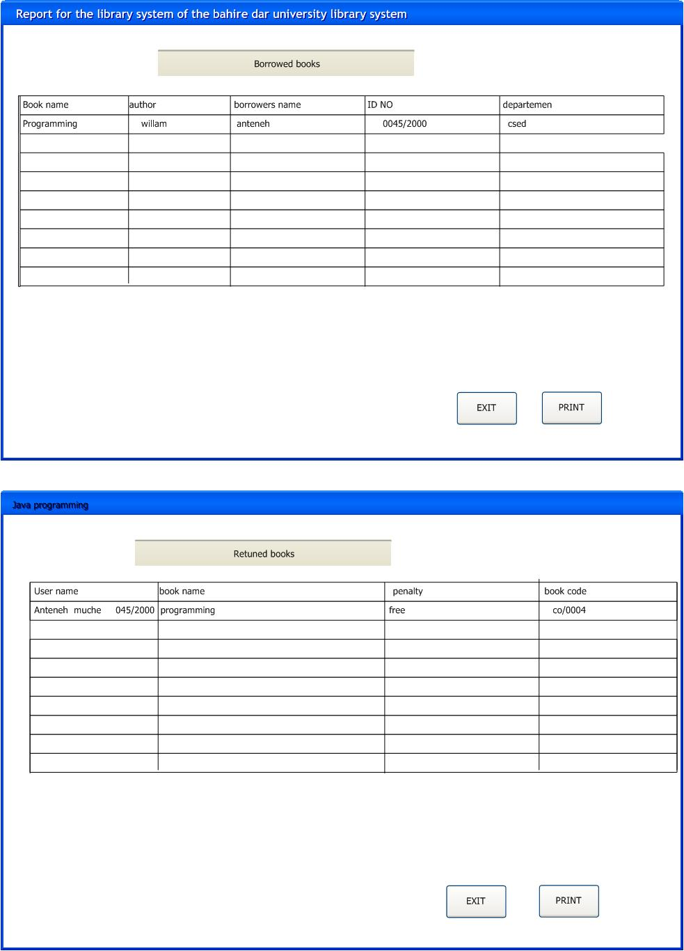
Sample user inter for the report

4.2 Hardware Interfaces
The system should be implemented in a hardware-independent fashion and should not rely on any particular hardware interfaces.

4.3 Software Interfaces

There are many library systems around and most of them share some common things and as a system our proposed library system shares these common features. We are also told that there are some works done before and now as well to automate the library. We were trying to do a good system that fulfill stakeholders needs as a result we r communicating with those stake holders to meet their requirement and this can describe the relationship of our system with those of others. Different data enter the system and processed for instance user registration, book registration each with different data then the system handles accordingly.

4.4 Communications Interfaces
When the "external user" user class is included, the proposed library system should allow submissions via standard email and via the World Wide Web. No other communications interfaces are mandated.

7. Analysis Models

7.1 Sequence diagram

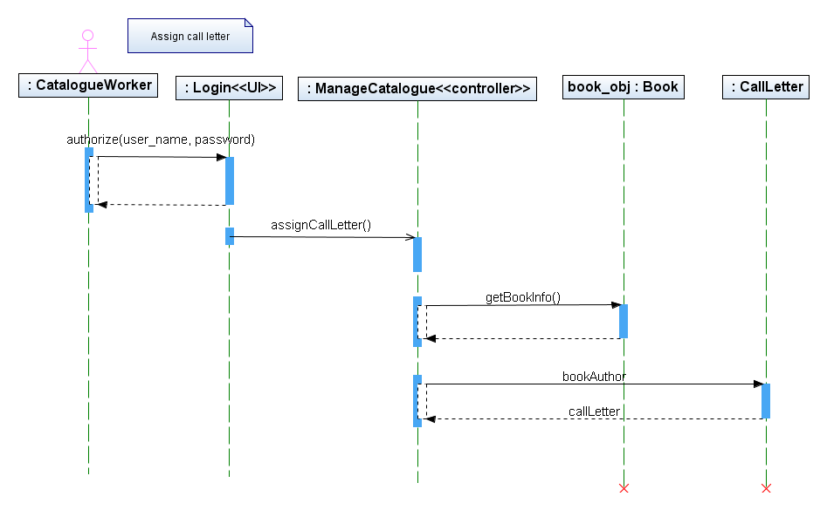

Assign call number
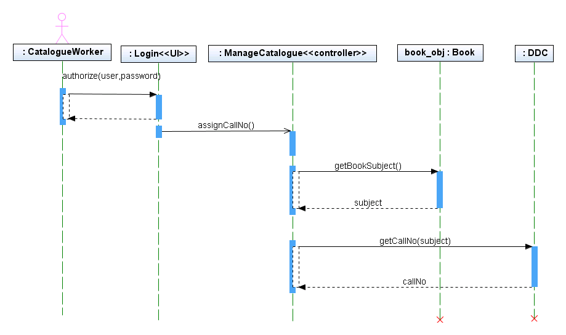
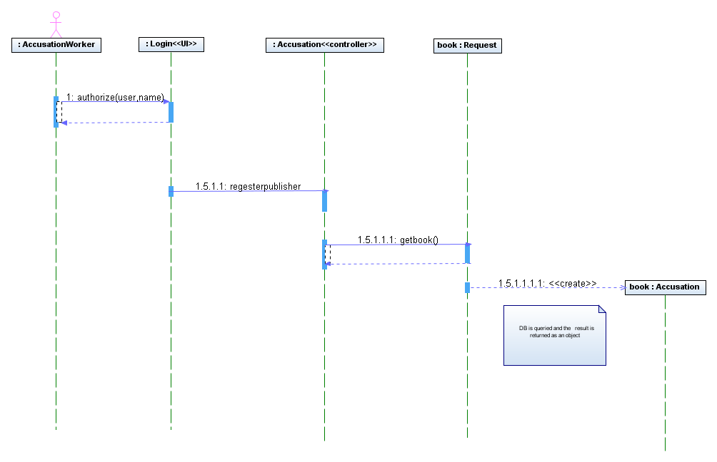

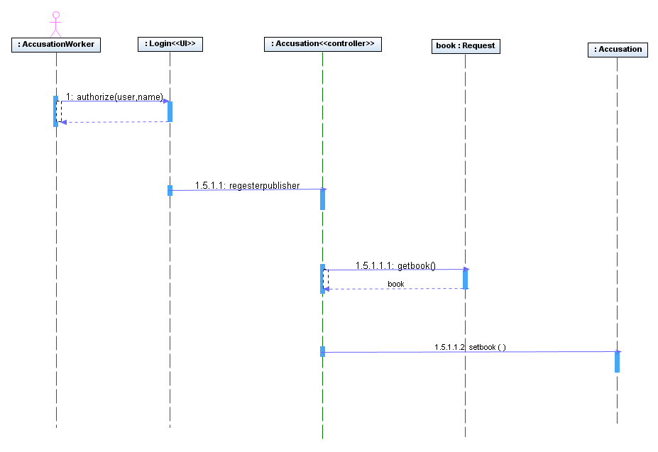

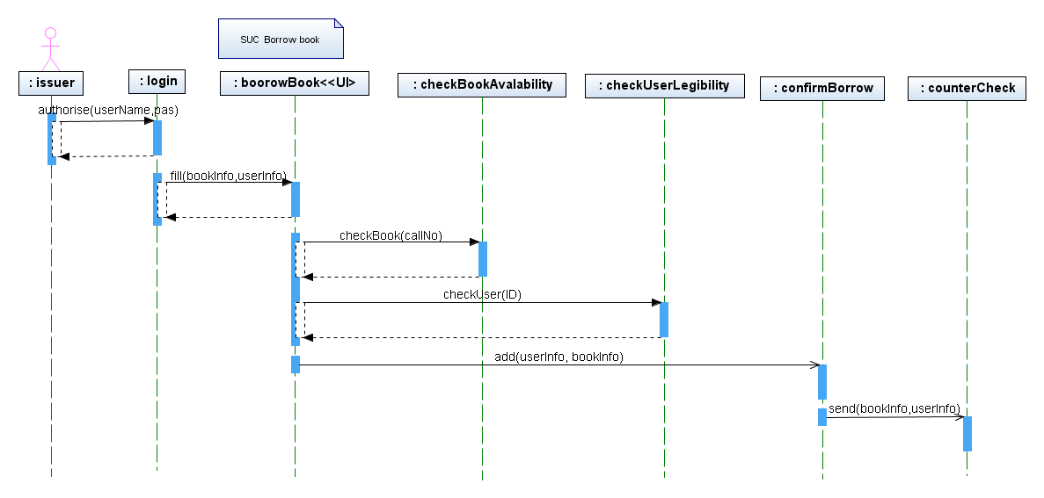

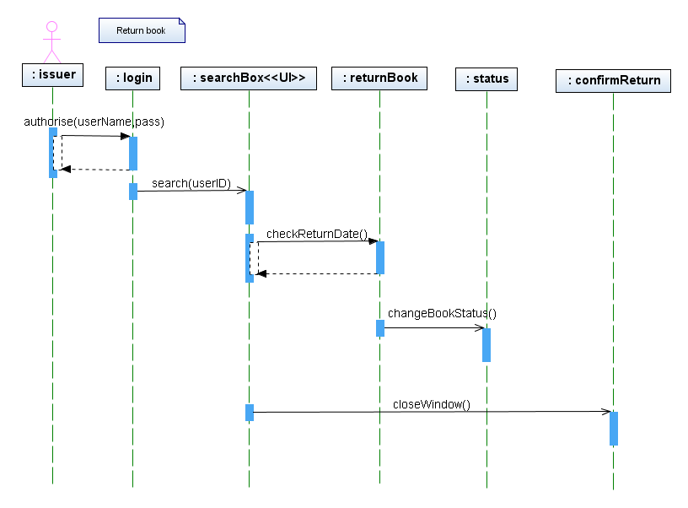

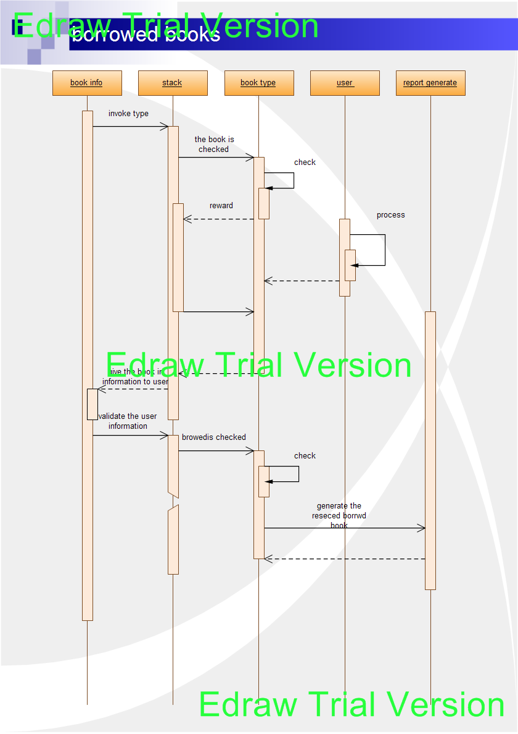
Figure 300: Sequence diagram borrowed
Sequence diagram for the reserved browed report

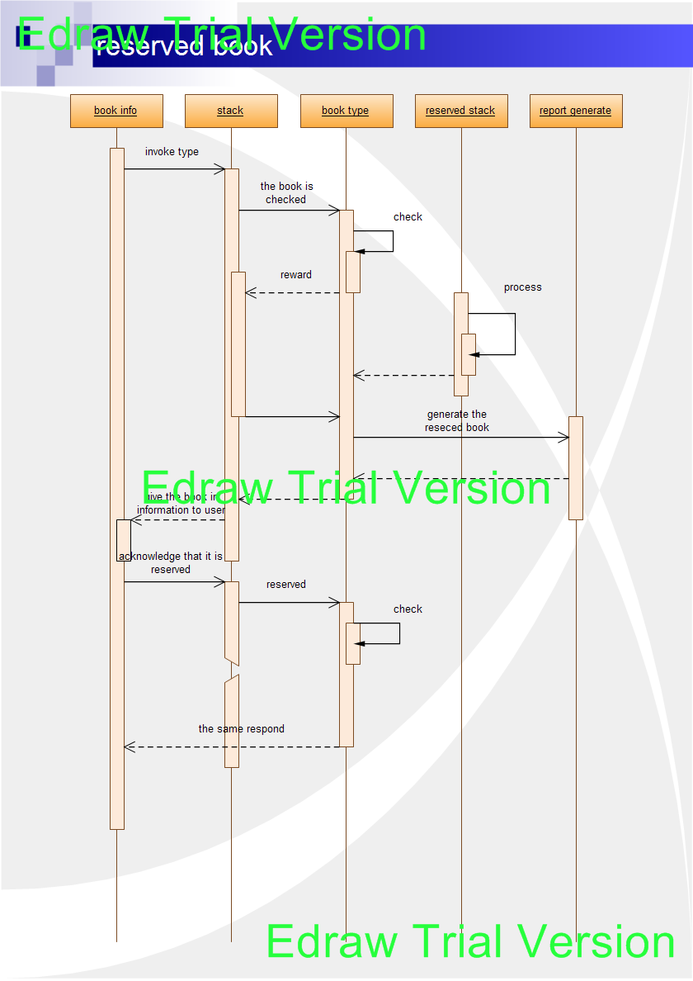
Figure 300: Sequence diagram
Sequence diagram for the reserved book report

`

Data Flow Diagram (DFD)

In this behavioral system model the overall work of the system is expressed. First the relation between the system & the entry is shown on level 0 of DFD. The detail DFDs are drawn as follow.
Level 0 DFD BDU Library System
Level 1 DFD of BDU Library System

Level 2 DFD of BDU Library System
Level 3 DFD of BDU Library System

Level 4 DFD of BDU Library System
Level 5 DFD of BDU Library System

Level 6 DFD of BDU Library System

Level 7 DFD of BDU Library System

7.3 State Transition Diagram

Librarian and book is add to the system

Book reserved to the system
Bdu library system management

Book catalog prepared
Proved search
Search of books and user
Catalog
Reserved book management
User get
Generating report
Reserve books for user

