Bahir Dar University


Institute of Technology

School of Computing and Electrical Engineering
Department of Computer Science and Engineering

E-commerce

System Design Document

Company Name: ethioSale Inc. []

Group Members.
Mulugeta Ayele………………………………….267/2000
Mulugeta Muche……………………………….268/2000
Nebiyou Samuel ………………………………..279/2000

Table of Content
1. Introduction 2
2. System Overview 3
3. System Functionality 4
4. Security Model 5
5. Use Case Diagram 7
Use Case Description 8
6. Class Diagram 10
7. Sequence diagram 11
8. Activity Diagram 14
9. Network Topology 15

Introduction
Electronic commerce, commonly known as e-commerce or e-Commerce, consists of the buying and selling of products or services over electronic systems such as the Internet and other computer networks. The amount of trade conducted electronically has grown extraordinarily with widespread Internet usage. The use of commerce is conducted in this way, spurring and drawing on innovations in electronic funds transfer, supply chain management, Internet marketing, online transaction processing, electronic data interchange (EDI), inventory management systems, and automated data collection systems. Modern electronic commerce typically uses the World Wide Web at least at some point in the transaction's lifecycle, although it can encompass a wider range of technologies such as e-mail, mobile devices and telephones as well.
Electronic commerce is generally considered to be the sales aspect of e-business. It also consists of the exchange of data to facilitate the financing and payment aspects of the business transactions. There are different types of e-commerce based on nature of market relationship and we chose the consumer-to-consumer (c2c) type.
Consumer-to-consumer (C2C) (or citizen-to-citizen) electronic commerce involves the electronically-facilitated transactions between consumers through some third party. A common example is the online auction, in which a consumer posts an item for sale and other consumers bid to purchase it; the third party generally charges a flat fee or commission. The sites are only intermediaries, just there to match consumers. They do not have to check quality of the products being offered.
We’ve tried to develop an e-commerce web site called ethioSale.com .It is a Consumer-to-Consumer (C2C) E-commerce type web site in which the site provides a way for consumers to sell to each other, with the help of an online market maker it also allows consumers to make an auction through the site .It has different functionalities with user friendly environment which makes it very interactive with the end users. Consumers registered to the site and can post what they want to sell and we deal with them in terms of payment for using our site and the other customers who really need the posted items deal with the customer who owns the item may be by sending him a message using the system or he/she can chat with the seller if they are both online so the system provides a means to make a communication channel between the two sides( buyers and sellers ) and the remaining process is done when they contact one another physically.

System Overview
The main goal of this web site is communicating customers remotely for any business activities and it has great contribution for ICT development of our county. In general it addresses the following issues for user of this site.
- It reduces the time that wastes for buying and selling of market product
- It saves human resources
- It provides easy and fast access of products that are available on the market
- It minimizes the cost of long journey for human being and materials

Consumers specifically sellers at different place of the country can post what they have got for sell and consumers now buyers from different sites can access what the sellers post on the web site . This provides introduction of culture from one area to the other for example a seller from Bahir Dar posting different items like cultural clothes then a buyer from Addis or any other place can actually see the item without moving to Bahir Dar and if they actually need it considering the cost, they can have the item easily. This indicates that the creation of this web site has a great impact on different perspective may be in terms of introducing culture as explained above, in terms of saving the precious time , additional cost for transportation or any other related things, the ability to get every single item in one place .

System Functionality

- Customer Registration
- Customer Login
- Item Registration for Post and for Biding
- Advert registration
- Messaging and chatting with item owner
- Item searching
- Item price compare
- Password recovery
- Item detail view
- Item info editing if it posted not for biding
- Payment processing for posting and advertizing
- Help System
- Suggest items

- Security Model
Even if there is no real money transaction in our web site, there are some secure processes that needs the system to perform its function for authenticated users. In general, this e-commerce
web site expected to fulfill the following security issues.
Customer login:
There are some services that can be done without customer login to our web site. Like item search, view item detail, item price comparison, browse for item and help system. Except all these functionalities customers are obliged to login to the site for other services including item posting, message and chat service, bid for items and product advertizing.


Customer
Internet
Web Server
SSL channel
Encrypted data
Password, SHA1 encryption
User name and password
Database

- Customer Message Security Issues
Sellers and buyers will get the following security advantages from this web site.
- Privacy
When customer login into the site, it provides SSL service for secure data transmission through their work. Their prepaid card number, login password and user name are kept from unauthorized users.
- Integrity
The messages send by sellers and buyer and also their instant message(chat) is kept from external attacks; it must not altered or tempered before the message reaches its destination.
- Authentication
Sellers and buyers can communicate each other if they only provide their identity each other. This helps them from unauthorized attacks.
- Non-repudiation
The system notifies weather the message received by a customer or not, so that senders will check their information is secure from external attacks.
- Customer Payment Security Issues
Our e-commerce web site mainly concerned on communicating sellers with buyers for the item that the seller posts on our site. The seller pays for the commission for us when he/she posts the item. The payment mechanism depends on the type of post (for bid or for only view), duration of post and price of the item to be posted. This payment needs highly secure information flow between us and our customer. When the customer fills the payment form, the information filled on the site should be processed securely. For this purpose we use SSL channel and SHA1 encryption algorithm for encrypting sensitive data like prepaid card number.

Customer
Internet
Web Server
SSL channel
Encrypted data
SHA1 encryption
Prepaid card info
Database

Use Case Diagram
Use Case diagrams show the associated roles and accesses available to actors and other systems external to the system. They show how users can interact with the system while avoiding the complications of diagramming the internal workings of the system. The following diagram shows the use cases that our system has.

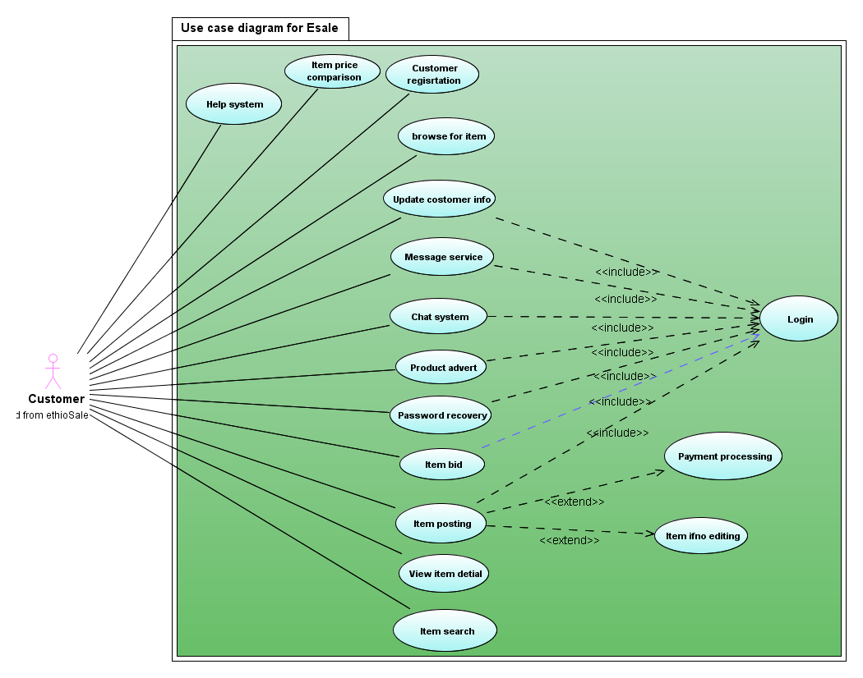

Use Case Description
Use case 1: Help system
The site gives complete help system for customers. They can get help how to sell, bid, post and search items. The payment system is also part of the help; they can view how to pay, how much they will pay for the item they post, and from where they will buy prepaid cards.
Use case 2: Item price comparison
If there are list of related item which may be displayed from search or any other case, they can compare their price. This helps them which one is better to buy.
Use case 3: Customer registration
Any new customer to the system must register to post item, bid item, advert their products. It is free and simple.
Use case 4: Browsing item
The site has link for all categories in which each category has many sub-category and each sub-category also composed of a number of items. By using all these hierarchies the user can browse for an item.
Use case 5: Update customer information
After the user has register to the site, if they need to update their personal profile they can update their detail information
Use case 6: Message service
Sellers and buyers can send a message each other after they login into the system. The message service is available
Use case 7: Chat service
If both the seller and the buyer are both online they can chat with each other.
Use case 8: Product advert
Any user can advert their product on our site if they are registered. During advert process the customer is expected to pay for us according the commission.
Use case 9: Item post
If a customer is registered user he/she can post the item that he want to post for bid or just for view.

Class Diagram
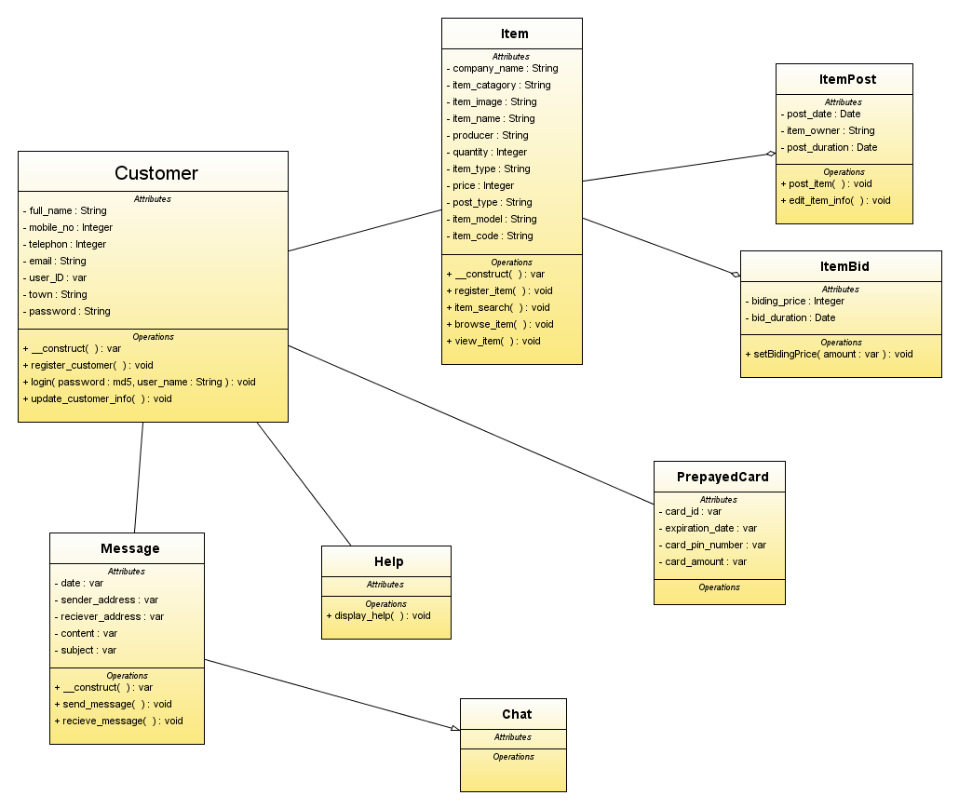

Sequence diagram
UML sequence diagrams model the flow of logic within our system in a visual manner, enabling us both to document and validate our logic, and are used for both analysis and design purposes.
Login use case sequence diagram
The above sequence diagram describes how the user login is done. The first thing to login to our page is input user name and password. Then the system will validate it and creates session. Here there are two things it could happen. The first thing is if the user enters invalid user name or password the system will display error message. If the it is valid user name and password the system will display user page.

User register use case sequence diagram
This diagram visualizes the registration of new user to our system. To register first the user have to open our home page. Next it have to click on the register new user link. This time the system will display registration page. What the user do now is that he have to the form and submit it. The system now validate the inputs. If validation succeed the system will display success message and limited user page until the user confirms the email we sent to him.

Item posting/register use case sequence diagram
This diagram shows how the user post/register an item in our system. To that first the user have to click on the post item link. At this point the system checks that whether the user has logged in or not. If the user does not logged in the system will display login page. If he has logged in the system will display the item register page. The user have to fill the form and submit. The system validates the inputs and displays success message if it is valid and error message if it is invalid.

Activity Diagram

Item Post
Customer Register

Network Topology

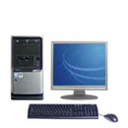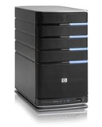
Customer
Internet
ethioSale Sever
SSL enabled
HTTP
Database
Card distributer
SHA1 encryption algorithm and payment transaction are processed

