How to Hide and Lock Hard Disk Drives in "My Computer"
Did you know you can secure the data on the hard disk drives by hiding or locking them. In Windows, use the steps below to do just that

Steps
- 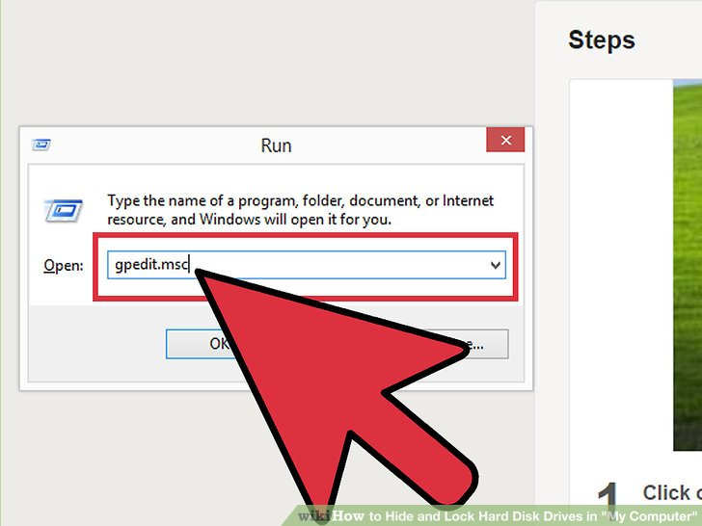
1
Click on the "Start" button. Go to "Run", type "gpedit.msc" and press enter.
- 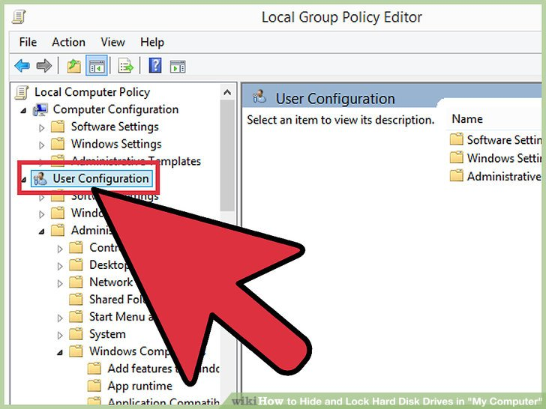
2
Wait for the "Group Policy" window to appear. Click on the "+" button beside User Configuration then click on the "+" button beside "Administrative Templates". Then click the "+" button beside "Windows Components" and then click "Windows Explorer", or "File Explorer"
- 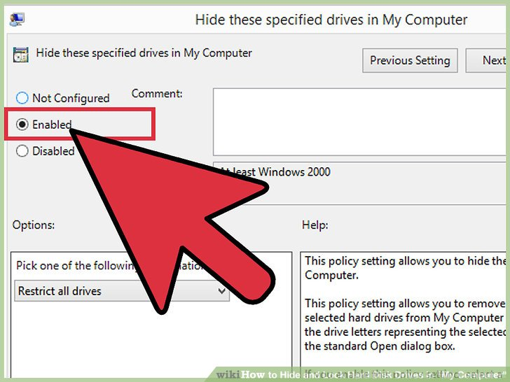
3
Search for "Hide these specified drives in My Computer" in the options that appear in the right column of the window. Double click it, enable it and choose the drive(s) you want to hide.
- 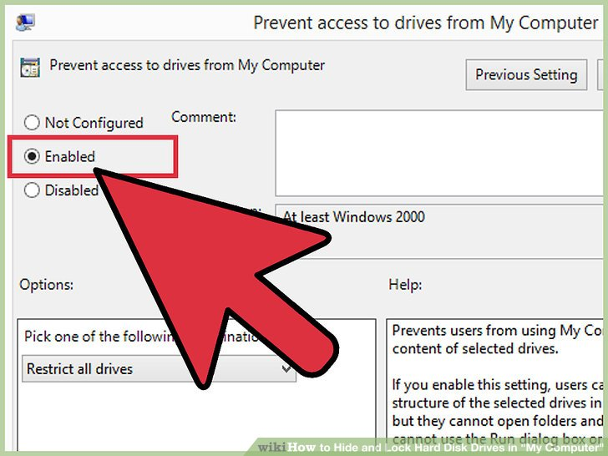
4
Search for "Prevent access to drives from My Computer". Double click it and repeat the previous step if you want to stop accessing any drive by "command" (e.g, by typing "C:" in the address bar or "Run").
- 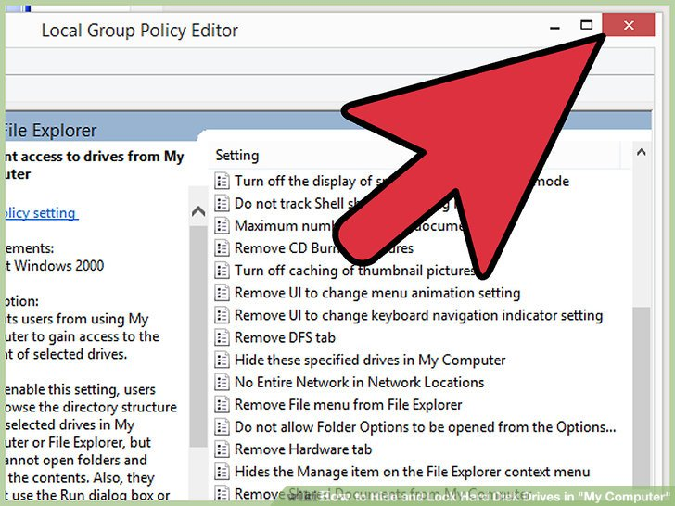
5
Close the group policy window.
- 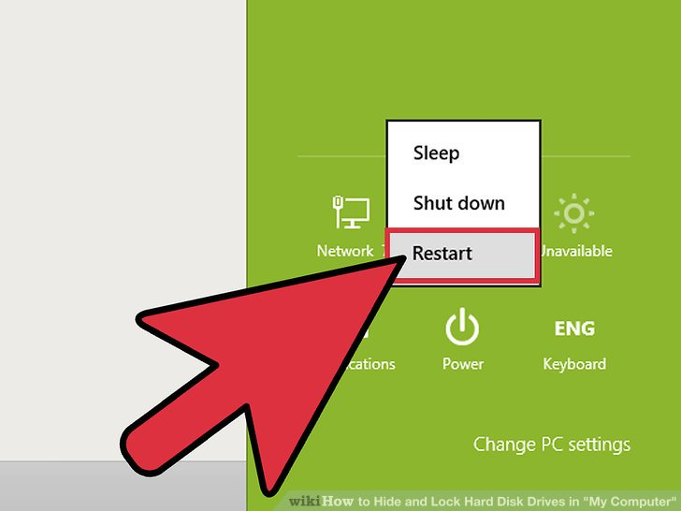
6
Restart your computer for changes to take effect.
- 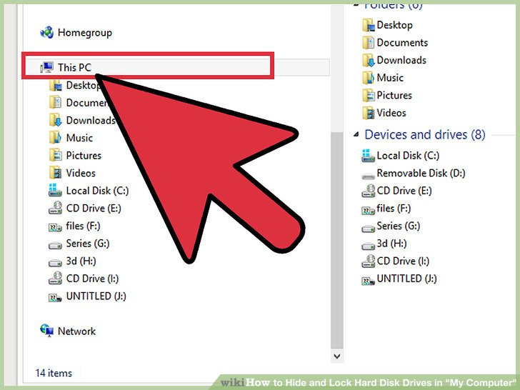
7
Only the first hard disk drives can be locked here.

Can you password protect an external hard drive?

**Download and install an encryption program, such as TrueCrypt, AxCrypt or StorageCrypt. ... **Plug in your external hard drive to your computer and wait for your computer to detect it. ... **Open your encryption program and select the option to create a new volume. ... **Choose the password you want for access to this drive.

How can I lock my USB flash drive?
To lock and protect USB flash drives, follow these simple steps:
- Plug in USB flash drive, and run the Setup program to install USB Secure on your USB flash drive. ...
- Open USB-Drive.
- Protect This USB Drive.
- Click 'Protect This USB Drive', and set and confirm a new password for the USB drive.

How to lock flash drives with USB Secure? - NewSoftwares.net
www.newsoftwares.net/usb-secure/howto/lock-flash-drives-with-usb-secure/

How can I lock a folder in external hard disk?

Password Protect Folder in External Hard Disk with Renee File Protector
- Step 1: Launch Renee File Protector and click “Lock File” in “External Disk”. ...
- Step 2: Click “Lock Folder” on the right side and select the target folder in external hard drive. ...
- Step 3: Check & edit the files inside the password protected folder.

How to Password Protect Folder in External Hard Drive?

https://www.reneelab.com/password-protect-folder-in-external-hard-drive.html
Search for: How can I lock a folder in external hard disk?
Can you password protect an external hard drive?
**Download and install an encryption program, such as TrueCrypt, AxCrypt or StorageCrypt. ...
**Plug in your external hard drive to your computer and wait for your computer to detect it. ...
**Open your encryption program and select the option to create a new volume. ...
**Choose the password you want for access to this drive.

How do you password protect an external hard drive?

**Step 1: Run the program and select a drive to encrypt. First of all, plug your external hard drive into computer and double click the icon of this program. Select a target drive disk in the drive list. ...
**Step 2: Set password to protect USB drive. Enter password and a" password hint" in the pop-up box.

