JAMES SOWERBY HIS PUBLICATIONS AND COLLECTIONS

Lawrence H. Conklin
N.B.: This article appeared in Mineralogical Record, volume 26, July-August, 1995.

Great hand-colored mineral books have appeared only rarely in history. James Sowerby produced two of the finest between 1802 and 1820; his five-volume British Mineralogy and his two-volume Exotic Mineralogy depicted in color over 1,500 specimens from the best mineral collections in England. These fascinating and exquisitely rendered books are justifiably among the most coveted items in all of mineralogical literature.
INTRODUCTION
For the past 40 years I have been fascinated by the superb and beautiful mineral colorplate works of James Sowerby and his descendants. As I became a serious book-collector, and then an amateur writer on the history of minerals and books, I promised myself that one day I would write about this fascinating family and their mineralogical publications.
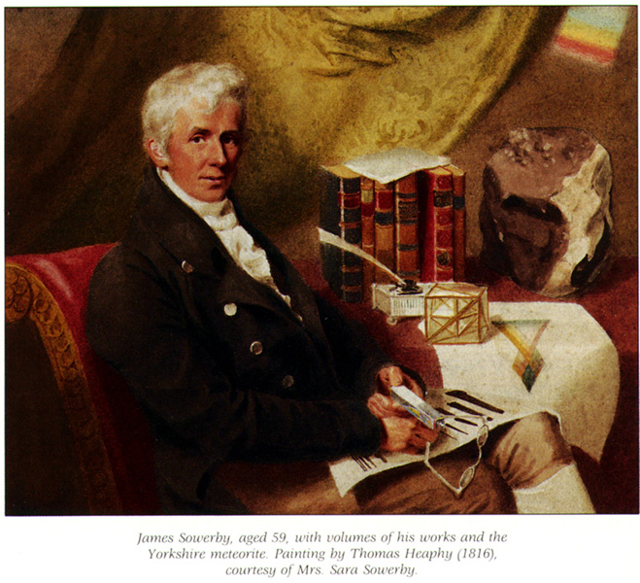 | James Sowerby, aged 59, with volumes of his works and the Yorkshire meteorite. Painting by Thomas Heaphy (1816), courtesy of Mrs. Sara Sowerby.
The two Sowerby mineralogies discussed here are very high on most mineral-book collectors' lists of desiderata, but with perhaps fewer than one hundred (I know of only 50 so far) surviving complete copies of British Mineralogy and far fewer (I know of only 24) of Exotic Mineralogy, only the most affluent, and in the case of the latter title, the most diligent, collectors will be able to add these works to their libraries.
The Sowerbys were a family of naturalists, collectors, artists and publishers who, for more than a century, offered the public, amateur and professional alike, a large selection of important, original, illustrated works on natural history. Through their accurate illustration, careful preparation and faithful publishing of these natural history books the Sowerbys strongly influenced the development of the study and teaching of natural history in 19th-century Great Britain, especially botany, paleontology and mineralogy. As a family they wrote and illustrated more than 100 natural history works between the years 1789 and 1897.
JAMES SOWERBY
James Sowerby was born on March 21, 1757, at No. 2 Bolt-in-Tun Passage, off Fleet Street, in the city of London; he died on the other side of the Thames River, at No. 2-3 Mead Place, Lambeth, on October 25, 1822.
James was the son of John Sowerby, a lapidary, and his wife Arabella Goodspeed. His father died when James' eldest brother John was still too young to carry on the family business, which was on the decline owing to the vagaries of fashion involving the use of semi-precious colored stones which had previously been in great demand.
James studied art at the Royal Academy in London and began making studies of wildflowers and plants to include in his miniature portraits. This led to an association with William Curtis (1746-1799), botanist and noted author of the magnificent Flora Londinensis; or Plates and Descriptions of such Plants as Grow Wild in the Environs of London (London 1777-1798). Curtis taught him how best to depict plants and their blossoms. Apparently James hand-colored many of the plates for this Curtis publication which has been described as "unsurpassed in the history of botanical illustration" and did the original engravings on copper for a number of them. Copies of this work are rare today.
While studying at the Royal Academy, James met and became friendly with a fellow student, Robert De Carle. De Carle invited Sowerby to his home in Norwich where Sowerby met his youngest sister Anne Brettingham De Carle. They were much attracted to each other and, in due course, were married. In 1786 they moved into the house in Mead Place, a gift of the bride's father. The house apparently survived until the bombing of London during World War II.
They had four children who lived to adulthood, all of whom, it is assumed, at one time or another during their childhood, helped their father in the production of his books. Indeed the two eldest sons, James De Carle and George Brettingham, did substantial original work and research for the family publishing projects, completing much that was begun by their father, and it is generally assumed that the phrase "(With Assistance)" printed above the author's name on the titles of British Mineralogy referred to them. When James Senior died in 1822, James De Carle took up the current work-in-progress, The Mineral Conchology of Great Britain, and saw it to completion.
In 1790 James Sowerby started the first of his illustrated works, with the descriptions supplied by Sir James E. Smith, English Botany; or Coloured Figures of British Plants, with their Essential Characters, Synonyms and Places of Growth, issued in parts over 23 years, was finished in 1813. This work, considered his most important, is complete in 36 volumes with 2,592 (!) hand-colored plates of British plants. Buyers of this work today must exercise extreme caution. Because of its popularity, editions were published over many years, sometimes with images produced from worn out plates, parts from earlier editions and other bibliographic nightmares.
The second edition of this work was merely a restrike of the first, and mixed editions were routinely produced. Sets of the final edition (usually in 13 volumes of quarto size, with 1,936 plates), designated the third edition, appeared as late as 1892, and were illustrated with crude lithographic (albeit hand-colored) copies of Sowerby's original engravings. There are also pirated editions.
Sowerby's second most important publication, Mineral Conchology of Great Britain, or Coloured Figures and Descriptions of those Remains of Testaceous Animals, or Shells which have been Preserved at Various Times, and Depths in the Earth (London l812-1846), is actually a work of invertebrate paleontology (a term that had not yet come into use in Sowerby's day) and it recorded, for the first time, many index fossils found in England. This publication secured, certainly for his lifetime, Sowerby-the-artist's credentials as a serious student of the geological sciences. This work, too, was issued in parts, over a 34 year period (the final parts were produced by James De Carle with the help of George Brettingham), and when complete (as issued), contains 650 colored plates, each with a letter-press description, in seven volumes. It is recorded that two unauthorized (or pirated) editions of this work were produced by Louis Agassiz, the first in French in 1837 and the second in German in 1845.
In addition Sowerby supplied the 19 plates for William Smith's Strata Identified by Organized Fossils (London, 1816), known popularly as Smith's Strata. He, and then later his family, produced the colored plates for most of the eleven editions of John Mawe's Familiar Lessons on Mineralogy and Geology (London, l819 through 1829) and Mawe's Treatise On Diamonds and Precious Stones. Sowerby almost certainly also produced for Mawe the one quarto-sized, hand colored, engraving of mineral specimens for Travels in the Interior of Brazil (London, 1812), although it is unsigned. (Interestingly, no colored plate accompanies the first American edition of this work published in Philadelphia in 1816, although it is similar to the London edition in every other way.)
The two Sowerby works to be discussed here are British Mineralogy: Or Coloured Figures Intended to Elucidate the Mineralogy of Great Britain (London, 1804-1817) and Exotic Mineralogy: Or Coloured Figures of Foreign Minerals as a Supplement to British Mineralogy (London, 1811-1820).
Both the British and Exotic mineralogies were published originally in "parts" or periodical issues, and were sold by subscription. The publishers also offered complete sets of the works after all the parts had been produced. These normally show up bound, with the addition of suitable title-pages and indices. The completed works are usually found in five volumes for the British and two for the Exotic, each volume carrying its individual title-page, although other binding variants are known. At least one ten-volume set (five volumes of plates and five of text) exists and many sets were bound, perhaps much later, in a mineral chemistry format with no regard to Sowerby's numerical order. Complete "parts" of both works have survived in their original printed paper covers or "wrappers." (See the illustration here of Part I of Exotic Mineralogy in original wrappers, which is a presentation copy from James Sowerby to The Linnean Society of London, of which he was a fellow.) Evidence that at least some of the bound volumes began their life as "parts" can be observed by noticing the remains of the "stab holes" from the original stitching of the parts, if these holes were not later trimmed away by the binder.
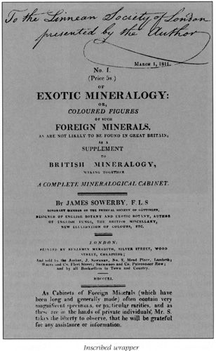
Inscribed wrapper
James Sowerby was a careful, meticulous and observant artisan and this is evident in the quality of the workmanship of the drawings he produced and the copperplates that he personally engraved and etched. The fine detail achievable by such drawing is, even to this day, preferred in some instances (medical, for one) to the most exacting photography. Indeed, in Arthur W. G. Kingsbury's article "Some minerals of special interest in South-West England" reprinted from Present Views on Some Aspects of the Geology of Cornwall and Devon (Truro, 1964), we read that Sowerby, with Tab. 134 on pages 63-64 of British Mineralogy, while figuring and describing wavellite, noticed and very carefully depicted "small dark circles" of a mineral that Dr. Kingsbury only recently determined to be variscite. This species was not described until more than 30 years after the Sowerby plate, in 1837. It is extremely rare in Great Britain.
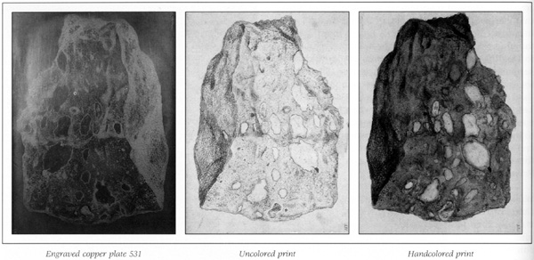
Engraved copper plate 531 | Uncolored print | Handcolored print
Sowerby's technique for producing the plates was relatively simple: The copperplate-engraved outline of the mineral image was printed, usually in black ink (in a few instances colored inks were used), on an octavo-sized sheet of paper; and was then hand-tinted within the printed outlines using watercolor paints. It has been stated that Sowerby ran, in effect, a production line, with artisans (some family members, some paid employees) each applying one color to the print and then passing it on to the next person for the application of the next color and so on. This apparently is not so, as suggested by the survival of sets of completely colored original "pattern plates" (done by Sowerby himself and some marked with "directions to the colourist") for each of two different sets of his works. These treasures were actually offered for sale by Bernard Quaritch Ltd. in their catalog Supplementa Sowerbiana; Or a Catalogue of Books and Manuscripts Written or Illustrated by Members of the Sowerby Family, compiled by John Collins and issued as a supplement to their Catalog No.894 (London, 1969). The set for Mineral Conchology, almost complete with 643 of 650 plates, was priced at $86.40, and was still available for sale in July, 1971! The production line tradition may have gotten its start from the fact that the Sowerby children were, at first, allowed only to paint the "dirt" (the background area at the base under the specimens in some plates) until they were capable of more skilled work. In any case, each family member had his or her own table or desk, colors, brushes and a cupboard of drawers in which to store supplies.
A comparison of the same colored plate in different copies of the same work sometimes shows a very slight variation in quality as, apparently, some colorists were more skillful than others. On the other hand, if we examine the first plates in British Mineralogy, executed in 1802, and compare them with the final examples of Exotic Mineralogy done almost 20 years later; we notice that the same very high standards of quality were maintained over this very long period.

One of Sowerby's surviving original copperplates is currently in my own collection. It has been framed with an original printer's proof (in which the plate came wrapped), and a modern restrike of the plate which has been colored by hand. It is Tab. (or Plate) 531, a depiction of toadstone, an amygdaloidal basalt, from British Mineralogy. It is quite well worn from its being printed many times, and the printed proof actually shows more detail than now remains on the copperplate! Nevertheless, the very careful engraving skills of James Sowerby can be appreciated at first glance. It is signed and dated in the plate-"J.S. scps, [sculpsit, Latin for engraved] 1816."
In placing the era in which James Sowerby worked and assembled his collection of minerals in historical context, it should be remembered that at the time of the publication of the first part of British Mineralogy in 1802, mineralogy was virtually the exclusive preserve of medical doctors, and chemists were just beginning to analyze minerals.
Abraham Gottlob Werner (1749-l817), "the father of mineralogy," was still to have 15 productive years at Freiberg in which to enhance his reputation; René Just Haüy (l743-1826), the "founder of mathematical crystallography," was to continue publishing his mineralogical research for another 20 years. Indeed in America, 1802 was the year of the legendary pilgrimage in which Benjamin Silliman of Yale College in New Haven, Connecticut, was obliged to take that institution's mineral collection "in a candle box," to faraway Philadelphia in order to have the minerals properly identified by Adam Seybert and the other experts there.
At this time books were the primary (and in some cases, the only) sources of scientific information, and these books were often purposefully written in a style which attempted to involve the reader. Sowerby's works were no exception, and his readers responded by supplying him with specimens and pertinent information. Sowerby's publications acted as a clearing-house, as it were, for observations and discoveries among the small number of geologists, mineralogists and botanists, who were widely scattered and who had little opportunity to exchange their ideas or many of their specimens. Philip Rashleigh, author of Specimens of British Minerals, Selected from the Cabinet of Philip Rashleigh, of Menabilly, in the County of Cornwall (two volumes, London 1797 and 1802), actually stated that he was dependent upon the Sowerbys for news of minerals. Indeed, Arthur Aikin, in the preface to his A Manual of Mineralogy (London, l814), stated- "For some of these [mineral] localities I am indebted to Mr. Sowerby's elegant work on 'British Mineralogy illustrated with coloured plates.'"
The accumulated specimens that Sowerby used in his works took on, more and more, the appearance of a museum, and in 1796 he was obliged to add a room to the rear of his house in which to store them. It was Sowerby's plan to have, eventually, a complete collection of the natural history of Great Britain. In a letter now in the British Museum (Natural History), Sowerby described his "museum" as "some thousands of minerals, many not known elsewhere, a great variety of fossils, most of the plants of English Botany about 500 preserved specimens or models of fungi, quadrupeds, birds, insects, &c. all the natural production of Great Britain." In a printed prospectus of 1821 Sowerby reminded the public that "a fire is kept in the Museum every Thesday during the winter; from eleven o'clock 'til four;" but his museum did not remain intact very long after his death in 1822. His original plan of creating a major public institution was attempted by his sons. Indeed, James de Carle Sowerby (1787-1871) was eminently capable of following in his father's footsteps. Along with his friend Michael Faraday (1791-1867), he studied under Sir Humphrey Davy (1778-1829), the inventor of the Davy lamp and in whose honor the mineral species davyne was named. His knowledge of chemistry led him to propose a classification of minerals according to their chemical composition, and to this end he analyzed many specimens published in British Mineralogy and Exotic Mineralogy. A notice in Mineral Conchology printed in 1827 stated that "tickets for admission to study in Sowerby's Museum and Library may be had at 10s each for three months, or £2 per annum." It should be kept in mind that Sowerby's "Museum" always sounded more formal when it was referred to in print than it was in fact. In any case by 1831 it ceased to exist.
It is not clear what the final disposition of all the minerals was, but a manuscript draft dated April, 1831 exists in the British Museum (Natural History), stating in part that it is ". . . necessary for the purpose of completing some family arrangements to dispose of the above splendid Collection, the result of forty year's labour, Messrs. J. & E. Sowerby, the administrators have determined to open it [the museum] for Private Sale, on Monday the 18th of this month." On June 23, 1831, the Stevens' Auction Rooms sold the remaining portion of the collection of minerals, stones, etc. In 1861 the Mineral Conchology collection of figured specimens, some 5,000 pieces, was sold to the British Museum for £400. It should be noted that this transaction was for "the general" but not, presumably, the entire collection.
In 1934 some Sowerby descendants offered to sell to the British Museum (Natural History) a group of mineral specimens that they called the "Sowerby Collection." The museum trustees suggested the nominal price of £50 for the lot, which was promptly accepted by the heirs. Included in this collection were five mineral specimens that had been depicted in British Mineralogy, calculated by the buyers to be worth nine shillings, or $2.25, each.
The list of lenders and donors of specimens to Sowerby and his museum reads like a mineralogical "Who's Who." We see such names as:
"Babington" (William Babington (1757-1833), after whom babingtonite was named)
"Wollaston" (William Hyde Wollaston (1766-1828)- wollastonite)
"Brooke" (Henry James Brooke (1771-1857)- brookite)
"Tennant" (Smithson Tennant (1761-1815)- tennantite)
"Bournon" (Jacques Louis, Count de Bournon (1751-1825)- bournonite]
"Heuland" (John Henry Heuland (1778-1856)- heulandite)
"Forster" (Adolarius Jacob Forster (1739-1806)- forsterite)
"Stromeyer" (Friedrich Stromeyer (1776-1835)- stromeyerite)
"Gmelin" (Christian Gottlob Gmelin (1792-1 835)- gmelinite)
Other notable lenders were: Sir Joseph Banks (1743-1820), president of the Royal Society; the Hon. Charles Francis Greville (1749-1809); and "Mrs. Mawe," the wife of John Mawe (1764-1829), author of Travels in the Interior of Brazil; Familiar Lessons on Mineralogy; and A Treatise on Diamonds and Precious Stones, etc. John Mawe opened a mineral shop in 1811 after returning from a voyage to Brazil. When Mawe died in 1829 the business was carried on by his apprentice, James Tennant (1808-1881), who then succeeded him.¹
____________________________________________________________
1 James Tennant began his apprenticeship with Mawe when he was 16 years of age and was only 21 when Mawe died. In 1838 he was appointed a teacher at King's College, and later became professor of mineralogy there. By 1840 he had become "mineralogist to queen Victoria" and was curator of the Baroness Burdett-Coutts mineral collection. Tennant is probably best remembered for his supervision of the recutting of the famous "Koh-i-noor" diamond. Recent writers have questioned the year of his birth, even though it is listed as 1808 in The Dictionary of National Biography (British). In my library, however is a copy of a photograph of Professor Tennant on which he has recorded his nativity data in holograph, and signed as follows- "James Tennant Born Feb. 8. 1808. at Upton near Southwell, Notts." This photo was formerly in the files of George F. Kunz and was given to him by one of his many correspondents who has inscribed it thus-"Above is Prof. Tennant's autograph, written when he gave me the photograph in the classroom at King's College, London after his lecture, 17th March 1870. [signed James T. B. Ives."
BRITISH MINERALOGY

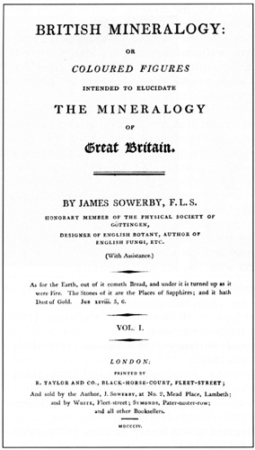
British Mineralogy: Or Coloured Figures Intended to Elucidate the Mineralogy of Great Britain is complete with 550 hand-colored plates of minerals and rocks, all, presumably, executed on copper by James Sowerby, and each accompanied by a letter-press discussion of the depicted subject, also by Sowerby. The importance of British Mineralogy in its time cannot be overstated. Today it is still considered the supreme work of British topographical mineralogy. It is certainly the most ambitious colorplate work on minerals ever published, and with its 550 plates is many times more extensive than its nearest rival.
The work was originally issued in parts, called numbers, between 1802 and 1817. From an almost complete and probably unique set in original wrappers in the Obodda Library, the dates of issue of the numbers with their respective plates are listed on Table 1. The Obodda copy is highly important because, to the best of my knowledge, the information that is unique to it has never before been published. (See the discussion of Exotic Mineralogy for similar information for that work which has previously been published.) In B. B. Woodward's Catalogue of Library British Museum (Natural History) (1982) we read that: "The text at first was not always issued with the illustrations. In the copy of Vol. I [in wrappers] referred to above, it was obviously not all in the original state of issue. . . ." The publishers left it to the subscribers to collate the work. Eventually that problem was corrected, and by the year 1811, and the start of the publication of Exotic Mineralogy, the text and corresponding plates were being issued together.
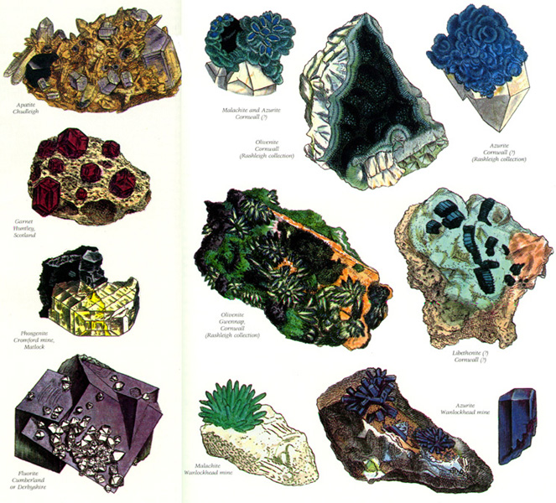 | Some specimen  illustrations from  British Mineralogy

On the front wrapper of No. I is the following:
"It was at first intended to have given a brief Catalogue of a valuable Collection which the author has been so fortunate as to procure; but, finding it necessary for that purpose to make Sketches of the various Fractures and Crystallizations of the Mineral Bodies in question, he has been advised to publish such Representations. To this advice he has the more readily consented, as he will, perhaps, be stimulated to proceed with more assiduity. The figures will be executed from actual Specimens, and the interesting Parts made conspicuous. The letter-press will be as intelligible as possible. References will be made to scientific Authors, especially Linnaeus, as far as can conveniently be done."
Printed on the rear wrapper is the following:
"The descriptions will be published occasionally, about Two Sheets at a Time, as a single Sheet is subject to a Stamp Duty. It is expected to publish another Number, or more, while the Letter-press is preparing. The first Number is an Example of the Execution of the Figures, and the whole is intended as a Companion to English Botany. Any Information, or Specimens, with Habitats &c. will be gratefully received, and duly remembered."
The price of each number (or part) started out, in 1802, at 3 shillings and 6 pence, and with number XXXI on June 1,1805 the price jumped to 5 shillings.That price was maintained at least until number LXXVII (which brought the subscribers well into the fifth and final volume) in November of 1813.
The first of the five title pages supplied by the publisher was issued in 1804, and bears that date, although the work was begun and the first number or part was issued two years earlier in 1802. It covers the first volume of 100 plates and descriptions. The succeeding title pages are dated 1806, 1809, 1811 and 1817. It is assumed that there was never a "book" edition separately published, and that all completed sets of the work were bound up from the parts with perhaps some parts reprinted as needed. Most of the subscribers acceded to the five volume format intended by the publisher. Complete sets of British Mineralogy are, however, considered rare in the book trade today, with shorter sets being the examples most usually offered for sale. Any publication extending over 15 years will surly have lost a number of its original subscribers along the way, and the sets they were assembling would end up incomplete.
Sowerby's attempt at perfection in the production of British Mineralogy is clearly demonstrated by an announcement on the front wrapper of Part No. XXVI of December 1, 1804. He states that included in this part is a new leaf of text and description that is to be substituted for pages 129 and 130 "which must be canceled." The reason was that page 129 (a right-hand page) was originally blank on the back, so that page 130 (also blank on the back) was a right-hand page, although even-numbered pages traditionally belong on the left-hand side. Sowerby corrected this esthetically unpleasing situation by eliminating the two blank pages with the substitution of the new leaf. His wishes, however, were not always carried out by the subscribers when the completed set of parts was finally bound. This is, technically, not a "point of issue," however, since all the subscribers were issued the cancel and were free to decide on whether to employ it or not.
The work also contained advertisements, of which the following, quoted from Volume Five, is an interesting example:
MINERALOGY
AND
GEOLOGY.
The rapid progress these Sciences are making in England, leads us to hope that we shall soon equal the Savans on the continent. Mr. MAWE, No.149, Strand, informs those who are desirous of becoming acquainted with these useful branches of Natural History, that they may be supplied with any specimens they want, or Collections classed and arranged, at from 2 to 50 guineas. Mr. MAWE has connexions in all the Mining districts of Europe,Brazil, North America, Ceylon, &c. from whence he receives the finest productions of those countries, and being concerned in several Mines in this kingdom, he regularly receives their finest produce; which, connected with his Manufactory in Derby, for forming Vases, &c. of the beautiful Fluor of that county, he is enabled to vend Minerals on the most reasonable terms.
New Descriptive Catalogue, price 3s.
The best Books on the subjects of Mineralogy, Geology, and Conchology, and whatever relates to those Sciences.
Incidentally, the leaf on which the above advertisement appears was almost always removed when the parts were permanently bound, and it is known today, apparently, in but a single example!²
________________________________________________________
2 The copy of British Mineralogy containing the Mawe advertisement was listed for sale by William Patrick Watson of London as number 92 in his Catalogue Three. The price asked was £6000 which, on October 26,1992, equaled $9,500. It is the same copy listed by Antiquaariat Junk at 19,000 Dutch florins ($12,000), and Mr. Watson informed me that he and A.J. were partners on the book.

There is, so far, only one bibliographical "point" that has been noted in British Mineralogy, and that is the misnumbering of Plate 421 as 221 in some copies and the subsequent correction of this error. Consequently there are first (or early) and second (or later) issues of the edition. The first or "uncorrected " shows the number 221 engraved on the plate, whereas the second or "corrected issue" bears the proper number, 421. This information could conceivably be used in a book-seller's catalog to praise the virtues, real or imagined, of an early (as opposed to a late) impression of the plate(s). Plates 413 and 415 have had their numbers interchanged in all the copies that
I have examined, and unless a copy comes to light where this is not the case, this is not a second "point."
In his introduction to British Mineralogy Sowerby states quite accurately that the "undertaking [of this work] was begun at a time when we [the British] had but just become aware of how far we were behindhand in this most essential knowledge, when even the Diamond, one of the oldest jewels in the known world, had but recently been discovered to be pure carbon" (by Smithson Tennant in 1796).
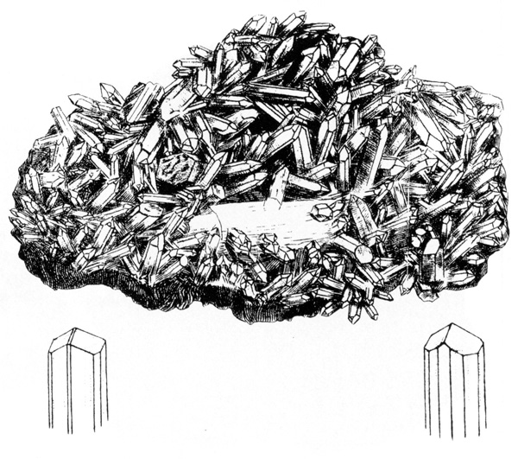
One of the most historically interesting plates in British Mineralogy is "Tab. CCCXXXI. ARGILLA electrica. White Tourmaline." Depicted is a mass of terminated quartz crystals, in the center of which is a large, white, prismatic crystal whose rhombohedral nature is clearly indicated by the two crystal drawings at the bottom of the plate. Sowerby states:
"This substance which seems almost new to the whole mineralogical world, not being spoken of by any author, was sent me in 1804. It was said to be found in a mine in St. Justs in Cornwall. I speak of it as new, being really a white Schorl or Tourmaline; for though Tourmaline is said to occur of all the colours in mixtures of yellow, red and blue, yet it is not mentioned as ever having been found colorless or white until now; therefore this is the rarest known."
It was, indeed, rare, except that now we know that Sowerby's "White Tourmaline" is actually the first description and crystal drawings of the mineral phenakite, which was not recognized as a new mineral species until its description by Nils Nordenskjold in 1830. It was named phenakite by him, from the Greek for "deceiver," alluding to its deceptive appearance. Nordenskjold considered that it could be confused with quartz however, not tourmaline. Incidentally, in the copy of British Mineralogy formerly in the library of Richard Hauck, penciled to the right of the printed words White Tourmaline are "Phenacite" and the initials "AR" which identify Sir Arthur Edward Jan Montagu Russell (1878-1964), a mineral collector extraordinary from Great Britain. Russell referred to this plate in 1920 when he wrote a paper on a later occurrence of phenakite in England. There were a few other such notations in Russell's holograph, but it could not be determined for certain if this copy was his very own. Sir Arthur's adventures and his generosity regarding minerals are fully and warmly covered by Embrey and Symes in their excellent book Minerals of Cornwall and Devon (London, 1987).
Sowerby can be forgiven for a lapse into nationalism when he stated, near the end of Volume V of British Mineralogy, in the description of Tab. 548:
"Before closing this work, it is a pleasure to meet with a triumphant and unexpected example of the produce of a country [England] hitherto but rarely quoted for any thing fine. The magnificent Tourmalines, of which I now figure two specimens, may vie with any thing of the kind brought from foreign climes . . ."
The tourmalines (schorl) from near Bovey Tracey, Devon, are indeed fine and actually superb (although some British Mineralogy plates depict specimens that are most unattractive) and in their day, before the tourmaline production from Brazil and elsewhere, must have created quite a sensation. Incidentally, the specimens from this occurrence probably rank today as the finest tourmalines ever found in Great Britain. Their collecting history is most interesting, and Sowerby was informed that "a barn was built with some of the largest and finest specimens before it was observed by a Gentleman in the neigbourhood." The barn was pulled down to recover the minerals from its foundation, and it is recorded that some specimens in private collections were seen with evidence of mortar remaining on them! A modern depiction of one of these crystals, the largest known, can be found on page 125 of Minerals of Cornwall and Devon, cited above.
Excellent apatites were found there too, and they are described separately by Sowerby in the next plate, Tab. 549. John Mawe wrote a paper "On the Tourmaline and Apatite of Devonshire" in The Quarterly Journal of Science in 1818. Sowerby also states in the tourmaline description that he was "favoured with the choice of Mr. Brooke's and Dr. Somerville's specimens, collected on the spot by them together." It is apparent that in addition to these pieces, many of the other specimens illustrated in the 550 plates were part of Sowerby's own collection at the time, and this might explain the mediocrity of some of them. This assumption becomes more likely when one compares these less attractive specimens to the examples depicted in Exotic Mineralogy wherein Sowerby, with the entire world as his territory, could be more selective without trying to be as comprehensive in the coverage of these foreign specimens.
In British Mineralogy Sowerby tried to bring some order out of the then-current mineralogical chaos, and he concocted an elaborate Linnean-style, binomial Latin classification as the heading for each mineral description. Mineral names were used infrequently and the chemistry of the mineral was generally listed first, for instance "Zincum carbonatum," followed by "crystallized Carbonate of Zinc" or "Zincum oxygenizatum (siliciferum), Silical Oxide of Zinc." Here he added "Class 3. Metals. Ord. 1 Direct Combinations. Gen. 4 Zinc. Spec. 1 Oxide. Sect. 2. Silical."
An early visitor to Mead Place, Eric Thomas Svedenstierna (1765-1825) of Sweden, noted that Sowerby was at that time organizing his mineral collection according to Haüy's system. Sowerby gave up completely on his binomial Latin classification in Exotic Mineralogy. This visitor also noted that Sowerby's collection of minerals was growing rapidly.
A recent depiction of a fine specimen that was originally Illustrated in British Mineralogy appears on page 77 of Minerals of Cornwall and Devon, wherein the authors, in amusing British understatement, inform us:
"This specimen (BM 1976, 246) [chalcocite] was bought in 1976 from the dealer Brian Lloyd, who acquired it as part of the Neeld collection formed in the early nineteenth century. It is so closely similar to the one owned by '__ Lounds [should be Lowndes] Esq.' figured by James Sowerby in his British Mineralogy (1817 vol. 5, Tab. DXVIII), that it may well be the same ." (Italics added.)
I and others I have consulted are all convinced that this specimen is indeed the original illustrated specimen.
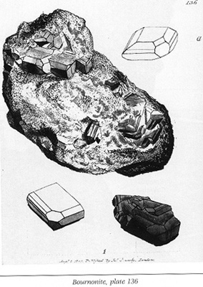

How interesting it is to study Tabs. CXXXV and CXXXVI and see two fairly easy-to-identify examples of what Sowerby called "PLUMBUM cupreoantimoniatum sulphureum" and to read further that Jacques Louis, Count de Bournon 1751-1825) had determined much of their habits of crystallization. We are, of course, looking at examples of the mineral which, shortly after the Sowerby depiction, was named bournonite by Robert Jameson in 1805.
Although the nature of meteorites was not fully understood in the early 19th century, James Sowerby knew full well the value to his public of anything new and unusual, and to the best of his ability he exploited one of the first recorded English falls, "The Yorkshire Meteorite." This famous stone fell, duly observed, at approximately 3 p.m. on Sunday, December 13, 1795, and was fully appreciated by the owner of the property on which it landed, one Major Edward Topham,who even went so far as to erect a tablet at the site of the fall which read as follows:
Here
On this Spot,
December 13th 1795, fell from the Atmosphere
An extraordinary Stone!
In Breadth 28 inches,
In Length 30 inches,
and
Whose weight was 56 pounds!
This Column
In memory of it was erected by
Edward Topham
1799
Apparently, by 1804 this "extraordinary stone" had become the property of James Sowerby and his Museum for "the Sum of Ten Guineas [ten and one half pounds] to be paid [to Edward Topham] at present and the Work [British Mineralogy] complete of the first Impression of the Plates and elegantly bound and lettered" according to the terms put down in a letter from Edward Topham to James Sowerby, dated November 1. What would a book-collector of today give to own (or even to see) that particular set, all "elegantly bound and lettered"? Most sets known to this writer that have survived in their contemporary coverings (not the paper wrappers, of course) have been rather modestly bound, usually in 1/2 or 3/4 leather with decorated, usually marbled, paper-covered boards. The most "elegantly bound" copy that I know of is a fine, tall set in full contemporary stiff vellum with gilt lettering and gilt decoration that retains the bookplates of the Earl of Tyrconnel.
Of course, Topham had to wait 13 years until the completion of British Mineralogy in 1817 to have this deal consummated, and, assuming he got his set promptly, he lived to enjoy it for only 3 years. However, this cash and barter deal proved to be a good investment, indeed, for the Sowerbys. In addition to the obvious value of the meteorite's presence in the family museum and all the publicity it garnered for more than 30 years, the British Museum purchased it from them in 1837 for the sum of £250. The price is believed by modern-day experts to have been an exorbitant one for its time, and perhaps this account waited to be balanced out by those 9-shilling specimens illustrated in British Mineralogy that were sold by the Sowerby descendants almost 100 years later!
Today, the "Wold cottage chondrite," as the Yorkshire meteorite is now called, weighs only 45.5 pounds, down from its original weight of 56 pounds. It is known from correspondence in the British Museum (Natural History) that Sowerby exchanged fragments that be broke off this meteorite for natural history specimens sent to him by his correspondents. Sowerby relates the story of this meteorite in great detail in British Mineralogy, including a long account of it by Topham, as part of a 19-page discussion (his longest) with Tab. CI.
A watercolor portrait of James Sowerby (see illustration) rendered by Thomas Heaphey (1775-1835) in the year 1816, and still in the possession of his descendants, shows him seated with volumes from his English Botany, British Mineralogy, and Exotic Mineralogy. Also depicted is a large crystal model and, dominating the painting, apparently still most prestigious after more than 20 years, even with its rather fresh looking (Sowerby-inflicted?) broken surfaces, The Yorkshire meteorite.
Sowerby's goal was to produce a complete popular mineralogy based on British specimens alone, but eventually realizing that not every mineral then known could be found in England, and that some might never be found there, he began a second series of mineral copper-plates and descriptions in order to complete his plan; he called it Exotic Mineralogy, the "exotic" meaning from outside Britain.
EXOTIC MINERALOGY
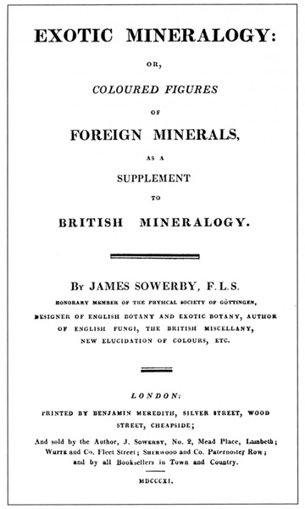
Exotic Mineralogy: Or Coloured Figures of Foreign Minerals, as a Supplement to British Mineralogy was also issued in parts, between 1811 and 1820 as enumerated in Table 2. The index to Exotic Mineralogy was sent to the subscribers in 1835.
The information in Table 2 is based on a nearly complete and probably unique set in original wrappers in the British Library. It lacks only the final part or parts after number 27 and the index; the information above is taken from the Woodward catalog. Number 17 was, in effect, a double number as it included the final text and plates for Volume I and the first text and plates for Volume II. It was at this time that Sowerby projected completing a total of 33 parts, but never reached that number. Because no part in wrappers later than Number 27 has survived it is not clear whether one or two parts completed the work. In either case, there were 10 more pages (141-151) and six more plates (CLXIV-CLXIX).
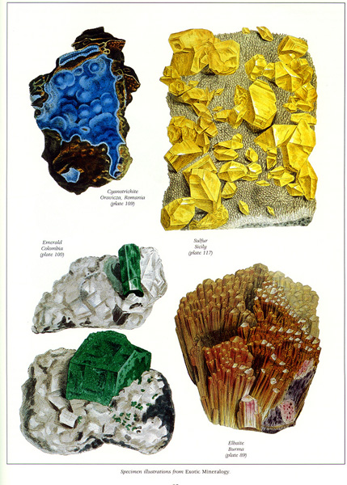 | Specimen illustrations  from Exotic Mineralogy
The wording of the title as it appears on the first wrapper is slightly different (and, I think, a little better than that used on the book title pages): Exotic Mineralogy: Or Coloured Figures of Such Foreign Minerals as are Not Likely to he Found in Great Britain, as a Supplement to British Mineralogy, Making Together a Complete Mineralogical Cabinet. On the front cover of this first wrapper Sowerby made his pitch: "As Cabinets of Foreign Minerals . . . often contain very magnificent specimens or particular rarities, and as these are in the hands of private individuals, Mr. S. takes the liberty to observe, that he will be grateful for any assistance or information."
Exotic Mineralogy is complete with 167 colored plates, plus one uncolored plate, for a total of 168, with letter-press descriptions for each, although most bibliographies including a most recent one call for 169 plates. No plate numbered 73 was ever issued, and on the rear of the wrapper for Part XVI the author explains why: "This plate [93] was formerly intended to have been published as tab. 73, but more figures being required, the two plates of Turquoise are numbered in succession, 92 and 93." In some copies of this work the turquoise plate was printed bearing the original engraved number "73" and was not changed to the corrected number "93" until sometime later; thus creating the first and second issues of this edition. The first, or "uncorrected issue" retains the original engraved number 73 and the second or "corrected issue" displays "93"-a "point" to be looked for if one wishes.
Exotic Mineralogy, because of its 167 colored plates, is second in importance only to Sowerby's own earlier work, British Mineralogy, in the mineral color-plate book category, and had that work never been published, Exotic Mineralogy would be the most significant publication ever in terms of size, scope and quality of workmanship. In my opinion, the only possible comparable works are Rashleigh's Specimens Of British Minerals (1797-1802), containing only 54 (albeit, quarto-sized) color-plates and, perhaps, but to a significantly lesser degree, the color-plate German language works Das Mineralreich in Bildern (1858) by J. G. Kurr, and F A. Schmidt's Mineralienbuch (1850). On the rear wrapper of Part XVII of Exotic Mineralogy, in a notice from the publisher, we read:
"It being necessary to form two volumes of this work, which will be completed in sixteen more Numbers [a total never reached] we recommend the possessors of it to have the first volume put in boards without cutting [the edges of the pages], that the two may be arranged according to an Index which will be given in the last Number."
So, it would be reasonable to expect to find an occasional Volume I of Exotic in contemporary boards, and I know of, but have not examined, such a volume. Incidentally, the subscribers to Exotic Mineralogy did not receive a printed index until fifteen years after receiving the final part. A separate index, including an "advertisement," was supplied by the Sowerbys in 1835, with instructions that it was to be bound at the end of Volume II. It is not surprising, therefore, that we find copies of the work complete but with the index lacking.
By the time of the completion of Volume I of Exotic, Sowerby had noticed two problems that we today see occasionally in his works, namely the off-setting of the pigments and gum-arabic from the plates, sometimes resulting in their adhering to adjacent leaves; and the off-setting of the ink from the letter-press descriptions. So, he cautioned his subscribers (and their binders) with a half-page note-from-the-publisher included in Number 17, which note, incidentally, is a rare survival. I know of only two copies. Such a note would have been routinely removed when the volume was permanently bound. It states:
One of the plates in this Number [Tab. 104, a large Chessy, France azurite, richly colored with blue pigment and coated with gum arabic for luster] being from necessity coloured with a substance very deliquescent in its nature, renders it particularly proper at this season of the year to caution our Readers against suffering the book to be laid in a damp place . . . [and to] keep the Numbers always in a dry place . . . give directions to Binders never to damp or beat [which is excessive flattening of the sheets off the volumes . . . but only to dry-press them well, as from their [the binders'] ignorance, coloured prints are frequently spoiled, and by their beating, the letterpress commonly sets off on the plates.
In some of the numbers of the copy of British Mineralogy in-parts in the Obodda library, are tissue-guards presumably supplied by the publisher; but which would have been removed during binding. In an almost complete Volume I of Exotic in parts are no surviving tissue guards. Most mineral-book collectors of my acquaintance, when confronted with off-setting, and the occasional stuck-down plate, simply assume that Sowerby stacked wet painted plates or wet inked text sheets together.
Exotic Mineralogy is, for some yet-to-he discovered reason, a much rarer work than British Mineralogy on the antiquarian book market. In one series of entries, extracted by a bibliophile from booksellers' catalogs between the 1940's and the 1980's, complete copies of British were available for sale fifteen times whereas only a single offering of Exotic was present. And this becomes even more surprising when one considers that Exotic, in only two volumes was much easier to complete than its companion work. The legendary George Frederick Kunz library, now at the United States Geological Survey, owns only the first volume (although the Kunz copy may have been complete originally). It has been suggested that the nationalistic pride that resulted from their seeing native minerals depicted in British Mineralogy prompted gentlemen of the period to become subscribers, and that the exotic (or foreign) specimens were, simply, of significantly less interest to them. But, if one is to take Sowerby at his word, he seemed quite satisfied with sales of the book, and he wrote in the preface of Volume II of Exotic in 1817 that:
"It was under the impression that about 100 plates of Minerals not known in Great Britain would have been a sufficient Appendix to British Mineralogy, for the student, that I commenced this work; but since 1811 so many new species and strongly marked varieties have crowded upon me, and so anxious have been my friends to see every thing extraordinary commemorated. . . I trust that the utility of the work having been acknowledged by the reception the first volume has met with . . . [italics added) will render it equally interesting, and make the extension acceptable."
All should agree that these are not the words of an author-publisher who is unhappy with the reception of his work by the public. Perhaps the answer will never be known.
Sowerby's introductory remarks in the preface of Volume I of Exotic are also of interest:
It was under rather peculiar disadvantages that my work upon British Minerals with figures was begun, as Mineralogy was considered merely as an appendage to Chemistry, and it was thought that figures would not elucidate it; but Mineralogy has now gained more importance, [perhaps due in part to the success and popularity of British Mineralogy] and figures have been found much to facilitate the study of that, as well as of the other branches of science. It is almost enough that a Mineralogist should know how far this empire is blessed with native Minerals, which since my work has been in its progress, are so much augmented, that but few are to be added, even from the whole remaining part of the globe. Indeed most former English authors, depending chiefly upon foreign information, did not know what was to he found at home; thus while the British Minerals require five or six volumes, the Exotic ones may he figured sufficiently complete in only one more, perhaps. The little catalogue [Catalogue of British Minerals, Chiefly in the Collection of James Sowerby London, 1811] which I have just published will serve to show this, and as I do not profess to enter largely into a collection of Exotic Minerals, I am happy to say that the generosity of those who possess the most perfect Cabinets fully supersede the necessity of so doing.
Although Sowerby stated that he did not want to collect foreign minerals, at least on the same scale as his British minerals, apparently he had many. It can be safely assumed that he was extremely careful in giving full credit to whomever supplied a specimen for illustration, yet for many of the depicted specimens he cited nothing in the way of provenance, leaving the reader to assume that those specimens were his own.
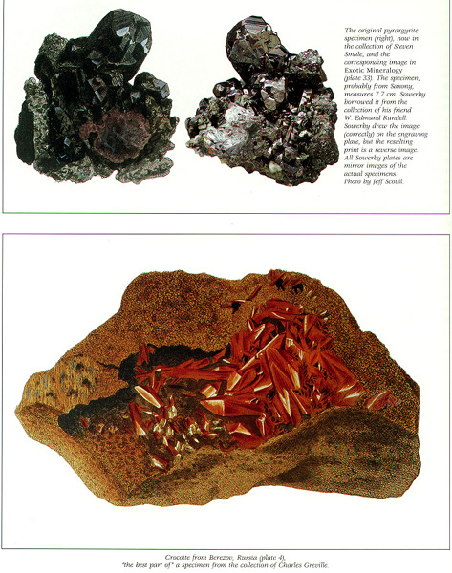 | Upper plate: The original pyrargyrite specimen (right), now in the collection of Steven Smale, and the corresponding image in Exotoc Mineralogy (plate 33). The specimen, probably from Saxony, measures 7.7 cm. Sowerby borrowed it from the collection of his friend W. Edmund Rundell. Sowerby drew the image (correctly) on the engraving plate, but the resulting print is a reverse image. All Sowerby plates are mirrror images of the original specimens. Photo by Jeff Scovil.  Lower plate: Crocoite form Berezov, Russia (plate 4) "the best part of" a specimen form the collection of Charles Greville.
The death in 1809 of the Honorable Charles Francis Greville (a mineral collector extraordinary and one of Sowerby's closest colleagues), during the time of the writing of Exotic Mineralogy, apparently gave the author some very nervous moments. We read in the description to Tab. IV:
"This beautiful specimen [of crocoite is] from the mine of Berezof, near Catherinbourg, in Siberia. The remarkable richness of colour that it possesses is nearly peculiar to itself, and is very characteristic of the truly orange and scarlet. Specimens so fine as the present are very valuable; this is the best part [italics added] of a superb one in the Collection of my late friend the Hon. Charles Greville, whose liberality invited me to partake of his matchless cabinet, with the pleasantest freedom, and I am happy to show this [the crocoite] as a proof of his generosity, which may be seen also in British Mineralogy and as our Government has secured them [the Greville minerals] in the British Museum, I may still hope to find a continuance of such favors." (Italics added.)
Apparently Sowerby's fears were groundless, and he stated in the preface to Volume I, which was written after the crocoite description:
"The first subject begun for this work. viz. the superb Chromate of Lead [crocoite], was drawn at my much to be lamented friend's, the Hon. Charles Greville, and I depended greatly on his matchless collection, and by application to the Trustees of the British Museum, who have so honorably interested themselves in securing this treasure to their country; I have to thank them for the free access to it which I now enjoy." (Italics added.)
Sowerby, for artistic purposes, often illustrated only parts of certain specimens, as noted above, without so indicating, and took other liberties in his illustrations, such as restoring or idealizing broken or incomplete crystals; one case in point is tab. CXVII, sulfur, surely one of the prize engravings of Exotic Mineralogy. In the description the author tells us that he "selected for this purpose the most magnificent group of crystals [of sulfur] ever brought to England; but as the mass upon which they repose is very broad, I have omitted a great portion of it, using principally the central parts, and condensing them a little." (Italics added.)
The Greville collection was a very important one and its sale to the British Museum was reported by Archibald Bruce in number 2 of his American Mineralogical Journal published in New York City in 1811. The article, on page 122, is as follows:
Mr. Greville's Cabinet.
"This splendid collection of minerals has been lately purchased by the British government for 13,727£. sterling, and now forms a part of their National Museum. The commissioners appointed to examine and value this cabinet, in their report to the committee of the House of Commons, concurred unanimously in giving a public testimony of the merits and services of Count Bournon, to whose exertions and talents the systematic arrangement of this collection is due."
Bruce also reported that Greville had purchased the "celebrated" mineral collection of Baron von Born, brought it to England, and "afterwards added an immense number of minerals from every part of the globe. . . . Thus his collection, before his death, had become, for the beauty of the specimens and their immense variety the first in the world." (Italics added.)³
One of the great treasures of the Greville collection was pictured by Sowerby in Exotic as Thb. LXXXIX. It is a marvelous group of tourmaline crystals from Ava (Burma), that was valued at the time at the very significant sum of £500! It is so large that Sowerby, in order to show the great specimen at natural size, was forced to engrave it on a double-sized copperplate, and he then had to fold the resulting print to fit it in the book.
______________________________________________________
3 For some reason, Greville, whose older brother was the very important Earl of Warwick and who was a nephew of Sir William Hamilton (1730-1806), author of the magnificent Campi Phlegraei, or Observations on the Volcanoes of the Two Sicilies . . (Naples, 1776) with more than 50 magnificent hand-colored plates, is not listed in the British Dictionary of National Biography. Archibald Bruce may have cited the reason when he wrote in his American Mineralogical Journal- "It may be easily supposed, that with the name and influence of the house of Warwick, the genius of such a man as Mr. Greville would not leave untried the more usual walks of ambition: but having sided against the Court [the King] in the memorable American war [of the Revolution] he lost its favour, [italics added] and philosophy had him for her own [that is, he was denied the political offices that would normally have been offered to a person of his social position]. He did not however; refuse to his country the knowledge of his comprehensive mind." Or, perhaps the D.N.B. simply missed him.
For Exotic Mineralogy Sowerby dropped his awkward attempt at mineral classification, except for the Latin binomial title. In place of the later subdivisions he listed the various names by which the mineral was known at the time and cited numerous authorities, such as Bournon, Daubenton, De l'Isle, Emmerling, Hauy, Jameson, Karsten, Kirwan and Werner.
Sowerby had another opportunity, as he had in British Mineralogy, to discuss meteorites. In this instance an eight-page summary of the knowledge of the time included, in the discussion for Tab. 163, a very interesting personal experience as follows:
"Fig. 3. is from my specimen of the Iron found near the great Fish River; it was obtained at the Cape of Good Hope, and brought to England by Fichtel . . . [It is known today as the Cape of Good Hope meteorite.] This is extremely pure and compact; it is considerably harder, but otherwise much of the texture of Lead it is not elastic when sawn into slices, but is easily rendered so by hammering; a shaving taken from the surface by a chizel is elastic without any further operation; it is so ductile and free from flaws that it may readily be rolled into sheets thinner than paper without cracking; its hardness is such that it takes an excellent polish, its lustre is superior to that of pure Iron, and its colour nearer that of silver. These properties rendered it an excellent material for a sword blade, consequently, upon His Majesty the Emperor of Russia visiting England, I had a slice 2 inches and three-fourths long, 2 inches wide, and nearly three-fourths of an inch thick, hammered at a low heat into a blade 2 feet long, and 1-1/2 inch wide, which welded into a steel haft, and mounted, I presented to his Majesty as a memorial of his visit."
The following inscription was engraved on the blade:
"This Iron having fallen from the Heavens, was upon His visit to England, presented to His Majesty Alexander, Emperor of all the Russias, who has successfully joined in Battle to spread the blessings of peace throughout Europe, by James Sowerby F.L.S., Honorary Member of the Physical Society of Gottingen, &c., June, 1814. [On the other side of the blade was engraved:] Pure Meteoric Iron found near the Cape of Good Hope."
One wonders what the knifesmiths of today, who believe that they are the originators of meteoritic iron knife blades, would think if they knew they were merely following a tradition originated by an Englishman in the year 1814.
Sowerby further remarked that "His Imperial Majesty [Czar Alexander] has expressed his approbation, by sending me a superb Emerald ring set with Diamonds, for which I feel Highly grateful." The ring apparently still survives in the hands of a Sowerby descendant.
For collectors of minerals in general, Exotic Mineralogy is rather more interesting than the narrower-in-scope, more specialized, British Mineralogy, and many of the depicted specimens are still highly prized today. For instance, the Colombian emeralds in Tab. C. (with their locality given as "Peru " of which present-day Colombia was once a part), certainly two of the finest matrix specimens known, are called by Sowerby "the pride of the collection at the British Museum." In Tab. CLVIII we see Kongsberg, Norway, silver specimens that would quicken the pulse of any modern-day collector.
We can read a little about Sowerby's "network" in Tab. CLXII. Writing of a rare example of "Argentum (sulphureum) flexile" (= sternbergite) he said that "the only specimen in England is the one figured; it was found in Mr. Partsch's cabinet of Minerals at Vienna, among the ores of Tellurium, and was brought to England with it by my son G. B. [George Brettingham] Sowerby."
Collectors of today know well the usual means of acquiring mineral specimens (that is field collecting, exchanging and purchasing), but Sowerby, in the description for Tab. XL, adds an entirely new dimension. He tells of Mr. Allan's (Thomas Allan, 1777 1833, after whom allanite was named) good fortune in obtaining a collection of Greenland minerals that were part of the booty on board a Danish vessel captured by a British privateer. We read later, in the discussion of Tab. LVIII (allanite), that the specimens belonged originally to Karl Ludwig Giesecke (1761-1833), a German mineralogist. What story lay behind the fact that in 1813 the very same Thomas Allan described and named gieseckite? In this description Sowerby gives us some clues as he relates:
"It [the mineral about to be named allanite] was placed in the hands of Dr. Thomson [Thomas Thomson, (1773-1852), after whom thomsonite was named] who, having analyzed and described it, gave it a name after its proprietor [owner; that is, Allan] not knowing at the time the person to whom it would have been more handsome and more correct to have done that honour [i.e. Giesecke]."
These were uncharacteristically strong words from Sowerby, and are not equaled elsewhere in either publication. In Tab. CI. (the description of gieseckite) the cat is out of the bag, and Sowerby related:
"The persevering researches of Sir Charles Giesecke, in Greenland, have been productive of several new and many rare Minerals, some of which a less intelligent Mineralogist would have passed over. The fortune of war had for some time deprived him of the honour due to his discoveries; [italics added] but now his merit is every where fully admitted."
There is one enticing and provocative little tidbit in the description to Tab. CXVI in which the author thanks "Professor Herrmann" for a drawing of (or, possibly, for the crystal itself) a specimen of "sulphuret of antimony" (= stibnite) illustrated as part of the plate. It is just barely possible that this is a reference to Professor Charles W. A. Herrmann (1801-1898), who was the subject of my short article in the Mineralogical Record (vol. 25, p. 225). C.W.A. Herrmann's obituary states that he was "educated at the University of Breslau, and turned his attention to the study of stones with such good effect that after his graduation, he became Professor of Mineralogy at the university." Since Herrmann was born in 1801 and Tab. CXVI was published in 1818 he would have been a very young professor indeed, but it is possible and perhaps he was another one of Sowerby's many correspondents.
Did Sowerby cheat a bit when he included a Welsh specimen in his Exotic collection? (Or did 19th-century Englanders regard Wales as a foreign country?) In Thb. LXXXII he described aplome, a variety of garnet, and remarked that "it bears a considerable resemblance to common Garnet, but is distinguished from it by the striae along the short diagonals of the faces. . . ." He added, "I am informed by Mrs. Mawe, from whom the Count [Bournon] obtained it that it was found in digging a well in some part of North Wales." He apologized by adding, "When I completed British Mineralogy I had not ascertained this fact." Mrs. Mawe is mentioned elsewhere in this work as a lender of mineral specimens and seems always to be associated with what we call today, "thumbnails" or thumbnail-sized minerals. Sowerby took a similar detour in Tab. CXXX when he discussed a not-too-exotic Scottish staurolite.
Sowerby committed an error in Tab. XXXI, but it was probably only of the typographical variety. In the description of a specimen of molybdate of lead (wulfenite) from Carinthia, he refers the reader to a projected plate which he said would be number 158, and which he said would discuss "yellow phosphates from Wanlock-head mine, near Glasgow." At that time no plate 158 was even planned and although the number 158 was eventually used by him, it describes native silver.
American minerals make a very good showing in Exotic Mineralogy when one considers the primitive state of mineralogy and mineral collecting in America at this time. They are represented by Tab. VI "Ferrum columbiatum . . . or Columbite," a specimen that came from an unspecified locality which is thought to be a Connecticut or Massachusetts pegmatite. According to tradition it was sent to Sir Hans Sloane in London by the American John Winthrop or possibly his grandson, John Winthrop the Younger, in the 18th century. Tab. LX describes "Ferrum chromiferum" or chromite from a site near Baltimore, Maryland, which almost certainly must be the Bare Hills. Tab. LXXV discusses "Magnesia hydrata. Hydrate of Magnesia" or brucite, named later for Archibald Bruce (1777-1818) who discovered the species and who presented the figured piece to the British Museum. The description for Tab. LXXXIV, "Zincum oxygenizatum, Oxide of Zinc" or zincite from the Franklin area in New Jersey notes that its discoverer was also Archibald Bruce.
Sowerby lavished particular care and attention on the diamond, devoting two plates to it (Tabs. CXVIII & CXVIX), although the second plate is merely one of crystal drawings and is uncolored. In the discussion of these plates we learn that the great blue diamond that was later to be known as the "Hope Diamond" apparently belonged at that time to "Daniel Eliason, Esq." of London. Mrs. Mawe's cabinet was again called upon to supply no less than eight of the figured diamond crystals, gratefully acknowledged, of course, by the author.
BOOK MARKET PRICES
A little bit of the history of the retail pricing of British Mineralogy, mostly from my personal experiences, might be interesting. Before my book-collecting days, in 1940, Henry Sotheran, a London book-seller, had offered a complete copy for $30. About the year 1960 I bought my first copy from Hugh A. Ford for $90 and sold it shortly thereafter for $125. The next copy to come my way, in 1972, was bound in contemporary three-quarter calf and I sold it for $600. In 1974 the booksellers Antiquaariat Junk listed a copy for $950. My third copy came from Antiquaariat Junk in 1979 for; a price more than double the price of that 1974 set, $2,050. It was in a contemporary German binding of rather unattractive, mottled, black paper-covered boards with orange labels, and was bound in ten volumes, five of plates and five of text. Less than one year later; in 1980, my next set came also from Antiquaariat Junk, but this time at $4,500,which was more than double (again) the price of the previous copy. (When I was writing this I was reminded of the Pete Seeger folk song "We all keep-a-doppleing - . . ," but Seeger was not referring to sets of British Mineralogy.) It was, however a fine, tall copy, sumptuously bound in full contemporary stiff vellum with decorative markings in gilt, and it came from the library of the Earl of Tyrconnel, retaining his armorial bookplates. This copy I sold to Richard Hauck in 1982, at cost, but with the understanding that I could retrieve it in exchange for another copy in the future. (I really loved that set and was sad to have parted with it.) My next copy did not come until 1990, and I paid $3,500 for it. It had been rebound in modern, full, dark-green calf by the prisoners of Warwick (Massachusetts) State Penitentiary and was of reasonably good workmanship. It had some penciled holograph notations by Sir Arthur Russell with his initials, and I used it to reclaim my vellum-bound set from Richard Hauck.
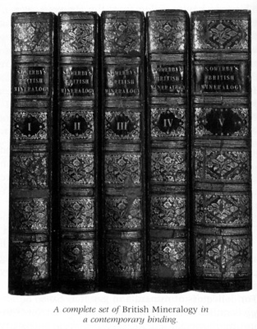 | A complete set of British Mineralogy in a contemporary binding
Since 1990, things Sowerby appear to have heated up significantly. At a New York City auction sale on August 18, 1992, a really poor set with much damage to all title pages, one that some booksellers might catalog as "a fair copy only," sold for $5,280 to a European dealer who bought it, without inspection, for resale. Informed insiders, myself included, were betting that it would be returned to the auction house, but, apparently, we were wrong. More recently, Antiquaariat Junk (which firm I truly believe is a price trend-setter for this work and, of course, other important books too) listed a set in "contemporary half-green-calf, slightly rubbed," for 19,000 Dutch florins which, on October 22, 1992, amounted to $12,350. Incidentally, in that same list they offered a copy of Exotic Mineralogy in "half-green-calf, slightly rubbed" which may have been bound en suite with the British (but was not so stated) for 21,000 Dutch florins or $13,700. The retail price these days for a fine, complete set of British Mineralogy seems to be around $12,000 and moving upwards (naturally), and somewhat more for a copy of Exotic. The traditional gap in price between British and Exotic, which exists mostly in the mineral-book-collecting world and not in the general book market, seems to be narrowing. This movement, in my opinion, is correct. Whereas it is true that Exotic Mineralogy is a very rare book, British Mineralogy is a much more important work and when you come right down to it, the latter contains three times the number of colorplates of the former!
Since this article was begun, a lovely, limited, reprint edition of Exotic Mineralogy in two volumes complete with facsimiles of all of the mineral plates in fine color, has been produced by Wendell E. Wilson and the Mineralogical Record Library. One can only hope that, with sufficient encouragement from the readers, a complete British Mineralogy will be next.
CONCLUSION
The Sowerbys were unique. As a family their accomplishments are beyond comparison, and there will almost certainly never be another like them. Mineral and book collectors, especially those who want and can afford the wonderful Sowerby mineral works, will be forever grateful for these beautiful publications.

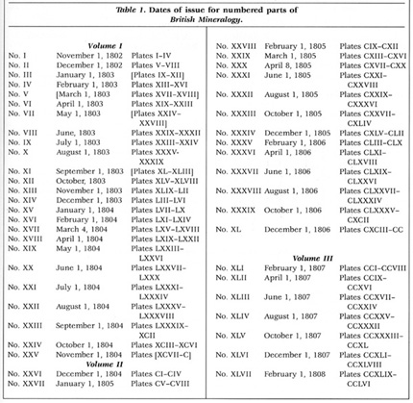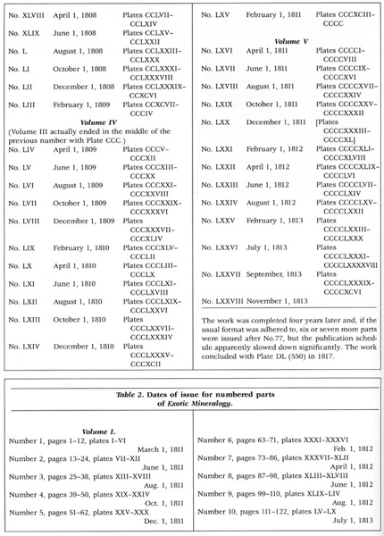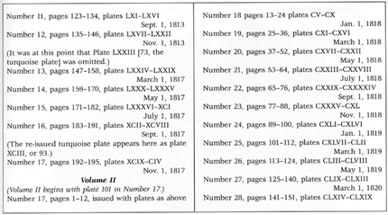
ACKNOWLEDGMENTS
A special thank you to Robert Thomas Curran, Jr. The following people also provided help and ideas:
Louis Zara, Carl Krotki, Stephen Smale, Richard Hauck, Herbert Obodda, Wendell Wilson (special thanks to Wendell Wilson and The Mineralogical Record Library for supplying me with a complete photocopy of Exotic Mineralogy before the reprint edition was available), Si and Ann Frazier, Bob Tichelman, Stephen Pober, Richard Bideaux, Joseph Freilich, E. R. Schierenberg, Curtis Schuh, William Patrick Watson, Frederick Blake, Timothy Johns, David Block and Ed Rogers.
I am compiling a census of all extant copies of Sowerby's British and Exotic Mineralogies and would appreciate hearing from any reader who has copies of either of these works, or who knows of copies that are privately or institutionally owned (complete or not). I should also appreciate hearing of any other related material by, or about, the Sowerbys.
SOURCES
ANONYMOUS (1871) Obituary of James de Carle Sowerby. Geological Magazine, 87, 478.
CLEEVELY; R. J. (1975) The Sowerbys and their publications, in the Light of the manuscript material in the British Museum (Natural History). Journal of the Society for the Bibliography of Natural History, 7, (part 4).
COLLINS, J. (1969) Supplementa Sowerbiana; Or A Catalogue of Books and Manuscripts Written or Illustrated by Members of the Sowerby Family. Supplement to Catalogue No. 894 of Bernard Quaritch Ltd., London.
COLLINS, J. (1973) A note on the History of the Sowerby Family Archive. London.
EMBREY, P. G., and SYMES, R. F (1987) Minerals of Cornwall and Devon. British Museum (Natural History), London, and Mineralogical Record Inc., Tucson, 154 p.
HATCHETT, C. (1801) An analysis of a mineral substance from North America. Philosophical Transactions of the Royal Society of London.
KINGSBURY, A. W. G. (1964) Some minerals of special interest in South-West England, in: Present Views on some Aspects of the Geology of Cornwall and Devon, Hosking and Schrimpton, eds.
LYMAN, L. P (1957) The New London Homestead of the Winthrop Family. Stonington.
POUGH, F H. (undated) [Early history of mineralogies]. Unpublished manuscript in the library of the author.
SOWERBY, A De C. (1952) The Sowerby Saga. 1, 23-26.
STEARN, R. P (1964) John Winthrop (1681-1747) and his gifts to the Royal Society. Transactions of the Colonial Society of Massachusetts, 42.
WHEELER, A., ed. (1974) Papers on the Sowerby Family. Journal of the Society for the Bibliography of Natural History, 6 (6), 373-568.
================================================================================================================================

