Annotated Bio-Bibliography of Mineralogy and Crystallography 1469-1919
by Curtis P. Schuh (1959-2007)

Sowerby, James.
(1757 - 1822)
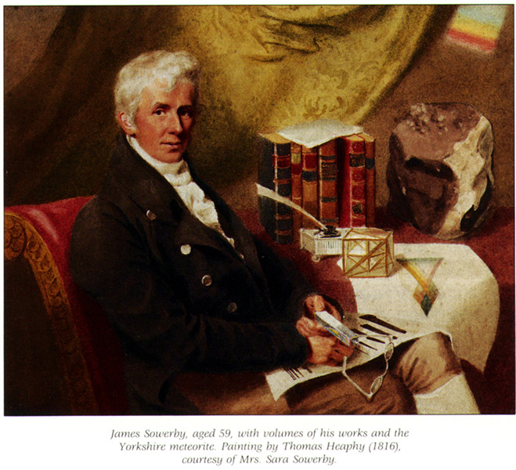

(Born: London, England, 21 March 1757; Died: Lambeth, England, 25 October 1822) English artist & naturalist.
Born the son of a lapidary who worked and lived in Fleet-street, Sowerby showed an artistic ability in his childhood. He became a student at the Royal Academy were he studied under the seascape artist Richard Wright [1735-1775]. He painted miniatures and portraits during his early career, and from a desire to make his backgrounds more realistic, Sowerby began a study of botany. Soon he became associated with the botanist William Curtis [1746-1779], who helped Sowerby become an expert illustrator of plants. From this relationship, Sowerby developed his principle publication, English Botany (36 vols., London, 1790-1813). Sowerby's memberships include the Geological Society, Royal Society and the Linnean Society all of London.
Biographical references: BBA: I 1024, 223-234. • Bryan's Dictionary of Painters, 1903-4: 5, 105. • Catalogue of Engraved British Portraits: 6, 551. • Cleevely, World Palæontological Collections, 1983: 272. • Cleevely, Bibliography of the Sowerby Family, 1974. • Cleevely, R.J., "The Sowerbys, the Mineral Conchology, and their fossil collection", Journal for the Society of the Bibliography of Natural History, 6, (1974), no. 6, 418-81. • Collins, J., A note on the history of the Sowerby family archive. Together with a short title catalogue of natural history works written or illustrated by members of the family. London, Seaton, 1973. 22 p., genealogical chart on rear endpaper. • Conklin, James Sowerby, his Publications, 1995. • DNB: 18, 713-5. • DSB: 12, 552-3 [by J.M. Eyles]. • Encyclopaedia Britannica, 11th edition. • Gentleman's Magazine: 92, pt. 2 (Dec. 1822), 562. • Lambrecht & Quenstedt, Catalogus, 1938: 406. • Poggendorff: 2, col. 965-6. • Sarjeant, Geologists, 1980: 3, 2151-2 & Suppl. 2 (1995), 2, 1095. • Simpkins, D.M., "Childhood reminiscences of James Sowerby", Journal for the Society of the Bibliography of Natural History, 6, (1974), no. 6, 416-7. • Sowerby, A.d.C., Sowerby saga: being a brief account of the origin and genealogy fo the Sowerby family and its history from the earliest times down to the present based upon research into available extant literature, by Arthur de Carle Sowerby, in collaboration with Alice Muriel Sowerby and Joan Evelyn Stone. Washington, D.C., Privately published, 1952. 3 vols. in 2 parts, v, 180 p. [Mimeographed production.]. • Stafleu & Cowan, Taxonomic Literature, 1976-88: 5, 759-62. • Thieme & Becker, Allgemeines Lexikon, 1907-50: 31, 314. • WBI. • World Who's Who in Science: 1582.
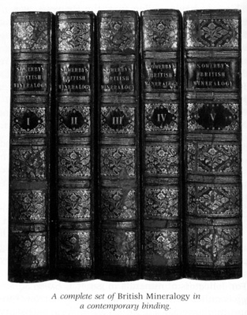

www.lhconklin.com

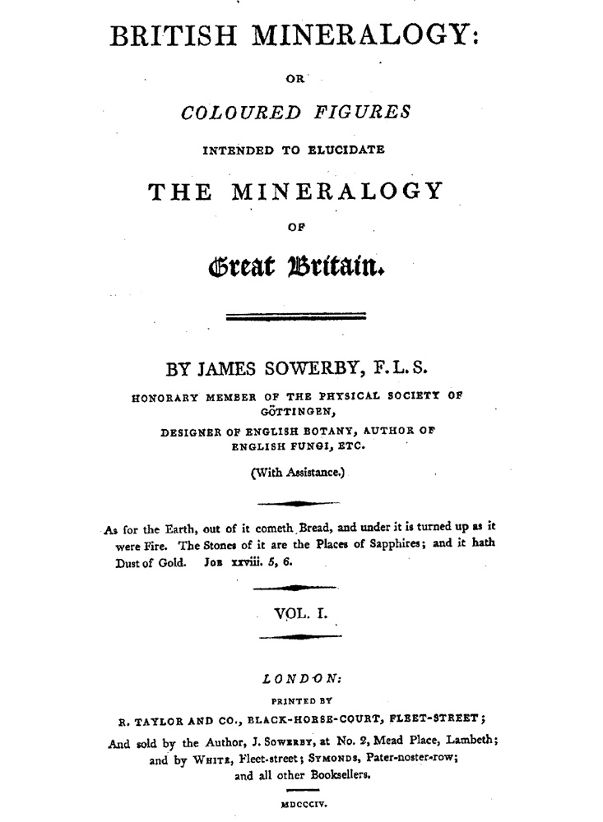
British Mineralogy, 1804
1. English, 1804-17.
British Mineralogy: | or | Coloured Figures | Intended To Elucidate | The Mineralogy | of | Great Britain. | [double rule] | By James Sowerby, F.L.S. | [... 4 lines of titles and memberships ...] | (With Assistance.) | [tapered rule] | As for the Earth, out of it cometh Bread, and under it is turned up as it | were Fire. The Stones of it are the Places of Sapphires; and it hath | Dust of Gold. Job xxviii. 5, 6. | [tapered rule] | Vol. I. | [tapered rule] | London: | Printed by | R. Taylor and Co., Black-Horse-Court, Fleet-Street; | And sold by the Author, J. Sowerby, at No. 2, Mead Place, Lambeth; | and by White, Fleet-Street; Symonds, Pater-noster-row; | and all other Booksellers. | [rule] | MDCCCIV [-MDCCCXVII].
5 vols. [Vol 1: 1804] 8°: [i]-xii, [1]-223, [1] errata p., plates 1-100; [Vol 2: 1806] 8°: [2], 1*-19*, [1] blank, [1]-199, [1] errata p., plates 101-200; [Vol 3: 1809] 8°: [2], [1]-209, [1] errata p., plates 201-300; [Vol 4: 1811] 8°: [2], [1]-78, 81-184 p., plates 301-400 (pages 79-80 are not included in the sequence); [Vol 5: 1817] 8°: [i]-vi, 1-281, [24] p., plates 401-550. In some copies plate 421 is misnumbered 221. Page size: 236 x 136 mm.
Contents: [Vol 1] [i-ii], Title page, verso blank.; [iii], Dedication to Sir Joseph Banks signed James Sowerby December 1, 1804.; [iv], Blank.; [v]-vii, "Preface."; [viii], Blank.; ix-x, "Sketch of a System | for | British Mineralogy."; xi-xii, "Observations on the System."; [1]-208, Text.; [209]-210, "Systematial Index | to | Vol. I."; [211]-223, "Alphabetical Index | of | Plates, & c. | to | Vol. I."; [1 pg], "Corrigenda."
[Vol 2] [2 pgs], Title page, verso blank.; 1*-19*, Text.; [1 pg], Blank.; 1-190, Text.; [191]-192, "Systematical Index | to | Vol. II.; [193]-199, "Alphabetical Index | to | Vol. II."; [1 pg], "Corrigenda."
[Vol 3] [2 pgs], Title page, verso blank.; 1-200, Text.; [201]-202, "Systematic Index | to | Vol. III."; [203]-209, "Alphabetical Index | to Vol. III."; [1 pg], "Addenda et Corrigenda."
[Vol 4] [2 pgs], Title page, verso blank.; 1-78, 81-176, Text.; [177]-184, "Alphabetical Index | to | Vol. IV.";
[Vol 5] [i-ii], Title page, verso blank.; [iii]-vi, "Preface."- signed James Sowerby Feb. 1 1817.; 1-281, Text.; [1 pg], Blank.; [8 pgs], "Systematic Index | to | British Mineralogy."; [15 pgs], "Index | to | British Mineralogy."; [1 pg], "Notes and Corrections."
Very scarce. British Mineralogy is most noted for its 550 engraved, hand-colored plates that depict the mineral wealth of Great Britain. Each plate is accompanied by descriptive letterpress that explains the pictured minerals in a casual style of someone who knew and appreciated minerals.
Due to an earlier success with his English Botany (36 vols., London, 1790-1813; 2,592 hand colored plates), Sowerby was undoubtedly trying to continue his prosperity by issuing other illustrated works in the natural sciences. It was only proper that he should venture into mineralogy which had become a very popular pastime among the wealthier classes, and around 1791 most notably with Sowerby himself. So in 1802 Sowerby began to publish by subscription an illustrated topographical mineralogy of Great Britain. The product of this venture is British Mineralogy, which contains the largest number of plates and some of the finest examples of hand-colored mineral illustration ever produced. During the years of its publication the mines of England were producing ores from some of the most richly mineralized deposits yet discovered; subsequently, many notable mineral specimens, including several unsurpassed examples of some species, were discovered and preserved. Sowerby sought out these unusually fine specimens and together with more typical examples, described and illustrated them in British Mineralogy, thereby creating an illustrated collector's compendium of the minerals of Great Britain that has never been superceded.
British Mineralogy was originally issued in 78 parts, called numbers, between 1802 and 1817. Conklin (1995) reproduces the sequence that these parts appeared. Periodically, after a sufficent number of plates had been produced (usually 100), the individual subscribers would have the volumes bound up to suit their tastes. As a result, this work, though most commonly found in five volumes, is also known in four and six volume sets, and in one copy, ten volumes, which split the text and plates into separate books.
Bibliographical references: BL. • BMC: 4, 1982. • Conklin, James Sowerby, his Publications, 1995: 26 (1995), no. 4, 85-105. • Dana's 7th (Bibliography): 81. • Freilich Sale Catalog: nos. 496-8. • Knight, Natural Science Books in English, 1972: p. 93. • LKG: XIV 451. • NUC: 559, 88-91 [NS 0771496]. • Ward & Carozzi, Geology Emerging, 1984: no. 2090.
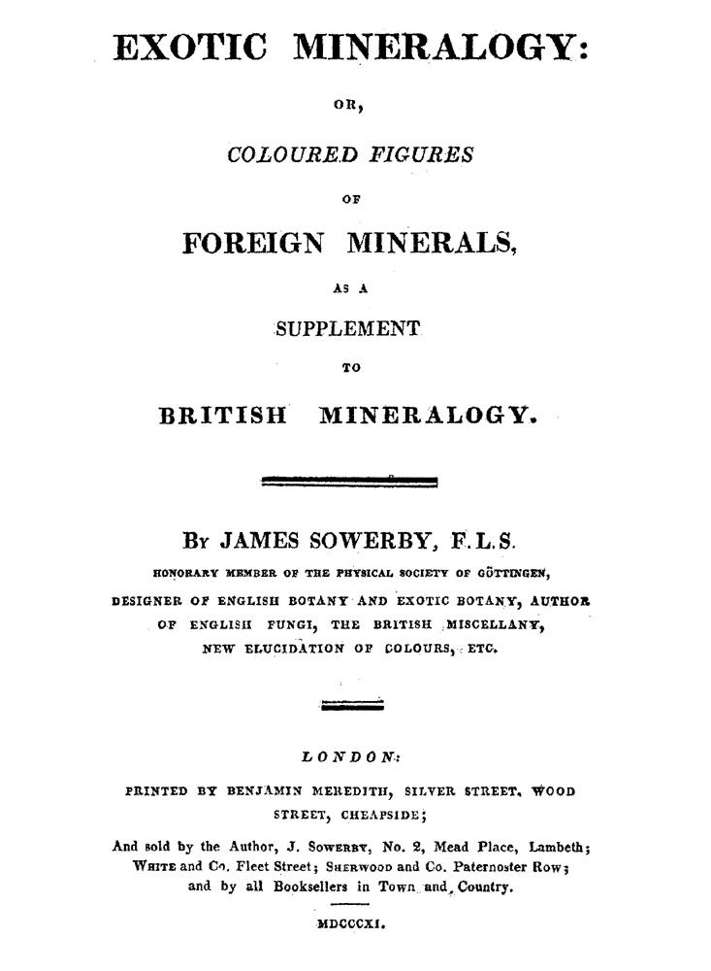
Exotic Mineralogy, 1811
2. English, 1811-7.
Exotic Mineralogy: | or, | Coloured Figures | of | Foreign Minerals, | as a | Supplement | to | British Mineralogy. | [double rule] | By James Sowerby, F.L.S. | [...4 lines of titles and memberships...] | [double rule] | London: |Printed by Benjamin Meredith, Silver Street, Wood | Street, Cheapside; | And sold by the Author, J. Sowerby, No. 2, Mead Place, Lambeth; White and Co. Fleet Street; Sherwood and Co. Paternoster Row; | and by all Booksellers in Town and Country. | [rule] | MDCCCXI [-MDCCCXVII].
2 vols. [Vol 1: 1811] 8°: [2], [i]-iv, 1-195 p., plates 1-72, 74-100; [Vol 2: 1817] 8°: [1]-159 p., plates 101-169. Page size: 235 x 142 mm.
Contents: [Vol 1] [2 pgs], Title page, verso blank.; [i], Dedication to Robert Ferguson, signed James Sowerby, March 1, 1811.; [ii], Blank.; [iii]-iv, "Preface."; 1-195, Text.
[Vol 2] [1-2], Title page, verso "Errata. | Preface to Vol. I, p. 1, line 4 from the bottom, for `supersede' read `supersedes.' "; [3], "Preface."- signed James Sowerby, 1817.; [4], Blank.; 5-151, Text.; [152], Blank.; [153]-160, "Index to Exotic Mineralogy, | Vols. I and II."
Very scarce. As the title states, Exotic Mineralogy was intended to supplement Sowerby's other great mineralogical work, British Mineralogy; however, perhaps due to a lack of interest in the mineralogy of localities outside Great Britain, there appear to have been far fewer subscribers to Exotic Mineralogy. The result is these two volumes are exceptionally rare.
Exotic Mineralogy is chiefly noted for its engraved, hand-colored plates, which are among the most realistic mineral depictions ever produced by Sowerby. In preparing the illustrations for this work, Sowerby sought out the best examples of minerals not then known in Great Britain. Weighted by a high quality in the models, the plates in Exotic Mineralogy are overall more appealing than those of British Mineralogy, whose purpose was to depict examples of every known type of mineral found in Great Britain - not simply prime examples.
Even though the plates of Exotic Mineralogy are numbered through 169, plate 73 was not always issued in section; therefore, a complete copy of the work contains only 168 plates. A note on the wrapper to the 13th section, which was to have contained the missing plate states, "It was intended to have published the Turquois in Tab. 73, but it has been found necessary to postpone that plate." In fact, plate 93 figuring turquois is the postponed plate with the seven clearly over-engraved into a nine in some printings.
Bibliographical references: BL. • BMC: 4, 1982. • Conklin, James Sowerby, his Publications, 1995: 26 (1995), no. 4, 85-105. • Freilich Sale Catalog: no. 499-500. • NUC: 559, 88-91 [NS 0771524]. • Ward & Carozzi, Geology Emerging, 1984: no. 2092.

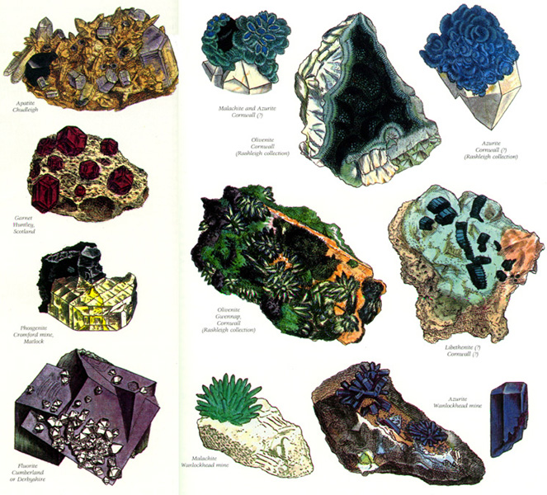
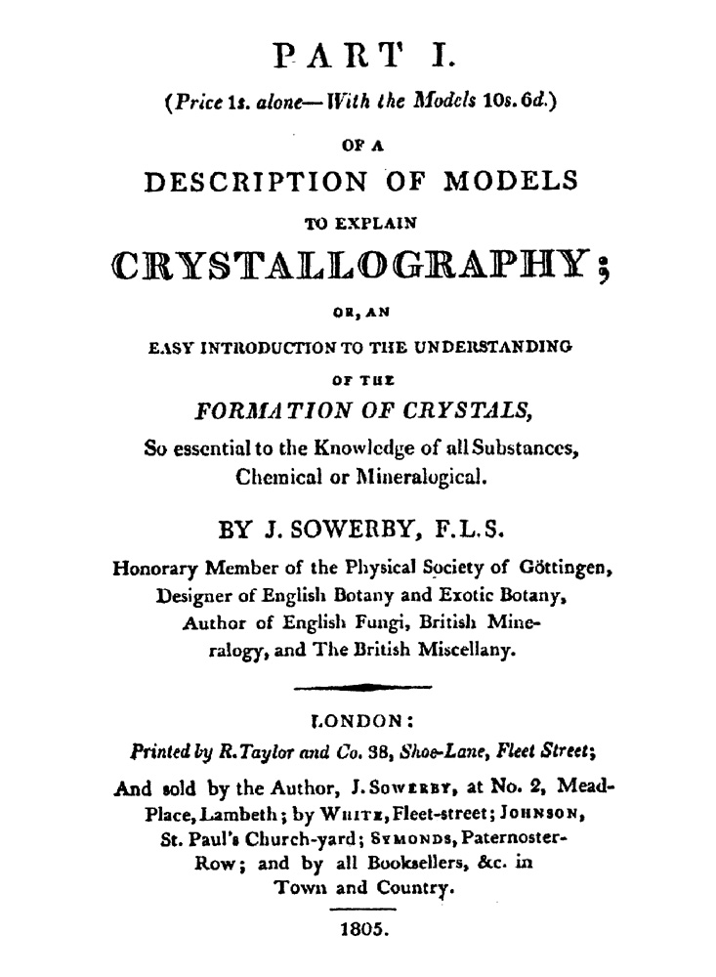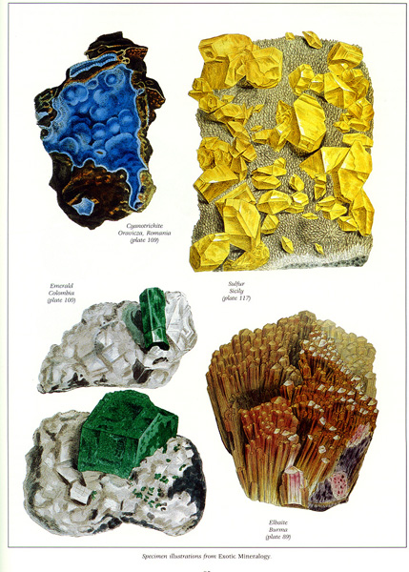

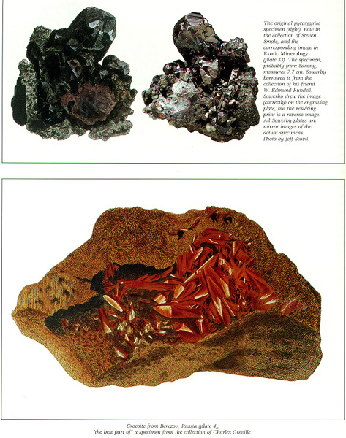

3 Color Plates www.lhconklin.com

Description of Models, 1805
3. English, 1805 [Part I].
Part I. | (Price 1s. alone-With the Models 10s. 6d.) | Of A | Description Of Models | To Explain | Crystallography; | Or, An | Easy Introduction To The Understanding | Of The | Formation Of Crystals, | So essential to the Knowledge of all Substances, | Chemical or Mineralogical. | By James Sowerby, F.L.S. | [...4 lines of titles and memberships...] | [tapered rule] | London: | Printed by R. Taylor and Co. 38, Shoe-Lane, Fleet Street; | And sold by the Author, J. Sowerby, at No. 2 Mead-|Place, Lambeth; by White, Fleet-street; Johnson, | St. Paul's Church-yard; Symonds, Paternoster-|Row; and by all Booksellers, &c. in | Town and Country. | [short rule] | 1805.
8°: [1]-16 p., one plate. Issued in a blue-grey wrapper with the following text on the cover: "Part | 1 | of | Crystallography | By | James Sowerby | FLS. &c. | 1805 | 2. Mead Place Lambeth."
Contents: [1-2], Title page, verso blank; [3]-7, "A Description of Models to Explain Crystallography."; [8], Blank; [9], "Part I. Newcastle Coal."; 10-16, "Decription of the Models, &c."; [At end], One plate-dated May 24, 1805.
Very scarce. No more published. This pamplet and the ebony crystal models to which it refers, were intended to supplement British Mineralogy (5 vols., London, 1804-17), to help those subscribers to better comprehend the science of crystallography. However, only the first part of the publication appeared, owing to insufficent interest. Worth noting is the odd subject choice for the first installment of "Newcastle Coal," a substance that does not crystallize.
Bibliographical references: BL.
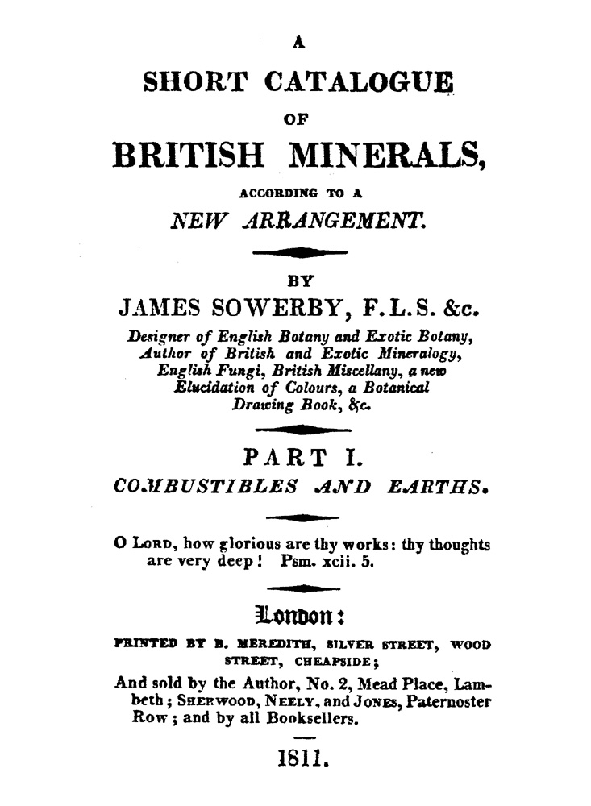
Short Catalogue, 1811
4. English, 1811.
A | Short Catalogue | Of | British Minerals, | According To A | New Arrangement. | [tapered rule] | By | James Sowerby, F.L.S. &c. | [...5 lines of titles and memberships...] | [tapered rule] | Part I. | Combustibles And Earths. | [tapered rule] | [...2 lines of quotation...] | [tapered rule] | London: | Printed By B. Meredith, Silver Street, Wood | Street Cheapside; | And sold by the Author, No. 2, Mead Place, Lam- | beth; Sherwood, Neely, and Jones, Paternoster | Row; and by all Booksellers. | [rule] | 1811.
12°: xvi, 72, [ii] p.
Very rare. No more published. The front wrapper reads: "Catalogue of British minerals, chiefly in the Collection of James Sowerby." Whereas the illustrated British Mineralogy (London, 1804-17) had no systematic arrangement, this apparently was Sowerby's attempt to apply a classification system to British minerals. However, there apparently was little interest in the work, and the author produced no more parts.
Bibliographical references: BL. • Ward & Carozzi, Geology Emerging, 1984: no. 2091.
5. English, 1819.
A | List | of | Minerals, | with | Latin and English Names, | and | Numerous Synonyms; | Arranged According To | A System | Founded Upon The | Specific Gravities of their Component Parts; | with | Reference | to | British and Exotic Mineralogy. | [double rule] | Printed In A Form Fitted For Labels As Used In | Mr. Sowerby's Museum. | [double rule] | London: | Printed by W. Arding, 21, Old Beswell Court, Carey Street; | And sold by the Author, J. Sowerby, No. 2, Mead Place, Lambeth; | Longman and Co. and Sherwoood and Co. Paternoster Row; | and by all Booksellers in Town and Country. | [wavy rule] | 1819.
8°: [i]-iv, [1]-22 p. Page size: 235 x 142 mm.
Contents: [i-ii], Title page, verso blank.; [iii]-iv, "Preface."-signed James Sowerby, July 1819.; [1]-22, "A | Catalogue Of Minerals."
Extremely rare. The plates in both the British and Exotic Mineralogies were not issued in any systematic order. As a remedy, A Catalogue of British Minerals was published in 1819 as a kind of appendix, to be used in making out labels for specimens in mineral collections. For each species listed, a reference is given to its plate in either the British or Exotic Mineralogies.
Bibliographical references: BL [728.e.21.]. • Smith, Early Mineralogy in Great Britain, 1978: 60.

