Augustus Choate Hamlin 1829-1905
http://artisfungallery.com/hamlin.html
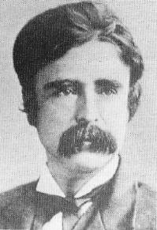

AUGUSTUS CHOATE HAMLIN (1829-1905), American
(painter, author, illustrator)
Augustus Choate Hamlin (1829-1905) was born in Columbia, Maine on August 28, 1829. He graduated from Bowdoin College in 1851 and from Harvard Medical School in 1857. After studying in Europe for two years, he returned to Bangor to practice medicine. In April, 1861, he entered the Civil War as assistant surgeon of the Second Maine Brigade, was promoted in 1862 to brigade surgeon, and in 1863 became a medical inspector. He served in the army during the entire war He was entrusted with important commands in the Army of the Potomac, as Medical Director, and in the Army of Western Virginia. He was afterward promoted to one of the highest positions, that of Medical Inspector, in the staff of the regular army; and served with distinction in the Army of the South during the famous siege of Fort Wagner, and was afterwards assigned to the armies of the Southwest under the command of Major General [Henry] Thomas. Dr. Hamlin is a man of high scientific attainments, and is a member of numerous scientific societies, both at home and abroad. - N. Y. Medical Record." (May 15, 1883, Oxford Democrat).
Later in Bangor, Dr. Hamlin served as the Surgeon-General of Maine from 1882 to 1886, on the staff of Gov. Robie, and is known as one of the most distinguished medical officers in New England history. He served also as Mayor of Bangor from 1879 to 1880. In addition he was an ardent salmon fisherman, and a lover of gem minerals. He purchased the Mount Mica farm in Oxford County, Maine in order to mine the pegmatite there, and assembled the finest collection of its specimens known in the 1880's.
Hamlin was also an accomplished artist. He exhibited a painting titled "Mount Katahdin" at the prestigious National Academy of Design in New York City in 1859.
He made small watercolor paintings of many of his tourmaline crystals, and published them in two books about Maine tourmaline: The Tourmaline (1873) and The History of Mount Mica (1895), was the author of "History of Andersonville "(Boston, 1866), and "Leisure Horn's Among the Gems" (1884)..
The originals of most of these paintings are preserved in the Harvard Mineralogical Museum. The is also a small chromolithograph of his painting of a Ceylon sapphire crystal from his collection in a third book of his: Leisure Hours Among the Gems (1891). He also contributed articles on "Alimentation," "Transfusion," "Transmission of Diseases," "Tetanus," and other subjects to the medical journals.
Augustus Choate Hamlin died in Bangor, Maine November 18, 1905 and is buried at Mt. Hope Cemetery in Bangor, Maine.
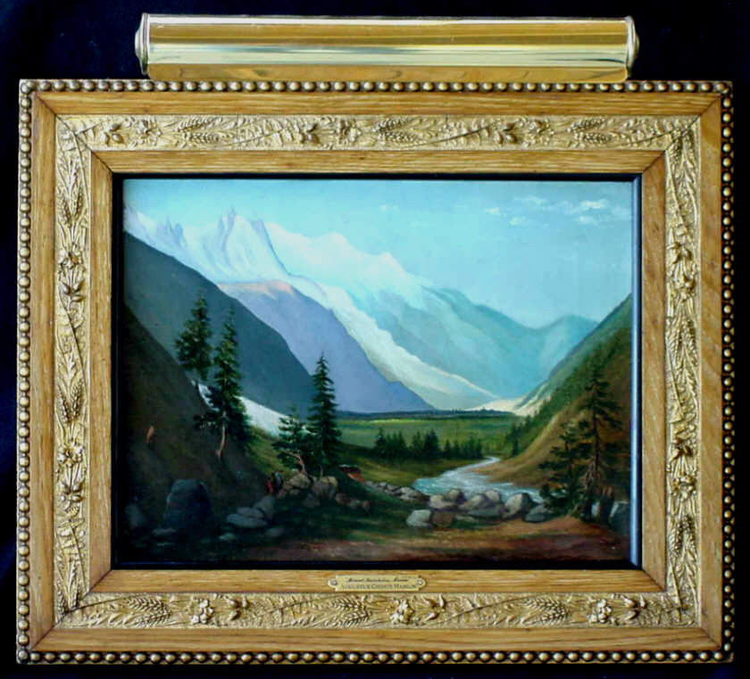
AUGUSTUS CHOATE HAMLIN (1829-1905), American
oil on canvas - image: 12" x 16" - framed: 18" x 22"
Notes: Dr. Augustus C. Hamlin was a key figure in the historical Maine of the 1800s (see biography below). This wonderful painting has a stencil on the back of the canvas that dates this work between 1846-1857. The frame is original and perhaps one of the finest examples of a mid-1800s period Maine frame as you will ever find. It is constructed using tiger oak with inlaided ornate gesso bands. It is signed indistictly (lower right corner), and signed/inscribed on the back of the stretcher 'A. C. Hamlin, Bangor'. It was once owned by the Bangor & Portland Railroad and may have been a commissioned work that was done as a promotional painting. During this period Railroads often enlisted the help of artists to paint romantic scenes of the countryside through which the trains passed. This particular painting depicts the Mount Katahdin basin with several indians on horseback (lower left side). Hamlin exhibited a painting titled "Mount Katahdin" at the prestigious National Academy of Design in New York City in 1859 and this very well be that piece.

===================================================================================================================================
http://politicalgraveyard.com/families/13078.html
Hamlin family of Maine
- Elijah L. Hamlin (c.1799-1872) — of Bangor, Penobscot County, Maine. Brother of Hannibal Hamlin; father of Augustus Choate Hamlin. Candidate for Governor of Maine, 1848, 1849; mayor of Bangor, Maine, 1851-52. Died in Bangor, Penobscot County, Maine, July 16, 1872. Interment at Mt. Hope Cemetery, Bangor, Maine.
- Stephen Emery — of Paris, Oxford County, Maine. Grandfather of Hannibal Emery Hamlin. Maine state attorney general, 1839-40. Burial location unknown.
- Hannibal Hamlin (1809-1891) — of Hampden, Penobscot County, Maine; Bangor, Penobscot County, Maine. Born in Paris, Oxford County, Maine, August 27, 1809. Brother of Elijah L. Hamlin; father of Hannibal Emery Hamlin. Republican. Member of Maine state house of representatives, 1836-40, 1847; Speaker of the Maine State House of Representatives, 1837, 1839-40; U.S. Representative from Maine 6th District, 1843-47; U.S. Senator from Maine, 1848-57, 1857-61, 1869-81; Governor of Maine, 1857; Vice President of the United States, 1861-65; candidate for Republican nomination for Vice President, 1864, 1868; U.S. Minister to Spain, 1881-82. Died in Bangor, Penobscot County, Maine, July 4, 1891. Interment at Mt. Hope Cemetery, Bangor, Maine. Hamlin County, S.Dak. is named for him.
  - Portrait: c.1855.
  - See also: congressional biography; National Governors Association biography; Wikipedia article; NNDB dossier.
  - Books about Hannibal Hamlin: Charles Eugene Hamlin, The Life and Times of Hannibal Hamlin (out of print); Mark Scroggins, Hannibal

- Augustus Choate Hamlin (1829-1905) — also known as A. C. Hamlin — of Bangor, Penobscot County, Maine. Born in Columbia, Washington County, Maine, 1829. Son of Elijah L. Hamlin. Republican. Mayor of Bangor, Maine, 1877-78. Died in Bangor, Penobscot County, Maine, November 18, 1905. Interment at Mt. Hope Cemetery, Bangor, Maine.
- Hannibal Emery Hamlin (1858-1938) — also known as Hannibal E. Hamlin — of Ellsworth, Hancock County, Maine. Born in Hampden, Penobscot County, Maine, August 22, 1858. Grandson of Stephen Emery; son of Hannibal Hamlin and Ellen V. (Emery) Hamlin. Republican. Lawyer; member of Maine state house of representatives, 1893-95; member of Maine state senate, 1899-1901; Maine state attorney general, 1905-08; delegate to Republican National Convention from Maine, 1924. Member, American Bar Association. Died in Bangor, Penobscot County, Maine, March 6, 1938. Interment at Mt. Hope Cemetery, Bangor, Maine.
======================================================================================================================================
http://www.joslinhall.com/Catalog_317.htm

43. Hamlin, Augustus Choate. The History of Mount Mica of Maine, U.S.A. and Its Wonderful Deposits of Matchless Tourmalines. Bangor; Augustus Choate Hamlin: 1895. This book is most notable for its 43 colored plates of tourmalines, but the text also contains much useful information about the discovery and exploration of Mount Mica by Hamlin's father, the visits of eminent scientists, the gemstones excavated there, a description of the excavations, and the growth of the mining company. One of the most famous 19th century books on American minerals, Sinkankas (Gemology: An Annotated Bibliography) noted that it was 'virtually unique in that it combines careful, concurrent reporting of day-to-day mining of an important gemstone deposit and descriptions of the finds during the period when Hamlin was in charge". Augustus Choate Hamlin [1829-1905] was an Army doctor during the Civil War and in his later years wrote several books on tourmalines and gems based on his work directing the famous quarries at Mount Mica. The illustrations are reproductions of his own watercolors. Hardcover. 6"x9", 72 pages of text plus 4 b/w plates (one folding), 43 color plates of crystals, 6 line diagrams of crystals and 2 plates of diagrams of the diggings. Top corner bumped, hinges ever so slightly shaken, but otherwise very clean and nice. [32762] $850.00
================================================================================================================================================
Mineralogy and Crystallography, An Annotated Biobibliography, 1469 until 1919 - Curtis P. Schuh 2007 A.O
HAMLIN, Augustus Choate. (Born: 28 August 1828;
Died: 1905) American physician & businessman.
Hamlin – also known as A. C. Hamlin – of Bangor,
Penobscot County, Maine. Son of Elijah L. Hamlin.
Born in Columbia, Washington County, Maine, 1829.
Republican. Mayor of Bangor, Maine, 1877-78. Died in
Bangor, Penobscot County, Maine, November 18, 1905.
Interment at Mt. Hope Cemetery, Bangor, Maine.
”Dr. A. C. Hamlin. - Dr. Augustus C. Hamlin, of
Bangor, Surgeon-General of Maine, on the staff of Gov.
Robie, is one of the most distinguished medical officers in
New England. He served in the army during the entire war.
He was entrusted with important commands in the Army
of the Potomac, as Medical Director, and in the Army of
Western Virginia. He was afterward promoted to one of the
highest positions, that of Medical Inspector, in the staff of
the regular army; and served with distinction in the Army
of the South during the famous siege of Fort Wagner, and
was afterwards assigned to the armies of the Southwest
under the command of Major General [Henry] Thomas.
Dr. Hamlin is a man of high scientific attainments, and
is a member of numerous scientific societies, both at home
and abroad. - N. Y. Medical Record.”
References: ABA: I 687, 14-21, 77-81. • Adams,
Dictionary of American Authors, 1904. • Andrews, Hamlin
Family, 1902. • Appleton Cyclopedia of American Biography.
• Herringshaw’s National Library of American Biography. •
WBI. • Who Was Who in America.
2087. English, 1873.
The Tourmaline. Its Relation As A Gem; Its
Complex Nature; Its Wonder- ful Physical
Properties, Etc., Etc.; With Special Reference To
The Beautiful And Match- less Crystals Found
In The State Of Maine. By A.C. Hamlin,
M.D. [...2 lines of titles and memberships...] With
Illustrations. [ornament] Boston: James R.
Osgood And Company, (Late Ticknor & Fields,
And Fields, Osgood, & Co.) 1873.
8_: 107 p., 4 chromo-lithographic plates.

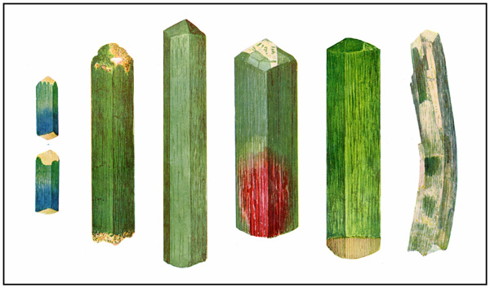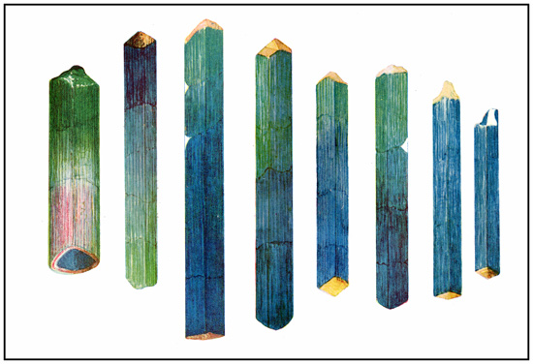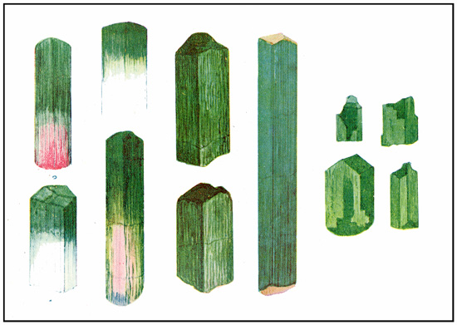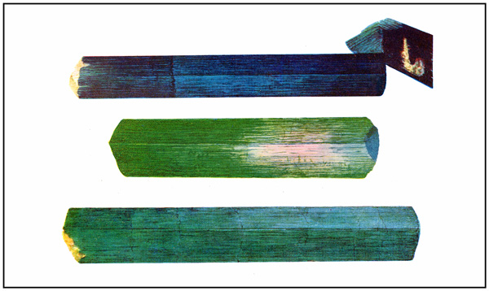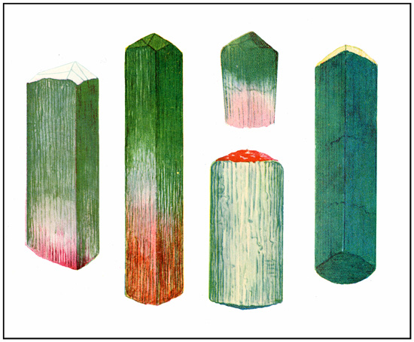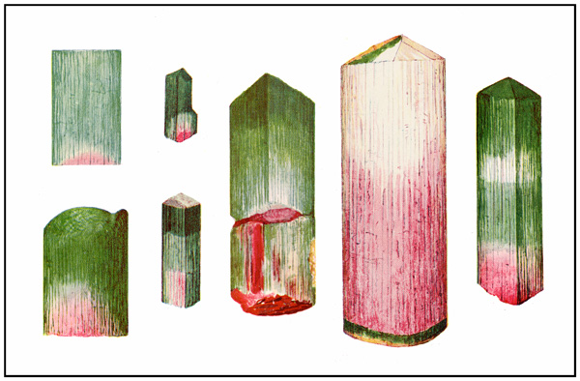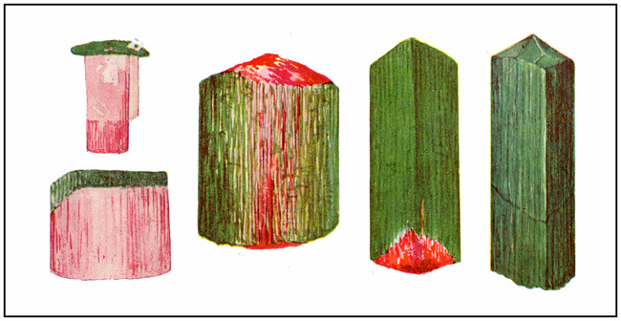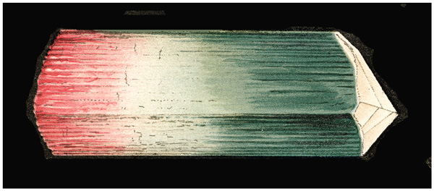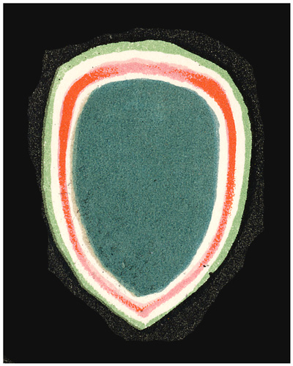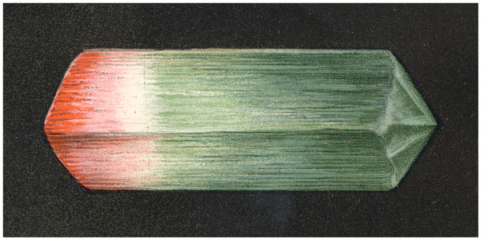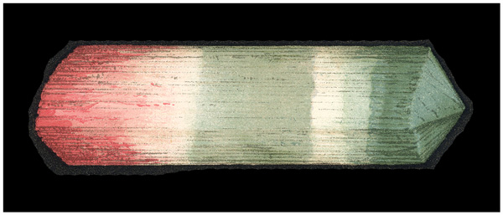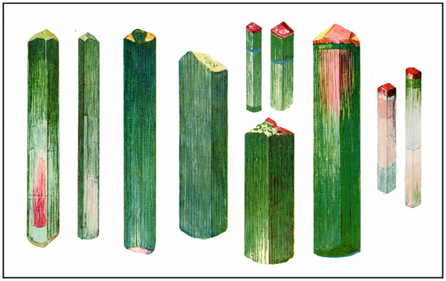

The Tourmaline, 1873
Very scarce. Chapter I. History of Tourmaline
– Its Discovery, and the Derivation of its name (pp.
13-22). Chapter II. Localities and Peculiarities of
Deposition and Distribution (pp. 25-35). Chapter III.
Description of Mt. Mica and Its Mineral Treasures
(pp. 36-74). Chapter IV. The Physical Wonders of
the Tourmaline – Its Electrical Properties – Its Optical
Phenomena – Its Play of Color, Compared with other
Gems (pp. 75-101). Origin of Precious Stones (pp.
102-107). The four plates figuring specimens of Maine
tourmaline are excellent productions.
References: Freilich Sale Catalog: no. 223. • McGrath,
D.F., American Colorplate Books, 1800-1900. A dissertation
submitted to the University of Michigan, 1966: p. 134. • NUC.
• Sinkankas, Gemology Bibliography, 1993: no. 2694.

2088. English, 1891 [Second edition].

LEISURE HOURS AMONG
THE GEMS
BY
AUGUSTUS C. HAMLIN
AUTHOR OF A TREATISE ON THE TOURMALINE
FELLOW OF THE AMERICAN ASSOCIATION FOR THE ADVANCEMENT OF SCIENCB
MEMBER OF THE ROYAL SOCIETY OF ANTIQUARIES OF NORTHERN EUROPE
CHEVALIER OF ST. ANNE, ETC.

" Now in matter of the knowledge of the works of nature, I would have
thee give thyself curiously ; so that there be no sea, river, nor fountain of
which thou dost not know the fishes ; all the fowls of the air ; all the metals
that are hid within the bowels of the earth ; together with the precious stones
that are to be seen in the east and south of the world. Let nothing of all
these be unknown to thee." — Rabelais.
BOSTON AND NEW YORK
HOUGHTON, MIFFLIN AND COMPANY
1891

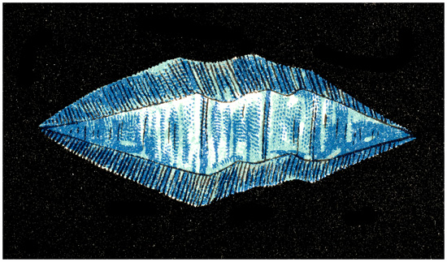

Leisure Hours Among The Gems By Augustus
C. Hamlin [...4 lines of titles and memberships...]
[...6 lines of quotation, signed Rabelais...] Boston
And New York Houghton, Mifflin And Company
The University Press, Cambridge 1891.
12_: extra blank flyleaf supplied + [10], [13]-
439 p., 2 chormolithographic plates.
Very scarce. A leisure tour of information
about various gemstones including the diamond, the
emerald, the opal and the sapphire. Written in Hamlin’s
easy style myths, lore and scientific data associated
with the stones is provided in the text about, and
it is clear that Hamlin was acquainted with early gemological books as they are cited within the text. The
two chromolithographic plates are crude, especially in
comparison with the author’s other two works. They
depict the Russian Imperial Crown of Empress and a
doubly terminated blue sapphire from Ceylon that was
held in the author’s collection. According to Sinkankas
(1993) the chapter on the emerald was reprinted in
Mineral Digest Magazine, New York, 3, (Summer 1973),
pp. 17-32, 7 color figs.
References: NUC: ??, ??. • Sinkankas, Gemology
Bibliography, 1993: no. 2696. 2089. English, 1895.
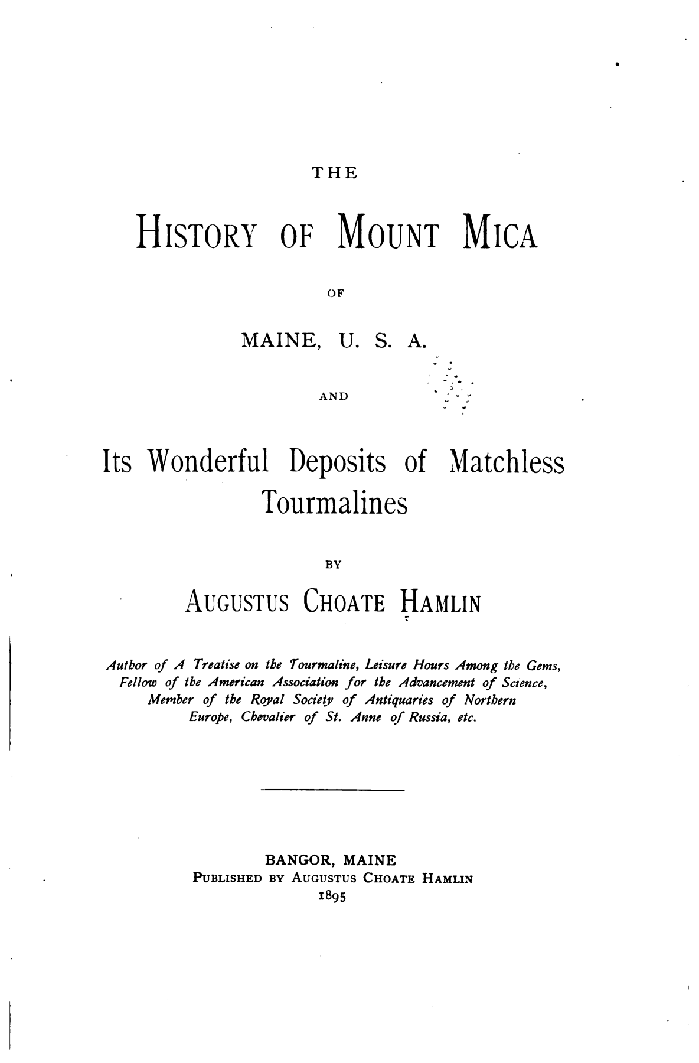

The History of Mount Mica Of Maine, U.S.A.
And Its Wonderful Deposits of Matchless
Tourmalines By Augustus Choate Hamlin
[...4 lines of titles and memberships...] [rule] Bangor,
Maine Published by Augustus Choate Hamlin
1895.
8_: [2], 72 p., 51 plates (43 chromo-lithographies),
4 illus.
Very scarce. This privately published volume
chronicles the history of an important, early American
gemstone locality. Beginning with a chapter on the
discovery of Mount Mica, the book continues with
stories of other explorations, a description of the
deposit, and diagrams showing where the major pockets
were found. Of particular interest are the finely
executed plates, showing various tourmaline crystals collected over the years. These plates are among the
best chromo-lithographes of minerals ever produced in
the United States.
References: Freilich Sale Catalog: no. 224. • NUC. •
Sinkankas, Gemology Bibliography, 1993: no. ??.
=================================================================================================================================

