Joel E Arem PhD and , in 1976, became the first American ever to
win the Tully Medal, the "Nobel Prize" of gemology, 1943-
Joel Arem PO Box 5056 Laytonsville MD 20882
joelarem@gmail.com
www.joelarem.com
https://www.joelarem.com/about-1

Dr. Joel E. Arem has more than 60 years of experience in the world of gems and minerals. After obtaining his Ph.D. in Mineralogy from Harvard University, he has published numerous books that are still among the most widely used references and guidebooks on crystals, gems and minerals in the world.
Co-founder and President of numerous organizations, Dr. Arem has enjoyed a lifelong career in mineralogy and gemology. He has been a Smithsonian scientist and Curator, a consultant to many well-known companies and institutions, and a prolific author and speaker. Although his main activities have been as a gem cutter and dealer, his focus has always been education.

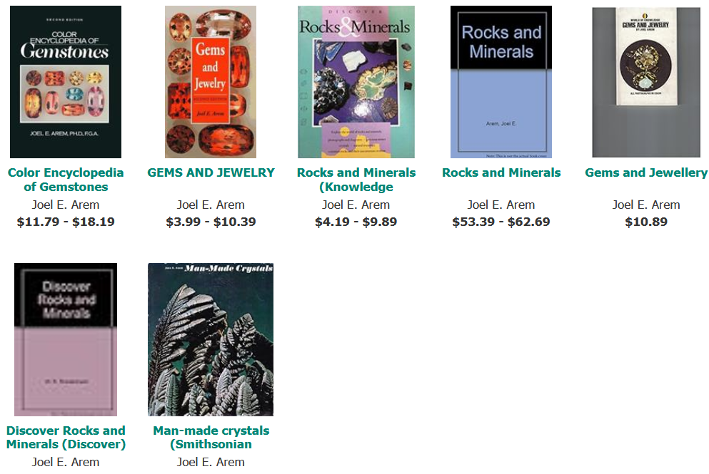

BOOKS
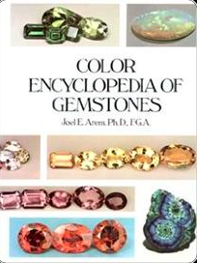

COLOR ENCYLOPEDIA OF GEMSTONES, 1ST ED.
ISBN: 0442203330
Although the literature on gemstones dates back thousands of years, no-one had ever produced a comprehensive, fully-color illustrated summary of all known gemstone species and color varieties, with relevant data on physical properties, record stone sizes and name origins. This became Arem's fourth and most ambitious book project. From 1974-76 Arem researched the entire literature on gemstones and made three trips across the U.S. with portable studio equipment to capture on film examples of extremely rare gemstones in private collections. Arem perfected several new and revolutionary gem photography methods, culminating in more than 300 new photos.In 1977, after Arem’s full-time three-year effort, Van Nostrand-Reinhold published the COLOR ENCYCLOPEDIA OF GEMSTONES. This highly acclaimed book quickly became a cornerstone work in the gemstone field.
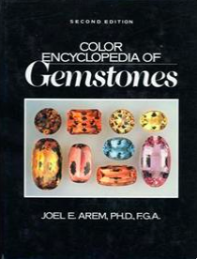

COLOR ENCYLOPEDIA OF GEMSTONES, 2ND ED.
ISBN: 9780442208332
In 1987, after a second massive (2-year) full time commitment, Arem published the second edition of the COLOR ENCYCLOPEDIA. The new book had far better color reproduction than the first and more than 200 completely new photos. In addition, the text was 100 pages larger and included chapters on synthetic gemstones and thermal measurements. The second edition also contains the first comprehensive tabulation in the gemological literature of precise, machine generated measurements of the color of nearly all gemstone species and varieties. As the only full-color gemstone encyclopedia ever published, the Color Encyclopedia of Gemstones (2nd ed.) has often been called the most-used reference book in its field.
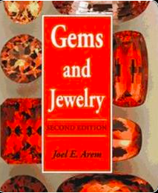

GEMS AND JEWELRY: ALL COLOR GUIDE (2ND ED.)
ISBN: 0945005091
The first edition of this book appeared in 1975 and was part of a huge series of Bantam paperbacks on natural history subjects. Over a period of several years it sold more than 1 million copies, and was printed in 4 languages. The 2nd ed. quickly became a basic textbook in many gemstone education courses around the world. In 1999 Amazon awarded this book as “Category Best Seller” in its Crafts & Hobbies: Lapidary section. A third edition, totally revised and greatly expanded, is currently in preparation. It is planned as an e-book for publication in 2014. Several chapters from this new work can be found on this website.
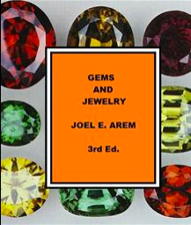

GEMS AND JEWELRY (3RD ED.) - TO BE PUBLISHED AS E-BOOK - FORTHCOMING
Significant changes in the gemstone market have prompted Joel Arem to create a 3rd edition of "Gems and Jewelry", and he began this work in 2011. The 3rd edition is planned as an e-book that will be available on this website in 2014. Excerpts are viewable now by clicking on the buttons on this page. Arem especially wanted to make immediately available the most ambitious chapter in the new book, dealing with synthetic and treated gemstones, because there is so much confusion about these subjects in the current marketplace. The Federal Trade Commission (FTC) is planning a large-scale revision of its guidelines for gemstone-related terminology, changes that will affect the gem trade for years to come. It is Arem's view that public education, and a true understanding of the technical issues involved, is more important than any set of regulations having to do with labeling. Please click on the link provided below to view this chapter in its entirety.
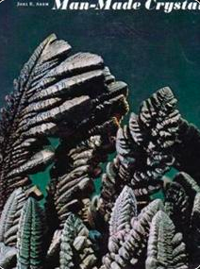
Buy the book HERE
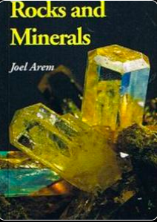

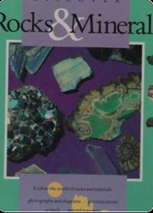
MAN MADE CRYSTALS
ISBN: 0874741416
In 1972, Dr. Arem founded and curated the National Synthetic Collection at the Smithsonian Institution in Washington, DC. In 1973 he wrote and produced a major exhibition of synthetic crystals that was displayed in the lobby of the Smithsonian’s Natural History Museum. The Smithsonian Press asked Arem if he would write a book for them on the subject, and it appeared in 1973 in conjunction with the exhibit. This book was (and remains) the first and only fully illustrated popular book on the subject of man-made crystals and gems.

ROCKS AND MINERALS
ISBN: 0945005067
Like Gems and Jewelry, this book originally appeared (in 1974) as a Bantam paperback in its “Knowledge Through Color” nature series, and was an instant best-seller with 200,000 copies distributed in its first printing. One of the first-ever pocket guides to minerals fully illustrated with color photos, Rocks and Minerals became the first-choice for young collectors worldwide and was printed in 4 languages. The English-language version was reprinted by Geoscience Press in 1991 and remains a classic introduction to its subject.

DISCOVER ROCKS AND MINERALS
ISBN: 1561734616
Publications International, a major distributor of popular books, asked Arem if he would write childrens’ book on Rocks and Minerals for their “Discover” series, and it was published in 1991. Only about 1/3 of the manuscript was actually used in creating this book, which has long been out of print. Arem is currently working on an e-book for young readers, using the entire (fully revised) original text and hundreds of new photos.

JOEL E. AREM, Ph.D, F.G.A BIOGRAPHY
https://static1.squarespace.com/static/5a45138512abd98855424f43/t/5b3c545a562fa782f9d01fd6/1530680410935/Joel+Arem+Biography++.pdf

Dr. Joel E. Arem has been involved with minerals and gemstones for 60 years. Born
and raised in Brooklyn, New York, he first became interested in minerals in grade school. A
long-standing commitment to a scientific career matured through High School and led to a
major, first in chemistry, and then in geology, at Brooklyn College. Arem graduated Magna
Cum Laude, elected to Phi Beta Kappa and Sigma Xi, and with Honors in Geology, and also
the highest graduating average in the history of the BC Geology Dept. During this time period
he was a part-time instructor and Director of the Geology program at the famous Brooklyn
Children's Museum. He also became interested in the art of gemstone cutting, started
collecting faceted gemstones and became active in gem cutting (lapidary). In the early 1960s
Arem served as Secretary of the New York Lapidary and Gem Society, and started to become
acquainted with museums and curators around the country. Academic success resulted in
admission to the Harvard University Graduate School of Arts and Sciences in the Fall of 1964.
Graduate work included a wide diversity of courses. A series of circumstances and changing
interests led Arem to take many more courses than are required in a normal PhD program. A
Masters degree (Geology) was awarded to him in 1967 and a PhD (Mineralogy) in 1970.
During his six years at Harvard Arem was the recipient of a Harvard University Scholarship
and a National Science Foundation Fellowship. He was a Teaching Fellow in the Geology
Department, giving instruction in such diverse fields as crystallography, mineralogy and
economic geology. Arem also served as a Research Assistant in the Department, and worked
part time for one of the professors doing gemstone identification for local jewelers.
The research Arem conducted at Harvard resulted in numerous publications in major
scientific journals. These, plus his reputation in the mineral collecting world, led to his selection
to fill the newly-created position of staff Crystallographer at the Smithsonian Institution in
Washington, D.C. During this three-year term appointment Arem founded and curated the
National Synthetics Collection, the world's first systematic collection of man-made crystalline
materials. He also wrote and produced a major display of these materials that was exhibited in
the lobby of the National Museum of Natural History during the summer of 1973, a display that
received national press coverage.
While at the Smithsonian, Arem lectured extensively and also taught mineralogy for
the Smithsonian Docent Program. He became a consultant to the Eastman Kodak Company,
in the field of mineral photography, and developed unique photographic techniques for
minerals and gemstones. Some of his photos were published by Kodak in the 9th "Here's
How" book of photographic methods. Arem also acted as a consultant to National Geographic
Society and provided photographs and teaching materials for their use. He was also the
primary photo source for the fledgling publication, "The Mineralogical Record".
In 1971 Arem was contacted by the well-known mineralogist and collector Arthur
Montgomery and asked if he would help to create a new mineral conservancy organization to
be called "Friends of Mineralogy". The three founders, Montgomery, Arem and Carl Francis
(later to become curator at the Harvard Museum) then invited a well-known mineralogist,
Richard Bideaux, to join the group. The regional structure of FM was drawn up by Arem and
Bideaux in John White, Jr.'s home in Bowie, Maryland. Arem served as an officer and Director
of FM for several of its formative years, created its first Logo, and arranged field trips that
allowed for the recovery of many unique and important mineral specimens. Friends of
Mineralogy is still very active and has become a major voice in mineral conservation efforts.
From 1971-73 Arem also served as Secretary of the Mineral Museums Advisory Council, the
first international organization of mineral museum curators.
In 1972 Arem was given the opportunity to write a book on minerals, part of a large
series of all-color books on natural history subjects called “Knowledge Through Color”. These
books were published by Bantam Books and featured color photos, and were specifically
designed to replace the well-known series of “Golden Guides” (with color illustrations) that had
long been a staple learning base for young readers. Arem created the paperback ROCKS
AND MINERALS and shared the responsibility for all the color photos with famous
photographer Lee Boltin. Then in 1973 Arem produced a book at the request of the
Smithsonian Institution Press, to appear in conjunction with his major exhibit of synthetics in
the National Museum of Natural History. This book, MAN-MADE CRYSTALS, was the first
color-illustrated popular book ever published dealing with the subject of synthetic crystals and
associated technologies. The book remained in print until 1988.
Arem left the Smithsonian at the end of his three-year term in order to pursue business
interests and gain experience in other fields. He had already begun to plan a career involving
the marketing of minerals and gemstones. However, he became temporarily sidetracked by
the challenge of a unique assignment. For a brief 7-month period (1973-74) Arem was
employed at the Atomic Energy Commission. The combination of a good physics background
and recognized writing skills made Arem ideal as a technical writer for the Rasmussen Report,
the largest and most comprehensive study of nuclear reactor safety undertaken to that time.
When funding for the writing staff was withdrawn in 1974 Arem made a full commitment to
gemstone marketing. In March he started his first corporation, Multifacet, Inc. and began
traveling across the country lecturing, meeting clients and displaying fine gemstones. The gem
collection he started in 1962 now became part of an initial sales portfolio. Contacts made in
the New York Lapidary and Gem Society, and later at Harvard and the Smithsonian, now
became useful in a business context. By 1974 Arem was already well known in the lapidary
and gem field. His existing publications were augmented by articles in such prestigious
publications as the Saturday Review of Science, Science Digest and the Smithsonian
Magazine.
The 1972 Bantam book, ROCKS AND MINERALS, was doing extremely well. Arem
felt a companion volume, on gemstones, would have a much wider audience. His proposal to
Bantam was accepted, and another book in the "Knowledge Through Color" series, GEMS
AND JEWELRY, was published in 1975. This landmark book was the first all-color, popular
introduction to the world of gemstones ever published. It was an immediate "best seller" with
more than 200,000 copies created in its first 3 printings. And with well over a million copies in
print in 4 languages it has become the all-time best selling popular introduction to gemstones
in the world.
Despite his gemstone marketing commitments Arem remained scientifically active. In
the period 1975-77 he became a consultant to the U.S. Department of Commerce, the
Encyclopedia Britannica Educational Corporation and the Jeweler's Circular-Keystone
magazine.
Arem had noted that although the literature on gemstones dates back thousands of
years no-one had ever produced a comprehensive, fully-color illustrated summary of all known
gemstone species and color varieties, with relevant data on physical properties, record stone
sizes and name origins. This became Arem's fourth and most ambitious book project. From
1974-76 Arem researched the entire literature on gemstones and made three trips across the
U.S. with portable studio equipment to capture on film examples of extremely rare gemstones
in private collections. This project fully utilized all of Arem's academic training, knowledge of
gemstone properties and localities, examples in museums and private collections and a
general ability to sort massive amounts of raw data into a readable format. But the book also
required extremely accurate color reproduction. Arem therefore perfected several new and
revolutionary gem photography methods. The Encyclopedia ultimately required more than 300
new photos, some of them extremely challenging.
In 1977, after Arem’s full-time three-year effort, Van Nostrand-Reinhold published the
COLOR ENCYCLOPEDIA OF GEMSTONES. This highly acclaimed book quickly became a
cornerstone work in the gemstone field. In 1987, after a second massive (2-year) full time
commitment, Arem published the second edition of the ENCYCLOPEDIA. The new book had
far better color reproduction than the first and more than 200 completely new photos. In
addition, the text was 100 pages larger and included chapters on synthetic gemstones and
thermal measurements. The second edition also contains the first comprehensive tabulation in
the gemological literature of precise, machine-generated measurements of the color of nearly
all gemstone species and varieties. The COLOR ENCYCLOPEDIA OF GEMSTONES is still
generally regarded as the most authoritative and comprehensive book of gemstone data in
existence, and is widely used as a reference text within the jewelry trade. It is also one of the
most frequently quoted books in the gemstone literature.
Arem decided in 1976 that if he required formal credentials in the field of gemology the
Gemmological Association of Great Britain would provide the most prestigious accreditation.
The procedure required 3 full days of examinations. The first was the Preliminary exam,
passing of which is a prerequisite for the 2-day Diploma examination. These examinations are
given every year in June, and simultaneously administered in as many as 40 countries. Those
who successfully complete the Diploma exam are granted the title of Fellow of the
Gemmological Association (FGA). Of more than 400 people (worldwide) taking the Diploma
exam in 1976 only 116 passed; of these, 4 received a grade of "A" and passed "with
distinction". Arem's paper was one of these. Moreover, if a Diploma examination paper is also
of sufficiently high caliber the examiners may, at their discretion, award a prize created by the
widow of Bond Street jeweler B.J. Tully in 1922. This prize is not awarded if the examiners feel
no paper of sufficient worth was turned in. Arem, in 1976, became the first American ever to
win the Tully Medal, the "Nobel Prize" of gemology. To this date he remains one of only two
Americans so honored, and one of only about 50 that have ever been awarded the Medal.
In 1975 some local Washington DC gemologists had organized a study group for
graduates of the British gemology course, under the guidance of well-known DC gemologist
Anthony Bonanno. Arem suggested that the group expand its horizons to include international
membership and also admit GIA graduates. This new entity, created by Arem and named by
him as the ‘Accredited Gemologists Association’, was the first organization of professionally
accredited gemologists in the world. Arem served as President of the AGA during its first three
years. He also produced and edited the AGA Newsletter. During his term membership rose
nearly 500%, and Arem's office became internationally recognized as a clearinghouse for
gemological information. Although his excellent teaching had inspired the students who
formed the initial study group, Bonanno strongly opposed its transformation into the AGA, and
during its first 3 years he refused to come to a single meeting. Eventually, however, he saw
the potential value of the organization, and agreed to become its second President. The AGA
is still extremely active and well known today, and is a significant force in assuring that gem
and jewelry appraisals are done by professional people with adequate skills.
In 1979 Arem organized and ran the first International Conference on Gemstone
Investments in Washington, D.C. He later became an organizer of and adviser to subsequent
conferences in Los Angeles and New York. From 1978 to 1980 Arem Co-Founded and served
on the editorial board of the PreciousStones Newsletter. He wrote numerous articles for the
PSN dealing with a wide range of gemological subjects. In 1982 Arem was invited to be the
Keynote Speaker at the First International Colored Gemstone Conference in Colombo, Sri
Lanka. During this time period he was also active as Chairman of Turamali, Inc., a leading
gemstone marketing firm. In 1985 Arem designed a massive pendant consisting of baroque
pearls, rubies, sapphires, emeralds and diamonds. He submitted the piece to the American
Gem Trade Association Spectrum Award competition for jewelry design. In 1985 it won
second place in the ‘top-value’ category, firmly establishing Arem as a jewelry designer of
international caliber.
A long-planned fifth book, a childrens' book on minerals and rocks (DISCOVERING
ROCKS AND MINERALS) was published in 1991. Also in 1991 came a much improved
reprint of the 1973 work ROCKS AND MINERALS, which had gone out of print in 1989. In
1992 Arem published a fully-revised, expanded, and updated second edition of GEMS AND
JEWELRY. The new books all received excellent reviews. The market for colored gemstones
"came of age" in the 1980s, and there is little doubt that Arem's paperback, first appearing on
the scene in 1975, had significantly enhanced the education of students and consumers about
the world of colored gemstones, and provided thousands of people with their first non-
technical view of this fascinating subject. This educational impact continued unabated. In 1999
Amazon.com, the world’s largest bookseller, recognized “Gems and Jewelry: 2nd ed.” with a
Certificate of Acknowledgment as the year’s ‘best-selling title in its subject category’.
In the year 2000, in recognition of his many contributions, Arem was inducted into the
Education Division of the Rockhound and Lapidary Hall of Fame. From 2008 until 2010 (when
it ceased publication) Dr. Arem was Science Editor of Colored Stone Magazine, the only
publication in the world devoted exclusively to providing current market and educational
information about colored gemstones. Arem also wrote extensively for this magazine.
Between 2012 and 2016 Arem organized and ran a new marketing company called
“Sapphires of Montana”, designed to sell gemstones from a mining property in which he had
partial ownership since 1988. This company successfully re-popularized Montana sapphires,
which were sold by Tiffany & Co. as early as 1900, and which are the only “precious”
gemstones commercially produced in the U.S.
From 2000 onward Dr. Arem has devoted himself to the challenge of creating and
funding a humanitarian Foundation. He is also actively involved with 2 animal rescue groups
and other philanthropic activities. Meanwhile, he is working on a completely re-written and
updated 3rd edition of Gems and Jewelry.
Dr. Joel E. Arem has a combination of experience and education that is unique in the
gemstone field. He has been involved with gems and minerals for more than 60 years. He
holds two advanced degrees from the most prestigious of the world's universities, as well as
global recognition of the highest academic achievement in gemology. He has delivered
hundreds of lectures on gems, minerals, crystals, synthetics and mining localities to
professional scientists, consumers and students. He has extensive experience as a collector,
curator and teacher, and his long list of publications includes both the all-time most-popular
best-selling introduction and the world's most relied-upon reference book on gemstones, as
well as dozens of technical and popular journal articles.
Dr. Arem is an internationally recognized and award-winning jewelry designer, lecturer
and trader who has traveled to more than 37 countries on 5 continents. As a lapidary since
1962, he has a hands-on familiarity with gemstone rough and the intricacies of cutting both
cabochons and faceted gems. As a gemstone dealer, he handled many of the world’s largest
and rarest collector gems, developed and trademarked a series of unique gemstone cuts, and
has overseen the production of tens of thousands of carats of cut gemstones.
This unique perspective of a trained scientist, teacher, lapidary, trader, museum
curator, collector, designer and author has provided Arem a widely-held reputation as one of
the world's foremost gemstone authorities and educators.
9-17

DR. JOEL E. AREM CURRICULUM VITAE
https://static1.squarespace.com/static/5a45138512abd98855424f43/t/5b3c548c8a922db5a52b1d62/1530680460710/JOEL+AREM+CV++.pdf

CONTACT P.O. Box 5056 Laytonsville, MD 20882 website: www.joelarem.com
Tel: (301) 977-0335 FAX: (833) 270-1180 email: joelarem@gmail.com
B.S. (1964) Brooklyn College (Geology)
M.A. (1967) Geology; PhD (1970) Mineralogy – Harvard University
EDUCATION F.G.A. (1976) Fellow, Gemmological Association of Great Britain
F. C. Gm. A. (1984) Fellow, Canadian Gemological Association
PROFESSIONAL President – Joel E. Arem Co. (1974-present)
ACTIVITIES Science Editor – Colored Stone Magazine (2009-2010)
Founder/President - Accredited Gemologists Association (1977-79)
Co-Founder/Editorial Board - PreciouStones Newsletter (1978-84)
Consultant - Jewelers' Circular-Keystone (1978-96)
Consultant - Encyclopedia Britannica Educational Corp. (1975-76)
Consultant - U.S. Dept. of Commerce (1975-76)
Consultant - Eastman Kodak Co. (1971-75)
Consultant - U.S. Atomic Energy Commission (1973-74)
Consultant - National Geographic Society (1971-80)
Crystallographer, Dept. of Mineral Sciences, Smithsonian Institution, Wash. DC (1970-73)
Instructor - Smithsonian Docent Program (1970-73)
Founder & Curator - National Synthetics Collection, Smithsonian Institution (1971-73)
Research Assistant - Geology Dept., Harvard University (1969-70)
Teaching Fellow - Geology Dept., Harvard University (1966-69)
Director, Geology Program - Brooklyn Children's Museum (1963-64)
PUBLICATIONS: "Rocks and Minerals" (1972, Ridge Press/Bantam; 1991, Geoscience Press)
"Man-Made Crystals" (1972, Smithsonian Institution Press)
"Gems and Jewelry" (1975, Ridge Press/Bantam; 1993, Geoscience Press, 2nd ed.)
(2nd ed . was “Best Seller in Category” – Amazon.com, 2002)
"Discovering Rocks and Minerals" (1991, Publications International)
"Color Encyclopedia of Gemstones" (1977, Van Nostrand-Reinhold;
2nd ed. 1987, Chapman & Hall)
"Crystal Chemistry & Structure of Idocrase: (1970 - PhD Dissertation)
Articles on gems, minerals, crystals, crystal growth in: Saturday Review of Science; Smithsonian
Magazine; Science Digest; Mineralogical Record; Mineralogy & Petrology; American
Mineralogist; Physician's Investment Digest; The Gemstone Investor; PreciouStones Newsletter;
Robb Report; Rock & Gem; Rocks & Minerals; Colored Stone Magazine, Independent Living,
InColor (ICA),…..others.
HONORS B.S. awarded with Honors in Geology; Magna Cum Laude
& AWARDS: National Honor Societies: Phi Beta Kappa (Liberal Arts); Sigma Xi (Science)
National Science Foundation Scholarships (1966-68) Harvard Univ. Scholarships (1964-65)
Tully Memorial Medal - Gemmological Association of Great Britain (1976);
First American Recipient; Diploma awarded with Distinction.
Winner - Spectrum Jewelry Design Competition - AGTA (1985)
Rockhound/Lapidary Hall of Fame - Inductee: Education, Year 2000
BIOGRAPHY: Who's Who in U.S. Executives; Who's Who in the East; Who's Who in the Jewelry
Industry; Who's Who of Emerging Leaders in America; Who's Who in Society; Men
of Achievement; Contemporary Authors; Distinguished & Admirable Achievers 2005; Outstanding
Scientists of the 21st Century.
PROFESSIONAL Fellow, Gemmological Association of Great Britain (F.G.A.)
SOCIETIES: Fellow, Canadian Gemological Association (F.C.Gm.A.)
Mineralogical Society of America - Life Member
American Association for Crystal Growth (Charter Member)
Mineral Museums Advisory Council (Co-Founder/VP)
Friends of Mineralogy (Co-Founder/VP)
Accredited Gemologists Association (Founder, President)
OTHER: Keynote Speaker, First Int’l. Gem Conference, Colombo, Sri Lanka (1982)
Lecturer - International Soc. of Appraisers International Appraisal Conference
Organizer & Chairman - First International Gem Investment Conference (1978)
More than 200 lectures to popular and scientific groups (1968-2011)
PUBLIC SERVICE Director – All Breed Rescue and Referral, Inc. (501-c-3 Nonprofit Animal Rescue)
Volunteer – MASR (Mid-Atlantic Samoyed Rescue (501-c-3 Nonprofit Animal Rescue)
Founder – The Arem Foundation (1995- present) 9-17

