Dr. Joel E. Arem

CURRICULUM VITAE

http://www.trugems.com/AREM%20CV%2020042.htm

PRIVATE P.O. Box 5056 Laytonsville, MD. 20882
ADDRESS: Tel: (301) 977-0335 FAX: (301) 869-5898 email: joelarem@comcast.net
EDUCATION: Ph.D. (1970) Harvard University (Mineralogy); M.A. (1967 - Geology)
B.S. (1964) Brooklyn College (Geology)
F.G.A. (1976) Gemmological Association of Great Britain (Tully Memorial Medal)
PROFESSIONAL Co-Founder/President - Accredited Gemologists Association (1977-79)
ACTIVITIES: Co-Founder/Editorial Board - PreciouStones Newsletter (1978-84)
Consultant - Jewelers' Circular-Keystone (1978-96)
Consultant - Encyclopedia Britannica Educational Corp. (1975-76)
Consultant - U.S. Dept. of Commerce (1975-76)
Consultant - Eastman Kodak Co. (1971-75)
Consultant - U.S. Atomic Energy Commission (1973-74)
Consultant - National Geographic Society (1971-80)
Crystallographer, Dept. of Mineral Sciences, Smithsonian Institution,
Washington, D.C. (1970-73)
Instructor - Smithsonian Docent Program (1970-73)
Founder & Curator - National Synthetics Collection, Smithsonian
Institution, Washington, D.C. (1971-73)
Research Assistant - Geology Dept., Harvard University (1969-70)
Teaching Fellow - Geology Dept., Harvard University (1966-69)
Director, Geology Program - Brooklyn Children's Museum (1963-64)
PUBLICATIONS: "Rocks and Minerals" (1972, Ridge/Bantam; 1991, Geoscience Press)
"Man-Made Crystals" (1972, Smithsonian Institution Press)
"Gems and Jewelry" (1973, Ridge/Bantam; 1993, Geoscience Press, 2nd ed.)
2nd Ed.= Best Seller in Category – amazon.com 2002
"Discovering Rocks and Minerals" (1991, Publications International)
"Color Encyclopedia of Gemstones" (1977, Van Nostrand-Reinhold;
2nd ed. 1987, Van Nostrand-Reinhold / Chapman & Hall)
"Crystal Chemistry & Structure of Idocrase: (1970 - PhD Dissertation)
Articles on gems, minerals, crystals, crystal growth in: Saturday Review of Science; Smithsonian Magazine; Science Digest; Mineralogical Record; Mineralogy & Petrology; American Mineralogist; Physician's Investment Digest; The Gemstone Investor; PreciouStones Newsletter; Robb Report; Rock & Gem; Rocks & Minerals; many others.

HONORS B.S. awarded with Honors in Geology; Magna Cum Laude
& AWARDS: National Honor Societies: Phi Beta Kappa (Liberal Arts); Sigma Xi (Science)
National Science Foundation Scholarships (1966-68) Harvard U. Scholarships
Tully Memorial Medal - Gemmological Association of Great Britain (1976); First American Recipient; Diploma awarded with Distinction.
Who's Who in U.S. Executives; Who's Who in the East; Who's Who in the Jewelry Industry; Who's Who of Emerging Leaders in America; Who's Who in Society; Men of Achievement; Contemporary Authors.
Winner - Spectrum Jewelry Design Competition - AGTA (1985)
Rockhound/Lapidary Hall of Fame Inductee: Education, Year 2000

PROFESSIONAL Fellow, Gemmological Association of Great Britain (F.G.A.)
SOCIETIES: Fellow, Canadian Gemological Association (F.C.Gm.A.)
Mineralogical Society of America - Life Member
American Association for Crystal Growth (Charter Member)
Mineral Museums Advisory Council (Co-Founder/VP)
Friends of Mineralogy (Co-Founder/VP)
OTHER: Keynote Speaker, First Int’l. Gem Conference, Colombo, Sri Lanka (1982)
Lecturer - International Soc. of Appraisers International Appraisal Conference
Organizer & Chairman - First International Gem Investment Conference (1978)
PUBLIC SERVICE Director – All Breed Rescue and Referral, Inc. (501-c-3 Nonprofit; Animal Rescue)
Volunteer – MASR (Mid-Atlantic Samoyed Rescue)

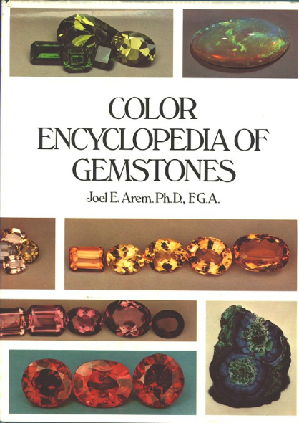
COLOR ENCYCLOPEDIA OF GEMSTONES, 1st Edition - By Joel E. Arem, Ph.D., F.G.A., 147 pages, 11 X 8 1/2 size, cloth bound. This important encyclopedia is a milestone in lapidary publishing – the first reference source to present data on every known species and variety of gemstone. Furthermore, its rich selection of color photographs illustrates more species than have ever before appeared in one volume. Arranged alphabetically by the name of the mineral species, the book includes a complete cross index of familiar gem names. Information on each gemstone mineral includes chemical formula, crystal structure, colors, luster, hardness, density, cleavage, optics, spectral data, luminescence, and sizes of large gemstones known for each mineral. Over 220 mineral species are covered, and the color plates illustrate more than 185 of these – including all known color varieties of each species. For as many as 100 of the rarer species a color photograph appears for the first time in print. The author’s transparencies represent the most sophisticated techniques for gem photography, illustrating the exact color of faceted gemstones while displaying to best advantage the cut and brilliance derived from the cutting of the stones. This book will prove an invaluable reference for the lay person, as well as for collectors, jewelers, and others interested in a complete reference of all known minerals used as gemstones. The book is in excellent condition, inside and out, with intact dust jacket. Published by Van Nostrand Reinhold Co., New York, 1977.
Order Item # BK-2060
Shipping weight: 4 pounds
Price: $65.00

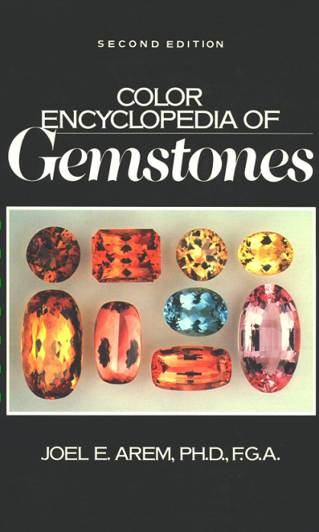
COLOR ENCYCLOPEDIA OF GEMSTONES, 2nd Edition - By Joel E. Arem, Ph.D., F.G.A. 310 pages, 11 X 8 1/2 size, cloth bound. This updated and greatly enlarged 2nd Edition of the Color Encyclopedia of Gemstones includes 62 pages of color plates – over 300 color plates in all, illustrating many gemstones that are depicted in no other gemstone book. At the time of its publication in 1987, Dr. Arem had produced the most complete and comprehensive tabulation ever available, on the properties of all known gemstone species and varieties. Accurate data is given on each gemstone’s physical properties, occurrence, chemistry, availability, rarity, and market potential. One of the major features of this 2nd Edition is the new coverage of synthetic gemstones, featuring complete data on all of the important synthetic materials, and including those both with, and without natural counterparts. Also of special interest, and new to this edition, is a detailed analysis of color, and color measurement as applied to gemstones. Here, the author presents a comprehensive listing of machine-generated color measurements on wide range of gemstone species and varieties. Machine color analysis is far more accurate than visual estimation in gemstone description, and this is the first work ever to present this kind of information. Additionally, a section on thermal properties of gems introduces the reader to this new and potentially useful diagnostic tool. Published by Van Nostrand Reinhold Co., New York, 1977, 1987.
Order Item # BK-2065
Shipping weight: 4 pounds
Price: $125.00

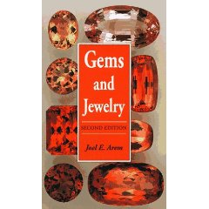

Gems and Jewelry: All Color Guide (Paperback)

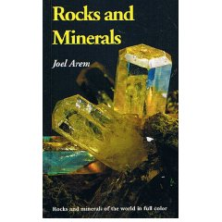

Rocks and Minerals (Paperback)

