GIA to House Bronze Bust of Edward J. Gübelin
http://www.whiteflash.com/diamonds_info/t/all_about.aspx?articleid=424&zoneid=21

The late Dr. Edward J. Gübelin has been immortalized in a bronze bust donated to the Gemological Institute of America (GIA) by Rober E. Kane, president and CEO of Fine Gems International in Helena, Montana.
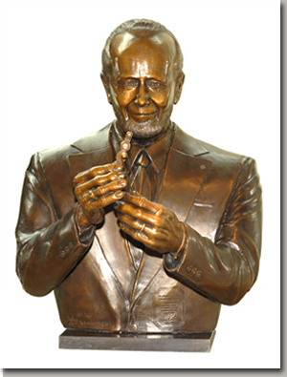
Photo by Robert Weldon, GIA
One of the world’s most honored and accomplished gemologists, Dr. Gübelin was born in 1913 and passed away in 2005. During his 65-year career he revolutionized gemology. Best known for his pioneering work on gemstone inclusions, he wrote extensively on nearly all aspects of gemology, recording his observations in 13 major books and more than 250 articles. A widely traveled explorer, he visited and reported upon many of the world’s most important gem localities. He was an influential educator, a major gem collector, an innovator in gem-testing instruments, and one of gemology’s most ardent and respected global ambassadors.
Award-winning sculptor Lyle Schwabauer created the bronze statue, which is mounted on a marble, freestanding base, depicting Dr. Gübelin looking through a loupe at a sapphire in a pair of tweezers. Edward Boehm, Dr. Gübelin’s grandson, loaned Schwabauer his grandfather’s 1965 gold and diamond Certified Gemologist lapel pin and 1950s Kruss loupe to make molds for the bust. A bronze-plated pair of Swiss gem tweezers was incorporated into the piece. The sculpture is on display in the Salvador J. Assael Grand Atrium at the Institute’s Robert Mouawad Campus in Carlsbad.
Mr Kane, a former manager of Gem Identification at GIA’s West Coast Laboratory and former director of the Gübelin Gem Lab in Lucerne, Switzerland, is a longtime supporter of the Institute and was a close friend of Dr. Gübelin's for more than 26 years. He commissioned the 32-inch-tall sculpture to honor Dr. Gübelin and celebrate the Institute’s 4th International Gemological Symposium and 75th anniversary.
“GIA is the ideal place for thousands of people each year to see this magnificent bronze sculpture of Dr. Gübelin,” said Kane. “Like the indelible legacy Dr. Gübelin left behind through his prolific writings and photomicrographs, gem collection, laboratory, and the organizations he helped establish, perhaps this sculpture also will inspire future generations of gemologists.”
Kane presented the bust to GIA Acting President Donna Baker, Museum Director Elise Misiorowski, Gems & Gemology Editor-in-Chief Alice Keller, and Director of In-Kind Gifts Patricia Syvrud on Aug. 24. Boehm also attended the presentation.
“Bob has again demonstrated his longstanding dedication to GIA by donating this beautiful sculpture of Dr. Gübelin, one of the century’s most important gemologists, to grace our halls,” said Syvrud. “His generosity enhances the presence of Dr. Gübelin’s gemstone collection, which recently became a part of GIA's permanent collection.”
In addition to the bronze bust, Kane and Fine Gems International sponsored a travel grant for the 2006 Gemological Research Conference. Kane is also a frequent donor to the Richard T. Liddicoat Gemological Library and Information Center and GIA Research, and is well known for his many Gems & Gemology articles on diamonds, colored stones, and gem identification.
=================================================================================================================================================

