The Truth About Vaccines 2020

https://secure.thetruthaboutcancer.com/the-truth-about-vaccines-docuseries/

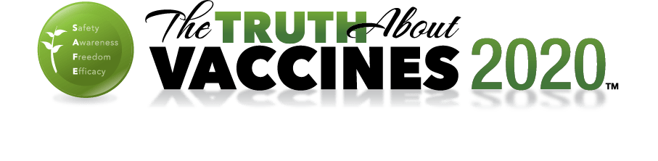
- Home

Welcome from Ty & Charlene
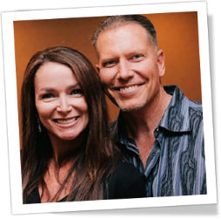
Thank you for choosing to join the movement and supporting our mission to save lives by ordering The Truth About Vaccines 2020 Docu-series.
This is “The Truth About Vaccines” members area, where you will find the videos and transcripts, including the unedited interviews with each of the experts we featured.
NOTE: Episodes 8 & 9, and Vaccine Roundtable videos and downloads have been added.
If you have any questions or we can help you in any way, contact us at https://support.thetruthaboutcancer.com/
Episode #1
Episode #2
Episode #3
Episode #4
Episode #5
Episode #6
Episode #7

The Truth About Vaccines Episodes

Episode 1 – The History of Vaccines, Smallpox, Vaccine Safety & the Current CDC Schedule
Download MP3
Download SD
Download HD

Episode 2 – What's in a Vaccine? Are Vaccines Effective? … and ... What About Polio?
Download MP3
Download SD
Download HD

Episode 3 – In Depth Analysis of the MMR and DTaP Vaccines & Vaccinating for the Greater Good
Download MP3
Download SD
Download HD

Episode 4 – Examining Influenza, the HIB and Pneumococcal Vaccines & Herd Immunity
Download MP3
Download SD
Download HD

Episode 5 – Considering the HPV and Hepatitis B Vaccines, SIDS & Shaken Baby Syndrome
Download MP3
Download SD
Download HD

Episode 6 – A Closer Look at the CDC, Chicken Pox and Rotavirus Vaccines & Retroviruses
Download MP3
Download SD
Download HD

Episode 7 – Natural Immunization, Homeoprophylaxis & Fundamental Freedom of Choice
Download MP3
Download SD
Download HD

Episode – Q&A Part I with Ty & Charlene
Download SD
Download HD

Episode – Q&A Part II with Ty & Charlene
Download SD
Download HD

Episodes 8 & 9

Episode 8 – Censorship & Suppression
Download MP3
Download SD
Download HD

Episode 9 – W.H.O.'s Not Telling The Truth?
Download MP3
Download SD
Download HD
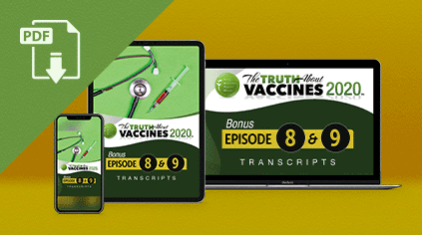
TTAV Transcripts (PDF): Episodes 8 & 9
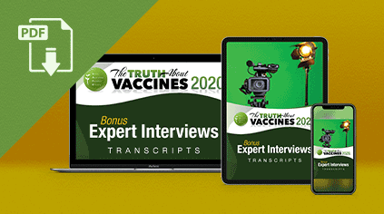
TTAV Transcripts (PDF): Bonus Expert Interviews

Vaccine Roundtable

TTAV 2020 Vaccine Roundtable Part 1
Download MP3
Download SD
Download HD

TTAV 2020 Vaccine Roundtable Part 2
Download MP3
Download SD
Download HD
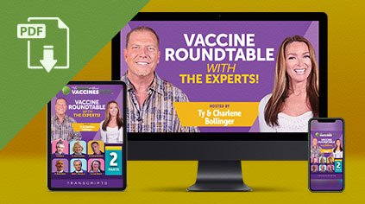
TTAV 2020 Vaccine Roundtable Transcripts (PDF)

Transcripts & eBooks (Episodes 1 - 7)
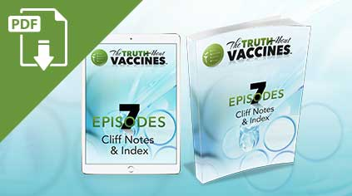
TTAV Index (PDF): Episodes 1 - 7 Cliff Notes Index
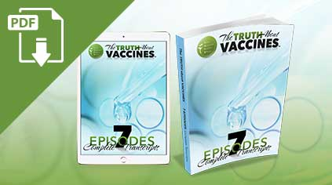
TTAV Transcripts (PDF): Episodes 1 - 7
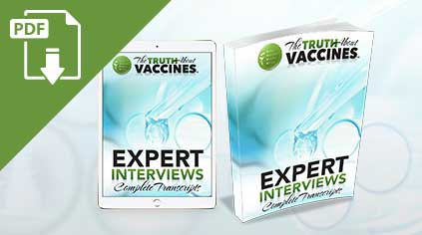
TTAV Transcripts (PDF): The Complete Expert Interviews

Uncut Expert Interviews

Allison Folmar J.D.
Civil Rights Attorney, Lecturer
https://parentalrights.org/about/
Download MP3
Download SD
Download HD
Download PDF

April Boden
Blogger, Activist, and Mother of Vaccine-Injured Child
Download MP3
Download SD
Download HD
Download PDF

Barbara Loe Fisher
Best-Selling Author & President of the National Vaccine Information Center (NVIC)
http://www.nvic.org/about/barbaraloefisher.aspx
Download MP3
Download SD
Download HD
Download PDF

Bob Krakow
Personal Injury & Medical Malpractice Attorney Specializing in Vaccines
http://www.krakowlaw.com/
Download MP3
Download SD
Download HD
Download PDF

Brandy Vaughan
Vaccine Activist & Whistle-Blower, Former Merck Sales Rep
https://www.learntherisk.org/
Download MP3
Download SD
Download HD
Download PDF

Charlene Bollinger
Founder and CEO of The Truth About Cancer
http://www.thetruthaboutcancer.com/
Download MP3
Download SD
Download HD
Download PDF

Del Bigtree and Polly Tommey
Del: Former Producer of the Emmy® Award-winning talk show, The Doctors® & Co-Producer of “VAXXED”
Polly: Author, Founding Editor-in-Chief of “The Autism File” & Co-Producer of “VAXXED”
http://vaxxedthemovie.com/filmmaker-biographies/
Download MP3
Download SD
Download HD
Download PDF

Dr. Andrew Wakefield, MB.BS.
Gastroenterologist, Fellow of the Royal College of Surgeons, Director of “VAXXED”
http://vaxxedthemovie.com/andrew-wakefield-biography/
Download MP3
Download SD
Download HD
Download PDF

Dr. Brian Hooker, Ph.D
Associate Professor of Biology at Simpson University, Inventor & Scientific Advisor
https://www.focusforhealth.org/meet-dr-brian-hooker/
Download MP3
Download SD
Download HD
Download PDF

Dr. Cilla Whatcott, Ph.D
Co-Founder of “Free and Healthy Children International”
https://realimmunity.org/
Download MP3
Download SD
Download HD
Download PDF

Dr. David Lewis, Ph.D
EPA Whistle-blower, Internationally Recognized Research Microbiologist
http://www.whistleblowers.org/index.php?option=com_content&task=view&id=74/
Download MP3
Download SD
Download HD
Download PDF

Dr. Debra Gambrell, D.O.
Practicing Pediatric Osteopath
https://westcountyosteopathy.tumblr.com/
Download MP3
Download SD
Download HD
Download PDF

Dr. Edward Group, D.C.
Author, Lecturer, Formulator & Founder and CEO of Global Healing Center
http://www.globalhealingcenter.com/about/dr-group/
Download MP3
Download SD
Download HD
Download PDF

Dr. Eric Zielinski, D.C.
Health Coach, Researcher, & Speaker
http://drericz.com/our-team/dr-eric-z/
Download MP3
Download SD
Download HD
Download PDF

Dr. Gadugu Srinivasulu, MD
Assistant Professor
Govt. Homeopathic Medical College
Cudappah, Andhra, India
https://www.facebook.com/zestchalakkudy/posts/1460996077507417:0/
Download MP3
Download SD
Download HD
Download PDF

Dr. Heather Rice, D.C.
Practicing Chiropractor, Activist & Author
Download MP3
Download SD
Download HD
Download PDF

Dr. Heather Wolfson, D.C.
Chiropractic Physician & Lecturer
https://www.thedrswolfson.com/
Download MP3
Download SD
Download HD
Download PDF

Dr. Irvin Sahni, M.D.
Physician, Surgeon, Scientist & Lecturer
Download MP3
Download SD
Download HD
Download PDF

Dr. Jack Wolfson, D.O.
Board-certified Cardiologist, Lecturer & Best-Selling Author
https://www.thedrswolfson.com/
Download MP3
Download SD
Download HD
Download PDF

Dr. Janet Levatin, M.D.
Pediatrician and Homeopath
http://tenpennyimc.com/about-us/our-staff/janet-levatin-m-d/
Download MP3
Download SD
Download HD
Download PDF

Dr. Joseph Mercola, D.O.
Founder of Mercola.com, New York Times Best-selling Author
http://www.mercola.com/
Download MP3
Download SD
Download HD
Download PDF

Dr. Judy Mikovits
Scientist, Publisher of 50 Scientific Papers & Former Lab Director at National Cancer Institute
http://www.plaguethebook.com/
Download MP3
Download SD
Download HD
Download PDF

Dr. Larry Palevsky, M.D.
Renowned Board Certified Pediatrician, Lecturer & Author
http://www.drpalevsky.com/
Download MP3
Download SD
Download HD
Download PDF

Dr. Marco Ruggiero, M.D.
Molecular Biologist & Former Italian Army Lieutenant
http://www.autismone.org/users/marco-ruggiero/
Download MP3
Download SD
Download HD
Download PDF

Dr. Muhammed Rafeeque, A.A., B.H.M.S.
Author & Practitioner of Classical Homoeopathy
Download MP3
Download SD
Download HD
Download PDF

Dr. Paul Thomas, M.D.
Board-Certified Pediatrician, Author & Founding Director of Physicians for Informed Consent
http://integrativepediatricsonline.com/
Download MP3
Download SD
Download HD
Download PDF

Dr. Rachael Ross, M.D.
Former Co-host on the Emmy® Award-winning talk show, The Doctors®
http://drrachael.com/
Download MP3
Download SD
Download HD
Download PDF

Dr. Rashid Buttar, D.O.
Practitioner, Researcher, Best-Selling Author & International Lecturer
http://www.drbuttar.com/
Download MP3
Download SD
Download HD
Download PDF

Dr. Robert Scott Bell, D.A. Hom
Author, Lecturer & Syndicated Host of the “Robert Scott Bell Show”
http://www.robertscottbell.com/
Download MP3
Download SD
Download HD
Download PDF

Dr. Shawn Centers, D.O.
Internationally Renowned Pediatrician & Medical Director at Children’s HOPE Center
http://thechildrenshopecenter.com/
Download MP3
Download SD
Download HD
Download PDF

Dr. Sherri Tenpenny, D.O.
Physician, Author, Lecturer, Researcher & Consultant
http://www.vaxxter.com/
Download MP3
Download SD
Download HD
Download PDF

Dr. Sin Hang Lee, M.D.
Former Faculty of McGill University and Yale University, Director of Milford Medical Laboratory
Download MP3
Download SD
Download HD
Download PDF

Dr. Stephanie Seneff
Senior Research Scientist at the MIT Computer Science & Artificial Intelligence Laboratory
https://people.csail.mit.edu/seneff/
Download MP3
Download SD
Download HD
Download PDF

Dr. Suzanne Humphries, MD
Author, Lecturer, and Board-Certified in Internal Medicine & Nephrology
http://drsuzanne.net/
Download MP3
Download SD
Download HD
Download PDF

Dr. Tetyana Obukhanych, Ph.D
Immunologist, Author & Founding Director of Physicians for Informed Consent
http://www.tetyanaobukhanych.com/
Download MP3
Download SD
Download HD
Download PDF

Dr. Tim O’Shea, D.C.
Practitioner, Researcher, Lecturer, and Author
http://www.thedoctorwithin.com/
Download MP3
Download SD
Download HD
Download PDF

Dr. Toni Bark, M.D.
Founder and Medical Director of the Center for Disease Prevention and Reversal
http://www.disease-reversal.com/about-us/
Download MP3
Download SD
Download HD
Download PDF

Edda West
Founder of Vaccine Choice Canada
https://www.facebook.com/VaccineChoiceCanada/
Download MP3
Download SD
Download HD
Download PDF

Edwin Black
Award-winning, New York Times Best-Selling International Investigative Author
http://www.edwinblack.com/
Download MP3
Download SD
Download HD
Download PDF

Erin Crawford
Vaccine Awareness Activist
https://www.facebook.com/erindcrawford/
Download MP3
Download SD
Download HD
Download PDF

Erin Elizabeth
Author, Researcher & Public Speaker
http://www.healthnutnews.com/about/
Download MP3
Download SD
Download HD
Download PDF

Heidi Bonaroti
Mother of Vaccine Injured Child
Download MP3
Download SD
Download HD
Download PDF

Ian Clark
Lecturer, Researcher & Founder of Activation Products
http://www.activationproducts.com/our-story/
Download MP3
Download SD
Download HD
Download PDF

Jefferey Jaxen
Researcher, Independent Investigative Journalist, Writer and Voice for Health Freedom
http://www.jeffereyjaxen.com/about.html/
Download MP3
Download SD
Download HD
Download PDF

Jennifer Margulis, Ph.D
Award-winning Science Journalist & co-author of The Vaccine Friendly Plan
http://jennifermargulis.net/
Download MP3
Download SD
Download HD
Download PDF

Laura Hayes
Speaker, Activist, Mother of Vaccine-Injured Child
http://www.vaccinationinformationnetwork.com/laura-hayes-vaccines-what-is-there-to-be-pro-about/
Download MP3
Download SD
Download HD
Download PDF

Mario Lamo-Jimenez
Writer & Award-Winning Investigative Journalist
https://www.linkedin.com/in/mario-lamo-9959bb5
Download MP3
Download SD
Download HD
Download PDF

Michael R. Hugo, Esq
International Lecturer in Pharmaceutical Products Liability and Toxic & Environmental Torts
Download MP3
Download SD
Download HD
Download PDF

Mike Adams
Founder of NaturalNews.com, Food Scientist, Author & Lecturer
http://naturalnews.com/
Download MP3
Download SD
Download HD
Download PDF

Minister Tony Muhammad
International Lecturer & Vaccine Activist
Download MP3
Download SD
Download HD
Download PDF

Neil Z. Miller
Medical Research Journalist & Director of the “Thinktwice Global Vaccine Institute”
http://www.thinktwice.com/
Download MP3
Download SD
Download HD
Download PDF

Nico and Davi LaHood
District Attorney for Bexar County, TX and Parents of Vaccine Injured Child
Download MP3
Download SD
Download HD
Download PDF

Robert F Kennedy, Jr.
Syndicated Radio Host, Author, Activist & Environmental Attorney
https://childrenshealthdefense.org/
Download MP3
Download SD
Download HD
Download PDF

Sayer Ji
Author, Lecturer, National Health Federation Advisory Board
http://www.greenmedinfo.com/
Download MP3
Download SD
Download HD
Download PDF

Thomas and Candice Bradstreet
Activists for Natural Health and Healing
Download MP3
Download SD
Download HD
Download PDF

TTAC SHOP


ABOUT US
Ty & Charlene Bollinger are founders of “The Truth About Cancer” and “The Truth About Vaccines.” After enduring the painful loss of both of Ty's parents and several relatives to cancer, they set out on a life-changing mission to discover the TRUTH about cancer … find real answers … bring hope … and defeat this disease once and for all. After 20+ years of research, their message is clear:
CANCER IS NOT A DEATH SENTENCE. THERE IS ALWAYS HOPE.

EXPLORE
- Home
- My Membership
- Insiders Newsletters
- FAQ

CONTACT US
TTAC Support Website
TTAC Publishing is a member of the Health and Wellness Business Association.


CONNECT WITH US





The content of this website is based on research conducted by TTAC Publishing, LLC, unless otherwise noted. The information is presented for educational purposes only and is not intended to diagnose or prescribe for any medical or psychological condition, nor to prevent, treat, mitigate or cure such conditions. The information contained herein is not intended to replace a one-on-one relationship with a doctor or qualified healthcare professional. Therefore, this information is not intended as medical advice, but rather a sharing of knowledge and information based on research and experience. TTAC Publishing encourages you to make your own health care decisions based on your judgment and research in partnership with a qualified healthcare professional.
Copyright © 2014-2020 TTAC Publishing, LLC
Home
Top of Form
Bottom of Form
- Home
- Favs
- Timmy's Account
- Logout
Live Chat Offline
Leave a message here

