Dr. Theresa Dale PhD, CCN, NP, of the Wellness Center for Research and Education, responds to recent news articles that indicate there may be a major widespread nuclear radiation exposure occurring due to Japan’s Fukushima accident in 2011 (http://www.enenews.com, a world Energy News and archive site).
According to Dr. Dale, unless the Japanese government entombs the entire Fukushima Plant as was done 25 years ago at Chernobyl, it will continue spewing into the environment, land, sea and air. A threat of radiation contamination to foods and supplies prompting us to reconsider our lifestyle, diet and choice of supplementation support.
In view of a contamination threat, Dr. Dale advocates we reconsider now our lifestyle, diet and choice of supplementation to naturally support the immune system to protect itself from ionizing radiation. When discussing ‘dangerous radiation levels’, most people refer to the ionizing radiation at levels reaching far above average ‘background radiation levels’ experienced every day. On the other hand, non-ionizing radiation such as visible light, radar, microwaves and radio waves are virtually harmless by comparison. Potential health effects of low frequency non-ionizing radiation devices such as common wireless phones are the subject of an ongoing examination by the Parliament Council of Europe (2011 document 12608). In contrast, ionizing radiation by definition is excessive energy, mass produced by unstable atoms. Dr. Theresa Dale, founder of the Wellness Center for Research and Education, notes that ionizing radiation is powerful enough to break molecular bonds in living tissue, causing damage and in extreme cases, death. Whenever ionizing radiation passes through living tissue, or are ingested, they have the potential of removing electrons from atoms, turning them into positively charged particles, or ions, which may possibly damage body’s cells.
Dr. Dale feels that the urgency under deliberation is the risk involved when every organism in the food chain is jeopardized. Radiation contamination to food and water supplies should motivate continued testing not only in Japan, but in countries around the globe, including here in the U.S. Meanwhile, Dr. Dale has put a dietary and supplementation plan together that is research based and sensible, designed to enhance the immune system.
After a direct experience with radiation exposure from the Chernobyl disaster, Dr. Theresa Dale of the Wellness Center for Research and Education, created a distinct product called HGP to repair the pathway that produces Glutathione in the body. Dr. Dale discerned that the best way to naturally recover from radiation is to actually fix the pathway in the body that detoxifies it - The Hepatic Glutathione Pathway. The key to repairing the pathway is so the body is able to detoxify, correct and protect itself from free radicals. Repairing the pathway using the Hepatic Glutathione Pathway (HGP) formula blend is much more effective than wasting money using expensive Glutathione supplementation.
Dr. Dale went a step further and put together an Anti-Radiation Protection Protocol to be used in conjunction with HGP – a Homeopathic RadiationX formula and a biologically available BioIodine supplement. The dosage depends on exposure length and proximity to the nuclear plant. Seaweed varieties are known sources of iodine and when found sourced from the U.S., appear to be safe. For additional defense, Dr. Dale’s Anti-Radiation Protocol also involves using Vitamin D3, an Optimal Multi Pro vitamin and Nano Ionic Minerals with Silica, along with the Ocean Med’s supplement that has high amounts of Fucoidan, a seaweed extract used for cancer and other health issues.
So what would a 21st Century Nuclear First Aid Anti-Radiation kit look like? For a start consider Dr. Theresa Dale’s Hepatic Glutathione Pathway formula, along with her Homeopathic RadiationX formula and BioIodine supplement product, available by contacting the Wellness Center for Research and Education; not forgetting to pack a few tasty, crisp, organic algae snack foods.
There are a plethora of diets in this day and age, but Dr. Dale says the Nuclear Anti-Radiation Diet should demand fullest attention. Based on research at the Institute of Radiation Medicine in Minsk and by Israeli scientists treating Chernobyl children with spirulina, Chlorella algae, or Dunaliella algae, it was found that these micro-algae foods helped normalize blood chemistry. In short, after radioactive exposure, eating seaweeds and algae’s are advised but do not eat foods that have been contaminated with fallout. Dr. Dale recommends that if a food supply has been exposed to radiation, consumers buy frozen veggies but find out where and when they are grown and packaged. According to Dale, an Anti-Radiation Diet should focus on the following organic foods:
Whatever the outcome of Fukushima or other nuclear plants making headlines, such as San Onofre, CA, or Salem, NJ, Dr. Dale feels a personal strategy change is needed to transition over to a powerful, whole plant food based diet that can improve detoxification of nuclides or radioactive elements. Dietary plant fibers, sulfur-containing antioxidants found in cruciferous vegetables such as broccoli, kale, and cabbage, along with pectin in fruits, and Green tea have all been shown to reduce levels of radioactive substances and provide protection against free radical damage. In addition, the Wellness Center for Research and Education recommends supplementation using specific Anti-Radiation formulas such as the Hepatic Glutathione Pathway formula, Homeopathic RadiationX, and BioIodine that can support the immune system and assist the body in detoxification and rejuvenation.
Health Professionals and other inquiries welcome.
For more information, call Theresa Dale's office at (800) 219.1261
- OA
- FOODIE BUZZ
  - Restaurant Buzz
- HEALTHY RECIPES
  - Appetizer Recipes
  - Breakfast Recipes
  - Cooking Tips
  - Dessert Recipes
  - Juice Recipes
  - Main Course Recipes
  - Salad Recipes
  - Sandwich Recipes
  - Sauces, Condiments, Dressings Recipes
  - Soup Recipes
  - Spirit and Drink Recipes
  - Stock and Miscellaneous Recipes
  - Vegetable Side Dishe Recipes
  - Snack Recipes
- ECO CHIC TABLE
  - Mojo Foods
  - Juicy Spirits
  - Cooking Dictionary
- KITCHEN GARDEN
- ENERGETIC HEALTH
  - Delicious Beauty
- SANCTUARY
  - Kids
  - Pets
  - Reviews
  - Guide
  - Laura's Letter
- CHEW NEWS
- OATV
- ABOUT
- \ASK LAURA  - \LAURA'S FAVES  - \HOT LISTS  - \FROM OUR FRIENDS  Related Articles:    The One Meal You Should Never Eat Out  3 weeks ago    Want Sexier Thighs?  3 weeks ago  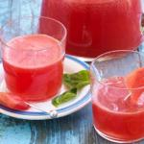  6 Drinks That Shrink Your Belly  6/1/2012    Human Babies Being Eaten for ‘Endurance’  5/13/2012  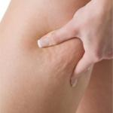  Get Rid Of Cellulite?  5/1/2012    The 5 Worst Types of Foods to Eat Late at Night  3/1/2012    8 Biggest Makeup Mistakes That Age You  1/1/2012    8 Flat Belly Shortcuts  12/1/2011  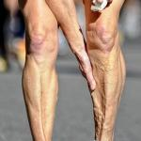  Inflammation: The Silent Killer (And How to Outsmart Your Own Body)  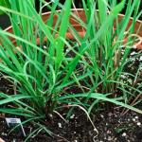  4 Foods That'll Re-Grow from Kitchen Scraps  Powered by Vertical Acuity  Place your ad here  Loading... | POPULAR NOW  Foodie Buzz  Energetic Health  Kitchen Garden  Eco Chic Table  Support OA and shop Amazon |           Learn about subscription options.  Top of Form  Bottom of Form  ORGANIC AUTHORITY TV  Caramelized Apple Hazelnut Oatmeal Recipe with Organic Whey - Episode 89 - Episode    Looking for a quick breakfast? Try these delicious whole rolled oats that cook up in just a few minutes. Or make this recipe in large batches on the weekend so you have for the week.  Organic Food  Going Green  Master Cleanse  Green Living  Organic Baby  energy healing  Detox
  11 Vitamins, Herbs & Foods that Detox Radiation Exposure
  Written by Jill Ettinger
  
  Experts have varying opinions on the severity—if any— the nuclear fallout drifting on to America's western shores will have as a result of the disastrous nuclear meltdowns in Japan after the 9.0 magnitude earthquake and 30-foot tsunami that rocked the country earlier this month. Whether or not we are in fact facing widespread nuclear contamination risks, we are exposed to low-level doses of radiation throughout our daily lives. From airport security scanners to X-rays to radioactive particles in the air, experts have estimated that every human on earth has low levels of radiation in their bodies. There are many risk factors in exposure to radiation—potentially life-threatening effects—and every body can react differently. Here are several all-natural immune-boosting foods and minerals that can help fight off the short and long-term risks of radiation exposure and poisoning.
  You've likely already heard about taking iodine to thwart radioactive iodine from binding to the thyroid. Iodine tablets have been sold out all over the west coast for weeks amidst fears that jet streams are rushing radioactive air in to California, Washington, Oregon and British Columbia from Japan. The thyroid, which is often referred to as the "shield gland" is one of the body's best defenses from toxins. When we're deficient in iodine—a trace mineral essential for proper thyroid function—we can develop health problems such as extreme fatigue, depression, weight gain and goiters. If our thyroids are deficient in iodine when we're exposed to radioactive iodine, it will bind to the thyroid in place of iodine, and can lead to cancer and other serious illnesses. Most of us in the U.S. are not iodine deficient, and overdosing on iodine amidst fears of radiation poisoning for example, can be harmful to the thyroid, with iodine toxicity symptoms similar to those found in iodine deficiency. In the case of radiation exposure, iodine's protection is only good for roughly 48 hours after a dosage. Always consult your health care practitioner before taking high levels of iodine or any nutrition supplements.
  There are several types of iodine supplements you may hear about: potassium iodine, Lugol's and nascent. All are suitable in providing the thyroid with enough iodine to keep radioactive iodine from binding, in most cases. Foods that contain high levels of naturally occurring iodine are seaweeds—particularly kelp. Many salts are also iodized, and sea salt especially, is also helpful in detoxification and can expedite removal of radioactive iodine from the body.
  Chlorella, which is a type of single-celled green algae, is very high in clorophyll, and has been shown to neutralize toxins in the body, often being used when someone has mercury poisoning. Taking recommended doses of chlorella when exposed to radiation—even after a visit to the X-ray machine—is a good way to speed up the detoxification.
  The reishi mushroom is considered the King of Chinese medicine because of its incredible immune boosting properties. It is not your pizza topping kind of fungus. Boosting your immunity with supermushrooms like reishi will help your body defend itself against toxins and may reduce the impact after exposure to radiation.
  Ashwaganda, or Indian ginseng, is a powerful Ayurvedic tonic herb that helps the body deal with stress. American and Siberian Ginseng can do this too. Even if you don't feel like you're under stress, when your immune system is fighting something foreign and potentially harmful, it stresses the entire body. So using adaptogens like ashwaganda and ginseng can enhance your overall body immunity performance. Likewise, vitamin C is an indispensible nutrient for boosting immunity and helping the body trigger its own defenses. It strengthens cells by acting almost like cement or glue, making it difficult for radioactive or cancer cells to penetrate and corrupt healthy cells. You cannot overdose on vitamin C, and Nobel Prize winner, Dr. Linus Pauling, used it in incredibly high doses—over 100,000 milligrams daily—to treat serious illnesses such as cancer.
  Coconut oil is very supportive of the thyroid gland and has been recommended for cancer chemo patients. It's got antifungal and antiviral properties too, which can help the body defend against contamination. It's also advised to use it topically on any skin that may be in danger of exposure to radiation, and that includes the sun's ultra violet radiation.
  Radiation can also increase our susceptibility to dehydration. And when we're fighting off any unwelcome guests, it's critical that we stay hydrated so that our body's natural defenses are working properly. Even if you don't feel thirsty (that means you're already dehydrated, BTW), drink at least 8 glasses of water a day.
  And when dealing with radiation exposure or any other serious health crisis, taking measures to reduce your stress can play a huge role in your health and wellbeing. Check out our tips on dealing with tragedy and loss naturally.
  Keep in touch with Jill on Twitter @jillettinger
  Photo: BlatantWorld.com
  Tweet
  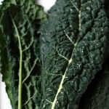 | 7 Reasons Kale Is the New Beef
  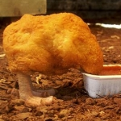 | What's in Fast Food Chicken? (Hint: It's NOT Chicken)  Tweet
   |  | The 8 Most Nutrient Dense Foods on Earth  Tweet
  CHEW NEWS
  
  Gates Foundation Gives $10 Million to GMO Research
  
  Eat More Words: Chick-Fil-A Addresses Anti-Gay Comments
  
  Nation's Two Largest Organic Dairy Suppliers Face-Off in Court Over Ethics
  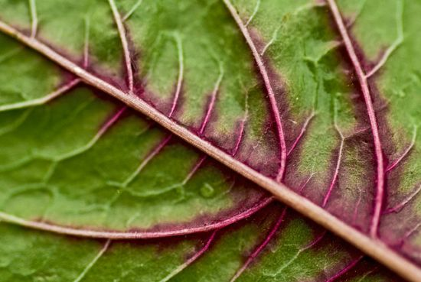
  Funding Cut for USDA's Fruit and Vegetable Safety Program
   | KitchenAid's 1,000 Cooks for the Cure  Tweet
   | Mariel Hemingway Crowdfunding Anti-Monsanto Film: Will You Help?  Tweet
  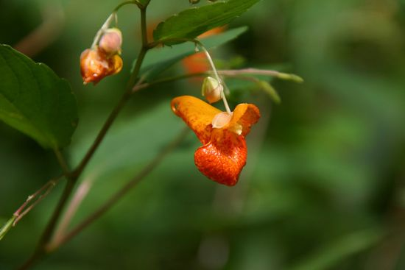 | The Only Cure for Poison Ivy You'll Ever Need  Tweet
  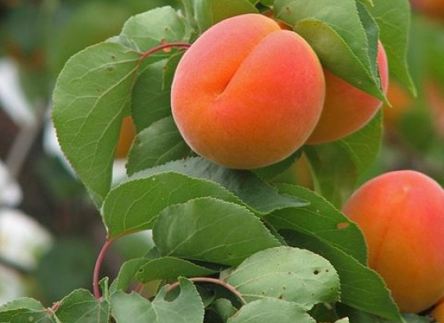 | Take a Bite! 5 Incredible Health Benefits of Apricots  Tweet
  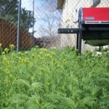 | Protect Your Organic Garden: 5 Ways To Get Rid Of Weeds, Naturally  Tweet
   | Garden Birdbaths: Great for Birds (and Gardens!)  Tweet
  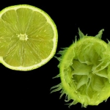 | Beyond Key Lime Pie: 4 Scrumptious Summer Lime Recipes  Tweet
   | How to Enjoy Fresh Fruit Over 3 Days  Tweet
- Contact Us
- About
- BIO
- Mission Statement
- Privacy Policy
- Green Products
- Advertising
- Green Living
© 2010 OrganicAuthority, LLC


__________________________________________________________________________
Use the following Radiation protective foods to keep your body protected from nuclear radiation sickness:

- Kelp
- Seaweed
- Saltwater Fish (Haddock is really good, then Cod)
- Sea Vegetables
- Daikon Radishes
- Burdock Root
- Unprocessed Sea Salt
- Medicinal Mushrooms
- Miso
- Cheese
- Cilantro
- Coriander
These foods can really help keep radiation moving out of your body.

Natural Supplements and Herbs for Radiation
Listed in order or potency and importance:
- Natural Zeolite (The best natural supplement against radiation and heavy metal poisoning and exposure) Take as directed.
- Pine Pollen (natural substance from pine trees that detoxes radiation, particularly cesium)
- SOD (Super-Oxide Dismutase – High level anti-oxidant with life extension properties
- Laminaria Kelp (natural source of iodine that is safe unlike Potassium Iodine (and naturally detoxes Radiation)
- Medicinal Mushrooms (take as indicated 3 times per day – very powerful immune system boosters that protect against radiation, particularly Reishi Mushroom)
- Beta d-Glucan ( 1 500mg capsule per day – protects from radiation exposure)
- Burdock Root extract (organic preferred, use as indicated on label – up to 3 times a day – removes radioactive isotopes from the body)
- Bladderwrack (one of the best sources of iodine which is really potent against radiation)
- Tulsi (Holy Basil – use aerial parts of herb, tincture or extract, helps the body eliminate radiation poisoning)
- Cilantro Leaf (Coriander – use fresh organic on foods or as a supplement as indicated – natural heavy metal detox (cesium 137 and plutonium are heavy metals)
- Ginseng (get red ginseng if you can, take as indicated on label 3 times per day – helps detox radiation)
- Milk Thistle (as indicated on label 3 times per day – helps the liver detox radiation)
- Marine Algae (Chlorophyll – increases resistance to radiation poisoning and toxicity)
- Bentonite Clay (edible clay – 1 tablespoon in juice or water per day for a radiation detox treatment)

Also take some Ionic Minerals and a good multi-vitamin to keep your body strong and give the radioactive isotopes no place to call home in your body. You should also take some nice hot baths with natural unprocessed dead sea salt (the highest natural mineral content), baking soda and dried ginger (about a 1/2 cup each for prevention, or 1 cup each for detox treatment in as hot water as you can stand).

It is also important to make sure the food that you eat and the water that you drink is safe and is helping you instead of hurting you. Visit the websites below for more information on radiation protection and treatment.

Alternative Radiation Protection
posted on Monday, March 14th 2011 12:42 pm
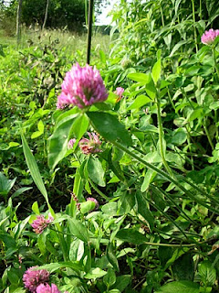
With the threat of the nuclear reactor meltdown, many people are now fearing fall out on the northwestern coastline of America. The typical recommendation is to take iodine tablets or dip your finger in liquid iodine or betadine (NEVER ingest it). Those living a more natural lifestyle may wonder what they can do naturally to increase their iodine intake without iodine tablets or liquid iodine.
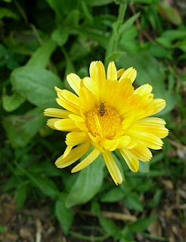
There are several great articles floating around on the internet that have been composed recently and in the past on what you can do naturally. Here is a list of my favorites:
Sean over at Greenman Ramblings
Laura Bruno
Dixie Pauline
Ingrid Naiman
Todd Caldecott
Susun Weed
Margi Flint
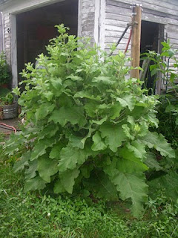
At the moment, I have little to fear about radiation from this event due to my geographical location. However, there are nuclear plants all around me and we live on a major fault line that could go at any time. This leads to the potential for a nuclear disaster. Because I take a natural approach and feel I can safely and effectively combat radiation with natural products, here is a list of what I am stocking my pantry with:
Kelp from Ryan Drum – I have a pound stored away that I like to add to food
Miso – due to concerns about soy, I’ll most likely stick with alternate forms of miso. you can find a wealth of recipes for using miso here.
14 Mushroom blend (thanks to Sean and Margi for this source, mine is in the mail)
Herbs: Calendula, Clover, Burdock, Nettles, Oatstraw (see Sean’s article for reasons behind this) – consumed in infusion form
Epsom salts and baking soda – there are so many uses for these 2 items, we always have extra on hand
Niacin supplements – blocks receptor sites that hold onto radiation
