 | Dear Nancy,  Jim Humble Technical Bulletin  NEW HEALTH TECHNOLOGY  I am sure that you have heard about the new Cleansing CDS of the Genesis 2 Church of Health and Healing. But what is it? Is it really something new or is it just old technology given a new name?  CDS is Chlorine Dioxide Gas dissolved in distilled water or reverse osmosis water. Distilled water is pure water with nothing, and Chlorine dioxide gas is the gas with nothing else in it. People have known that chlorine dioxide gas would go into water, but no one really had a use for it until now. Our Bishop Andreas Kalcker in Spain was creating CDS while an American company was also creating the same thing in the USA for a different reason.  The American company was creating it for industrial uses such as treating vegetables before going to market and they have FDA and EPA approval. So they cannot say it is a dangerous poisonous industrial bleach as their approval is for 3000 parts per million which is exactly what Bishop Andreas made. If you want to check this they call it CDG. You can put CDG into a Google search, there is much data about it, it is exactly the same as the Church CDS.  However, since the Church uses the CDS as one of its Sacraments and since the Church is worldwide we are not limited by the FDA or EPA. Where the FDA research might have one or two people test the CDG or even CDS, we have had thousands try it worldwide and we have found some amazing uses for health.  You may or may not know of the Cleansing Water spray of the Church; it is sprayed on the skin to create health regardless of the unhealthy conditions that might be present. l am sure that you understand that it is not our job to treat the various skin diseases of mankind. When you anoint the skin with our spray Sacrament, health is brought to the skin regardless of the unhealthy condition that was there before the anointment.  Well, that is true for most known unhealthy conditions of the skin, but what about really bad stuff such as poisonous spider bites, or sting ray stings? What about extreme fungal conditions of the skin that nothing seems to overcome ?. Our spray Sacrament that has been given to people all over the world is only 320 ppm (parts per million) and it has had phenomenal results. But with the new CDS we are getting even better results from 3000 ppm sprayed directly on the skin.  A bite by an unidentified spider happened to me here in the tropics where my apartment is sitting among the trees. The pain continued no matter what technology I used. The Spray Sacrament at 320 ppm made no difference, the pain continued. I used DMSO, Aztec clay, Zinc Oxide, a mixture of Aztec and Diatomaceous Earth, soaking, and nothing worked. The pain continued. You may know that as long as there is pain, some damage is being done by the poison. That is the purpose of pain, it is nature telling you that damage is continuing, so you must do something about it.  I had found a way to make CDS much stronger than the 3000 ppm that the FDA had approved for the CDG. So one night several days after the spider bite I was unable to sleep because of the pain, and of course, I couldn't go to the hospital as they don't know as much about it as I do. I decided to see just how strong I could make the CDS. After a few hours I had created as solution of CDS that read 25,000 ppm, which is about 8 times the strength of our CDS and the FDA approved CDG. I don't know if it can be made stronger or not as I seemed to reach a plateau at that point.  The pain was now stronger. I said (to myself), OK, this is either going to cure me or kill me. I first dabbed the 25,000 ppm solution directly onto a clean healthy spot of skin. There was no reaction; you see, I had already proven years ago and around the world that chlorine dioxide does not react against healthy skin, but who knows what will happen when you use something 75 times stronger than what has been in use for years. Then I put it directly on the spider bite. In less than 20 seconds the pain was totally gone.  Once again the chlorine dioxide refused to damage healthy skin and it also destroyed the poison present. It took a few days of continued use of the 25,000 ppm solution, but the spider bite was healed. I have treated hundreds of people with spider bites and I have known of people who died when they were treated by medical people. This particular spider bite in question was the worst bite I have seen, and yet the 25,000 ppm CDS killed the poison right away. I guess that you fortunately have not been associated with a lot of spider bites; let me tell you that this was nothing less than amazing that the CDS did that job.  So let me tell you now about how we learned a little bit more about our Cleansing CDS and how the technology of our Church is advancing. In a particular country of Africa where that has a lot of malaria in the jungle we decided to send one of our ministers to treat some local people who were sick with malaria. The problem was that there were also guerilla fighters in the area.  They reluctantly gave us permission to have our minister treat the people. Because the CDS had already brought health to several diabetes cases and some cancer cases the minister was confident of CDS although it had never been used on malaria before. So when he got there he mixed up some strong doses of CDS that he thought would bring health to the malaria victims.  He treated the malaria cases while the guerilla fighters were looking on. Nothing happened. The malaria cases did not get well. The guerillas were going to torture and shoot him as they thought he was using the idea of curing the malaria cases to see and record their camp. However, the women that were with our minister convinced the guerillas he was sincere, but they would not allow him to change the doses to MMS instead of CDS. Instead they sent him away. He was embarrassed to say the least.  What did we learn? We learned that although CDS works better than MMS for direct contact on unhealthy areas of the body, and it does not work for parasites that are inside of cells and cannot be contacted directly. The blood must carry the chlorine dioxide to the parasites and that only happens when the chlorine dioxide goes into the blood.  We have proven that CDS cannot be go into the blood when taking it by mouth, BUT MMS DOES GET INTO THE BLOOD WHEN TAKEN BY MOUTH. We also learned that we must test and prove all our theories before we try to demonstrate them to a bunch of people with guns.  Basically we must not use the Cleansing CDS to attempt to bring health to those who are unhealthy because of parasites. But the fact is, hundreds of thousands of malaria cases have been returned to health when using MMS, the Cleansing Water of the Church. CDS is very effective when it can contact the diseases by direct application to them, but not when it must travel through the digestive system.  Overcoming the bad taste of the Cleansing Water (MMS) and making it more effective.  Some of us cannot stand the bad taste, and thus many have given up trying to be healthy by using Cleansing Water. However, it has been found that the bad taste is mostly due to the pH of the solution. By adjusting the pH just a couple of notches the bad taste disappears. It is a delicate adjustment but you can do it. And an amazing thing is, this pH adjustment makes the Cleansing Water an even more effective anointment.  When the Cleansing Water has the proper pH it travels through the stomach into the intestines more easily as the stomach doesn't have to generate certain fluids to change it thus allowing it to retain more of its power that it would otherwise lose in the journey. From the intestines it can be taken to unhealthy parts of the body by the blood in a more powerful condition.  To make Cleansing Water that overcomes the unpleasant taste for Sacrament 1000 using 3 drops per hour for 8 hours, use either a one quart or a 1 liter glass or plastic container. Mark it so it has 8 equal parts which would actually equal about 4 ounces per marked part. While the container is still clean and dry add 24 drops of Cleansing Water and 24 drops of citric acid (50% citric acid). Wait 20 seconds exactly, and then add the water to the top mark, a full quart or liter.  TO CHANGE THE TASTE OF REGULAR MMS: Use baking soda (Sodium Bicarbonate). Add 1/8th teaspoon of baking soda. You should buy a set of measuring spoons that has a 1/8th teaspoon in the set. This is the amount needed to change the taste. If you are making a drink for protocol 2000 at more drops per hour than three, add 1/3 of a 1/8th teaspoon measure for each additional drop, no more. So that would mean if you are doing a 6 drops dose per hour you would only be using two 1/8th teaspoon measures or 1/4th teaspoon measure total. (Developed by Dr. Ron Neer who donated the information to the Church. He can be contacted at h2oairwateramericas.com.)  Well anyway, I hope you see that we are keeping at it and doing our best to bring the world a health technology that really works and for a reasonable price so that one does not have to spend all of his savings to be treated. Again, we help you regain your health free of charge. We then ask for donations once you are well. There is nothing more fair than that. Our Ministers of Health are located around the world.  As always with love,  Archbishop Jim  Still Time to Come to the next MMS Seminar!  Dominican Republic Feb.12th-22nd  There have been a lot of developments in regard to MMS and MMS/CDS in the last few months. We are looking forward to sharing a lot of this new info through our newsletters, but we can't cover everyhting that we cover in the seminars. Plus, people from all over the world come to learn and also give their experiences with MMS. This info is not only interesting but very important as we develop new health sacraments/protocols. Also, each person gets to ask Jim and I questions personally. Alot of Information is shared and we have a lot of laughs also. Come to one of our seminars. You will see!!  Bulletin  CDS AND THE BLOOD  I gotta say this, I was mistaken. Sorry. The evidence is, in fact, that CDS does get into the blood of humans and of animals, as shown in tests involving hundreds of cows. I have received a number of letters from people with evidence that CDS, taken orally, did get into their blood.  I mistakenly reported otherwise because I was taking information from only one source. I am embarrassed, to say the least. I will be careful to never make this mistake again.  So now let’s look at it for a minute. There have been a number of cases where Cancer has been overcome using CDS and there have also been several diabetes cases overcome with CDS.  Additionally dozens of positive reports about CDS have come to us from around the world. I have personally taken CDS to heal a very serious spider bite. With all of this evidence there is little doubt that CDS does get into the blood.  Only the malaria cases were not helped. That was a great embarrassment to our Minister in the jungle, and to me as well. I told people that they could cure malaria with CDS and then it did not work.  That was an embarrassment, but even worse I complicated the situation by writing and sending out a bulletin with incorrect information as well. Sorry.  So let’s get back on track. Someone wanted to know about the more powerful CDS. We have settled on a CDS solution that has 3000 ppm (parts per million) of chlorine dioxide.  Without getting into complexities, 3000 ppm is just a measurement of the strength of the CDS. When you drink a standard 3 drops dose of MMS for protocol 1000 you are drinking 4 ounces of water with a MMS strength of approximately 24 ppm.  So you see when you have 3000 ppm it must be diluted. You do that by taking 4 ounces of clean water and adding enough CDS to bring the ppm up to 24 ppm. So it doesn’t matter whether you are drinking MMS or CDS you are drinking 24 ppm strength chlorine dioxide.  The difference between MMS and CDS is that MMS tastes bad because of the low ph and other things that are in the solution such as citric acid and the components of citric acid, sodium and chlorite.  On the other hand when CDS is made right it is ultra-pure because it is made from distilled water and nothing else except chlorine dioxide gas. It is just gas and water. That is the reason that it tastes almost like water. There is nothing to make it taste bad. Protocol 1000 (which is Church Sacrament 1000) calls for 1- 3 drops of MMS.  If one chooses to substitute CDS, the equivalent amount to supply the same ppm is 8 times the number of MMS drops. So one must be sure to only take the equivalent of 1-3 drops of MMS when using CDS. However, if one moves on to protocol 2000 (Church sacrament 2000) he will need to take the equivalent of 4-10 drops of MMS (number of MMS drops X 8).  Many have taken these strong doses of CDS and have had excellent results.  So then let’s talk about a stronger CDS. The 3000 ppm was easy to settle on, because one standard drop of the 3000 ppm equals one single ppm, so 24 drops would equal 24 ppm which is a single MMS or CDS dose as long as you are using it with 4 ounces (1/2 cup) of water.  But do you see? If you were using MMS it would only take 3 drops to make the 24 ppm drink. So some people would like to make a strong enough CDS so that one could use it drop for drop with MMS. In that case one would use only 3 drops of CDS to make a 24 ppm drink instead of 24 drops.  In order to make a solution of CDS that strong it would have to be 24,000 ppm and that is very strong indeed. It could be dangerous because if someone tried to drink it, it would burn their mouth severely. However, when it is put on skin, it does not burn.  It is amazing that 24,000 ppm does not burn the skin. When applied to skin it has no effect except to remove some dead skin. It can be used to successfully treat spider and mosquito bites, and some fungus.  It absolutely cannot be used in the mouth until it is extremely diluted. The MMS spray that we have been using for several years has been 40 drops of activated MMS in 4 ounces of water which is 350 ppm.  At that strength it seems to overcome most things on the skin, even though the skin can tolerate the much stronger dose of 25,000 ppm. Well, we don’t have a lot of research yet but we are hoping that this strong CDS will help those suffering with morgellons.  When we learn more we will let you know. We don’t encourage others to do research on these things, but we don’t discourage it either; that’s up to you. We encourage people to take total responsibility for their own health.  You can see that there are thousands of new things to learn that science should have already taught us years ago. For example, the facts about MMS and CDS have been known for a long time but no one has used them for healing before.  About Genesis II Church Ministers and Bishops  Now I have told you some of the things we are working on. I also want to say that I am extremely anxious for people to become Ministers of Health of our Church and then to become Bishops of our Church.  No one on this planet deserves to become a Bishop more than our Ministers and in this world Bishops are highly respected.  All Bishops can register as Corporation Soles and they essentially become above the law at that time. I KNOW, I know, that is not considered possible and is terrible to say, and the governments of the world have been doing their best to overcome religion where they can but a lot of the power of churches still exists; read below.  “Religion is Antecedent to all Legislatures  A legislature must not obstruct our obedience to Him from whose punishments they cannot protect us. Robin vs. Hardaway, 1 Jefferson 109 (1772).  In other words, since no legislature can prevent the consequences of our actions from returning to us in accordance with the workings of natural law, no legislature can abrogate our right to maintain allegiance to that which is necessary for us to obey to avoid experiencing adverse natural law consequences for our deeds.  Sir William Blackstone, the celebrated English jurist who’s Commentaries on the Laws of England was used for more than a century as the foundation of all legal education in Great Britain and the United States, stated concerning this issue:  This law of nature, being coeval with mankind and dictated by God Himself, is of course superior in obligation to any other, It is binding over all the globe in all countries, and at all times: no human laws are of any validity, if contrary to this; and such of them as are valid derive all their force, and all their authority, mediately or immediately from this original.  As example of the power and recognized inviolability of a corporation sole one can observe the actions of the legal system of a government in dealing with a Catholic Bishop.  Every Bishop is a Corporation Sole under the Pope and—except for egregious crimes such as child molestation where public-relations concerns dictate the only real solution—subject only to Catholic Ecclesiastical Law.  Generally, no Bishop is touchable by civil-law jurisdictions regardless of what he does. Whatever his offense, it is understood that the Church will deal with him and not any secular government. “  You might think that this is only a law for the Catholic Church, however there are other laws that point out the equality of the rights of Churches in the eyes of God and thus must also be in the eyes of courts.  And governments might fight it, but we don’t fight the government. We have methods of never having to come to court. There are ways to stay out of court. The world needs for you to become a Bishop of the Genesis 2 Church of Health and Healing.  How to become a Genesis II Church of Health and Healing Bishop  You must first become a Minister of Health of our Church. Come to one of our Seminars and learn how to bring more people to health than any other Church has ever done. Then just start a Church where you are. All you must do is put up our logo on your door or the side of your house facing the street.  This then means that either you have a room in your house for Church purposes or your whole house is for Church purposes. All of our Bishops must have a Church building or a Church room. Of course these things are not churches, as a church is a group of people and a building or a room cannot be a church.  When you become a Bishop you are also a Corporation Sole under the Archbishop Jim Humble. You can then register as a corporate sole with a government in order to make sure that you are recognized.  We are getting it set up so that everyone can register their Corporate Sole in the state of NEVADA, USA regardless of what country they come from. You can continue with a Mission or Church Chapter of the Genesis II Church or you can start your own personal Church.  Then in your Church or Church room you post: Authorization Certificate to Start a Church, Certificate Naming the Beliefs of Our Church, Certificate Naming the Health Protocols of Our Church, and your Bishop Certificate.  I know that many of you hate the idea of a Church, but please go beyond that. For thousands of years men have formed churches to protect themselves from the government and other oppressive organizations.  The question is this. Do you want to get hung up on a name that changes nothing, or do you want to help change the world and save mankind from the brutality of mankind?  Right now the brutality of mankind is in the process of destroying mankind. We have a vehicle that protects us from much of that and allows us to do something about it. Please join us now.  As always with love,  Archbishop Jim Humble |  | The Master Mineral Solution of the 3rd Millennium  Download Partial Ebook for FREE  Download Full Ebook  Order Hard Copy  Order for Kindle  Order for iPhone, iBook, iPad  Order Audiobook  Order the MMS home training DVD, pass exam and become a Genesis II Church Reverend and MMS Health Minister.  Sign up for the next MMS seminar  More information about our MMS seminars  Take our MMS seminar, pass exam and become a Reverend, Health Minister and Doctor of MMS.

No longer interested in our newsletters?
Click here to Unsubscribe
Bishop Mark Grenon Newsletter

That is the question that only you can answer. You've heard the expression, "Damned if you do, damned if you don't", right? Well, our Church maintains a neutral position in regard to all world views.
Religion and politics are two areas where we are completely neutral in our views and encourage everyone to make their own decisions. We believe in taking "personal responsibility" in every area in our life.
Recently, we had some people offended when we sent out a letter wishing everyone a "Merry Christmas". Why? Should we have said, "Happy Holidays" to be more politically correct? How about if we said, "Happy Hanukah"? Or "Happy Kwanzaa", or "Happy New Year" ? No matter what we say, someone will be offended.
Why? The answer to this is the reason why this world has a problem cooperating, no matter what the religion, culture or political views.
The Christians are offended by Muslim ideas, the Jews are offended when Christmas is mentioned and Atheists are offended when anything religious is mentioned. Why? The people of this world are in a box that they can't get out of and their security or comfort is in this box. We at the Genesis II Church of Health and Healing have left the "box" behind!! For example, if we encounter a homosexual person that is HIV positive should we not help that person even if we don't approve of the lifestyle? Or how about the prostitute we are helping who has a venereal disease. Or the smoker who has cancer; should we treat that person? Do they deserve it because of their lifestyles ?
You see, we cannot be asking these questions because we want to help everyone!! We believe everyone needs to be healthy and can be healthy. We want to work with people
that will help anyone, anywhere, at anytime. The people of this world will never be able to have this freedom until they climb out of their "boxes of intolerance". We have to put our beliefs aside to help this world!!! What if we are in a country at war and both sides need help in regard to their health. Which side do we choose? We would choose to help both sides, would you?
It shouldn't matter if someone says "Merry Christmas", "Happy New Year", "Happy Hanukah" or "Happy Halloween"!!! There is no basis or reason why anyone would stop being a part of helping bring health to the world because they were offended because someone sent them a " Merry Christmas" message. Grow up and think out of the box! Aren't you happy that they are happy? All one has to say is, "Thank you". It doesn't mean that you are now a Christian. Do you see how childish that is? Someone doesn't have your similar belief so you separate yourself from them? Stop being offended and reach out to the world with us!! We at the Genesis II Church of Health and Healing have only 5 beliefs you must believe to be a member. We believe the whole world can embrace this creed. Most of the world already believes and practices them consciously or unconsciously.
Here is our creed:
We of the Genesis II Church believe in...
(1) Doing good deeds
(2) Doing what is right
(3) Good health for all mankind
(4) Freedom for all mankind
(5) Enlightening others with truth

We have also reworked our logo. We are now focused on "Bringing Health to the World" rather than focusing on disease and healing. The reasoning behind this is: If you are healthy you have experienced "healing" and the diseases that plagues this world will be gone!!

***************************************************
Here are six proven ways to move MMS into your body.
***************************************************
1. Drink it. Swallow activated MMS with any amount of water or juice flavoring added. This is the most common method. Adding water or limited juice to the mix after the three minute wait enables you to drink the mixture. The amount of water matters very little provided that you drink it all - typically one half to a full glass of water. If you drink the entire amount you will get all of the MMS benefit. Diluted little or much it will still do the same cleansing within in your body.

After the three minute wait, when you add water or juice, no more chlorine dioxide is generated. It is locked into the water or juice. After drinking the mix with the water added, the ClO2 gas will circulate in the body for less than two hours as described above. Insignificant amounts of ClO2 are generated after the water is added, but not enough to consider.

You could repeat any MMS dose every two hours (or less) without harm provided you observe the temporary barriers created by diarrhea or nausea.

2. You can spray activated MMS on skin anywhere. It is effective against localized skin sores or diseases. The mixture must have a small amount of water added to make the liquid ready for spraying. It does not bleach hair and does not harm the skin. If you have open sores or cuts, it may cause sensations of burning but it promotes rapid germ-free closure of wounds.

3. MMS retention enemas are effective in cleansing intestinal walls. They also cause the ClO2 to be absorbed and mixed with the plasma of the blood - the blood liquid. MMS benefits are more available to more parts of the body more quickly when the ClO2 is carried in the plasma.

4. Hot tub baths with activated MMS in the water expose the entire skin surface to ClO2 ions. Add hot water continually while sitting in the tub. Skin pores open and the ClO2 ions pass deep below the skin and into muscles. Since blood is always present in muscles, the ClO2 ions merge into the plasma of the blood providing greater concentration of detoxifying action against parasites, yeast, fungus and other pathogens.

5. Some people briefly breath the ClO2 gas into the nose, head, and sinuses. DO NOT DEEPLY BREATH the ClO2 gas into the lungs because damage can happen to the lungs without you feeling it. Later you will find that you can almost not breathSitting with your mouth or nose over a cup of activated 2 drop mixture (definitely no more than 2 drops), and with no water added, draw the odorous ClO2 gas into the nostrils or mouth. Approach this with caution. If it seems too strong move the cup further away or prepare a weaker mixture. The first time should be no more that two small breaths until you feel a tiny "Bite."This has proven effective in killing germs in the sinuses that are often the cause of post-nasal drip. One or two brief nasal breathing session have been reported to eliminate post-nasal drip after all other medicines had failed to stop it.

Caution: If you have any history of asthma, use low doses and stop immediately if you have any sensation of an asthma attack. Never exceed the 4 drop maximum. This method is effective in situations where sinuses, vocal cords, or ear infections are retaining germs or pathogens.

Remember, it is the ClO2 Ion - the gas that you can smell - that is the germicidal agent. Use a 2 to 4 drop dose activated with 5 drops of citric acid or vinegar for each drop of MMS that you use. There's no need to add water since you won't be drinking it. Germs live and thrive in MUCUS and PHLEHM. The odor of ClO2 can kill them and prevent further production of mucus.

NOTE: Some people report "catching a cold" when using this method. Yes, there can be strong mucus films in your lungs from a cold you had a year ago known as Biofilm. Biofilm is also known in industry. Germs are sometimes encapsulated in the hardened but live mucus. The ClO2 gas weakens the mucus and the former cold germs excape. In this case, continue with internal 2 drop doses of activated MMS every hour (drink it), and continue deep breathing every four hours from the cup (Observe the limits and cautions above). The cold will soon vanish.

CAUTION: DO NOT EXCEED the 4 drop maximum mixture and take one one or two breaths. You can always mix a second dose later if you want more time span. Bird cages and free-flying house birds should be kept in another room because of their sensitivity to various gases. HEED THESE CAUTIONS. You are responsible for using this strategy responsibly so avoid prolonged deep breathing of the ClO2 gas, always separated with deep breathing of normal air.

6. DMSO can sometimes be added to the MMS activated mix in special or life-threatening situations. Special DMSO instructions are located under the 3000 protocol. Always test yourself first with a small DMSO spot on your arm. People who have a damaged or weakened liver should reduce the use of DMSO if any aching or pain is felt in the liver area. Put 1 or 2 drops of DMSO on your arm and rub it in. Wait for several hours. If there is no liver pain, you are probably safe in using DMSO.

One tablespoon of DMSO with two or more tablespoons of water can be taken internally by drinking it once or twice a day while fighting a severe disease. Normally use juice and dilute the DMSO much more. A 50-50 dilution will burn most people's throat. It's best to dilute DMSO with at least 2 parts water or juice to 1 part DMSO.

**

Blessings,

I pray this email finds you in good health.

Last year we completed the largest MMS community survey ever. If you were one of the thousands of people who responded…thank you.

There were several themes in the results we got but one of the main ones was "what are the basics to using MMS safely?"

There is much information surrounding this topic.

I am not sure if you have seen this before but I thought I would send it over if you are still using MMS. If not, feel free to hit the unsubscribe button. These 5 fundamentals come straight from Jim.

*****************************************
Here are the 5 Fundamentals for using MMS
*****************************************

Fundamental One:
Repeated small doses are more effective than large morning and evening doses. It has been demonstrated more than 1000 times that small doses administered often, up to once each hour, are more effective than large doses administered once or twice a day.

We now know that the chlorine dioxide chemical generated by MMS does not remain in the body more than one or two hours at most. The size of the dose does not seem to make a great deal of difference to the amount of time that MMS remains active in the body. That basically is because it doesn't matter if it is a large amount or small amount it still deteriorates into mostly just table salt in an hour or two.

So in reading the various methods of using MMS elsewhere on this web site, keep in mind - it is going to be much more effective to take MMS either each hour, or each two hours, and with smaller doses that will be equal to - or maybe larger than - one large dose.

If you are in the habit of taking larger MMS doses only in the morning and evening as was suggested in the past, MMS will still cleanse the body of microbes and pathogens. However, new research clearly reveals that a smaller-but-continuous circulation of ClO2 prevents regrouping and reproduction of pathogens, especially in situations where you are fighting a specific health issue - whether a cold or herpes or hepatitis.

After you are cleaned out a maintenance dose is still the same as always, 6 drops a day of MMS along with the citric or other acids required for activation. That's for older people and 6 drops twice a week for younger people, older people being over 60.

Fundamental Two:
Decrease the number of drops as needed if diarrhea or nausea occur, but do not stop taking MMS. Nausea and diarrhea are both good indicator signs that MMS is working. Diarrhea lasting for an hour or two is very good, but to keep it up for any amount of time can cause more harm than good. So always decrease the drops when these temporary barriers arise - they are temporary in most cases. .

Fundamental Three:
Never take more than 3 drops and hour unless in a life threatening condition. In the case of life threatening situation use protocol 2000.

Fundamental Four:
Avoid all forms of Vitamin C for two hours before and after use of MMS. This is a temporary requirement, necessary during the significant weeks of your ramping up to the level of drops where you can be considered to be "Cleaned Out." If you are taking Vitamin C capsules marked as "12 hour" type, you will have to discontinue their use and only take capsules or tablets that do not indicate a timed action and take them only at night after MMS hours.

Fundamental Five:
Thoughtfully maintain a nutrition program adequate to maintain your immune system. MMS takes unwanted pathogens and parasites out of your body with great efficiency but it provides no nutritional minerals or vitamins. Maintain intake of friendly micro-organisms (acidophilus, and other flora). MMS itself does not kill intestinal friendly micro-organisms but forceful diarrhea can sometimes reduce their numbers. Similarly, maintain intake of minerals - especially calcium and magnesium.

Nutritional intake is critical to the immune system. Daily sunshine on the skin will maintain your vitamin D or, if you rarely see the sun, you must maintain "D" with supplements - - essential for maintaining the immune system. While MMS is the most potent germicidal agent on the planet, only the immune system produces healing and maintenance of health.

The five fundamentals above are basic to all the various methods and protocols that are explained on this Web Site. Be sure to click through to the various specific protocols that are highlighted below.

**

Blessings,

Dr Ron Neer
www.voiceofmms.com
www.voiceofmmsblog.com (coming soon)

PS-My business partner and I are heading the to Dominican Republic to spend a week with Jim getting the latest developments for you. We are also donating wireless internet equipment so that Jim will have better access to everyone. We will be sure to post the video footage when we return

Dr. Anderson's Ten Steps To Make Your Cleanse Exceptionally Powerful and Effective
- Maintain positive and happy thoughts and feelings
2. Avoid all judgments, criticisms and complaints; let nothing disturb you.
3. Train yourself to observe yourself.
4. Intend your self to practice love and always see the beauty and joy in life, which is everywhere if you look for it.
5. Practice relaxation
6. When you make a mistake,
laugh at it
7. When something happens that would normally bring grief or disappointment, stop and think; “What is the highest thing for me to do right now?”
8. Know that every challenge as an opportunity to that can help release something within that needs to be released.
9. Posture – Walk, sit and act as though you are the Master of your life.
10. Eliminate all indulging. Never indulge in grief, regret, resentment, anger, jealousy, envy, fear or food. ..... (Click Here to read more)
This newsletter contains graphics. If you don't see them,
click here to view it in your web browser.
(Unsubcription details available at the bottom of the newsletter.)


 | Dear Nancy,  MMS/CDS News  in South America  Last October when Jim and I were in Spain, Andreas Kalcker shared his research, showing us how to make a solution of Chlorine dioxide, i.e. CDS. Since then we have been exclusively using MMS/CDS and have had some great experiences we'd like to share with you.  During the past week we returned from 7 weeks in South America. There we were able to teach 7 groups of people how to make the MMS/CDS. Many of the students also started on the 1000 Protocol which was recently renamed "Sacrament 1000".  Mauricio, who attended our first Seminar in the Dominican Republic back in 2010, was among those we taught in South America. He has set up a website, mmscolombia.com, to assist the Latin American community in taking back the control of their health.  Making MMS/CDS in the Kitchen  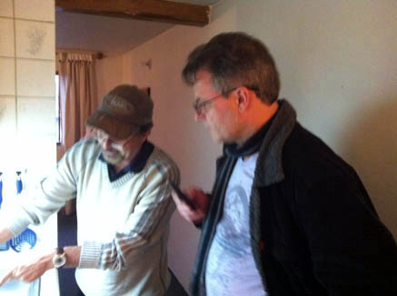  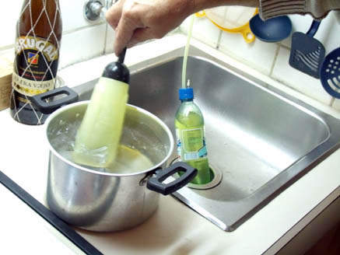  Next we went to meet Jorge. He has been taking MMS personally and for 20 years he has been going into the Amazon helping the sick. We showed him how to make MMS/CDS and supplied him for a 3 week journey into the Amazon where he will treat hundreds that are suffering with malaria and many other ailments.  Teaching Jorge how to make MMS/CDS  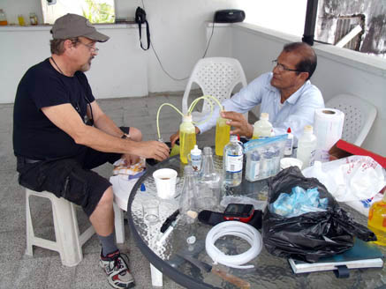  The Finished product!!!  4 - 500 ml of fresh MMS/CDS 3,000 ppm  Note: We have CDS we made 4 months ago that is still good (1500 ppm). Store it in a dark place sealed tight or a refrigerator.  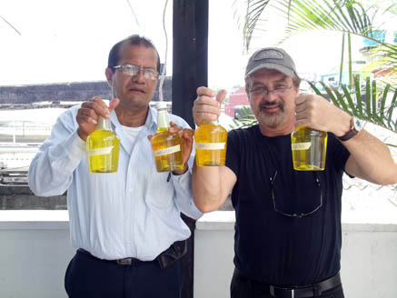  Supplies for Jorge's trip to the Amazon. It takes many days to get there and several by boat!! We sent him with malaria blood test strips, a water proof camera,spray bottles, eye droppers, etc. and enough MMS/CDS for to treat hundreds!! He needs our constant thoughts and prayers for safety.  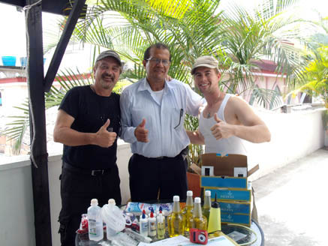  Here is a lady we treated with Stage four cancer. She was sent home to die and looked horrible. This is her after 3 weeks with the Sacrament 1000, (previously known as Protocol 1000). The doctor said she was cancer free!!!  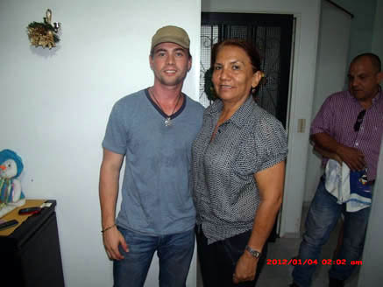  Note: The MMS/CDS Sacrament 1000 is 8cc's of MMS/CDS in a liter of water. Here is a sample of the Sacrament 1000 kit we prepared and distributed freely.  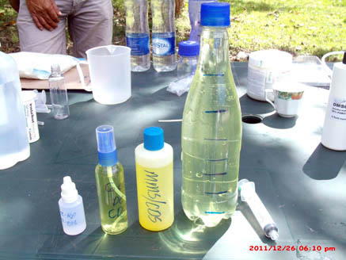  We then headed to an indigenous group that had been using MMS previously with great results but ran out. We were able to teach a small group in a remote village. It was cold at night!!! Making MMS/CDS  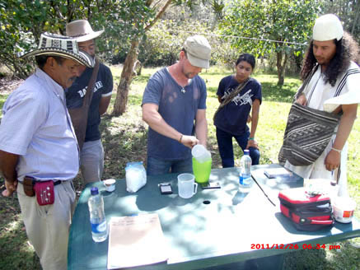  Eye drops  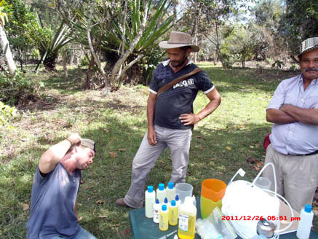  Five more healers!!!  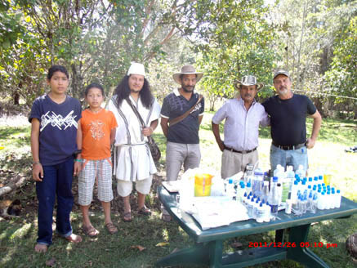  We were in several other towns treating people with MMS/CDS. Amazing results! During the 3 weeks we were treating people with Sacrament 1000, we saw:  • Stage 4 Breast cancer cured!! (Sacrament 1000)  • Diabetes cured!! Blood sugar level 210 before Sacrament 1000, now 108!!  • Diabetes cured!! Blood sugar 250, now 110!! (Sacrament 1000)  • Pin worms gone!! (Sacrament 1000)  • Fibroid tumors gone, Sacrament 1000 and Douche, (Douche - 3cc's CDS in ½ liter water) Before bed is best.  • Chargas, leichmisis gone in days, Sacrament 1000 with CDS spray bottle, (3 cc's per ounce)  • Multiple sclerosis, improving daily, (couldn't move left hand, now it moves freely)  • Mana Ray wound (straight CDS poured on wound; neutralized poison).  • …..Pain gone immediately!!  • Warts gone!! Sacrament 1000 plus spray applied numerous times daily.  Note: Use 3 cc's per 1 ounce when making spray bottle with CDS)  Our Health Ministers, (Healers), are being trained to document everything now!! Do the same and add your testimonies at genesis2church.org.  Donate to the Malaria Project / Indigenous people's project – Use Rev. Joe's Paypal link at, JTG1987@gmail.com  Home video Course discount for the next month.  We would like to offer starting today, $100 off our MMS Home Video Course for the next 30 days only. Also, for an additional $25 you will receive the new updates about MMS/CDS and all the protocols updated.Please contact Rev. Jon at, genesis2mission@gmail.com  South American Spanish Seminar March 1-4  We need to know if there you have interest in our First Latin American MMS Seminar in Colombia March 1-4. (Only in Spanish) Please sign up by mailing gmark777@gmail.com, read more at http://mmsnews.org/all-newsletters/92-latin-american-seminar-in-South America-01-11-2012.html  try the MMS Home Video Course.  Please contact us at genesis2mission@gmail.com  For information about Church membership,  please contact us at: gen2church@gmail.com  MMS Saves Lives |  | 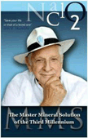  The Master Mineral Solution of the 3rd Millennium  Download Partial Ebook for FREE  Download Full Ebook  Order Hard Copy  Order for Kindle  Order for iPhone, iBook, iPad  Order Audiobook  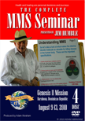  Order the MMS home training DVD, pass exam and become a Genesis II Church Reverend and MMS Health Minister.  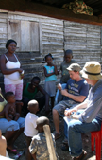  Sign up for the next MMS seminar  More information about our MMS seminars  Take our MMS seminar, pass exam and become a Reverend, Health Minister and Doctor of MMS.

 | Genesis II Church membership:  • Sign up here  Donate to the Genesis II Church:  • Donate here  Upcoming MMS seminars:  • Jan 19th – Jan 24th 2012 in Costa Rica  • Feb 12th – Feb 22nd 2012 in Dominican R.  • Mar 25th – Apr 4th 2012 in Dominican R. |  | Genesis II Church of Health & Healing:  • http://www.genesis2church.org  Genesis II Forum & MMS / CDS support:  • http://www.genesis2forum.org  Archbishop Jim loves social media:  • Follow Jim on Twitter  • Befriend Jim on Facebook  • Subscribe to Jim on YouTube

No longer interested in our newsletters?
Click here to Unsubscribe
Top of Form
Bottom of Form
Top of Form
Bottom of Form
Top of Form
Bottom of Form
Top of Form
Bottom of Form
Go to Previous message | Go to Next message | Back to Messages
Top of Form
Bottom of Form
| Full Headers
Reply Reply All Forward Forward
Top of Form
Bottom of Form
Top of Form
Bottom of Form
Top of Form
Mail Search
Bottom of Form
WelcomeInboxNewFoldersMail Options

to STOP GOING TO MEDICAL DOCTORS TO BE DIAGNOSED WITH DISEASES. You are an 81-year-young lady, so this is a dangerous age to be going to medical doctors as they are comparing you to the perfect metabolic model in Grey’s Anatomy and guess what—you are not perfect, baby.
I knew a man younger than you who went in for a checkup and was told he had Macular Degeneration and was going blind. I tried to convince him that life is a “limited time offer” and that we are all going blind as we age, but instead he decided to get depressed and a year later he bought a pistol and blew his brains out. My point being, we are all aging, we are all dying and if we start focusing on what is wrong with us, we will get ourselves in a lot of physical, emotional and spiritual trouble.
As I was just writing this, I couldn’t remember the name Macular Degeneration, it took me about 1 minute to remember that name. Does this mean I have premature senility, or Early Onset Dementia (as I am only 59), or even the beginning stages of Alzheimer’s Disease? Who knows and who cares! Personally, I love the aging process, as I don’t care enough about disease names anymore to be worried about forgetting a few of them.
Hard Drive Almost Full
I heard recently that the amount of stimulus, mental input and information we get on a daily basis, from talking, radio, television, movies, newspapers, magazines, telephone, the internet, and so on, is more input in one day that the average American got in their ENTIRE LIFETIME 100 YEARS AGO!
THIS IS JUST TOO MUCH STUFF TO FIT INTO OUR BRAINS! OUR COMPUTER HARD DRIVE CAPACITY IS FULL. So my question is: Do you have Early Onset Dementia, or is your brain just saying enough is enough, and simply filled up with too much stuff?
STOP TAKING DRUGS
I am so happy that the drugs the medical doctor gave you made you puke and poop your brains out, so you stopped taking them. I hope you learned your lesson. If not, read this BLOG I wrote to a woman last year, who asked me about her 84-year-old father using pharmaceutical drugs. In my answer, I discuss in detail about seniors using drugs, covering many aspects, and even when I suggest using them.
So Dottie, let’s just say that your computer hard drive is so full, and that you are bombarded with so much input, that you cannot hold all of this information anymore, or at least cannot immediately recall everything at a moment’s notice. You know that the more data that you store on a computer hard drive, the longer it takes the computer to sort through it and find the particular file, so why would it be any different in your brain? You are older, you have a huge library up there, so it takes you a little more time to find the books, and then the particular page. This sounds perfectly normal to me.
OK, LET’S GET THIS BRAIN IN SHAPE…
The Brain
The brain, like any other organ in our body, is made up of millions of cells, in this case brain cells. I remember when I first held a brain from a cadaver in my hand—it was a very enlightening experience. I knew from medical books what a brain looked like, but I had always imagined it to be a very special organ. I don’t know, maybe I expected it to be slightly gaseous, or have some shiny stars spinning around it or something, but no gas, no stars, nothing special, it’s just a hunk of meat.
And, like every other organ or group of cells, it must have nutrition going IN and it also must eliminate waste OUT. So, great circulation is a fundamental here if we want the brain, or any organ, to function at its best.
More Blood to the Brain
So how do we get more blood to the brain? Well, this is not very difficult. The first way is simply by reversing gravity.
GRAVITY is simply the downward pressure on your body caused by the sun, moon, earth and planets. This pressure has a dramatic influence on the fluids of your body. Therefore, the hardest place for your heart to pump blood to is your brain, and this is why you have one of the biggest sets of arteries (carotid) and biggest sets of veins (jugular) to accommodate a large volume of blood flow to and from your brain. But as we age, gravity takes more of a toll on us and the flow of our bodily liquids. It can simply make it harder for you to get good circulation to all of your extremities as you age, especially your brain. This is part of the reason that, as people age, they often have problems with vision, hearing, memory and many other brain functions. So the simplest answer is to get more blood flow and circulation to your brain.
SLANTING and INVERSION. A great way to start is simply to reduce the size of your pillow that you use in bed, and also to take a few books that you won’t read again, I suggest medical books, and put them under the foot posts of your bed. Get your bedposts at the foot of your bed raised up about two inches on each side. This will slant your bed slightly so if you were to put a ball at the foot of your bed it would roll towards the head of the bed. By doing this, you will assist your body in getting more blood to your head ALL NIGHT LONG. YOGA inversion poses are awesome, like shoulder stands, SLANT BOARDS, and even BACK SWINGS and other similar devices that you strap yourself into and go into a slant or even an upside down position and even gravity boots for the most extreme inversion. Be careful, and always start slowly.
HERBALLY, you can also drive a lot more blood to your brain, and two of the greatest herbs to do this are Cayenne and Ginkgo biloba, two of the main ingredients in my Brain Tonic. My Brain Tonic will drive more blood, oxygen and whatever is in the blood like nutrition, into the brain. It DRAMATICALLY increases blood circulation to the brain. I suggest 2 droppersful four times a day, indefinitely, mixed with an ounce or two of juice.
Better Blood to the Brain
Now that we are getting a lot more blood to your brain, with inversion, slanting and my Brain Tonic, let’s make sure that your blood is rich with nutrition. After all, driving blood filled with sugar and chemicals is not going to help your brain function. We need to make sure that your blood is supercharged with nutrition and the best way to do that is to eat a food program that is loaded with organic fresh foods, and also to start taking my SuperFood Plus, either making breakfast blender drinks with the powder or taking 5 tablets three times a day. This will give your brain the nutrition it needs to function at peak performance. For maximum results, try a double dose of SuperFood Plus by taking it in the morning and afternoon.
More Waste Out of the Brain
During autopsies, I have seen the brains of people with dementia, senility, Alzheimer’s disease and numerous other brain diseases. I have also read numerous autopsy pathology reports. In both instances, there is often mucous (thick off-white and yellow viscous waste fluids) or we can simply call it gunk, glue or toxic waste. Whatever you want to call it, it is an obvious sign that either the blood getting to the brain is contaminated with junk, or the metabolic waste of the brain cells is not getting out of the brain. Yes, the brain, as it functions, makes metabolic waste that must be removed frequently. And what moves all of this waste out is great blood circulation, so back to inversion, slanting, and my Brain Tonic.
Detoxification
We must also make sure that the waste we are removing from the brain has a place to go and your body is able to eliminate and get rid of it. I always suggest starting with my 5-Day BOWEL Detox Program and then a month or two later, do my 5-Day LIVER Detox. This will assure you that any brain waste that is being flushed out will get out of your body ASAP!
Exercise
Exercise is another awesome way to stimulate blood flow in and out of the brain, so let’s start walking an hour a day, and looking at all the ways you can increase your exercise during the day. You know, if you rest you rust, but if your lifestyle is too sedentary, you will also build-up waste in your brain. So at 81, exercise is no longer a suggestion—it is a life-extending MUST!
Finally
Dottie, PLEASE don’t pay any attention to this stupid diagnosis of Early Onset Dementia. NOTHING POSITIVE will ever come from being told you have this, nor you thinking about this. It is NEGATIVE garbage, so please LET THIS GO.
INSTEAD, let’s focus on getting healthier, creating a really healthy lifestyle, and building up your body and brain for the next 81 years.
Think about all the things that you DO remember!
Now get slanting, start taking my Brain Tonic and SuperFood Plus, and get outside for some power walks, and wander into a yoga class now and then, and have FUN with all of this!
— Dr. Schulze

Copyright © 1994-2012 Yahoo! Inc. All rights reserved. Terms of Service - Copyright/IP Policy - Guidelines
NOTICE: We collect personal information on this site.
To learn more about how we use your information, see our Privacy Policy - About Our Ads.

