Photo by Analiese Trimber
If you haven’t zoodled yet in life, you are seriously missing out. I mean let’s be honest, who knew that slicing zucchini into noodle form and sautéing it briefly would taste good. While zoodles are definitely not the same as pasta, they are a perfectly suitable and guilt-free way to indulge in a one-pot meal of creamy deliciousness.
Level: Easy
Prep Time: 10 minutes
Cook Time: 10 minutes
Total Time: 20 minutes
Servings: 1 (or 2 if you eat like a rabbit)
Ingredients:
2 tablespoons olive oil
2 cloves garlic, finely diced
2 medium zucchini or squash
Juice from 1 lemon
1 ½ tablespoons corn starch (or tapioca starch if you want to make it Paleo)
¼ cup water
Any veggies or toppings you’d like—you can see I added some sweet potato and asparagus
Salt and pepper, to taste
½ tablespoon dill
Directions:
1. Using a spiralizer, slice zucchini and squash into noodle form. If you don’t have a spiralizer, you can use a mandolin, super sharp knife, or vegetable peeler to slice the squash thinly, and then cut into noodle-sized width from there.
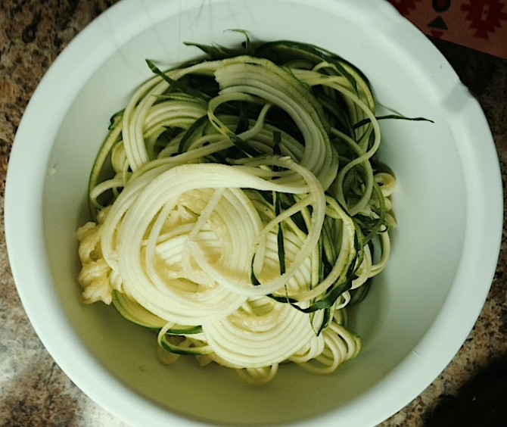
- Share
- Pin It
Photo by Jen Berger
2. In a medium-sized frying pan, heat the olive oil and garlic over medium heat.
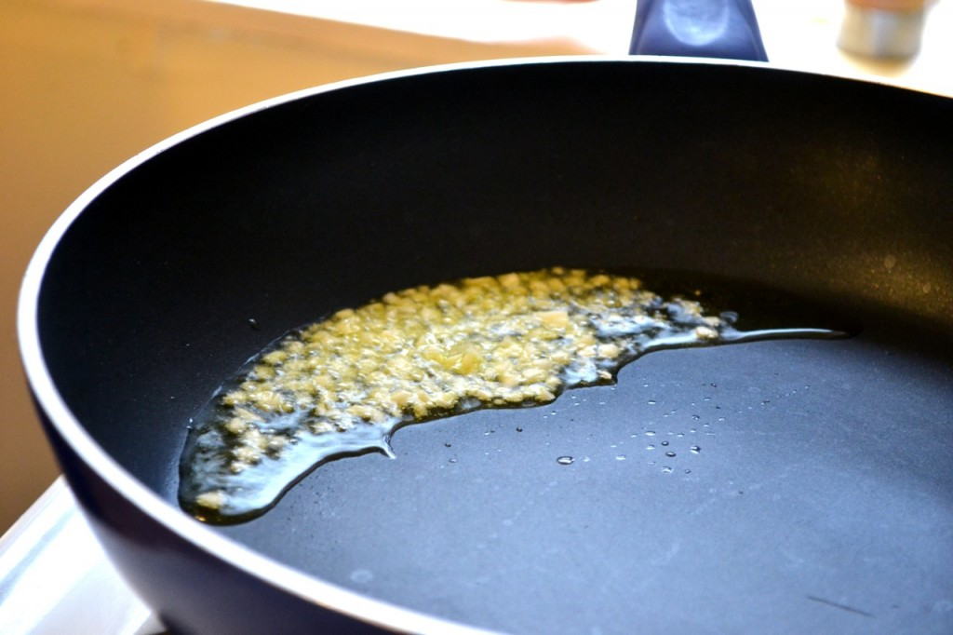
- Share
- Pin It
Photo by Kelda Baljon
3. Add whatever veggies you’d like to the pan and cook for 5-10 minutes or until nearly cooked.
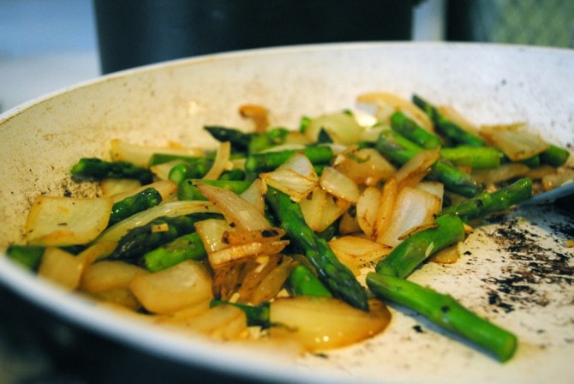
- Share
- Pin It
Photo by Kelda Baljon
4. Add the zucchini noodles and lemon juice and sauté for another 5-10 minutes or until soft.
5. In a small bowl or cup, combine corn starch and water and stir until fully incorporated. Add to pan and stir everything constantly until the mixture starts to thicken.

