
FOOD MATTERS FMTV

- FILMS
- Wellness Guides
- Recipes
- Videos
- Articles
- Superfoods
- About Us
- Store



Homemade Falafels With Quinoa Tabbouleh & Tahini Sauce
13 October, 2015
3.3k LIKE
10 TWEET
618 PIN
4 COMMENT
0
4.0k SHARES
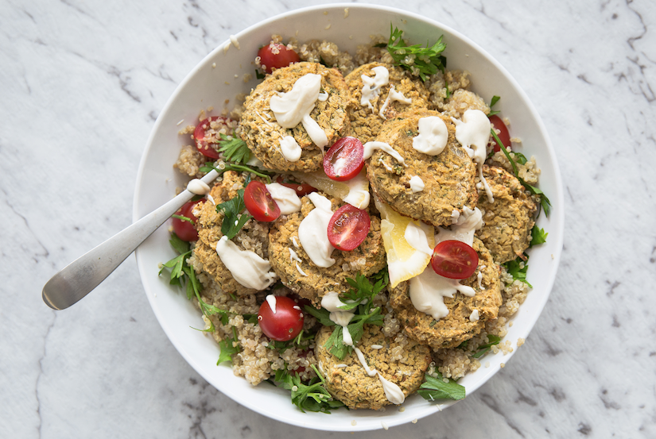
Rachel Morrow (Food Matters)
Regular falafels claim to be healthy, but they're often deep-fried and loaded with fillers and gluten. Try this tasty, gluten-free, oven baked version instead. It's packed with flavor!
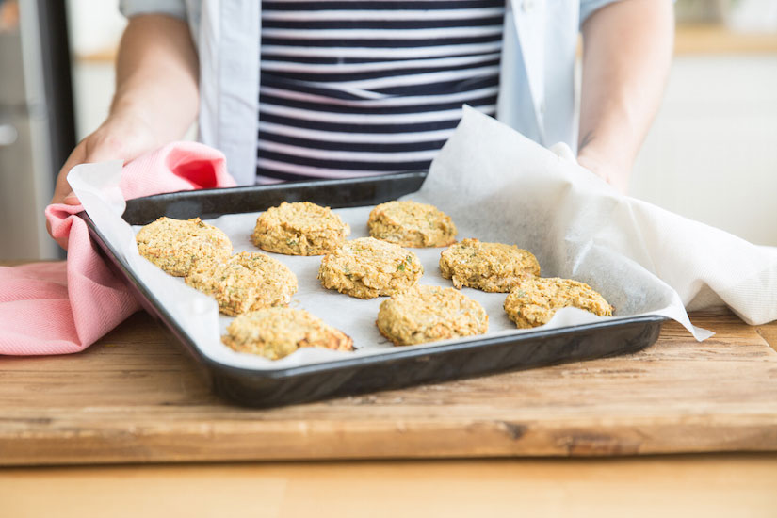
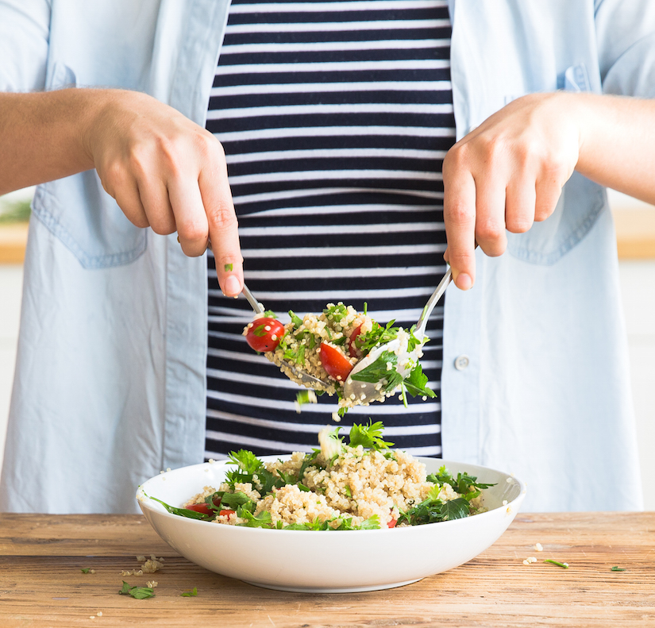
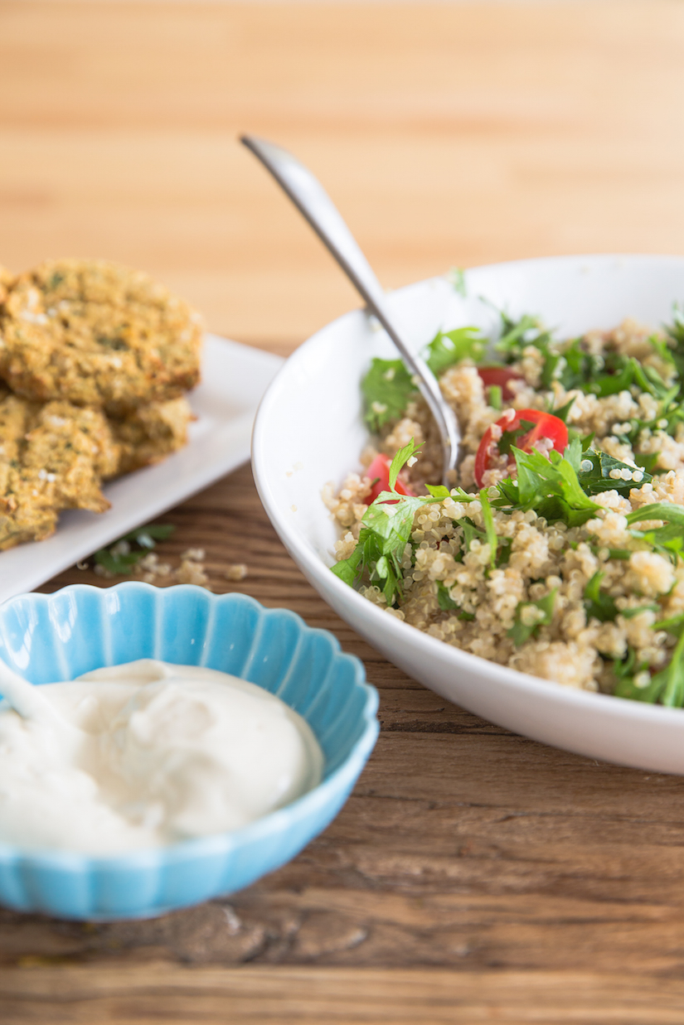

FALAFEL INGREDIENTS
- 2 x cans organic chickpeas (rinsed)
- 2 garlic cloves, crushed
- 1 onion, finely diced
- handful of parsley
- handful of cilantro
- 1 lemon, juiced
- 1 tsp ground turmeric
- 1 tsp ground cumin
- 1/2 tsp ground chilli
- 1/2 tsp sea salt
- 1/4 - 1/2 cup tapioca flour

QUINOA TABBOULEH
- 1 cup cooked quinoa
- 1 punnet tomatoes, halved
- 1 cup parsley
- juice of 1 lemon
- salt and pepper
This is from our FMTV Recipe Series, check out the recipe step-by-step here.

TAHINI SAUCE
- 3 tbsp tahini
- 3 tbsp yogurt
- 1/2 lemon, juiced
Optional: Serve with organic pita pockets or make our gluten-free tortilla wraps to serve them with.

WHAT TO DO
- Preheat oven to 350 degrees F (180 degrees C).
- Add the onion and garlic cloves to the food processor and pulse just until they are finely minced.
- Add the chickpeas, parsley, cilantro, salt, chili powder, turmeric, and cumin to the food processor and pulse until they are roughly blended but not pureed.
- Add just enough flour so that when you pulse the processor, the mixture begins to form a small ball and is not sticky. Start by adding ¼ cup of flour, and then the remaining ¼ cup. You can add more if the mixture is still too wet.
- Transfer the falafel mixture to a bowl, cover and refrigerate it for 1 hour.
- While the falafel mixture is chilling, prepare the tahini sauce by whisking together the yogurt, tahini and lemon juice. Season it with salt and pepper.
- Prepare the tabouli salad by mixing together the cooked quinoa, parsley, tomatoes, lemon juice and season with salt and pepper.
- Once the falafel mixture has chilled, use a small ice cream scoop or spoons to form the mixture into balls (roughly 3 Tablespoons per ball) and place onto a lined baking tray.
- Bake in the oven for 20-30 minutes or until nice and golden brown.
- Serve with a dollop of tahini sauce and a serve of quinoa tabouli or put together a falafel wrap.

Do You Love Falafel's? How Do You Love To Serve Them?

3.3k LIKE
10 TWEET
618 PIN
4 COMMENT
0
4.0k SHARES

About the Author


Rachel Morrow
Rachel is the Social Media and Communications Guru for Food Matters, and a qualified Nutritionist. When she isn't mingling with you on Social Media, she's busy creating delicious, healthy recipes in the Food Matters kitchen to share with you!
VIEW MY PROFILE

Related Articles
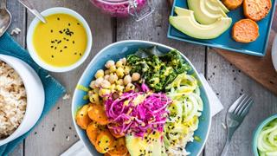

5 Nourish Bowls We Love & How To Make The Perfect Mix
04-Oct-2015
We’ve pulled together some of our fave creations from around the interwebs for you to enjoy.

SHARES 7.8k
7
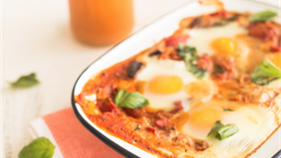

Shakshuka (Baked Eggs Recipe)
07-Sep-2015
Shakshuka is believed to have originated from Tunisia. This dish of poached eggs in rich, spiced sauce makes the ultimate centre-of-the-table breakfast!

SHARES 2.4k
9
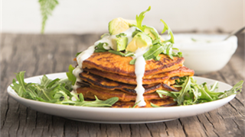

Sweet Potato Pancakes With Breakfast Greens
08-Sep-2015
This little number is a refreshing take on everyone's favorite breakfast recipe: pancakes! With just a few ingredients and no gluten, this will be your new fav pancake recipe. Sweet or savory!

SHARES 6.6k
32

Related Products


FMTV
No more wasting time scouring the internet for the latest film or obscure health doc. We've got you covered, bringing you the best of the best (and leaving the rest).
from $7.95/month
LEARN MORE
VISIT FMTV
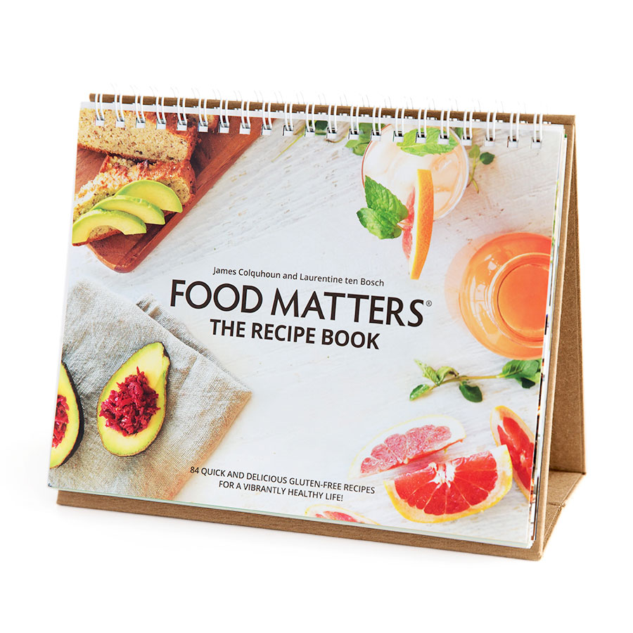

Food Matters the
Recipe Book
Introducing the 'Food Matters' Recipe Book, your ultimate kitchen and healthy living companion! If you've watched 'Hungry For Change' and 'Food Matters' and you are looking for ways to incorporate the lessons from these films into your daily life then this book is for you.
RETAIL: $34.99
$29.99
LEARN MORE
ADD TO CART
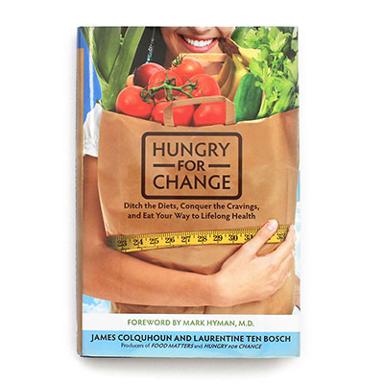

Hungry For
Change The Book
A how-to guide for breaking free from the diet trap, Hungry for Change is based on the indisputable premise that 'Food Matters,' as it exposes the truth about the diet industry and the dangers of food addictions and enables you to take charge of your health and strengthen your mind and body.
RETAIL: $26.99
$19.99
LEARN MORE
ADD TO CART



Looking to kickstart your health?
GET STARTED WITH A FREE FOOD MATTERS GIFT PACK
CHOOSE YOUR GIFT >


We here at Food Matters are committed to helping you help yourself. We believe that your body is worthy of good care and that no one is more suitably qualified to care for it than yourself. Think of us as your nutritional consultants and know that we are here with you on your journey to a healthier life.

Read more about us.



Get a weekly dose of wellness inspiration
- Healthy Lifestyle Tips
- Quick & Easy Recipes
- Natural Healing News & More!


Join The Food Matters Community For Free!
Weekly recipes. Health tips and more!

Home Store Recipes Articles Wellness Guides Your Stories About Us Write For Food Matters Careers & Internships
Superfoods Study Nutrition Juicer Buying Guide Events Screenings Health Resources Affiliate Program Press
Hungry For Change FMTV Distribution

The Team Live Chat Contact Us Shipping
1.4M fans 24k fans 50k fans 82k fans
Live Chat | Contact Us | Shipping | Disclaimer | Privacy Policy | Terms & Conditions | Copyright © Food Matters International Pty Ltd, All Rights Reserved
<img height="1" width="1" border="0" alt="" src="https://googleads.g.doubleclick.net/pagead/viewthroughconversion/1041016591/?frame=0&random=1445460684133&cv=8&fst=1445460684133&num=1&fmt=1&guid=ON&u_h=768&u_w=1366&u_ah=768&u_aw=1366&u_cd=24&u_his=1&u_tz=60&u_java=true&u_nplug=11&u_nmime=101&frm=0&url=http%3A//foodmatters.tv/content/homemade-falafels-with-quinoa-tabouli-tahini-sauce&ref=http%3A//foodmatters.tv/content/does-cutting-out-gluten-really-make-you-feel-better%3Futm_medium%3Demail%26utm_campaign%3DFM+NL+Oct+21+2015%26utm_content%3DFM+NL+Oct+21+2015+CID_88781994b89b082b3103a4e97854987a%26utm_source%3DCampaign%2520Monitor%2520Email%2520Marketing%26utm_term%3DREAD%2520MORE" />

