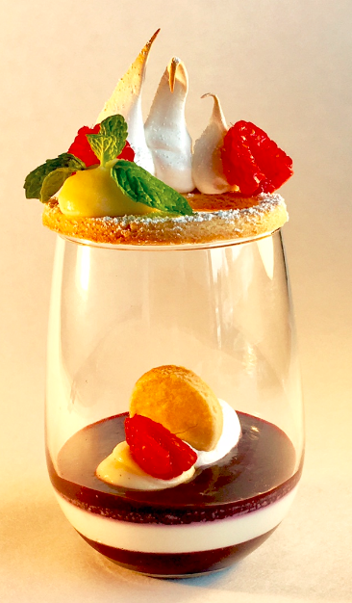

ITALIENNE
MERINGUE
FRESH HALF
RASPBERRY

MINT LEAF

ALMOND
SABLE
DOUGH LEMON CURD

WHIPPED
CREAM

BLUEBERRY COMPOTE GELIFIE VANILLA PANNA COTTA
Blueberry Compote: 60 gr
Panna Cotta: 60 gr
Lemon Curd: 20 gr
Whipped Cream: 6 gr
Almond Sable: 31 gr
Italienne Meringue: 5 gr

