Isometric Exercises
Order FACE LIFTING BY EXERCISES / ISOMETRIC EXERCISES book today.
Doing isometric exercises
Only facial isometric exercises are of value to the facial muscles. Isometric exercises are possible only if a muscle or a muscle group is worked against proper resistance, whereby the resistance has to be held at the point of muscle function, permitting the fullest muscle contraction at the slowest range possible. Any other muscle movements cannot be considered as isometric exercises. Tone and flabbiness can be improved through isometric exercises that produce slow, long- range expansion. orrect facial isometric exercises when done faithfully will work. acial isometric exercises also apply to all areas of the face and throat.
Why do isometric exercises work?
The facial muscles, like muscles everywhere on our bodily structure, need to be exercised to maintain their firmness and proper facial isometric exercises provide remarkable results.
The isometric exercises demonstrated in face lifting by exercise involve resistance. These isometric exercises are specifically designed to firm and shorten elongated facial muscles, thus, literally lifting the face.
The skin is merely a thin covering over the flesh that has to go along with the muscle formation which will return to the size of the muscle flesh when shortened through isometric exercises. For unelastic muscle tissues isometric exercises will shorten, thicken and restore the elasticity to the muscles.
What is a good isometric exercise to try?
You must first perfect the preliminary practice of isometric exercises before you proceed to any of the isometric exercises in the book and the timeframes must be adhered to. See a sample of isometric exercises below.
Isometric exercises - corrective throat exercise:
- lift chin slightly upward,
- with flat point of index and middle fingers press against indentation (hollow) formed by the two upper nodules of the larynx located at the curve from chin to throat. Do not be concerned in the beginning as to the precise location of pressure which you will discover through practice. Regard finger pressure as the resistance against the working muscles,
- now press your back teeth firmly together and while maintaining this position,
- press the tip of your tongue against the inside of lower front teeth (gum line) increasing pressure with the tip of the tongue in 10 or more gradual and definite steps.
- hold end position of pressure for 6 seconds.
- release muscle work for 10 gradual steps.
- remove finger resistance.
- repeat 4 more times.
Note: if resistance is kept at the right place you will feel the muscles pushing against your finger resistance. For each increase of pressure with tip of tongue you will sense a stronger push against your resistance.

Types
• There are various isometric exercises you can do for the face:
Close you mouth, then pout your lips straight out in front of you and hold for about 10 seconds. Relax, then pull your lips back toward your ears and hold for about 10 seconds.
Open your mouth and jaws really wide and hold for about 10 seconds. Make the motion like you are yawning.
Close your lips and open your jaws. Suck your cheeks in toward the center of your mouth as far as you can and hold for about 10 seconds.
Lay on your back on your bed with your head hanging over the edge. Lift it up until it is in a straight line with your body and hold for 10 seconds.

Identification
• Isometric facial exercises can be done every day, and the holds can be done four to five times each. It is also a good idea to do these exercises while standing in front of a mirror where you can monitor your form. You also might want to be alone when you do them because you will be making some interesting faces.


Complete Facelift in 7 Days Without Surgery
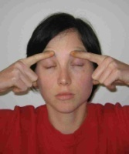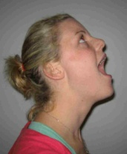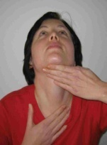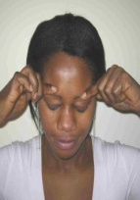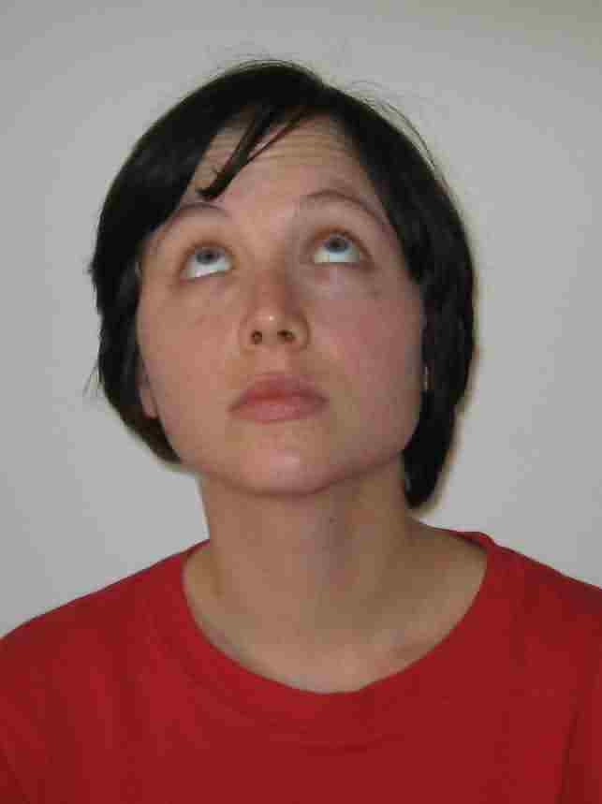
Claim Your Copy Now
Caution! Don't Ever Consider Plastic Surgery Until You Read This....

Did you know it is very possible to have a thorough face-lift without plastic surgery? I tell you, if you want the best antiaging treatment without going broke, then the advanced form of facial exercises known as facial gymnastics is the way to go. You'll discover on this page how you could boost your skincare routine, attain the status of an ageless goddess, and bid cosmetic surgery bye bye forever.
You need not, and you shouldn't submit to invasive, and painful anti-wrinkles procedures that could go wrong. Facial gymnastics offer you the full benefits of plastic surgery without the risk of facial deformity.

Facial Gymnastics
There Is No Other Known Natural Antiaging Alternative To Plastic Surgery. This Proven Advanced Face Exercise Is It. I Christened It Facial Gymnastics After Many Years Of Scientific Research.
Now
Imagine looking into the mirror, and seeing absolutely no signs of aging on your face year after year, by just following a very simple set of activities which only involve your face and your 2 hands.

My dear Friend,
I've been saying it for over 10 years that you can have a perfect face lift using facial exercises, and better still facial gymnastics, without the need for a plastic surgery. I have said it times without number that your best anti-wrinkle solution is not in the hands of the so called experts who will milk your bank account dry in the name of new fads from the cosmetics industry. I'm saying it loud and clear again that your anti-aging skin care strategy is as personal to you as choosing a cloth to wear from your word robe.

Just like many other things in life, what you want for your face is up to you. You may decide to take action in order to have a smooth and ageless skin. You may opt for a face endowed with youthfulness. On the other hand, you may choose to do nothing, and watch helplessly as your face keeps to accumulate wrinkles, your cheeks continue dropping, your forehead infested with lines, your chin multiplying to 2 or 3, your eyes developing bags under them, and several other unsightly signs associated with aging.

After over a decade in this business of showing women how easy it is to remain ageless, I'm yet to come across a single person who decides to settle for the second option of being indifferent to her looks. Yet, many of those I encounter are using complicated approach to solve a simple problem. I will therefore urge you to take a few minutes to reassess your position concerning the actions you've taken so far on your face as far as anti-wrinkle, and anti-aging skincare are concerned.

I have packaged for you an advanced form of scientifically proven facial exercise program known as facial gymnastics that will bring your face to lime light. You will experience a first hand benefit of ageless personality with this program in just 7 days. I guarantee you, your face will never remain the same.
You Don't Need Plastic Surgery At All!.
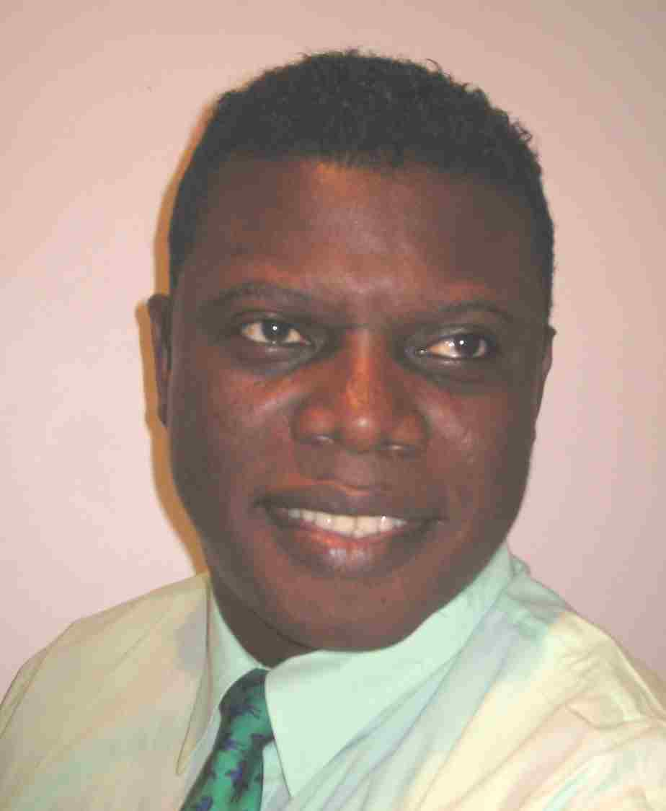
All You Have To Do is Give Me 30 Minutes Of Your Time Every Day, For 7 Days, And I Will Turn You Into That Ageless goddess Of Beauty. (100% Guaranteed)
Ade Adeyemi Coles
(M.Sc, MAIMS, MNSBMB, MAIEH)
CEO Facial gymnastics
5 June 2010

Surgical or natural facelift,
Which one suits your fancy?
Have you ever sat down to weigh the different options
open to you on keeping aging and the ugly
signs of it away?

If you, like countless number of women I've helped with my program are eager to do something about wrinkles and other signs of aging on your face, then you will be confronted with 2 choices
• The first alternative that readily comes to mind is to settle for complicated plastic surgery. This luxury however remains only a dream, and will remain so for several women because of the prohibitive cost involved. And if care is not taken you may come out of the surgery facially deformed. If you're in doubt take a trip to Hollywood and check out what has befallen the faces of some celebrities.
• The second option which is by all standards the most reasonable, and acceptable choice is to engage yourself in scientifically proven advanced form of facial exercise program, known as Facial Gymnastics whose benefits remove all the pains that accompany cosmetics surgery. For instance, it is non-invasive, and it is affordable for everybody.

I receive mails everyday from women around the world. It is the contents of such mails that inspired my coming to the two choices I mentioned above. Here are desperate women who want to share their thoughts on their looks. They want a quick, easy, and safe way to improve their faces. Most of these women could not afford surgical facelift, and are totally ignorant of facial gymnastics.

Among those who are aware of this natural way to remain ageless and tone facial firmness, majority harbor some misgivings which stemmed from poor understanding of the subject such as: "Well, they say facial exercises can create wrinkles, if facial gymnastics are their advanced form, it therefore follows that I will develop more wrinkles from facial gymnastics". Nothing can be farther from the truth than the above statement. As we all know, ignorance is a disease, and only right and helpful information can cure it. This page has helped several thousands of people to gain sound insight into what they stand to gain from facial gymnastics. Your own case will not be different. I can assure you that.

Back to the affordability of plastic surgery. Some women on the other hand can afford surgical face lift but are stone scared because of all kinds of ugly stories emanating from those who have undergone such procedures.

Having a Facelift Without Surgery Has
Never Been Easier

Forget the thought of surgical facelift. Forget
the agony of testing every new solution that suddenly
surfaces in the the market, and then disappears leaving your
face with more wrinkles and
your purse lighter than
a feather

My Anti-wrinkle, and Anti-aging Facial Gymnastics
Program will leave your purse still intact with
your money, and your face lighter of wrinkles
with other signs of aging brought to zero point.

What is your concern about your face?

- Do you have lines and wrinkles? Not to worry, my anti-wrinkle facial gymnastics program take care of them for you. It is dead easy.

- Do you have folds and bags under your eyes? Just relax, this anti-aging program will bail you out. The muscles responsible for the conditions will be called to order.

- Are you worried you may lose your beauty with time? Be not troubled. By simple facial muscle toning, my ageless facial gymnastics program will help you regain, and or retain your looks, and keep those unwanted signs of aging several thousands of miles away.

- Do you have droopy double or triple chin? This superior form of facial exercise program will help you clear those unwelcome chins away in no time.

- Do you have hanging cheeks or sign of it? This is the right time to take action, grab a copy of this facial gymnastics program and watch those cheeks return to their normal orientation.

- Do you desire to be ageless? The key to what is thought to be a fantasy lies right inside my facial gymnastics program. You are now at liberty to live your fantasy.

- Do you have puffy and droopy eyelids? My comprehensive facial gymnastics program will help you bring those eyelids up and keep them up.

- Do you have folds in your neck and throat? If you follow the simple techniques in this advanced form facial exercises, such folds will be eradicated without any qualms.

- Do you have puckered up mouth? This facial gymnastics program will teach you how to target specific facial muscles responsible for such appearance, and your days of concern will be become instantly numbered.

- Do you have vertical lines above your upper lip? This powerful anti-aging facial gymnastics program will smoothen out those lines, and give your face even smoothness that will make Hollywood stars envious.

- Do you dream of having plump-up lips? Your dream is nearer to reality more than you know. My facial gymnastics program will tutor you how to pump those lips up, and your mouth will give angelic curvatures when you smile.

- Do you feel you are losing tone and facial firmness? Perish the feeling, my facial gymnastics program will take you on a tour of facial muscle toning, and translate you to an ageless phenomenon.

- Do you have wrinkles at the corner of your eyes? This particular type of wrinkles appear like bird's claw. Most people I have met or that I have had to counsel online are frantically finding ways of getting rid of these wrinkles. Most of these people would like to know from me if my facial gymnastics program can help them out. I will tell you what I told them. A whole section is devoted to tackle this problem in my program. Those wrinkles will literarily melt away, and you will have in their place smooth skin fortified with inbuilt anti-aging activities, as well as soundly toned facial muscles.

"Ade I've heard enough. How do I get my own copy of this
amazing anti-aging facial gymnastics program?"

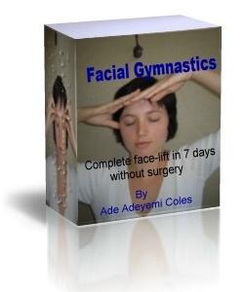
To grab your own copy instantly is dead easy

Click Here to Buy Your Copy Online Through Clickbank
Looking beautiful, and forever young need not cost you a fortune and life time of aches. All you ever need is to work with a program that works with you, and at the same time work for you.
...and that is the program I'm presenting to you. It is not facial exercise program. It goes far beyond facial exercises by selectively targeting and modulating the facial tissues and muscles responsible for aging signs, bringing them under control and directing their activities in such a way that encourages elimination of wrinkles, and promotion of healthy facial skin cells turn-over. This leads to glowing and radiant face skin. This program is known as Facial gymnastics.

Testimonials! Testimonials!! and more
Testimonials!!!

I will now share some of the mails I receive almost on daily basis from happy and satisfied customers with you. They come from all around the globe. They all have only one message in common. And that is: this facial gymnastics program works wonders

Listen to Roseline who got heads turning
Hi Ade,
I can't thank you enough for all the benefits I gained from your comprehensive facial gymnastics program. A friend I saw 2 years before starting your program could not believe I did not go under the knife to get my new looks up till today. He never looked my way twice back then, but presently he's been on my neck for a date. I'm a single mum of two, and these days I have heads turn my way from suitors. This facial gymnastics program really works.
Roseline Adams,
Alabama, USA
___________________________________

How about Jessica who now loves looking into the mirror
Ade,
You can't believe I hardly looked myself in the mirror prior to buying your facial gymnastics program. What I used to see in the mirror was not pleasant to the eyes, and I was often depressed with the wrinkles and lines that rapidly developed on my face. I could not afford a surgical face lift, and that made the situation worse until I came across your program. My face has been turned around for good. I have fewer wrinkles, my facial skin is more toned, and I dare say that I'm no longer terrified to look into the mirror. I now love what I see in the mirror. Thanks for such a wonderful anti-aging program.
Jessica Owens,
Toronto, Canada
_________________________________

Check out what Melissa has to say about her self-esteem
Hello Ade,
Just to drop a few lines about your facial program. Although I'm in my mid 20's and a successful career woman, I kind of developed wrinkles quite early. This battered my self-esteem because I looked several years older than my age. I was nursing the thought of going for a cosmetic surgery when a friend came along and introduce your facial gymnastics program to me. I took her advise just because of how smooth and beautiful her own facial skin was, and still is. My self-esteem has since been restored, my face is getting smoother and smoother everyday as I continue with the program. You saved me several thousands of dollars I would have spent on plastic surgical face lift.
Melissa Brown,
London, UK
________________________________________

I also got mails from down under in Australia
Hello Ade,
My problems has always been bags under my two eyes. I have been to different doctors, and what I was repeatedly told is that my only hope was in surgery. Well, I did not have the money to start with, and our medicare program did not cover such medical bills. Fortunately, as I surfed the net for alternatives, I stumbled on your facial gymnastics program. I bought it, started the program and paid greater attention to the section that deals with my problems. To my amazement, I started noticing changes in a few days, and after a few weeks those bags faded away completely. Keep on spreading the good news of this alternative to surgical facelift.
Margaret Holden,
Melbourne, Australia
____________________________________________

...... and another one from Sydney, Australia
Hi Ade,
Just to let you know that your comprehensive facial gymnastics program has effectively addressed the issues I long have with dropping cheeks. I'm sure if all women know about this simple, yet practical and effective natural face lift program, cosmetics industry would have since stopped taking us for a ride in the name of anti-aging treatment craps.
Laura Holmes,
Sydney, Australia

Click Here to Buy Your Copy Online Through Clickbank

Words of regrets came in as well
Friends, I've heaps of mails praising how well my facial gymnastics program has helped countless number of women around the world to effectively manage their looks.
At the same time, I feel so sad to say that there are also mails expressing regrets of not taking advantage of the anti-aging power derivable from this advanced form of facial exercises, which is capable of turning back the clock by toning facial muscles and reducing face fat.

Just listen to one of such unfortunate mails
Hello sir,
Am sure you may not remember me. It's been few years now, but I once wrote you for advise if I should submit myself for surgical face lift. You advised me then to try out facial gymnastics program first, but should I not be satisfied, I could opt for surgery. I'm ashamed to admit that I went for the surgery without trying the facial gymnastics, and came out looking bizarre. I've since had two major operations to correct the mistakes made in the first one, and my lawyer is putting papers together for court action against the doctor and the hospital.
I'm purposely writing again if your program can fix the sagging skin in my neck, and folding one around my throat? I'm dead scared of plastic surgery now.
Tina Jacobs,
Paris, France
_____________________________________
To be honest, I didn't know what to make out of Tina's mail at first. If I advised her before on what to do, and she didn't do it; why should I advise her again on what she knows already?

But I was still compassionate
When I brought myself together to read Tina's mail the second time, I was so moved by her predicament that I immediately sent the comprehensive facial gymnastics program to her free of charge.

Your day should not be spoilt
I would not like to spoil your fun of reading this site by digging into other mails of regrets. Why should I anyway? They all spell doom, and I don't want any of that for you. What I can assure you though, is that by adding a scientifically proven facial gymnastics program to your skin care regimen, you would not be tossed up and down by the so called experts, neither would you be running from pillar to post for anti-aging skin care treatment. Looking young and beautiful has now been reduced to a simple set of time proven formular found in facial gymnastics.

Girls, this program works like magic !
If you are looking for a magic bullet for wrinkles, contours, lines and other signs of aging, you may need not look any further. The only disappointment you would have to come to terms with is how cheap that magic bullet is. Of course you know what I'm talking about. I'm talking about facial gymnastics . You can't compare it's price to the other alternative, which is plastic surgery.

Who can place a price on a Super Wonder?
Alright, if you want to know how much this facial gymnastics program really worth, let me give you an idea of the price of its counterparts
.....which is surgical face lift and its extended family.

Are you really ready to get the cost on just some aspects of a face job?
Alright, here we go!

Cost of surgical, and allied face lift will suck you dry. I tell
- Forehead lift $3,500 - $5,000
- Eyelid tightening $4,000 - $5,500
- Face lift $7,000 - $9,000
- Dermabassion $2,000 - $4,000
- Deep chemical peel $3,500 - $5,000
- Botox $200 - $600 per area
- Collagen injection $500 - $1,500
- Medium peel $1,500 - $2,500
- Blue peel $500 - $700
- Chin or cheek implant $3,000 - $4,500

And there's is no end to the list. It continues until your pocket is hit beyond recognition

Now if you can afford the prices quoted above, maybe my program is not for you. And that assertion in itself can't stand alone on its feet. You have to consider the risks associated with such procedures. Even if you can afford the prices why would you throw such money away when you can have a natural, safe, and non-invasive alternative for a micro-fraction of the above prices.

By The Way, Did You Know That Botox is a Poison?

Listen my dear friend, several fads and treatments that come up every now and then and seem very hot and popular among unsuspecting victims usually have downsides which are sparingly understood by those joining the bandwagon. Such is the case with Botox.

Its real name is Botulinum toxin. It is a neurotoxic protein produced by the bacterium Clostridium botulinum. It is one of the most poisonous naturally occurring substances in the world. I repeat, Botox is one of the most dangerous substances you can find naturally anywhere on this planet as far as toxicity is concerned. That is a strong statement. Isn't it? Yet that is one of the most trust worthy statement you can ever come across. It was initially prepared to treat painful muscle spasms.

Nobody Can Guarantee Its Future Adverse Effects (Oh! That Botox)

As I write this line no scientist in the world can beat his chest and guarantee he knows what the future side effects of botox are. All we have at the back of our minds is that since it is a naturally occurring toxin, those who are getting regular doses of it should prepare themselves for the worst in terms of side effects in the future. Its mechanism of action is to paralyze facial muscles. What else do you expect from a poison? If you have taken it before you would have noticed you won't be able to move the part of the face where you received the injection. If you haven't taken it before, ask those who have done so recently on their foreheads to raise up their eyebrows. I tell you it is easier for a camel to pass through the eye of a needle than for those guys to lift their eyebrows.

What more? You Will Need More And More Of This Poison To Kill Your Face More And More Permanently

I want you to also bear in mind that its so called "positive effect" is temporary. So if you take several shots in different parts of your face, for $600 per area, after a short while the effects wear off. What do you do next? You race again to your doctor's place to get another round of poison injected to your face. That is on assumption that you have the money. Just ask yourself the simple question. "If I keep slamming my face with poisonous substance on a regular basis, what will happen to that face few years from now"? Honestly, I quake and tremble on imagining the different possible adverse outcomes.

It Is Never Too Late To Act!

For Goodness sake, if you are reading this line I want you to be adequately informed. I want you to know that Botox is a toxin, it is a poison, and it is deadly dangerous. Its long term adverse effects can't be ascertained by even the smartest and brightest in the scientific community.
You will do yourself a world of good to change your orientation about botox. It is only a mad person that will read this site and not take advantage of "Facial Gymnastics" in terms of every positive goodies it has to offer. It is non-poisonous, not invasive, no side effects, and better and lasting results. It is never too late to jump into the train of this time proven new hope of facial rejuvenation program known as Facial Gymnastics. Inside this train you will meet people from all walks of life. This program is taking the world by storm. Everybody is talking about its efficacy. Those who were depressed because of aging looks have found hope. Those who have withdrawn themselves into their shells have suddenly found cause to come out confidently because of their new found appearance.

So how much does my comprehensive scientifically proven facial gymnastics program cost?

If surgical face lifts cost between $70000 to $9000, I will be insane to offer my proven program for nothing less than half of the lower price limit. That is if I have to be considerate and be a fool willfully, then I will sell it for $3500.....But I'm not selling it for that price

Ok, if I wish to consider just the forehead lift which costs $3500 - $5000, and again I go for half the lower price bracket. That means I'll be selling the program for $2750........But I'm not selling for that price.

Alright, Suppose I want to select the cheapest procedure from the price list and make that the price of my anti-aging program. Yea, that is botox, right? Ok, it costs between $200 and $400. If I choose the lower price limit, which is $200. How does that sound, fair enough?. Right ......... But I'm not selling for that price .

Do I need psychiatrist assessment if I sell for half that price? That is $100. Well, I don't care what anybody thinks.......But I'm not selling for that price

As a matter of fact, I'm not even selling for half of $100. That is, $50.

This is insane

I'm giving this wonderful, extraordinary, and power-packed program, which is way far superior to its rivals for just
$47.67

I know that really sounds insane. Yes I'm giving it away for that cheap, because that's my own little way of giving back to the society. Tons of studies and researches went
into this program in order to locate, identified, and target specific muscles.

Now, why should you spend several thousands of dollars for what you can get for $47.67?

But wait a minute!

If you buy right now, you will not pay $47.67. I will sell it for you for just $35.67. But this offer is only for a limited time Tomorrow this offer may have ended.

Yes, buy now and pay just $35.67
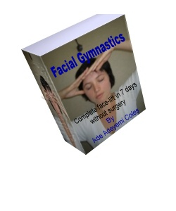
Please click here for immediate download through Clickbank
Frequently Asked Questions
I understand you may have some questions bordering your mind as to why choosing my program, Facial Gymnastics: Complete face-lift in 7 days without surgery is a great idea. I have itemized some of the questions I get asked almost everyday below.
Q. Would I develop wrinkles and baggy skin if I exercise my face and neck gymnastically?
A. Absolutely not. Facial exercises, and by extension facial gymnastics have been known to tighten loose and baggy skin, as well as greatly reducing the incident of wrinkles on the face and neck to almost zero. However, you should only choose a scientifically proven facial exercise or better still facial gymnastics program. This will save you from hurting the same muscles you are aiming to tone. Just as incorrectly exercising your body can lead to injury to your body muscles, so also will you hurt your facial muscles by engaging in wrong or inappropriate facial exercises.
Q. I am in my early 20's, can I also benefit from exercising facial muscles?
A. Facial exercises and gymnastics are not just for mature individuals. They are for people of all ages. While the mature people are striving to regain young, radiant, and ageless face: people of your age will banish wrinkles and aging from their faces before they appear by regularly exercising their faces. The younger ones will therefore retain their youths almost forever. And candidly, the earlier you start facial exercises and facial gymnastics in life, the more benefits you will receive from the program, because they fight wrinkles formation, and enhance smooth, glowing, and anti-aging skin.
Q. If facial exercises and gymnastics work, why don't plastic surgeons recommend them?
A. Well, the answer to that question is not far-fetched. Facial gymnastics program is an alternative to plastic surgery. If plastic surgeons recommend facial exercises and gymnastics, they will simply be out of business. Have you ever seen a company promoting the product of its major competitor? More so when the competing company sells its own product for a tiny fraction of the price of what that company sells its own. Though, few plastic surgeons recommend facial gymnastics, but dare not do so openly for fear of retribution and intimidation from their colleagues.
Q. I have a sound skin care routine, why do I need facial gymnastics again?
A. No matter how perfect you may think your skin care regimen is, without facial gymnastics, a time will come when your whole face will just migrate south. That time is not far off after you scale your early 20's in life. After this period, without incorporating facial gymnastics into your skincare routine, your facial muscles will start to become slack, baggy, saggy, creepy, and lax. That accumulation will remind you of leaving your washings pile up, and unattended. How messy will the look be?
Q. How often do I need to do facial gymnastics in order to get results?
A. It is recommended that facial gymnastics be done once a day, for at least 15 to 30 minutes. This regimen can then be continued for the rest of your life. You may decide to scale down to 3 times a week, after a continuous daily exercise routine of a month.
Q. I noticed some minor spots on my face after starting the facial gymnastics program.
A. Yes, some people report appearance of minor spots or blemishes after starting facial gymnastics. However, this is perfectly normal. You see, facial gymnastics program stimulates the skin to produce its natural oils and lubricants, and this explains the appearance of minor spots in some people when starting out facial exercises. But as soon as the skin starts functioning efficiently again, those spots will disappear.
Skin cells have the tendencies to get lazy, and stagnated which is brought about by sluggish circulation. With proper exercises in facial gymnastics these cells become activated, and blood flow to the skin cells is greatly boosted.

Here is a Taste of How this #1 Best Selling Facial Gymnastics Program will Help you
Discover the only natural way to getting face lift without going under the knife. You will have in your possession the program that has helped countless number of women to rejuvenate their faces naturally without having to go under the knife. It is a practical approach to repair your looks, boost your self esteem, and sky rocket your confidence. I am assuring you, by the time you are through with this program, you will discover you're no longer the same person. You will not only feel good, you will look really cool and great.

My facial gymnastics program is designed to be an easy-to-use program in the comfort of your home. Getting rid of wrinkles has never been made so easy. Right in the comfort and privacy of your own home you can put this program into use. There is no need for time consuming and expensive consultations with plastic surgeons who will end up explaining the advantages and disadvantages of plastic surgery, and the risks involved. With my program there is no risks involved, no disadvantages, and no expensive consultations. As a matter of fact, you can do the exercise while you watch the TV, cook, wash dishes, and of course while you're driving. With facial gymnastics it is a Win! Win!! and Win!!! situation.

Gain instant access to immediate ways to stop accumulation of lines on your face. Cross lines happen to be prevalent problems to most people when you talk of aging disfiguration. This program reveals different methods you can use to stop lines formation on your forehead. You will be endowed with a new look that will make you the envy of friends, fans, and colleagues.

Stop wrinkles with the program before they appear, and keep them away forever. My program will help you get rid of wrinkles, achieve smooth and radiant skin. After this is achieved, you will thereafter stop wrinkles before they make appearance again. This also applies to other signs of aging, such as saggy jowls and undefined jaw lines.

Recommended for all skin types. The health of your skin is determined to a large extent by the underlying tone, vitality, and strength of the muscles that support it irrespective of your skin type. This facial gymnastics program will turn on your skin's capacity to regenerate itself from within on constant basis. You may have dry, oily, normal or whatever skin type, it does not matter.

Suitable for all ages, race, and color. This program does not discriminate on the basis of age , neither does it concern itself with race or color. People of all ages, races and colors around the world have been benefiting from this program. The old are getting younger and becoming ageless, the middle aged are keeping smooth, glowing and fresh face, and the young are experiencing healthier, and more radiant skin. This program will bring out not only your outer beauty, but that of your inner one as well. All this will combine to make you a more fulfilled individual. Your new look can earn you promotion at work, attract more friendships, feel increasingly more confident, and you won't shy away from attending classes of reunion.

Achieve long-term, permanent results with NO side effects. My facial gymnastics program will help you achieve your desired wrinkle-free face with no side effects whatsoever. No skin irritations that could occur in reaction to botox injections, no after-surgery mishap, absolutely no side effects.

Practically inexpensive, and enduring solution. The cost is totally incomparable to other options in terms of affordability. The expense is one time off, the results are lifelong. If in doubt check out other alternatives. I outlined some of the costs involved in these options earlier on this page. You are free to make your own independent findings.

Please click here for immediate download through Clickbank
Buy Now, Pay $35.67 and Receive Free Bonuses Worth Over $200

Bonus #1: "How to use water as your major weight loss solution"
You will discover why water is the most important element in
any weight loss program. You will be thought how to use this
God given substance to achieve the results in weight loss that
you have always dreamed of.
Valued at $29.95 - You get it free

Bonus #2: "Facial Waste elimination through lymphatic drainage"
Here, you are taken through the step-by-step guide to eliminate
toxic waste which can lead to other problems from your face. You
will do it by yourself without having to pay visits to doctors.
You will be amazed how easy it is.
Valued at $49.95 - You get it free

Bonus #3: "Guide to Healthy meals for perfect skin"
Discover how to achieve perfect skin through what you put into
your mouth. To have glowing and radiant skin at any is no magic,
and definitely not a myth. You will be armed with the vital
information you need to achieve this.
Valued at $25.95 - You get it free

Bonus #4: "Things to do and what to not do to avoid wrinkle formation"
More often that you may want to believe, your lifestyle play a
major role in contributing to how rapidly wrinkles develop on
your face. You may even be engaging in activities that may land
aging onto your face unconsciously. You will discover all these
and much more.
Valued at $49.90 - You get it free

Bonus #5: "Guide to facial massage and choosing appropriate oils"
Massaging the face is so tricky that many people end up doing
it wrongly, and in the process causing damage to their facial
muscles. A guide is provided on how to go about it correctly
in graphical details. You will also learn how to choose the
appropriate carriers oils that are right for your skin type when you
want to massage your face. Facial massage will compliment your
efforts in any anti-aging, and anti-wrinkle skin care routine.
Valued at $49.50 - You get it free

What's Stopping You?

Enjoying the rest of your life without ever worrying about wrinkles, lines,
saggy jowls or dropping chins has been presented to you today to take
advantage of. You either take a right decision today and have a
secured wrinkle free face both now and in the future or you delay and take
no action. If you decide not to act now, then you're making it more difficult for
yourself to bring wrinkles and other signs of aging under control. Because
when you eventually want to fight the menace of aging face, the effort required
will be so much that you will be discouraged after a few practice of the facial
anti-wrinkle program.

You Have Absolutely nothing To Lose

To be frank, what have you got to lose? Absolutely nothing except your wrinkles. Come to think of it: The cost of the whole program is less than what you will spend on a dinner in a decent restaurant. If you can afford to pay more to give yourself a treat in one night, what stops you giving your face a treat forever by grabbing a copy right now?
The discovery from this facial gymnastics program will shock you. You will be shocked to discover you do not need plastic surgery to get a face make-over. You will be shocked to discover how easy it is to have a natural anti-wrinkle treatment without cosmetic procedures. And of course you will be surprised to personally experience a life long anti-aging benefits made possible by these simple, yet greatly effective facial exercises.
It is time to remove trial and error from your skincare regimen. Now is the time to enjoy that wrinkle-free skin on your face, and neck which is the dream of every woman. Now is the time for you to act and secure your face from aging effects.
Remember, no plastic surgery, no cosmetic surgery. Say no to costly anti-aging treatment, say no to expensive anti-wrinkle procedures. Take face exercises to another level, add facial gymnastics to your normal skincare routine and experience a natural face-lift that only angels have access to.

To process your order online now through our safe and secure merchant, Clickbank, please use the link below.

Affiliate Program Affiliate Program

Facial exercise benefits
The appearance of your skin relies in part on supportive facial muscles. In order for these facial muscles to remain smooth and firm, they need to be exercised and well toned. Facial exercise will assist in achieving this. The benefits of face exercises are removal of puffiness or 'bags' under the eyes. The milking action of the muscles drains the lymph in areas where it tends to accumulate. This tends to be prominent under the eyes and in the lower jaw. With the right face exercises, facial lines and wrinkles are minimized and potential wrinkles are prevented. Improved muscle tone will result in better blood circulation and therefore a more radiant complexion.
http://www.targetwoman.com/articles/face-exercises.html
Face exercises also activate better nutrition to the skin. Consequently, you will see improved collagen and elastin production. Balanced sebum distribution balances out the oily and dry patches and leads to smaller pores. A maximum of half an hour a day is sufficient for a routine that would lead to visible results.

Facial Exercise 1
A great exercise it to sit upright, tilt your head back looking at the ceiling, while keeping your lips closed and then start a chewing movement. You will feel the muscles working in your neck and throat area. Repeat 20 times.
Facial Exercise 2
Sit upright, tilt your head back looking at the ceiling, while keeping your lips closed and relaxed. Start puckering your lips together in a kiss and stretch the kiss, as if you were trying to kiss the ceiling. Keep your lips puckered for 10 counts. Relax and bring your head back to normal and repeat 5 times.
Facial Exercise 3
Sit upright, tilt your head back looking at the ceiling, while keeping your lips closed and relaxed. Open your lips and stick your tongue out as if you were trying to touch your chin with the tips of your tongue. Keep your tongue out in this position for 10 counts and return your tongue and head to its normal position.
Face Exercise 4
Sit upright, tilt your head back looking at the ceiling, while keeping your lips closed and relaxed. Next move your lower lip over your top lip as far as possible and keep it there for a count of 5. Relax and repeat 5 times.
Facial Exercise 5
Lie on your bed, with your head hanging down over the edge. Slowly bring your head up towards your torso and keep it there for 10 counts. Relax and lower your head towards the floor again. Repeat 5 times.
Face Exercise 6
Sit upright and face forward and while keeping your lips together, separate your teeth by dropping your jaw and then push your jaw forward, keep for a count of 10 and bring back to starting position. Repeat 5 times.
Face tapping is yet another good facial exercise to pep up the blood circulation. Tap dots on the face with the pads of your middle fingers. Sharp, light and quick taps can help boost the circulation. Massaging the ears can go a long way in lending a glow to the face. With index finger and thumb, massage the rim of the ear and pull it slightly. Do not miss out the crevices and spirals of the ear too.
If puffy and droopy eyelids and sagging chin stare at you from the mirror, it is about time to tighten the elongated muscles and rebuild the atrophying muscle tissues. Get started on a face exercise regimen!


Correcting Flabbiness Under Chin
Step 1 | Lift chin slightly upward.
Step 2 | With flat point of index and middle fingers press against indentation (hollow) formed by the two upper nodules of the larynx located at the curve from chin to neck. Do not be concerned in the beginning as to the precise location of pressure which you will discover through practice. Regard finger pressure as the resistance against the working muscles.
Step 3 | Now press your back teeth firmly together * and while maintaining this position.
Step 4 | Press the tip of your tongue against the inside of lower front teeth (gum line) increasing pressure with the tip of tongue ** in 10 or more gradual and definite steps (Count to 10).
Step 5 | Hold end position of pressure for 6 seconds (count slowly to six).
Step 6 | Release muscle work for 10 gradual steps (count to 10).
Step 7 | Remove finger resistance.
 | Repeat 4 more times.

Results | Note | Suggestion
Visible in approximately one week. | * If resistance is kept at the right place you will feel the muscles pushing against your finger resistance.  ** For each increase of pressure with tip of tongue you will sense a stronger push against your resistance. | Since the pressure of the finger tips against resistance may be felt unpleasantly and also may slip, it is advisable to cushion finger tips with cotton.
_____________

Facial Fitness exercises  It is very important to do this programme in the order as set out for you in both the books and on the videos. By working on the basic programme first you will gradually strengthen the muscles to enable you to go onto the more advanced section. Your muscles will be too weak in the beginning to start at the advanced level. It is important that you read all instructions carefully before you start your Facial Fitness exercises.  Let us look at the upper eyelids muscles. Here again, when the muscles weaken you will be left with folds and or sagging. This can be strengthened by the following exercise  Eyelid exercise  1. Look straight ahead into the mirror throughout this exercise.  2. Curve index fingers under eyebrows then raise your eyebrows and hold against the bone.  3. Close lids and stretch upper eyelids downwards in 5 small movements.  4. Hold for a count of 6  5. Release the squeeze slowly in 3 counts.  6. Open lids, Relax, Breathe.  7. Repeat once more.  *Alternatively place 4 fingers of each hand just under the line of eyebrows and proceed as above.  All the exercises are done twice, once a day 5 days a week. Choose a time when you are not tired.  How long before I see a difference?  I would love to say in 3 - 4 weeks all is restored as so many of us want an instant result and then feel disappointed. There is no magic wand.  However, you will feel strength in your facial muscles you have not felt before. That melting wax feeling when you are tired will be gone - this can happen in the first few weeks. After this you should see an improvement in the contour of your face week by week. Over the next 4 -6 months you will see a marked improvement.  The secret: Work out for 10 minutes a day - minimum 4 days a week until you are pleased with the result.  What people are saying about Facial Fitness
  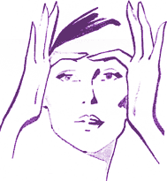
  Eyelid exercise
  Click here to view a sample video clip of neck, jaw and lower face lift (875k)
  I have talked to clients who rave about this technique, swearing that it is the equivalent of a gentle face lift
  Sarah Stacey - Chair of the Guild of Health Writers
Contact us | Terms & Conditions | Copyright | Web design

Order FACE LIFTING BY EXERCISES / ISOMETRIC EXERCISES book today.


