FREE FACE EXERCISES
There are 44 muscles in the face and toning these muscles gives the face a brighter appearance, a natural lift , smoother skin,
and results in a younger look.
Use these face exercises to tighten up your skin and get it glowing - exercises the chin area to reduce those sagging jowels and 'turkey' neck.
The hardest part of these face exercises is keeping them up - try to get into a routine and do them every morning or every evening or when watching the tele or doing the ironing -
with only 5-10 minutes of daily face exercises you should see results and that sagging face should slowly disappear.
Forehead
To firm up your forehead place your index fingers just above your eyes and pull down while trying to raise your eyebrows - repeat 10 times
Eyes and Crows Feet
This ones easier said than done - I've not managed it yet!! - try raising your lower eyelids without moving your upper ones - repeat 10 times
Cheeks
Push your lips out and make a round shape, stretching forward, now smile as wide as possible - hold for a second and resume the round shape - repeat 10 times
Lips
1) Suck on your finger as hard as possible and then slowly remove it - repeat 10 times
2) to get rid of smokers wrinkles! (STOP SMOKING) and hide your teeth with your lips and then make a small 'O' shape, keeping the lips as tense as possible smile as wide as possible.
Neck and chin
1) Looking straight ahead place the index finger and thumb on your neck and gently pull the skin down as you lift your head - repeat 10 times
2) keeping your mouth closed and your teeth together press the tip of your tongue against the bottom of your lower teeth, gradually increasing the pressure to the count of 10, hold for 6, and slowly release - at the same time, use 2 fingers at the hollow of your neck as resistance - gently pressing in.
3) jut your lower lip out as far as possibe, place your fingers on your collarbone and point your chin as high as possible and then pull the corners of your mouth down.
4) Place your thumb behind the bone just under your chin,
press tongue against your lower gums and pretend to touch
your tongue to your thumb.
5) Tighten your chin muscle as firm as you can by
pushing your lower lip up and out as though pouting.
Tighten as hard as you can so chin turns white and dimpled.
6) Begin looking straight ahead with your chin level. Turn your head to the right so that it is even with your right shoulder and then push your head backwards. Hold 6-8 seconds. Return head to forward position with chin level. Turn your head to the left, even with your left shoulder. Push your head back and hold 6-8 seconds - repeat 6 times
A Facelift Without Surgery and for Free - Wouldn't it be marvellous if someone told you that you could dispense with all those overpriced creams and treatments that, allegedly, promote youthfulness, increase weight loss, remove cellulite, wrinkles and saggy, baggy skin? And that the reason you could discard all these gimmicks, whose only effect has been on your wallet, is because you could achieve greater results for free (TIP: check out the other health and exercise links on this page) ......... more
Face Tapping, Stroking and Massage - Simple facial exercises from Fashion India -
If you want firmer facial skin, and want to look years younger just follow these ten exercises every morning and watch the age on your face fade away and your skin glow ......more
Flex Effect - Muscle Firming Techniques for the Face - flex effect increases the size of the muscles, firming the face, filling it out and creating lift....more
Face Lift Lab - a series of excercises designed to rejuvenate the facial muscles .....more
Welcome to the Face-Lift Lab! Before we begin I must reiterate IF YOU HAVE HAD A SURGICAL FACE-LIFT, DO NOT DO THESE EXERCISES!!! They could undo all of the work you have had done. This is no joke. Don't test it. Please! If you have not, let's begin. Some of the techniques may seem difficult to get the hang of. I suggest you take the Heal Thyself Series to refine your skills, but give it your best shot for now and have fun!
1. Chest Expansion
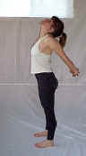
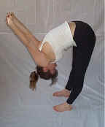
Begin in a standing position. Bring your arms around behind and clasp your hands together. Now raise your arms as high as you can and then bend all the way forward. As you hang forward continue raising your hands and allow gravity to help facilitate an even greater stretch in the chest and arms. Remember to breathe fully to create an even greater release. Perform this stretch three times holding for a count of 30.
2.Neck Stretch
Before we begin, I need to give you a word of caution. These are neck rolls and they must be performed very carefully and very slowly. You must be very aware of any pain you may feel while slowly rotating your neck especially when you are bending it backwards. There is no reason to injure yourself unless you are careless. When you bend your neck backwards, it is imperative that you keep your mouth shut and your teeth together! With that said, let's begin.
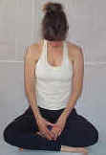
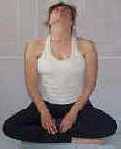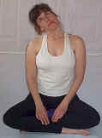
Sit down on the floor or in a chair so that your spine is relatively straight. Allow your head to drop forward and hang for a slow count of 10. Remember to breathe releasing your head more and more with every breath. Then slowly rotate your head to the left and allow it to hang for a slow count of 10. It is very important here that you actually achieve a curvature of the cervical spine (the neck part of the spine) to the left. See if you can achieve a greater, more balanced curve of the cervical spine every day that you do this exercise. After counting slowly to 10, carefully rotate your head backwards making sure to KEEP YOUR MOUTH SHUT. Slowly count to 10 and the carefully rotate your head to the right. Again make sure you are achieving a nice curve of the cervical spine. Slowly count to 10 and then rotate your head down and allow it to hang forward for a count of 10. Then come back the way you came. Slowly rotate the head to the right. Hold for ten. Keeping your mouth closed, slowly rotate your head backwards and hold for 10. Carefully rotate it to the left and hold for 10. Then rotate it down and allow it to hang forward and hold it for 10.
The above paragraph constitutes one repetition of the neck stretch. Ideally I would like you to do four repetitions per day. As you are rotating your head, if you find that there are places of tension that lie between your destinations of forward, right, left, and back, feel free to stay on those spots and stretch them out too. If you stick with this your neck will feel great and your face will start to look more youthful!
3.Lion's Pose

This is a stretch for the whole face and the muscles that operate the tongue. Basically you stick your tongue out as far as you can, open your eyes as wide as you can, and open your mouth as big as you can. Be careful not to stretch to quickly or you may have a spasm in your jaw. Hold this stretch for a count of ten and perform it five times.

4. Low Back and Side Stretch
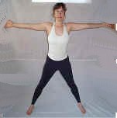
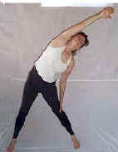
Spread your feet about three feet apart. Strongly reach your arms out to the side. Never stop reaching even for a second. Continuing your reach, bring your right arm up over your head reaching towards your left while simultaneously bending your trunk to the left. Brace yourself by placing your left hand on your left leg and bending the left elbow. Reach out feeling your stretch all the way down your arm to your low back. Hold your most intense stretch for a count of 20. Then perform the stretch to the opposite side for a count of 20. Perform this three times on each side.
5. Power Breath
This next exercise is a very powerful way to oxygenate the blood, relax the body, expand the ribcage and sharpen the mind.
Inhale on a count of 7. This means that by the time you get to 7, your lungs are filled to their absolute maximum capacity.
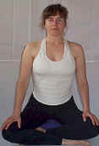
Hold this air in for a count of 28. Holding it this long allows you to maximally absorb the oxygen you have taken in. Usually when we breathe, a great deal of our oxygen is exhaled before we can even assimilate it. This exercise will actually increase your red blood cell count!
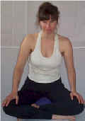
Exhale the air slowly on a count of 14. Taking this long to release the air actually allows toxins to be expelled in the form of gas from your lungs.
That is one repetition of the Power Breath. Do no less than 10 of these per day. Ideally you should do 30 of these per day. Find a place with nice scenery to look at as you hold your breath. It's a great way to start your morning or wake up if your afternoon is starting to drag.
6. Manual Releases of the Face
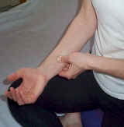
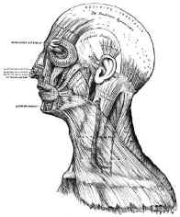
We will now move on to the more manual techniques for releasing and lifting the face. With these techniques, you will literally be moving tissue from one part of your face to another. Let's practice first on the forearm. Press the pads of your fingers firmly into your forearm. Now create a tug on the tissue underneath your fingers by moving them up the arm. Your fingers may glide a little bit, but this happens very slowly. You are not gliding over the skin so much as actually creating a tug. This is how we will do the following techniques on your face. Take a look at the musculature of the face. These are the muscles we will be affecting. Notice how these muscles attach not only to the bones of the face, but to eachother. These are the muscles we will be moving over. While we move over these muscles, we will be contracting and relaxing them to help them release.
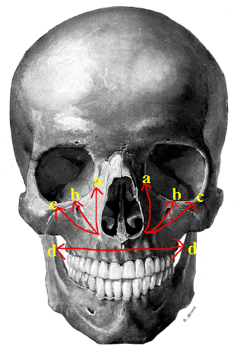
a. Start at the base of the nostrils. Gently hook your fingers into the tissue. Press down lightly against the bone and pull upwards to the eyes. While you are doing this, scrunch up your nose and relax. Scrunch and relax over and over until the stroke is done. Perform this stroke three times.
b. Perform the same stroke as above continuing to scrunch up the nose only this time, take the stroke out on more of an angle. Perform this stroke three times.
c. Perform the same stroke as above continuing to scrunch up the nose only this time, take the stroke out on even more of an angle. Perform this stroke three times.
d. Please your fingers directly under the center of your nose above your upper lips in the middle. Gently press the pads of your fingers towards the bones and create a tug away from your nose. While you perform this stroke, be pursing and relaxing your lips over and over again. Perform this stroke three times.
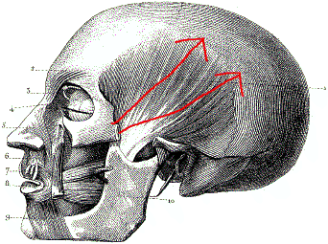
e. Place your fingers firmly on the sides of your temples in line with the tops of your ears. Create a tug on the tissue that moves upwards and slightly towards the back of your head. While you perform this stroke you are to alternately bite down, and open your mouth over and over again. Perform this stroke three times.
7. Manual Fluid Drainage
Our last technique is designed to help drain fluids and puffiness from the face by stimulating the lymphatic system. These lymphatic organs lie very superficially directly under the skin so there is no need to apply great pressure. You're really just moving the skin around in a circular motion to shake up the lymph vessels of the neck.
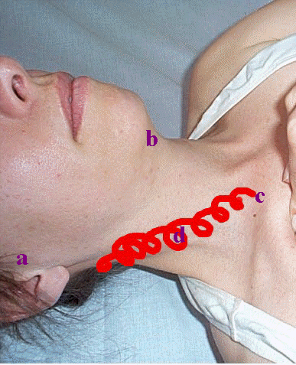
a. Place your fingers right in front of the flap in the middle of your ears and move the skin around in a circular motion for about ten seconds.
b. Place your fingers underneath your chin and move the skin around in a circular motion for about ten seconds.
c. Place your fingers just above your clavicle (collar bone) and move the skin around in a circular motion for about ten seconds.
d. Bring your circular motions above the clavicle diagonally up the sides of the neck all the way around to the base of your skull and then allow your fingers to slide back down over the skin to their original position just above the clavicle.
There you have it! A lot of these techniques will come a lot easier to you once you have completed the Heal Thyself Series so if you haven't already, I highly suggest you check that out and don't forget to read Today's Focus. It will help keep you on track in your goal of achieving physical freedom. It is my wish for you that your life blossom into vibrant, radiant health! Use this connective tissue face-life class to show you how malleable your body really is. May this inspire you to complete the process on a full body level!

