Essential Oils for Vibrant Health

Free Essential Oil
Downloads, Charts, PDF's
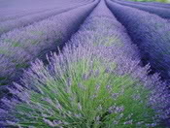

Free Essential Oil Downloads
These free essential oil downloads are available to use and share.

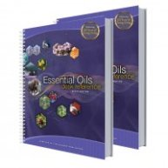

The following charts are taken from the "Essential Oils Desk Reference" Guide, also commonly referred to as the EODR.
This book, which contains valuable information on essential oils and how to use them, it is available from
Life Science Publishing

Vita Flex Charts
The Vita Flex Technique is a highly effective form of foot massage, designed to deliver the health benefits of essential oils, to specific areas of the body. By using essential oils and this technique together, you can greatly enhance the benefits of both.
How does it work?
When essential oils are applied with pressure to the reflex points, electrical impulses are released. These impulses carry the essential oils up the nerve pathway and into specific areas of the body.

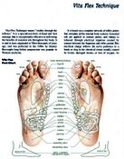
Vita Flex Foot Chart
The “Vita Flex Technique” means "vitality through the reflexes". This is a highly effective massage that can be used on the feet and/or the hands. Using this technique is effective in delivering the benefits of essential oils throughout various systems within the body.
Vita Flex is based on a complete network of reflex points that correspond to all the internal body systems. Energy is released through electrical impulses that are created by contact with the fingertips on the reflex points. Essential oils greatly enhance the benefits.
The feet will absorb the essential oils quickly because they have such large pores. The wrists also absorb essential oils quickly, though not as fast as the feet.
Combine the Vita Flex technique with 1-3 drops of essential oil. Apply it to the reflex points, the areas of the feet that correspond to the parts of the body that need support.

