How To Use Essential Oil Roller Bottles:
- Add 15-30 drops of essential oil (or oils) to a 10ml Roller Bottle
- Fill rest of bottle with carrier oil of choice (jojoba oil, fractionated coconut oil, sweet almond oil, etc)
- Add top and shake well to mix, label bottle and you are ready to roll!
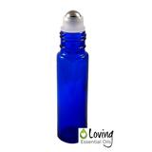Need roller bottles? We offer high quality blue glass roller bottles that are durable and include a stainless steel roller ball for smooth application. Click here to buy our blue roller bottles that are pictured in this post - FREE Shipping!

Tips for Roller Bottles
Roller bottles can be rolled onto just about any body part with a few exceptions. Keep away from eyes, inside ears and mucous membranes to prevent irritation. Favorite places to roll oils on are bottoms of feet, neck, behind ears, wrists, temples, chest, spine/back and belly.
You can use just single oils in the roller bottle like peppermint, lavender, melaleuca, or frankincense. Having these oils diluted in a carrier oil ready for application will be a real time and money saver.
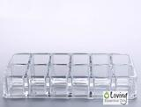If your oil brand has premade oil blends, you can use those blends as well. Start with 15 drops of your favorite oil brands premade blend, then add the carrier oil. If using on a child, you may want to start with only 10 drops of essential oils. Want to keep all your roller bottles together and ready for use? Click here to buy our roller bottle organizer.
Need some inspiration for what eo blends to make? Check out our list of essential oil roller recipes below. You are guaranteed to find a recipe, be sure to share this guide as well with others on Pinterest, Facebook or Twitter.
Recipes For Essential Oil Roller Bottles:
Click here to download a PDF of the recipe guide below!
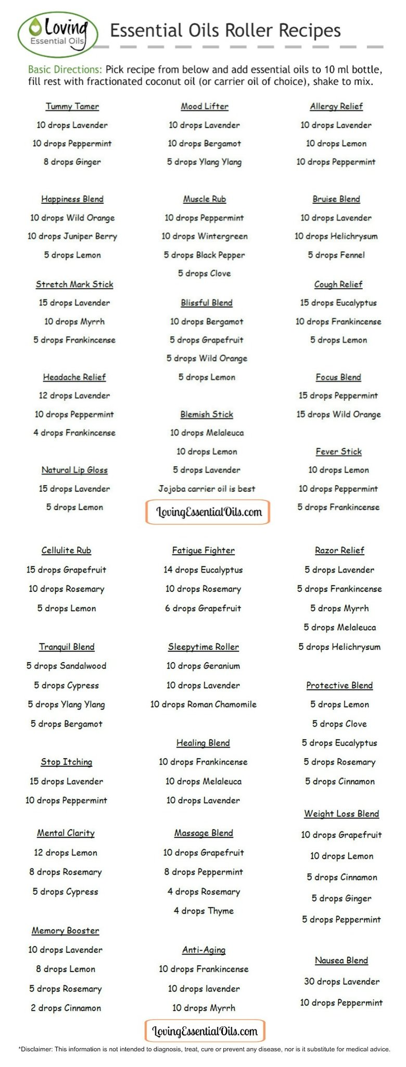
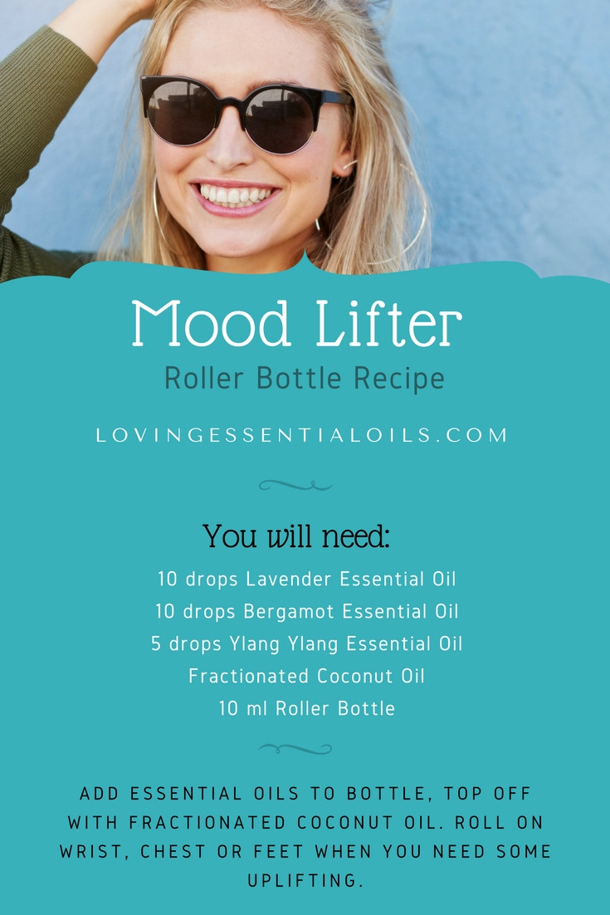

- Home
- About
- Advertising/PR
- Media Mentions
- Contact

Top of Form
Bottom of Form


- Beauty
- Food
  - Recipe Index
- Life
- Style
- Whole Living
- Shop
1.7k
Shares
1.4k238111

25 Essential Oil Rollerball Blends & Recipes For Families
June 25, 2015 by Kelly 46 Comments
This post may contain my affiliate link, which means I will make a small commission if you click and make a purchase. Also, I am a participant in the Amazon Services LLC Associates Program, which is a program designed to proved a means for sites to earn advertising fees by linking to amazon.com. Thank you for supporting Redefined Mom. For more information, see my disclosure policy.
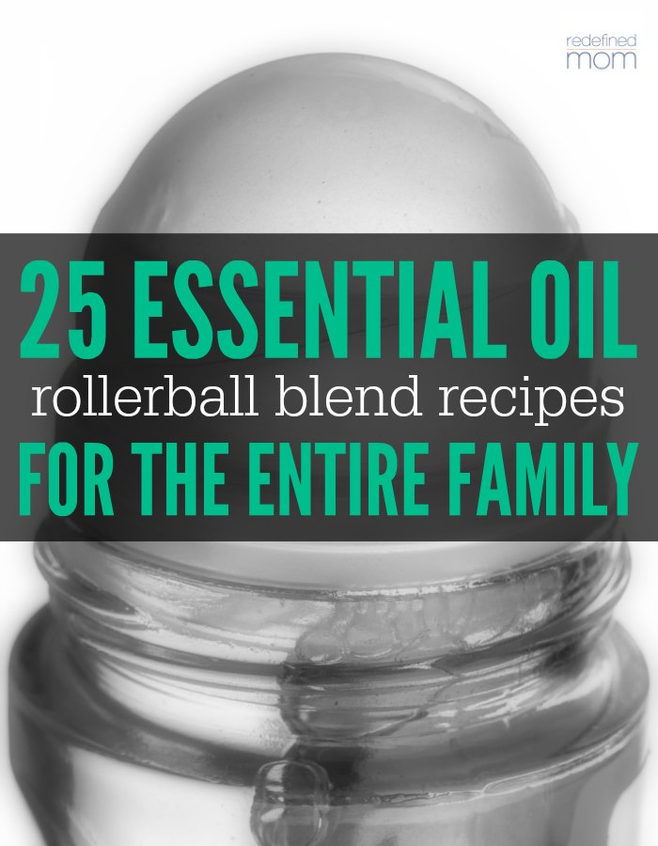
One of the best things about essential oils is their ability to solve common everyday ailments naturally vs taking an over-the-counter medicine. Most of the common items in your medicine cabinet (pain relief, sleep aids, digestive aids, cuts and wounds ointments), can be replaced with a few drops of essential oil.
Depending on the ailment our family is treating, we’ll either…use the oil and apply it directly, apply the oil directly with a carrier oil, or mix the oils together in roller bottles. And that is what I want to share with you…my personal “list” of essential oil rollerball blends & recipes for families.
There are several great things about rollerball bottles. They are premade mixtures – which saves time when something hurts; they are easy to apply – roll it on your feet, your neck, your wrists and you are ready to go; and they stretch out oils, making them last longer by using a carrier oil. (By using a carrier oil, you are not diluting the effectiveness of the oil, you are just giving your oil more coverage with help of something to carry it where you want it to go.)

Essential Oil Rollerball Blends & Recipes For Families
Here are a couple of things you need to know and purchase before you start making your roller bottles.
- You need 10 mL glass roller bottles. These are my favorite.
- You need a carrier oil. I like (and use) this avocado oil, fractioned coconut oil (my personal favorite) or almond oil.
- You need essential oils.
- Optional: Plastic droppers. I like using these to make up my roller bottles. They are inexpensive and make sure all of the oil gets in the bottle vs on the counter or the outside of the essential oil bottle.
You’ll place the number of drops, per recipe, in a 10 mL rollerball and then fill to the top with your carrier oil of choice. Roll the blends over your neck, feet and wrists (and if applicable, the place that hurts). If there are special instructions, you’ll see them at the end of the recipe. Finally, to be most effective, apply less oil and apply it more often. 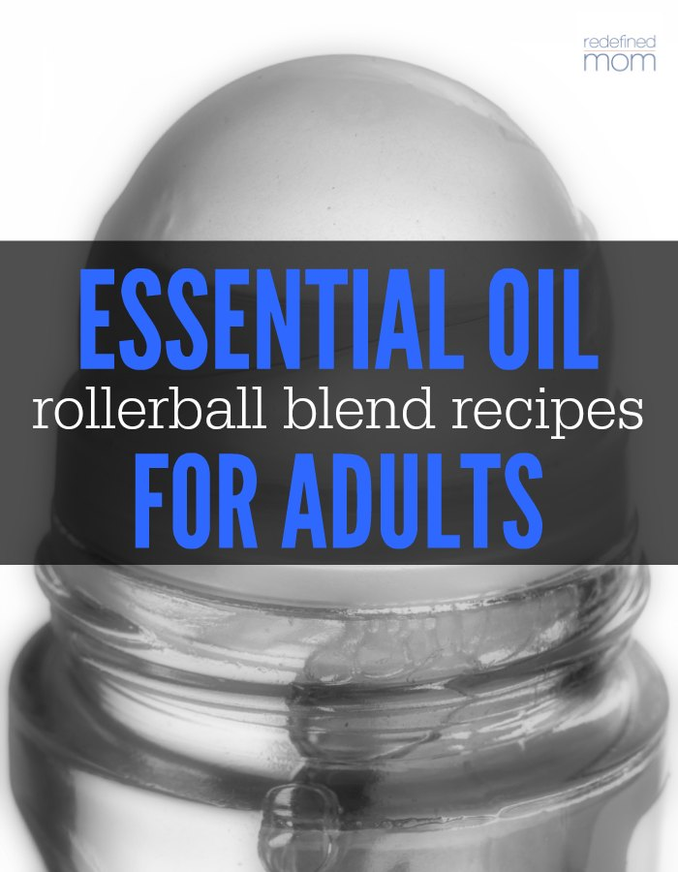

Essential Oil Rollerball Blends & Recipes for Adults
stress away blend for mama:
18 drops balance
18 drops serenity
18 drops lavender
18 drops grapefruit or citrus bliss
4 drops wild orange
peace & calming blend for mama:
6 drops sandalwood
6 drops ylang ylang
6 drops cypress
6 drops bergamot
6 drops black pepper
“grounding” blend for adults:
2 drops patchouli
2 drops vetiver
2 drops lime
20 drops balance
20 drops lavender
upset tummy blend for adults:
10 drops peppermint
10 drops ginger (or you can use a pre-made blend like digestzen)
sleep blend for adults:
4 drops marjoram
10 drops frankincense
10 drops bergamot
12 drops roman chamomile
12 drops vetiver
15 drops lavender
10 drops cedarwood
“liquid morphine” for adults:
30 drops marjoram
30 drops lemongrass
30 drops frankincense
aching muscles blend for adults:
10 drops peppermint
6 drops clove
10 drops wintergreen
6 drops black pepper
(Massage into achy areas.)
body aches blend for adults:
10 drops eucalyptus
10 drops lavender
10 drops deepblue
“wakeup” blend for adults:
30 drops lemon
8 drops eucalyptus
6 drops peppermint
2 drops cinnamon
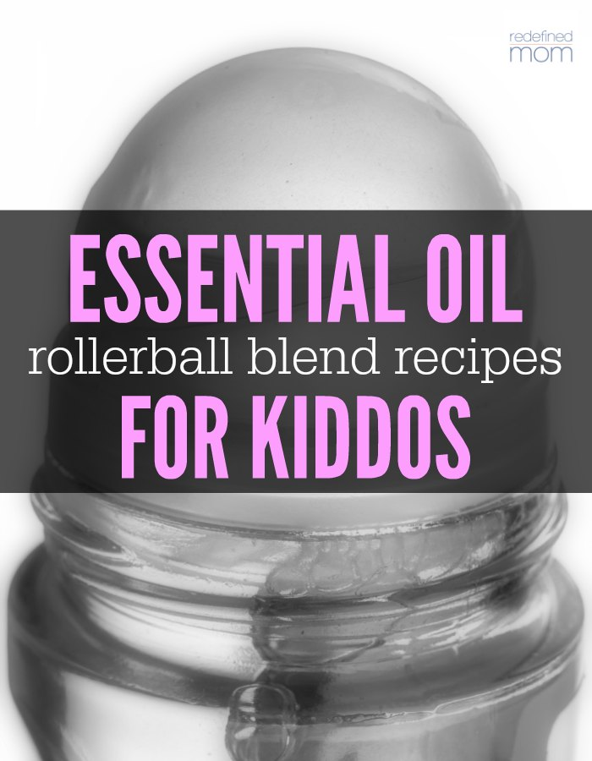

Essential Oil Rollerball Blends & Recipes for Kids
sleep blend for kiddos:
15 drops lavender
10 drops serenity
5 drops roman chamomile
owies blend for cuts, scrapes and bug bites for kiddos:
10 drops lavender
10 drops of melaleuca
(Apply on effected area.)
focus on school blend for kiddos:
10 drops peppermint
10 drops wild orange
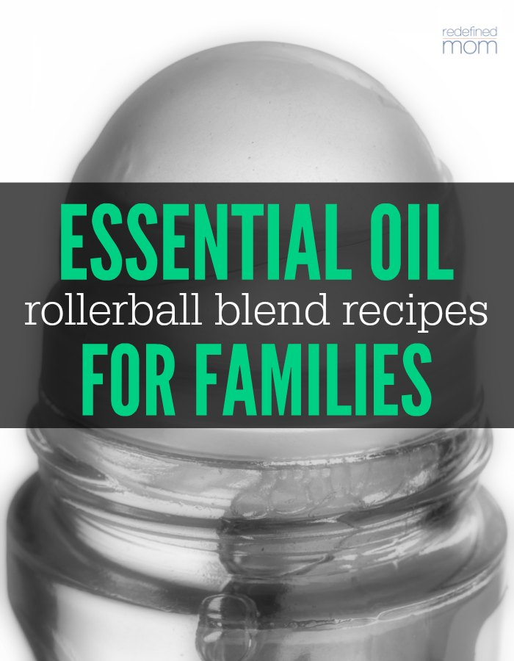

Essential Oil Rollerball Blends & Recipes for Families
congestion blend for families:
40 drops of breathe
25 drops of lime
(Apply over sinus, temples, and ears)
“flu bomb” for families:
10 drops oregano
18 drops lemon
15 drops melaleuca
15 drops onguard
(Apply on lymph nodes, neck, spine and feet when the flu is spreading or at the first sign of symptoms.)
headache blend for families:
10 drops frankincense
10 drops lavender
10 drops peppermint
tension headache blend for families:
9 drops peppermint
5 drops clove
9 drops wintergreen
6 drops ginger
ADHD blend for families:
30 drops balance
14 drops patchouli
30 drops serenity
50 drops lavender
16 drops vetiver
mental clarity blend for families:
8 drops rosemary
12 drops lemon
4 drops cypress
anti-anxiety blend for families:
4 drops frankincense
4 drops marjoram
6 drops geranium
6 drops clary sage
4 drops orange
motion-sickness for families:
16 drops peppermint
16 drops ginger
(Apply to wrists, back of neck and clockwise on tummy.)
“anti-exhaustion” blend for families:
14 drops eucalyptus
10 drops rosemary
6 drops grapefruit
“bruise blend” for families:
20 drops of lavender
20 drops of cypress
20 drops of frankincense
(Roll on bruised area.)
sickness & cold prevention blend for families:
10 drops onguard
10 drops oregano
10 drops lemon
(Apply on feet when the flu is spreading or at the first sign of symptoms.)
seasonal discomfort blend for families:
10 drops lavender
10 drops lemon
10 drops purify
5 drops frankincense
allergy blend for families:
10 drops lavender
10 drops lemon
10 drops peppermint
(Apply to bottoms of feet up or back of neck up to 3 times a day.)
Caveat: I’m sharing the 25 Essential Oil Rollerball Blends & Recipes for Families that I’ve made doing my own research, but please make sure to do your own research as well. Everyone’s body is very different and responds differently to different oils. If these blends don’t work for you, there are many other recipes available to use in its place for comfort and relief. Want to know more about essential oils? Here is my story.
Like this post? Make sure to follow my Whole Living Board on Pinterest where I share information about ways to live a more holistic whole life.
Kelly @ Redefined MomWhole Natural LivingFollow On
Disclaimer: These statements have not been evaluated by the Food and Drug Administration. The information on this site is not intended or implied to be a substitute for professional medical advice, diagnosis or treatment. Please confirm any information obtained from or through this web site with other sources, and review all information regarding any medical condition or treatment with your physician. Never disregard professional medical advice or delay seeking medical treatment because of something you have read on this website. This information is not intended to diagnose, treat, or cure any disease.
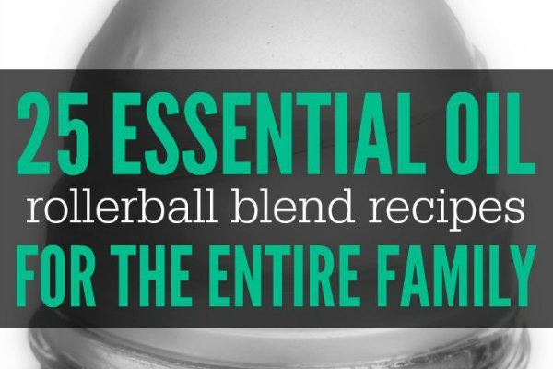
One of the best things about essential oils is their ability to solve common everyday ailments naturally vs taking an over-the-counter medicine. Most of the common items in your medicine cabinet (pain relief, sleep aids, digestive aids, cuts and wounds ointments), can be replaced with a few drops of essential oil.
Depending on the ailment our family is treating, we’ll either…use the oil and apply it directly, apply the oil directly with a carrier oil, or mix the oils together in roller bottles. And that is what I want to share with you…my personal “list” of essential oil rollerball blends & recipes for families.
There are several great things about rollerball bottles. They are premade mixtures – which saves time when something hurts; they are easy to apply – roll it on your feet, your neck, your wrists and you are ready to go; and they stretch out oils, making them last longer by using a carrier oil. (By using a carrier oil, you are not diluting the effectiveness of the oil, you are just giving your oil more coverage with help of something to carry it where you want it to go.)

Essential Oil Rollerball Blends & Recipes For Families
Here are a couple of things you need to know and purchase before you start making your roller bottles.
- You need 10 mL glass roller bottles. These are my favorite.
- You need a carrier oil. I like (and use) this avocado oil, fractioned coconut oil (my personal favorite) or almond oil.
- You need essential oils.
- Optional: Plastic droppers. I like using these to make up my roller bottles. They are inexpensive and make sure all of the oil gets in the bottle vs on the counter or the outside of the essential oil bottle.
You’ll place the number of drops, per recipe, in a 10 mL rollerball and then fill to the top with your carrier oil of choice. Roll the blends over your neck, feet and wrists (and if applicable, the place that hurts). If there are special instructions, you’ll see them at the end of the recipe. Finally, to be most effective, apply less oil and apply it more often.

Essential Oil Rollerball Blends & Recipes for Adults
stress away blend for mama:
18 drops balance
18 drops serenity
18 drops lavender
18 drops grapefruit or citrus bliss
4 drops wild orange
peace & calming blend for mama:
6 drops sandalwood
6 drops ylang ylang
6 drops cypress
6 drops bergamot
6 drops black pepper
“grounding” blend for adults:
2 drops patchouli
2 drops vetiver
2 drops lime
20 drops balance
20 drops lavender
upset tummy blend for adults:
10 drops peppermint
10 drops ginger (or you can use a pre-made blend like digestzen)
sleep blend for adults:
4 drops marjoram
10 drops frankincense
10 drops bergamot
12 drops roman chamomile
12 drops vetiver
15 drops lavender
10 drops cedarwood
“liquid morphine” for adults:
30 drops marjoram
30 drops lemongrass
30 drops frankincense
aching muscles blend for adults:
10 drops peppermint
6 drops clove
10 drops wintergreen
6 drops black pepper
(Massage into achy areas.)
body aches blend for adults:
10 drops eucalyptus
10 drops lavender
10 drops deepblue
“wakeup” blend for adults:
30 drops lemon
8 drops eucalyptus
6 drops peppermint
2 drops cinnamon

Essential Oil Rollerball Blends & Recipes for Kids
sleep blend for kiddos:
15 drops lavender
10 drops serenity
5 drops roman chamomile
owies blend for cuts, scrapes and bug bites for kiddos:
10 drops lavender
10 drops of melaleuca
(Apply on effected area.)
focus on school blend for kiddos:
10 drops peppermint
10 drops wild orange

Essential Oil Rollerball Blends & Recipes for Families
congestion blend for families:
40 drops of breathe
25 drops of lime
(Apply over sinus, temples, and ears)
“flu bomb” for families:
10 drops oregano
18 drops lemon
15 drops melaleuca
15 drops onguard
(Apply on lymph nodes, neck, spine and feet when the flu is spreading or at the first sign of symptoms.)
headache blend for families:
10 drops frankincense
10 drops lavender
10 drops peppermint
tension headache blend for families:
9 drops peppermint
5 drops clove
9 drops wintergreen
6 drops ginger
ADHD blend for families:
30 drops balance
14 drops patchouli
30 drops serenity
50 drops lavender
16 drops vetiver
mental clarity blend for families:
8 drops rosemary
12 drops lemon
4 drops cypress
anti-anxiety blend for families:
4 drops frankincense
4 drops marjoram
6 drops geranium
6 drops clary sage
4 drops orange
motion-sickness for families:
16 drops peppermint
16 drops ginger
(Apply to wrists, back of neck and clockwise on tummy.)
“anti-exhaustion” blend for families:
14 drops eucalyptus
10 drops rosemary
6 drops grapefruit
“bruise blend” for families:
20 drops of lavender
20 drops of cypress
20 drops of frankincense
(Roll on bruised area.)
sickness & cold prevention blend for families:
10 drops onguard
10 drops oregano
10 drops lemon
(Apply on feet when the flu is spreading or at the first sign of symptoms.)
seasonal discomfort blend for families:
10 drops lavender
10 drops lemon
10 drops purify
5 drops frankincense
allergy blend for families:
10 drops lavender
10 drops lemon
10 drops peppermint
(Apply to bottoms of feet up or back of neck up to 3 times a day.)
Caveat: I’m sharing the 25 Essential Oil Rollerball Blends & Recipes for Families that I’ve made doing my own research, but please make sure to do your own research as well. Everyone’s body is very different and responds differently to different oils. If these blends don’t work for you, there are many other recipes available to use in its place for comfort and relief. Want to know more about essential oils? Here is my story.
Like this post? Make sure to follow my Whole Living Board on Pinterest where I share information about ways to live a more holistic whole life.
Kelly @ Redefined MomWhole Natural LivingFollow On
Disclaimer: These statements have not been evaluated by the Food and Drug Administration. The information on this site is not intended or implied to be a substitute for professional medical advice, diagnosis or treatment. Please confirm any information obtained from or through this web site with other sources, and review all information regarding any medical condition or treatment with your physician. Never disregard professional medical advice or delay seeking medical treatment because of something you have read on this website. This information is not intended to diagnose, treat, or cure any disease.

