Transform any of your favorite Young Living essential oils into an easy-to-use roll-on bottle with the patents pending AromaGlide™ advanced roller fitments technology. Each fitment is customized to fit a 5- or 15-ml bottle with an “Sb” marking on the bottom. Includes 10 AromaGlide fitments and caps.

10 pk (#4578)
Retail:
$12.83 USD
Wholesale:
$9.75 USD

__

10 Oil Case - Fuchsia
- New and Seasonal
- Essential Oils & Blends
- At Home
- Healthy & Fit
- Personal Care
- Diffusers & Accessories
Take ten favorite essential oils on the road with this compact and durable carrying case. Fill the case with your ten favorite essential oils for a thoughtful, practical gift! Branded with the Young Living logo and available in your choice teal, green, or fuchsia.
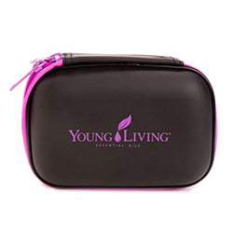

(#5282)
Retail:
$21.05 USD
Wholesale:
$16.00 USD

Oil Bottle Labels
Oil bottle labels are small, circular labels that fit perfectly on the tops of the 5 & 15 ml essential oil bottles, to help keep your oil bottles organized. The package contains three sheets with a total of 312 labels including duplicates for many popular oils.
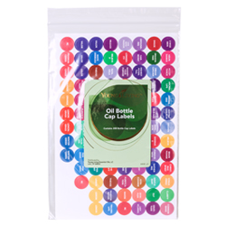
Top of Form
1 Set (#3939)
Retail:
$3.95 USD
Wholesale:
$3.00 USD
Bottom of Form

