From: Exposing The Darkness Newsletter <lionessofjudah@substack.com>
Date: Mon, Nov 11, 2024 at 3:48 AM
Subject: Cleveland Clinic Issues a Chilling Warning: Wave of Mass Deaths Will Wipe Out Covid-Vaxxed Within ‘5 Years’

Cleveland Clinic Issues a Chilling Warning: Wave of Mass Deaths Will Wipe Out Covid-Vaxxed Within ‘5 Years’
The prestigious Cleveland Clinic has issued a chilling warning of an incoming wave of deaths that will kill off huge numbers of people who received Covid mRNA “vaccines.”
Lioness of Judah Ministry

Nov 11

Exposing The Darkness is a reader-supported publication. To support my work, please consider becoming a paid subscriber.
The prestigious Cleveland Clinic has issued a chilling warning of an incoming wave of deaths that will kill off huge numbers of people who received Covid mRNA “vaccines.”
However, rather than issuing a red alert to the public about the looming catastrophic death wave, the Ohio-based nonprofit academic medical center quietly dropped the bombshell in a recent update on its website.
According to Cleveland Clinic, mass mortality is expected to surge due to a ticking time bomb of myocarditis among the Covid-vaccinated.
Myocarditis is inflammation of the heart muscle or myocardium.
This inflammation weakens your heart muscle, making it harder for your heart to pump.
Myocarditis can cause strokes, blood clots, cardiac arrest, and ultimately sudden death.
Doctors warn that myocarditis acts as a silent killer as it can often be symptomless, with many sufferers not being diagnosed until it’s too late.
According to the U.S. Centers for Disease Control and Prevention (CDC), myocarditis is a known side effect of Covid mRNA injections.
As cases of myocarditis have surged since the Covid “vaccines” were rolled out in early 2021, Cleveland Clinic has now updated its website with alarming new information on the disorder.
According to the renowned medical center, 50 percent of people who contracted myocarditis will be dead “five years later.”
“For some people, myocarditis can lead to dilated cardiomyopathy and they may need a heart transplant,” the webpage explains.
“Almost 20% of sudden deaths in young people have a connection to myocarditis.
“The survival rate for myocarditis is 80% one year after having it and 50% five years later.”
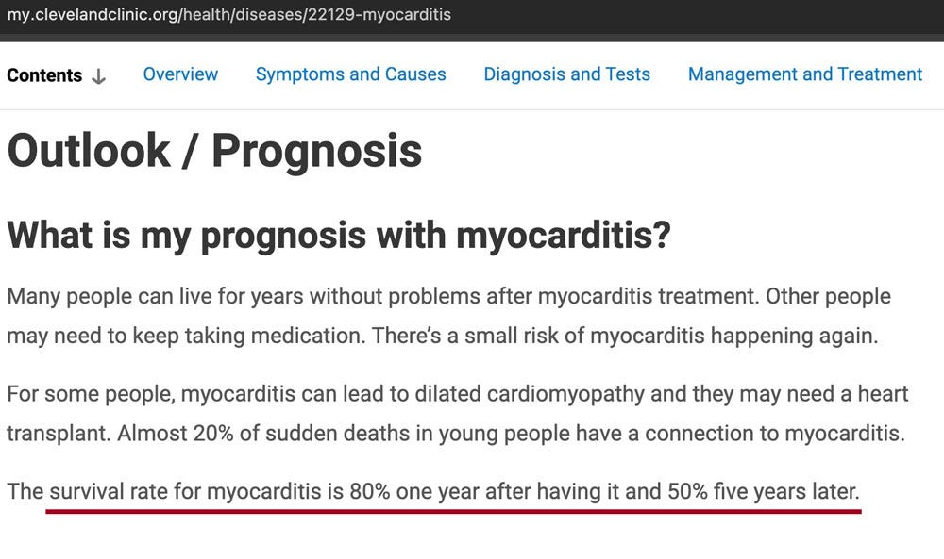
The damning update comes as experts around the world continue to raise the alarm about the long-term health impact of the mass vaccination campaign.
As Slay News recently reported, a world-renowned virologist, who served as Bill Gates’s lead vaccine advisor, has warned the public that a “wave” of “unprecedented deaths” is looming for those who received Covid mRNA injections.
Former Bill & Melinda Gates Foundation scientist and vaccine expert Dr. Geert Vanden Bossche has blown the whistle to warn of a coming “wave of morbidity” and “mortality” among the Covid-vaccinated.
Dr. Bossche has warned that population numbers worldwide will soon experience a “completely unprecedented” plunge.
Bossche predicts that “up to 30-40%” of the general public will soon die “in highly vaccinated countries.”
The top scientist raised the alarm during an interview with vaccine expert and investigator Steve Kirsch.
“In some of the highly vaccinated populations … I would not be surprised that we will be dealing with serious decimation of the population, in some populations, maybe up to 30 or 40 percent,” Bossche warned.
WATCH:
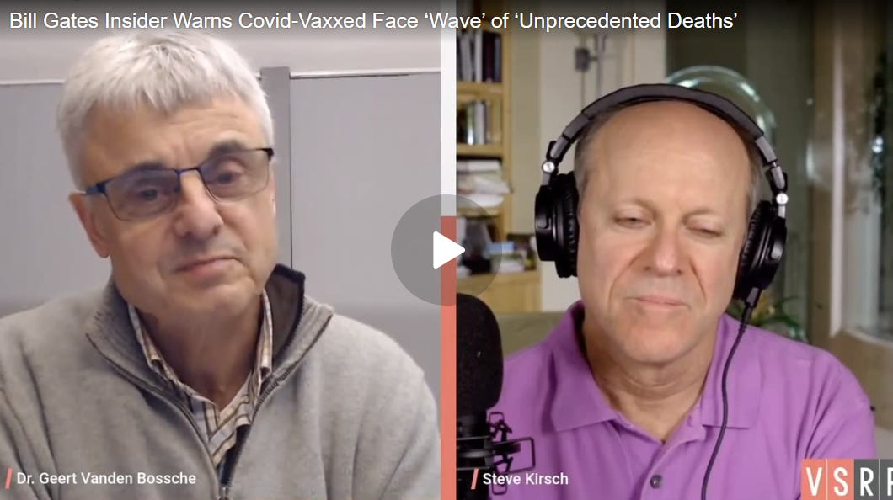
As Slay News reported, Bossche warned the public during a separate interview that a “massive tsunami” of “chaos” and “death” is about to decimate the global Covid mRNA-vaccinated population.
Bossche warned that a “huge, huge wave” of illness and deaths among those vaccinated for Covid is now “imminent.”
The top scientist says this “massive tsunami” will collapse hospitals and cause financial, economic, and social “chaos.”
Alarmingly, Bossche is not the only top expert predicting a major population plunge, however.
Professor Dolores Cahill, a world-renowned immunology expert, issued an explosive warning to the public that everyone who has been vaccinated with Covid mRNA shots “will die within 3 to 5 years, even if they have had only one injection.”
Prof. Cahill has over 25 years of expertise in high-throughput protein array, antibody array, proteomics technology development, and automation.
Since the Covid mRNA shots were rolled out in early 2021, Cahill has been sounding the alarm about the devastating impact they will have on public health.
Not only does Cahill think the shots are dangerous, but she warns that they will eventually kill everybody who has received one or more doses.
During an interview, Cahill explains how mRNA in the injections harms all recipients and acts like a ticking time bomb in the Covid-vaccinated.
After explaining how the shots impact human health, Cahill made this following chilling prediction:
“Everybody who has an mRNA injection will die within 3 to 5 years, even if they have had only one injection.”
WATCH:
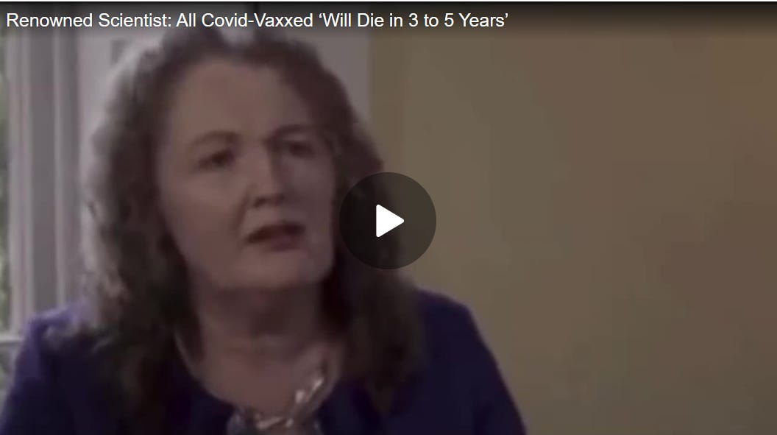
Meanwhile, as some experts are warning of looming deaths, others are putting the public on notice over current surges in mortality.
Dr. Peter McCullough, a world-renowned cardiologist and epidemiologist, has sounded the alarm after a bombshell peer-reviewed study found a staggering 1,236% surge in excess cardiac arrest deaths among people who received Covid mRNA vaccines.
McCullough performed an exploratory data analysis evaluating the cardiac arrest deaths following the Covid vaccination campaign in King County, Washington.
The team of researchers, led by McCullough, uncovered evidence of a shocking quadratic increase in excess cardiopulmonary arrest mortality corresponding to higher vaccination rates.
The study was peer-reviewed and published in the Journal of Emergency Medicine: Open Access.
Source: slaynews.com

Related articles:

  Dr. Mike Yeadon Blows The Lid on COVID 'Vaccine' Injuries
   |  | Nov 10
    Lioness of Judah Ministry |  | ·
  Read full story
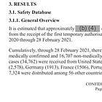
  Dr. Michael Yeadon: THIS MUST STOP! Pfizer Documents Show FDA Knew of Death Risk
   |  | January 23, 2022
    Lioness of Judah Ministry |  | ·
  Read full story


  DEVASTATING: Fully-Vaxxed New Zealand Suffers a Staggering 3000% Spike in Excess Deaths
   |  | October 31, 2023
    Lioness of Judah Ministry |  | ·
  Read full story

  Edward Dowd: “Something HORRIBLE Is Going On but No One Wants To Talk About It”
   |  | Jan 16
    Lioness of Judah Ministry |  | ·
  Read full story


  Prominent Pro-Vaccine Doctor Blows Whistle: ‘Biggest Crime in History of Medicine’
   |  | Jun 2
    Lioness of Judah Ministry |  | ·
  Read full story

  SHOCKING: Dr. Cartland Describes Horrific Vaccine Injuries. Urges Doctors to Speak Up
   |  | Feb 6
    Lioness of Judah Ministry |  | ·
  Read full story

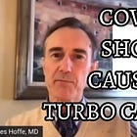
  Dr. Charles Hoffe: In My Practice 2/3rds Of All Cancer Diagnosis is Stage 4 Since The Vaccine Rollout
   |  | Apr 21
    Lioness of Judah Ministry |  | ·
  Read full story

  SHOCKING - Here is What Really is in the Vaccines
   |  | October 26, 2022
    Lioness of Judah Ministry |  | ·
  Read full story


  PREMEDITATED MASS MURDER: Alarming Data From Canada and Vaccines Batch Scandal
   |  | May 9, 2022
    Lioness of Judah Ministry |  | ·
  Read full story

  Globalists Aiming to “Peacefully” Depopulate Six Billion People With Mass Euthanasia
   |  | May 23
    Lioness of Judah Ministry |  | ·
  Read full story

© 2024 Lioness of Judah
48 Market Street PMB 72296, San Francisco, CA 94104

- • • •

Robert Morningstar
robert.morningstar@gmail.com
+ Add to contacts

