John Raymond Christopher 1909–1983 Wikipedia Aug 4 2015
https://en.wikipedia.org/wiki/John_Christopher_%28herbalist%29
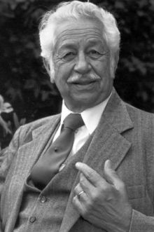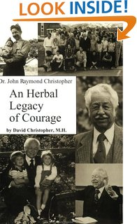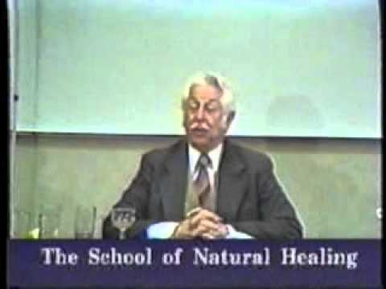
John Raymond Christopher (1909–1983) was an American herbalist, often called "Dr. Christopher" while not holding any doctorate. He is known for his numerous publications on herbs and natural healing, including School of Natural Healing. He is also notable for developing over 50 herbal formulas that are used worldwide and founding The School of Natural Healing in Springville, Utah. He was hailed as America's foremost herbalist in a nationwide survey conducted by Utah Survey Associates.^{[1]}

Contents
- 1 Biography
- 2 Books by Christopher^{[4]}
- 3 References
- 4 External links

Biography
Christopher was born to European parents. He was left in a Salt Lake City, Utah orphanage and adopted by Leander and Melissa Christopher. Born with advanced rheumatoid arthritis, he endured excruciating pain. As a child, he sometimes walked with a cane or used a wheelchair. He also developed hardening of the arteries and a nearly fatal case of croup. Doctors of his day proclaimed that he would never reach the age of thirty.
As a child Ray showed interest in being a doctor who would heal people with nature's remedies.
In 1945 he was drafted into the military and was stationed at Fort Lewis where he was allowed to experiment with herbs. After his military service he moved to Canada and studied at Dominion Herbal College in Vancouver where he obtained his degree in Naturopathy, then went on to study at the now defunct Iowa's Institute of Drugless Therapy and the now defunct Los Angeles Herbal Institute.
He spent time practicing in Olympia, Washington, Salt Lake City, Utah and Evanston, Wyoming.
In 1953 he formed the School of Natural Healing and began teaching. In 1979, he began publication of a newsletter about using herbs for healing^{[2]}
Christopher created more than 50 herbal formulas including Complete Tissue & Bone, Lower Bowel Formula, Blood Stream Formula, Female Reproductive Formula, Super Garlic Immune Formula, Herbal Tooth and Gum Powder and Hormonal Changease.^{[3]}
Christopher's son, David Christopher, began studying and working with his father and became the director of the School of Natural Healing in 1979. David has furthered the work of his father by creating additional courses and formulas. In 2009 David announced that an online version of the School of Natural Healing was being released to honor the centennial of his father's birth.

Books by Christopher^{[4]}
- 3 Day Cleanse & Mucusless Diet. ISBN 1-879436-04-3
- Cold Sheet Treatment. ISBN 1-879436-07-8
- Curing the Incurables. ISBN 1-879436-08-6
- Dr. Christopher’s Guide to Colon Health. ISBN 1-879436-20-5
- Every Woman’s Herbal (completed by his family after his death). ISBN 1-879436-10-8
- Herb Syllabus (completed by his family after his death). ISBN 1-879436-05-1
- Herbal Home Health Care. ISBN 1-879436-03-5
- Just What is the Word of Wisdom. ISBN 1-879436-05-1
- Newsletters (found in The Complete Writings of Dr. Christopher CD). ISBN 1-879436-25-6
- Regenerative Diet. ISBN 1-879436-00-0
- School of Natural Healing ISBN 1-879436-01-9

References

• Central Utah Journal, March 9, 1983 - Christopher was considered the number one authority on herbs by 57% with the next highest authority being 5%
• • http://www.herballegacy.com/Herbal_Legacy_of_Courage.html
• • http://www.herballegacy.com/Dr._Christopher_Formulas.html
  - • http://www.christopherpublications.com/Dr_Christopher.html

External links
- Informational website about Dr. John R. Christopher
- The School of Natural Healing
Categories:
- 1909 births
- 1983 deaths
- Herbalists
- People from Salt Lake City, Utah
===========================================================================================

