Featured Download eBooks Special Reports
Featured Download
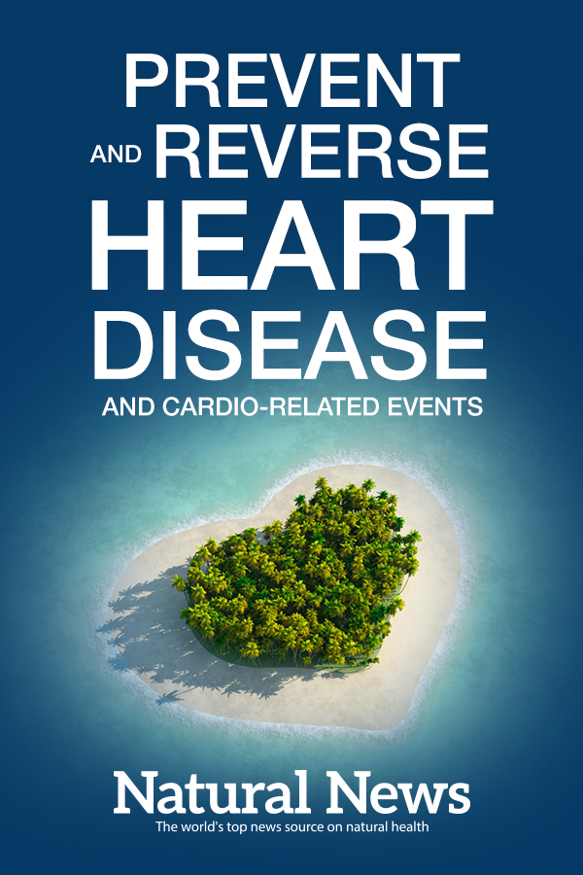
Prevent & Reverse Heart Disease and Cardio-Related Events
Heart disease can go by many names and comes in many different forms. Heart disease isn't just one disease, but rather numerous problems and conditions related to the heart muscle. Arrhythmia, angina, coronary artery disease and genetic defects can all be considered heart diseases.
Learn how you can prevent and reverse heart disease and cardio-related events in this free eBook from NaturalNews.com
Download for Free
More eBooks

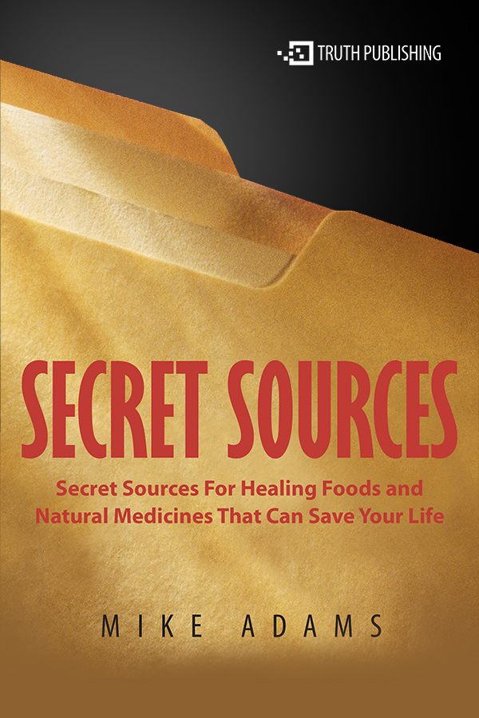
Secret Sources for Healing Foods and Natural Medicines That Can Save Your Life
Discover where you can purchase foods and products that are critical for overcoming chronic diseases.
Download

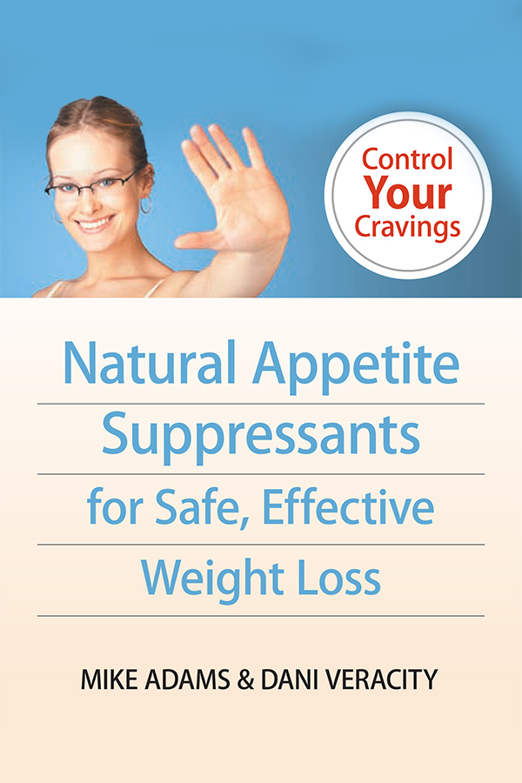
Natural Appetite Suppressants for Safe, Effective Weight Loss
Discover weight loss eating plans and strategies, how to fight food cravings, and more.
Download

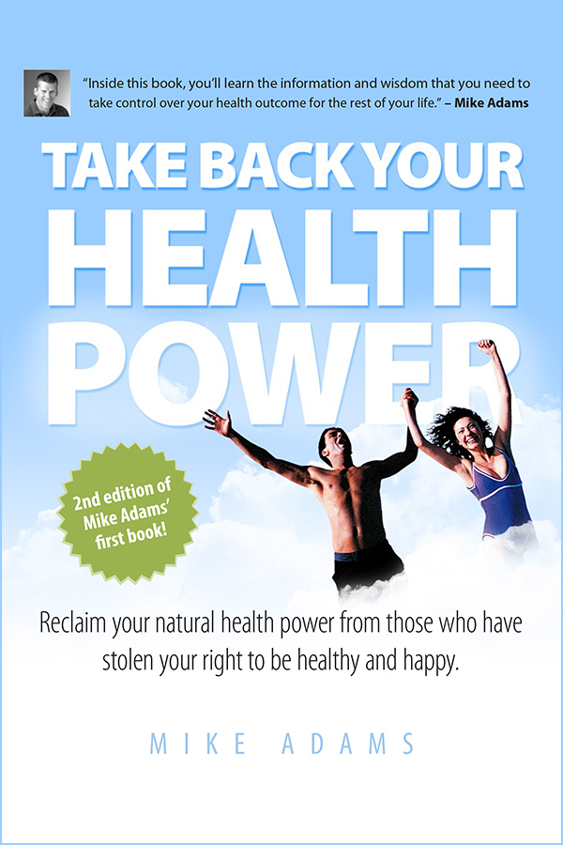
Take Back Your Health Power
Reclaim your natural health power from those who have stolen your right to be healthy and happy.
Download

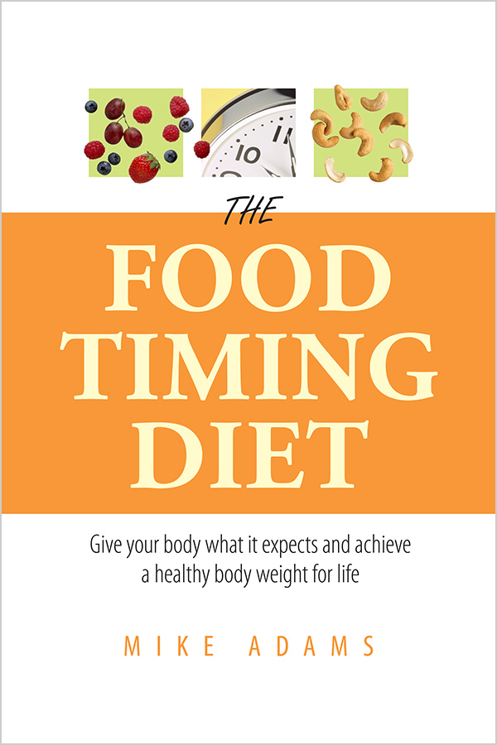
The Food Timing Diet
Give your body what it expects and achieve a healthy body weight for life.
Download

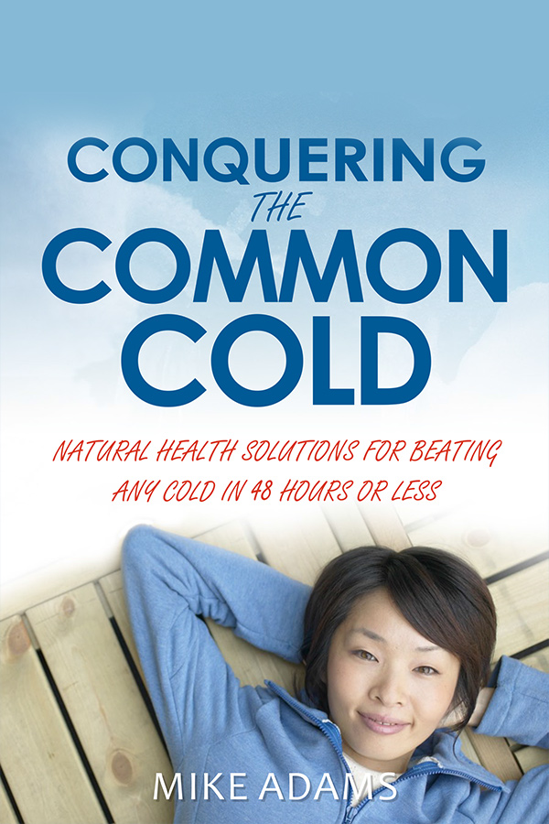
Conquering the Common Cold
Natural health solutions for beating any cold in 48 hours or less.
Download

Free Special Reports

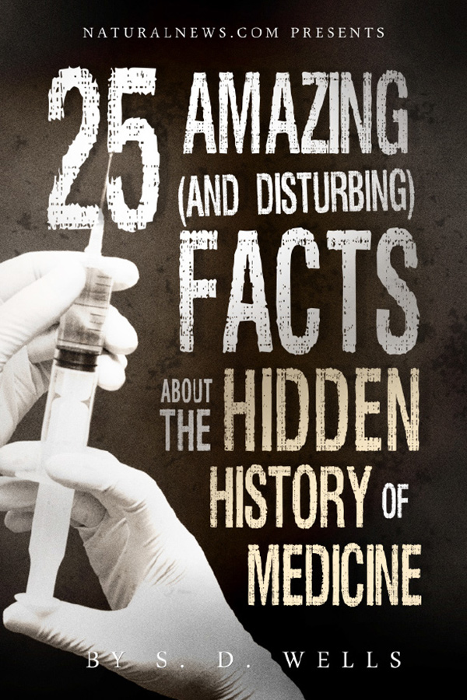
25 Amazing (and Disturbing) Facts About the Hidden History of Medicine
Discover the startling details that are 100% true, yet never mentioned in the mainstream media or by health authorities.
Download

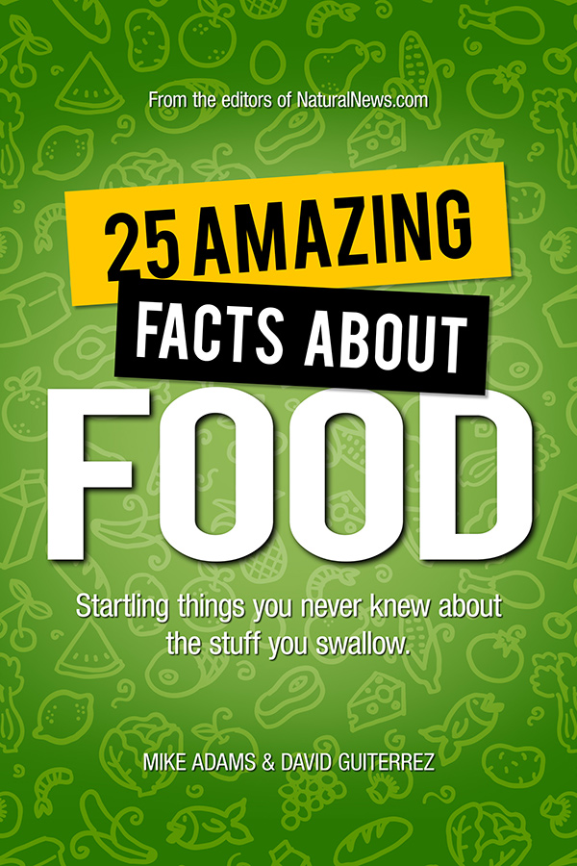
25 Amazing Facts About Food
In this exclusive NaturalNews report, you'll learn the surprising truth of how you've been eating cloned fruit without even knowing it!
Download

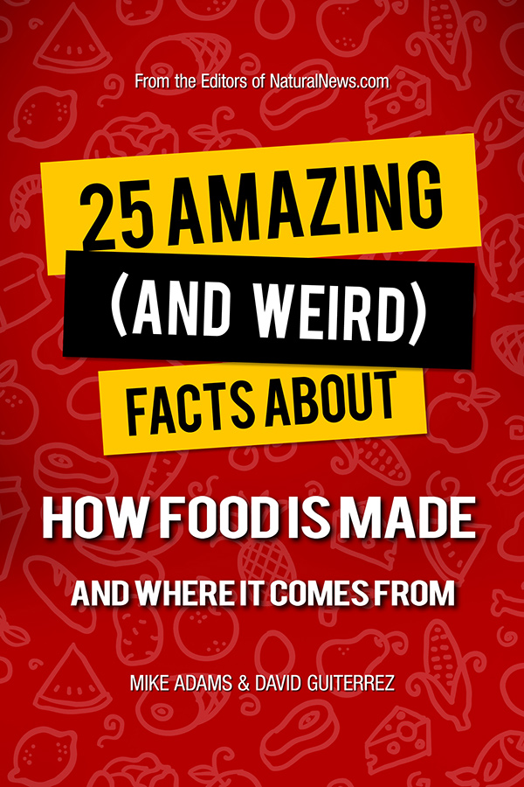
25 Amazing (and Weird) Facts About How Food is Made and Where it Comes From
Discover absolutely shocking details about food origins and manufacturing processes...
Download

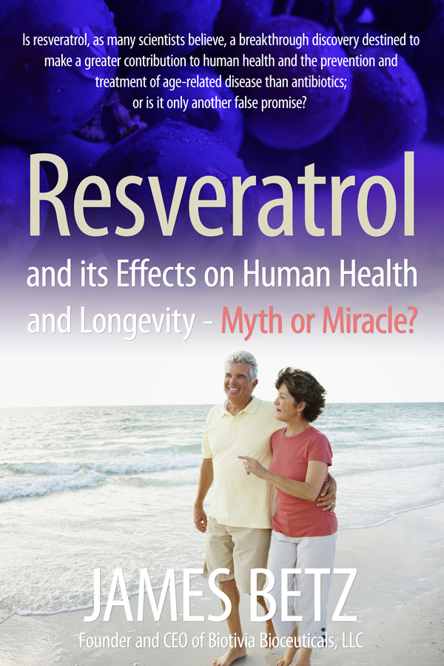
Resveratrol and its Effects on Human Health and Longevity - Myth or Miracle?
Unlock the secrets of cellular health with this "miracle" nutrient.
Download

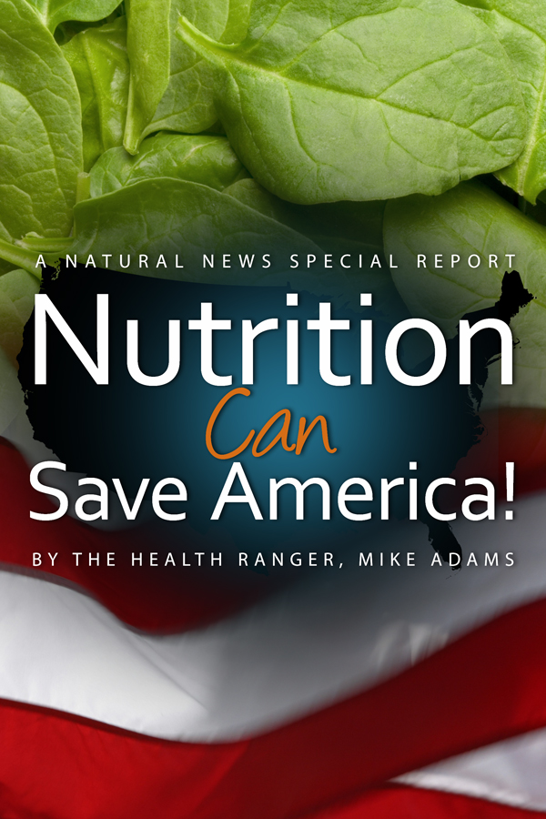
Nutrition Can Save America!
In this special report, you'll learn why nutrition plays such a powerful role in the rise or fall of any nation.
Read Online

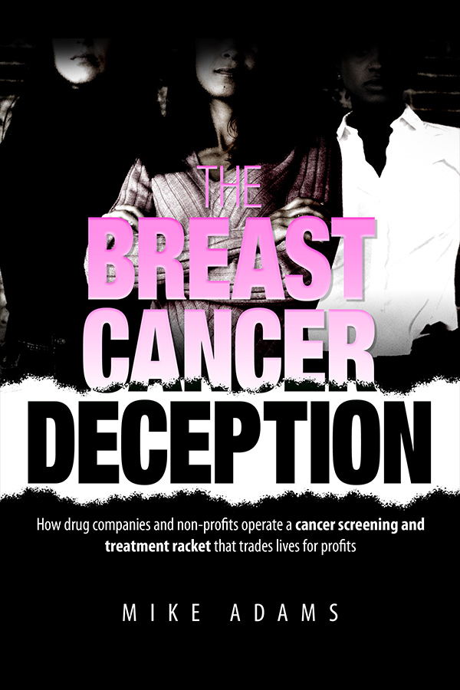
Breast Cancer Deception
This is a shocking, tell-all report that exposes the scam of today's breast cancer industry.
Read Online

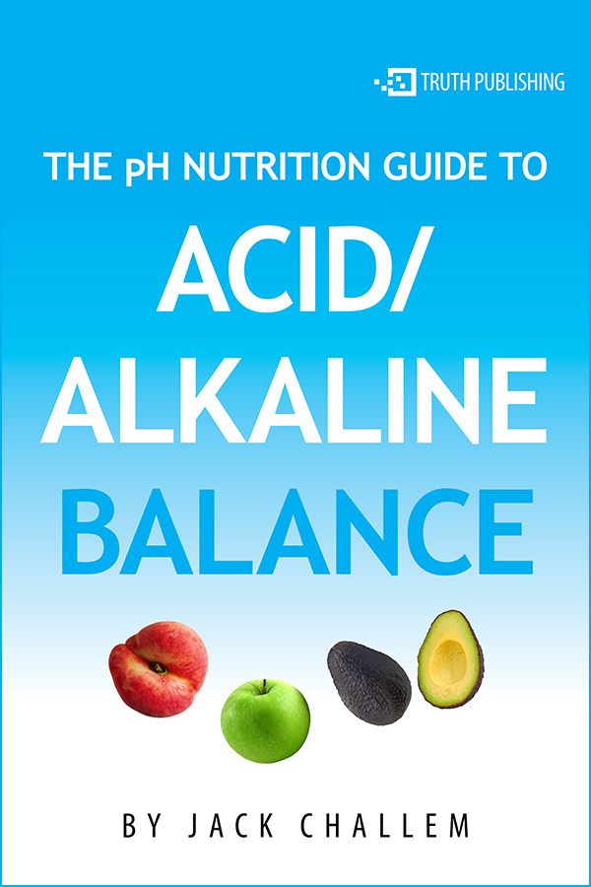
The pH Nutrition Guide to Acid / Alkaline Balance
In this exclusive report, you'll learn one of the most important health secrets found in nutritional science: the pH secret to good health!
Read Online

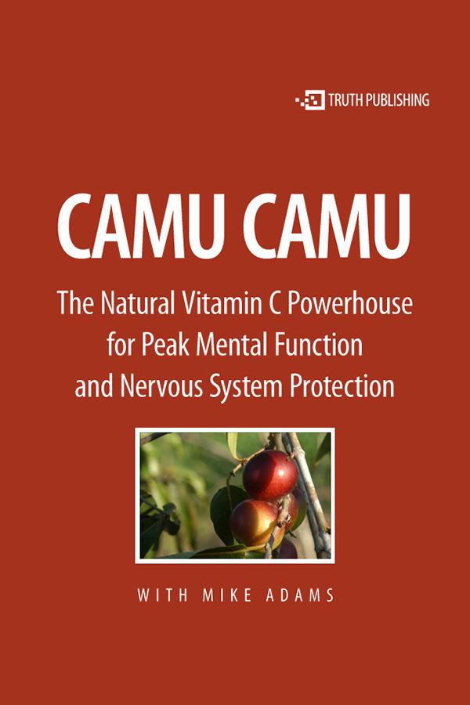
Camu Camu: The Natural Vitamin C Powerhouse For Peak Mental Function and Nervous System Protection
Learn about this unique superfruit and its phenomenal health benefits.
Read Online

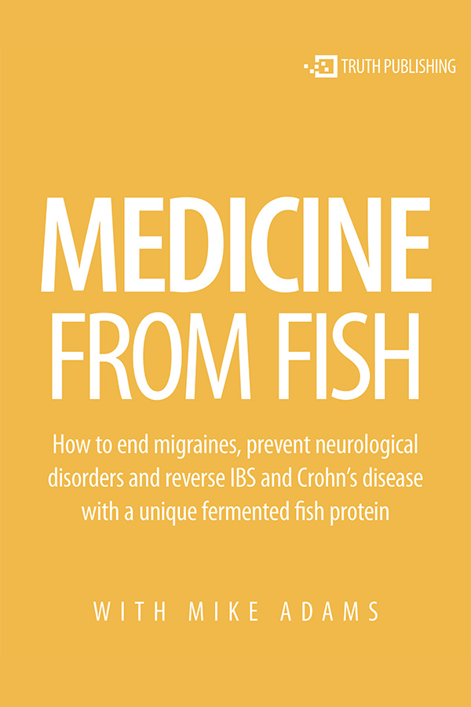
Medicine From Fish: How to reverse disease with therapeutic protein
Interview Tom Staverosky about a unique fermented protein product that shows benefits for migraine sufferers and people with digestive disorders.
Download

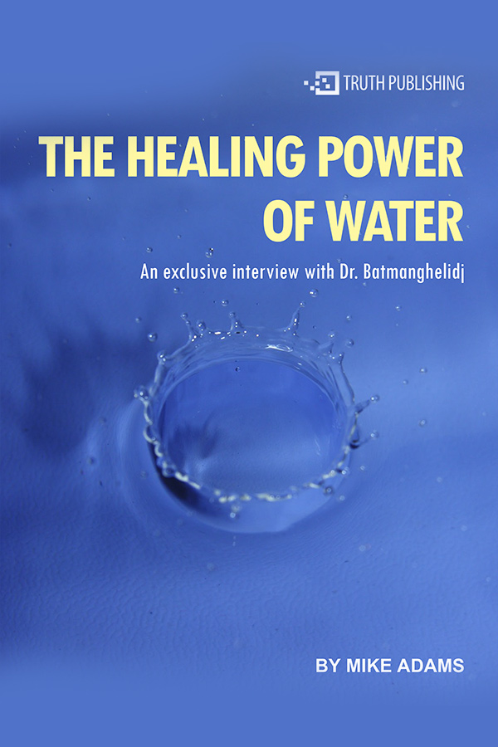
The Water Cure: An interview with Dr. Batmanghelidj
Dr. Batmanghelidj, M.D. has studied water's effect on the human body and has found it to be one of the best pain relievers and preventative therapies in existence.
Download

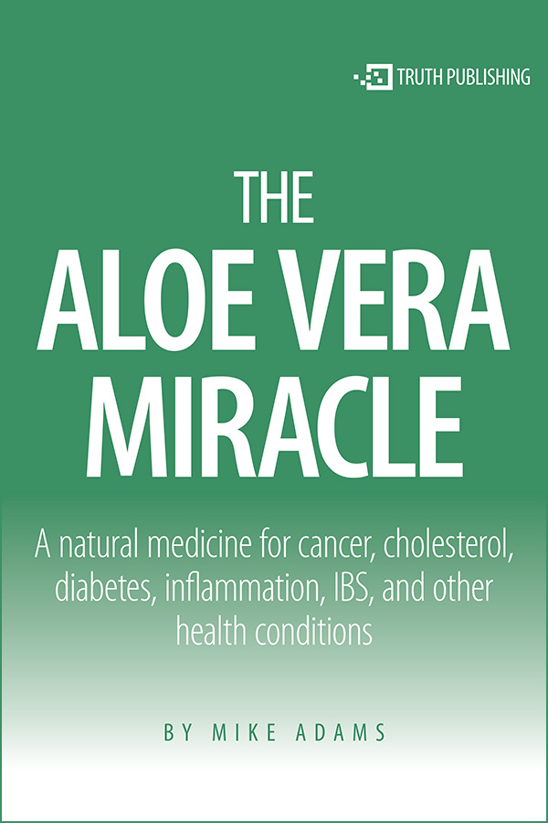
The Miracle of Aloe Vera
A natural medicine for cancer, cholesterol, diabetes, inflammation, IBS, and other health conditions.
Download

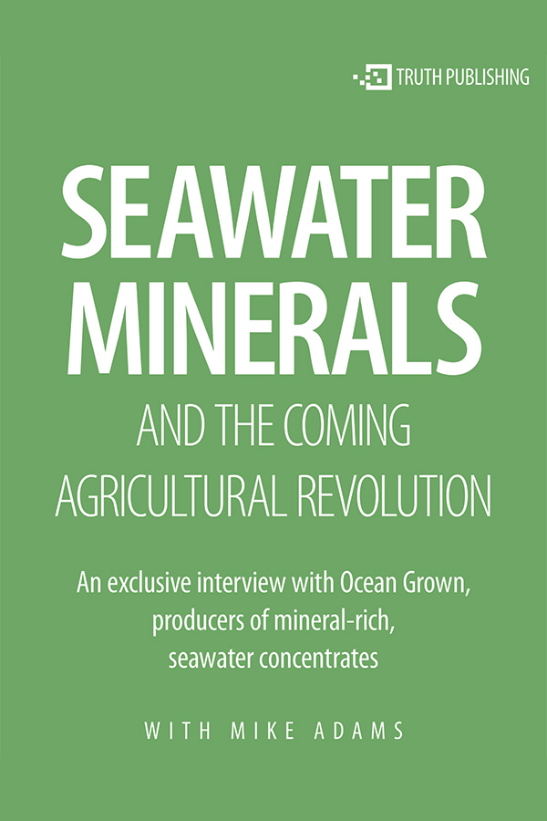
Seawater Minerals and the Coming Agricultural Revolution
An exclusive interview with Ocean Grown, producers of mineral-rich, seawater concentrates.
Download

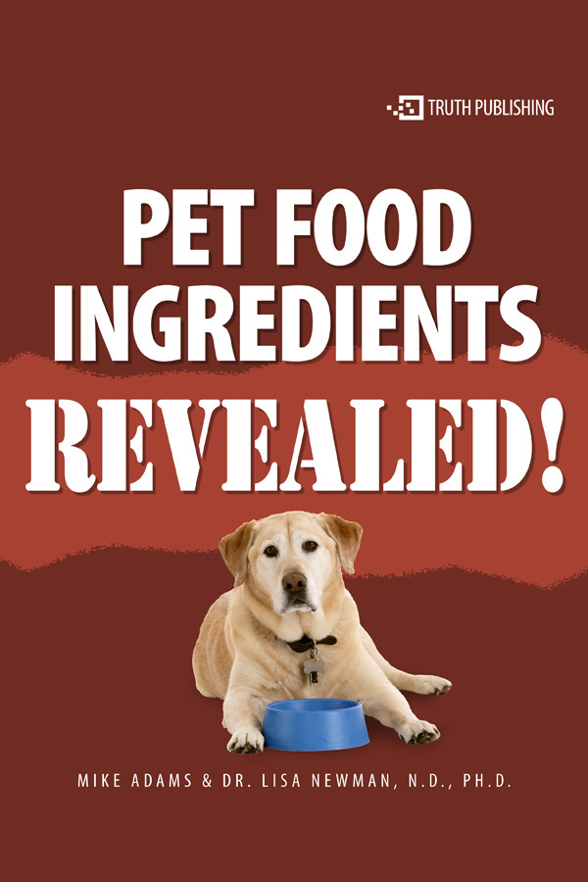
Pet Food Ingredients Revealed!
A NaturalNews Special Report by Dr. Lisa Newman and Mike Adams
Read Online

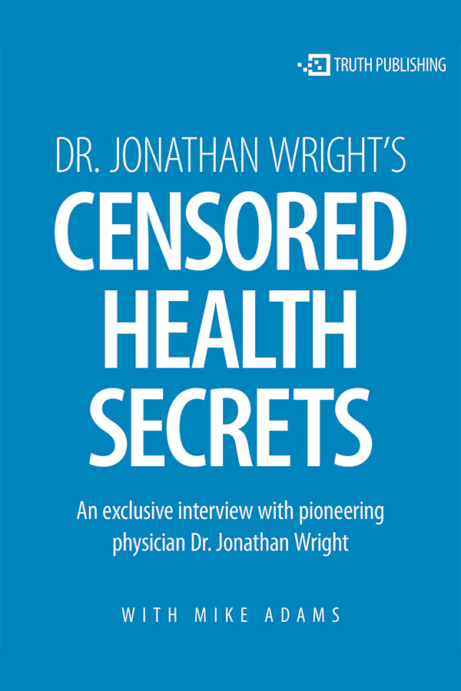
Censored Health Secrets
In this exclusive NaturalNews interview, Mike Adams talks with Dr. Jonathan Wright, M.D., a true pioneer in nutrition, disease prevention and health freedom.
Download

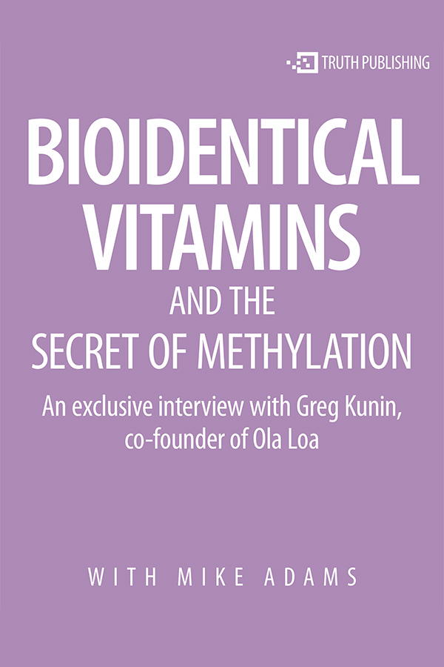
Bioidentical Vitamins and the Secret of Methylation
Discover a treasure chest of little-known truths about vitamins and health from one of the top experts in the supplements industry.
Download

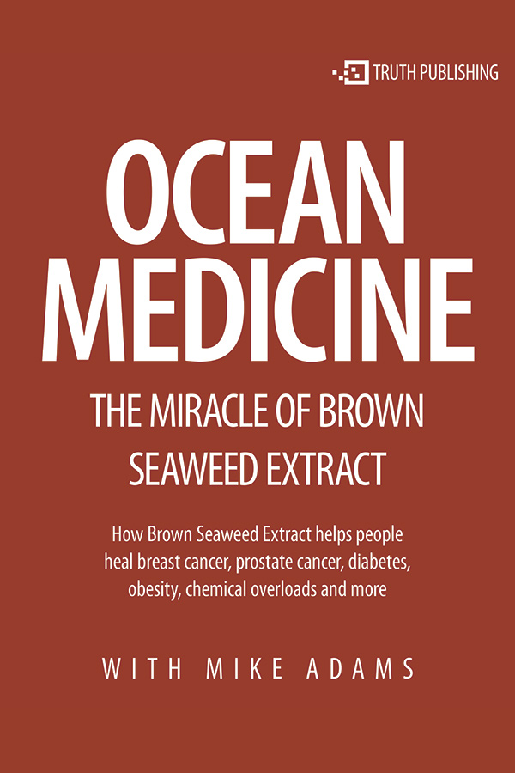
Ocean Medicine: The Miracle of Brown Seaweed Extract
Sergei Zimin, the founder of Modifilan, reveals never-before-published details about the harvesting, processing and packaging of this truly amazing medicine.
Download

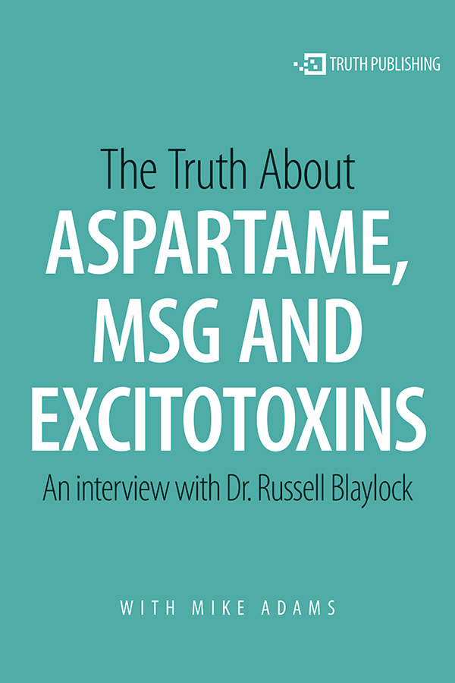
The Truth About Aspartame, MSG and Excitotoxins
Dr. Blaylock is the author of Excitotoxins: The Taste That Kills, and Health and Nutrition Secrets That Can Save Your Life.
Download

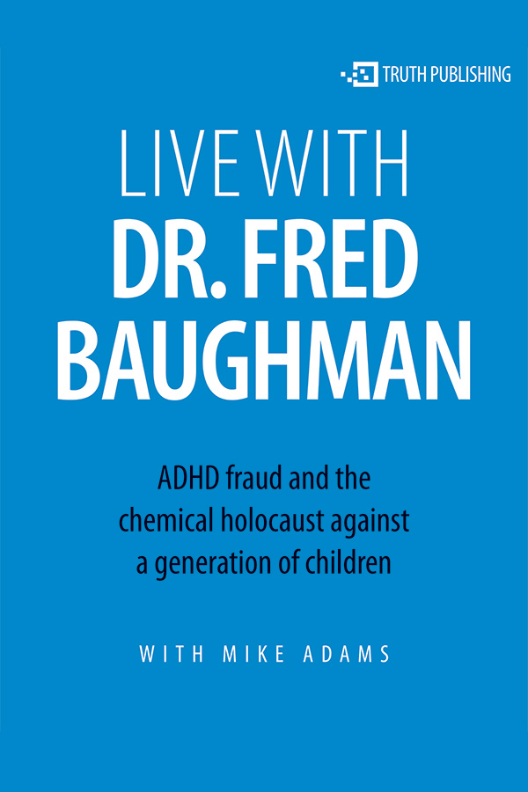
Live with Dr. Fred Baughman
In this interview, Dr. Baughman discusses ADHD fraud and the chemical holocaust against a generation of children.
Download

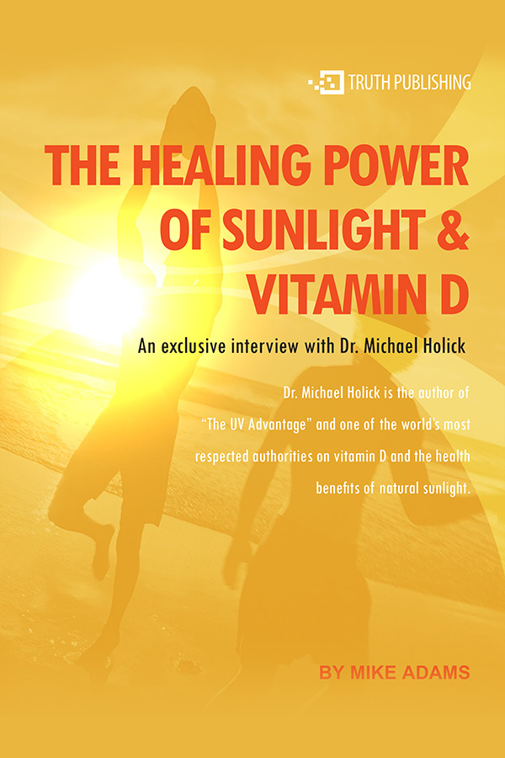
The Healing Power of Sunlight and Vitamin D
Dr. Holick reveals fascinating facts on how vitamin D is created and used in the human body to ward off chronic diseases like cancer, osteoporosis, mental disorders and more.
Download

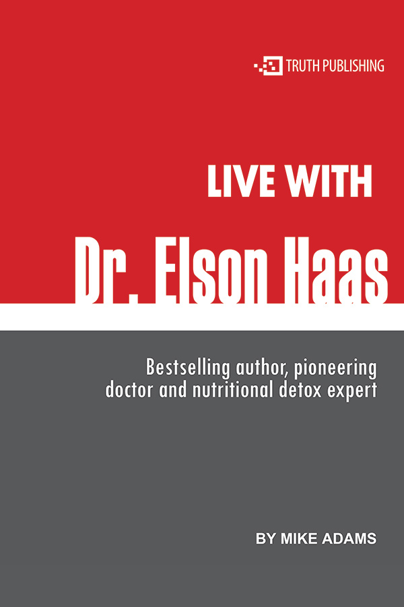
Live with Dr. Elson Haas
Dr. Haas is a bestselling author, pioneering doctor and nutritional detox expert.
Download

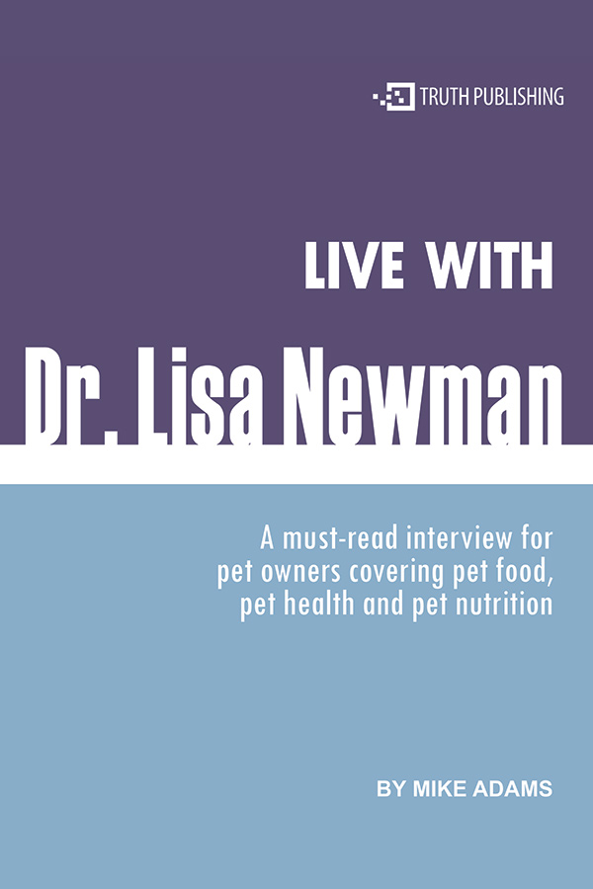
Live with Dr. Lisa Newman
A must-read interview for pet owners covering pet food, pet health and pet nutrition.
Download

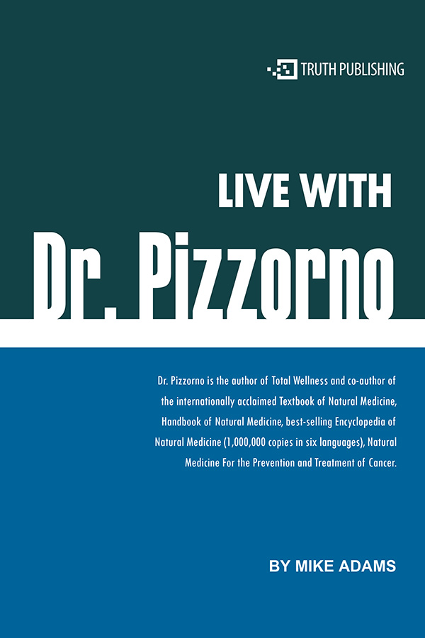
Live with Dr. Pizzorno
Dr. Pizzorno is the author of Total Wellness and co-author of the internationally acclaimed Textbook of Natural Medicine.
Download

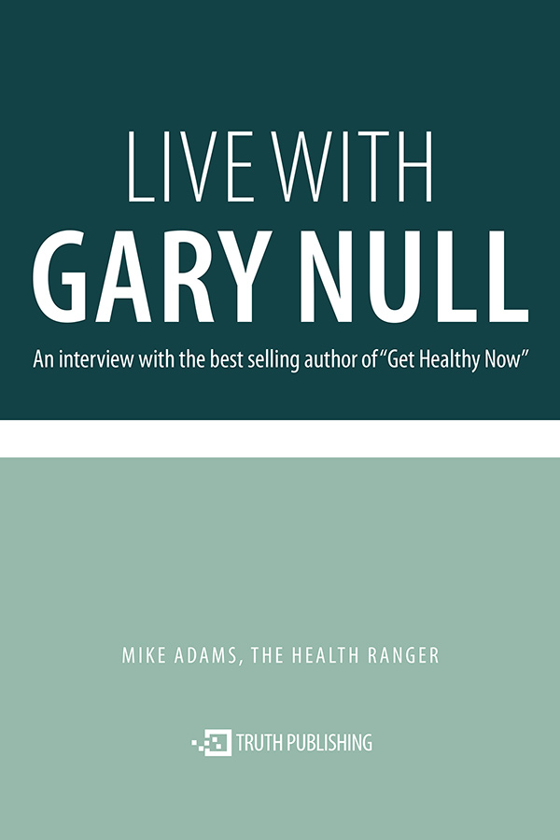
Live with Gary Null
Gary Null is the best selling author of Get Healthy Now.
Download

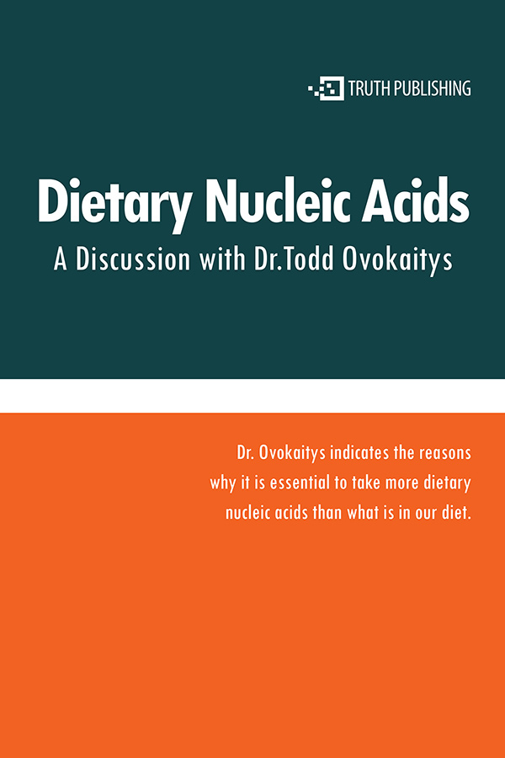
Dietary Nucleic Acids
A discussion with Dr. Todd Ovokaitys
Download

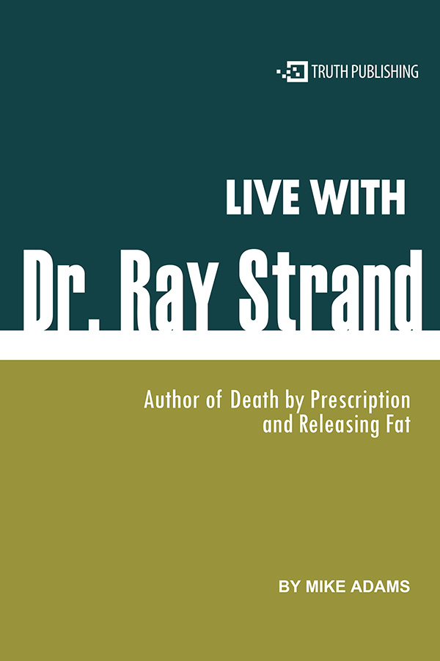
Live with Dr. Ray Strand
Dr. Strand is one of the most courageous doctors to speak out about the health effects of prescription drugs.
Download

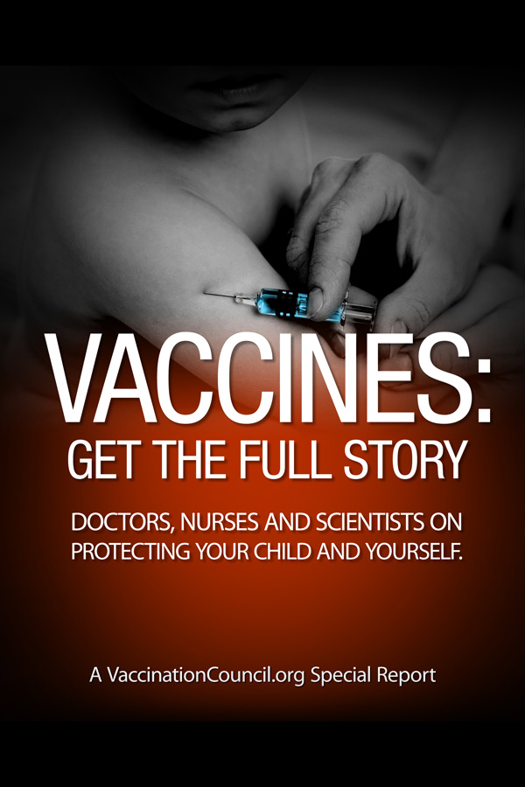
Vaccines: Get the Full Story
Doctors, Nurses and Scientists on Protecting Your Child and Yourself.
Download

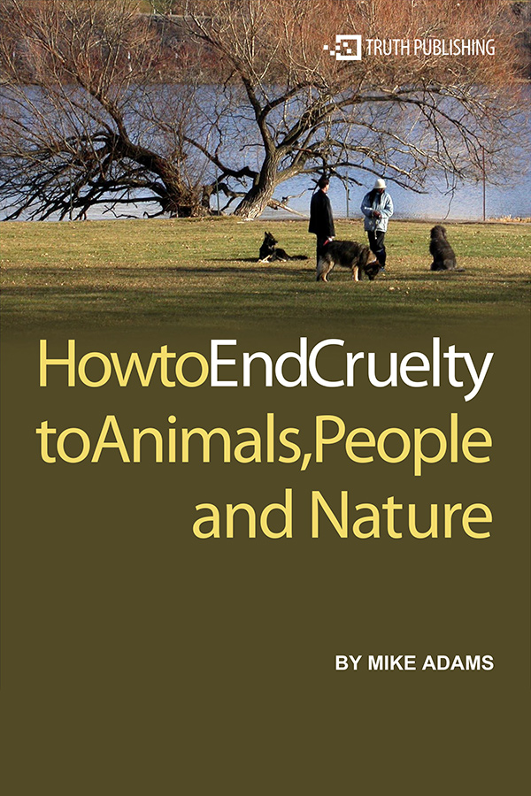
How to End Cruelty to Animals, People and Nature
Discover what we can do to help end cruelty and enhance compassion in the world.
Download

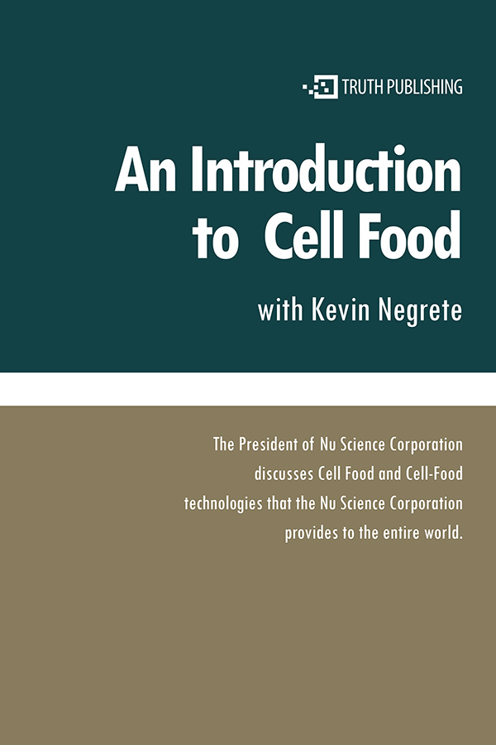
An Introduction to Cell Food with Kevin Negrete
The President of Nu Science Corporation discusses Cell Food and Cell-Food technologies that the Nu Science Corporation provides to the entire world.
Download

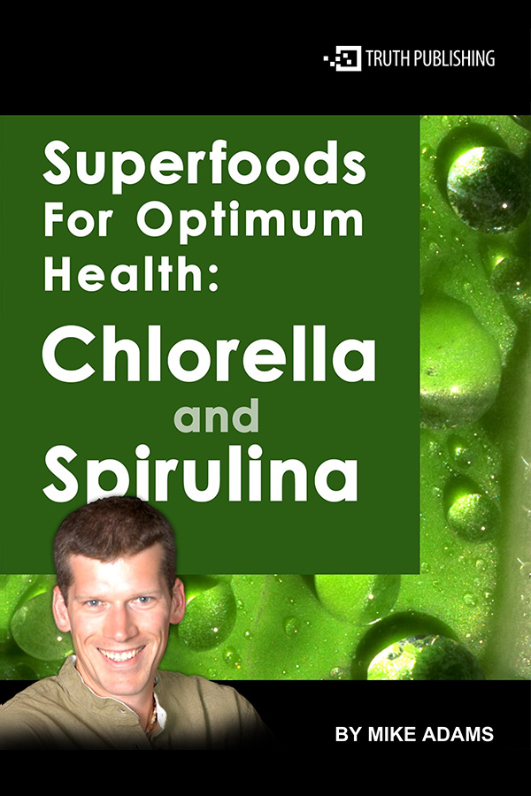
Superfoods for Optimum Health: Chlorella and Spirulina
Discover the astonishing health benefits and nutritional achievements of these two foods.
Download

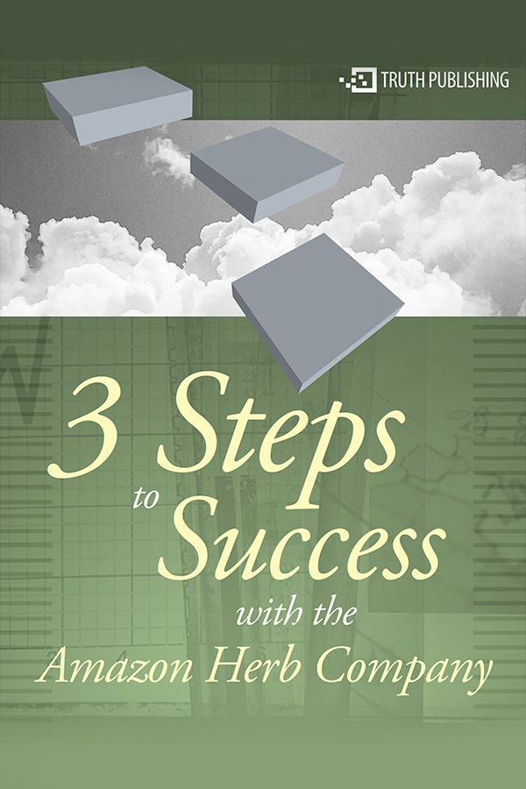
3 Steps to Success with the Amazon Herb Company
This program is for people who want to start off on the right track and really make it a success.
Download

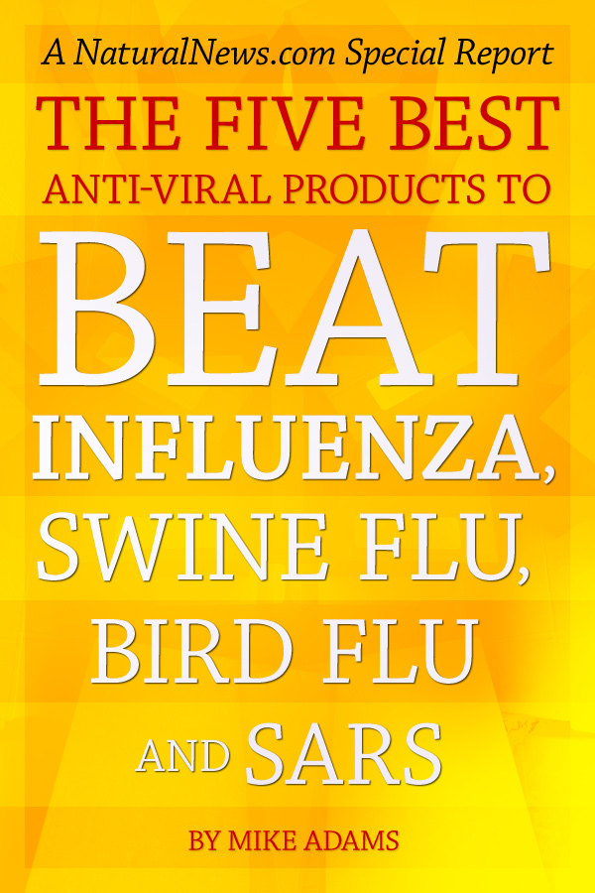
The Five Best Anti-Viral Products to Beat Influenza, Swine Flu, Bird Flu and SARS
This is a special report the FDA doesn't want you to read.
Read Online

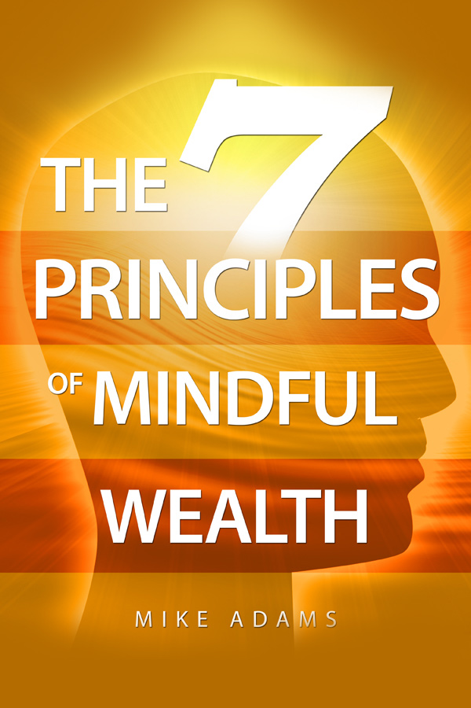
The 7 Principles of Mindful Wealth
Learn how to let go of unconscious limitations to personal wealth and embrace a conscious wealth attraction philosophy that's aligned with natural living principles.
Read Online

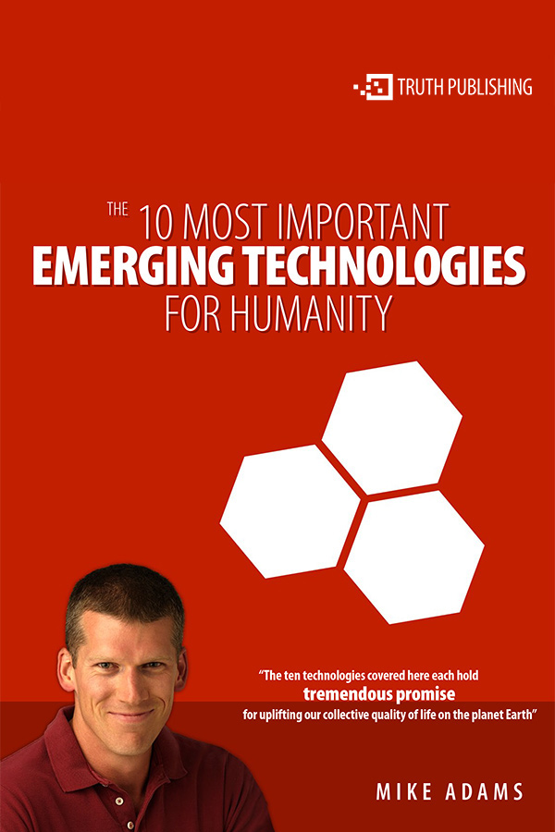
The 10 Most Important Emerging Technologies for Humanity
Most of these technologies will, at some point, be hotly debated for their social, economic, and political implications.
Download

This site is part of the Natural News Network © 2019 All Rights Reserved. Privacy | Terms All content posted on this site is commentary or opinion and is protected under Free Speech. Truth Publishing International, LTD. is not responsible for content written by contributing authors. The information on this site is provided for educational and entertainment purposes only. It is not intended as a substitute for professional advice of any kind. Truth Publishing assumes no responsibility for the use or misuse of this material. Your use of this website indicates your agreement to these terms and those published here. All trademarks, registered trademarks and servicemarks mentioned on this site are the property of their respective owners.
Your privacy is assured and your information is kept confidential. You may unsubscribe at anytime.

