Home Remedies for Pinworms
By Gary Wickman | Home Remedies | Rating:
Many parents may have never heard of pinworms. By understanding about these parasites, you may finally have a clue on what had happened to your children. Pinworms are intestinal parasites, these worms have thin shape and white in color. The males are slightly shorter than the female and usually visible at night at the rectum area. These worms are very contagious and you can contract it by accidentally ingesting or inhaling the eggs. The eggs can be lodged under the children's nail and when they eat or scratch their skin, the eggs can finally enter the body through the mouth or the tiny opening on the skin.
Pinworm Symptoms
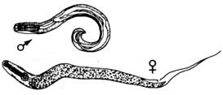
The most common symptom of pinworms is burning sensation and itching on the rectum and sometimes in the genital area. The females produce gelatin-like eggs when they lay eggs near the anus opening, causing itchiness to occur. It usually happens a few hours after your child goes to sleep. The worm movements may also cause some itchiness. Stomach cramping, especially on the lower abdominal area, may happen on children with pinworms. At nighttime, pinworms are more likely to be active, as this is the moment when the females lay their eggs. Pinworms are often responsible for the restlessness during the night; some children may also experience diarrhea or bedwetting. The children often complain that their anus is hurting and they couldn't sleep. These children may refuse to go to sleep and parents may suspect that their children simply refuse to sleep.
Pinworm Diagnosis
It is advisable to see a doctor to confirm whether your child has pinworms infestation. The doctors will take the liquid sample from the rectum and check it under the microscope to see whether the pinworms and their eggs are visible. During the night, you should check your child's rectal opening and see whether there are any worms present.
Home Remedies for Pinworms
1) Garlic is very effective in treating pinworms. There a number of methods in using garlic to eradicate the parasitic worms. The simplest way to use garlic is by eating it raw. Unfortunately, powdered garlic has limited effectiveness. If your child can't tolerate the taste, simply add plenty of garlic in their foods. You should also make a topical cream made from fresh garlic, grind a few cloves of garlic into a smooth paste and mix it with Vaseline. Apply the cream on the rectum; this can help to kill the eggs and provide relief for the itchiness.
2) Grapefruit seed extract is another effective way to treat pinworms. This product is available in major drugstores and it may come in pill or liquid form. The pills are usually taken three times a day and if you use the liquid form, you may need to mix 10 drops with a glass of water, three times a day. If there is no improvement after a week, it is advisable too immediately see a doctor.
3) Wormwood contains a potent worm-killing chemical and it is among the safest natural remedies for pinworms. Santonin, isothujone and thujone are active substance found inside the wormwoods, which can also kill other parasitic organisms beside pinworms. Wormwood can weaken the parasite's cell membranes, thereby killing the worms gradually. Simply add a few grams of wormwood into a cup of hot water. Give it to the child in the morning on an empty stomach. Give your child the wormwood tea every three hours to improve the effectiveness of the treatment.
4) Coconut is often used in India to eradicate pinworms. During breakfast, take one tablespoonful of fresh coconut followed a teaspoonful of castor oil three hours later. Repeat this each day until pinworms are gone completely.
5) Take a cup of shredded raw carrots before and after sleep to help your body push intestines out of the intestines. Some children may find it difficult to eat raw carrot, if so mix it with some honey.
6) You can use food-grade diatomaceous earth to treat pinworms infestation. It is a sedimentary, chalky rock that is made from fossilized small algae, called diatoms. Diatomaceous earth can dehydrate pinworms and kill them slowly.
7) White willow bark is commonly known as rich in salicylic acid, the principal ingredient of aspirin. You can also use it for treating pinworms.
8) People with diet rich in carbohydrates and sugar are more vulnerable to parasitic infestation. Parasites often thrive on sugar. If your children have pinworms, you should limit the sugar and carbohydrate intake. It is important to slightly lower the pH level of the digestive tract, to make it more unpleasant for pinworms to live in it. Add two tablespoonfuls of apple cider vinegar to one glass of water and drink it each day.
9) Crush raw pumpkins sees in a bowl and mix it with two cups of water. Put it on low heat, on the stove, for two hours. Never let the mixture boil, after two hours, set it aside for cooling. Filter the mix and remove any layers of oil. For one hour, take one tablespoonful of the filtered water, every 15 minutes. Wait for two hours and take a laxative. Wait for two more hours and eat a bowl of warm oatmeal. Children between 2 to 3 years old should use about 45 grams of pumpkin seeds, while adults may take up to 300 grams of pumpkin seeds.
10) You can also grind one part of cloves and ten parts of flaxseeds. Add the mixture to your meal. For one month, take the powder by alternating three days on and three days off.
11) Mix a glass of boiling with 50 grams of smashed squash seeds. Boil the mixture for about 15 minutes and put it in a thermos for two hours. Then filter the mixture and take half a glass of the filtered water between meals.
To prevent the pinworms from spreading to other family members, you should ask your children to stop scratching their rectum. Always clean the toilet thoroughly after your child uses it and if possible, replace the bedding each day, don't let other family members to enter the child's room until the pinworms infestation is fully treated.

Gary Wickman

Copyrighted material; do not reprint without permission.
View all articles by Gary Wickman

How would you rate the quality of this article?
Poor
1
2
3
4
5
Excellent
ADD COMMENT
Verification:
Enter the security code shown below:


Related Articles And Other Topics
- Can a Relationship Survive an Affair?
- The Many Benefits of Moringa Oleifera
- Understanding Blood Pressure – An Introduction
- Are You 'Too Nice'? Why (Some) Nice Guys Finish Last
- How to Know If It's Broken
Comments
- Comment #1 (Posted by rahul)
Rating
Superb; really helpful information.
Thanks a lot
- Comment #2 (Posted by Victoria)
Rating
Excellent, will keep up with regime, and let you know how it goes. Am fed up with doctor's giving you half the information. This has helped greatly!
- Comment #3 (Posted by majorie c andersen)
Rating
Just discovered that my 2 older daughters have pinworms and I'm trying to take all the necessary steps to get rid of them and reading this site will help me more...
- Comment #4 (Posted by Tina)
Rating
If any or all of these remedies work, it will be well worth the time spent.
- Comment #5 (Posted by Dawn)
Rating
Sadly, the garlic, coconut and castor oil do not work... :-( For my son at least, he's been up all night just miserable.
- Comment #6 (Posted by Casalina)
Rating
Great information
- Comment #7 (Posted by lindsay)
Rating
My daughter is being re infected with pinworms. I keep treating us all and it comes back two months later. I am assuming she is catching it from a school friend. Can anyone recommend something to help sooth her bottom as I usually find out she has them when it's the middle of the night and she can't sleep.
- Comment #8 (Posted by Lala)
Rating
I have been taking 2 tablespoons of diatomaceous earth diluted in 2 cups of water every day before going to bed for 8 days. I have noticed more worms coming out the perianal area and spreading further and more anal itching. Is it true that DE is a good way to get rid of pinworms or I should take the DE in the morning or after meals? Should I take more DE per day? Please let me know because these pinworms bother like hell!

Copyright 2017 Healthguidance.org. All rights reserved. DISCLAIMER: By printing, downloading, or using you agree to our full terms. Review the full terms at the following URL:
Skip to content
- World's Largest Home Remedy Portal
- My Account
  - Logout
- Contact us
- Cart
- Checkout


- Login

- Cart / $0.00 0

    - No products in the cart.

Top of Form
Bottom of Form

Top of Form
Bottom of Form
- Home Remedies
- Herbal Remedies
- Herbal Supplements
  - Herbal Supplements
    - Male Health
    - Arthritis / Joint Pain
    - Cough & Throat care
    - Diabetes Support
    - Colon Support
    - Digestive Support
    - Immunity Boosters
  - Herbal Supplements
    - Women’s Health
    - Breast Care
    - Heart Support
    - Cholesterol
    - Hair Loss / Dandruff
    - Kidney Support
    - Liver Support
  - Herbal Supplements
    - Stress Relief
    - Memory Support
    - Skin Problems
    - Vitamins / Anti aging
    - Weak Eyesight
    - Weight Loss
- Natural Cures
- Fitness
  - Vitamins
  - Diet
  - How To
  - Yoga Treatments
- Questions Board
- Ask Question

9 Remedies For Wriggle Pinworms
167 Shares
Share
Tweet
Pin

The most common type of intestinal worm infestation in adults as well as children, pinworm infection is harmless as such apart from the intense itching around the anal region. Pinworm itching can drive you crazy and the very fact that you cannot control the itching makes way for more infections and spreading as the eggs can survive in clothes and nails and can get back to the intestine causing more severe infection. Pinworm infection in its severest form can lead to appendicitis, vomiting, nausea, weight loss, insomnia, irritability and bed wetting.
Migration of pinworms to the vagina can lead to vaginitis and severe itching. There are many medications that treat pinworm infections. But they are effective only in killing the adult worms. The eggs could still be in the rectal region and can hatch again to cause recurrence. There are a multitude of home remedies for pinworm infection which can destroy the eggs as well as the worms and get rid of the infection much more efficiently and safely than medications.

Natural Methods To Treat Pinworm Infection

Garlic
Talk about the garlic effect! The great vegetable is sure to show its prowess wherever there is an infection or an inflammation. Garlic can remove the pinworms straight from the intestines. They are much better than over the counter medications in that they are capable of destroying the eggs as well, removing the infection from your system completely without any cause for recurrence.

The most common type of intestinal worm infestation in adults as well as children, pinworm infection is harmless as such apart from the intense itching around the anal region. Pinworm itching can drive you crazy and the very fact that you cannot control the itching makes way for more infections and spreading as the eggs can survive in clothes and nails and can get back to the intestine causing more severe infection. Pinworm infection in its severest form can lead to appendicitis, vomiting, nausea, weight loss, insomnia, irritability and bed wetting.
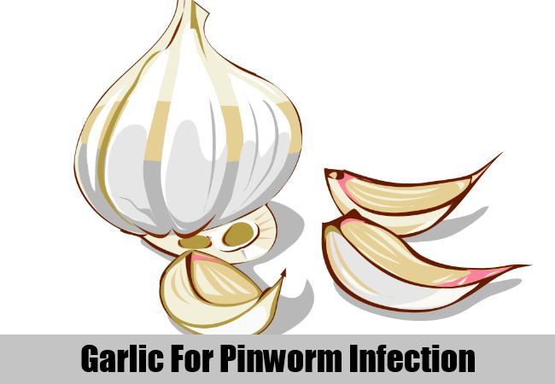
For intense itching and removal of pinworms and eggs from the anal region, make a paste of garlic and add petroleum jelly to it. Mix well and apply directly on the anal region. The itching will be stopped immediately and one would wonder as to where all the pinworms disappeared in such a hurry!

Grapefruit Seed Extract
Crush the seeds of grapefruit and extract the juice out of it. Take 8 ounces of water and ten drops of the extract into it. Drink this solution three times a day. Continue this for a week and be ready to be surprised with the fast results.
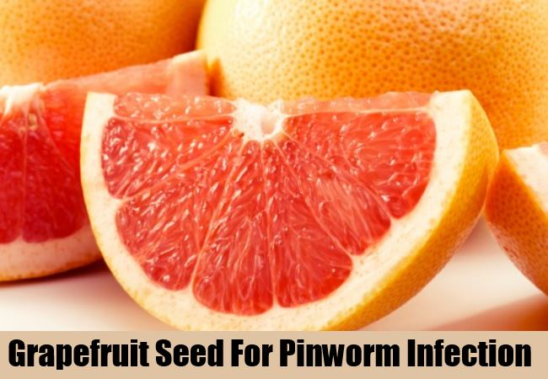
The anti parasitic nature of this extract will kill all the pinworms in the intestine and remove the infection effectively. For any eggs in the anal region, apply garlic paste. You are now free from pinworm infection!

Coconut
Coconut has been used and praised for its abundant goodness since time immemorial. It is also touted as one of the most efficient ways to treat pinworm infection. You can grate some coconut and take a spoonful in the morning while you have breakfast.
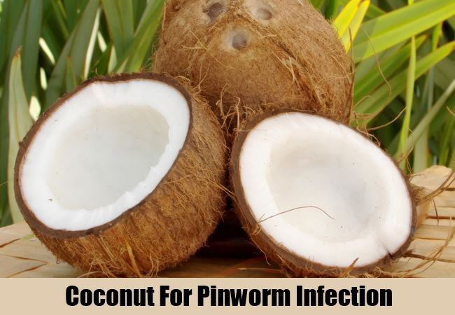
You can add tender coconut too in your diet. After three hours of taking coconut, take one tablespoon of castor oil. Do this every day until the pinworm infections is completely removed.

Carrots And Cabbages
Carrots contain natural sulphur compounds which help in removing pinworms from the intestine. Grate a carrot and consume it in the morning every day.
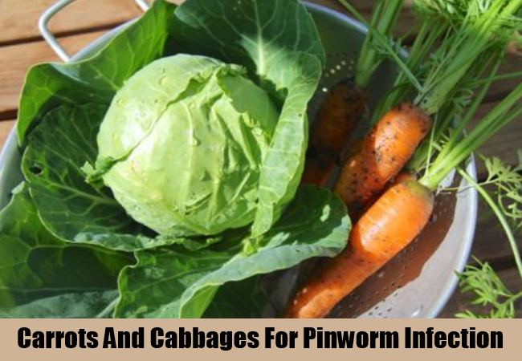
Continue this for 2-3 days and all the pinworms will be destroyed. Cabbages too have sulphur compounds and hence can be used for destroying pinworms.

Onions
Onion has abundant sulphur globules that can evacuate the pinworms in a day from the intestine. Chop two onions and leave them in a pint of water for 12 hours.
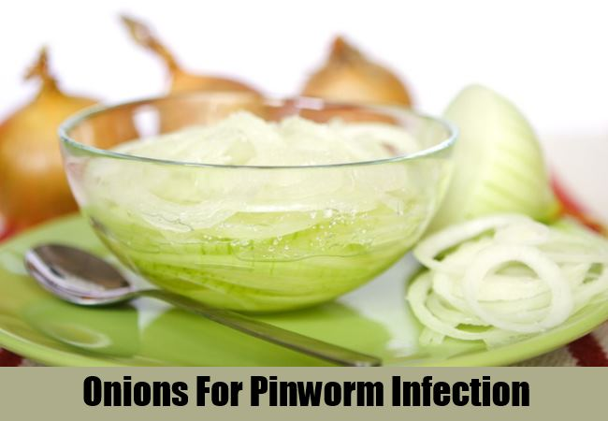
Strain and take the juice and drink one cup of this onion water three times a day. All the pinworms will be gone in 2 days.

Bitter Gourd
Bitter gourd is known to reduce diabetes. It can also be used to treat pinworms. Take two bitter gourd and extract the juice from it.
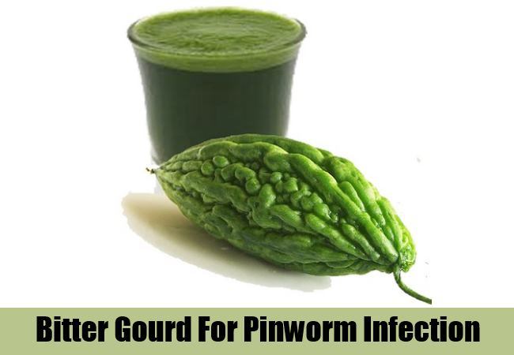
Drink this juice every day. Continue the treatment for a week and see how much of a relief you get form pinworms.

Pumpkin Seeds
Pumpkin seeds are used for removing pinworms from the intestine. Take a handful of pumpkin seeds and crush it. Take two cups of water and heat in a low flame. Add the crushed seeds and allow it to heat in a low flame for about two hours. After cooling, take one tablespoon of this water every hour.
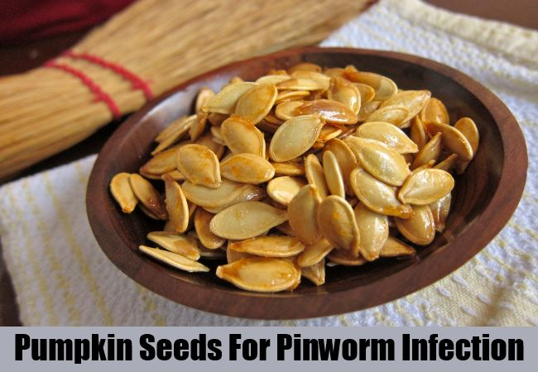
This must be followed by a laxative after two hours and oatmeal after another two hours. For adults, you can use 300 g of pumpkin seeds. Children will need much less, starting from 50 g and moving on to 150 g depending on the age.

Wormwood
Wormwood has active ingredients like thujone, santonine and isothujone which help in removing parasites from the body. As you gulp wormwood down your throat, the water reaches the intestine and weakens the membranes of the parasites that are housed in the intestine, thereby killing them completely.
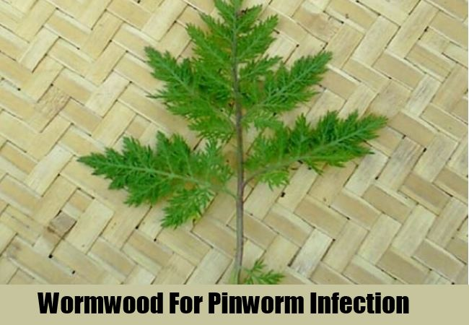
Take one teaspoon of wormwood and boil in a cup of water. Allow it to cool and drink early morning empty stomach. You can continue drinking wormwood tea every two hours for complete removal of parasites including pinworm and its eggs from the body.

Apple Cider Vinegar
Apple cider vinegar is a definite solution for pinworms. Vinegar does not kill the worms in your intestines, but will rid the body of the worms with continued application. Take a glass of water and add two teaspoons of apple cider vinegar into it. Drink this every day to lower the ph level in your intestine. This will make it difficult for the worms to thrive and force them to die a natural death.

Drinking apple cider vinegar every day will prevent the worms from multiplying in your system and also prevent its occurrence.
While trying these home remedies, it is also important to observe personal hygiene. Leave your anal region clean by washing with soap and water. It is also important to give some hot treatment to your bed sheets by laundering them in hot water. Always wash your hands with soap and water after touching the anal region and try not to scratch!
167 Shares
Share
Tweet
Pin
Leave a Comment
Caution: Please use Home Remedies after Proper Research and Guidance. You accept that you are following any advice at your own risk and will properly research or consult healthcare professional.

This entry was posted in Featured, Natural Cures.
13 Simple Yet Effective Home Remedies For Cold Sores
7 Natural Methods To Lose Belly Fat

Worth Buying
-70%
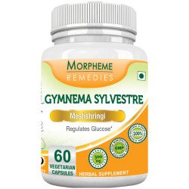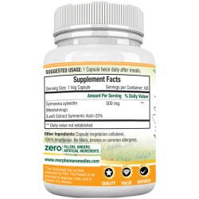

+
Quick View
Diabetes Support
Morpheme Gymnema Slyvestre (Meshshringi) 500mg Extract 60 Veg Caps
5 out of 5
$19.79
-30%
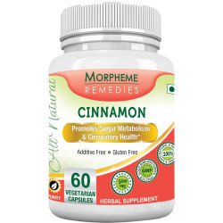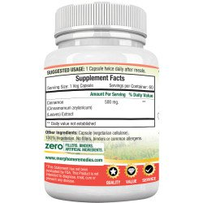

+
Quick View
Cholesterol
Morpheme Cinnamon 500mg Extract 60 Veg Caps
5 out of 5
$19.79
-30%
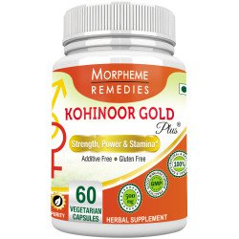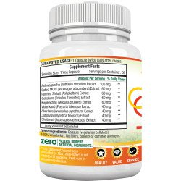

+
Quick View
Male Health
Morpheme Kohinoor Gold Plus – 60 Veg Caps
4.69 out of 5
$40.50
-30%
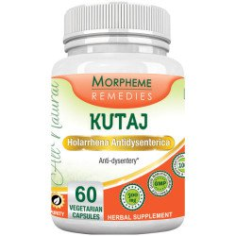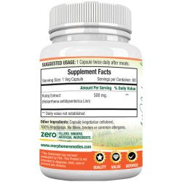

+
Quick View
Colon Support
Morpheme Kutaj Caps – 500mg Extract 60 Veg Caps
5 out of 5
$19.79

- Ricialove
LOL at the end….last but not least, make sure to wash your ass! LOL
- Nicholas Canada-Jenkins
I love the information on here great article but I have a real issue of one thing how the hell am I supposed to have 3 cups a day from the onion water if there is only two cups in a pint especially if I have to wait 12 hours I’ve really limited resources that It just drives me insane please respond thank you
  - Abbyboard
Are you okay now? If you are what did you do? I’m really scared right now lol.

Search Home Remedies
Top of Form
Bottom of Form
Top of Form
Bottom of Form
FREE
350+ Pages
Home Remedies
Ebook
Top of Form

Bottom of Form
Top of Form
Bottom of Form



Follow us
Follow us

Most Popular Today:
- 
10 Home Remedies For Genital Itching
- 
10 Home Remedies For Wrinkles Under Eyes
- 
How To Make Apple Cider Vinegar Detox Drinks
- 
9 Best Effective Home Remedies For Skin Pigmentation
- 
8 Home Remedies For Dry, Cracked Hands
- 
11 Home Remedies For Bacterial Infections
- 
Top 6 Exercises For Reducing Breast Size
- 
13 Efficient Home Remedies For Thyroid
- 
5 Amazing Home Remedies For Breast Lifts
- 
10 Home Remedies For Asthma

Recommended Products
- 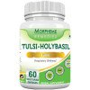Morpheme Tulsi Holy Basil Caps- 500mg Extract - 60 Veg Caps $19.79
- 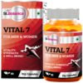St.Botanica Vital 7 For Men & Women - 90 Veg Caps $45.00
- 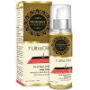Morpheme 7 Ultra Hair Oil - 100 ml $19.49
- 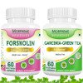Garcinia Cambogia Green Tea AND Forskolin - Weight Loss Supplement $37.00
- 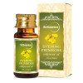St.Botanica Evening Primrose Pure Coldpressed Carrier Oil, 30ml $14.39

Best Home Remedies
- 10 Home Remedies For Genital Itching
- 10 Home Remedies For Skin Tags
- Top 6 Exercises For Reducing Breast Size
- 5 Amazing Home Remedies For Breast Lifts
- 13 Home Remedies For Receding Gums
- 9 Best Effective Home Remedies For Skin Pigmentation
- 10 Home Remedies For Wrinkles Under Eyes
- 13 Home Remedies For Ant Bites
- 8 Remedies For Weight Loss
- 10 Home Remedies For Asthma

Can You Answer These Questions?
- Help asked by Anonymous, 18 hours ago
- I have to sing a day after 2moro. asked by Anonymous, 1 day ago
- vomiting asked by Anonymous, 2 days ago
- Millets role in psoriasis asked by Anonymous, 3 days ago
- Millets role in psoriasis asked by Anonymous, 3 days ago

Twitter @findhomeremedy
Tweets by @findhomeremedy

Best Sellers
- 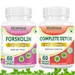Forskolin AND Complete Detox - Complete Body Cleansing and Weight Loss $42.00
- 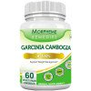Morpheme Garcinia Cambogia - 500mg Extract 60 Veg Caps $19.79
- 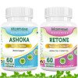Retone AND Ashoka $42.49
- 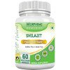Morpheme Shilajit 500mg Extract 60 Veg Caps $19.79
- 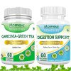Garcinia Cambogia Green Tea AND Digestion Support $42.00

Featured
- 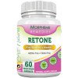Morpheme Retone Caps - 500mg Extract - 60 Veg Caps $25.19
- 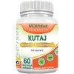Morpheme Kutaj Caps - 500mg Extract 60 Veg Caps $19.79
- 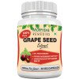Morpheme Grape Seed Extract 500mg Extract 60 Veg Caps $19.79
- 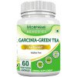Morpheme Garcinia Cambogia Green Tea - 500mg Extract 60 Veg Caps $19.79
- 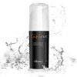St.Botanica Cupidrex Serum for Men's Sexual Health $99.00

Recommended
- 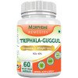Morpheme Triphala Guggul Supplements 500mg Extract 60 Veg Caps $19.79
- 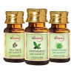St.Botanica Lemongrass + Peppermint + Tea Tree Pure Essential Oil (10ml Each) $37.50
- 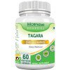Morpheme Valerian (Tagara) 500mg Extract 60 Veg Caps $19.79
- 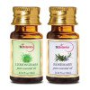St.Botanica Lemongrass + Rosemary Pure Essential Oil (10ml Each) $25.00
- 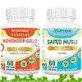Kohinoor Gold Plus AND Safed Musali $56.94

Recently Sold
- 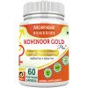Morpheme Kohinoor Gold Plus - 60 Veg Caps $40.50
- 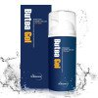St.Botanica Butea Superba Gel For Men's Sexual Health $49.00
- 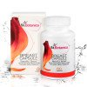St.Botanica Pueraria Mirifica Breast Supplements - Breast Nutrition $49.00
- 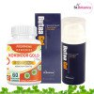Kohinoor Gold Plus AND Butea Gel $86.00
- 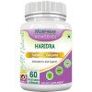Morpheme Turmeric Curcumin (Haridra) 500mg Extract 60 Veg Caps $25.19

Subscribe Newsletter
Top of Form
Get the best viral stories straight into your inbox!
Bottom of Form
Top of Form
Bottom of Form

Follow Us



Search
Top of Form
Bottom of Form
Top of Form
Bottom of Form
- Home
- Contact us
- Returns Policy
- Shipping Policy
- Write For Us
Copyright 2016 © FindHomeRemedy.com - All Rights Reserved. We Do not Intend to Treat or Cure Any Disease. All Content Given In This Site is For Information Use Only.

