Water sources compared: Tap, bottled, filtered, spring water, reverse osmosis and more
Thursday, October 19, 2017 by: Derek Henry
Tags: clean water, filtered water, sping water, tap water, water filters, water filtration systems, water ratings, water sources
7,730Views
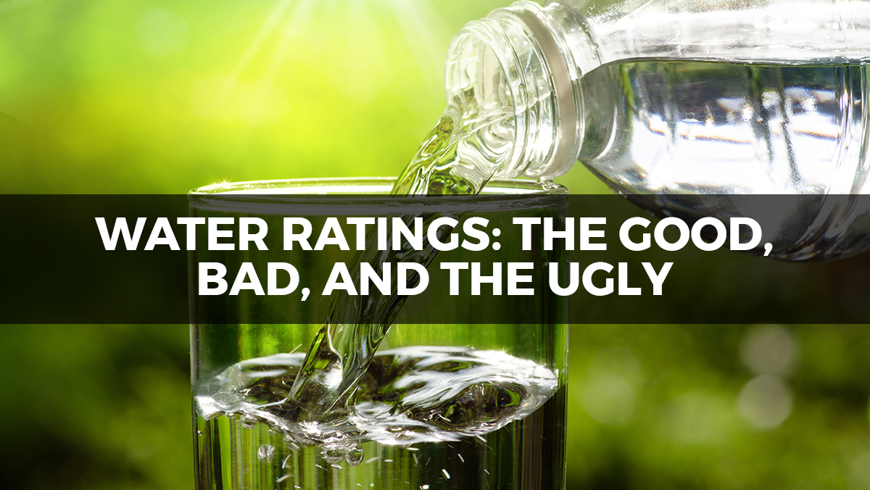

(Natural News) Are you a water snob? Given the state of water options today and their negative impact on the body, it may be a good idea to become a bit more discerning about the source of your drinking water.
Sure, your city, region, or municipality may have assured you that your drinking water is clean and fit for consumption and they may whole-heartedly believe that, but let’s face it, they are not exactly experts in how their “clean” water affects the vitality of the human body. In fact, most of them probably have NO idea that your body is estimated to be made up of 70 percent water, and physiological functions absolutely rely on pure water for proper function (including your brain).
So, it’s not exactly something you want to screw up. Yet millions are doing so everyday in North America, to the detriment of their body and brain.
Let’s nip that in the bud now. Here is the good, the bad, and the ugly (in reverse order) of water sources today.

Tap water
Hopefully by this point you have discovered that the public water supply is the farthest thing from healthy drinking water. Fraught with various toxins and contaminants like fluoride, chlorine, heavy metals (lead, mercury, aluminum), medication residue, insecticides, herbicides, and PFASs (Poly- and Perfluoroalkyl Substances from industrial sites), this water systematically destroys your body and brain.
These contaminants can result in lowered IQ, thyroid issues, behavioral problems, fatigue, weakness, increased cavities, bone fractures, and allergies just to name a few.
Not only is this water heavily contaminated, it is also “dead” water, meaning there are virtually no minerals left in it.
This is why tap water gets a big fat F rating and would be considered part of the “ugly” category.

Plastic bottled water
Bottled water took off as we became more aware of the importance of hydrating ourselves regularly, and didn’t want the inconvenience of carrying our own supply. However, like most man-made projects, there is a sinister component that does not make this a reliable option.
First of all, many popular brands of bottled water have been found to actually get their water from public or municipal water sources, which automatically puts those brands in the tap water category. Secondly, due to poorly cured plastics being used to fill these bottles with municipal tap water, you end up with another formidable toxin, xenoestrogens, which are known to artificially raise estrogen levels which can eventually lead to fibroids, ovarian cysts, endometriosis, and some cancers.
As a result of these toxins, the pH of these plastic bottled waters come in quite acidic (6-6.5) states. When sourcing good water, the pH should be between approximately 7.2 – 8.5 pH. High quality bottled waters (often in glass) taken from natural springs are usually within these values and can be considered quality sources. Be careful though – labeling is tricky and many claim it’s “spring water” when it really isn’t. To get an example of a bottled water that is truly sourced from springs, check out Poland Springs water.
For the majority of the plastic bottled waters containing tap water and swimming in xenoestrogens, you get an F rating as well. For those with real spring water but in plastic, you get a C. Natural spring water in glass bottles, you move to the head of the glass – you get an A!

Distilled water
Distilled water is an acceptable approach to getting your hands on clean water, but certainly has its drawbacks. Since it is more acidic due to the lack of minerals, it certainly is not one of your best options, unless you have no access to efficient filtration systems.
If you do drink distilled water, make sure to add some minerals back into it by adding a pinch of high quality Himalayan sea salt, or these mineral drops.
Drinking distilled water with no modifications gets a C+ rating, as at least it is devoid of contaminants. Adding in minerals, you can move up to a B+.

Reverse osmosis water
This water system has become very popular, and like distilled water it is certainly a nice option to avoid contaminants. However, like distilled water, it removes any naturally occurring minerals so becomes the “white flour” of water. It can also be considered dead water. However, adding in minerals as stated earlier will help offset that issue.
Again, for reasons noted with distilled water, reverse osmosis water with no modifications gets a C+, but adding in minerals will get you a B+.

Spring water
When collected from an inspected source that shows it’s fit for human consumption, spring water is undoubtedly the best source of water on the planet. Spring water is what all other systems are trying to copy, due to it being “alive”, mineralizing, full of oxygen, and especially hydrating (due to bioavailability). These springs will often register a pH between 7.4 and 8.5.
Getting raw spring water can definitely be a challenge though, depending on your location, so this makes it not a viable option for many people who don’t want to travel several hours or across the country to get it. To see if you have a spring near you, check out Findaspring.com.
Since pure spring water is the best source of water on the planet, it gets an A+!

Filtered water
Filtered water has been a thing for many decades now, but as is usually the case, not all filters are created equal. In fact, many of the most popular brands of water filters, like Brita and Culligan, have very weak performance when filtering out contaminants like aluminum, copper, arsenic, strontium, cadmium, cesium, mercury, lead, and uranium. You can get access to the water filters we tested and the results, here.
Now, when you get a filtration system that properly removes a wide variety of contaminants, and doesn’t strip out all the minerals, then you’re onto a great water filtration system. This way, you get rid of the toxic burden in your water supply, while keeping some of the mineralization intact. Since water filtration systems are widely available and can be shipped directly to your home, they make an excellent option if you don’t have access to natural spring water at the source.
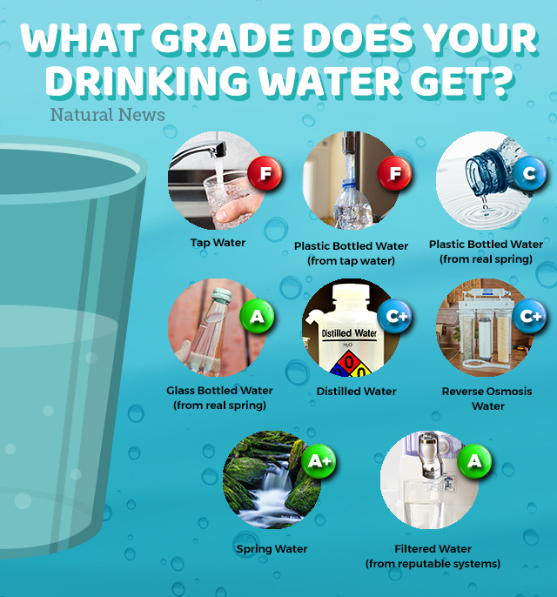
Just be careful with using alkaline water systems, for these reasons.
Now, if you are in need of an exceptional water filtration system that outperforms ALL the others, get the Big Berkey System (no electricity required). The investment in a clean water supply that leaves minerals intact is one of the most important things you can do for your health! That’s why it gets an A!
Cheers to proper hydration!
Sources include:
Healingthebody.ca
Naturalnews.com
Naturalnews.com
Healingthebody.ca

Water filters tested for heavy metals removal: Zero Water, Pur, Brita, Mavea, Culligan, Seychelle and Waterman

Wednesday, August 20, 2014
by Mike Adams, the Health Ranger
Tags: water filters, heavy metals, lab results
416KViews
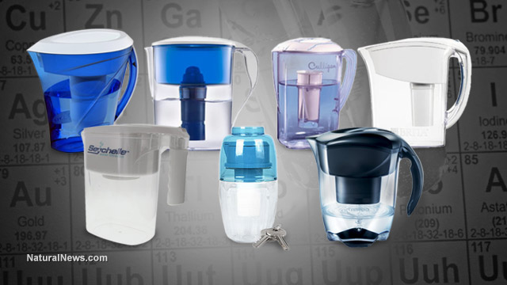

(NaturalNews) As promised, we've now published the results from testing countertop water filters for their ability to remove toxic heavy metals and elements with radioactive isotopes. The brands we tested are:
* Zero Water
* Pur
* Brita
* Seychelle
* Culligan
* Mavea
* Waterman Portable Alkaline Water Purifier
(We also tested large "survival" gravity filters, with results to be published separately here on Natural News.)
Click here to see the full results at the Natural News Forensic Food Lab.

What we tested
Using ICP-MS instrumentation (see lab videos here), we tested these water filters for their ability to remove toxic heavy metals and elements which have radioactive isotopes.
Specifically, we tested for removal of:
* Aluminum
* Copper
* Arsenic
* Strontium
* Cadmium
* Cesium
* Mercury
* Lead
* Uranium
Why didn't we test for fluoride removal? Fluoride is an extremely difficult element to work with due to its high reactivity (which is one reason why you probably shouldn't drink it). It is also very difficult to remove from water. Testing fluoride concentrations via ICP-MS requires a complicated process run separately from other elements, using different matrix solutions and different plumbing for the instrument.

How we tested for heavy metals removal
To conduct the tests, we created a multi-element "spike" solution containing from 1300 ppb to 2300 ppb concentrations of each of the tested elements. This spike solution consisted almost entirely of laboratory-grade water (DI water), with a very small fraction (less than 0.1%) of laboratory acids found in element standards for the purpose of matrix stabilization.
For each water filter, we first ran several cycles of pure water through the filter in order to "flush" it and pre-load the filter cartridge with purified laboratory water. Once that was complete, we loaded each water filter pitcher with the spiked solution containing the multiple elements listed above.
After the water passed through the filter and was emptied into the holding section at the bottom of the pitcher, that filtered water was then sampled with a clean pipette, weighed on a calibrated laboratory scale and prepped for ICP-MS analysis.
Each sample was run via ICP-MS using a variety of quality control methods, including the use of calibration checks during the run and a four-point calibration curve for each element. Keep in mind that our ICP-MS instrumentation is far more accurate and sensitive than labs running ICP-OES. In fact, we have had to correct other labs using ICP-OES who discovered their calibrations were way off. The Natural News Forensic Food Lab is in the process of ISO 17025 certification.
Click here to see the actual results at Labs.NaturalNews.com
Click here to learn about Heavy Metals Defense, a supplement invented by the Health Ranger for capturing toxic heavy metals during digestion.

What we did NOT test for
We did not test for removal of PCBs, pesticides, chlorine or other organic compounds. Accordingly, we cannot reach any conclusions on how well these filters might work on removing those substances.
Testing for those complex molecules would require additional instrumentation which we do not yet have in our lab. (Remember, the Natural News Forensic Food Lab is entirely self-funded and receives no grant money from the government.)

Performance overview
What shocked me the most about the results of this testing is just how poorly most water filters performed on the removal of toxic heavy metals.
Most of the water filters we tested were entirely unsatisfactory in terms of heavy metals removal, in my informed view. Only two filters showed results which I would consider to be sufficient. Most filters also appeared to perform very poorly for removal of elements with radioactive isotopes (uranium, cesium, strontium).
Here's an overview of what we found, element by element:

Aluminum removal
Four of the seven filters tested here actually increased aluminum concentrations in the filtered water.
This indicates they are using a filtration media which contains aluminum and allows some amount of aluminum to enter the water stream during filtration.
Only one filter removed 100% of all aluminum (Zero Water). See full results here.

Copper removal
Copper removal ranged from a low of 8.6% to a higher of 99.1%.
The average copper removal rate was 44.8%.
Copper is associated with mental insanity if consumed in very high quantities. Many homes still contain copper pipes, causing copper contamination of tap water.

Arsenic removal
Arsenic removal ranged from 12.1% to 99.3%, with an average removal of 42.6%.
Arsenic is a cancer-causing metal that's linked to cancer and organ damage. It's a common contaminant in well water. Click here to see full results on arsenic removal.

Cadmium removal
Cadmium is a toxic heavy metal which can cause kidney damage, heart damage and hardening of the arteries.
Cadmium removal ranged from 6.6% (Brita) to a high of 99.2% (Zero Water). The average removal was 33.1%.

Mercury removal
Mercury is an extremely toxic heavy metal that can cause brain damage, kidney damage and reproductive damage.
Because mercury is a "sticky" element, it's the easiest to remove of all. Removal rates ranged from 62.4% (Culligan) to a high of 99.7% (Waterman Mini).
Average mercury removal across all the filters was 88.5%.

Lead removal
Lead is a toxic heavy metal that causes brain damage and organ damage in the human body. Natural News has found significant quantities of lead in Organic Rice Protein superfoods imported from China.
Lead removal ranged from a low of 14.1% (Brita) to a high of 93.7% (Waterman Mini).
Average lead removal was 52.5%.

Strontium removal
In its non-radioactive form, strontium is a bone-building nutrient that's often found with calcium.
Some water filters removed almost no strontium (Brita and Mavea), while the Zero Water Filter removed 100% of strontium.
One filter, the Waterman mini, increased strontium concentrations in the resulting water, indicating use of strontium in the filter media. This is not a bad thing. Strontium is actually a nutritive mineral, much like calcium.

Cesium removal
Cesium removal is important to consider due to the Fukushima disaster and the radioactive fallout of Cesium-137.
I am intimately familiar with cesium binding and removal technologies, as I invented the patent-pending Cesium Eliminator dietary supplement that binds with and captures radioactive isotopes of cesium.
In our testing of water filters, cesium removal varied from a low of 9.5% (Brita) to a high of 100% (Zero Water).
Average cesium removal was 35.3%.

Uranium removal
Removal of uranium is crucial for those planning on surviving a nuclear accident or nuclear war. Following nuclear events, uranium and cesium both fall out of the sky in radioactive forms, settling on bodies of water which are used for irrigation and public water supplies.
Removing radioactive uranium isotopes from drinking water is a crucial survival strategy following a nuclear incident. Only two filters we tested showed an ability to remove substantial amounts of uranium: Zero Water and the Waterman Portable Alkaline Water Purifier.
Click here to see actual results and uranium removal rates for all filters.

Magnesium mineralization
Two water filters we tested substantially increased the level of magnesium in the filtered water. The highest water mineralization rate was achieved by the Waterman mini filter, which is advertised as creating "alkaline water."
The claim is true. While the magnesium concentration of the water we poured into the water filters was only 1.3 ppm, the Waterman Mini increased the magnesium concentration of the resulting water to nearly 250 ppm.
This is a substantial increase in magnesium concentration. The Seychelle filter also increased magnesium concentrations to nearly 250 ppm, indicating it has a "mineralization" component in its filter cartridge.

Recommendations and conclusions
Based on the laboratory analysis completed here at Natural News, I can only recommend two water filters in the category of countertop "pitcher" filters.
Natural News does not sell any of the water filters tested here, but they are available at retailers like Amazon.com. If you wish to help support our non-profit efforts to conduct more testing, please click this Amazon Smile link before shopping on Amazon.com, and Amazon will donate 0.5% of your purchase price to the non-profit Consumer Wellness Center.
The two filters I recommend are:
1) Zero Water
2) Waterman Mini
Click here to see full laboratory testing results and data.

Heavy Metals Defense - a breakthrough in dietary self defense
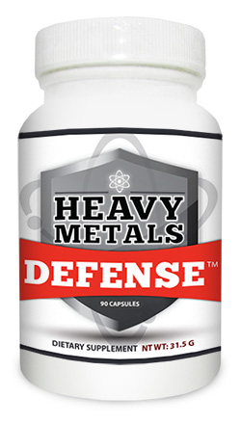
In addition to researching the removal of toxic heavy metals in water filters, I've also pioneered extensive, original research into heavy metals contamination of foods, superfoods and dietary supplements.
From this research, I was able to invent a patent-pending dietary supplement formula called "Heavy Metals Defense" which binds and captures toxic heavy metals during digestion.
This formula is laboratory validated to reduce heavy metals by the following factors:
Aluminum reduction: 98.7%
Arsenic reduction: 77.6%
Cadmium reduction: 98.5%
Copper reduction: 95.8%
Lead reduction: 99.9%
Mercury reduction: 92.9%
Uranium reduction: 76.5%
Click here to view the full laboratory results data on Heavy Metals Defense and see how it works.
Essentially, Heavy Metals Defense works in a very similar way to the "ion exchange membrane" of the Zero Water filters. That's why the metals capturing capacity is so high.
Also, check out these other sources of heavy metals in your own kitchen:
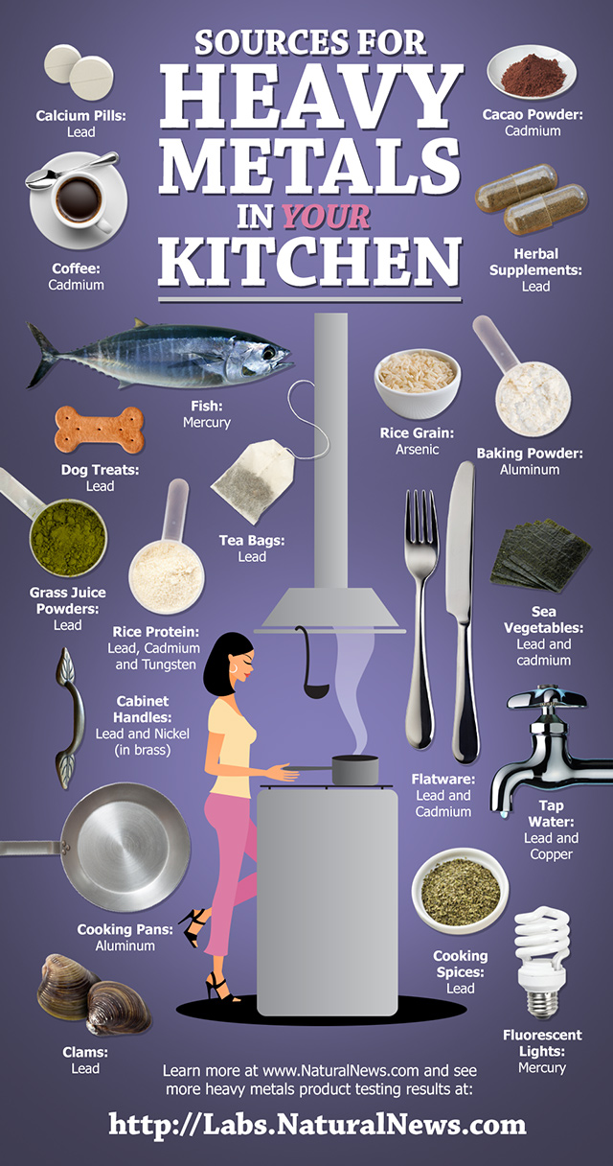
416K

