The Most Powerful Natural Antibiotic Ever, It Cures Any Infection In The Body And Kills Parasites!
 March 3, 2017 |  Health, Health Tips, Natural Remedies |  0 |  admin
share
This natural antibiotic is regarded to be the most powerful one by numerous experts, and it effectively cures infections and destroys parasites.
The master cleansing tonic is, in fact, an antibiotic which destroys gram-positive and gram-negative bacteria.
It has potent antiviral and antifungal properties, boosts blood circulation and lymph flow in the entire body. It is plant-based and offers multiple health benefits.
It is a potent weapon against Candida, and all kinds of viral, bacterial, parasitic and fungal diseases.
The master tonic purifies the blood, boosts blood circulation, and treats various chronic conditions. Its effectiveness is due to the combination of high-quality, natural and fresh ingredients!
However, note that you should wear gloves when preparing it, as the hot peppers might cause a tingling sensation, and the intense smell might stimulate the sinuses.
This is how to prepare it:
Ingredients:
- ¼ cup finely chopped garlic
- ¼ cup grated ginger
- 2 tablespoons grated horseradish
- 24 oz. /700 ml organic apple cider vinegar
- 2 tablespoons turmeric powder or 2 pieces of turmeric root
- ¼ cup finely chopped onion
- 2 fresh hot peppers
Instructions:
In a bowl, mix all the ingredients except the apple cider vinegar. Then, transfer the mixture to a Mason jar, and pour the vinegar to fill the jar to the top. 2/3 of the jar should consist of dry ingredients, and the other third should be filled with vinegar. Close the jar well and shake.
The jar should be kept in a dry, cool place for 2 weeks. You should shake it several times every day.
After two weeks, squeeze well and strain the mixture. You can use the dry ingredients in cooking.
The master tonic does not need to be stored in the fridge, as It lasts long. If mixed with some olive oil, you can use the master tonic as a salad dressing, or you can add it to stews.
Use:
The flavor of this antibiotic is very strong and hot, so after its consumption, you can eat a slice of lime, lemon, or orange, to soothe the burning sensation. Gargle and swallow, without diluting the tonic.
You should take a tablespoon of it to boost the immune system and prevent common colds. You should gradually increase the dose until you reach a dose of a small glass daily.
In the case of serious infections and diseases, take a tablespoon of the master tonic, five to six times during the day. Also, it is perfectly safe for pregnant women and children, as its ingredients are all-natural and toxin-free.
The miraculous effects of this natural antibiotic are due to the various medicinal properties of its ingredients, as follows:
Apple cider vinegar is an extremely healthy item, which has been used as a medicine for millennia. Its healthy properties were commonly used by Hippocrates, the father of medicine, around 400 BC.
It is made from fresh, ripe apples, which are fermented afterward, and undergo a rigorous process s the vinegar as a final product. It is high in pectin, which is a fiber that regulates cholesterol and blood pressure.
It also assists the extraction of calcium from foods it is mixed with, and thus supports the health of the bones. It is a rich source of potassium, whose deficiency leads to slow growth, sinusitis, hair loss, brittle nails and teeth, and runny nose.
Therefore, its regular use will help you prevent these health issues. Potassium also detoxifies the body.
Apple cider vinegar also helps the process of weight loss, as it breaks up fat. Vinegar is also abundant in beta-carotene which prevents free radical damage and keeps the skin young and soft.
Furthermore, apple cider vinegar contains malic acid, which fights bacterial and fungal infections. It soothes joint pain as it dissolves uric acid deposits around the joints, and it is afterward removed from the body.
Apple cider vinegar is also used in the treatments of indigestion, diarrhea, sore eyes, constipation, hair loss, headaches, eczema, arthritis, obesity, chronic fatigue, weak bones, high cholesterol, mild food poisoning, high blood pressure, and many others.
Turmeric is undoubtedly one of the healthiest spices on the planet, and it soothes inflammation and treats infections. Moreover, it prevents dementia, alleviates joint pain, and inhibits the development of cancer.
Garlic is also one of the healthiest natural foods, as it is a strong antibiotic with a wide range of uses.
It kills bad bacteria and microorganisms, supports the growth of healthy bacteria, fights fungi, and all kinds of antigen, pathogen, and harmful disease-causing microorganisms.
Its closest relative, onion, has amazing effects on the sinuses and lungs, boosts blood circulation, and treats common colds and flu.
Ginger is rich in healthy nutrients and thus offers various health benefits. It has powerful anti-inflammatory properties and stimulates the blood circulation.
Chili peppers are extremely potent circulation stimulators, and also possess strong antibiotic properties which effectively fight diseases.
Horseradish has an excellent effect on the sinuses and lungs, opens the sinus channels, boosts circulation, and fights common colds and flu.
The master tonic is an extremely potent natural remedy that is your best ally against numerous ailments and diseases. Therefore, prepare this natural antibiotic and enjoy your optimal health.
Source: www.healthylifetricks.com

  Hello Friends!  You have very powerful, natural intuition, we all do. We just need to learn how to listen to it. Once we do, we begin to see how connected we are with each other and the world around us, the ground below us and the sky above us.  There comes a time in all of our lives when our natural inner balance becomes, well... unnaturally unbalanced. Sudden trauma or a prolonged life of stress and poor diet can have very serious consequences on our overall health and quality of life. What matters most is getting back in balance with ourselves and the earth and when that happens, you will see immediate and amazing transformations in your life.  Would you like to connect with that natural balance within you?  Would you like to live an abundant life in harmony with the Earth?  Would you like to learn tools from nature to balance and calm your daily life?  I have spent my life studying all over the world and have gained many beautiful insights that I want to share with you.  I want to help you connect with your inner Earthie Mama and encourage you to make the change that will keep you happier and healthier for life while finding your own way to THRIVE!  In Gratitude and In Service,  ~ Alex  Earthie Mama  info@earthiemama.com | Top of Form  To get discounts, recipes, and the latest information subscribe to Earthie Mama news  Name *  First  Last  Email *  Bottom of Form
Top of Form
Submit
Bottom of Form
Earthie MamaFollow On

Check out my product line
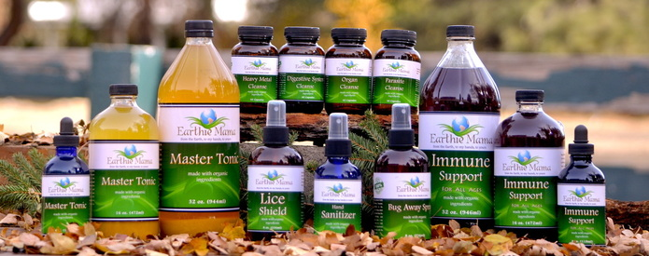
MASTER TONIC ~ Nature's Antibiotic in One Bottle
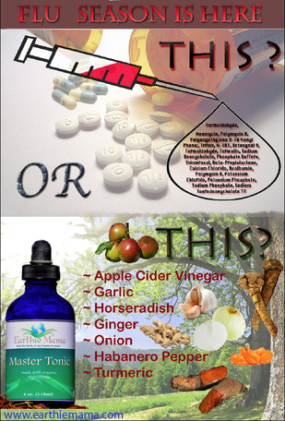
The Master Tonic is an antibiotic, destroying both gram-positive and gram-negative bacteria. It is also a potent anti-viral and anti-fungal/yeast formula, and will increase blood and lymph circulation to every part of the body. It is so effective that it is said to be the cure for colds and the flu, and is the herbal preparation of choice against Candida.
Benefit of each Ingredient: (All Organic Of Course!!)
- Garlic is a broad spectrum antibiotic. Unlike chemical antibiotics that kill off millions of friendly bacteria that your body needs, Garlic only targets the invading bacteria and even promotes and increases your healthy bacteria. Garlic is also a powerful anti-fungal and literally destroys any antigen, pathogen and any harmful or disease causing micro-organism.
- Onion is Garlic's next of kin and has similar but milder action. Together they are a tremendous fighting duo.
- Horseradish is a potent herb for the sinus and lungs. It opens up the sinus passages and increases the circulation there, where most doctors agree, the common cold and influenza often starts.
- Ginger contains powerful anti-inflammatory properties and is a tremendous circulatory stimulant.
- Hot Peppers are the most powerful circulatory propellant known. It simply sends the antibiotic and disease fighting properties of the other herbs where they're needed most.
- Turmeric clears infection and reduces inflammation inside of the body. It blocks cancer from developing. Especially helpful for those with joint pain.
- Apple Cider Vinegar There surely must be something really healthy in using apple cider vinegar, since The Father of Medicine, Hippocrates, used this vinegar around 400 B.C. for its health giving qualities. It is said that he had only two remedies: honey and apple cider vinegar.
All About Apple Cider Vinegar
Apple cider vinegar is made from fresh ripe apples that are fermented and undergo a stringent process to create the final product. The vinegar contains a host of vitamins, beta-carotene, pectin and vital minerals such as potassium, sodium, magnesium, calcium, phosphorous, chlorine, sulphur, iron, and fluorine.
It is claimed that apple cider vinegar is helpful in ailments such as constipation, headaches, arthritis, weak bones, indigestion, high cholesterol, diarrhea, eczema, sore eyes, chronic fatigue, mild food poisoning, hair loss, high blood pressure, obesity, along with a host of many other ailments. No wonder then many know apple cider vinegar as the "Wonder Drug".
Just thought you would like to know how powerful this tonic is!
To Read More and for the Recipe, CLICK HERE
​

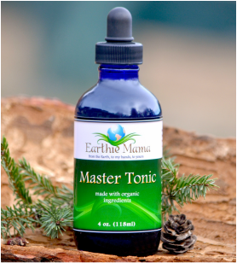 | Master Tonic  - Size: 4 oz.  $18.00  Add to Cart  Get a bottle of Earthie Mama's absolutely incredible 100% Organic Master Tonic mailed directly to your door!  It is an antibiotic, respiratory aid, anti-inflammatory, circulatory propellant, aids in clearing infections, anti-viral, anti-fungal, immune booster and much more!  Apple Cider Vinegar, Horseradish, Garlic, Onions, Habanero Peppers, Ginger and Turmeric ***ALL CERTIFIED ORGANIC INGREDIENTS  http://www.earthiemama.com/

