The Dalai Lama Reveals the Ultimate Morning Ritual That Will Brighten Your Day
2159
SHARES
Share On FacebookShare On Twitter
How do you usually start your day? If you’re like most of us, it involves hitting the alarm clock several times before struggling to get your body out of bed.
But perhaps there’s a better way.
Instead of dreading the day ahead, what if we embraced gratitude and kindness? What if we actually told ourselves we will make the most of the upcoming day?
Would you achieve more? Would you be more kind and compassionate to others?
According to the Dalai Lama, you just might.

Here’s how the Dalai Lama recommends you start your mornings
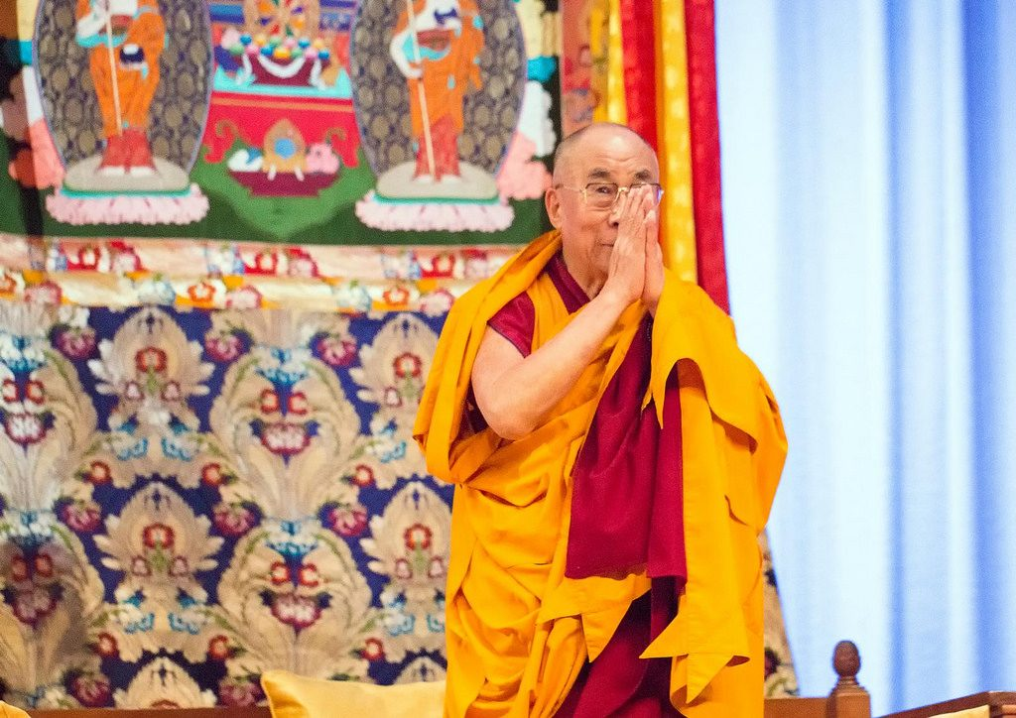
“Every day, think as you wake up, today I am fortunate to be alive, I have a precious human life, I am not going to waste it. I am going to use all my energies to develop myself, to expand my heart out to others; to achieve enlightenment for the benefit of all beings. I am going to have kind thoughts towards others, I am not going to get angry or think badly about others. I am going to benefit others as much as I can.”
I don’t know about you, but that sounds like a pretty good way to start your day!
To get into this positive mindset, it can help to practice meditation. Below we’ve gone over 6 steps you can use every morning that will help you cultivate a positive attitude like The Dalai Lama.

A meditation practice that will help you let go negativity
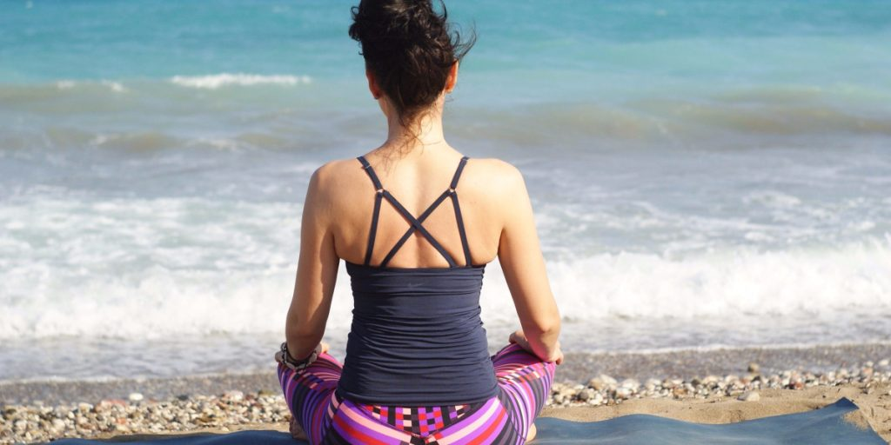
1. Find a comfortable position.
This could be on a chair, cushion or lying down.
2. Notice and relax your body.
Try to feel your body, and let any bodily tension let go and relax. Just breathe.
3. Tune into your breath.
Feel the natural flow of breath—in, out. You don’t need to do anything to your breath. Not long, not short, just natural. Notice where you feel your breath in your body.
4. Be kind to your mind.
Yes you will have thoughts and your mind might wander. This is natural and happens to everyone. Just accept the thought is there and bring your attention back to your breath.
5. Stay for five to seven minutes.
That’s all you need to do. Just try your best to focus on your breath.
6. Check in before check out.
After a few minutes, check your bodily sensations again and relax any tension as you breath out.
Originally published on the Ideapod blog.

