Start Eating These 12 Foods Every Day And Watch Your Eyesight Improve
 March 3, 2017 |  Health, Health Tips, Video |  0 |  admin
share
Aging is inevitable, and it leads to numerous changes in our appearance, hair, skin, joints, melanin, eyesight, and the entire body in general.
However, there are numerous natural foods which can help us slow down the aging process and reduce its effects. Today, we will reveal 12 foods which enhance the eyesight and stop its loss.
Our ability to see things close and at a distance is affected by the length and the shape of the eyeballs, as well as the thickness of the eye lens. Moreover, vision is also affected by the light-sensitive cells in the retina, which is located at the back of the eyes.
According to BBC:
“Lutein and zeaxanthin are found commonly in dark green leafy vegs such as kale and spinach, and also bell peppers, corn, and saffron. Meso-zeaxanthin is generally not found in plants — it is thought to be made in our bodies from lutein (although it is also present in some fish … ) These pigments, once we eat them, appear to be important in our vision and in helping keep the macula healthy.”
Hence, the consumption of Lutein and Zeaxanthin is of high importance for the eyesight. These ingredients are rich in nutrients which are beneficial for our vision.
Mosley writes:
“The results of my tests were both fascinating and depressing. My detection of yellow and blue colors was extremely poor — something that [Professor John] Barbur said was likely the result of my brush with diabetes many years ago.
My night vision and perception of details were also poor compared with younger people — but consistent with my age. The Trust Me team then handed me a 90-day supply of supplement pills that were supposed to help.”
After 3 months of consumption, lutein, and zeaxanthin drastically improve the eyesight.
Studies have shown that the daily intake of 10 milligrams of lutein and 2 mg of zeaxanthin normalize vision and treat all vision issues.
According to Mosley:
“Should we all, then, be taking supplements to protect and even improve our eyesight? Well, the research certainly shows that supplements work.
Even for someone like me, who has a relatively healthy diet with plenty of fruit and vegetables, and whose blood levels of the compounds that weren’t particularly low, the supplements helped. However, some researchers believe that diet can simply be enough if we eat the right things.”
These nutrients can be found in high levels in green leafy vegetables, such as kale and spinach. The results of another study also confirmed this, and authors stated:
“Most of the dark green leafy vegetables, previously recommended for a higher intake of lutein and zeaxanthin, have 15 [to] 47 percent of lutein, but a very low content (0 to 3 percent) of zeaxanthin.
You can also consume egg yolk which presents a good source of these nutrients. SO it will improve the eye health too.”
The bright orange yolks of the eggs from free-range, pastured hens, indicate that they are high in lutein and zeaxanthin content. On the other hand, pale yellow yolks are obtained from caged hens fed with unnatural foods, and they are low in these.
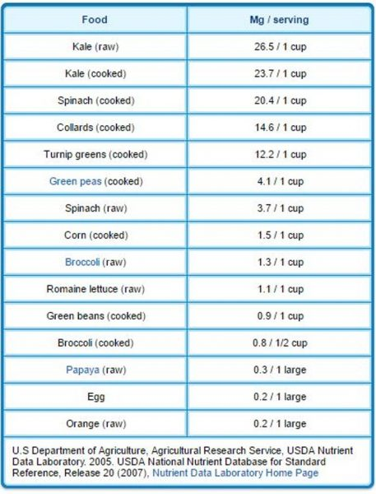
A recent study has also shown that the regular consumption of vitamin C prevents cataracts, which are ones of the main causes of vision loss. Therefore, eat citrus fruits, including limes, lemons, and oranges in order to raise the vitamin C levels in the body.
Acerola cherries are especially beneficial, so make sure you consume them often. Each cherry contains 80 mg of this vitamin, numerous micronutrients, and only one calorie.
Moreover, make sure you consume omega 3 fats to prevent blindness. Researchers have found that these fats are found in highest doses in fish.
We recommend the following marine sources rich in omega-3 and low in environmental pollutants:
- Krill oil
- Wild Alaskan salmon (which is also high in astaxanthin — a powerful promoter of eye health)
- Fish roe
- Small fatty, cold-water fish, like sardines, herring, and anchovies
Bilberry is excellent for the eyesight as well, and experts advise the following:
“When looking for a bilberry supplement for the eye, choose one that also includes 10 to 20 mg lutein and 1 to 2 mg zeaxanthin. Patients should target 80 to 160 mg daily. Those seeking prevention of eye disease, or just protection of the cells, can target 40 to 80 mg daily in combination with other antioxidant vitamins or in fruit combinations, such as blueberry/bilberry/raspberry.”
Additionally, it is of high importance to prevent damage to the docosahexaenoic acid (DHA — which is an essential animal-based omega-3 fat) in the retinal pigmented epithelium (RPE), as its role is to convert photons from sunlight into electrons.
This is done via the photoelectric effect which was the reason Einstein received a Nobel prize in 1921. These electrons provide a DC electric current which is vital for the proper functioning of the body.
Make sure you consume healthy foods, and lead a healthy lifestyle in order to support overall health, and thus enhance the eyesight as well.
Sources and References:
articles.mercola.com
holisticlivingtips.com

