

Why Strong People Attract Difficult Relationships
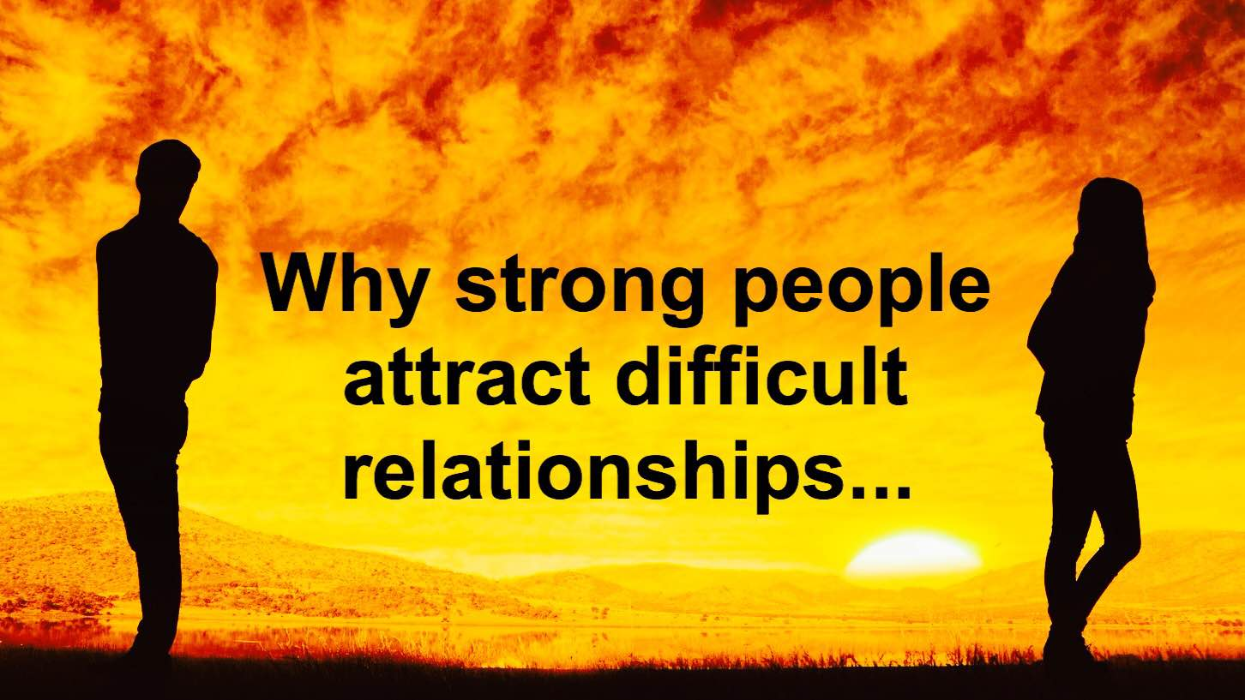
It is never smooth sailing for strong people. They go and tackle every obstacle, solve every problem, pass every test put in front of them. Yet they get home only to find out their dearest love is upset with them for having forgot that it was their turn to do the dishes. You would think that their life is all rosy and from the outside looking in, it appears that way. This could not be further from the truth.
Sometimes these relationships are actually the hardest tests that strong people have in their lives. It is not unheard of to have both mental and physical violence in them, along with manipulation and constant rowing.
Why is this?

Why Strong People Attract Difficult Relationships
The answer may lie in the fact that these people are completely in their comfort zones, and this changes when coexistence is in play. This makes the strong suffer with more baggage to deal with than first thought, having already exorcised their own demons by themselves. There is also the explanation of wanting to go through another process of self-discovery of learning more and growing further via another, like a repeat of the butterfly leaving its cocoon.
There are three types of relationships that strong people are attracted to: the soulmate relationship, the healing relationship, and the karmic relationship.

Soulmate Relationship
They attract this type so much that they have had a few of them. Working on this type requires a lot of it. It is exhausting, stressful, yet it can be rewarding. However, soul growth is the main aim here. It is in this type of relationship that the aforementioned self-discovery is attained. This is because, when in a romantic union, their flaws are apparent. As understood from earlier, soulmate relationships do not necessarily imply that it will last forever, but the effects of the relationship could.

Healing Relationship
Strong people tend to be healers also. They are the go-to person for a consoling hug, a shoulder to cry on, an ear to listen, a proverbial sponge to soak up sadness. Therefore, they attract someone who requires this kind of strength. The benefits are never one-sided, unless the someone in the relationship is taking advantage. If that is the case, abort mission now! Also, if the strong feel emotionally “drained” from constant healing, take a step back and just enjoy being in the company of the other half. That is what life is about, after all.

Karmic Relationship
Baggage from this life is tough, let alone past lives, the breaking of the shackles of things that happened long ago. It can make you feel confused and annoyed, stopping you from moving ahead. This type of relationship can be full-on, especially at the start when euphoria from something new and exciting is at its highest. There can be an intense pull or revulsion, depending on the mood of both participants of the relationship at the time. Releasing old hurts is very therapeutic and rewarding, which is why the Universe is throwing strong people from one into another, purifying and cleansing along the way.
What can strong people do? In a nutshell:
1. Let go and allow themselves to go into autopilot within the relationship. Like the cliché says: “Go with the flow.”
2. Move past obstacles hampering their reception of love. Strong people, due to their independence, do not let many in emotionally, therefore minimising the likelihood of being vulnerable.
Related article: High Risk Relationships – How to Tell If You’re In One
3. Let the experiences strengthen them as people and as lovers. Let these experiences nurture them and learn from them.
4. Concentrate on the self. Loving yourself truly will help immensely towards reaching goals within the current relationship.
5. If the relationship is tough, embrace it and move forward. Sometimes the most difficult relationships are also the most helpful.

