
- 
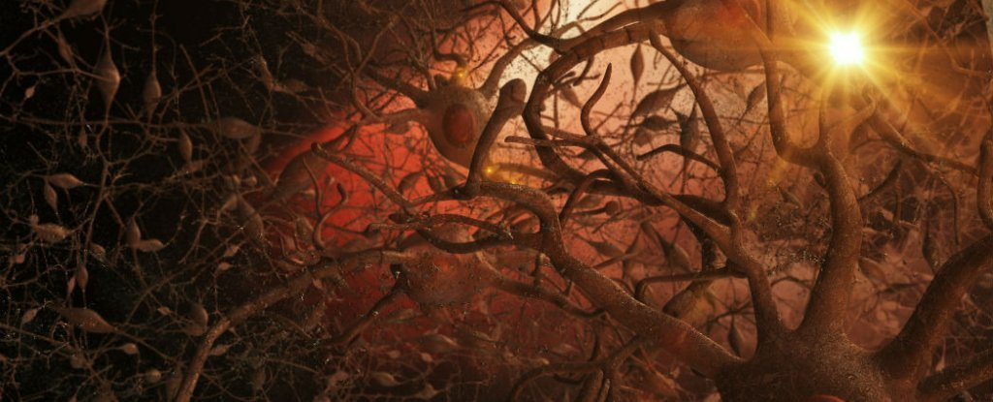
3Dme Creative Studio / Shutterstock.com

New Alzheimer’s Treatment Fully Restores Memory Function
Of the mice that received the treatment, 75 percent got their memory function back.
BEC CREW
18 MAR 2015
AddThis Sharing Buttons
Share to FacebookShare to TwitterShare to FlipboardShare to Copy Link
Australian researchers have come up with a non-invasive ultrasound technology that clears the brain of neurotoxic amyloid plaques - structures that are responsible for memory loss and a decline in cognitive function in Alzheimer’s patients.
If a person has Alzheimer’s disease, it’s usually the result of a build-up of two types of lesions - amyloid plaques, and neurofibrillary tangles. Amyloid plaques sit between the neurons and end up as dense clusters of beta-amyloid molecules, a sticky type of protein that clumps together and forms plaques.
Neurofibrillary tangles are found inside the neurons of the brain, and they’re caused by defective tau proteins that clump up into a thick, insoluble mass. This causes tiny filaments called microtubules to get all twisted, which disrupts the transportation of essential materials such as nutrients and organelles along them, just like when you twist up the vacuum cleaner tube.
As we don’t have any kind of vaccine or preventative measure for Alzheimer’s - a disease that affects 343,000 people in Australia, and 50 million worldwide - it’s been a race to figure out how best to treat it, starting with how to clear the build-up of defective beta-amyloid and tau proteins from a patient’s brain. Now a team from the Queensland Brain Institute (QBI) at the University of Queensland have come up with a pretty promising solution for removing the former.
Publishing in Science Translational Medicine, the team describes the technique as using a particular type of ultrasound called a focused therapeutic ultrasound, which non-invasively beams sound waves into the brain tissue. By oscillating super-fast, these sound waves are able to gently open up the blood-brain barrier, which is a layer that protects the brain against bacteria, and stimulate the brain’s microglial cells to activate. Microglial cells are basically waste-removal cells, so they’re able to clear out the toxic beta-amyloid clumps that are responsible for the worst symptoms of Alzheimer’s.
The team reports fully restoring the memory function of 75 percent of the mice they tested it on, with zero damage to the surrounding brain tissue. They found that the treated mice displayed improved performance in three memory tasks - a maze, a test to get them to recognise new objects, and one to get them to remember the places they should avoid.
"We’re extremely excited by this innovation of treating Alzheimer’s without using drug therapeutics," one of the team, Jürgen Götz, said in a press release. "The word ‘breakthrough’ is often misused, but in this case I think this really does fundamentally change our understanding of how to treat this disease, and I foresee a great future for this approach."
The team says they’re planning on starting trials with higher animal models, such as sheep, and hope to get their human trials underway in 2017.
You can hear an ABC radio interview with the team here.

by Taboola
Sponsored Links
From The Web

Young Living Sacred Frankincense Essential O…RM 426 - lazada.com.my

The most addictive game of the year!Forge Of Empires - Free Online Game

Tiny Device Allows You To Track Anything (it's Geni…TrackR Bravo

Megahype: This invention storm the internet...ECOCUT pro

Sponsored Links
PARTNER CONTENT

Cheap Flights - At Lasttripsinsider.com

A Solution That Puts Snoring to BedMy Snoring Solution

The Ultimate Way to Get Cheap Hotel RoomsSave70

More From ScienceAlert

This New Treatment Could Provide Weeks of Glucose Control For Type 2 Diabetes Patients
No more daily insulin shots.
5 hours ago

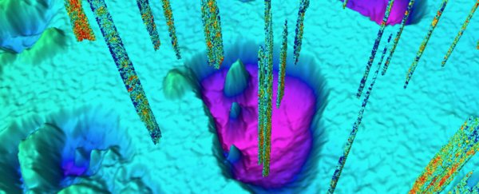
Massive Underwater Domes of Methane Look Set to Blow at Any Moment
5 hours ago

Learn How to Build Awesome Interactive Websites With The Full Stack JavaScript Bundle
3 hours ago

This Simple Blood Test Can Predict Cancer Years Before Symptoms Appear
7 hours ago
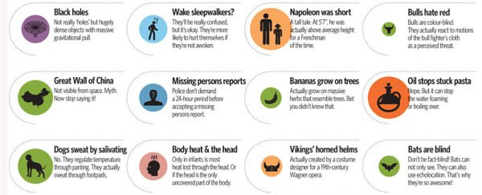
This Infographic Breaks Down 52 of The Most Common Misconceptions
9 hours ago

A Giant Crack in Antarctic Ice Is "Days or Weeks" From Breaking Off a Colossal Iceberg
10 hours ago

This Controversial Startup Is Attempting to 'Reverse Death' in Brain-Dead Patients
9 hours ago

 LOAD MORE

