Health

Tartar: How you can remove it yourself without visiting the dentist
Abdul Samad 3 months ago
Prev Article Next Article
Normally, the dentist removes the stubborn tartar that clings to your teeth, which you can’t shift with your regular tooth brushing. However, if you discover tartar between your regular visits, you don’t have to wait. Instead, you can tackle it yourself with a range of household products.
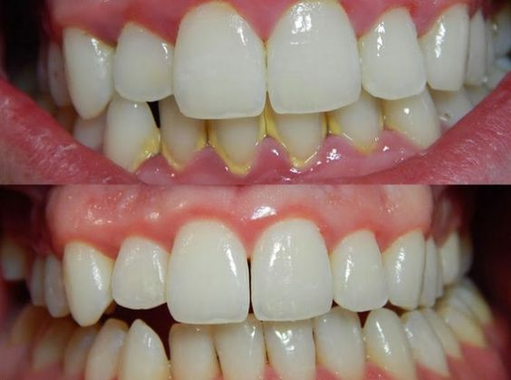
Pinterest/
What is tartar and how do we recognize it?
Tartar is calcified dental plaque. Calcium and phosphate compounds, which are deposited in the plaque, are what cause it to harden, creating tartar. If it is not removed, there is a danger that it will be colonized by bacteria. This increases the risk of gum disease (periodontitis). The mostly whitish-yellow to brownish tartar commonly forms on the inside of the lower incisors and on the first molars in the upper jaw. It can also be found near the ducts of the salivary glands, on uneven tooth surfaces, under the gums or in gaps between teeth.
You can combat tartar yourself with the following methods:
1. Toothpick Method
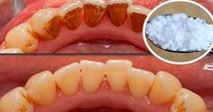
Pinterest/USA Magazine
You’ll need:
- 1 toothbrush
- ½ tsp salt
- ½ cup warm water
- 1 cup hydrogen peroxide
- 1 toothpick
- baking soda
- antiseptic mouthwash
Here’s how:
Mix some baking soda with the salt and a little water. Now clean your teeth thoroughly with this before spitting out the rest. Then mix the hydrogen peroxide with the water and rinse out your mouth. After this, it’s important to rinse your mouth out again with water. This will have loosened the tartar: now remove it with the toothpick. Thanks to the previous treatments, it should crumble easily away from the teeth. Finally, it is important to rinse your mouth once again with the antiseptic mouthwash.
2. Fruit Method
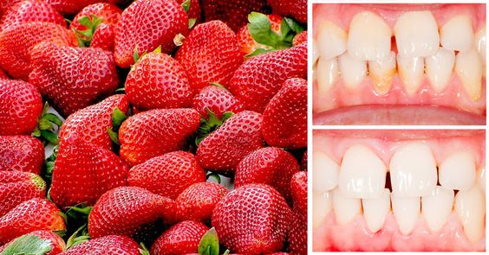
Pinterest/conocersalud.com
Press a lemon rind or half a strawberry against the tartar on your teeth for 10 minutes. It will be dissolved by the acid in the fruit and can then be removed with a toothbrush.
3. Baking Powder Method
Mix some baking powder, which among other things, contains sodium bicarbonate, with a little water and use it to clean your teeth. Not only will this brighten your teeth, but it will also tackle your tartar.
4. Tea Tree Oil Method
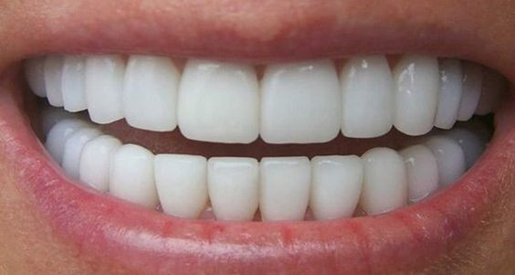
Pinterest/yourhealthremind.com
Put two drops of the oil in some water and use it to clean your teeth.
To prevent tartar, you should brush your teeth at least two times a day, and clean between your teeth with dental floss or an interdental brush. Using mouthwash and brushing with softer brushes will also help with prevention. In between times, you should eat apples, drink green tea or chew gum containing xylitol to make sure you don’t give bacteria any chance. Keep those gums healthy!

