http://www.enlightened-consciousness.com/earth-strongest-energy-fields-chakras-and-vortices/

image: http://www.enlightened-consciousness.com/wp-content/uploads/2016/08/1459246_405221752940891_781766410_n.jpg

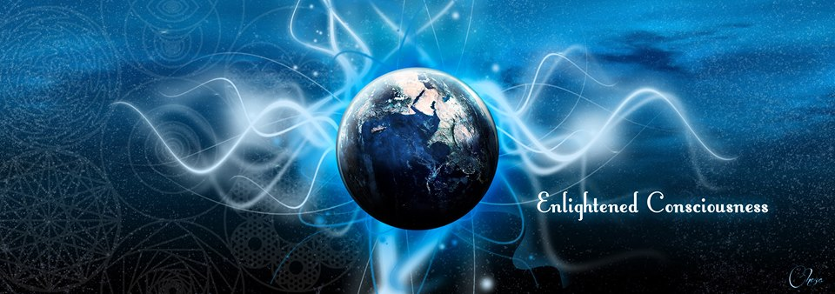
- Home
- Life
- Uplifting
- Spirituality
- Science
- Metaphysics
- Health & Alt

Earth Strongest Energy Fields – Chakras and Vortices
Staff Contributor | April 27, 2016 | Life, Spirituality | No Comments

image: http://www.enlightened-consciousness.com/wp-content/uploads/2016/04/sedonavortex-1-300x185.png
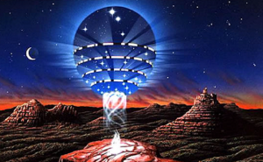
Looking at Nature all around us, we cannot help but marvel at its raw beauty and rhythm. Planet Earth is a conscious and vibrant living entity. With its own free will, it is meticulously orchestrating a symphony of equilibrium and constant evolution, communicating with all its inhabitants, the solar system and the universe.
Ancient civilizations revered their host as a sacred entity: they believed her to be their “Great Mother” and often built their megalithic sacred monuments in areas they considered “Earth’s Highest Energy Vortexes” or “Earth Chakras”. Structures like Stonehenge, the Pyramids of Egypt and Mayan, Aztec, and Incan monuments along with many temples, churches and pilgrimage sites are now considered powerful energetic spots.

Location of the Earth’s Seven Major Chakras
Ancient civilizations and modern esoteric traditions believe that the body of our
image: http://www.in5d.com/images/earth-chakras1.jpg
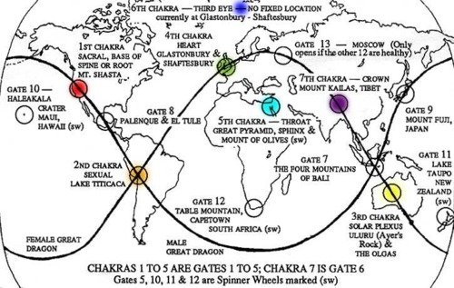
physical blue planet materialized from a universal energy matrix and has a subtle structure, similar to the human energy field.
This energetic structure peaks in seven major “Chakra Sites” located on each continent, where the strongest Energy Vortexes are situated. Hundreds of minor earth chakras are also spread all over the planet. They are believed to be spherical in shape, expanding in all three dimensional directions in a spiral motion, with a radius extending for hundreds of kilometers. They may either spin clockwise or anti-clockwise.
Their location varies according to different traditions,but most accept the 7 main Chakras as being:

1. Root chakra: Mt. Shasta, California, United States.
Mt. Shasta is located at the southern end of the Cascade Range, which runs like a dragon from northern California, through Oregon, and through Washington to the Canadian border. There are many powerful mountains in this range, with Mt. Shasta and Mount Rainier – overlooking Seattle – the best known. If Shasta is the tail of this dragon, then Rainier is its mouth, or head. Impulses generated from Mt. Shasta, and directed to Mt. Rainier, resulted in the 1947 “UFO” phenomena gaining world
image: http://www.in5d.com/images/shasta.jpg
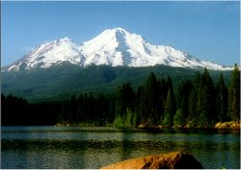
attention. This increase in earth chakra transmission was in reaction to humanity’s introduction of atomic weaponry to conclude World War II.
Shasta is the most primal of the earth chakras. It is at the “base” of the world energy system. Here, the raw precursors of biological life are released into global circulation and development. Mt. Shasta regulates the universal life force prior to its integration into individual life forms and species. The energy of Shasta, as the first chakra, is like a geyser – a great uprush of life energy, or prana, without shape or structure.
When working with the forces of Mt. Shasta, it is vital to transfer all evoked energies to at least one of the other major world chakras. The life current of Shasta does not take form until it is transformed within one of the other great continental chakras. There are times when the transfer is from Chakra One to Chakra Two, or from One to Seven, for example. Factors which determine the direction of these transfers will be introduced and discussed later.

2. Sacral chakra: Lake Titicaca, on the border of Bolivia and Peru
image: http://www.in5d.com/images/lake-titicaca.jpg
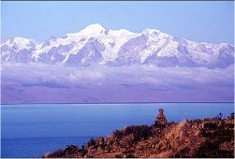
On the Island of the Sun, in Lake Titicaca, is found the Titicaca Stone, which is the geometrical centre for the second earth chakra. This is the world center for the creation of new species, and significant evolutionary advances within existing species. In the human body, Lake Titicaca correlates to the sexual chakra. The difference is that the world second chakra governs all species, taking a special interest in positive mutations and evolutionary advancements.
From Titicaca is born what is truly New. This sequence, over the Aeons, of innovative births always points in the direction of the goal of life – everlasting life. How can life force and structure be combined in a way that overcomes entropy? The Earth wisdom of the Andes continually seeks to answer this question with ever-increasing clarity.
The undifferentiated life force of Chakra One, Mt. Shasta, is transmitted to Lake Titicaca via the great world ley artery – The Plumed Serpent. This life-giving telluric current encircles the world, and has its evocational home at the El Tule tree in Mexico. Lake Titicaca is one of the two greatest ley crossroads on Earth. The Rainbow Serpent intersects the Plumed Serpent at the Island of the Sun. These two gigantic ley arteries also cross each other on the island of Bali, in Indonesia.
If you construct this second world chakra on a map, let the circumference pass through the junction of the Napo and Maranon rivers, near Iquitos, Peru, where the Amazon River begins. Notice that this great circle includes the heart of the Andes range, and includes many other sacred sites, such as Cuzco and Machu Picchu. All sacred sites within the expanded sphere of a world chakra partake of the same defining qualities. Thus, Machu Picchu is also a world second chakra force.

3. Solar Plexus chakra: Uluru-Katatjuta, Australia
image: http://www.in5d.com/images/uluru.jpg
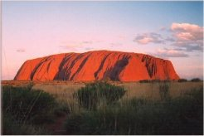
These twin sites in the Northern Territory, Australia, comprise the world “solar plexus” chakra. Uluru, formerly known as Ayers Rock, is the more famous of the two. This large red monolith is, along with the Sydney Opera House, an icon of the smallest continent. Katatjuta, also called The Olgas, is equally impressive. Rather than one monolith, this site consists of a large number of massive red stones.
The global function of this chakra is to maintain the vitality of the Earth, and all living species. In the future, if there is a world art of immortal health, then the wisdom of this art will be gained from Chakra Three in central Australia. This wisdom is delivered to the rest of the world via the ley artery, the Rainbow Snake.
The Rainbow Serpent travels the path of life. It arises from deep beneath the surface of the Earth, and first emerges at Uluru. The Uluru magick is then transmitted to Katatjuta via a special song line which exits Uluru on its western side from the cave of the hare wallaby, Mala Puta. Once in the natural cathedral of Katatjuta, the universal vitality force is shaped into the various designs suited to the many different species of life on Earth. After the “packaging” of solar plexus energies, in the Valley of the Winds, the Rainbow Serpent leaves this area from the large heart-shaped stone, Ngunngarra (scarlet Fuchsia),and travels on to Bali.
Chakra Two energies from Lake Titicaca are directly sent to Chakra Three – Uluru and Katatjuta – via the world ley artery, the Rainbow Serpent, which crosses the South Pacific Ocean, sweeps underneath New Zealand, and enters the Australian mainland at Wilson’s Promontory.
In the ancient creation legends of “Dreamtime”, there is a story about a great ritual which has yet to be completed at Uluru. This ritual was meant to complete the great plan of the earth spirit. When the ritual is complete, then perfection will spread throughout the world, and death will disappear from all species. This event is symbolized by a great pole, or cosmic umbilical cord, which is destined to unite the Sun with the Earth – heaven with earth. It is predicted that this cord begins to function in 2020 AD, at the time of the rare Saturn-Pluto conjunction.

4. Heart chakra: Glastonbury and Shaftsbury, England
image: http://www.in5d.com/images/glastonbury-tar.jpg
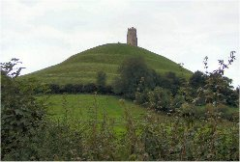
Glastonbury, Somerset and Shaftesbury, Dorset define the centre of the world’s heart chakra. In order for the force of greater life to be directed to maximum effect, the Grail of Immortality must be permeated by the Wand of the True Will. Glastonbury is the home of the Holy Grail; and Shaftesbury is the high place of the Sacred Spear of Purpose. When the earth energies of Glastonbury unite with those of Shaftesbury, then the Rainbow Serpent ley artery is able to deliver the immortalizing frequencies of the Holy Grail to all beings worldwide.
The great circle of the Rainbow Serpent travels from Uluru to Bali to Mt. Kailas to Sergiev Posad (Zagorsk), then crosses Denmark before entering England near Great Yarmouth. As this broad ley river crosses England it sweeps through many famous sacred sites, all of which contribute to the world heart chakra. Avebury Stone Circle and the Tor at Glastonbury are perhaps the two most famous of these heart “acupuncture” points. If you imagine this ley artery as having width, then Shaftesbury is near its southern back, while Glastonbury is on the northern bank.
It was said during Medieval times that if the Abbot of Glastonbury married the Abbess of Shaftesbury, then their children would be wealthier than the King of England. This is an alchemical riddle. If you unite the archetypes of the two areas, then love is united with will in a way that is revolutionary. For those who study the Cabala, this alchemical formula unites Binah (Grail) with Chokmah (Wand). The Grail, directed by the Will of the Earth spirit, has the power to dissolve all boundaries between nations. If the heart of the Earth expands to its full circle, then – throughout the world – pain, suffering, and physical death among all species will fade from experience and memory.
The most famous legend of Glastonbury tells the story of Joseph of Arimathea and the Holy Grail. After the Resurrection of Jesus, Joseph shifted the archetype of Everlasting Life – the Grail – from Jerusalem to Glastonbury. This ritual act established the foundation for the eventual shift of the mobile world sixth chakra from the activation circle for the Aeon of Pisces, 2000 years ago, to the present Aquarian Aeon area in western Europe. Currently, the mobile sixth chakra is conjunct the world heart chakra.
To move world solar plexus energies to Chakra Four, the principal direction is from Uluru-Katatjuta to Bali to Mt. Kailas (Chakra Seven), to Sergiev Posad, Russia to Shaftesbury-Glastonbury. As this Rainbow Serpent force travels around the world it absorbs and releases information at the various sites. Shaftesbury, in particular, acts to decode information brought by the Rainbow Snake from Mt. Kailas, in Tibet.
It is also possible to shift the force from Chakra Three to Four by utilizing the opposite direction on the Rainbow Snake – from Uluru to Lake Titicaca, over the Azores, into Cornwall, and up to Glastonbury-Shaftesbury. Also, a simultaneous dual impulse in both directions would complete a great world circle involving the Following Earth Chakras: Two, Three, Four, Six, and Seven.

5. Throat chakra: Great Pyramid of Giza and Mt Sinai, Egypt; Mt of Olives, Jerusalem.
image: http://www.in5d.com/images/great-pyramid.jpg
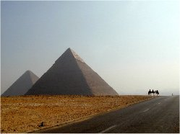
The world “Throat” chakra, where the voice of Earth is emerging, is unique among the world sacred centres. Alone among the chakras, it is not on either the Rainbow Serpent (feminine) or Plumed Serpent (masculine) ley flows. By its spinning function this chakra does help to drive the force along the Rainbow Serpent path – but at a great distance. This sphere of fifth chakra energies, in the Middle East, is also a major component of another vital Earth structure – the Four Vortices, or Spinner Wheels, which regulate qualities related to the four elements of fire, air, water, and earth. Sacred sites related to these four areas will be described after this section on the seven world chakras.
For all of the earth chakras, the art of listening to the will of the Earth is something which needs to be mastered. Humans will never harmonize with the purpose of life until they learn to hear and respect the voice of the Earth spirit. Nowhere is this more crucial than in the Middle East, where the world throat chakra resides.
The Earth is speaking, and no one seems to be listening. Imagine a Middle East where Jerusalem and Mecca are world heritage cosmopoli, open to all cultures. Imagine a Middle East that is at the world vanguard in advancing the respect for all beings – human and non-human – to live, and live abundantly. From Egypt to Iran, imagine a Middle East that is culturally united, and communicating to the rest of the world the art of everlasting life. The voice of the Earth is singing the gospel of life in this region. Who is listening?
Three sites are given here as best defining the center of this chakra. Mt. Sinai, between the other two, is a useful point from which to construct the expanded circle. The Immortal Moses, who carried Cabalistic wisdom from out of Egypt, crossed the abyss and beheld Living Eternity at Sinai. The Great Pyramid is one of the few artificial earth chakras. Unite your own True will with the Highest Purpose of the Earth and, with energized enthusiasm, project this united force as a living word from out of the Queen’s Chamber of the Great Pyramid – or from the summit. The Mount of Olives, on the eastern edge of Jerusalem – overlooking the mystic Golden Gate – is a focus for Jewish, Christian, and Islamic futurism. If Immortality is the key, archetypal Word of this Aquarian Aeon, then this Word needs to be clearly heard, by all cultures, from the Mount of Olives. From here, let the Word of the Aeon open the Golden Gate, so that all beings may enter into full life within a planetary New Jerusalem – an eternal home to all species, cultures, and faiths.

6. Third Eye chakra: Kuh-e Malek Siah, Triple border of Iran, Afghanistan and Pakistan.
image: http://www.in5d.com/images/iran.jpg
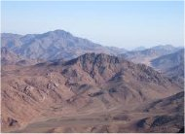
This earth chakra, like the others, has a geometrical center and an ideal, expanded circumference. The difference is that this “third eye” moves 1/12th of the way around the world, to the west, at the dawn of each new Aeon. The great Aeons are determined by a slow revolution of the Earth’s axis. The names given to these Aeons are taken from the 12 signs of the zodiac. Currently, we are said to be leaving the Aeon of Pisces, and entering the Aeon of Aquarius. Sometime after 4000 AD, this shift occurs again, when the Earth enters the Capricornian Aeon …
When the time arrives, the Earth spirit sends out a signal which invites all interested forces to gather in a certain geographical area for the purpose of inaugurating a new age. As these forces coalesce, the world sixth chakra establishes itself, begins to operate, and expands. This chakra remains in place for 150 to 200 years – long enough for the new Aeon archetypes to be instituted – and then it dissolves. Over two millennia ensue, and then the call goes out again to gather 1/12th to the west.
The purpose of this activity is to distill the gathered wisdom of life on Earth from over the centuries, and then to use these fruits of wisdom to open new directions of Earth evolution. In each great Aeon, different themes are emphasized. Compassion, for example, was a key Word of the previous Piscean Aeon; physical immortality is the word of the new, emerging Aquarian Age.
At the present time (1904 to 2084) the sixth chakra is geographically conjunct with the world heart chakra in western Europe. In terms of time, this Aquarian frequency is at its most potent in April and May of 2008 AD. Worldwide cultural forces which accelerate at this time reach their full maturity in 2065 AD.
In many regions of the world, there are legends of the Immortals. Often, when these stories imagine a collective body of immortals, an invisible city is named. Examples of this are Pulaki (Bali), Shambhalla (Mongolia), Avalon (England), and The Church of the First Born (biblical). These legends interpret a revolutionary truth – immortality has existed for a long time on Earth. Often, the immortals follow very individualistic, solitary pathways, hidden from the outer world. Then, when the Earth spirit summons all forces for the birth of a new Aeon, many of these social misfits make new contributions to the new area and its new themes. This coalition is temporary, and, after the Aeon is activated, all parties resume their individual pathways for another 2000+ years.
Here is a list of the geometrical centers for the most recent Aeons, and for two future Aeons: Gemini – Tai Shan, China; Taurus ¬Mt. Belukha, Siberia; Aries – Kun-E-Malek-Siah, Iran; Pisces – Mt. of Olives, Great Pyramid; Aquarius – Glastonbury-Shaftesbury; Capricorn – near Recife, Brazil; Sagittarius – near Manaus, Brazil. (Brazil plays an important role in the next two Aeons, circa 4000 and 6000 AD.)

7. Crown chakra: Mt. Kailas, Tibet.
image: http://www.in5d.com/images/mt-kailas.jpg
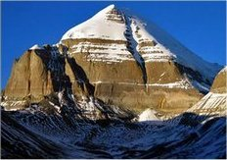
Kailas is the most sacred mountain in the Himalayas, and is the center of the world crown chakra. Located in Tibet, it is the focus for the annual Scorpio full moon event, in April or May. For the Earth, and for all immortals, this moon marks the new year, in terms of global evolution. For those who have never worked with the lunar calendar, this particular full moon, associated with Mt. Kailas, is a good place to start.
Chakra Seven broadcasts the Earth purpose, or True Will. If we see the world as an architect, at work in building a global immortal structure, then the blue prints for this vibrant edifice are being released, year by year, from the crown at Kailas. For this reason, it is important to give one’s full attention to this annual full moon, in particular, to the 90 minute period leading up to the exact culmination time of the Scorpio full moon. It is at this time that an individual may find their own True Will illuminated by the Earth spirit. The design and details of one’s own work becomes clarified through this activity.
Work progresses through time. In addition to the annual lunar cycle, Kailas also releases information concerning larger time cycles. For example, the principal constructive activity of the mobile sixth chakra is controlled from Kailas, through four great 19 year time cycles based on special Scorpio full moons, from 1989 to 2065. These 19 year periods are sometimes called Great Wesak Cycles. A second, more frequent, 12 year cycle is also utilised by immortals in the building of the future. This 12 pattern is called the Melchizedek Cycle, and is initiated when Jupiter is in the sign of Aries. Recent Melchizedek starting points were in 1939, 1951, 1963, 1975, 1987, and 1999. The next one will be in 2011.
There is a legend about the Lost Chord of Creation, somewhat like the story of the Holy Grail. If three lost notes could be found, and sounded together, then the world will unveil its eternal nature, and all things mortal will vanish. It is possible to reconstruct this lost chord by working with the earth chakras. Listen for the sound of praise emanating from Chakra Seven, Mt. Kailas. Hear the note of love sounding from Chakra Four, the world’s heart centre. Then hear the sound of joyous thanksgiving singing from Chakra Three, Uluru and Kata Tjuta. Have the creativity and wisdom to combine these three notes into one force, and then regenerate the world.
Like human chakras, Earth Chakras can be damaged or blocked affecting the areas surrounding them and the whole body of the globe. Ancient Druids and Shamanic cultures held festivals using sounds, drums and songs to thank and heal “Gaia”.

Earth’s Energy Field
A continuous interaction is believed to take place among the Earth’s major and minor Chakras through an “Earth Energy Field”. It is described as a matrix of connective pathways resembling the human circulatory, nervous, or acupuncture meridian systems. Their intersection culminates creating high energy vortexes. Some are deemed positive in nature and others negative. The Himalayas and the Peruvian Inca territories are considered Positive Vortices. On the other hand, the Bermuda Triangle and the Devil’s Sea, east of Japan, were identified as “Vile Vortexes” or “Electromagnetic Disturbances” by American biologist Ivan P. Sanderson. He discovered twelve Negative Energy Spots, caused by hot and cold currents, symmetrically distributed at equidistant locations from the equator. Mapping those locations revealed an energetic network connecting them.
Many individuals studied the Earth Energy Field: historian Nikolai Goncharov, construction engineer Vyacheslav Morozov and electronics specialist Valery Makarov were a team of Russian researchers who detected a geometric grid pattern interlinking a wide number of natural phenomena, all establishing a single planetary energy system. Likewise,Professors William Becker and Bethe Hagens followed their predecessors’ results to chart an “Earth Energy Grid”. Becker stated: “… the Earth is really a living crystal being, with a geometric skeleton that could be mapped in its patterns of energy flows… in ocean currents, the winds, river systems, and distributions of precious minerals. It even seemed that ancient humans had known this sacred, hidden body of the Earth, and sited their civilizations to take advantage of her very visceral powers…”
The relationship between us and Earth has always been reciprocal: we are connected through an omnipresent universal energy. Unfortunately, our modern economy and the wide spread pollution have contaminated the planet. As the dominant conscious species on this planet, it is our duty to keep a healthy energetic flow by synchronizing our lifestyles to her rhythm and create a harmonious habitat for ourselves and other sentient beings.
source 1 source 2

The 10 Vile (Strong) Vortices
image: http://www.in5d.com/images/10-vile-vortices.gif
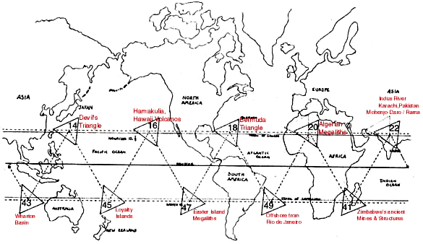
The highest energy areas seem to center near the 31.7 degree (Positive) or 25 degree (Negative) parallels – North and South:

image: http://www.in5d.com/images/vortice-chakras.jpg

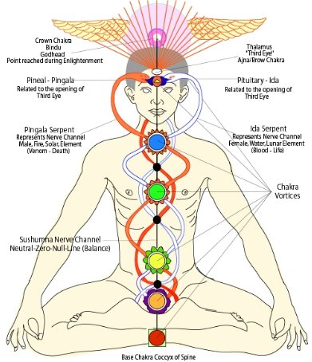
There are 5 areas of the Northern Hemisphere near 25 North that may be doors to other dimensions, often called “Vile Vortices”:
Bermuda Triangle (planes & ships disappear in green fog)
Algerian Megalithic Ruins (South of Timbuktu)
Karachi (Pakistan) [site of Mohenjo Daro – Rama culture, the ancient origins of Hindu culture]
Devil’s Sea Triangle (near Iwo Jima, Japan) (planes & ships disappear – Japan officially calls dangerous)
Hamakulia, S.E. Hawaii (heaviest volcanic activity) – actually, the focal point is in the ocean, more to the SE of Hawaii. It is in the Ocean, where some ships and planes have disappeared in the past.

There are 5 areas of the Northern Hemisphere near 31.7 North that are Positive healing Energy Vortices:
Between Sedona, AZ & Sonora, Mexico (31.7N 112.8W) – Hopi & Yaqui Indian, Hohokom waterworks, Sedona Healing Vortex (& magnetic anomalies at Torreon, Mexico?)
The calculated Vortex Focus is near the Papago Indian Reservation, W of Tucson, AZ, S of Pisinimo/W. of Cowlic/Vamori/Little Tucson
According to Ken Eagle Feather, in “A Toltec Path” p.11, Castenada’s Books on Don Juan (Matus) were centered here (mid-Atlantic, Atlantis per Edgar Cayce – “the position … Atlantis occupied is between the Gulf of Mexico … and the Mediterranean”)
Egypt – Pyramids (focus Energy)
Himalayas, N.E. of Lhasa (Tibet) – Center for Tibetan Enlightenment – also, not far from Xi’an Pyramids in China. Home of the Panda and ancient irrigation systems and Midway Island

Further North, near 50 to 55 North, are some well known Vortices:
Findhorn, Scotland: Key Celtic/Druid Ley Line: Calendish megaliths, Loch Ness, Maes Howe, Ring of Brodger
Kiev (Ukraine, Russia) – Key Eastern Orthodox Religious Site
Buffalo Lake (Alberta Canada), major Indian Medicine Wheels
Hudson Bay, Canada north Magnetic pole, Ugansk Bay, Eskimo Art, Chubb meteor crater
Lake Baikal (Northern Mongolia): Meteor Crash? – unique soil, strange plant & animal genetic changes

In the southern Hemisphere, there are also 5+5 areas, near 25 & 30 South, (most are in less-traveled ocean areas), some of which are the:
Megalithic structures at Sarawak (Borneo)
Nan Madol (Pohnpei Island, Micronesia)
Incan Culture in South America
Easter Island – Megalithic Statues, many of evil Cthulhu – culture degraded to cannibalism, then enslaved
Gabon (West Africa) [alleged natural Atomic Reactor 1.7million yrs ago] / Zimbabwe Megaliths
source
Thanks to in5d for this article.
Featured image source
Other interesting articles:
The Helical Model – Our Solar System is a Vortex
Electromagnetic Energy In The Air
Magnetism and Free Energy: Uncovering the Missing Secrets of Magnetism
Facebook Comments
2.2KShare 1Tweet 5 3Email 0 0Reddit 0Tumblr 2.2KShare
image: http://www.enlightened-consciousness.com/wp-content/uploads/2016/08/555952_405229606273439_10192884_n-150x150.jpg
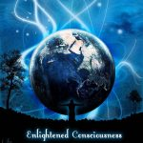

Staff Contributor
Staff contributors has always been curious of the world around. We take people's interest at heart. From an early ages we developed psychic abilities, but likes to class ourselves as a guidance councilor.
More Posts - Website
Copyright © 2017 .
Disclaimer: The content on www.enlightened-consciousness.com is information based on the opinions and scholarship of the authors. This site is intended for educational and commentary purposes only, both of which are strictly protected by Free Speech. Enlightened Consciousness is not responsible for the opinions or content written by its writers. The information on this website is not intended to replace your relationship with a qualified health care professional and is not intended as medical advice. All trademarks and registered trademarks mentioned here are the property of their respective owners and are not used here for commercial purposes. Paid advertising on Enlightened Consciousness may not represent the views and opinions of this website and its contributors. No endorsement of products and services advertised is either expressed or implied. All the pictures and information shown on this blog are the property of their respective owners. We don't hold any copyright about these pictures and news. We are not responsible for any incorrect or incomplete information. These pictures have been collected from different public sources including different websites, blogs considering to be in public domain. If any one has any objection to displaying of any picture and news, it may be brought to our notice by sending message through 'contact us' page & the same will be removed immediately, after verification of the claim. Contact us: Enlightened Consciousness.

Read more at http://www.enlightened-consciousness.com/earth-strongest-energy-fields-chakras-and-vortices/#ZKQ2kGjKmE7txYZC.99

