Place a Clothespin on Your Ear For 20 Seconds. The Results Will Surprise You
 April 2, 2017 |  Health, Health Tips, Video |  0 |  admin
share
The famous reflexologist Helen Chin Lui maintains that “Each ear contains a complete reflex map of the body, rich with nerve endings and multiple connectors to the central nervous system.”
She speaks about one unusual way people can boost their health, treat various issues, and experience relief soon. Namely, the technique involves placing clothespins on different areas on the ears.
The ears have 6 spots which are related to different body organs and regions. Therefore, by stimulating these spots, you can solve various health issues.
Here are the details:
- The Upper Part Of The Ear
This ear part is related to the shoulders and back, so pressing it for a minute daily will reduce the built-up tension in the areas.
- The Top Of the Ear’s Curve
This point is linked to the organs, and in the case of internal tenderness or discomfort, place a clothespin there to treat it.
- The Upper-Middle Part of the Ear
It is related to the joints, so when pressed, it soothes the pain and stiffness in joints.
- The Lower-Middle Part of the Ear
When pinched, this spot will relieve the sinusitis or the sore throat, treat congestion, and help you fall asleep easily.
- Just Above the Earlobe
It is linked to the digestive system, so its stimulation will soothe stomach pain and boost digestion, and prevent such issues.
- The Earlobe
This point is linked to the head and heart, so it can help you soothe headaches and migraine, and support heart health.
If you think that clothespin is too strong give this massage a try:
Sources:
www.davidwolfe.com
www.healthandhealthyliving.com
positivemed.com

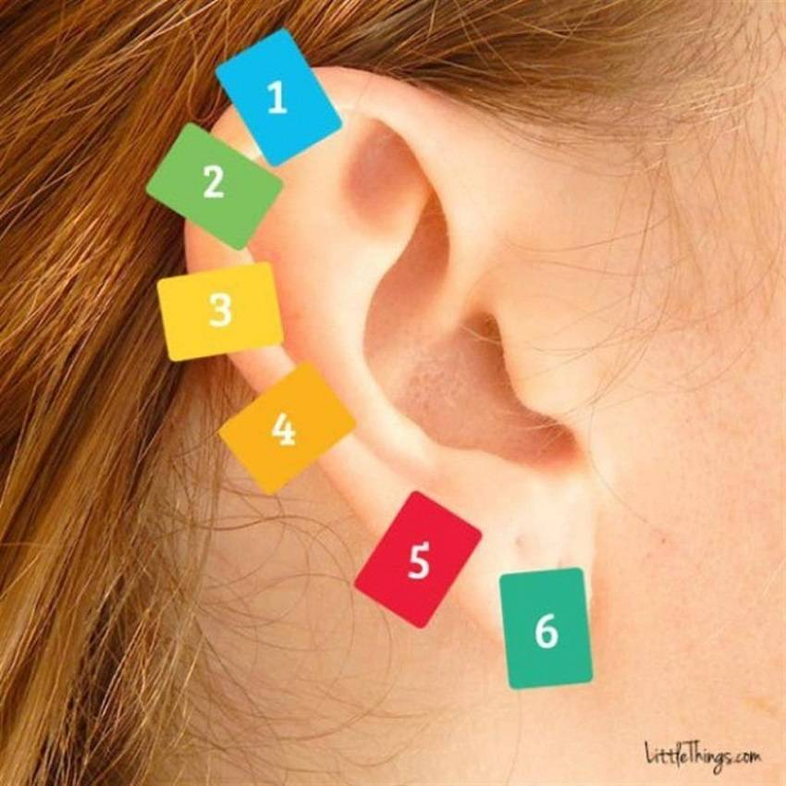

Ear Reflexology, or Auricular therapy, is a method of finding pressure points in the body, which has been a part of Chinese Medicine for hundreds of years.
Much like other aspects of reflexology, ear reflexology can be used to treat various ailments in different parts of the body, equally to and if not more effective than foot reflexology.
Reflexology is the ancient healing method that can be used as a treatment for a whole host of ailments. This non-invasive form of healing originated and evolved in Egyptian and Chinese medicine over 5,000 years ago and is still very popular to this day, with more and more research into the method continuing.
But let me tell you more about Ear Reflexology. Did you know that our ears each contain a complete reflex map of our body? Each of which are full of nerve endings and connections to our central nervous system. By using Ear Reflexology we can pinpoint zones and points in the ear that relate to certain energy centers in our bodies, known as meridians. For example, our head is located in the earlobe and our legs at the opposite end.
For minor aches and pains there are natural methods to treating, by drinking herbal teas or performing full body stretches, but these all pale in comparison to the pressure points that are accessible through your ears!

So where exactly are these pressure points?

1. Back and Shoulders
The first point is located at the top of your ear the very tip. This area is linked to your back and shoulders and can help cure soreness in these areas. Massage this area for as little as a few minutes each day and it can help resolve any soreness you are feeling in your back and shoulders.

2. Organs
Minor internal pain can be resolved by massaging the area just below the tip of your ear, where the bridge of the ear meets the outside of the ear. Massaging this area can help resolve internal discomfort. Of course if the pain is severe you should always consult a physician.

3. Joints
The upper-middle part of the ear can be used to relieve joint pain. A pain that may stem from change in season or arthritis that can be cured without medication by simply applying pressure to this part of your ear each day.

4. Sinuses and throat
Cold and sinus infection can be cured by applying pressure to the lower-middle part of your ear. This pressure can help alleviate pain and soreness in your throat and sinuses.

5. Digestion
Minor digestive issues can be resolved by massaging the point just above your earlobe. This treatment can help relieve minor discomfort, bloating or gas. After a few minutes of massaging the area you should start to feel better.

6. Head and heart
The area most closely associated to the major parts of your body is the earlobe. Massaging the earlobe can help promote a healthy heart and relieve tension in your head. Massaging this point can also help rid you of headaches with only a few minutes of attention each day.
Every day minor discomforts can be relieved and cured by using the pressure points on your ear. Bare that in mind next time you feel a niggly headache or stomach upset before you take your place in the doctor’s waiting room.
References:
- http://www.littlethings.com/clothespin-ear-reflexology/
- http://healingplacemedfield.com/reflexology-what-is-ear-reflexology/
Image Credits: www.littlethings.com
By Charlotte H.

