Find Out What’s Making Your Stomach Hurt Using This ‘Belly Map’
 April 17, 2017 |  Health, Health Tips |  0 |  admin
share
Abdominal pain can be of different types and might range from intense to mild. However, it can be a symptom of various health conditions, depending on the place it causes the discomfort:
-Constipation
-- Kidney stones
-- Stomach ulcers
-Gallstones
-Pancreatitis
Sometimes, the reason for the abdominal pain or cramps might be an upset stomach, manifested by swelling or inflammation of the stomach lining and intestines, or simply due to the consumption of large meal or too many drinks.
This pain might also be caused by a virus or allergic reactions, fatty foods, or alcohol.
According to Healthline, the most common symptoms of an upset stomach include nausea, chills, heartburn, gas, vomiting, belching, and an increase in bowel movements.
Yet, if the abdominal pain you are experiencing is too intense and severe, you might suffer from some severe health issue, so we recommend visiting your doctor.
The following graphic will illustrate the meaning of the pain in the stomach according to the place where it occurs:
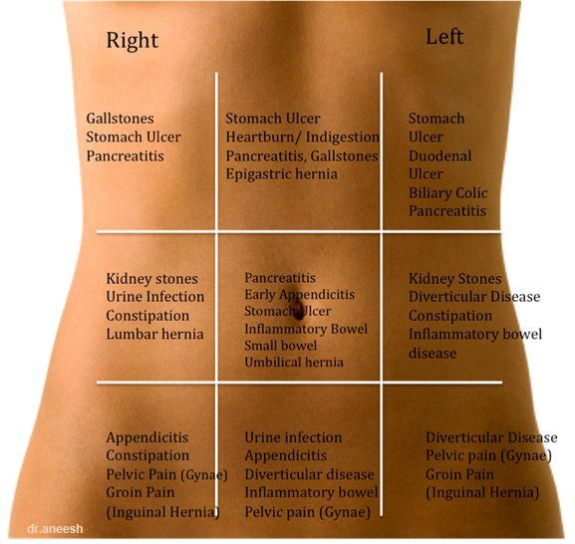
Source: besthealthyguide.com
Image source: imgur.com

