Cancer, Sulfur, Garlic & Glutathione
Published on June 25, 2012
- share on

- Facebook

- Twitter

- Email

- Print this

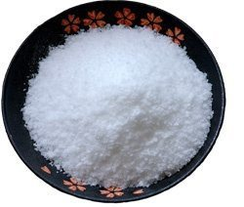
What do garlic and glutathione have in common? Sulfur! Sulfur is commonly used in Asia as an herbal medicine to treat inflammation and cancer. Organic sulfur has been studied on oral and other cancers and has been found to have remarkable benefit in anti-cancer therapy.[1]
Sulfur is an essential element for all life, and is widely used in biochemical processes. In metabolic reactions, sulfur compounds serve as both fuels and respiratory (oxygen-replacing) materials for simple organisms. Sulfur in organic form is present in the vitamins biotin and thiamine, the latter being named for the Greek word for sulfur. Sulfur is an important part of many enzymes and in antioxidant molecules like glutathione and thioredoxin.
Organically bonded sulfur is a component of all proteins, such as the amino acids cysteine and methionine. Disulfide bonds are largely responsible for the strength and shape of proteins. Since sulfur bonds are required for proteins to maintain their shape, and these bonds determine the biological activity of the proteins, we can see why sulfur is critical for health and life itself. There is no doubt that sulfur helps us battle cancer so it’s a good time to become more familiar with this basic element.
Sulfur is required for the proper structure and biological activity of enzymes. If you don’t have sufficient amounts of sulfur in your body, the enzymes cannot function properly. This can cascade into a number of health problems since, without biologically-active enzymes, your metabolic processes cannot function properly.
Sulfur enables the transport of oxygen across cell membranes.
Because sulfur is directly below oxygen in the periodic table, these elements have similar electron configurations. Sulfur forms many compounds that are analogs of oxygen compounds and it has a unique action on body tissues. It decreases the pressure inside the cell. In removing fluids and toxins, sulfur affects the cell membrane. Sulfur is present in all cells and forms sulfate compounds with sodium, potassium, magnesium, and selenium. Organic sulfur, in addition to eliminating heavy metals, regenerates, repairs and rebuilds all the cells in the body.
The newest work from Dr. Sircus: First Consultation Video Class Learn More

Mercury & Sulfur
Sulfur is very complicated topic because:
Thiol poisons, especially mercury and its compounds, reacting with SH groups of proteins, lead to the lowered activity of various enzymes containing sulfhydryl groups. This produces a series of disruptions in the functional activity of many organs and tissues of the organism. – Professor I. M. Trakhtenberg[2] – Russia
Mercury, in its various forms, has a great attraction to the sulfhydryls or thiols—these sulfa bonds. A thiol is any organic compound containing a univalent radical called a sulfhydryl and identified by the symbol -SH (sulfur-hydrogen).
Enzymes are proteins, and like all proteins they consist of chains of amino acids. These chains have to be faulted in a specific way to give the enzyme its activity. The structure of many enzymes is ensured by cross-bonding of the amino-acid chains. These cross-bonds consist of double sulfur bonds. Sulfur bridges are covalent S-S bonds between two cysteine amino acids, which tend to be quite strong. These sulfur bonds are damaged when poisonous substances that are not naturally present are added to the cellular and blood environments. Mercury binds to the -SH (sulfhydryl) groups, resulting in inactivation of sulfur and blocking of enzyme functions while producing sulfur metabolites with high toxicity that the body has difficulty handling. Sulfur is essential in enzymes, hormones, nerve tissue and red blood cells. These sulfur bonds are crucial to human biology.
If the geometry of insulin has been changed by mercury, the message that insulin has arrived to give glucose to the cell is not received.
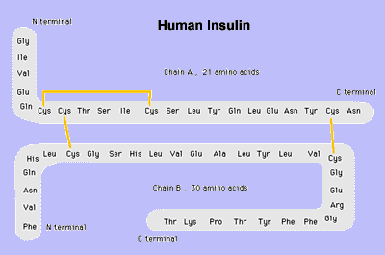
Amino Acid Structure of Insulin
Yellow lines indicate disulfide bonds.
Various molecules or atoms will affect the rate of an enzyme-catalyzed reaction by binding to the enzyme. Some bind at the same site as the substrate (the active site) and prevent the substrate from binding. Others bind at sites on the enzyme remote from the active site and affect activity by modifying the shape of the enzyme. Many of these molecules reduce the activity of the enzyme and are referred to as inhibitors.
Mercury is the most potent enzyme inhibitor that exists; it is in a class of its own and well deserves its title as the most toxic non-radioactive element. Since mercury and lead attach themselves at these highly vulnerable junctures of proteins, they can readily provoke biochemical shifts and then morphological changes in the body. Transsulfuration pathways in the body are fundamental for life. When mercury blocks thiol groups, cellular proteins lose their reactive properties and lose their ability to carry out their routine function.
Because glycemic regulation is one of the body’s most central homeostatic mechanisms, mercury’s attack is most problematic, even at low concentrations, and indicates that it is playing a great role in the dramatic rise of diabetes.
Insulin has three sulfur-containing cross-linkages and the insulin receptor has a tyrosine-kinase-containing sulfur bond; these are the preferred targets for binding by both mercury and lead. Should mercury attach to one of these three sulfur bonds, it will interfere with the normal biological function of the insulin molecule. The average adult inhales thousands of trillions of mercury atoms a day from a mouthful of amalgams; fish provides trillions more, the air more, and in children, vaccines provide surges of trillions of mercury molecules per day in the form of ethyl-mercury, which is vastly more toxic than metallic mercury. Insulin molecules are directly assaulted as are insulin receptor sites.
We are all receiving, just through our air, water and food, about a microgram of mercury a day. Sounds like very little until you calculate that a microgram contains 3,000 trillion atoms each of which hold the potential to deactivate insulin and the receptor sites crucial to their function. Then you have to add the amount leaking from each of your dental amalgams, the mercury injected with your flu shot, and your proximity to a coal-fired plant or other mercury-contaminating source point like crematoriums and municipal incinerators.
Sulfur is present in all proteins, which makes it universally available throughout the body for binding with mercury. Some of the important biochemical sulfur-containing compounds of the body besides insulin are glutathione, prolactin, growth hormone, and vasopressin.
The bottom line is that no other element including oxygen has more of an ability to combine with other elements than sulfur. All the metals except gold and platinum combine with sulfur to form inorganic sulfides. Sulfur combines with aluminum to form aluminum sulfate, it combines with barium to form barium sulfate, and it combines with strontium to form strontium sulfate.
If you not getting the hint, I will say it outright! Sulfur is crucial for detoxification and chelation of heavy metals and radioactive particles, which behave like heavy metals chemically.

Sulfur & Garlic
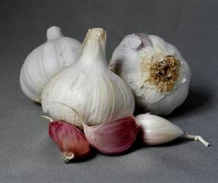
As early as 1550 B.C., Egyptians realized the benefits of garlic (a high-sulfur food) as a remedy for a variety of diseases. Many epidemiological studies support the protective role of garlic and related allium foods against the development of certain human cancers. Natural garlic and garlic cultivated with selenium fertilization have been shown in laboratory animals to have protective roles in cancer prevention.[3]
Dr. Budwig fed terminal cancer patients a mixture of skim milk protein (a sulfur-containing protein) and flaxseed oil. The Budwig diet and the Gerson Therapy diet are two leading anti-cancer diets. The badly needed sulfur protein L-methionine is found in cottage cheese. L-methionine is the essential amino acid responsible for breaking down omega-3 fatty acids.
Sulfur is essential for the metabolism of carbohydrates. Sulfur is required for proper assimilation of the alpha amino acids methionine and cysteine. There is no recommended daily allowance (RDA) for sulfur, though it is believed that most of us ingest about 9 gm/day from our diets with more needed in cancer treatments.[4] There are no known toxic effects from organic sulfur.
The first scientific report to study sulfur-laden garlic and cancer was performed in the 1950s. Scientists injected allicin, an active ingredient from garlic, into mice suffering from cancer. Mice receiving the injection survived more than six months whereas those that did not receive the injection survived only two months.[5]
The National Cancer Institute found that individuals who ate the most allium vegetables (red onions, scallions, garlic, chives and leeks) had a nearly 50% lower cancer risk than those who ate the least.[6]
A large-scale epidemiological Iowa Women’s Health Study looked at the garlic consumption in 41,000 middle-aged women. Results showed that women who regularly consumed garlic had 35% lower risk of developing colon cancer.[7]
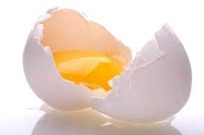
Sulfur-rich foods help to give you healthy hair, skin and nails. Sulfur foods are important as this mineral is present in every one of your cells. Sulfur deficiency is a big threat to vegans and vegetarians who do not consume any eggs or dairy food. Sulfur foods are primarily found in unprocessed animal foods and seafood. It is also found in great abundance in raw egg yolks.
Sulfur Deficiency Symptoms
- Fatigue and sluggishness
- Brittle nails and hair
- Hair loss and slow growth of hair
- Poor growth of fingernails
- Joint problems like arthritis
- Skin problems like rash
- Dermatitis and eczema
- Skeletal and growth problems
- Varicose veins and poor circulation
- Increased aging of skin
- Inability to digest fats
- Blood sugar problems
- Inability to digest food
- Increased allergies
- Parasitical infestations
Several population studies show an association between increased intake of garlic and reduced risk of certain cancers, including cancers of the stomach, colon, esophagus, pancreas and breast. The European Prospective Investigation into Cancer and Nutrition (EPIC) concluded that higher intakes of onion and garlic were associated with a reduced risk of intestinal cancer.[8]
Several studies conducted in China cantered on garlic consumption and cancer risk. In one study, investigators found that frequent consumption of garlic and various types of onions and chives was associated with reduced risk of esophageal and stomach cancers, with greater risk reductions seen for higher levels of consumption. Similarly, in another study, the consumption of allium vegetables, especially garlic and onions, was linked to a reduced risk of stomach cancer. In another study, greater intake of allium vegetables (more than 10 g per day vs. less than 2.2 g per day) was associated with an approximately 50% reduction in prostate cancer risk.
Evidence also suggests that increased garlic consumption may reduce pancreatic cancer risk.[9] A study conducted in the San Francisco Bay area found that pancreatic cancer risk was 54% lower in people who ate larger amounts of garlic compared with those who ate lower amounts.
In addition, a study in France found that increased garlic consumption was associated with a statistically significant reduction in breast cancer risk.[10] After considering total calorie intake and other established risk factors, breast cancer risk was reduced in those consuming greater amounts of fiber, garlic and onions.

Sulfur, Glutathione & Selenium
Oxyradicals are involved in multiple mutational events and can contribute to the conversion of healthy cells to cancer cells. Glutathione (GSH) and the GSH-replenishing enzymes keep the antioxidant status of normal cells at a level where they can avert oxyradical-derived mutations. When we talk about sulfur pathways and sulfur sufficiency we are at the same time touching on glutathione because glutathione is a sulfur enzyme.[11]
Selenium compounds have been shown to have powerful anticarcinogenic activity. In view of certain similarities between selenium and sulfur biochemistry, scientists tested selenocystamine/cysteamine, semethylselenocysteine/S-methylcysteine and selenobetaine-sulfobetaine. In these sulfur compounds only cysteamine and S-methylcysteine produced anticancer activity. These sulfur-selenium compounds are active in cancer protection and may have a multi-modal mechanism in preventing cellular transformation as well as in delaying or inhibiting the expression of malignancy after carcinogen exposure.[12]
Garlic also contains selenium, which is crucial for glutathione enzymes.
Glutathione, the most important antioxidant in the body, is that place where sulfur and selenium meet up to protect us from cancer. The immune system cannot function properly without it and antioxidants such as vitamins C and E rely on it to function properly within the body. The glutathione and cancer connection has been well established. Patients with cancer, serious chronic illness, AIDS and over 60 other diseases have reduced glutathione levels. Glutathione plays a specific role in the detoxification of many well-known cancer-causing and cell-damaging substances in our environment.
A Japanese study showed that even low concentrations of DMSO (sulfur) had radio-protective effects through the facilitation of DNA double-strand break repair, providing protection against radiation damage at all cellular levels in the whole body.[13] Boosting your body’s antioxidant levels is a key to surviving cancer. DMSO can be used for various medical applications.
In my Natural Allopathic protocol I suggest two principle products for sulfur supplementation. The first is organic sulfur and I have found a company with the best-priced and highest-quality product. Second I am recommending a new product from LL Magnetic Clay—magnesium oil with MSM (sulfur) added. It is a very nice transdermal way of injecting sulfur into our systems and it makes the magnesium oil even oiler and better for the skin.
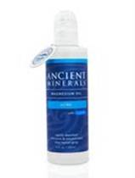
Ancient Minerals Magnesium Oil Ultra ecorporates the unique synergistic benefits of MSM and magnesium. MSM (methylsulfonylmethane) has long been revered as a superior form of sulfur supplementation, but as a topical it enhances cell membrane permeability and facilitates more efficient uptake of magnesium ions. Ancient Minerals Magnesium Oil Ultra contains approximately 1.6 g elemental magnesium and 3.6 g of MSM per fl oz. I’m sure my readers will like this new magnesium oil formula. It’s gentler on the skin—the MSM counteracts the itching and it’s being offered at 40% off with the rest of the Ancient Mineral magnesium line of products until the end of June 2012.

See References ▼
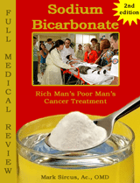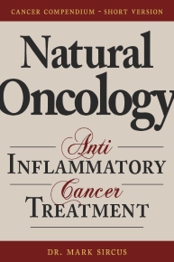

Learn how to treat yourself and your loved ones safely at home With powerful medicinals
Learn Dr Sircus protocol including dosages, methods, side effects and contra-indications. This bundle includes the Sodium Bicarbonate and Natural Oncology eBooks.
get yours
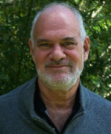

Dr. Mark Sircus AC., OMD, DM (P)
Director International Medical Veritas Association
Doctor of Oriental and Pastoral Medicine
On Facebook On Youtube
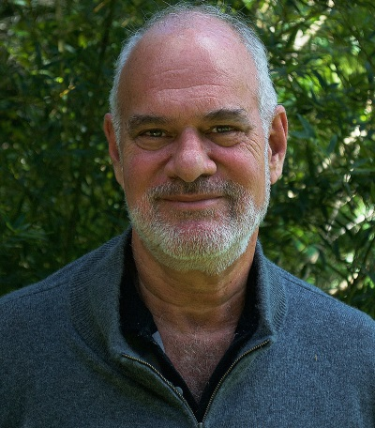
Dr. Mark Sircus, Ac., OMD


Learning and Practicing
Intensive Health Care
Simple but powerful medical interventions that are combined in a way pharmaceuticals cannot be.
Learn More

The newest work from
Dr. Sircus

Today more than ever before, we need new ways to diagnose and treat our families and ourselves in a safe, effective and affordable way.
Here is the key


Most Popular Posts
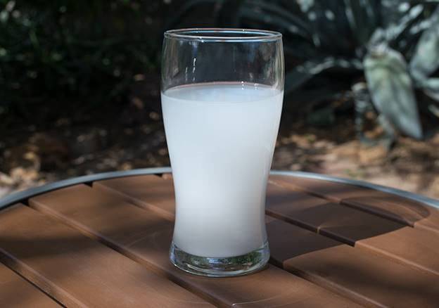

Bicarb Magical Mineral Supplement
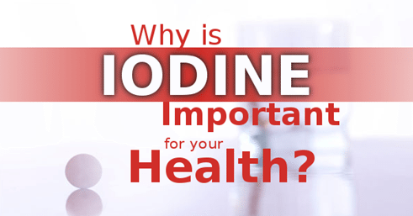

Main Reasons Iodine Supplementation is Essential
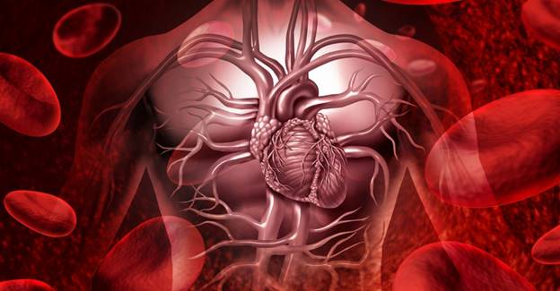

Revolution in Blood Medicine – Intranasal Laser Therapy
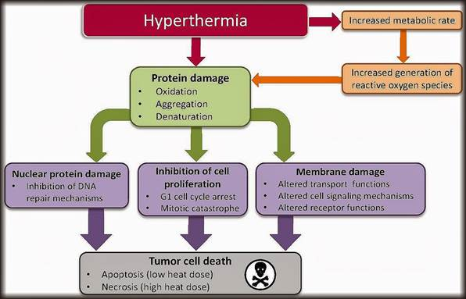

Low Body Temperature Symptoms and Causes – And How to Treat It
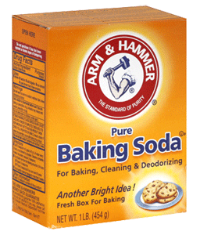

Baking Soda Uses in Daily Health

Medical Articles
- > Magnesium
- > Sodium Bicarbonate
- > Iodine
- > Cancer
- > Diabetes

Tag Cloud
No tags found.

Join 60,000 others
in my newsletter and
get a free ebook!
Subscribe to Dr Sircus newletter and receive for free an ebook and introductory articles that will guide you through his protocol and the medicinals that compose it.

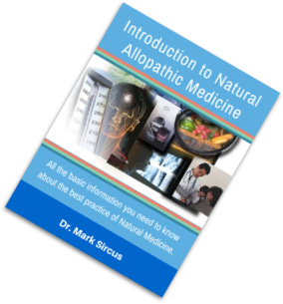

comments
For questions pertaining to your own personal health issues or for specific dosing of Dr. Sircus's protocol items please seek a consultation or visit our knowledge base to see if your question may have been answered previously.
My Account Affiliate Area
Legal notice: The Author specifically invokes the First Amendment rights of freedom of speech and of the press without prejudice. The information you will receive with our consultations is for informational purposes only under the rights guaranteed by the First Amendment of the Constitution for the United States of America, and should not in any way be used as a substitute for the advice of a physician or other licensed health care practitioner. The statements contained on my sites and in my books have not been evaluated by the FDA. The products discussed are not intended to diagnose, cure, prevent or treat any disease but are proven useful for health and life extension. We always recommend when and wherever possible that licensed local healthcare professionals be consulted.

