Indian State of Goa to Pay Farmers to Go 100% Organic
- Nov 1, 2016
- 15,306
- 26
- 0
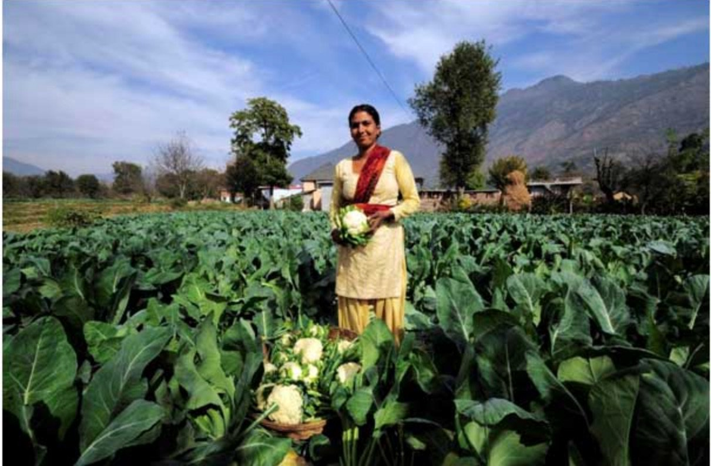
Sikkim, located in the Himalayan mountains, along Nepal and China’s Tibet Autonomous Region, announced that it had become India’s first independently certified organic state earlier this year. Now Goa’s state government has come out with a specific plan to become organic as well.
Using a state-assisted program titled, “organic imputs for farmers”, the state plans to shun the damaging chemicals often used in industrial farming. “This is the first step we have taken in the direction of organic farming in the state. Hopefully, more and more farmers should adopt the practice of organic farming after availing this scheme.” said director, agriculture, Ulhas Pai Kakode.
Organic Farm in Rajasthan, India
Under the state supported program, farmers having 10,000 -20,0000 hectares of land can receive up to 50 percent assistance for agreeing to only use organic imputs – this means organic fertilizers such as vermi-compost, mushroom waste, neem cake; bio-fertilizers such as rhizobium, azotobacter, azospirillium etc.
These will be made available to farmers at a greatly discounted rate in order to help them transition from genetically modified farming models which rely on millions of pounds of chemical fertilizers and carcinogenic herbicides to grow crops.
Farmers with as little as 0.1 hectares are also eligible for the program, keeping the tradition of indigenous farming on small plots intact.
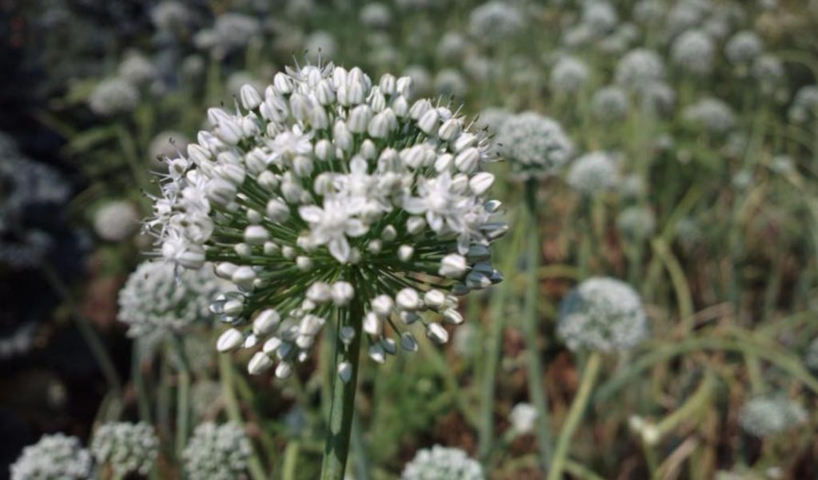
Onion Flower Grown on a Bio-Diverse, Organic Farm in Goa, India
Not only will this program restore organic food to farmers and families who rely on them for sustenance, but the soil can expect to be remediated with a large portion of India’s farm land receiving the organic, non-chemical nutrients it needs.
The immune system of plants will greatly benefit from this change to organic imputs over chemical soil additives. John Kemp, an Amish farmer that saw crops on his family’s five-generation, 66-acre farm riddled with pests and fungus that chemicals couldn’t treat went 100% organic, and discovered that a plant’s immunity is based almost entirely on the soil in which it is planted. When it is rooted in nutrient dense soil comprised of lots of organic matter, the plant’s immunity thrives.
Restored soil also helps to replenish other natural resources, since plants grow stronger and are better able to resist disease, as well as drought conditions, with nutrient-dense soil. This translates to lower water use, along with the eradication of chemicals which often ruin drinking water supplies.
Moreover, the wide variety of medicinal and herbal remedies used in India are simply astounding. The methods used to grow these plants could never be cultivated and passed down to future farming generations under the current chemical/mono-cropping model.
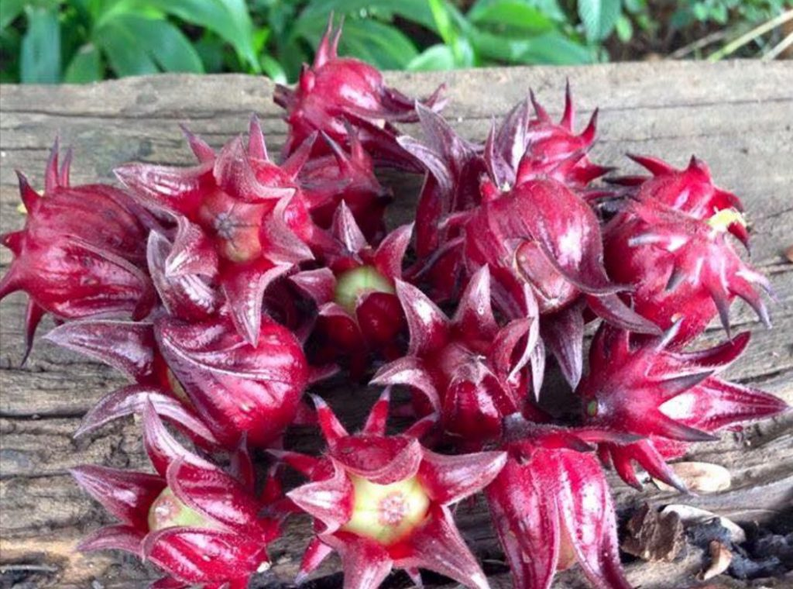
Rosella Flowers Grown on an Organic Food Forest in Goa, India
Tribal farmers have practiced these organic farming methods in India and other areas of the world for centuries, prior to the Industrial Revolution in the US which spread into other country’s farming systems. It is only in the last hundred years of so, that we have so dramatically altered the farming landscape with the mono-cropping, genetically modified, chemical farming models of companies like Bayer, Syngenta, Monsanto, and Dow Chemical.
From one corner of the planet to another, farmers are returning to age-old practices, and eschewing the industrial agricultural model. Our planet and our health will surely benefit from such an enormous change.
Image credits: Goa Food Farm, MartJackStorage

