Himalayan Salt Lamp Is One Of The Greatest Things You Could Own!
share
Nowadays, Himalayan salts lamps are becoming really popular, and there are several good reasons for it.
Namely, it offers numerous health benefits, including relaxation, body detoxification, and respiratory support. Thus, this mineral-rich lamp can provide various health benefits and enhance your entire living.
It is made from pieces of Himalayan salt, which can vary in size. It has a small bulb inside and its shape makes it look like a really attractive decoration object. The small bulb is surrounded by a pile of crystals, creating a bucket.
In order to understand its benefits, you need to understand the nature of ions. They can be positive and negative as they are unbalanced molecules.
They are not equal to neutrons and electrons. Namely, the positive ions are harmful and should be neutralized. People who live in big cities, constantly crowded and noisy, feel their effects.
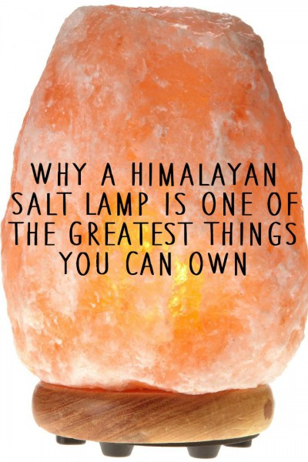
On the other hand, the Himalayan lamp provides negative ions, which are extremely beneficial for the health. For instance, the air is filled with them after raining, and that is why you feel great when you go outside after the rain. This lamp provides the same feeling, inside your home.
Furthermore, the Himalayan lamps have been confirmed to provide numerous other health benefits, including:
- headaches
- blood system disorders
- rheumatism
- Colds
- respiratory issues
- allergies
- stress -related problems
- skin conditions
- insomnia and sleep disturbances
Hence, you will benefit a lot if you have one of these lamps at home. Simply put it on some prominent place in the room where you spend most of your time, or where the air is affected by various electronic devices, and you will soon experience positive changes.
Sources and References:
healthpositiveinfo.com
www.livetravelenjoy.com
livingtraditionally.com
Sponsored by Revcontent

