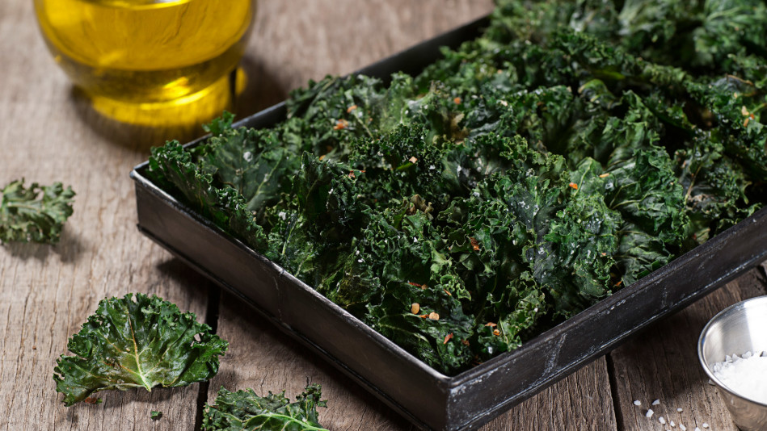

Notes for making the snacks below: Use healthy seasonings WITHOUT hidden MSG
Best to use a dehydrator but a low oven ok.
Use ORGANIC if possible.
Enzymes in raw foods are reportedly “destroyed” (denatured may be more accurate) when food is heated above a certain critical temperature, approximately 48° C/118° F. Foods heated above this critical temperature – even if only for a very brief period - are said to be “cooked” or “dead”.

Weigh out the options. If you are going to pig out on packaged unhealthy chips then please use the
oven set at a higher 300 degree setting

The Crunchy Green Kale chips
There's a lot to love about kale chips: They're low in calories, packed with nutrients and surprisingly tasty. The baked snack is simple to make, too. You just tear kale leaves into pieces; coat them with olive oil, salt and pepper; and, bake for 10 to 15 minutes. But one small post-munching tip—you may want to do a quick mirror check before heading out,

http://ohsheglows.com/2014/03/12/6-tips-for-flawless-kale-chips-all-dressed-kale-chips-recipe/

Notes for making the snacks below: Use healthy seasonings WITHOUT hidden MSG
Best to use a dehydrator but a low oven ok.
Use ORGANIC if possible.
Enzymes in raw foods are reportedly “destroyed” (denatured may be more accurate) when food is heated above a certain critical temperature, approximately 48° C/118° F. Foods heated above this critical temperature – even if only for a very brief period - are said to be “cooked” or “dead”.

Weigh out the options. If you are going to pig out on packaged unhealthy chips then please use the
oven set at a higher 300 degree setting

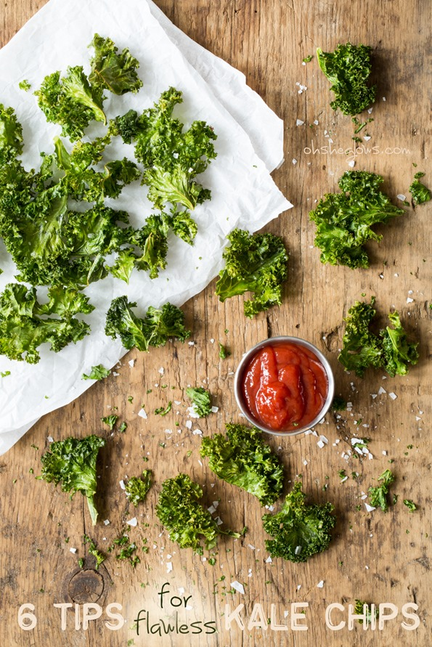
I’ve suffered through one too many batches of burned or soggy kale chips over the years. It took me a while to master my baked kale chip recipe, but I’ve learned some valuable lessons along the way and I’d like to pass my tips along to you! From the good ‘ol Culinary School of Hard Knocks (aka: my kitchen) to you. Gotta love it.
The first time I made kale chips I remember thinking, “Should they taste burnt like this??” The easy answer is no. I’ve come to find a nice balance between crispiness and chewiness without any burnt edges. Yes, this is very serious business, this kale chip business. When baked properly, they really do make the perfect base for a satisfying chip alternative.
I know some people are eager to claim that kale is “over” due to its popularity in recent years, but seeing as it’s still rated number #1 (along with Mustard/Turnip/Collard Greens) on the Aggregate Nutrient Density Index (ANDI), I don’t think it’s going anywhere anytime soon. At least not in my diet. Kale for life!
With these few simple techniques you’ll be well on your way to kale chip bliss. Or maybe you already are, in which case, feel free to skip ahead to my All-Dressed Baked Kale Chip recipe below and get crunching!
Ok, here are my top 6 tips for baking the perfect kale chips. No dehydrator required.
1. Remove the stems and tear leaves into large pieces
I don’t know about you, but I’m not a fan of chewing through woody baked kale stems. I remove the stems very quickly by grabbing the base of the stem with one hand and pushing outwards along the stem to slide off the leaves. Works like a charm!

2. Wash and thoroughly dry the leaves before beginning
If the leaves aren’t properly dried, the water can “steam” the kale chips while baking and lead to the dreaded soggy kale chip! Be sure they are nice and dry before you massage in the oil. A salad spinner works great; just be sure not to overload it so the leaves can properly dry.
3. Don’t skip the oil, but don’t drench it in oil either
A little bit of extra virgin olive oil (or coconut oil, if you prefer) goes a long way. I like to use ½ tablespoon of oil per baking sheet of kale chips. “Massage” the oil into the leaves to ensure all the nooks and crannies are coated. Oil also helps the spices stick to the leaves.
4. Spread kale into a single layer on the baking sheet
I used to dump all the kale into a very thick layer on the baking sheet and hope for the best, but doing this tends to lead to soggy, unevenly baked kale chips. I’ve learned to be a bit more patient and spread them out into a thinner layer on each baking sheet. Be sure to rotate the baking sheet half-way through baking. There’s no real need to flip the chips unless you have the patience for it.
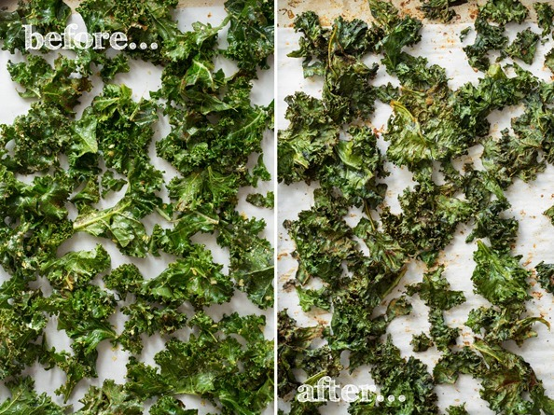
5. It’s all about the low-heat for even baking
As I wrote in my cookbook, I tested all kinds of kale chip recipes at different temperatures from very low to high heats. Surprise, surprise the batches that worked the best were the ones I baked at a very low temperature of 300F. Sure, it takes a bit longer to bake, but I can assure you it’s worth it because you don’t get any burnt pieces. Remember, the goal is to crisp the kale, not scorch it into smithereens! In my oven, I bake at 300F for 10 minutes, then I rotate the pan, and bake for another 15 minutes. So 25 minutes total for kale chip perfection in my oven. This will vary based on your oven, but it’s a good starting off point!
6. Cool for just a few minutes on the baking sheet
I’ve found that waiting just 3 minutes allows the kale chips to crisp up even more once they are out of the oven. Just like baked cookies or roasted chickpeas, kale chips really firm up even more when cooled. Those 3 minutes will feel like hours though. I won’t lie.
Bonus tips: Avoid adding liquids (such as vinegars or hot sauces) pre-baking as liquids can result in soggy chips. It’s best to add a light spritz of liquid seasoning after they’ve been baked, if at all. Also, if your oven has one, feel free to try out the dehydrator or convection setting.
Now, read on for my All-Dressed Kale Chip recipe! I promise this batch will not last long…minutes while standing in front of the oven if you are like me.

All-Dressed Kale Chips
Vegan, gluten-free, grain-free, nut-free, refined sugar-free, soy-free
4.8 from 177 reviews
Crispy and chewy kale chips baked in the oven and seasoned to perfection. Enjoy these as a healthy alternative to potato chips.

Yield
1-2 servings

Prep Time
15 Minutes

Cook time
25 Minutes

Ingredients:

per baking sheet:
- approx. 1/2 bunch kale leaves
- 1/2 tablespoon extra virgin olive oil or melted coconut oil
- 1.5 tablespoons nutritional yeast
- 1 teaspoon garlic powder
- 3/4 teaspoon chili powder
- 1/2 teaspoon onion powder
- 1/2 teaspoon smoked paprika
- 1/4 teaspoon fine grain sea salt or pink Himalayan sea salt
- 1/8 teaspoon cayenne pepper (optional)

Directions:
- Preheat oven to 300F. Line a large rimmed baking sheet with parchment paper.
- Remove leaves from the stems of the kale and roughly tear it up into large pieces. Compost the stems (or freeze for smoothies). Wash and spin the leaves until thoroughly dry.
- Add kale leaves into a large bowl. Massage in the oil until all the nooks and crannies are coated in oil. Now sprinkle on the spices/seasonings and toss to combine.
- Spread out the kale onto the prepared baking sheet into a single layer, being sure not to overcrowd the kale.
- Bake for 10 minutes, rotate the pan, and bake for another 12-15 minutes more until the kale begins to firm up. The kale will look shrunken, but this is normal. I bake for 25 mins. total in my oven.
- Cool the kale on the sheet for 3 minutes before digging in! This really makes all the difference! Enjoy immediately as they lose their crispiness with time.
- Repeat this process for the other half of the bunch.

Tips:
Feel free to make these in a dehydrator if you have one. You can also experiment with the convection or dehydrator setting on your oven (if applicable).

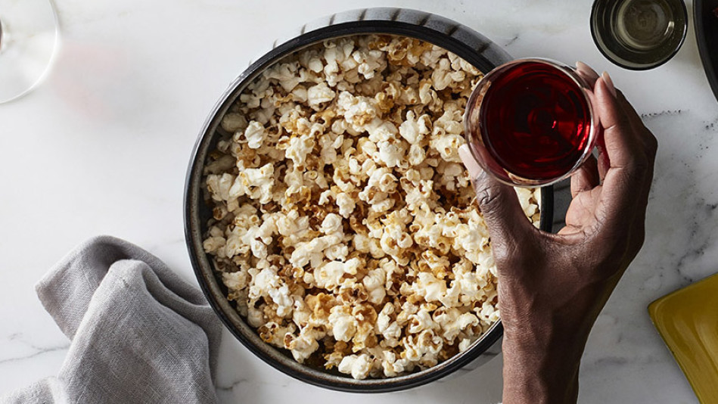

Remember pop corn kernels are bad for your intestines. Only eat once a week and spit out any extra hard casings on the pop corn.

Serves about 12
Ingredients
• 1/4 cup coconut oil
• 1/4 tsp. coarse sea salt
• 3/4 cup popcorn kernels
Directions
Total time: 10 minutes
In a Dutch oven over medium-high heat, melt coconut oil with salt. Add a few popcorn kernels to hot oil and cover. After kernels pop, remove and discard, then add remaining kernels to hot oil and cover. Continue to cook, shaking pot frequently, keeping lid slightly ajar. Remove from heat when popping sound slows nearly to a stop, 3 to 7 minutes. Transfer popcorn to large serving bowl.
From The Ultimate Appetizer Ideabook, by Kiera and Cole Stipovich (Chronicle); October 2016), founders of Cole + Kiera Photography, a Boston-based photography business.
Read more: http://www.oprah.com/food/stovetop-popcorn-recipe#ixzz4fWKivbhW
A New Way to Jazz Up a Fiber-Filled Classic
Oprah calls truffle popcorn her "all-time greatest snack." You can follow this recipe (she uses grapeseed oil in place of canola); then pour the just-popped, hot popcorn into a big bowl and toss with fine sea salt, freshly ground black pepper and truffle zest, which has an earthy, salty and ever-so-sweet taste and is one of Oprah's favorite ingredients. For the finishing touch, spritz everything with lemon juice, mixing to evenly infuse the popcorn with the juice—it helps the seasoning stick and adds a bright and zippy flavor.
_____________________________________
_ Popcorn with an Amazing, Surprising Topping
Air-popping your corn, and then making a topping from melted coconut oil adds a subtle, wonderfully addictive flavor to a familiar snack that you may not have tried before—and you can use as much, or as little, oil as you wish. Along with sugar, cayenne and sea salt, this is one of the tastiest iterations of popcorn that we've ever tasted.
Read more: http://www.oprah.com/food/healthy-snacks-for-work#ixzz4fWekN1kc
This recipe is healthy and quick to pull together. The secret ingredient (coconut oil) adds a subtle flavor that people can't quite put their finger on—and it makes this popcorn addictive. Season the popcorn while it's still warm so it sticks.
Makes 12 to 14 cups

Ingredients

• 12 to 14 cups air-popped corn (from about 1/3 cup kernels)
• 2 Tbsp. coconut oil
•1 Tbsp coconut oil
• 2 Tbsp. coconut sugar Or omit for less calories and just add any other spice you are craving
• 1 1/2 tsp. chili powder
• 1/2 tsp. sea salt

Directions
Place popped corn in a large bowl.
In a small saucepan over low heat, combine coconut oil Heat, stirring occasionally, until coconut oil is melted. Remove from heat and stir in sugar, chili powder and salt. Sugar will not melt.
Pour mixture in a thin stream over popped corn, stirring constantly until kernels are evenly coated. Store in an airtight container.
Reprinted from Coconut Every Day: Cooking with Nature's Miracle Superfood (Pintail; June 3, 2014). Photos: © Kathleen Finlay. Recipe: © Sasha Seymour, 2014.
Published 06/24/2014
Read more: http://www.oprah.com/food/sweet-and-spicy-popcorn-recipe#ixzz4fWf5c9Hc

___________________
Healthy Snacks Every Busy Woman Should Keep at Her Desk
These insta-pick-me-ups are way better than what you'll find in most vending machines. Plus, you can stash them in your drawer or cabinet (no refrigeration necessary).
By Lynn Andriani
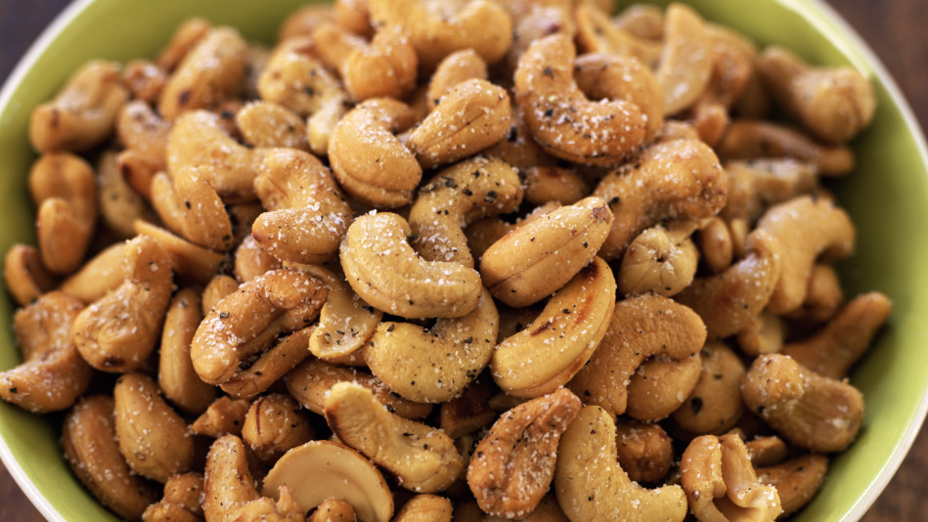
The Handful of Sweet, Spiced Goodness
We know that nuts are an ideal between-meal food, packed with protein as well as healthy monosaturated fat and fiber, but it's easy to overdo it (a serving size is a modest 1 ounce). If you roast your own, though, you can season to the hilt, so it only takes a small amount to make you feel satisfied. This easy recipe for curry and lime cashews from chef Marco Canora's A Good Food Day takes about five minutes to prepare and bursts with Southeast Asian flavor.
Get the recipe: Curry and Lime Cashews
It's almost too easy to go overboard on nuts, but these cashews have so much flavor from curry powder and fresh lime zest and lime juice that one handful really does the trick.
Makes 2 cups

Ingredients

• Grated zest of 1 lime
• 2 Tbsp. fresh lime juice
• 4 tsp. curry powder
• 1 1/2 tsp. fine sea salt
• 2 cups raw cashews

Directions
Many ovens don't cook evenly, so it's important to shake the nuts around a few times while they roast. Pay special attention to the nuts near the edges of the pan, since those tend to brown more quickly.
Preheat the oven to 300° F. You could also dry in an oven @115 degrees or in a dehydrator to preserve enzymes
In a large bowl, combine the lime zest, lime juice, curry powder and salt. Add the cashews and toss to coat.
Spread the nuts in an even layer on a baking sheet and roast, stirring every 10 minutes, until the cashews are lightly browned, about 30 minutes. Cool to room temperature, then store in an airtight container.
Read more: http://www.oprah.com/food/curry-and-lime-cashews-recipe#ixzz4fWgvnlx9

_______________

______________________
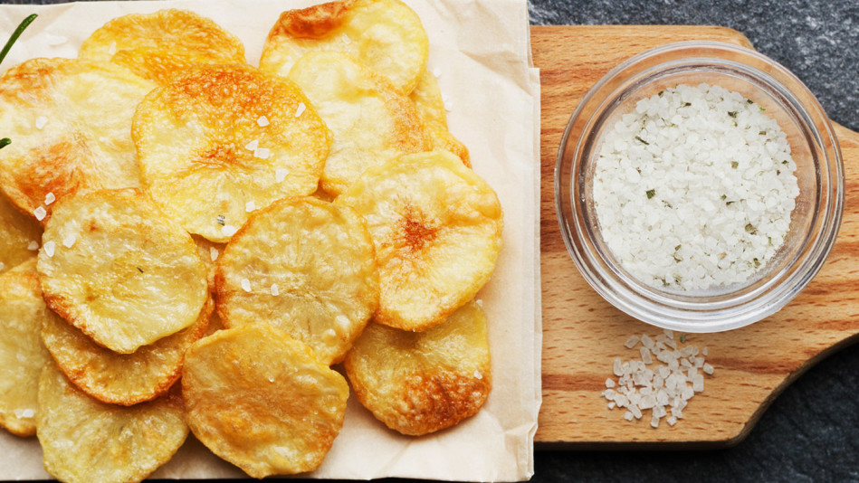
Chips That Are Pure Joy
When her first try at making homemade truffled potato chips turned out perfectly, Oprah wrote that she had tears of happiness. Achieving such delightful results is easier than you'd think; all you need are three simple ingredients (potatoes, olive-oil cooking spray and truffle salt), a mandoline to slice the spuds thinly and a baking sheet. Oprah's trick for getting the crispiest chips: Use very fresh potatoes (they should be firm, smooth, have shallow "eyes" and no green tint).

Baked Potato Chips
Recipe by Rori Trovato
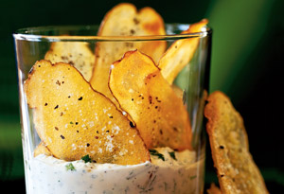
Photo: Richard Gerhard Jung
The secret is finally out of the bag: Homemade potato chips baked with a hint of olive oil have a crisper snap and are simply more potatoey tasting than store-bought. When they're served with a phenomenal Parmesan cheese, herb, and garlic dip, we guarantee no one will eat just one.
Note: For this recipe, you will need a food processor with a thin slicing blade or a mandolin.
Serves 8

Ingredients
- 1 1/2 to 2 pounds large baking potatoes, scrubbed
- 4 Tbsp. extra-virgin olive oil
- 1 large garlic clove, peeled
- Salt and freshly ground pepper

Directions
Preheat oven to 350°. Slice potatoes lengthwise very thin (about 1/16 inch).
Brush 2 baking sheets with 1/2 Tbsp. olive oil each. Rub garlic over surface, pressing hard to extract as much garlic juice as possible. Place baking sheets in oven to warm for 5 minutes.
Place potato slices side by side on hot baking sheets. Sprinkle generously with salt and pepper. Bake 7 to 10 minutes, rotate pans (for even browning), and bake another 10 to 15 minutes.
Flip potatoes and bake 5 minutes longer or until golden. Remove and cool on paper towels. Repeat with remaining potato slices. Eat warm or store in airtight container.

Another topping:
Ingredients
- 3 tablespoons nutritional yeast
- 1/4 ounce dried mushrooms, such as cremini
- 1/4 teaspoon finely grated zest from 1 lemon
- 1/4 teaspoon granulated garlic
- 1 teaspoon minced fresh thyme or 1/2 teaspoon crushed dried thyme
- 1 recipe Extra-Crunchy Potato Chips (see note above)
- Kosher salt and freshly ground black pepper

Directions
- 1.
In an electric spice grinder or high-power blender, combine nutritional yeast, dried mushrooms, lemon zest, garlic powder, and thyme and blend until a fine powder forms.
- 2.
While chips are still hot and fresh from the oil, and working in batches if necessary, set in a large paper-towel-lined bowl and sprinkle nutritional yeast mixture all over. Season with salt and pepper. Using clean hands, toss to coat chips evenly, then transfer to a serving bowl. Cooled chips can be stored in a zipper-lock bag or airtight container for up to 2 days.

Smoky Paprika-Baked Garbanzo Beans Recipe
Recipe created by Art Smith
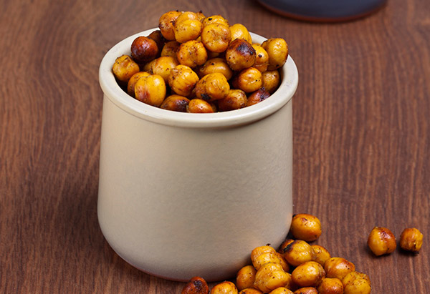
Photo: Thinkstock
A New Way to Do Salted Nuts
We love munching on roasted almonds between meals; but, even better? Roasted chickpeas. In addition to being lower in fat than nuts, chickpeas can have a positive impact on your eating habits, found one study. People who ate 3/4 cup of chickpeas (or other pulses) daily lost weight without making special efforts to avoid other types of foods. This recipe calls for smoked paprika and onion powder, but you can flavor the chickpeas, which are called garbanzo beans in Spanish, with any spice (we also like cinnamon and sugar; or, cumin, chili and cayenne).
Read more: http://www.oprah.com/food/snacks-for-weight-loss#ixzz4fWKKCXqy
These jazzy little beans are hard to stop popping in your mouth—and they are so easy to make it's almost ludicrous to call this a recipe. I often have some around to snack on. Big taste, little damage!
Serves 4

Ingredients
- 30 ounces canned garbanzo beans, drained
- 1 Tbsp. smoked paprika
- 1 tsp. onion powder

Directions
Preheat the oven to 350 degrees.
In a medium mixing bowl, toss the drained garbanzo beans with the smoked paprika and onion powder. Spread the beans on a parchment-lined baking sheet. Bake for 1 hour, stirring occasionally, until the beans are browned and crisp. Remove from the oven and cool the beans to room temperature. Store in an airtight container until ready to enjoy.
Read more: http://www.oprah.com/food/smoky-paprika-baked-garbanzo-beans-recipe#ixzz4fWJRLHEg

____________________________________________________________________________________+
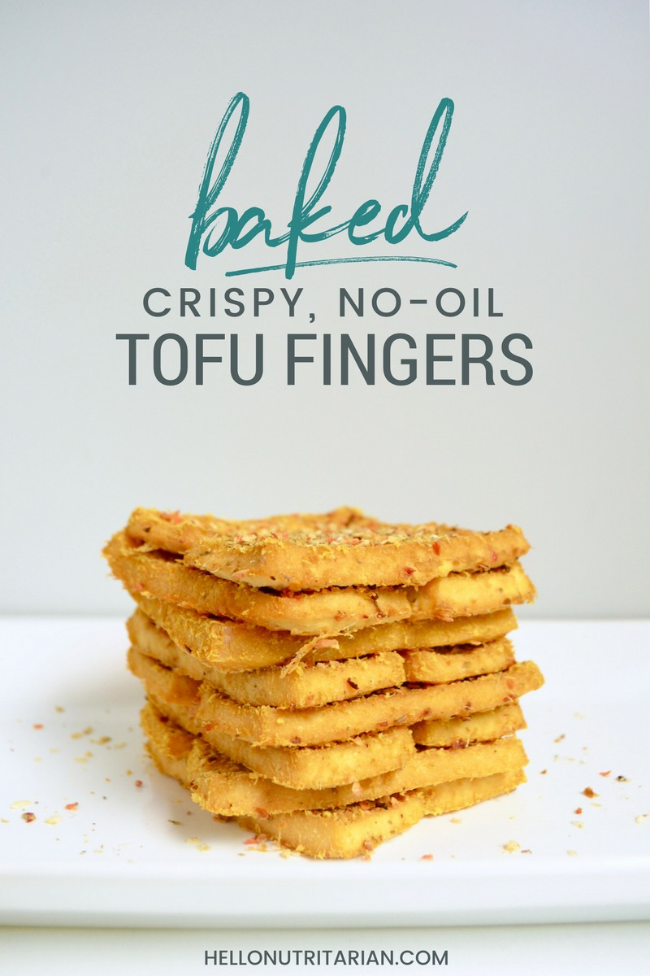
re craving chicken fingers make these no-oil, low salt, crispy, oven-baked tofu fingers instead! Perfect when you're eating vegan, whole food plant based, or nutritarian!
Servings 24 fingers
Author Kristen | Hello Nutritarian

Ingredients
- 2 packages firm tofu (I use 14 ounce packages)
- 1/2 cup nutritional yeast (you won't use it all)
- no-salt sasoning, to taste

Instructions
- Preheat oven to 375 degrees. Line a baking sheet with parchment paper and set aside (or use a Silpat pad).
- Drain tofu and press slightly with napkins or paper towels. Cut each tofu block into 12 equal slices. Slice the block in half, then slice each half in half again--now you have fourths. Cut each fourth into 3 slices, about 1/4 inch thick.
- Pour 1/2 cup nutritional yeast into plate. Coat each slice of tofu in nutritional yeast. Start with the edges then do the larger sides, this will minimize buildup on your fingers. Lay each slice on your prepared baking sheet.
- After all slices are coated, sprinkle liberally with your favorite no-salt seasoning.
- Bake in the oven, at 375 degrees for 30 - 40 minutes (depending on your desired crunch). You do not need to flip the slices during baking. You'll know they are ready when the edges are just starting to get brown and lift off the pan.
- Let the fingers rest for at least 5 minutes before using a spatula to remove.

Recipe Notes
Use these tofu fingers just like you would chicken fingers! Chop them up and add them to salads, or dip with your favorite no-salt, no-sugar dips and sauces!

______________________________________________________________________________ Chickpea Patties Recipe
Recipe created by Andrea Duclos
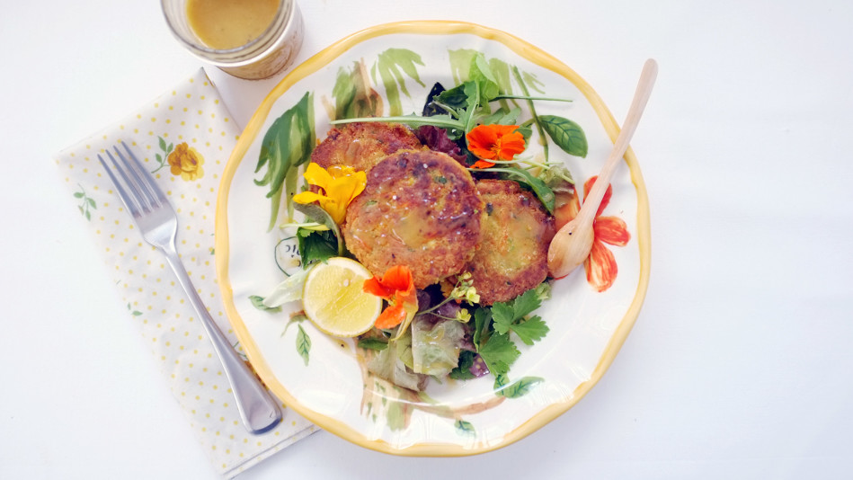
This was the first veggie burger I made from scratch. Over the years, I've tweaked the recipe slightly, here and there, to make it even better. These burgers are absolutely perfect on buns, but I love them most served on a nice bed of mixed greens and fresh veggies.
Makes 6 large patties

Ingredients

• 1 (15-ounce) can chickpeas, drained
• 2 garlic cloves
• 1/3 cup fresh, or frozen corn
• 1/2 cup fresh, or frozen and thawed, peas
• Large handful of fresh herbs (I like to use basil, oregano and/or thyme)
• 1 to 2 large handfuls of spinach (optional)
• 2 medium carrots, shredded
• 1 small onion, diced
• 1/2 tsp. spicy, smoked Spanish paprika (optional)
• 1/2 tsp. cumin (optional)
• 3 Tbsp. dried bread crumbs
• 3 Tbsp. all-purpose flour
• Salt and black pepper, to taste
• Olive oil for cooking
Directions
In a food processor, blend together the chickpeas, garlic, corn, peas, herbs and spinach (if using) for a few minutes, until smooth.
Add the carrots, onion, spices, bread crumbs and flour to the food processor and blend together. Turn the mixture out into a large bowl and season with salt and pepper.
Heat the oil in a skillet over medium-high heat.
Form the mixture into patties (I like to make 3 1/2-inch patties) and fry until golden, 3 to 5 minutes per side. You can cook a few at a time, but keep in mind they're much easier to flip when you have more space! Do not fuss with the burgers while they're cooking; flip them just once, very carefully.
TIP: These are great for freezing. Once the patties have fully cooled, individually wrap each and place in a freezer-safe container and freeze for later. When you're ready to enjoy them again, reheat on the stove in an oiled pan, or in the oven, on low heat, until heated through.
Recipe from
Read more: http://www.oprah.com/food/chickpea-patties-recipe#ixzz4fWTbFM00
- 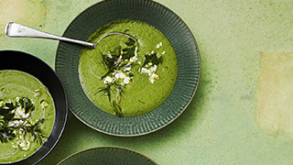
The Dish That's Been Close to Oprah's Heart Her Whole Life

- 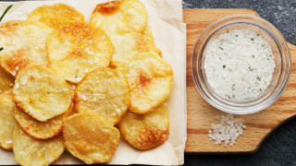
Oprah's Top 3 Healthy Go-To Snacks

- 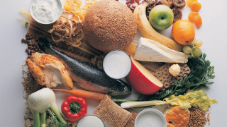
The Recipes Gayle King's Raving About

- 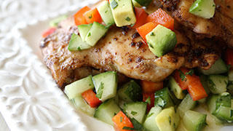
10 Easy Weeknight Meals for When You Want to Skip Carbs

Whipped Cauliflower Recipe
Recipe created by Megan Roosevelt
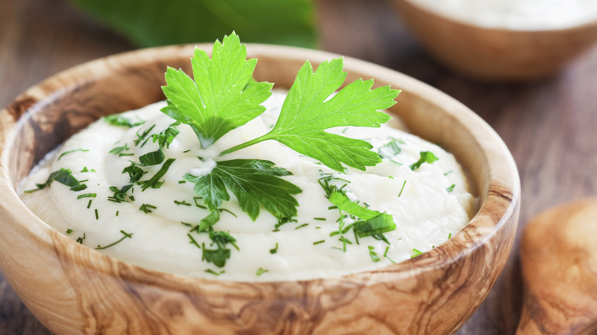
Photo: Юлия Атаева/iStock/Thinkstock

You can make this healthy base dip ANY flavor – be creative!

Serves 4 to 6

Ingredients

• 1 head of cauliflower
• 10 cups of water, for steaming
• Pinch of sea salt
• Pinch of freshly ground pepper
• 1 Tbsp. organic, unrefined coconut oil
• 1/4 cup unsweetened, canned coconut milk
• Fresh herbs, such as parsley (optional)

Directions
Wash and chop cauliflower into 1-inch pieces. Boil water in a large stockpot. Add cauliflower to a large vegetable steamer, and place on top of stockpot to steam for 10 minutes, or until soft and tender.
Transfer steamed cauliflower into a high-speed blender or food processor; add in sea salt, pepper, coconut oil, coconut milk and fresh herbs, if using. Blend or pulse together until creamy.
Published 03/02/2015
Read more: http://www.oprah.com/food/whipped-cauliflower-recipe#ixzz4fWUMqzZD
_______________________

_________________________________

____________________________________

Crowd-Pleasing Vegan Caesar Salad
Vegan, gluten-free, grain-free, no bake/raw, refined sugar-free
4.9 from 146 reviews
This is a delicious, creamy vegan Caesar salad that will wow any crowd! Everyone who’s tried it goes absolutely nuts over it, and it’s my most popular salad recipe on the blog. To take it over the top, I garnish the salad with a generous amount of crunchy Roasted Chickpea Croutons and a delectable Nut and Seed Parmesan Cheese for the ultimate vegan Caesar salad. The dressing recipe easily doubles for a larger group and it’ll keep in the fridge in a sealed container for a few days so you can make it in advance. Dressing adapted from My Vega.

Yield
5-6 small bowls

Prep Time
45 Minutes

Cook time
35 Minutes

Ingredients:

For the Roasted Chickpea Croutons:
- 1 (15-ounce) can chickpeas (or 1 1/2 cups cooked), drained and rinsed
- 1 teaspoon extra-virgin olive oil
- 1/2 teaspoon fine grain sea salt
- 1/2 teaspoon garlic powder
- 1/8 to 1/4 teaspoon cayenne pepper (optional)

For the Caesar Dressing (makes 3/4-1 cup):
- 1/2 cup raw cashews, soaked overnight
- 1/4 cup water
- 2 tablespoons extra-virgin olive oil
- 1 tablespoon lemon juice
- 1/2 tablespoon Dijon mustard
- 1/2 teaspoon garlic powder
- 1 small garlic clove (you can add another if you like it super potent)
- 1/2 tablespoon vegan Worcestershire sauce (I use Wizard's gluten-free brand)
- 2 teaspoons capers
- 1/2 teaspoon fine grain sea salt and pepper, or to taste

For the Nut and Seed Parmesan Cheese:
- 1/3 cup raw cashews
- 2 tablespoons hulled hemp seeds
- 1 small garlic clove
- 1 tablespoon nutritional yeast
- 1 tablespoon extra-virgin olive oil
- 1/2 teaspoon garlic powder
- fine grain sea salt, to taste

For the lettuce:
- 1 small/medium bunch lacinato kale, destemmed (5 cups chopped)
- 2 small heads romaine lettuce (10 cups chopped)

Directions:
- Soak cashews in a bowl of water overnight, or for at least a few hours. Drain and rinse.
- Roast chickpea croutons: Preheat oven to 400°F. Drain and rinse chickpeas. Place chickpeas in a tea towel and rub dry (it's okay if some skins fall off). Place onto large rimmed baking sheet. Drizzle on oil and roll around to coat. Sprinkle on the garlic powder, salt, and optional cayenne. Toss to coat. Roast for 20 minutes at 400°F, then gently roll the chickpeas around in the baking sheet. Roast for another 10 to 20 minutes, until lightly golden. They will firm up as they cool.
- Prepare the dressing: Add the cashews and all other dressing ingredients (except salt) into a high-speed blender, and blend on high until the dressing is super smooth. You can add a splash of water if necessary to get it blending. Add salt to taste and adjust other seasonings, if desired. Set aside.
- Prepare the Parmesan cheese: Add cashews and garlic into a mini food processor and process until finely chopped. Now add in the rest of the ingredients and pulse until the mixture is combined. Salt to taste.
- Prepare the lettuce: Destem the kale and then finely chop the leaves. Wash and dry in a salad spinner. Place into extra large bowl. Chop up the romaine into bite-sized pieces. Rinse and then spin dry. Place into bowl along with kale. You should have roughly 5 cups chopped kale and 10 cups chopped romaine.
- Assemble: Add dressing onto lettuce and toss until fully coated. Season with a pinch of salt and mix again. Now sprinkle on the roasted chickpeas and the Parmesan cheese. Serve immediately.

Tips:
- Be sure to check the label to ensure your Worcestershire Sauce is gluten-free (if necessary) as not many are. I use Wizard`s Gluten-Free Organic Worcestershire Sauce.
- The dressing thickens when chilled, so be sure to leave it at room temperature to soften before using.

Vegan Chocolate Chip and Salted Chili Cookies Recipe
Recipe created by Sam Talbot
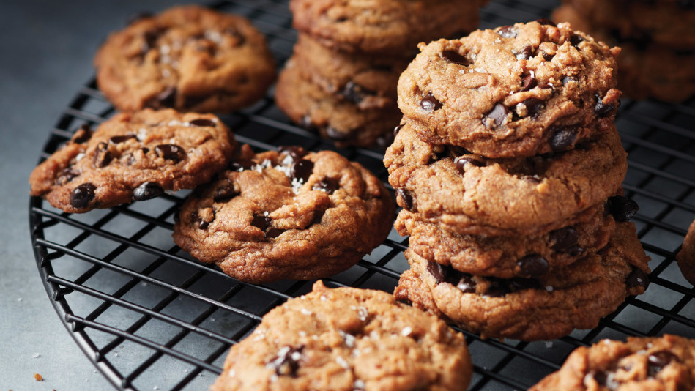
Photo Courtesy of Time Inc. Books
Makes 3 dozen cookies

Ingredients

• 2 cups organic flour
• 1 1/4 tsp. baking soda
• 1 1/2 tsp. smoked ancho chili powder
• 1 1/2 tsp. fine sea salt, plus more to finish
• 1 3/4 cup coconut sugar
• 1/4 cup date sugar
• 1/2 cup coconut oil
• 1/4 cup organic apple cider
• 2 Tbsp. applesauce or apple puree
• 1 to 2 Tbsp. almond milk or water, if needed
• 1 3/4 cups dark chocolate chips (70-percent cacao)
Directions
Preheat oven to 350°. Line 2 baking sheets with parchment paper.
Whisk together the flour, baking soda, chili powder and salt in a bowl.
Combine the coconut and date sugars, coconut oil, cider and applesauce in a bowl. Beat with an electric mixer at medium-high speed until well blended. Gradually add the flour mixture, beating at low speed just until blended. (If the dough looks dry, beat in 1 to 2 tablespoons of almond milk or water, a little at a time, just until the dough comes together.) Stir in the chocolate chips.
Drop the dough by rounded spoonfuls onto the prepared baking sheets, 2 inches apart. Sprinkle the dough with the sea salt.
Bake in preheated oven, in batches, until the edges are set, 10 to 12 minutes. Cool the cookies on wire racks.
Excerpted from 100% Real by Sam Talbot. Copyright © 2017 Oxmoor House. Reprinted with permission from Time Inc. Books, a division of Time Inc. New York, NY. All rights reserved.
Published 04/07/2017

Oatmeal, Walnut and Dried Plum Cookies
Recipe from The Kind Diet by Alicia Silverstone
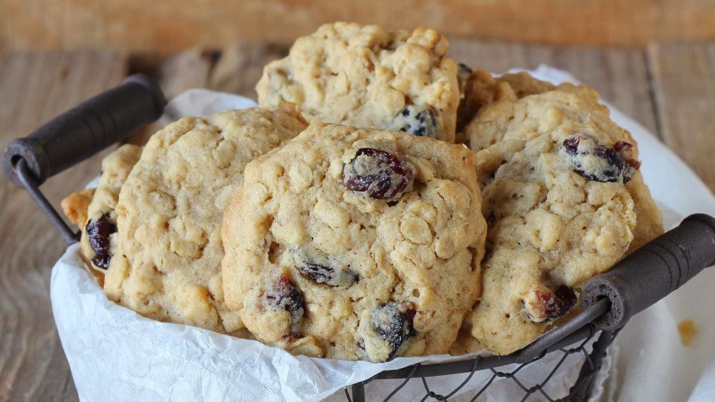
Recipe from The Kind Diet by Alicia Silverstone
My friend Kristina Brindley is a wonderful vegan caterer who does home delivery. Her vittles are so delicious, I order from her almost every week. I think it's safe to say she is quite possibly the greatest dessert-maker to ever walk the earth—her desserts are insane!
I'm not usually a big fan of oatmeal cookies, but I'm obsessed with these. (My mom, an oatmeal cookie connoisseur, just can't get enough.)
Servings: Makes 10 to 12 cookies
Ingredients
- 1 cup quick-cooking rolled oats
- 3/4 cup unbleached all-purpose flour
- 1/3 cup maple sugar
- 2 tsp. baking powder
- 1 tsp. baking soda
- 1/4 tsp. fine sea salt
- 1/3 cup maple syrup
- 1/2 cup safflower oil
- 1 tsp. vanilla extract
- 1/2 tsp. molasses
- 1/4 cup chopped dried plums or other dried fruit
- 1/4 cup finely chopped walnuts
Directions
Preheat the oven to 350 degrees F. Line a baking sheet with parchment paper.
Combine the oats, flour, sugar, baking powder, baking soda, and salt in a large bowl. In a separate bowl, combine the syrup, oil, vanilla extract, and molasses. Add the wet ingredients to the dry ingredients, and stir to combine. Fold in the dried plums and nuts.
Using your hands, roll tablespoon-size scoops of dough into balls. Place the balls onto the prepared baking sheet and press down slightly on the balls to flatten the tops. Bake for 8 to 12 minutes or until lightly browned. Transfer cookies to a baking rack to cool completely.
For variety, replace the all-purpose flour with whole wheat pastry flour, barley flour, spelt flour, or a gluten-free baking mix (choose one that does not include baking soda and baking powder). You can also substitute chocolate chips for the dried fruit and any kind of nuts for the walnuts.
The Kind Diet by Alicia Silverstone. P
Read more: http://www.oprah.com/food/oatmeal-walnut-and-dried-plum-cookies#ixzz4fWSnbAGf

7 Essential Healthy Recipes to Master in 2016
Here are the decadent-tasting-yet-good-for-you mains and sides you'll want to put in heavy rotation in your kitchen this year.
By Lynn Andriani
Photo: Andrea Duclos

Veggie Burgers You'll Be Happy to Heat Up
Whether you serve them on a bun or over a bed of mixed greens, plant-based patties are a satisfying and healthy vegetarian meal. This simple recipe, from the new book The Plantiful Table, by Andrea Duclos, from the blog OhDearDrea, uses a can of chickpeas as its base and also includes corn, peas, fresh herbs and carrots. The fresh-tasting burgers freeze well, so you'll never need to buy packaged ones again.
Read more: http://www.oprah.com/food/healthy-recipes-for-dinner#ixzz4fWTJrq5y
http://ohsheglows.com
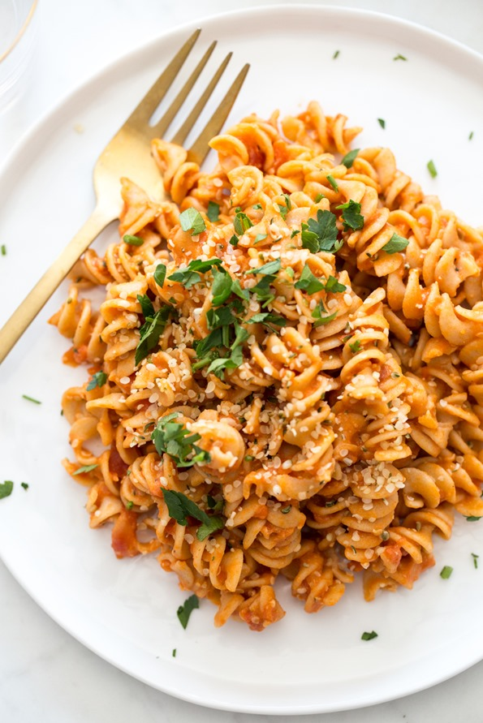
At long last, I’m sharing the recipe I’ve probably made the most since Adriana started eating solids (which somehow feels like forever ago and just yesterday at the same time). I’ve had so many requests for this recipe, but never got around to sharing it because it would always be devoured right away, leaving no time for photos. Last week, I finally made it in the morning so I’d have a bit of time to snap a few shots.
I use the term “recipe” lightly here because I never measure the ingredients for this pasta; not having to measure anything is part of its beauty and ease. I measured it here so you can get a feel for it, but once you do, I encourage you to throw caution to the wind and wing it! It’s really hard to mess up. You can often find me glugging marinara, spooning hummus, and dumping hemp hearts with abandon into the cooked pasta. The quicker the better, especially when there’s a hangry toddler screaming “Paaaaaaaasta!” at your feet.
Not only is this pasta fast and delicious, it packs in tons of protein, fibre, and healthy fats. You can also change it up and customize it so many different ways—I’ve provided a few ideas in the recipe, but I’d love to hear what you come up with, too!
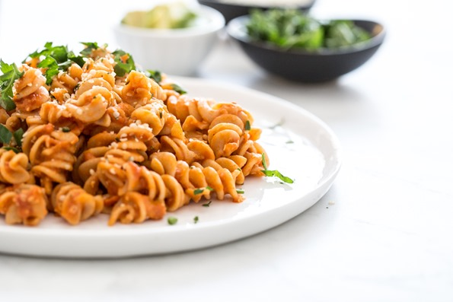
I’ve been hesitant to share “toddler-friendly” recipes on here because I’ve learned a few things about feeding a toddler: 1) what they claim to love and hate changes by the day (or minute), 2) toddler likes and dislikes are not one size fits all, and 3) the food my daughter loved at one year old (virtually everything!) is certainly not what she loves at two years old (this age is much more hot and cold, as she loves to assert her independence). It’s not uncommon for me to think I’ve found a foolproof toddler-friendly recipe to share with you, only for it to then be rejected for a month straight. (And I once read that a little one often needs 20 exposures to the same food before they take to it, too.) Luckily, my dear recipe tester, Nicole, runs a daycare and she shares most of my recipes with her daycare children, which gives me a much better idea whether a recipe will be, generally speaking, a winner. I’m happy to say this one was enjoyed!
Anyway, I’m sure we’ll have a mix of “my baby/toddler/kid loved this” and “my kiddo only ate one bite” in the comments—that’s just the nature of the beast. (And by “beast” I mean toddler, in a sometimes cute/sometimes scary kinda way…am I right?) But my hope is that some of you will be able to fall back on this recipe as often as we do. I don’t know what I’d do without it as it’s just so easy. Oh, and yes, us adults like it too, so even if you don’t have kids you may want to give it a try on those busy, too-tired-to-cook weeknights. It’s great paired with a simple side salad and Lemon-Tahini Dressing, which can be thrown together while the pasta cooks.
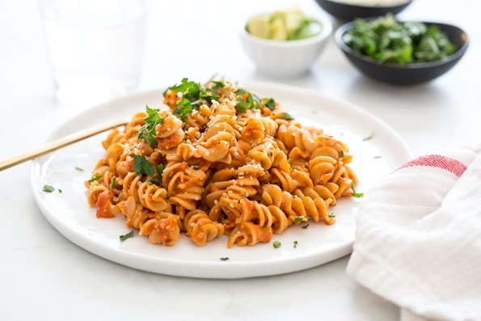

Adriana's Fave 10-Minute Pasta
Vegan, nut-free, refined sugar-free, soy-free
4.8 from 18 reviews
I’ve made this pasta countless times for our family; it’s hard to beat how fast and nutritious it is, and it can be changed up so many ways. It packs in around 20 grams of protein and 11 grams of fibre per (adult-size) serving (depending on which kind of pasta you use, of course—see my notes), not to mention healthy fats from the hemp hearts. My advice if you’re in a rush is to start heating up the water first, before you gather any other ingredients, as it can take some time for the water to come to a boil. If you happen to have a batch of my Fail-Proof Marinara Sauce from Oh She Glows Every Day (p. 175) on hand, it works wonderfully in this dish. Of course, store-bought marinara works just as well, too.

Yield
4 (adult-size) servings

Prep Time
2 Minutes

Cook time
8 Minutes

Ingredients:

For the pasta:
- 1 box (340 g/12 ounces) rotini or fusilli pasta*
- 2 cups (500 mL) marinara sauce
- 1/3 to 1/2 cup (80 mL to 125 mL) hummus
- 1/4 cup (35 g) hemp hearts

Optional add-ins:
- Fine sea salt, to taste
- Garlic powder, to taste
- Frozen peas or other veggies**
- Cooked lentils or beans
- Fresh spinach or basil, minced in food processor
- Puréed cooked carrots or cauliflower***

Directions:
- Add water into a large pot and bring to a boil over high heat. While you are waiting for it to boil, gather the rest of the ingredients. Once boiling, reduce the heat to medium, add the pasta, and stir with a wooden spoon. Cook the pasta according to the package directions, stirring every now and then to prevent the pasta sticking.
- Drain the cooked pasta well and place it back into the pot. Stir in the marinara, hummus, and hemp hearts until combined. Taste and add a bit of salt or other mix-ins if desired.
- Heat over low until warmed throughout. If serving this pasta to a little one, spread a scoop of pasta out on a plate to gently cool it before serving.
- Leftovers can be stored in an airtight container in the fridge for a couple days. To reheat, add the pasta into a pot along with a bit of extra marinara sauce (this adds moisture back) and stir to combine. Heat over medium-low heat until warmed throughout.

Tips:
* I typically use whole-grain kamut pasta. And sometimes, I mix in a bit of red lentil pasta for a protein boost. Feel free to use any kind of pasta you and your family enjoy!
** To quickly thaw frozen peas, add them to the pot during the last minute or two of cooking the pasta.
*** When I have time, I love to steam or boil carrots (or cauliflower) and then purée them until smooth. Then I stir the puréed veggies directly into the pasta. It’s an easy way to add even more nutrition without impacting the flavour too much.
This pasta goes lovely with a simple side salad and garlic bread. If your little one isn't a salad fan, try giving them small lettuce leaves for dipping into the dressing.
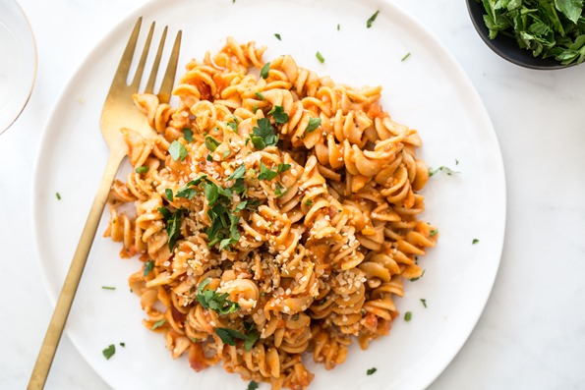

__________________________
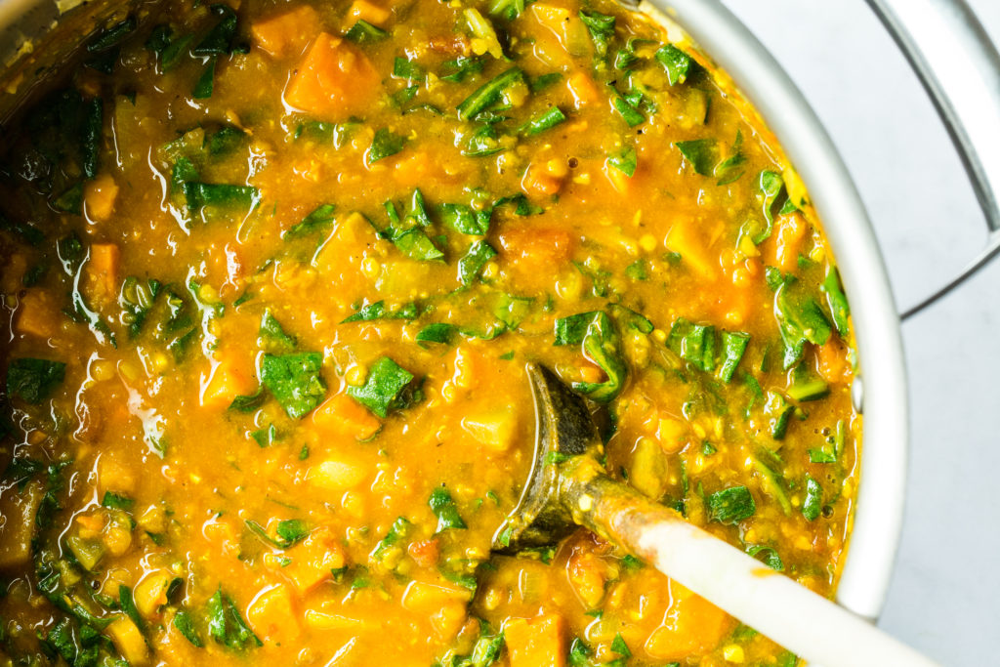

Cozy Butternut, Sweet Potato, and Red Lentil Stew
Vegan, gluten-free, nut-free, refined sugar-free, soy-free
5 from 70 reviews
Butternut squash, red lentils, and sweet potato are wrapped in a lightly sweet and creamy coconut and tomato broth accented with spicy notes of turmeric, cumin, chili powder, cayenne, and garlic. Apple cider vinegar provides a tangy brightness to bring everything together. This stew tastes better the next day once the flavours have had a chance to mingle; if you can make it the day before serving, I’d highly recommend it! This recipe was created for Pulse Canada, and was inspired by Deliciously Ella.

Yield
11 cups (2.75 quarts)

Prep Time
20 Minutes

Cook time
30 Minutes

Ingredients:

For the stew:
- 2 tablespoons (30 mL) extra-virgin olive oil
- 1 medium onion, diced (about 2 cups/280 g)
- 3 to 4 large garlic cloves, minced
- 3 cups (400 g) peeled, seeded, and diced butternut squash*
- 1 large sweet potato (450 g), peeled and diced (2 1/2 cups/340 g)*
- 3 cups (750 mL) low-sodium vegetable broth
- 1 (14-ounce/398 mL) can diced tomatoes
- 1 (14-ounce/398 mL) can light coconut milk
- 1/2 cup (100 g) dried red lentils, rinsed**
- 3 tablespoons (45 mL) tomato paste
- 1 1/2 teaspoons ground turmeric
- 1 1/2 teaspoons ground cumin
- 1/2 teaspoon chili powder
- 1/4 teaspoon cayenne pepper, or more if you like heat
- Fine sea salt, to taste (I use 1 1/2 teaspoons pink salt)
- Freshly ground black pepper, to taste
- 3 teaspoons (15 mL) apple cider vinegar, or to taste
- 1 bunch chard, stemmed and finely chopped***

Optional accompaniments:
- Fresh cilantro or parsley, minced
- Cooked rice
- Garlic powder and chili powder

Directions:
- To a large pot, add the oil, onion, and garlic. Stir to combine. Increase the heat to medium and sauté for 3 to 5 minutes, until the onion is softened.
- Add the squash and sweet potato and stir to combine. Add a pinch of salt and continue sautéing for a few minutes longer.
- Add the broth, diced tomatoes (with juices), coconut milk, lentils, tomato paste, turmeric, cumin, chili powder, cayenne, salt, and pepper. (If you are spice-shy, feel free to add half the amount to start and increase from there after cooking, to taste.) Stir well to combine.
- Increase heat and bring to a boil. Reduce the heat to medium, stir again, and simmer uncovered for about 30 minutes, stirring occasionally, until the squash and potato are fork-tender. Reduce the heat if necessary.
- Add the apple cider vinegar to taste. Adjust the other seasonings if desired.
- Optional step: Using a handheld immersion blender, blend the stew for only 2 to 3 seconds (any more and you’ll blend too much of the veggies). This thickens the broth.
- Stir in the chard, and cook for another couple minutes until the greens are wilted.
- Scoop some cooked rice onto the bottom of a bowl and then ladle the stew overtop. Garnish with minced cilantro or parsley and a good dusting of garlic and chili powder, if desired.
- Leftovers will keep in the fridge for up to 5 days, and they freeze beautifully too.

Tips:
* Make sure to dice the squash and potato very small (about the size of almonds), as this will expedite cooking. Also, if you are short on time, you can skip peeling the butternut squash as the skin is edible. (I don’t recommend skipping peeling the potato, though.)
** You can swap the red lentils for 1 (14-ounce/398 mL) can chickpeas (drained and rinsed).
*** You can swap the chard for 5 ounces of baby spinach or a bunch of kale (stemmed). I recommend chopping the greens into small bite-size pieces for easier eating.

Ultimate Green Taco Wraps
Vegan, gluten-free, grain-free, soy-free
4.9 from 111 reviews
Get ready to pack a ton of veggies into one irresistible, healthy meal! If you haven't tried my lentil-walnut taco meat, this is a great recipe to do so. It's high in protein, and the taco seasonings and chewy texture create a realistic-tasting taco base. Feel free to use tortilla wraps or corn shells instead of lettuce wraps to change it up, or you can make this recipe into a big salad, too. You can save time by cooking the lentils and prepping the taco meat in advance (or simply use canned lentils). This recipe is inspired by Minimal Eats taco wraps. The lentil-walnut meat is adapted from the from the The Oh She Glows Cookbook (page 186).

Yield
8 large tacos (approx)

Prep Time
30 Minutes

Cook time
30 Minutes

Ingredients:

For the lentil-walnut taco meat (makes 2 1/2 cups):
- 1 cup uncooked French green lentils (you will use 1 3/4 cups cooked lentils)*
- 1 cup walnut pieces, toasted
- 1 1/2 teaspoons dried oregano
- 1 1/2 teaspoons ground cumin
- 1 1/2 teaspoons chili powder
- 1/2 teaspoon fine grain sea salt, or to taste
- 1 1/2 tablespoons extra-virgin olive oil
- 2 tablespoons water

For the toppings and wraps:
- 1 to 2 large bell peppers, thinly sliced
- 1/2 to 1 large onion, thinly sliced
- Cashew Sour Cream
- Diced tomatoes or salsa
- Green onion
- Fresh lime juice
- Lettuce wraps (large romaine, iceberg, or butter lettuce leaves)
- Other topping options: sliced avocado, hot sauce, cilantro, etc.

Directions:
- Cook the lentils: Rinse lentils in a fine mesh sieve. Add to a medium pot along with a few cups of water. Bring to a boil, reduce heat to medium, and simmer for 20 to 25 minutes until tender (cook time will vary depending on the type of lentils you use—see package). Drain off excess water.
- Toast the walnuts: Preheat oven to 300°F. Add walnuts onto a rimmed baking sheet and toast for 10 to 13 minutes, watching closely, until lightly golden and fragrant. Set aside to cool for a few minutes.
- Sauté the pepper and onion filling: Add 1/2 to 1 tablespoon of oil into a large skillet or wok. Cook the onion and peppers over medium heat for about 15 to 20 minutes, reducing heat if necessary and stirring frequently, until translucent.
- Prepare the taco meat: Add 1 3/4 cups cooked lentils (you'll have some leftover) and all the toasted walnuts into a food processor and pulse until chopped (make sure to leave texture). Stir or pulse in the oregano, cumin, chili powder, and salt. Stir in the oil and the water until combined.
- Prepare the rest of your vegetable toppings and wash and dry the lettuce wraps.
- Assemble: Add a large lettuce leaf onto a plate, top with taco meat, sautéed peppers and onion, and the rest of your desired toppings.
- Leftovers can be stored in the fridge in sealed containers to be enjoyed the next couple days. The cashew cream will keep for at least a week in the fridge. Use sour cream leftovers on sandwiches, wraps, stirred into salad dressings, on vegan nachos, or with chili or soup.

Tips:
- * To save time, you can use one (15-ounce) can of lentils (drained and rinsed) instead of cooking the lentils from scratch. When I have time, I love to cook French green lentils due to their chewy texture, but regular green and brown lentils will work too. Do not use red lentils as they are much too mushy and don't have the required chewy texture for this recipe.
- Make it nut-free: I haven't tried this yet, but you could try subbing the walnuts for 1/2-3/4 cup toasted pepita seeds (shelled pumpkin seeds) and swapping the Cashew Sour Cream with vegan mayo (such as Veganaise).
  - _______________________________

http://www.seriouseats.com
Serious Eats
Top of Form
Photos
Bottom of Form
« Return to Article

Make These Easy Crispy Tofu Spring Rolls With Peanut-Tamarind Sauce
J. Kenji López-Alt
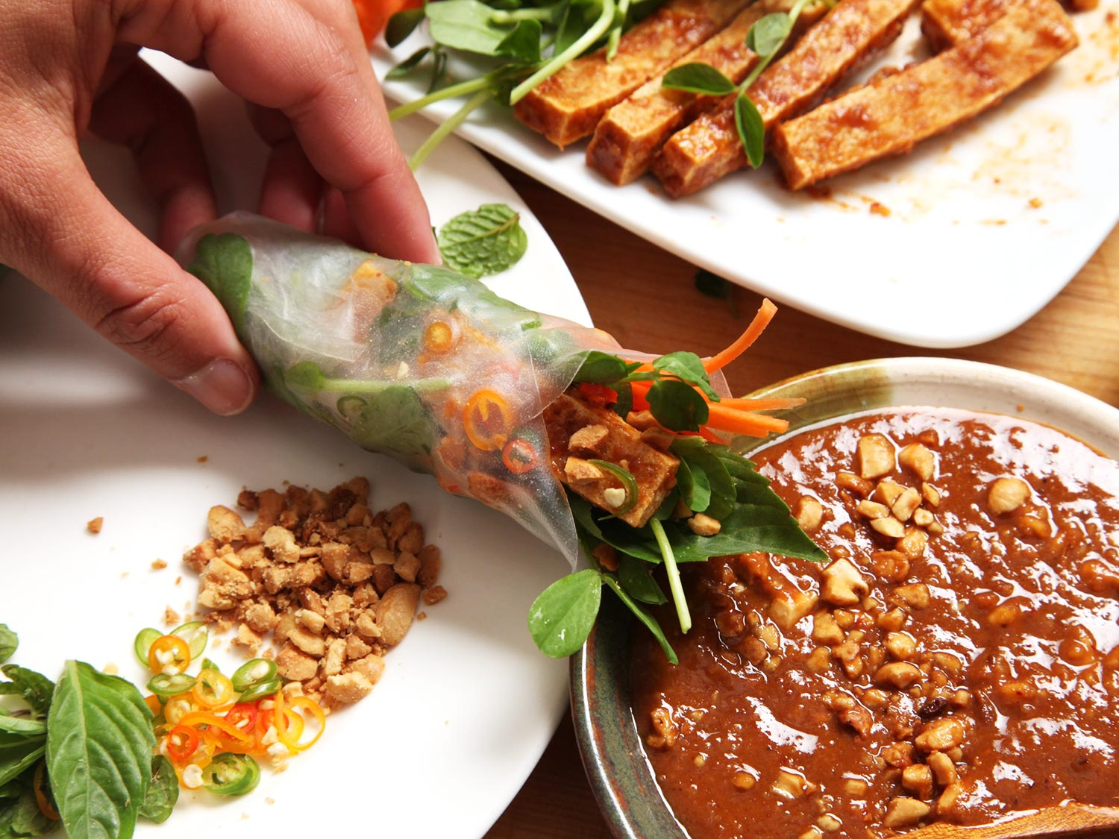
I don't know why I don't serve spring rolls more often at home. They're inexpensive, typically easy to prepare, and have that same DIY-at-the-table appeal that the taco nights of my youth did, but with flavors that are a little more sophisticated than premixed taco seasoning and jarred salsa.* The real key to great spring rolls is to balance the textures and flavors of the ingredients inside the soft, stretchy rice paper wrapper. For this version, I'm using tender pea shoots, along with carrots cut into a fine julienne, crispy marinated tofu, herbs, chilies, and toasted peanuts. You could add rehydrated rice or mung bean vermicelli if you'd like, or cucumbers, citrus fruits, spinach, bean sprouts, radish—really anything you want.
* That reminds me: I've been meaning to come up with a series of hard-shell taco night recipes for that straight-from-the-supermarket-shelf nostalgia factor, but with much better flavor.
To get the tofu extra crisp, I use my low-and-slow frying technique, which delivers a golden-brown exterior and a substantially thick, crisp crust that makes the tofu perfect for absorbing a flavorful marinade. The key is to dry out the tofu by first pouring boiling water over it (a step that, counterintuitively, ends up evaporating more moisture than it adds), then drying it carefully with paper towels and slowly frying it in oil.
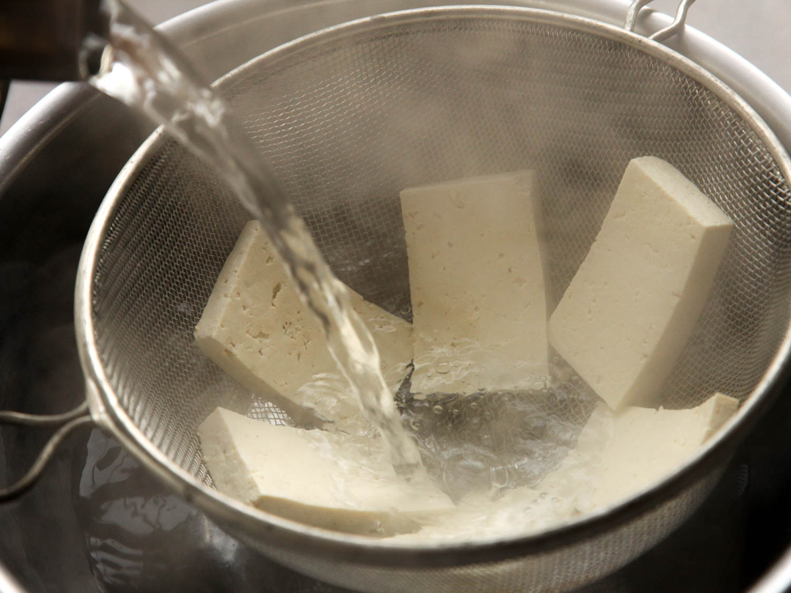
The balance of crunchy, flavorful ingredients inside the rice paper wrapper is important, but I'd argue that the right dipping sauce is even more important. For this vegan recipe, I wanted to make a sauce that is as hearty as the spring roll itself, so I decided to base mine on peanuts and tamarind. It's more of a classic Thai pairing than a Vietnamese one, but it works just fine as a dipping sauce (save some to use as a satay sauce the next time you fire up the grill) and as a post-fry marinade for the tofu (as I've discovered, marinating tofu after frying is far more important than marinating it before frying).
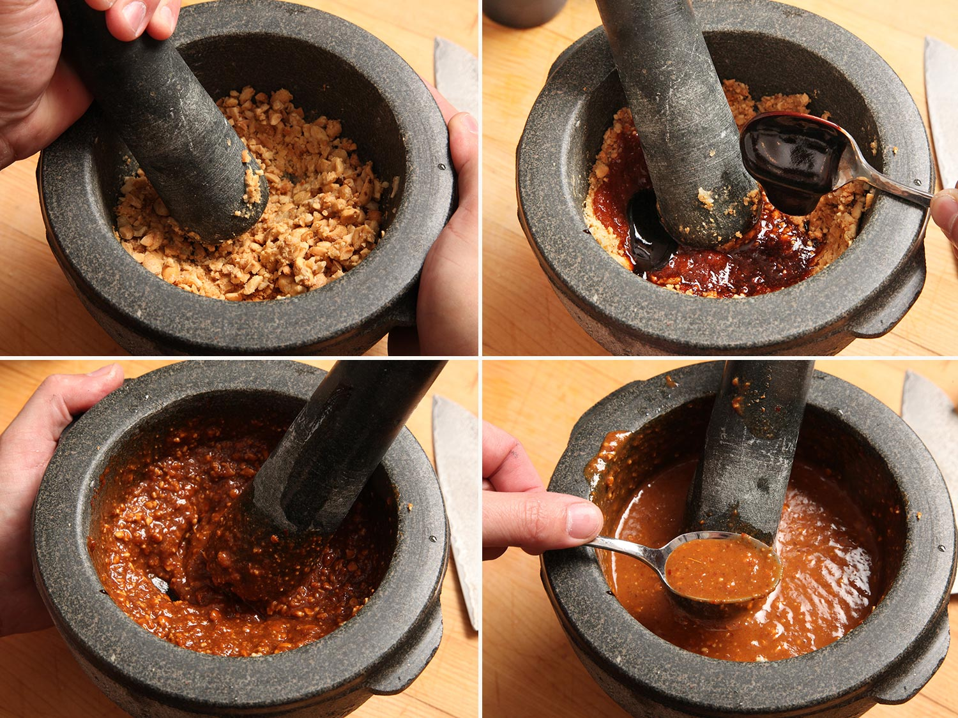
I start by toasting peanuts in the oven. Meanwhile, I pound together garlic and sugar using a mortar and pestle. A mortar and pestle is the best tool for making chunky purées and sauces like this, as it extracts much more flavor through grinding and masticating than a food processor or a knife can.
Next, I add the peanuts, pounding them down into a purée. For flavor, I add soy sauce and intensely sour concentrated tamarind paste. (It's widely available in any Asian market, in the international aisle of most grocery stores—I found it at both Whole Foods and Safeway here in the Bay Area—or online.) I've made similar dipping sauces from scratch using lemongrass, shallots, coriander roots, and chilies, but it's much easier to just add some commercial curry paste, which has comparable ingredients conveniently packaged in one jar. If you're trying to make a world-class Thai curry, you'll want to make your curry paste from scratch, but for a quick and easy dipping sauce, this is great to have around.
When the paste is incorporated, I add vegetable oil and water until I get a pourable yet rich and creamy consistency.
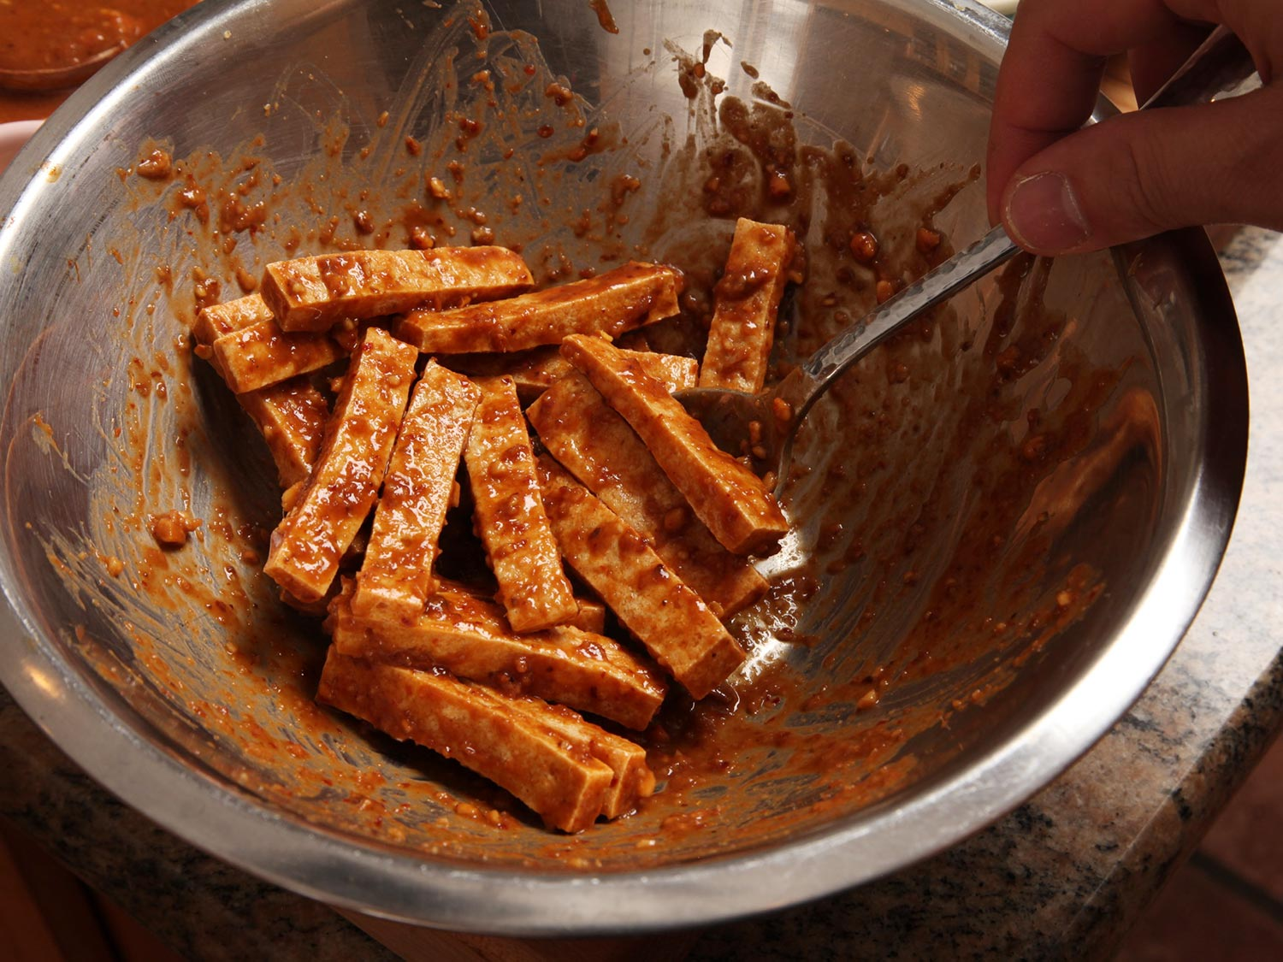
Some of it goes into a bowl with the tofu, while the rest I keep for serving.
And, as far as preparation goes, that's about all you need to do. The rest is up to your dinner guests. Arrange all the fillings on a large platter or two, serving the dipping sauce, extra crushed peanuts, and herbs like cilantro, mint, and basil on the side, along with a plate of rice paper wrappers and a bowl of warm water for moistening them.
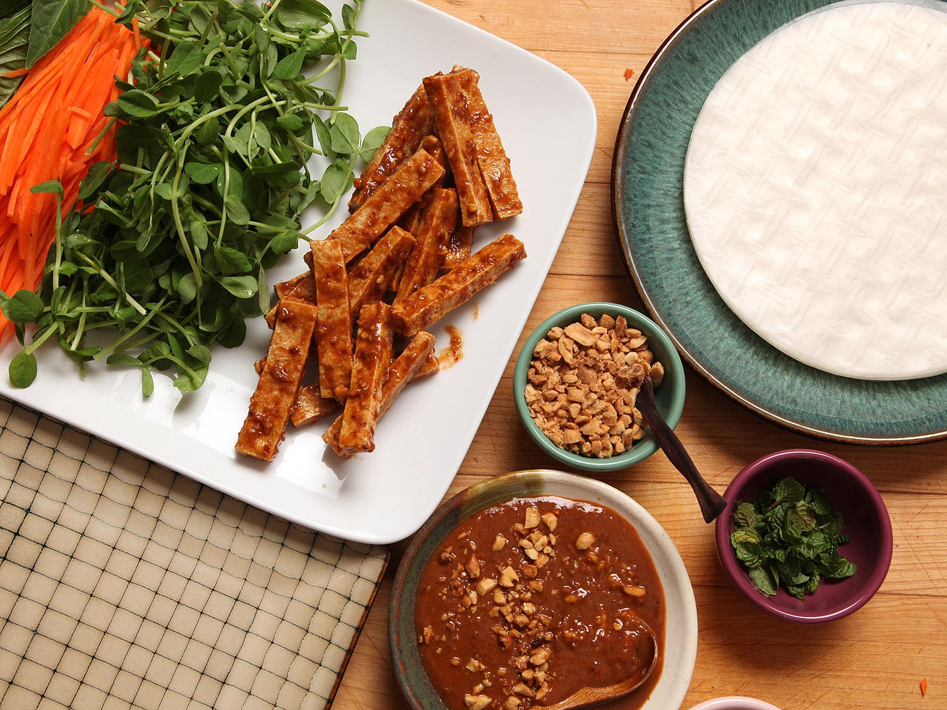
To form a spring roll, start by dipping the rice paper in the warm water, then transfer it to your plate or cutting board. Layer a small amount of each filling into the center of the wrapper. The number one error I see folks making here is overloading the wrapper. It's the same error people tend to run into when making dumplings for the first time, or perhaps when stuffing a burrito. Go easy—you can always eat more of them when you're done with the first!
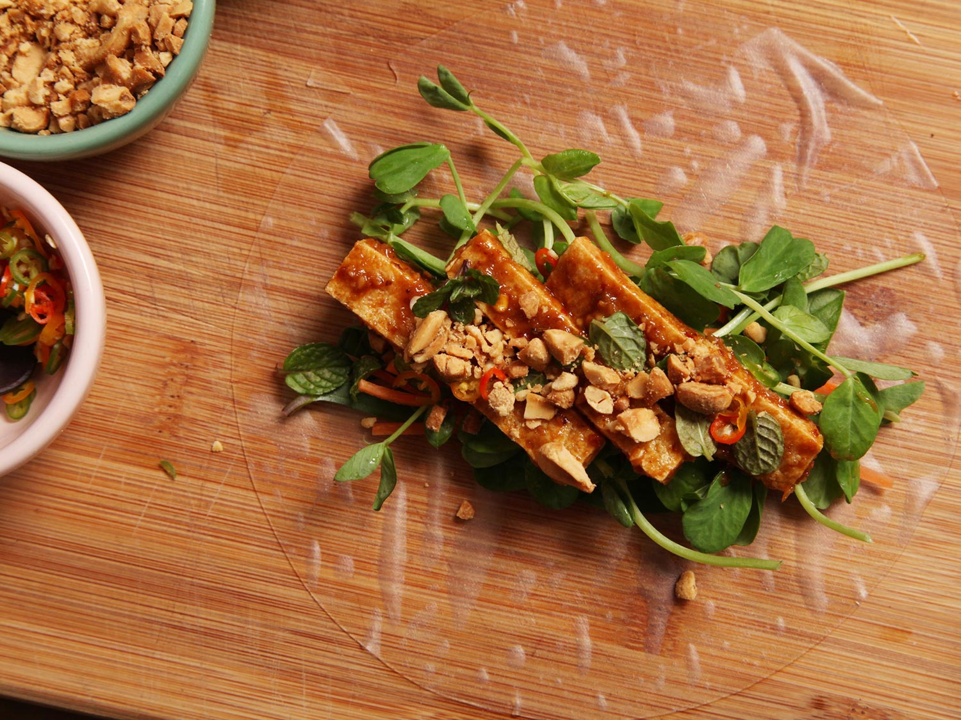
To roll the spring rolls, I lift up the edge of the rice paper closest to me with the thumbs and forefingers of both hands, pulling it forward over the filling while simultaneously pushing back on the filling with the middle finger of each hand to get the roll nice and tight. Once the paper is over the filling, I fold one side inward, then continue rolling forward, keeping everything nice and tight. (If you are making these in advance and want to store them for later on, you'll need to fold both sides inward to form a completely sealed roll.)
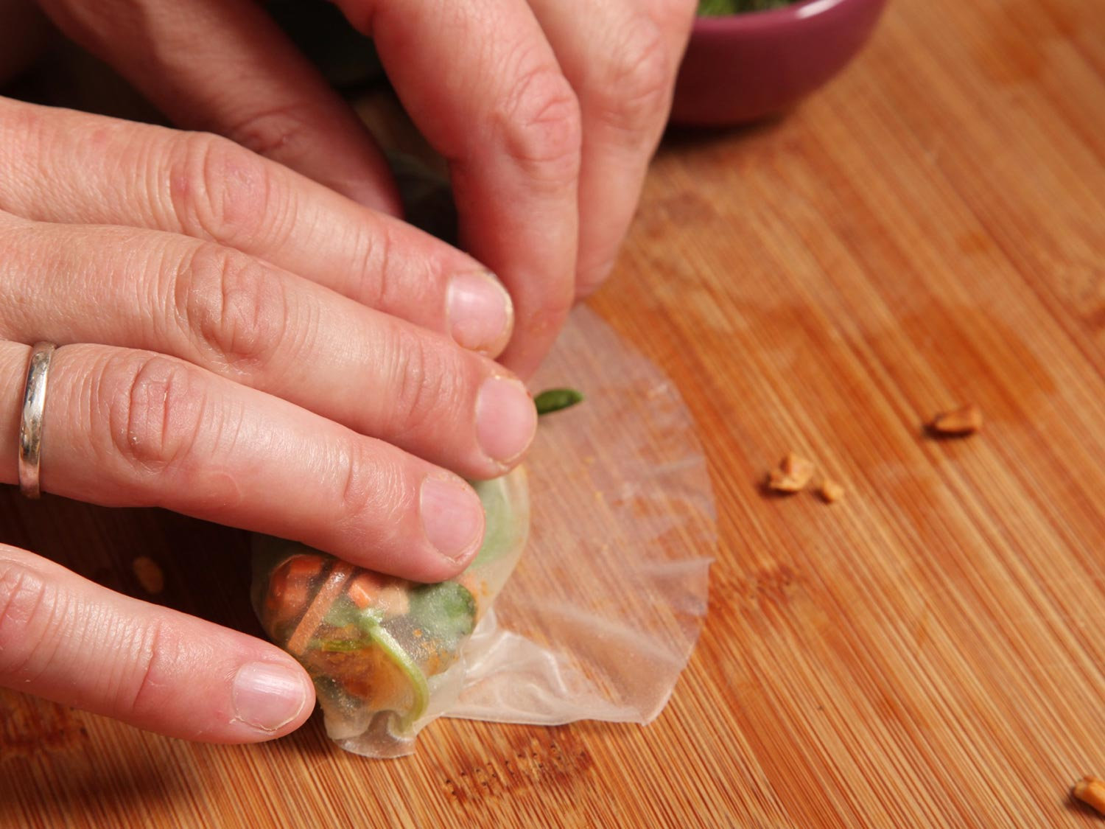
You should end up with a tight package that's open on one side, showing off its fillings and ready to be dipped.
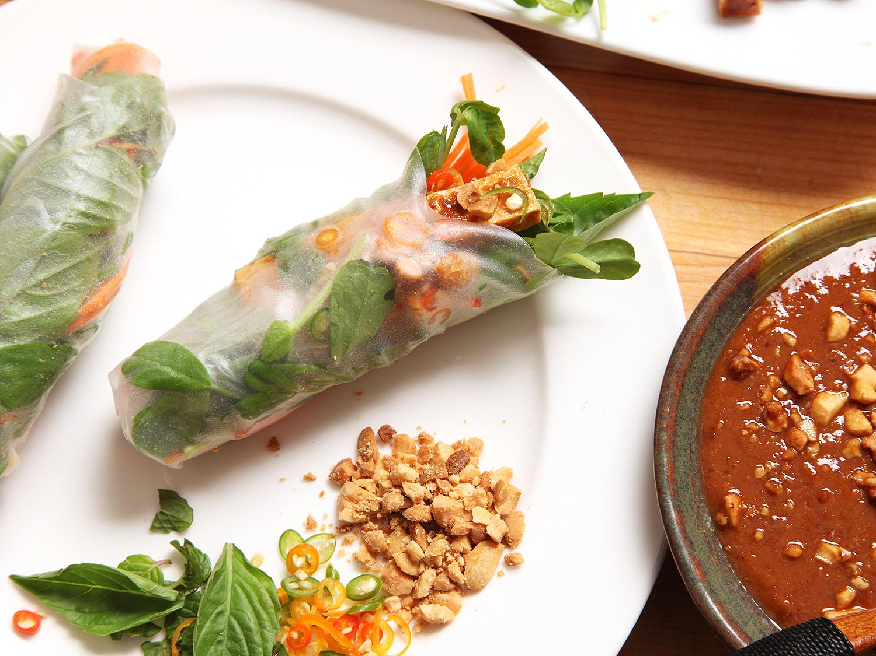
And, once you taste the peanut sauce, you're going to want to dip it again and again.

_____________________________

3-Course Vegan and Gluten-Free Holiday Menu – Step-by-step!
104 comments
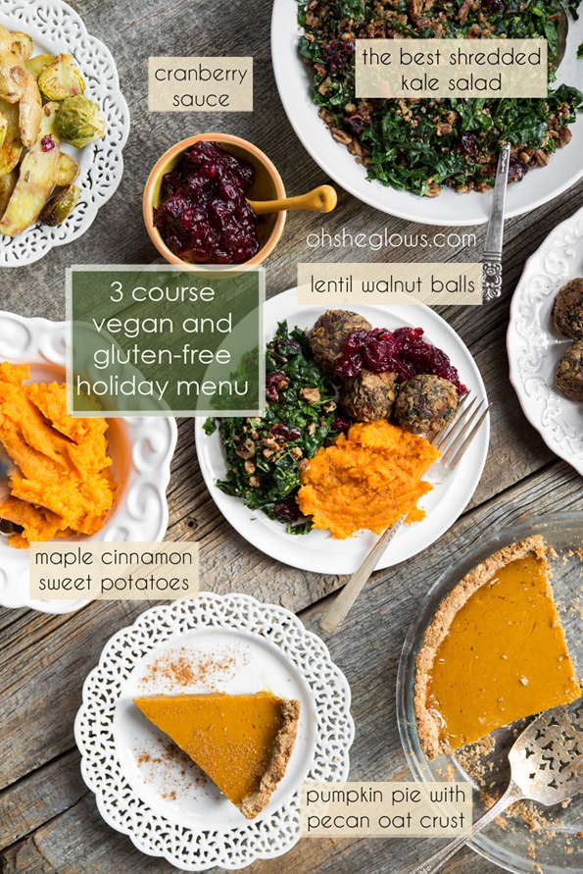
It’s a really good thing that I love to cook because you told me loud and clear that you wanted some help with menu planning. I understand it’s not easy, but now it can be much less stressful. It looks like we’re going to be eating really well for the next few days. No complaints here.
Not that this is the first time I’ve posted a holiday menu on the blog. There was that time in 2010 for Project Food Blog and then again in 2011 just for kicks. I guess I was due for an update! I truly think this is the best one yet. Maybe I’m biased, but I think my recipes improve over the years. That means there’s always room for a fresh take on a menu. Yeehaw!
I’d like to walk you through a relatively simple holiday meal plan today for 4 people. Adapt it as you see fit. My goal was to create some dishes that could be made the day before. I also wanted the prep on the day of to be minimal. So no, I’m not throwing a ton of recipes at you today and telling you to spend 3 full days in the kitchen. I did my best to simplify things without sacrificing flavour. It’s a fine line! My prep time the day before was under 2 hours and my prep time the day of was about 1 hour. Not too shabby, right?
This isn’t meant to be a huge, extravagant holiday meal, but rather a delicious and special menu for 4 people. If you are serving a big crowd, you will definitely need to multiply this to suit your group size.
Prepare the day before:
- Pumpkin Pie with Pecan Oat Crust (this pie needs to sit in the fridge overnight to set)
- Cranberry Pear Sauce
- Lentil Walnut Balls (prepare, but do not cook until the day of your meal)
Prepare the day of:
- Maple Cinnamon Mashed Sweet Potatoes (easiest side dish ever!)
- The Best Shredded Kale Salad
- Bake the lentil walnut balls
- Coconut Whipped Cream (if serving with the pie – optional)
Shall we begin? [Note: where ever you see a green link you can click it to be brought to the recipe page.]

Appetizer:

The Best Shredded Kale Salad – vegan, gluten-free, grain-free, soy-free
Prepare this salad the day of your meal. The flavour is much better when served shortly after preparing it compared to letting it sit overnight. (Yes, I compared the two! I thought the overnighter was going to win, but it didn’t).
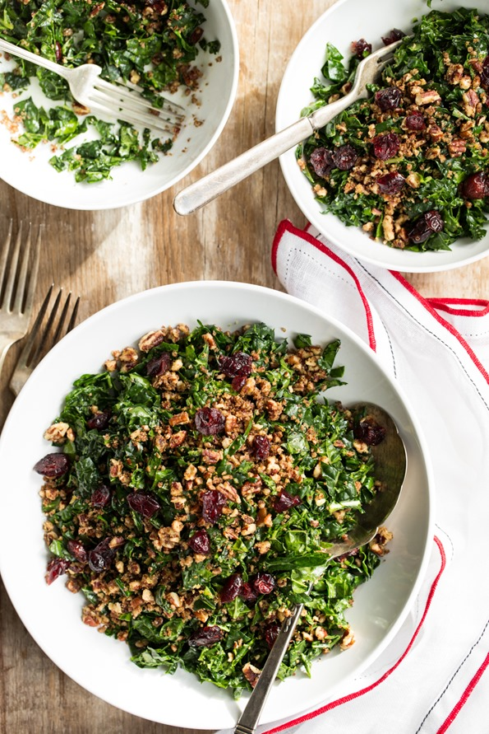
[note: in the photos below I served the salad with the main course, but you can serve it either before or with your meal. Your call.]

Main Course:

Lentil Mushroom Walnut Balls with Cranberry Pear Sauce – vegan, gluten-free, soy-free
Prepare both the day before, but do not cook the balls until the day of. I shaped the mixture into balls, placed them on a plate, covered with wrap, and refrigerated until the next day. Then I cooked as directed just before the meal. Easy! You can also cook and freeze the balls for up to 1-1.5 weeks. Thaw on the counter or fridge and reheat in the oven.
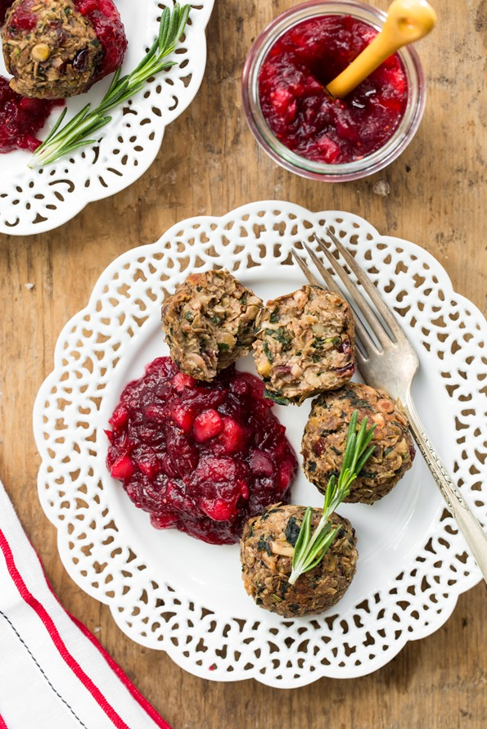

Side Dish:

Maple Cinnamon Sweet Potatoes – vegan, gluten-free, grain-free, nut-free, soy-free option
{recipe follows}
Prepare this quick and easy side dish the day of. This side dish stole my heart! I absolutely love mashed sweet potatoes made with a bit of vegan butter, maple syrup, sea salt, and cinnamon. Nothing beats it. If you haven’t tried them prepared this way, you really should. The prep is just 10 minutes! I used 2 large sweet potatoes, but you could easily get away with using 3 potatoes for 4 people.
If you are looking for another side dish to add to the fun, I recommend my Cranberry, Apricot, and Pecan Wild Rice Pilaf. You can probably prepare this pilaf the day before.

Maple Cinnamon Mashed Sweet Potatoes
Vegan, gluten-free, grain-free, nut-free
Like little fluffy clouds of pure bliss, these maple cinnamon mashed sweet potatoes make a lovely addition to any holiday meal. It reminds me a bit of sweet potato casserole, only without the marshmallows. The prep is just 5-10 minutes, so it makes a quick, last minute side dish without much fuss at all. This batch will just barely serve 4 as a side. You could easily get away with increasing the potatoes to 3 instead of 2 (and adding more of the other ingredients as needed). No one ever complained of having too many sweet potato clouds, you know.

Yield
3-4 small servings

Prep Time
5 Minutes

Cook time
8 Minutes

Ingredients:
- 2 large sweet potatoes, peeled and roughly chopped
- 2 tablespoons vegan butter
- 2 teaspoons pure maple syrup
- a couple generous pinches of fine grain sea salt, to taste
- cinnamon, to taste
- 1/4 teaspoon pure vanilla extract

Directions:
- Add peeled and chopped potatoes into a medium pot and cover with water. Bring to a boil. Reduce heat to a simmer and cook until the potatoes are fork tender, about 5-8 minutes. Drain.
- Add potatoes back into the pot and with a potato masher, mash in the vegan butter until smooth. Now add the rest of the ingredients to taste. Serve immediately.

Tips:
Note: Instead of vegan butter you can try using coconut oil, although I haven't tried this yet. For a soy-free option, use soy-free vegan butter or coconut oil.
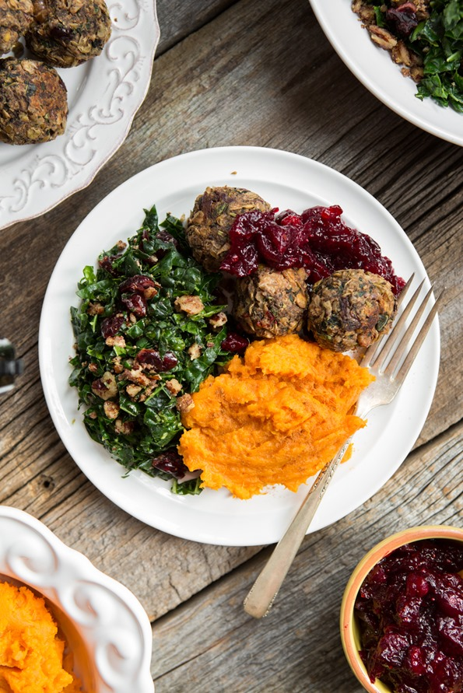

Dessert:

Pumpkin Pie with Pecan Oat Crust – vegan, gluten-free, soy-free
{recipe follows}
Prepare this pumpkin pie the day before. A simple pumpkin pie filling with a delectable nutty crust! This pie is lightly sweetened and doesn’t feel too heavy or give you a sugar crash after indulging. Tip if you need a nut-free pie, feel free to use a store-bought crust (or your favourite homemade crust recipe). I really think this crust makes the pie though, so if you can swing it, definitely make it! It’s so easy too – all you do is press it in…no rolling involved.
Optional: Serve with Coconut Whipped Cream
Not feeling pumpkin pie? Try my Chilled Dark Chocolate Pie instead. A little chocolate around the holidays is always appreciated.
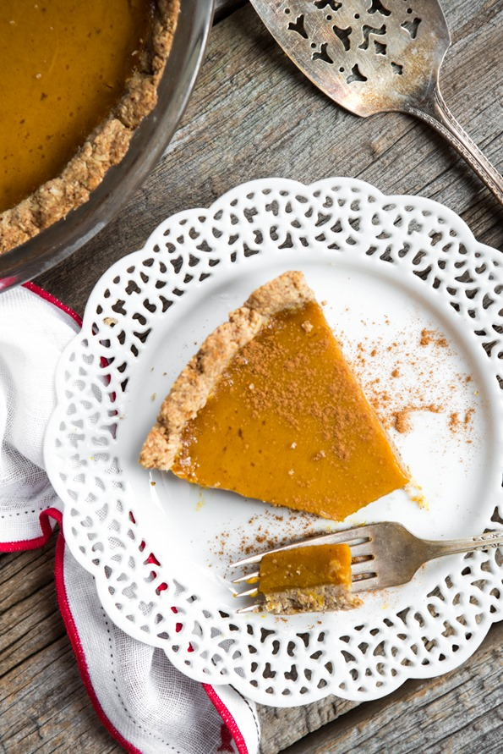

Pumpkin Pie with Pecan Oat Crust
Vegan, gluten-free, soy-free
A simple pumpkin pie filling with a delectable nutty crust! This pie is lightly sweetened and doesn't feel too heavy or give you a sugar crash after indulging. Prepare this pie the day before, so it has time to set in the fridge overnight. Crust is adapted from my Chilled Dark Chocolate Pie and the filling is adapted from my Vegan Pumpkin Pie Squares with a Graham Cracker Crust.

Yield
8 slices

Prep Time
30 Minutes

Cook time
50 Minutes

Ingredients:

for the pecan oat crust:
- 3/4 cup pecan halves
- 1/4 cup virgin coconut oil
- 3 tablespoons pure maple syrup
- 1/4 teaspoon fine grain sea salt
- 1/2 cup + 1/3 cup gluten-free oat flour
- 1 cup gluten-free rolled oats.

for the pumpkin filling:
- 1/4 cup full-fat canned coconut milk (the white cream portion) OR almond milk
- 2 tablespoons + 1 teaspoon arrowroot powder
- 1 (15-ounce) can pumpkin puree
- 6 tablespoons pure cane sugar (or granulated sugar of choice)
- 1/4 cup pure maple syrup
- 1 teaspoon pure vanilla extract
- 1.5 teaspoons cinnamon
- 1/4 teaspoon ground ginger
- 1/4 teaspoon ground nutmeg
- pinch of fine grain sea salt

Directions:
- For the crust: Preheat oven to 350⁰F and lightly grease a 9-inch pie dish with coconut oil. Add pecans into a food processor and process until a fine crumb forms, the size of sand. Be sure not to process the pecans for too long, or the oil will release. Now add the coconut oil, maple syrup, salt, and oat flour and process again until the dough comes together. Finally, pulse in the rolled oats until the oats are finely chopped, but still have some texture to them. The dough should stick together when pressed between your fingers. If it doesn’t, try processing for a bit longer.
- With your fingers, crumble the dough evenly over the base of the pie dish. Starting from the middle, press the mixture firmly and evenly into the dish, moving outward and upward along the side of the pie dish. The harder you press the crumbs into the dish, the more it will hold together. Poke 5-6 fork holes into the bottom to let the air escape.
- Bake pie crust, uncovered, at 350⁰F for 10-13 minutes, until lightly golden and fragrant. Remove from oven and set aside to cool on a rack for at least 5 minutes.
- For the filling: In a small bowl, whisk together the coconut milk (or almond milk) with the arrowroot powder until smooth.
- In a large mixing bowl, whisk together all of the pumpkin filling ingredients, including the arrowroot and cream/milk mixture. If your pumpkin puree is firm and grainy - add this filling into a processor and whirl it until smooth. You might need to add a bit more cream/milk if your pumpkin was really dense. Pour this filling into the baked crust and smooth out.
- Bake the pie, uncovered, at 350F for 37-45 minutes until the pie is semi-firm, but still a bit soft. Watch the crust and cover with tin foil if necessary. My crust was nice and golden at 40 minutes (when I took it out), but not burned.
- Cool the pie for 2 hours on a cooling rack and then cover with foil and transfer to the fridge overnight to set.
- Serve the pie straight from the fridge, with some coconut whipped cream, if desired. Note that the pie will get quite soft at room temperature so I don't suggest keeping it out for longer than 10 minutes at a time.

Tips:
Note: 1) To make the oat flour, add 1/2 cup + 1/3 cup rolled oats into a high speed blender. Blend on high until a fine flour forms. 2) Note that using the coconut cream will give the pie a light coconut flavour. Use almond milk as an alternative if desired.
Edited to add: We’re having a small issue with our recipe plug-in (in this post) and we’re working on fixing the bug. Thanks for your patience!
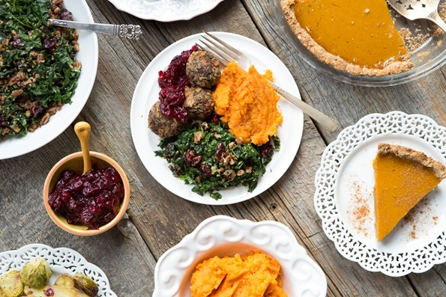
Well, we have full, grateful, and happy bellies going on over here. And the best part is, I don’t feel like sleeping on the couch for 6 days. Success!
Let me know what you think of the recipes if you try them out. Love ‘em, hate ‘em, find a new way of doing something? Let us know in the comments, as always.
Wishing those of you in the US a happy, safe, and fun Thanksgiving! xo
Let's get social! Follow Angela on Instagram (@ohsheglows + @theglowspot), Facebook, Twitter, Pinterest, Snapchat, and Google+
Comments (104) | Share on Facebook | Tweet | Pin It | Snapchat | Google+

Previous Posts

The Best Shredded Kale Salad
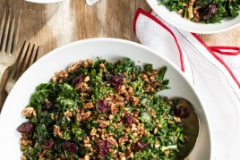

Coconut Whipped Cream: A Step-By-Step Photo Tutorial
499 comments
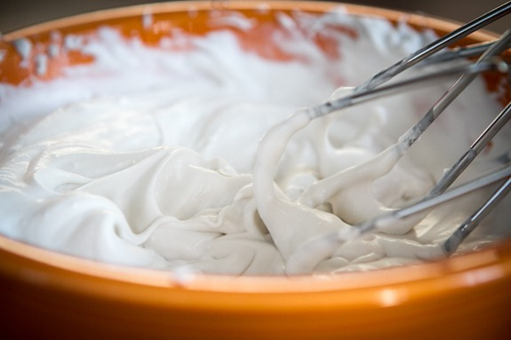
Did you know you can make a decadent whipped cream by using a can of coconut milk? Not only is it simple to make, but it’s easily the best-tasting whipped cream I’ve tried.
I know whipped coconut cream isn’t new to many of you – people have been making coconut whipped cream for years and years. I first read about it a couple years ago on Vegan Joy’s website and have seen it popping up everywhere.
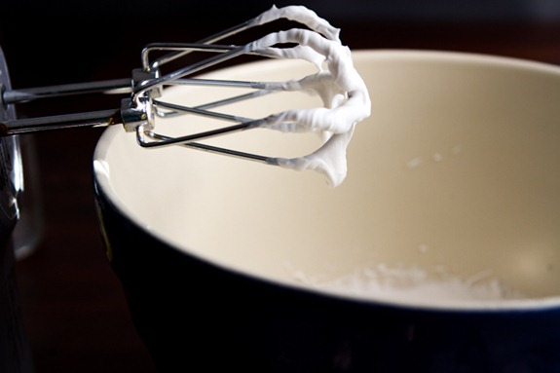
In today’s post, I’ll show you just how easy it is to make. I can promise you, your life will change when you taste this stuff!
1. Grab a can of full-fat can coconut milk (without guar gum listed as an ingredient) – Update: Native Forest now puts guar gum in the ingredients and this causes the cream and water to emulsify which is not what we want. The can must also be full-fat because you will be whipping the solid cream. Do not use light coconut milk because it won’t turn out. In summary – look for a full-fat can of coconut milk that does not have guar gum listed on the ingredient list. Cool?
Many of you have had trouble making whipped coconut cream with certain brands because some cans don’t always separate. A reader let me know that Thai Kitchen has changed their formula so that it doesn’t separate anymore. Apparently they are coming out with small cans of pure coconut cream instead. Be on the look out! I used Native Forest with decent result, although I have had some duds before.
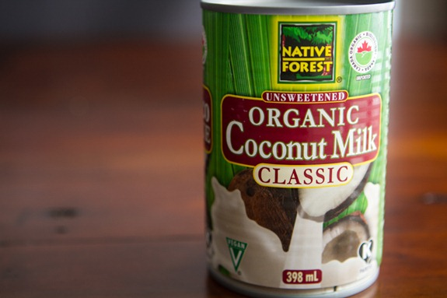
2. Place can in the fridge overnight. This is another crucial step. You need to chill the coconut cream until it’s very firm. I once tried to make whipped coconut cream without chilling the can – big mistake! It was a watery mess. I like to keep at least a couple cans in the back of my fridge just in case I need a quick whipped cream for a recipe. Then you always have it on hand and don’t have to wait overnight to use it. A few extra cans of chilled coconut milk never hurt anyone.
Just before you make your whipped cream, place a mixing bowl in the freezer for 5 minutes or so. This helps keep everything cold and will be especially helpful for those of you in very warm climates.You can also put the beaters in the freezer too, but it’s not necessary.
3. Remove the chilled can from fridge and FLIP it upside down.
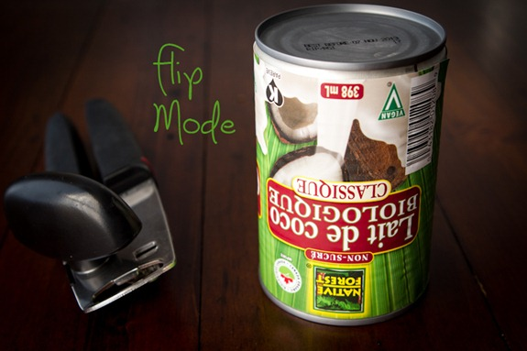
Why flip it upside down?
The liquid coconut milk (the part that doesn’t harden) will now be at the top of the can! Note: Not all cans work for this – check yours.
4. Open the can. See the liquid at the top? You won’t be whipping this part.
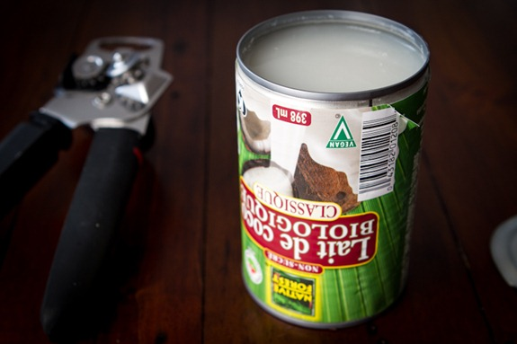
5. Pour the coconut liquid into another bowl. You should have just under 1 cup of liquid, but this yield will vary a bit by brand and even by can.
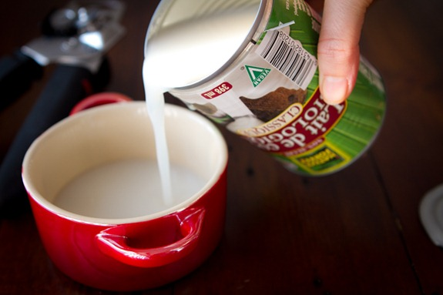
Don’t throw it away – I like to use it in smoothies along with mango, kale, banana, and chia for a fun tropical smoothie. You can also use it in baking and cooking.
As you can see below, you are left with only the hardened coconut cream! Come to mama!! This is exactly what we want to use to make our coconut whipped cream.
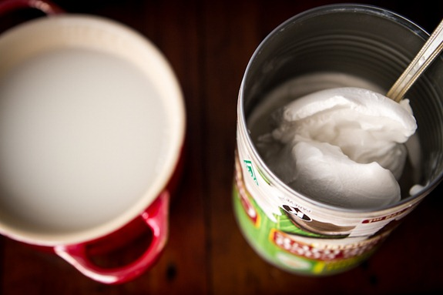
6. Scoop the coconut cream into your chilled bowl. (I don’t recommend using a shallow bowl like this one – I only used it for photo purposes so you could see it better!)
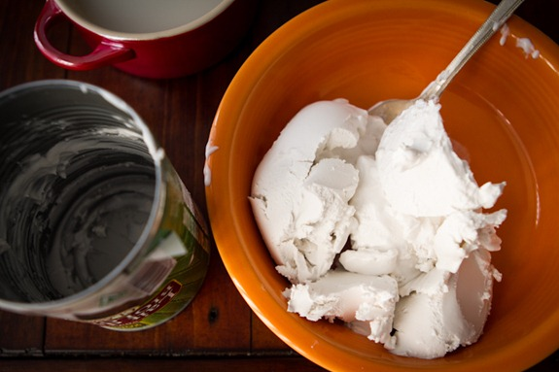
As you can see, you get a lot of hardened cream to work with!
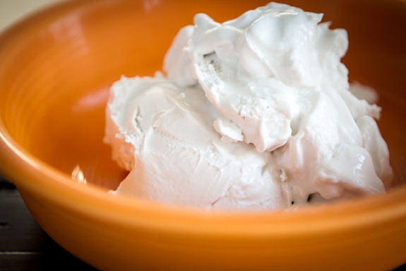
7. Whip the cream. Grab a hand mixer (alternatively, you can do this in a stand mixer – just chill the bowl first) and whip the cream until fluffy. It’s really too much fun.

Coconut Whipped Cream
Vegan, gluten-free, grain-free, no bake/raw, nut-free, oil-free, refined sugar-free, soy-free
5 from 6 reviews
You can easily create a decadent, fluffy whipped cream by using a can of full-fat coconut milk. Not only is the technique imple, but it’s easily the best-tasting whipped cream I’ve tried. You can use this whipped cream just like regular dairy whipped cream. I like to use it in a bowl of fruit, on top of a fruit crisp, or stirred into Banana Soft Serve. The options are really endless! One important tip: you’ll want to chill the can of coconut milk for at least 24 hours before you begin to ensure the white coconut cream solidifies (be sure to read all my tips below on how to buy the right coconut milk for this recipe).

Yield
3/4-1 cup

Prep Time
10 Minutes

Cook time
0 Minutes

Ingredients:
- 1 can full-fat coconut milk, chilled for 24 hours*
- 1 to 2 tablespoons sweetener (maple syrup, powdered sugar, cane sugar, etc), to taste
- 1 vanilla bean, scraped or 1/2 teaspoon pure vanilla extract (optional)

Directions:
- Chill the can of coconut milk in the fridge for at least 24 hours. I like to keep a few cans in the fridge at all times so I don’t have to wait.
- About 1 hour before making the coconut whip, chill a mixing bowl in the freezer.
- After chilling the can, open the can and scoop the solid white coconut cream into the bowl. Discard the coconut water or save it for another use (such as coconut water ice cubes).
- Using an electric hand mixer or a stand mixer with the whisk attachment, beat the cream until fluffy and smooth. Add in sweetener to taste and vanilla.
- Return whipped cream to fridge until ready to use. It will firm when chilled and soften at room temperature. This will keep in the fridge in a sealed container for up to 1 week or you can freeze it in an airtight freezer-safe bag for up to 1 month. After chilling in the fridge, allow it to sit at room temperature until it softens slightly and then you can re-whip it as needed.

Tips:
- * Some brands of canned coconut milk will be better than others for making whipped cream, and even some cans within the same brand can vary quite a bit. For whatever reason, the cream and water in some brands or cans do not separate. A few of the most consistent brands for making coconut whipped cream are: Thai Kitchen full-fat coconut milk, Trader Joe’s Coconut Cream (just the cream—no water in the can!), and Native Forest. I always keep at least a few cans of full-fat coconut milk in my fridge at all times just in case I get a “dud”—then I know I have more on hand. If you happen to get a dud don’t be discouraged. Try out one of the brands above, and be sure to chill it for at least 24 hours. Odds are you will find your perfect brand after some trial and error!!
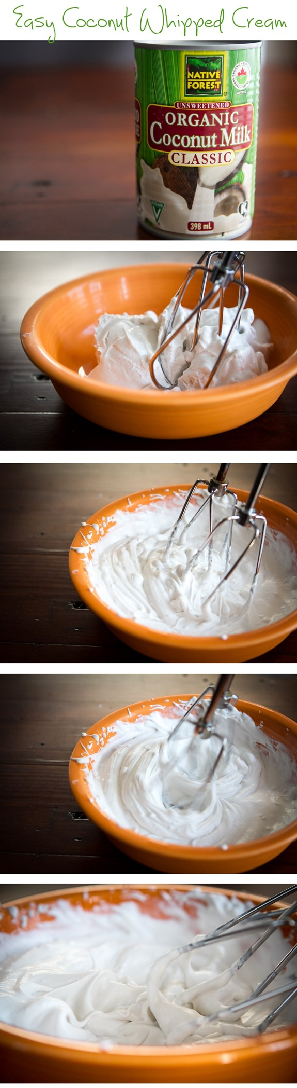
There may be a strong urge to shove your face in the bowl.
8. Add in a touch of sweetener and vanilla extract and whip it again.
You can use regular cane sugar, confectioner’s sugar, or even a touch of maple syrup. I find 2-3 teaspoons usually does the trick for my taste buds. I also like to add about 1/4-1/2 tsp pure vanilla extract or a vanilla bean. The vanilla really takes it over the edge – I don’t suggest skipping it!
The first time I made this I could not get over how amaaaaazing it tastes. Eric even said he wouldn’t be able to tell that it wasn’t made from dairy. Two big thumbs up from us!
How to use:
You can use this whipped cream just like regular dairy whipped cream. I like to use it in desserts & frostings, it’s amazing over a simple bowl of fruit or pancakes, and sometimes I add a dollop on my vegan overnight oats for an extra creamy bowl. You can even spoon a bit on top of a pie or fruit crisp or stir some into a bowl of banana soft serve. The options are really endless! Have fun making different kinds of flavours and fooling your friends and family.
If making a whipped frosting, I suggest storing the decorated cake/cupcakes in the fridge until ready to serve.
Storing:
Have leftovers? You can easily store it in the fridge for at least 1.5 weeks (probably longer) in a sealed container. It will firm up a bit more in the fridge. Simply scoop it into a bowl and re-whip it when you need it.

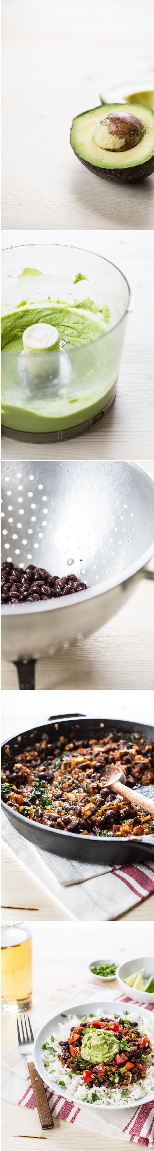

DIY Burrito Bowl
Vegan, gluten-free, nut-free, refined sugar-free, soy-free
5 from 55 reviews
This burrito bowl is so filling and healthy! The Spicy Black Beans are adapted from one of my favourite cookbooks, Super Fresh: Super Natural, Super Vibrant Vegan Recipes by Jennifer Houston and Ruth Tal. The spicy black beans are to die for. (Or, to live for!) I love to use the beans in a wrap, sprinkled on a salad, or even as a dip with tortilla chips and guacamole. The Avocado-Lime Sauce is also a must-make. It yields about a heaping half cup so if you are a big avocado lover you can always double the recipe. To change up this recipe, stuff everything into a large soft tortilla wrap rather than enjoying it bowl style.

Yield
3 servings

Prep Time
25 Minutes

Cook time
20 Minutes

Ingredients:

For the burrito bowl:
- 1 cup dry white long-grain rice (or rice of choice)
- 1 tablespoon refined coconut oil or vegan butter*
- Salsa, as needed
- Sliced green onion, for garnish
- Sliced grape tomatoes, for garnish (optional)

For the Spicy Black Beans:
- 2 tablespoons refined coconut oil or extra-virgin olive oil
- 1 cup diced sweet onion
- 4 medium garlic cloves, minced
- 3/4 to 1 cup chopped fresh tomatoes
- 1 teaspoon chili powder
- 1 teaspoon garlic powder
- 1 teaspoon dried oregano
- 1/4 teaspoon cayenne pepper (optional)
- 1/2 plus 1/8 teaspoon fine sea salt, or to taste
- 2 1/2 tablespoons tomato paste
- 1 (14-ounce) can black beans, drained and rinsed
- 1/2 cup unpacked cilantro, large stems removed and finely chopped

For the Avocado-Lime Sauce (makes heaping 1/2 cup):
- 1 large garlic clove
- 1 large avocado, pitted
- 1 tablespoon fresh lime juice, plus more to taste
- 1 tablespoon water
- 1/4 teaspoon fine sea salt, or to taste

Directions:
- For the rice: Add the rice and 1 tablespoon of oil or butter into a medium pot along with 2 cups of water. Increase heat to medium-high and bring to a simmer. Immediately reduce the heat to low-medium, and cover with a lid. Cook the rice until it’s tender and the water is absorbed. For white long-grain rice this will take 13 to 20 minutes, but please follow the directions on your specific package for best results.
- Meanwhile, prepare the Spicy Black Beans: In a large wok or skillet, add the oil and melt it over medium heat. Stir in the onion and garlic, along with a pinch of salt, and sauté for about 5 to 6 minutes, until softened.
- Stir in the chopped tomatoes, chili powder, garlic powder, dried oregano, cayenne (if using), and 1/2 teaspoon of salt. Continue sautéing for another 3 to 5 minutes (increasing/reducing heat if necessary), until the tomato softens.
- Now stir in the tomato paste and drained and rinsed black beans. Cook for a few more minutes until heated throughout. Taste and add more salt if desired. Stir in the cilantro. You can leave the mixture over low heat until ready to serve or simply turn off the heat and reheat before serving.
- For the Avocado-Lime Sauce: Mince the garlic clove in a mini food processor (or use a regular size processor, if necessary). Now add the avocado flesh, lime juice, water, and salt. Process until smooth. Taste and adjust lime juice if desired. I usually add another teaspoon.
- When the rice is ready, reheat the bean mixture, if necessary. Divide the rice between 2 to 3 bowls. Top each with a couple scoops of the hot black bean mixture, and a large spoonful of both the salsa and the Avocado-Lime Sauce. Garnish with sliced green onion and optional sliced grape tomatoes. Serve immediately.

Tips:
- * Why the use of refined coconut oil? Unlike virgin coconut oil, refined coconut oil doesn't have a noticeable coconut flavour. I use it whenever I don't want a coconut flavour to come through. That being said, if you don't mind a bit of coconut flavour feel free to use the virgin kind.
- __________________________________________________

Korean Fried Cauliflower (Vegan) Recipe
Sautee cauliflower in coconut oil until crispy – don’t deep fry.
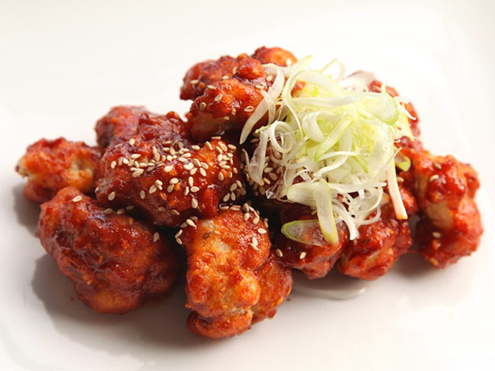
[Photographs: J. Kenji Lopez-Alt]
Ultra-crisp fried cauliflower Korean-style, served with a sweet and hot chili sauce or a sweet soy glaze.
Serve this cauliflower with either of these sauces:
- Sweet Soy Sauce »
- Sweet and Spicy Chili Sauce »
Read the Whole Story
- Yield:Serves 4 to 6 as an appetizer
- Active time: 15 minutes
- Total time:15 minutes
- Rated:

Ingredients
- ¼ cup coconut oil
- 1/2 cup cornstarch
- 1/2 cup all-purpose flour
- 1/2 teaspoon baking powder
- 1/3 cup toasted sesame seeds, plus more for garnish
- 1/3 cup unsweetened coconut flakes
- Kosher salt
- 1/2 cup cold water
- 1/2 cup vodka
- 1 head cauliflower, cut into 1-inch florets
- 1 recipe Sweet Soy Sauce or Sweet and Spicy Chili Sauce
- 4 to 5 Finely sliced scallions

Directions
- 1.
Preheat oil to 350°F in a large wok, Dutch oven, or deep fryer.
- 2.
Combine cornstarch, flour, baking powder, 2 teaspoons kosher salt, sesame seeds, and coconut in a large bowl and whisk until homogenous. Add water and vodka and whisk until a smooth batter is formed, adding up to 2 tablespoons additional water if batter is too thick. It should have the consistency of thin paint and fall off of the whisk in thin ribbons that instantly disappear as they hit the surface of the batter in the bowl.
- 3.
Add cauliflower to batter. Working one at a time, lift one piece and allow excess batter to drip off. Carefully lower into hot oil. Repeat with remaining cauliflower until wok or fryer is full. Do not crowd pan. (You'll be able to fit about half of the cauliflower in each batch). Fry, using a metal spider or slotted spatula to rotate and agitate pieces as they cook until evenly golden brown and crisp all over, about 6 minutes. Transfer to a paper towel-lined plate and season immediately with salt. Keep warm while you fry the remaining cauliflower.
- 4.
Toss fried cauliflower with sauce and serve immediately, sprinkled with extra sesame seeds and scallions.

Israeli-Style Extra-Smooth Hummus
J. Kenji López-Alt
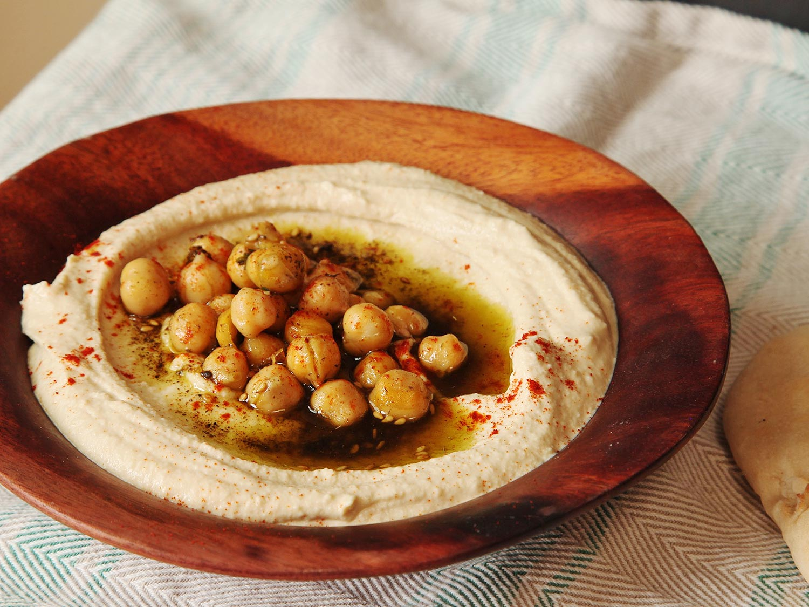
I love hummus, especially the Israeli version made with tons of tahini and a touch of cumin, but it's hard to find a perfect batch. Store-bought hummus typically has a great, ultra-smooth and -creamy texture, but it lacks flavor and is not easily customizable to our own personal tastes. Homemade hummus, especially when made with dried chickpeas, may have amazing flavor that we can play with any way we like, but it's quite difficult to get it as smooth as the store-bought stuff. So what if you want hummus that is smooth and flavorful? Our recipe uses a few tricks to pack in flavor and give you great texture.

Why It Works
- Puréeing garlic directly in lemon juice prevents the formation of sharp, pungent compounds, delivering smoother garlic flavor.
- Dried chickpeas provide better flavor than canned.
- Overcooking the chickpeas in water with baking soda makes them easier to blend.
- Puréeing the chickpeas while they're still hot lets you use a blender instead of a food processor for smoother texture.
- Yield:Makes about 5 cups, serving 8 to 10
- Active time: 15 minutes
- Total time:2 hours 15 minutes, plus overnight soak if using dried chickpeas
- Rated:

Ingredients
- 1/2 pound dried chickpeas (1 generous cup; 225g) (see note above)
- 2 teaspoons (12g) baking soda, divided
- Kosher salt
- 1 small onion, split in half
- 1 small stalk celery
- 1 small carrot
- 2 medium cloves garlic
- 2 bay leaves
- 1 1/2 cups (350ml) Tahini Sauce With Garlic and Lemon
- Extra-virgin olive oil, for serving
- Za'atar, paprika, whole warmed chickpeas, and/or chopped fresh parsley leaves, for serving

Directions
- 1.
Combine beans, 1 teaspoon baking soda, and 2 tablespoons salt in a large bowl and cover with 6 cups cold water. Stir to dissolve salt and baking soda. Let stand at room temperature overnight. Drain and rinse beans thoroughly.
- 2.
Place beans in a large Dutch oven or saucepan. Add remaining baking soda, 1 tablespoon salt, onion, celery, carrot, garlic, and bay leaves. Add 6 cups water and bring to a boil over high heat. Reduce to a simmer, cover with lid slightly cracked, and cook until beans are completely tender, to the point of falling apart, about 2 hours. Check on beans occasionally and top up with more water if necessary, they should be completely submerged at all times.
- 3.
Discard onion, celery, and bay leaves. Transfer chickpeas, carrot, and garlic to a food processor or high-powered blender (such as a Vitamix, BlendTec or Breville Boss)(see note above) with enough cooking liquid to barely cover them. Cover blender, taking out the central insert on the blender lid. Place a folded kitchen towel over the hole in the center of the lid to allow steam to escape. Holding the towel down firmly, turn the blender to the lowest possible speed and slowly increase speed to high. If the mixture becomes too thick to blend, add cooking liquid until it has the texture of a very thick milkshake, always starting the blender on low speed before increasing to high. If your blender comes with a push-stick for thick purees, use it. Continue blending until completely smooth, about 2 minutes.
- 4.
Transfer hot chickpea mixture to a large bowl. Whisk in tahini sauce. Whisk in salt to taste. Transfer to a sealed container and allow to cool to room temperature. It should thicken up until it can hold its shape when spooned onto a plate.
- 5.
Serve hummus on a wide, shallow plate, drizzled with olive oil and sprinkled with za'atar, paprika, whole warm chickpeas, and/or chopped parsley. Leftover hummus can be stored in the refrigerator for up to 1 week. Allow to come to room temperature before serving.

Special Equipment
Food processor or high-powered blender

Notes
Canned chickpeas can be used in place of dried if you want a faster version. To use canned chickpeas, drain and rinse 1 (28-ounce) can of chickpeas. Transfer to a saucepan with 1 carrot, 1 small onion split in half, 1 celery stalk, 2 cloves of garlic, and 2 bay leaves. Cover with water, bring to a simmer, and cook until very tender, about 1 hour. Proceed as directed starting with step 3. A food processor can be used in place of the blender, though it won't produce hummus that is quite as smooth.

The Best Baba Ganoush
J. Kenji López-Alt
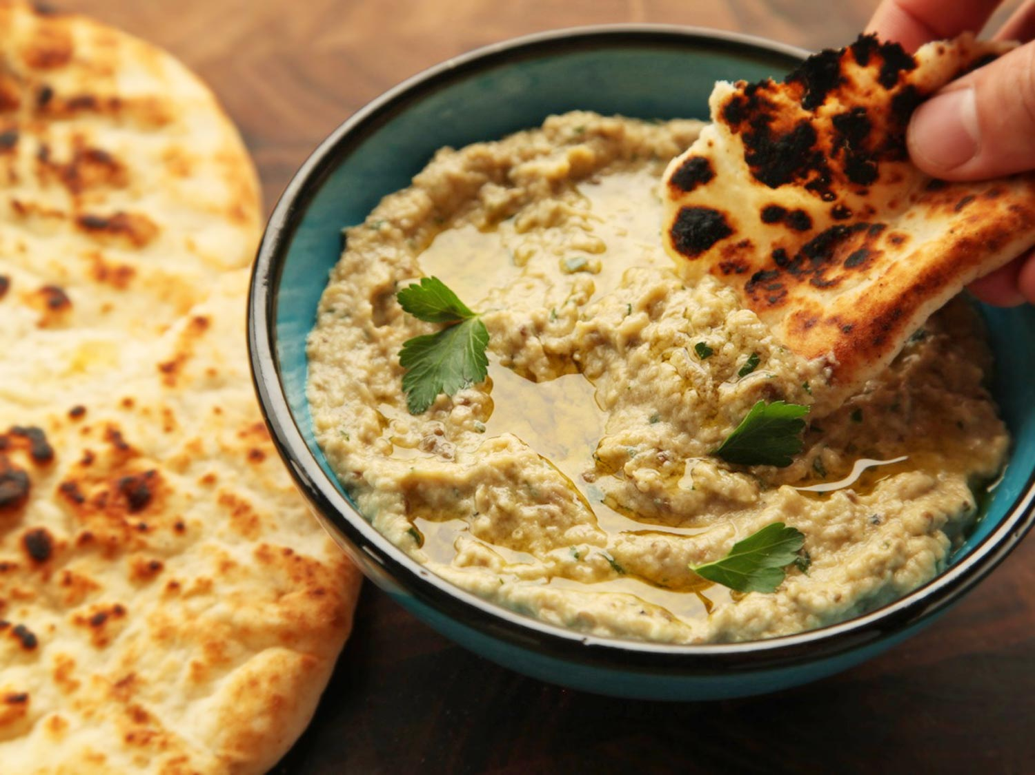
Rich, smoky, and creamy, our recipe for baba ganoush uses the salad spinner to concentrate flavor and a slow emulsion method for the ultimate in dippable texture.
- Yield:Serves 4 to 6 as an appetizer
- Active time: 15 minutes
- Total time:45 minutes (1 1/2 hours if using a broiler)
- Rated:

Ingredients
- 3 medium Italian eggplants (about 2 pounds total)
- 3 medium cloves of garlic, minced
- 2 tablespoons juice from 1 lemon, plus more as desired
- 3 tablespoons tahini
- 1/3 cup extra-virgin olive oil, plus more for serving
- 1/4 cup chopped fresh parsley leaves
- Kosher salt

Directions
- 1.
If using a gas burner or grill (recommended): Preheat a gas or coal grill to medium heat and place eggplants directly over heat source. Cook, turning occasionally with tongs, until completely tender and well charred on all sides, 30 to 40 minutes. Wrap with foil and let rest 15 minutes. Continue to step 3.
- 2.
If using the broiler: Adjust rack to 6 inches below broiler element and preheat broiler to high. Place eggplant on a foil-lined rimmed baking sheet. Broil, turning occasionally, until charred on all sides and completely tender, about 1 hour. Eggplants should be very, very tender when cooked. Test near the stem and bottom ends. If a toothpick or skewer meets any resistance, continue cooking. (See note above.) Remove from oven and gather up foil, crimping it around the eggplants to form a sealed package. Let the eggplants rest for 15 minutes. Continue to step 3.
- 3.
Open foil package. Working one eggplant at a time, use a sharp paring knife to slit it open lengthwise. Carefully scoop out soft flesh with a large spoon and transfer to a strainer set in a large bowl. Once all eggplant is scooped, pick out any stray bits of skin and blackened flesh and discard.
- 4.
Transfer eggplant to a salad spinner, distributing it evenly around the perimeter. Spin gently until all excess moisture is extracted. Discard all drippings, wipe out bowl. and return eggplant to bowl.
- 5.
Add garlic and lemon juice to eggplant and stir vigorously with a fork until eggplant breaks down into a rough paste, about 1 1/2 minutes. Stirring constantly and vigorously, add the tahini followed by the olive oil in a thin, steady stream. The mixture should become pale and creamy. Stir in parsley and season to taste with salt and more lemon juice if desired.
- 6.
Transfer to a serving bowl, drizzle with olive oil, and serve with warm pita bread or vegetables for dipping. Baba ganoush can be stored in an airtight container in the refrigerator for up to four days. Let baba ganoush warm to room temperature before serving.

Fully Loaded Vegan Queso Dip
J. Kenji López-Alt
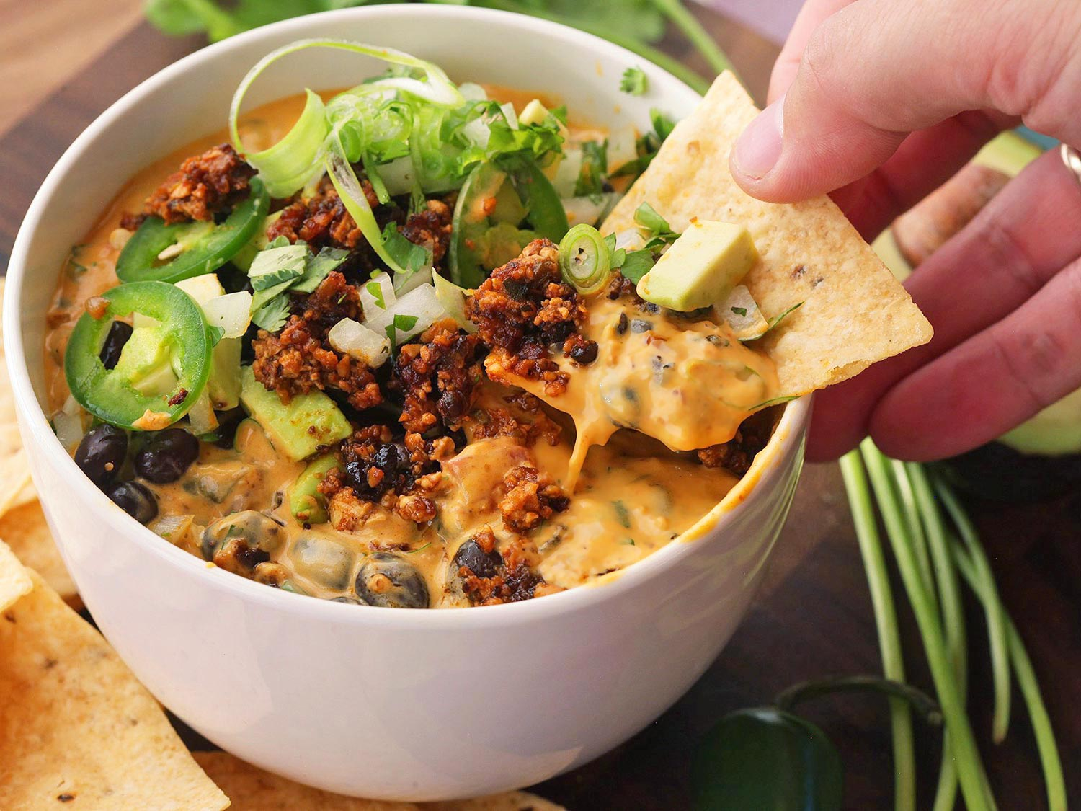
The ultimate party snack, now in a 100% animal product-free form. This vegan queso dip is packed with a gooey cashew and potato-based nacho sauce, soy-lentil chorizo, avocados, scallions, tomatoes with chilies, and black beans. The flavor is so good even your omnivore friends won't know that it's vegan.
Note: If Ro*Tel tomatoes are unavailable, substitute with 1 (15-ounce) can drained diced tomatoes mixed with 1 (4-ounce) can drained chopped green chilies.
- Yield:Serves 6 to 8 as an appetizer or snack
- Active time: 15 minutes once cheese sauce and chorizo are made
- Total time:15 minutes plus time to make cheese sauce and chorizo
- Rated:

Ingredients
- 1 tablespoon vegetable oil
- 3/4 pound vegan chorizo
- 1 recipe Vegan Nacho Cheese Sauce
- 1 (15-ounce) can black beans, drained and rinsed
- 2 (10-ounce) cans Ro*Tel Diced Tomatoes with Green Chilies, drained (see note above)
- 3 tablespoons chopped fresh cilantro leaves, plus more for garnish
- 4 scallions, thinly sliced, plus more for garnish
- 1 avocado, finely diced
- 1 Serrano or jalapeño pepper, minced (reserve a few whole slices for garnish, if desired)
- Hot sauce, to taste
- 1 bag tortilla chips

Directions
- 1.
Heat vegetable oil in a medium saucepan over high heat until shimmering. Add chorizo and cook, stirring frequently, until well browned and slightly dry, about 10 minutes. Remove 2 tablespoons and set aside for garnish. Add cheese dip, black beans (reserving 2 tablespoons for garnish), tomatoes, cilantro, scallions, avocado, and minced Serrano or jalapeño and stir to combine. Stir in hot sauce to taste. Heat, stirring, until hot. Transfer to a warm serving bowl, garnish with reserved chorizo, black beans, cilantro, and scallions, and serve immediately with tortilla chips.
Bottom of Form
« Return to Recipe

The Ultimate Fully Loaded Vegan Nachos
J. Kenji López-Alt
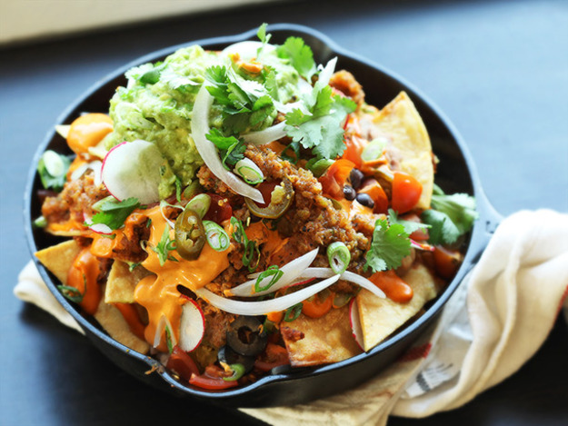
The ultimate fully-loaded vegan nachos with chili, black beans, roasted tomato salsa, refried beans, tomatoes, olives, onions, jalapeños, radishes, guacamole, and a gooey nacho sauce.
Note: You can use as many or as few of the toppings as you wish. High quality store-bought tortilla chips can be used in place of the fresh, but the chips will not stay crisp as long. For better results, cut the recipe for the vegetarian bean chili in half, omitting the kidney beans and using the full amount of chopped garbanzo beans for a chili with more uniform texture.
This recipe requires that you complete many other recipes before you begin. All recipes except for the guacamole can be completed several days in advance, leaving only the guacamole, fresh sliced vegetables, and layering for the final day just before serving. If using chilled pre-made toppings, warm them up in the microwave or on the stovetop before applying, or alternatively, build nachos in layers, placing them in the oven for five minutes to warm the toppings in between each layer.
- Yield:Serves 2 to 3 as a main course or 6 to 8 as an appetizer
- Active time: 15 minutes once ingredients are assembled (see note above)
- Total time:20 minutes

Ingredients
- 1 1/2 quarts peanut, vegetable, or canola oil
- 16 fresh corn tortillas, stacked in groups of 8 and cut into 6 wedges each
- 2 cups (about 1/6th of a full recipe) Vegetarian Bean Chili (see note above)
- 2 cups (about 1/4 of a full recipe) Spicy Vegan Refried Beans
- 2 cups (1 recipe) Vegan Nacho Sauce
- 1 (15-ounce) can black beans, drained and rinsed
- 1 1/2 cups (1 recipe) Roasted Tomato Salsa
- 1/2 cup quartered grape or cherry tomatoes
- 1/2 cup sliced black olives
- 1/2 cup sliced pickled jalapeños
- 1/4 cup thinly sliced fresh radishes
- 1/4 cup thinly sliced scallions
- 1/3 cup thinly sliced white onion
- 1/4 cup fresh picked cilantro leaves
- 1 recipe The Best Basic Guacamole

Directions
- 1.
Adjust oven rack to center position and preheat oven to 375°F. Heat oil in a large wok or Dutch oven to 350°F. Add 1/3 or tortilla chips and cook, agitating and flipping them constantly with a wire mesh spider until bubbles slow to a trickle and chips are pale golden brown, about 2 minutes. Transfer to a paper towel-lined bowl, season with salt, and toss. Allow to drain for 30 seconds, then transfer to a second bowl. Repeat with remaining chips in two more batches.
- 2.
Layer 1/3 of chips in the bottom of a large cast iron skillet or baking dish. Dollop with 1/3 of chili and 1/3 of refried beans. Drizzle with 1/3 of cheese sauce, then sprinkle with half of black beans.
- 3.
Layer with another 1/3 of chips. Dollop with 1/3 of chili and 1/3 of refried beans. Drizzle with 1/3 of cheese sauce, then sprinkle with remaining half of black beans.
- 4.
Layer with remaining 1/3 of chips. Dollop with 1/3 of chili and 1/3 of refried beans. Drizzle with 1/3 of cheese sauce. Transfer to oven and bake until edges of chips are well browned, about 5 minutes. Remove from oven.
- 5.
Top with half of salsa, tomatoes, olives, jalapeños, radishes, scallions, onions, cilantro, and a big dollop of guacamole. Serve immediately with remaining salsa and guacamole on the side.

The Best Vegetarian Bean Chili
J. Kenji López-Alt
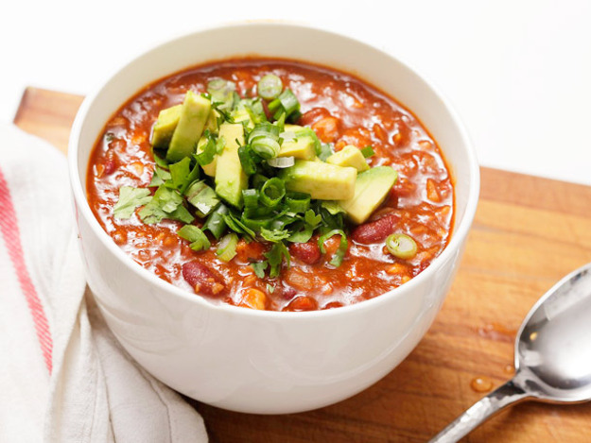
A 100% vegan chili recipe that has all of the deep chili flavor, textural contrast, and rib-sticking richness that the best chili should have.
- Yield:Makes about 3 quarts, serving 6
- Active time: 30 minutes
- Total time:2 hours
- Rated:

Ingredients or add dried chilies – to flavor and hotness desired
- 3 whole sweet dried chilies like Costeño, New Mexico, or Choricero, stems and seeds removed
- 2 small hot dried chilies like Arbol or Cascabel, stems and seeds removed (optional)
- 3 whole rich fruity dried chilies like Ancho, Mulatto, Negro, or Pasilla, stems and seeds removed
- 1 quart water
- 2 whole chipotle chilies in adobo sauce with 2 tablespoons sauce from can
- 2 (14-ounce) cans chickpeas
- 1 (28-ounce) can whole tomatoes packed in juice
- 2 tablespoons vegetable oil
- 1 large onion, finely diced
- 3 cloves garlic, grated on a microplane grater
- 1 1/2 tablespoons cumin
- 2 teaspoons dried oregano
- 1 tablespoon soy sauce
- 1 teaspoon marmite or vegemite
- 2 (14-ounce) cans dark red kidney beans, drained, liquid reserved separately
- 2 tablespoons vodka or bourbon
- Kosher salt
- 2 to 3 tablespoons masa

Directions
- 1.
Add dried chiles to large heavy-bottomed Dutch oven or stock pot and cook over medium-high heat, stirring frequently, until slightly darkened with intense, roasted aroma, 2 to 5 minutes. Do not allow to smoke. Remove chiles to small bowl and set aside. Alternatively, place dried chilies on a microwave-safe plate and microwave on high power in 15-second increments until pliable and toasted-smelling, about 30 seconds total. Transfer to a 2-quart microwave-safe liquid measuring cup or bowl. Add water and chipotle chilies, cover with plastic wrap, and microwave on high power until gently simmering, about 5 minutes. Remove from microwave and set aside. Transfer chilies and liquid to blender and blend, starting on the lowest possible setting and gradually increasing speed to high (make sure to hold the lid down with a clean kitchen towel or a potholder to prevent it from blowing out). Blend until smooth, about 1 minute.
- 2.
Drain chickpeas, reserving liquid from can. Transfer chickpeas to a food processor and pulse until just roughly chopped, about three 1-second pulses. Set aside.
- 3.
Roughly squeeze tomatoes trough your fingers into approximate 1/4-inch pieces. Add to chickpea water along with any juices.
- 4.
Heat oil in a large saucepan or Dutch oven over medium-high heat until shimmering. Add onions and cook, stirring frequently, until softened but not browned, about 4 minutes. Add garlic, cumin, and dried oregano and cook, stirring constantly, until fragrant, about 30 seconds. Add pureed chilies, soy sauce, and marmite and cook, stirring constantly, until fragrant, about 30 seconds. Add reserved chickpea/tomato water mixture and stir to combine. Add chopped chickpeas and kidney beans. Stir to combine.
- 5.
If beans are sticking out of the top, add reserved kidney bean liquid until just barely submerged. Bring to a boil over high heat, reduce to a bare simmer, and cook, stirring occasionally, until thick and rich, about 1 1/2 hours, adding more reserved kidney bean liquid as necessary if chili becomes too thick or sticks to the bottom of the pan.
- 6.
When cooked, add vodka or bourbon and stir to combine. Season to taste with salt and whisk in masa in a slow steady stream until desired thickness is reached. For best results, allow chili to cool and refrigerate for at least one night and up to a week. Reheat to serve.
- 7.

Serve, garnished with cilantro, chopped onions, scallions, avocado, lime wedges, and warm tortillas as desired.
++++++++++++++++++++++++++++++++++++++++++++++++++++++++++++++++++++++++++++++++
Tofu Tostada Salad Recipe
Recipe created by Georgeanne Brennan
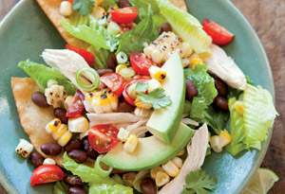
This is a refreshed version of the ubiquitous taco salad, with tofu and chopped vegetables piled high on a crispy tortilla. For a shortcut, omit frying the tortillas and serve the tofu salad over large handfuls of good-quality corn tortilla chips.
Serves 4

Ingredients
Lime vinaigrette:
- Grated zest and juice of 2 limes
- 1 clove garlic, minced
- Salt and freshly ground pepper
- 2/3 cup olive oil
Salad:
- 1 can (15 oz) black beans, drained and rinsed
- 2 cups (12 oz) fresh corn kernels (from about 2 ears of corn, grilled if desired)
- 2 cups (12 oz) cherry tomatoes, halved
- 4 canned green chilies, chopped
- 1 cup (8 fl oz) corn oil
- 4 corn tortillas, each 6 inches in diameter, halved
- 1 small head romaine lettuce, cut into bite-sized pieces
- 2 cups browned/sauteed hard tofu
- 1 avocado, peeled, pitted and sliced
- Fresh cilantro leaves and sliced green onion for garnish (optional)

Directions
To make the vinaigrette, in a bowl, whisk together the lime zest and juice, garlic, 1/4 tsp. salt, and 1/8 tsp. pepper. Add the oil in a thin stream, whisking constantly until the vinaigrette is smooth.
Transfer 3 Tbsp. of the vinaigrette to a large bowl and add the beans, corn, tomatoes, and chiles; mix gently. Reserve the remaining vinaigrette. Let the salsa stand for at least 10 minutes to blend the flavors.
Meanwhile, in a frying pan, warm the corn oil over medium-high heat. When it is hot, slip 3 tortilla halves into the oil and cook until golden and almost crisp, 1-2 minutes. Using tongs, transfer to paper towels to drain. Repeat with the remaining tortilla halves.
Add the lettuce to the reserved vinaigrette and toss to coat. Place 2 fried tortilla halves on each of 4 plates and divide the lettuce among them. Spoon the salsa over the lettuce, top with the chicken and avocado, garnish with the cilantro and green onion, if desired, and serve.
From Williams-Sonoma Salad of the Day: 365 Recipes for Every Day of the Year (Weldon Owen) by Georgeanne Brennan.

Penne with Plum Tomatoes, and Black Olives
Recipe created by Judith Jones
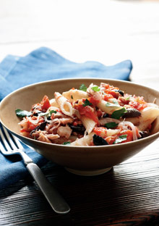
Common kitchen staples take on a Mediterranean flair when tossed together in this penne with, plum tomatoes, and black olives.
Servings: Serves 1
Ingredients
• Salt
• 3 ounces penne (or fusilli or shell pasta)
• 1 Tbsp. olive oil
• 1 small onion or fat shallot , thinly sliced (about 1/4 cup)
• 1 clove garlic , peeled and thinly sliced
• 2 large, ripe plum tomatoes (about 7 ounces), cut into rough chunks
• 1 Tbsp. white wine
• 10 Italian or Greek black olives , pitted and quartered
• 2 Tbsp. chopped fresh flat-leaf parsley
Directions
Bring a large pot of water with 1/2 tablespoon salt to a boil. Drop in pasta; stir it around.
Meanwhile, heat olive oil in a medium skillet over medium-low heat; sauté onion or shallot 3 to 4 minutes, until limp. Add garlic and tomatoes and sauté for another minute. Splash in wine and cook down, about 4 minutes Stir in olives. Add at least 1/4 cup pasta water to the sauce. When pasta is al dente (taste to be sure), use a big strainer-like spoon to transfer it to the pan. Stir to combine, and cook for a minute. Add salt to taste if needed and more pasta water if sauce is too dry. Spoon pasta with sauce into a bowl, and scatter parsley on top.

Thai Curry and Rice Recipe – in less than 9 minutes!
Recipe created by Jaden Hair
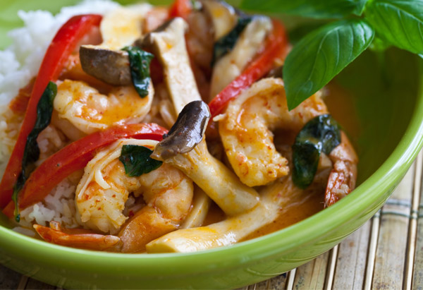
Jaden Hair, who writes the blog Steamy Kitchen, promises this entire meal comes together in a flash. She cooks jasmine rice in the microwave while a coconut Thai curry—which you can make with shrimp, chicken or tofu—simmers on the stove.
Serves 4

Ingredients
Curry:
- 1 tsp. cooking oil
- 2 Tbsp. red curry paste
- 12 ounces coconut milk
- 1 red bell pepper, seeded and cut into strips
- 6 ounces fresh mushrooms, such as Japanese King Trumpet Mushrooms, sliced
- 1 cup baby corn, snow peas, broccoli or cauliflower florettes
- 8 fresh basil leaves (optional)
- Cooked rice, to serve
Rice:
- 1 1/2 cups white rice (basmati, jasmine or sushi) cook first then make curry
- 2 1/4 cups water

Directions
Heat a skillet over medium high heat. Once hot, add in the cooking oil and red curry paste. Whisk for about 30 seconds. Pour in the coconut milk and continue whisking. Add in the mushrooms and the red peppers and continue cooking for 3 minutes. Add the shrimp to the curry and cook for another 2 minutes. Stir in the basil and serve over cooked rice.

___________________________________________
Easy One-Skillet Lasagna Recipe
Recipe created by Kate Dean
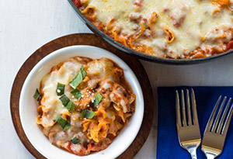
Kate Dean, who writes the blog I Heart Eating, created this one-skillet recipe for nights when her main goal is: Get dinner on the table. Fast.
Serves 6 to 8

Ingredients
- 2 pkgs hard tofu sautéed, browned and crumbled
- 1 cup onion, diced
- 3 cloves garlic, minced
- 1 Tbsp. Italian seasoning
- 1 (15-oz.) can diced tomatoes, undrained (I like to use the tomatoes with onion and garlic)
- 1 can tomato paste
- 1 cup water to cook 10 oz. wide egg noodles
- 1 cup chopped frozen spinach
- Salt and pepper to taste
- 2 cups shredded vegan cheese – maybe half mozzarella and half cheddar
- Basil and soy parmesan to sprinkle on top

Directions
In a large skillet, brown tofu over medium-low heat.
Add the onion and cook, stirring occasionally, for 3 minutes. Add the garlic and Italian seasoning, and cook for 30 seconds. Stir in tomatoes, tomato paste, Stir in chopped frozen spinach and add salt and pepper to taste. Cook egg noodles until noodles are al dente. Combine. Cook down liquid first, or pour off excess liquid.
Remove from heat, and top with Italian cheese blend.
Let the lasagna sit for about 5 minutes for cheese to melt. If I already have the oven on, I just pop the pan in (make sure it's oven-safe first, though) and let the cheese melt. It takes about 3 to 4 minutes. Top with fresh basil just before serving.

Lisa Oz's Cornmeal-Crusted Tofu with Mashed Sweet Potatoes
Recipe created by Lisa Oz
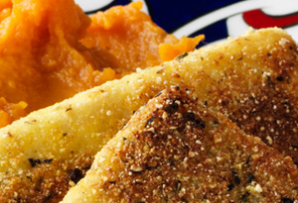
This crispy and sweet dish makes the perfect family dinner.
Serves 4

Ingredients
- 3 large sweet potatoes (about 2¼ pounds)
- 1 14-ounce package firm or extra-firm tofu, cut into ¼"-thick slices
- ¼ cup cornmeal
- ½ tsp. dried oregano
- ½ tsp. kosher salt, divided
- ¼ tsp. ground black pepper
- ¼ tsp. granulated sugar
- 3 Tbsp. canola oil
- 3 Tbsp. vegan butter - optional
- 1 tsp. brown sugar

Directions
Active time: 35 minutes
Total time: 1 hour
Preheat oven to 350°. Place sweet potatoes on a sheet tray and bake until soft, about 1 hour. Place tofu on a paper-towel-lined plate. Cover with more towels and press down, then cover with a heavy plate for 15 minutes.
In a shallow bowl, combine cornmeal, oregano, ¼ tsp. salt, black pepper, and granulated sugar. Coat tofu on both sides. In a large skillet, heat oil over high heat. Pan-fry tofu until golden brown, about 2 minutes a side.
Scoop out sweet potatoes and mash with vegan butter, ¼ tsp. salt, and brown sugar. Serve with tofu.

Lemon Zest Pasta Recipe
Recipe created by Oprah Winfrey
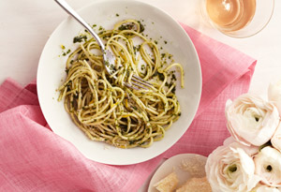
Serves 4

Ingredients
- 1 pound spaghetti
- 1½ cups basil leaves
- 1 tsp. lemon thyme leaves
- 1 Tbsp. oregano leaves
- 2 Tbsp. olive oil
- 1 Tbsp. lemon juice
- 2 Tbsp. vegan butter spread
- ½ tsp. truffle salt (or kosher salt)
- ¼ tsp. ground black pepper
- ¼ cup grated vegan Parmesan cheese
- Zest of 1 lemon

Directions
Active time: 7 minutes
Total time: 20 minutes
Bring a pot of water to a boil and cook pasta according to package directions. Blend the herbs, olive oil, and lemon juice in a food processor. When pasta is al dente, drain and toss with herb mixture, butter spread, truffle salt, and black pepper. Garnish with Parmesan cheese and lemon zest.
Read more: http://www.oprah.com/food/oprahs-lemon-zest-pasta-recipe#ixzz4gBNokQDK
__ Food

30 Quick Vegan Dinners That Will Actually Fill You Up
You can make these in thirty minutes or less. But you'll be satisfied all. night. long.
Posted on October 5, 2014, at 9:12 p.m.

1. Mediterranean Baked Sweet Potatoes
Mediterranean Baked Sweet Potatoes

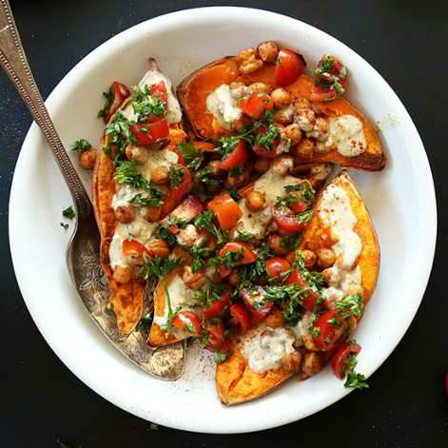
Print Friendly Version
Prep time
5 mins
Cook time
25 mins
Total time
30 mins

Simple, 30 minute baked sweet potatoes topped with roasted chickpeas, a simple garlic-herb sauce and a parsley-tomato salad. Delicious, fresh, healthy, and naturally vegan and gluten free.
Author: Minimalist Baker
Recipe type: Entree
Cuisine: Vegan, Gluten Free, Mediterranean
Serves: 4
Ingredients
- 4 medium sweet potatoes* (~140 g each)
- 1 15-ounce (425 g) can chickpeas, rinsed and drained
- 1/2 Tbsp olive oil
- 1/2 tsp each cumin, coriander, cinnamon, smoked (or regular) paprika
- optional: Pinch of sea salt or lemon juice
GARLIC HERB SAUCE
- 1/4 cup (60 g) hummus (or tahini)
- juice of 1/2 lemon (~1 Tbsp)
- 3/4 - 1 tsp dried dill (or sub 2-3 tsp fresh)
- 3 cloves garlic, minced (1 1/2 Tbsp or 9 g)
- Water or unsweetened almond milk to thin
- optional: Sea salt to taste (I didn’t need any)
TOPPINGS optional
- 1/4 cup (45 g) cherry tomatoes, diced
- 1/4 cup (15 g) chopped parsley, minced
- 2 Tbsp (30 ml) lemon juice
- Chili garlic sauce
Instructions
- Preheat oven to 400 degrees and line a large baking sheet with foil.
- Rinse and scrub potatoes and cut in half length wise. This will speed cooking time. Otherwise leave whole and bake longer (approximately double the time (45 min - 1 hour).
- Toss rinsed and drained chickpeas with olive oil and spices and place on a foil-lined baking sheet.
- Rub the sweet potatoes with a bit of olive oil and place face down on the same baking sheet (or another baking sheet depending on size).
- While the sweet potatoes and chickpeas are roasting, prepare your sauce by adding all ingredients to a mixing bowl and whisking to combine, only adding enough water to almond milk to thin so it’s pourable. Taste and adjust seasonings as needed. Add more garlic for more zing, salt for savoriness, lemon juice for freshness, and dill for a more intense herb flavor. I found mine didn’t need anything else.
- NOTE: If you don’t have hummus, tahini (which you can DIY!) will make a great base substitution for the sauce - just adjust the seasonings to accommodate the lack of flavor tahini provides.
- Also prepare the parsley-tomato topping by tossing tomato and parsley with lemon juice and setting aside to marinate.
- Once sweet potatoes are fork tender and the chickpeas are golden brown - roughly 25 minutes - remove from oven.
- For serving, flip potatoes flesh-side up and smash down the insides a little bit. Then top with chickpeas, sauce and parsley-tomato garnish. Serve immediately.
- Additional side ideas might include Hummus, Pita Chips, Baba Ganoush, or Persian Eggplant Dip. Enjoy!
Notes
*Adjust number of sweet potatoes per person, and buy organic when possible for best quality and flavor.

minimalistbaker.com
FYI: These are really good for impressing your guests.
__________________________

Vegan Lemon Fettuccine Alfredo
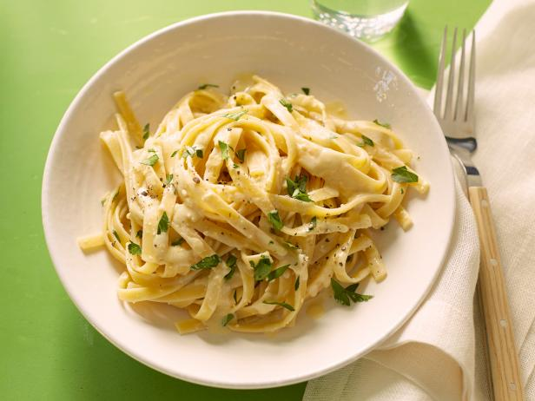
Total:
35 min
Active:
5 min
Yield:
4 servings
Level:
Easy

Nutrition Info
Healthy

Ingredients
- 12 ounces eggless fettuccine
- 2 cups unsweetened soy or almond milk
- 4 ounces soy cream cheese
- 3 tablespoons blanched sliced almonds
- 3 tablespoons nutritional yeast, plus more for sprinkling
- 1 teaspoon finely grated lemon zest
- Kosher salt and freshly ground black pepper
- 2 tablespoons extra-virgin olive oil
- 3 cloves garlic, finely chopped
- 1/2 cup loosely packed parsley leaves, chopped

foodnetwork.com
Not sure what's more exciting: The 22 grams of protein per serving from the soy milk, soy cream cheese and nutritional cheese, or the fact that it's ready in 20 minutes. Recipe here.

4. 30-Minute Coconut Curry
30 Minute Coconut Curry

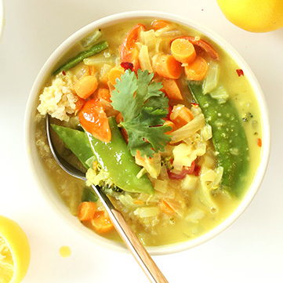
Print Friendly Version
Prep time
5 mins
Cook time
25 mins
Total time
30 mins

A vegan, gluten free 30-minute curry that’s loaded with veggies and swimming in a perfectly-spiced coconut milk broth. Coconut quinoa sends this over the top. Simple, healthy, fast and so delicious.
Author: Minimalist Baker
Recipe type: Entree
Cuisine: Vegan, Gluten Free
Serves: 4
Ingredients
CURRY
- 1 Tbsp (15 ml) coconut or olive oil
- 1 small onion, diced (150 g)
- 4 cloves garlic, minced (2 Tbsp or 12 g)
- 1 Tbsp (6 g) fresh grated ginger (or 1 tsp ground)
- 1/2 cup (45 g) broccoli florets (or green bell pepper), diced
- 1/2 cup (64 g) diced carrots
- 1/4 cup (45 g) diced tomato
- 1/3 cup (28 g) snow peas (loosely cut)
- 1 Tbsp (8 g) curry powder
- Pinch cayenne or 1 dried red chili, diced (optional for heat)
- 2 14-ounce (396 g) cans light coconut milk (sub full fat for richer texture)
- 1 cup (240 ml) veggie stock
- Sea salt and black pepper to taste
COCONUT QUINOA
- 1 14-ounce (396 g) can light coconut milk
- 1 cup (170 g) white quinoa, rinsed in a fine mesh strainer*
- 1 Tbsp (15 ml) agave nectar (optional)
FOR SERVING optional
- Fresh lemon juice
- Cilantro, mint and/or basil
- Red pepper flake
Instructions
- If serving with coconut quinoa, begin by washing thoroughly in a fine mesh strainer. Add to a medium saucepan over medium heat and toast for 3 minutes. Add 1 can light coconut milk and 1/2 cup water. Bring to a boil, then reduce heat to simmer, cover and cook for 15 minutes or until the quinoa is light, fluffy and the liquid is absorbed. Set aside until serving.
- In the meantime, heat a large saucepan or pot to medium heat and add 1 Tbsp coconut oil. Add the onion, garlic, ginger, carrot, broccoli and a pinch each salt and pepper and stir. Cook, stirring frequently, until softened – about 5 minutes.
- Add curry powder, cayenne (or chili pepper), veggie stock, coconut milk, another healthy pinch of salt and stir. Bring to a simmer then reduce heat slightly and continue cooking for 10-15 minutes.
- Add the snow peas and tomatoes in the last 5 minutes so they don’t overcook.
- Taste and adjust seasonings as needed. I added another pinch or two of salt.
- Serve over coconut quinoa (see other options below in Notes) and garnish with fresh lemon juice and herbs.
Notes
*An alternative to coconut quinoa would be plain quinoa, millet, coconut rice, white or brown rice.
*Curry slightly adapted from Tyler Florence
*Coconut quinoa adapted from Cookie and Kate

minimalistbaker.com
The beauty of this recipe is that you can make it with any vegetables you have in the fridge. Recipe here.
5. Poblano and Portobello Fajitas
Poblano and Portobello Fajitas

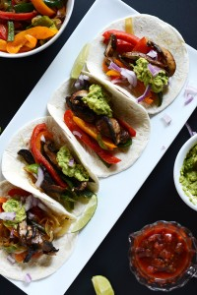
Print Friendly Version
Prep time
10 mins
Cook time
20 mins
Total time
30 mins

Simple vegan fajitas with portobellos mushrooms and poblano and bell peppers, made extra satisfying with healthy spoonfuls of guac.
Author: Minimalist Baker
Recipe type: Entree
Cuisine: Mexican, Vegan
Serves: 2-3
Ingredients
- 1 poblano pepper, seeds removed and thinly sliced
- 2 bell peppers, seeds removed and thinly sliced
- 1 jalapeño, seeds removed and thinly sliced
- 1 yellow or white onion, cut into thin rounds
- 2 large or 4 baby portobello mushrooms, stems removed, wiped clean and thinly sliced
- 2 ripe avocados
- juice of 1/2 lime
- sea salt, cumin & garlic powder
- 1 tsp A1 steak sauce (for mushrooms, optional)
- 6 small flour or corn tortillas
- Optional: fresh red onion, hot sauce, cilantro, salsa
Instructions
- Heat a large skillet and a medium skillet over medium-high heat. Once hot add a dash of olive or coconut oil to the large skillet, then the onion and peppers. Season generously with salt, cumin and garlic powder.
- Cook until softened and slightly caramelized, stirring often. Set aside and cover to keep warm.
- At the same time, add a dash of oil to the medium pan, then add the mushrooms. Season with a bit of salt and once softened and brown (see photo), add a dash of A1 (vegan-friendly) for more flavor (optional). Remove from heat, set aside and cover.
- Prepare guacamole by adding two avocados to a bowl then adding the juice of half a lime and a generous pinch of salt. Fresh cilantro and onion is optional.
- Warm tortillas in the microwave or oven and you’re ready to go. Serve tortillas with peppers and onions, mushrooms, guacamole and any other toppings you desire such as salsa, hot sauce, and vegan cheese or sour cream
Notes
*Nutritional information roughly calculated based on 1/3 recipe without toppings
Nutrition Information
Serving size: 1/3 recipe Calories: 427 Fat: 27.8g Saturated fat: 5.7g Carbohydrates: 43.1g Sugar: 7.1g Sodium: 215mg Fiber: 14.8g Protein: 6.7g

minimalistbaker.com
Because FAJITAS. Recipe here.
6. Vegan Philly Cheesesteak
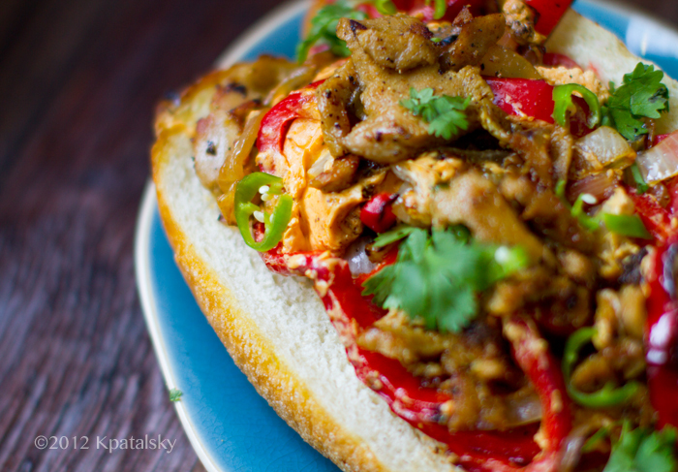

This was an easy and fun dinner feast. I served our sandwiches with a light spring mix + avocado salad and some sunset sangria on the side. My sunrise sangria mix shown in the photo includes 1 part fresh orange juice, 1 part pomegranate juice + 1/2 orange (sliced) + 1/2 apple (chopped). Then you add it to red wine as you'd like. Serve over ice.
My vegan Philly Cheese Sandwich is made using farmer's market red bell peppers, a few green Anaheim chilies, some mild hatch chilies (canned), sweet onions, pepper, spices, extra virgin olive oil, a hoagie roll and a nice layer of melted vegan cheese.
Teese it. Since the cheese on a Philly Cheese is supposed to be melty, orange, cheddar and "kind of like CheezWhiz." (Or so I was told.) I opted for Teese vegan cheese. It melts in a flash and has a very "low brow" feel to it. However, Daiya Pepper Jack or Follow Your Heart Cheddar would also work.
Teese comes in a tube and you squeeze it out. It melts in seconds on a hot skillet - over top the veggies and seitan.
Seitan. I bought some easy seitan strips, WestSoy brand. For a gluten-free option, substitute with sliced portobello mushrooms - use gluten free bread too.
You could also use strips of tofu or tempeh. Or you could even make your own seitan using vital wheat gluten flour - if you want to go all Martha Stewart on me.
Vegan Philly Cheese Sandwich
vegan, serves two
2 vegan hoagie rolls, split down the center (optional: "scoop" the center of the roll)
spicy saute:
1 large red bell pepper, thinly sliced into strips (use red an/or green peppers)
1 medium sweet onion, sliced
1/4 tsp black pepper
a few dashes chipotle or cayenne powder for heat
salt to taste (I used Penzey's seasoned chili salt 4/s)
1-2 tsp oil (EVOO, safflower or other to saute)
optional: 1 small Anaheim chili, sliced (or any spicy chili - jalapeno works too)
2 Tbsp hatch chilies, diced (canned)
cheese: 2-5 Tbsp Teese vegan cheddar cheese
seitan: 3/4-1 cup seitan strips (WestSoy brand was used)
garnish: fresh cilantro, chopped, fresh tomato, sliced fresh chilies or jalapeno
Directions:
1. Prep your rolls and warm in the oven to toast. Tip: brush inside and/or outside of bread with olive oil if you'd like.
2. Prep your veggies.
3. Add oil to skillet and heat over high heat.
4. Add peppers, onions and optional chilies. Cook until the edges begin to blacken and the onions begin to caramelize. Add in the spices, pepper and salt during cooking process.
5. When veggies are just about done, add in the cheese and watch it melt over top the veggies. Transfer this veggie / cheese mixture carefully to a sheet of foil or plate.
6. While pan is still hot, add another small splash of oil and add the seitan strips. Saute until the edges blacken. If your seitan is already seasoned (As mine was) you can just add in some extra spices to taste if desired. Pepper, spicy cayenne, nutritional yeast - whatever you'd like.
7. Add the veggies + cheese back to the hot skillet and toss with the cooked seitan. Remove from heat.
8. Add the filling to the rolls. Garnish with the fresh cilantro, tomato and green chilies. Pepper too. Serve hot!
kblog.lunchboxbunch.com

8. Roasted Vegetable Salad with Garlic Dressing and Toasted Pepitas
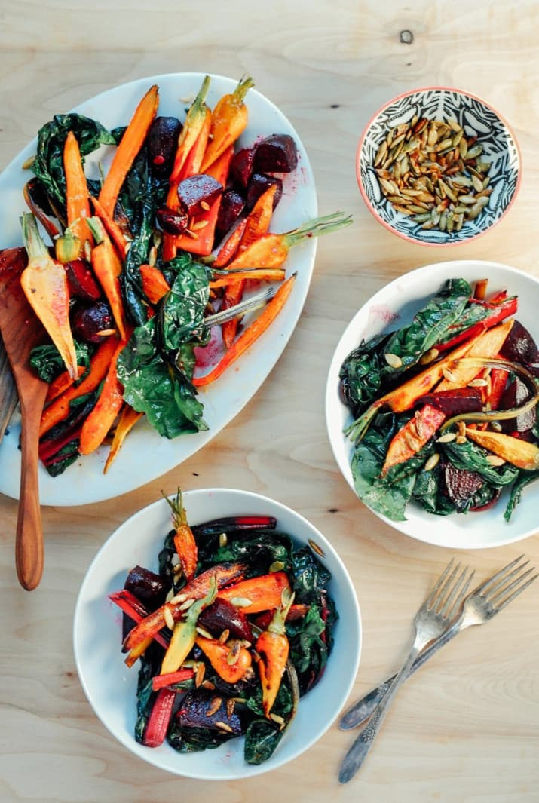
withfoodandlove.com
F Roasted Vegetable Salad with Garlic Dressing + Toasted Pepitas

print
prep time
10 mins
make time
30 mins
total time
40 mins

Recipe by, Elizabeth Stark of Brooklyn Supper. If you're a fan of leftovers the beet and carrot part of the salad will hold up beautifully after a day or two, but the greens are best consumed right away.
By: Sherrie Castellano | With Food + Love
Makes: 4 servings
Ingredients
- 1 head garlic
- 5 tablespoons olive oil, divided
- 1 bunch carrots, scrubbed and peeled
- 1 bunch beets, scrubbed and trimmed
- 1 bunch rainbow chard
- 1 tablespoon lemon juice
- ¼ cup raw pepitas
- sea salt, to taste
- black pepper, to taste
Instructions
- Preheat the oven to 350 degrees.
- Cut the top quarter off the head of garlic and drizzle with ½ tablespoon olive oil. Wrap it in foil and set it in a small oven-proof dish. Bake it for 20 minutes. Remove it from the oven and keep it wrapped to cool. It will continue to cook as it cools.
- Turn the oven up to 425 degrees.
- While the garlic roasts bring a pot of water to a boil. Blanch the carrots in the boiling water for 2 minutes. Then add the beets and boil for 8 to 10 minutes. Remove them with a slotted spoon and run under cold water. At this point, the skins should easily peel off the beets by using your finger. Use a peeler if needed for tougher skins.
- Halve the carrots and quarter the beets. Arrange them on a baking sheet. Drizzle with 1 tablespoon olive oil and sprinkle with salt. Roast for 20 minutes, flipping vegetables halfway through.
- Arrange the chard on another baking sheet. Drizzle with ½ tablespoon oil and pinch of salt, and rub it all over the leaves. Roast for 5 minutes, or just until the leaves have softened and become slightly browned.
- Next make the dressing. Squeeze the roasted garlic out of its papery skin and into a small mixing bowl. Mix in lemon juice and add a pinch of salt. Next, whisk in the remaining 3 tablespoons olive oil and combine until smooth.
- Lastly, toast the pepitas in a small skillet over medium heat. Cook, while flipping almost constantly for 2 minutes or until they start to pop. Sprinkle with salt.
- To serve, toss the carrots and beets with the garlic dressing. On a large platter, layer roasted chard on the bottom, then the carrots and beets, a drizzle more of garlic dressing then sprinkle on the pepitas, black pepper and more salt if desired.
or those who don't habla español, pepitas are pumpkin seeds. Recipe here.

10. Amazing Vegan Quesadillas
Props to Kieran at Health is Happiness for coming up with this masterpiece. I adapted it ever so slightly to make it gluten-free and to use up some veggies I had on hand. A friend gave me a huge bag of mini sweet peppers, which is what brought me to this recipe. I was looking for a way to use them up, and this recipe certainly helped. Of course, you can just use regular bell peppers instead.
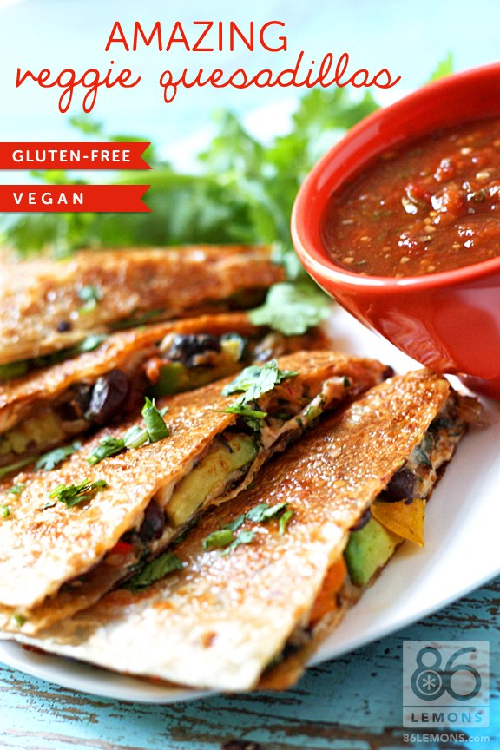
They taste as good as they look – I promise.
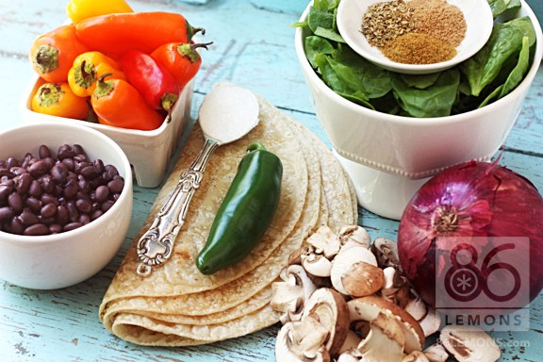
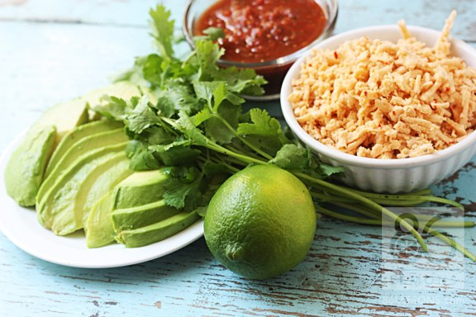
YIELDS 3-4 LARGE QUESADILLAS (depending on how full you pack ’em)
***
INGREDIENTS:
2 Tbsp. coconut oil
1 medium to large red onion, diced
1 large green pepper + 1 large red pepper, chopped (or about 10-12 mini sweet peppers)
1 jalapeño, minced or chopped
1 can of black beans, drained and rinsed
1 cup fresh mushrooms, chopped
1 tsp. ground cumin
1 tsp. ground coriander
1 tsp. dried oregano
3 cups fresh spinach, chopped
sea salt and black pepper to taste
6 or 8 Food for Life Brown Rice Tortillas (wheat and gluten-free)
EXTRAS:
Daiya Pepperjack Style Shreds
sliced avocado
fresh cilantro
lime juice
salsa (gluten-free, if need be)
*NOTES:
I used ALL of the extras in my quesadillas and I would highly recommend it. The Daiya cheese is important because it holds it all together. The avocado makes it creamy and delicious. Cilantro, lime juice and salsa help to amp up the flavor factor. You could also add minced garlic in STEP 1 if you like. You’ll need 6 or 8 tortillas, based on how full you stuff them. I used 6 and had a little filling left over, but not much. If you can find the brand I mentioned above, use it – they brown up perfectly and get nice and crispy on the edges (they are also great for wraps). Locals, you can find them at Apple Valley.
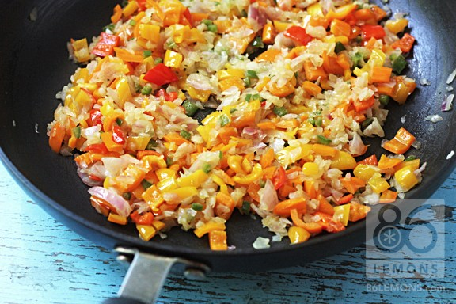
STEP 1
In a large, deep skillet over medium or medium-low heat, add coconut oil, onion, and peppers (including jalapeño) with a pinch of sea salt. Sauté for 15 minutes until softened and translucent. You don’t want them to brown, so reduce the heat if necessary. Cook it slowly so everything gets soft and sweet.
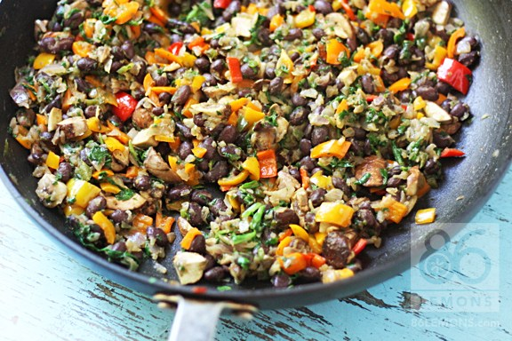
STEP 2
Add black beans, mushrooms and spices. Mix everything together and continue cooking for 5 minutes.
STEP 3
Add spinach and continue cooking for a few minutes, until spinach wilts. Add salt and pepper to taste and remove from heat.
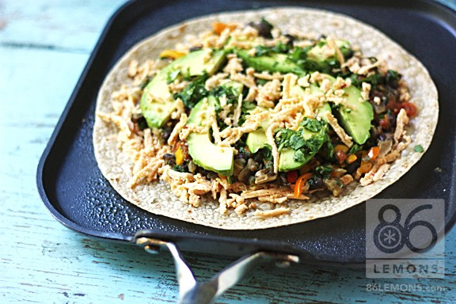
STEP 4
I used a large, shallow pan (sprayed with cooking spray, over medium heat) to cook the quesadillas. This makes it easy for flipping if you use a large plate or thin cutting board to sandwich the quesadilla and flip the pan upside down. Then slide the quesadilla off the plate/cutting board back onto the pan so you can cook the other side.
I assembled the quesadillas directly on the pan. Begin with one tortilla, topped with about ¼ cup Daiya Shreds (cheese), followed by some of the bean/veggie filling. Do not spread the filling to the edge of the tortilla. It will spread out as it’s cooking. Add your preferred extras (avocado slices, cilantro, salsa, lime juice). Add a little more cheese on top, then top it off with a second tortilla.
I set a cast iron skillet on top of the quesadilla while it was cooking. The weight helps everything stick together inside. Cook for about 5 minutes (until tortilla browns up slightly), then flip and repeat.
STEP 5
Cut quesadilla in half, then cut each half into 6 triangles. Optional – garnish with chopped cilantro, serve with salsa and/or guacamole.

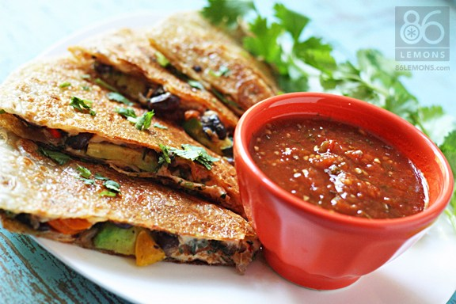
Don’t you just want to eat these up right now!?!?
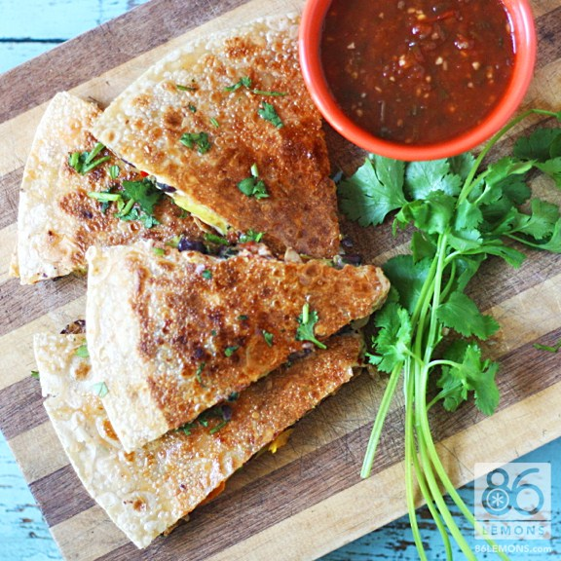
They are the perfect combination of flavor, spice, creamy and crunchy. I may have done a little victory dance when I took the first bite. Thanks again, Kieran!
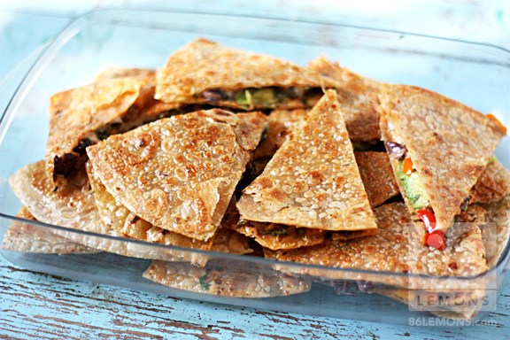
The leftovers reheat perfectly in the toaster oven. Looks like I’m all set for a day or two ;)
Enjoy!!!

86lemons.com
Black beans guarantee plenty of protein. Avocado guarantees plenty of MMMMMMM. Recipe here.
12. Spicy Chickpea Veggie Burgers
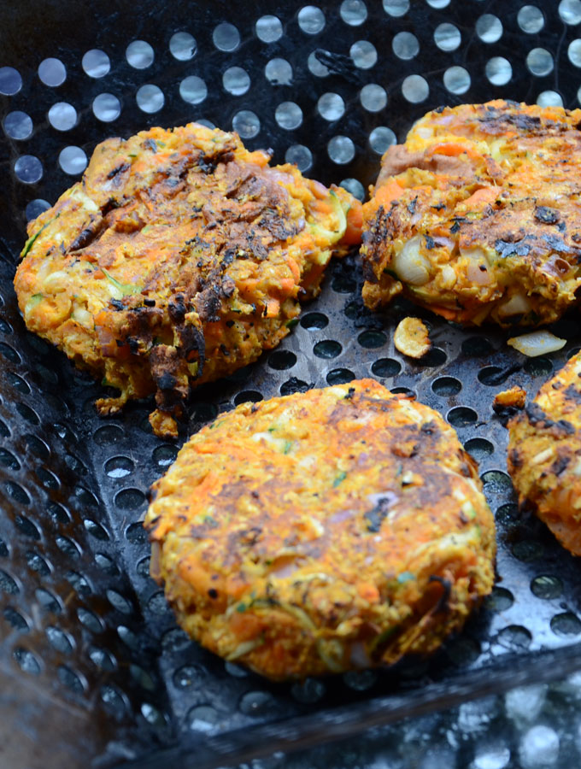Save

Spicy Chickpea Veggie Burgers
In the end I ate this patty on a toasted whole-wheat bun topped with avocado, salsa and lettuce but I had to take a few fancy, pretty pictures first! Tomorrow I’ll eat a few patties over salad for lunch. They will even work as a healthy and filling grab-n-go snack since they actually hold together!
Print

Chickpea Veggie Burgers
★★★★★
4.8 from 67 reviews
These easy to make veggie burgers are bursting with flavour and make an excellent alternative to store-bought versions. Try them on the BBQ for a delicious meal perfect for a summer afternoon.
- Author: Deryn Macey
- Prep Time: 10 mins
- Cook Time: 10 mins
- Total Time: 20 minutes
- Yield: 6-8

Ingredients
- 1 can chickpeas, drained, well-rinsed,and mashed
- 1/2 red onion, finely diced
- 1 small zuchinni, grated
- 3 tbsp finely chopped cilantro
- 3 tbsp red wine vinegar
- 1 tbsp sriracha sauce
- 2 tbsp natural peanut butter
- 1 tsp cumin
- 1 tsp garlic powder
- 2 tsp black pepper
- 1/2 tsp sea salt
- 1 cup quick oats (gluten-free if needed)
- 2 tbsp olive oil

Instructions
- After draining and rinsing the chickpeas, place them in a bowl and mash them with a fork.
- Add all the other ingredients to the bowl.
- Use your hands to mix very well.
- Form into 6-8 patties.
- Cook on the BBQ around 400 F for approximately 10 minutes each side.
- You can also fry these in a pan with some oil for 3-5 minutes a side.

14. Vegan Mushroom Stroganoff
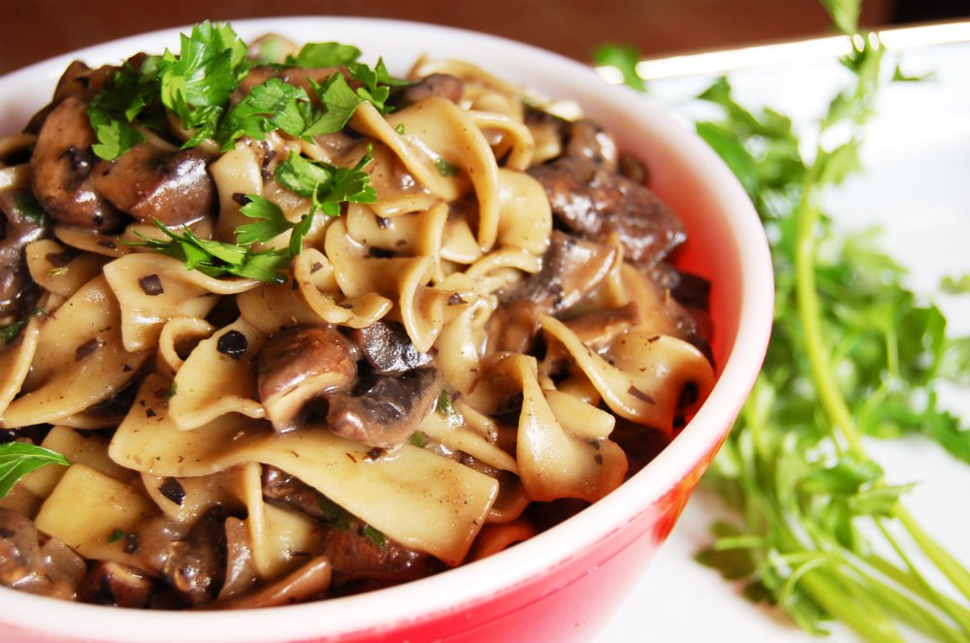
Food Monster - Recipes

Mushroom Stroganoff [Vegan]
has hundreds of search filters and features like bookmarking, meal plans and more! The app shows you how having diet/health/food preferences can be full of delicious abundance rather than restrictions!
This is a classic comfort food dish that pairs perfectly with a cracking fire and snow falling outside your window. After you’ve made it once, you will quickly add it to your weekly dinner rotations until tank top season, at which point, you only might give it a rest.

Vegan Mushroom Stroganoff
This Recipe is :
Dairy Free High Carb Vegan Vegan

Serves
4 - 6

Ingredients
- 8 ounces uncooked ribbon noodles
- 1 tablespoon olive oil
- 1 yellow onion, chopped
- 3 tablespoons whole wheat flour, divided
- 2 cups beefless beef broth or vegetable broth
- 1 tablespoon soy sauce
- 1 teaspoon lemon juice
- 1 teaspoon tomato paste
- 1 1/2 pounds mushrooms (half Portobello and half White Button mushrooms), cut into large 2-inch chunks
- 1/2 teaspoon dried thyme
- 1/2 teaspoon dried sage
- 1/2 teaspoon salt
- 1 tablespoon white wine vinegar
- 1/4 cup vegan sour cream (optional)
- 10 turns of fresh ground, black pepper
- 1/4 cup flat-leaf parsley, minced

Preparation
- Cook the noodles per the direction on the package. Under cook them a bit because they will be cooked again once incorporated into the sauce.
- Drain and set aside.
- In a large saucepan, add the olive oil and sauté the onions for 3 minutes over medium heat.
- Add the flour and cook for 30 seconds, stirring constantly.
- Gradually add the broth, soy sauce, lemon juice, and tomato paste, while stirring at the same time. Stir until mixture becomes thick and bubbly, about a minute.
- Add the mushrooms, thyme, sage, and salt. Stir to combine.
- Cook for 5 minutes, stirring frequently until mushrooms have shrunk in size.
- Add the vinegar and simmer for 4 more minutes.
- Add the noodles, sour cream, 1 tablespoon of flour, black pepper, and parsley and cook on low for an additional 5 minutes.
- Garnish with parsley.

Notes
You can make this dish gluten free if you use gluten free pasta, gluten free soy sauce and substitute the whole wheat flour with rice flour.
If you want a soy free version, swap out the soy sauce with sea salt to taste.

EXPLORE MORE RECIPES WITH THESE INGREDIENTS:

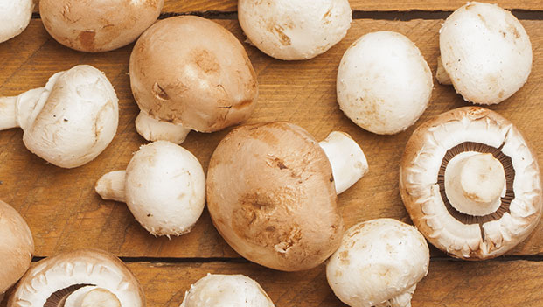Mushroom

onegreenplanet.org
Buh-bye beef. Recipe here.

15. Lemon-Quinoa Avocado-Cilantro Chickpea Salad
Up next we had a Lemon Quinoa Cilantro Chickpea Salad.

Yet again, I was mean and didn’t make their sample with quinoa. I actually was thinking later that night that throwing in some grain would definitely add more “Va Va Voom” to this meal, so the next day I made it again.

You get your protein from the beans and quinoa, some good grains from the quinoa, healthy fats from the avocados, veggies from the spinach and tomatoes, and delicious-ness from the tasty dressing.
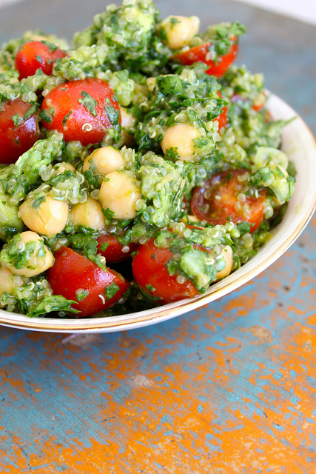
Lemon Quinoa Cilantro Chickpea Salad

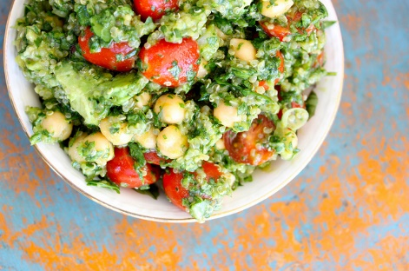
Print
Ingredients
- ½ c. dry quinoa
- 1½ c. vegetable broth
- (OR 1 c. prepared/cooked quinoa)
- 1 c. garbanzo beans, drained and rinsed
- 1 c. cherry tomatoes, halved
- ¼ diced onions
- 3 cloves garlic, chopped
- 2 avocados, diced
- 1 bunch cilantro, bottom stems cut off
- 2 c. spinach
- (dressing)
- 2 tsp. dijon mustard
- zest of 1 lemon
- Juice of 1 juicy lemon, or two not so juicy lemons
- 2 tsp. olive oil
- 1 tsp. honey
- ½ tsp. cumin
- salt and pepper
Instructions
- Prepare quinoa according to package directions. I like to use a rice cooker on the white rice setting to make it easy!
- Once the quinoa is cooked, set it aside to cool.
- In a food processor, add cilantro and spinach. Process the greens until the are chopped up finely.
- In a bowl, add the chickpeas, chopped greens, tomatoes, avocado, onion, and garlic.
- In a bowl, whisk the dressing ingredients together. Pour over the salad.
- Add salt and pepper to taste.
- Let sit in the fridge until ready to eat! Enjoy!
Wordpress Recipe Plugin by EasyRecipe
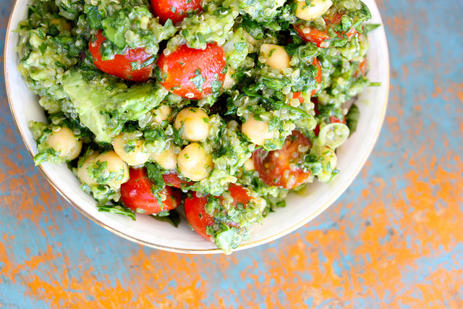
Salad originally adapted from Oh She Glows, Cilantro Lime Chickpea Salad.
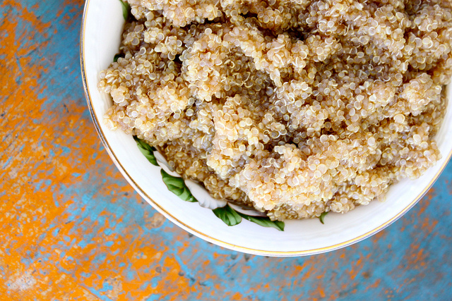

thediva-dish.com
Quinoa, avocado, and spinach in one bowl?! What is this, a superfood convention? Recipe here.

19. Sweet and Spicy Asian Tofu
Ingredients
- 7 ounces extra firm tofu
- 1 tablespoon high-heat oil (I use regular olive oil)
- cooking spray
- 1 clove garlic, minced
- 3 cups assorted stir-fry vegetables
- 3 tablespoons sweet chili sauce (I recommend Mae Ploy)
- 2 tablespoons Sriracha hot sauce
- 2 teaspoons soy sauce
- optional: a few drops of fish sauce
- ⅔ cup brown rice, cooked
Instructions
- An hour before cooking, wrap the tofu in paper towels and place between two plates to help press out the liquid. I like to change the paper towels once during this process. Slice the tofu into even cubes.
- Heat the oil in a non-stick pan over medium-high heat. Once it's hot, add the tofu cubes and allow them to pan fry until golden on one side and then use tongs to turn the pieces. Brown at least 4 sides for the best texture.
- Set the tofu aside and if the pan is no longer oily, add some cooking spray. Saute the garlic and vegetables over medium-high heat with a bit of salt. I prefer my veggies slightly crunchy.
- While the tofu and vegetables are cooking, stir together the sauce ingredients.
- Serve the tofu and vegetables with the sauce over brown rice.
Notes
You want to use tofu that's been packed in water for this recipe, not the silken boxed variety. I recommend using a non-stick pan for the tofu because you will need less oil.
Nutrition Information

savorysimple.net
Stir-fry: Always there for you when you need it. Recipe here.
86lemons.com
Some days all you can do is throw your ingredients in a bowl and stir. Recipe here.

Layered Raw Taco Salad for Two
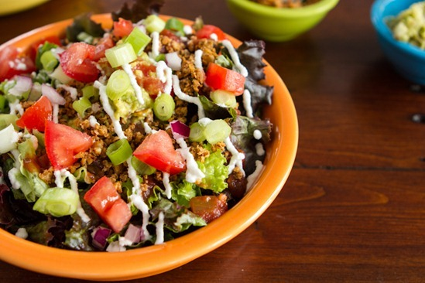

Don’t let the long ingredient list put you off; the entire recipe took me about 30 minutes or so. Feel free to adapt this salad depending on what you have in your kitchen.
Walnut Taco Meat: (adapted from my taco meat recipes) (yield: scant 1/2 cup)
- 1/2 cup walnuts, soaked for 2-8 hours or sun flower seeds
- 1 & 1/2 tsp chili powder
- 1/2 tsp cumin powder
- fine grain sea salt, to taste
- cayenne pepper, to taste (optional)

Cashew or Macadamia cream: (yield: 1 heaping cup)
- 1 cup macadamia (or cashew) nuts, soaked in water for 2-8 hours
- 11-12 tbsp water (use as needed to achieve desired consistency)
- 2-3 tbsp fresh lemon juice, to taste
- fine grain sea salt, to taste (I used just over 1/4 tsp)

3-Minute Guacamole: (yield: 3/4 cup)
- 1 large ripe avocado
- 1/4 cup chopped red onion
- 1/2 small tomato, chopped
- 1/2 tsp ground cumin
- 1 tbsp + 1 tsp fresh lime juice
- scant 1/4 tsp fine grain sea salt, or to taste

Other salad ingredients:
- greens of choice
- salsa
- green onion (optional)
- crackers

Taco meat: In a food processor (or by hand), pulse (or chop) the ingredients until combined. Make sure to leave the walnuts chunky. Remove and set aside.
Cream sauce: Drain and rinse the soaked nuts. Add them into a processor and process. Stream in about 1/2 cup water and a couple tbsp of lemon juice. Add more water as needed to achieve your desired consistency. The nut sauce should be super smooth and not grainy. Add salt to taste.
Guacamole: In a medium-sized bowl, mash the avocado flesh with a fork, leaving some chunks. Stir in the chopped tomato, red onion, lime juice, and seasonings to taste.
To assemble: (per bowl) Add a hefty base of greens in a large bowl followed by a heaping 1/4 cup scoop of guacamole in the middle. Spoon on 2 tbsp of salsa over the greens followed by half of the taco meat. Add a couple tbsp of cream into a plastic baggie, snip off end, and pipe over top the taco meat. Garnish with a chopped green onion and leftover chopped tomato and red onion. Place a few crackers into the salad before serving. If you find yourself with leftover lemon and lime juice like I did, place juice into a glass, fill with water, add liquid sweetener to taste, and serve over ice.

152 Comments

Spicy Potato ‘n Black Bean Burritos
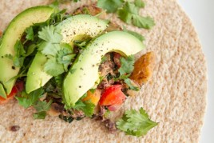

105 Comments

24. Cheesy Vegan Alfredo with Peas and Kale

luminousvegans.com
It's just so creamy and delicious. Recipe here.

25. Millet Bowl with Chickpeas, Red Pepper, and Snow Peas

buzzfeed.com
Not just pretty, but tastes good too. Recipe here.

26. Quick Homemade Ramen
Next Recipe

Seven-Vegetable Couscous

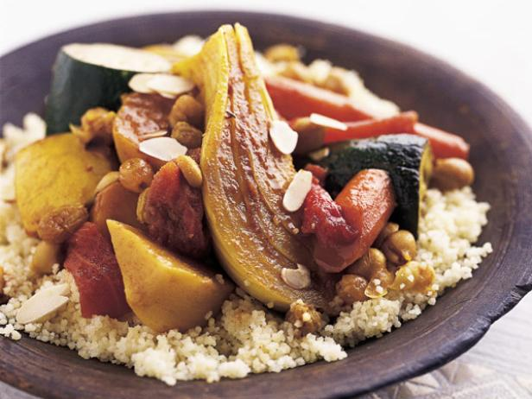
Total:
1 hr 5 min
Active:
30 min
Yield:
4 to 6 servings
Level:
Easy
Healthy

Ingredients

Seven-Vegetable Stew:
- 3 cloves garlic, smashed
- 2 small turnips, peeled and quartered
- 1 medium yellow onion, quartered lengthwise, root end intact
- 1 large carrot, peeled and cut into 2-inch chunks
- 1/2 fennel bulb, thickly sliced lengthwise, root end intact
- 1/3 cup golden raisins
- 1 tablespoon peeled, chopped, fresh ginger
- 1 tablespoon kosher salt
- 2 teaspoons each ground cumin, paprika, and sugar
- 1 1/2 teaspoons ground turmeric
- 1/8 teaspoon ground cloves
- 1 cinnamon stick, snapped in half
- 2 cups water
- 1 pound butternut squash
- 1 small zucchini, cut into 2-inch rounds
- 1 (15 1/2-ounce) can chickpeas, rinsed and drained
- 4 sprigs fresh flat-leaf parsley, tied together with kitchen string
- 1 cup canned whole peeled tomatoes, with their juices

Couscous:
- 2 cups cold water
- 1 tablespoon unsalted butter
- 1 teaspoon kosher salt
- 1 1/2 cups uncooked couscous
- 1/2 cup sliced almonds, toasted
- Harissa (Tunisian hot sauce)
Add Checked Items to Grocery List

Directions
For the stew: Put the garlic, turnips, onion, carrot, fennel, raisins, ginger, salt, cumin, paprika, sugar, turmeric, cloves, and cinnamon in a large soup pot with a tight-fitting lid. Add 2 cups water and bring to a boil over high heat; cover, reduce the heat, and simmer until the vegetables are somewhat soft, about 10 minutes. Halve and seed the butternut squash and cut it into wedges. Tie parsley sprigs together with kitchen string. Add squash, zucchini, chickpeas, and parsley sprigs to the pot. Using your fingers and working over the pot, tear the tomatoes into big pieces and add them to the pot with their juices. Simmer the stew, covered, until it is slightly thick and fragrant, and the vegetables are fork tender but not mushy, about 15 minutes. (You can test the vegetables a bit sooner, remove them as soon as they are tender, and return them to the pot when you are ready to serve. All the vegetables should be tender enough to cut with the side of a fork, but still hold their shapes.) Remove cinnamon sticks.
For the couscous: Bring water to a boil with the butter and salt in a small saucepan. Stir in the couscous, pull the saucepan off the heat, cover, and set aside until the water has been absorbed and the couscous is plump, about 5 minutes. Transfer to a bowl and fluff with a fork.
To serve, spread the couscous over a large serving platter and, using a slotted spoon, mound the vegetables in the center. Pour some of the broth over the vegetables and sprinkle with the almonds. Pass the remaining broth and the harissa, if desired, at the
table.

27. Raw Kelp Noodles with Kale and Garlic Almond Miso Dressing
Raw Kelp Noodles with Kale and Garlic Almond Miso Dressing
Serves: 2

Ingredients
- 1 packet kelp noodles
- 4 kale stems
- 1 tablespoon garlic flavoured extra virgin olive oil (or regular)
- ½ avocado
- A pinch of sesame seeds
Sauce
- ¼ cup water
- 3 tablespoons almond/peanut butter
- 1 tablespoon sesame oil
- 1 tablespoon white cooking wine
- 2 teaspoons miso paste
- 1 teaspoon garlic powder
- 1 teaspoon onion powder
- 2 teaspoon lime juice
- ½ teaspoon pure maple syrup
- ¼ teaspoon ground ginger
- A few sprinkles ground pepper
- A pinch of red pepper flakes
Red Nuts
- 1 tablespoon crushed pecans/walnuts
- 1 teaspoon smoked paprika
- 1 teaspoon low sodium soy sauce
- ½ teaspoon coconut sugar
Instructions
- Open a packet of kelp noodles and either use a scissors to cut it smaller or a knife to chop it in small chunks. This will make eating it much easier. Once done, toss the kelp noodles in a large bowl.
- Take off the hard stem part of the kale and chop the leaves in small pieces and toss the kale with the kelp noodles. Drizzle a tablespoon of extra virgin olive oil and use a spoon to stir. This will give kale a chance to be massaged.
- In a bowl, add the water, peanut/almond butter, sesame oil, cooking wine, miso paste (be sure to get ones without added fish), garlic powder, onion powder, lime juice maple syrup, pepper and red pepper flakes. Whisk until all the mixture is even. Pour the sauce over the kale and kelp noodles and give it a very good stir until the sauce is blended in.
- Grab a tablespoon of pecans/walnuts and break them with your hands into very small pieces. Put it in a small bowl and add the paprika, soy sauce and coconut sugar and stir well. If you want, you can use other unrefined sugar or not even include it.
- Open the avocado and chop it in half. Get rid of the seed, and slice the avocado in small, thin pieces.
- Add both the red nuts and avocado pieces in the large bowl with the kelp noodles and give it a brief stir, don’t overdo it.
- Finally, add the sesame seeds on top and serve.
- 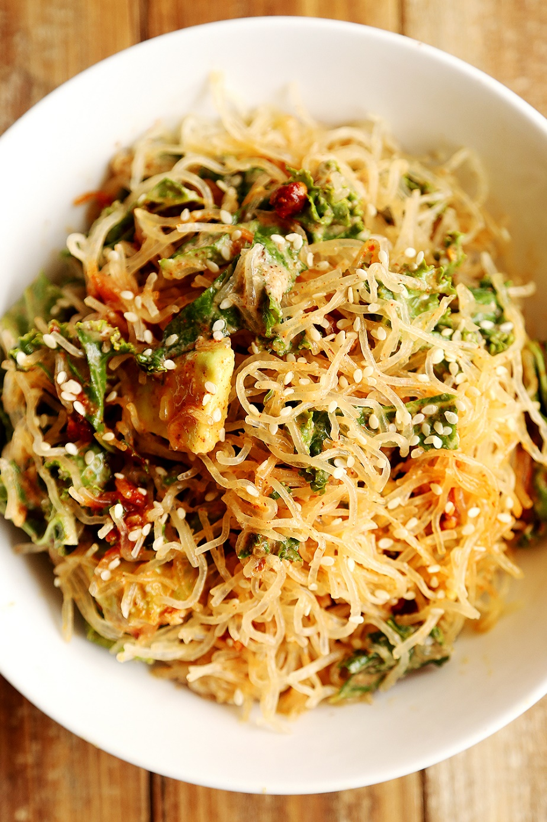

29. Seven-Vegetable Couscous

foodnetwork.com
For when you feel like you just haven't been eating enough vegetables. Recipe here.

30. One Pot Spaghetti Alla Puttanesca

I don’t blame you for being skeptical, since I was too, about this idea of cooking the pasta directly in the sauce. But holy smokes, the pasta really was perfectly cooked, and it could not have been easier. The liquid, as promised, thickened up thanks to the starch in the pasta (here is the whole wheat spaghetti I often use), and formed a light, savory sauce. I foresee that a non-puttanesca iteration will also be happening very soon.
Update 8/2014: I love this recipe so much that I made another one pot pasta using fresh spring veggies (namely zucchini) and a white wine lemon sauce. I’m sure a summer variation will also be coming soon!
Update 4/2016: Yes, the one pot craze bit me hard. Check out my latest one pot recipes! One pot tandoori quinoa; one pot coconut curry pasta; one pot creamy vegan fettuccine alfredo; one pot Moroccan quinoa with red lentils.
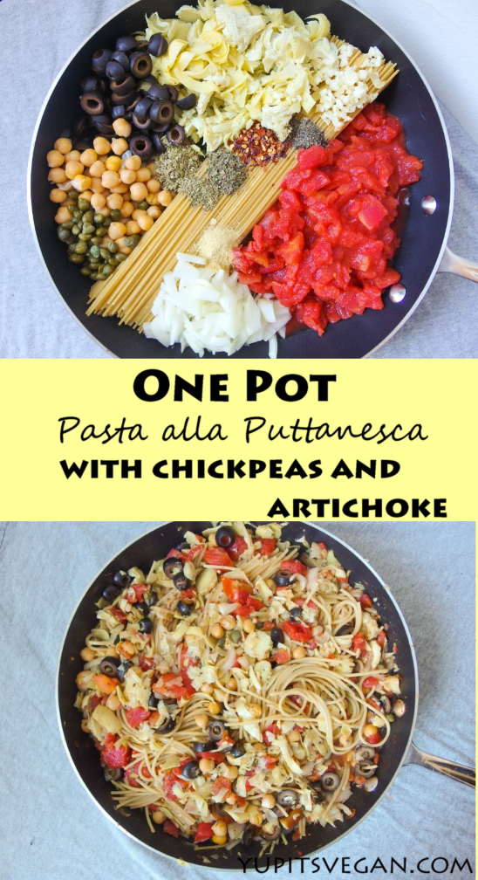
Whether it’s puttanesca or not, I really do think you should try out this one pot pasta cooking method! It’s fast, easy, delicious, and pretty fun to make. Have a bountiful week and weekend!
5.0 from 4 reviews
Save Print
One Pot Spaghetti Alla Puttanesca with Chickpeas & Artichoke Hearts
Prep time: 10 mins
Cook time: 15 mins
Total time: 25 mins
Serves: 4-6 servings

This one pot spaghetti alla puttanesca packs a punch of protein & flavor with whole wheat pasta, olives, capers, chickpeas, and artichoke hearts, plus a little spice. It can be ready in under 30 minutes, and it's totally vegan!
Ingredients
- 12 oz. whole wheat spaghetti (you should not substitute for this; see notes)
- 2 oz. sliced black olives (up to 4 oz. for olive lovers)
- 1 (14-oz.) can artichoke hearts, rinsed, drained, and chopped
- ¾ c. cooked chickpeas
- 2 tb. capers
- ½ large white or yellow onion, minced
- 2 cloves garlic, minced
- 1 (14-oz.) can diced tomatoes, low sodium or no salt added
- 1 tb. dried oregano
- 1 tsp. dried basil
- ½ tsp. dried thyme
- ½ tsp. red pepper flakes (reduce to ¼ tsp. if sensitive to heat)
- ½ tsp. ground black pepper (reduce to ¼ tsp. if freshly ground)
- salt (see notes)
- 3 c. vegetable broth, low sodium or no salt added
Instructions
- (Optional step). If you have a few extra minutes, warm a teaspoon or so of olive oil in the pan, and then add the onions and garlic, stirring occasionally until just starting to turn golden. Add a splash of broth to loosen up the onion and garlic before proceeding to the next step as written.
- Add the pasta to a large, deep skillet, breaking in half if needed (a saucepan may also work)
- Add the rest of the ingredients, minus the broth, to the pan on top of the pasta (artsy arrangement not necessary!)
- Pour the vegetable broth over everything.
- Cover the pan and bring to a boil. Reduce to a steady simmer (medium to medium-low heat) and, keeping covered & stirring occasionally, cook for 8-10 more minutes, or until pasta is done through.
Notes
The starch from the whole wheat pasta thickens the broth into a mild sauce and that's what makes this recipe work its magic. Gluten-free pasta will have different results and may need different quantities of liquid. Check out the comments for some readers' experiences making this gluten-free. Regular (not whole wheat) pasta is what the original recipe used, and it called for more liquid (4 cups) because white pasta releases more starches. I personally have not tested with anything other than whole wheat.
My olives, artichoke hearts, chickpeas, capers, and tomatoes all came from (BPA-free) cans, so I found that I didn't need to add any salt, even with my homemade salt-free vegetable broth. It's easiest to salt to taste after the pasta is done cooking, but if none of your ingredients have salt added, I recommend adding a bit before cooking in order to get the same results that I did.
In my picture the onions are chopped, but they will do a better job cooking through if you mince them. Sorry for the visual deception.
Finally, I have heard some feedback that the leftovers can get soggy. I think you can minimize the chances of this by: 1) cooking the pasta to al dente, 2) tossing with a bit of olive oil before you store it, and/or 3) let it fully cool, uncovered, before storing.

yupitsvegan.com
It doesn't get much easier (or more delicious) than this. Recipe here.

_Spicy Chickpea Veggie Burgers (Vegan, Gluten-Free)
I’ve made veggie patties at home many, many times before but they almost almost fall apart. You can imagine how happy I was to find tonights spicy chickpea veggie burgers sticking together throughout cooking and eating. Not only did they stick together but the taste was awesome! I found myself sneaking bites of the uncooked mixture as I was making the patties. Feel free to sample as you go – no raw eggs or meat involved!
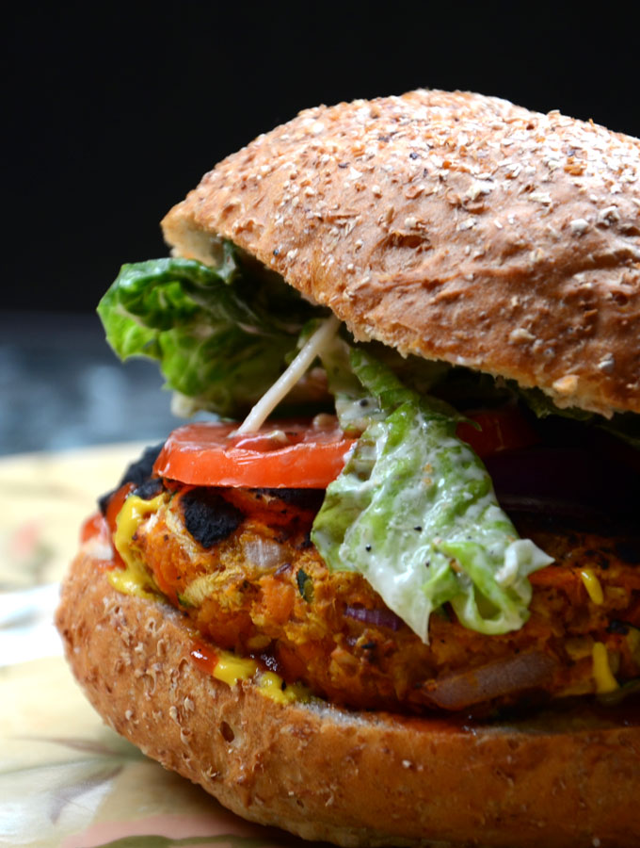Save
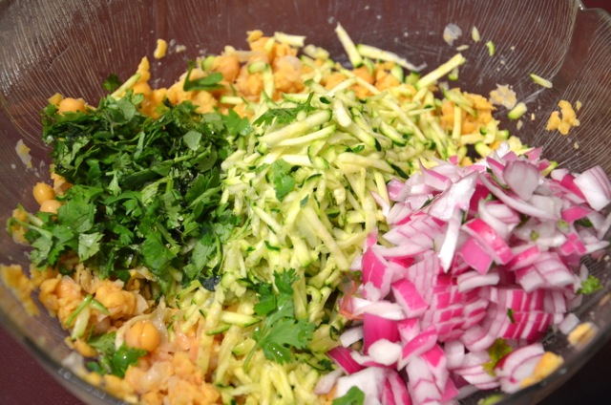Save
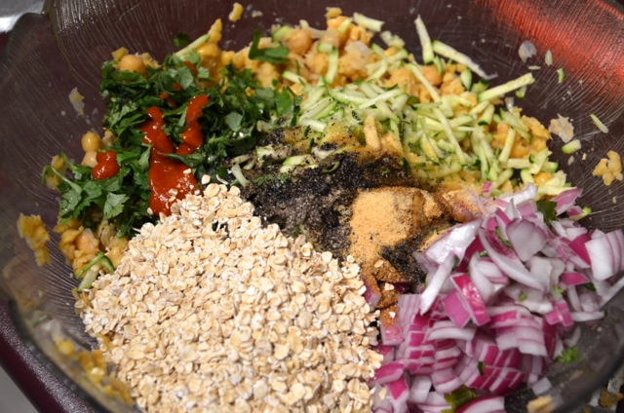Save

Homemade All The Way
These wonderful patties are an excellent alternative to those store-bought versions that pretend to be veggie burgers. Have you ever read the list of ingredients in some of those products?! Wow! There’s not much resembling vegetables in them and they’re often packed with preservatives, sodium and other additives.
Years ago, I used to buy those frozen, boxed veggie burgers and other meat-wannabe products, but these days I just can’t stomach those yucky ingredients and honestly the taste leaves plenty to be desired. Homemade patties to the rescue!
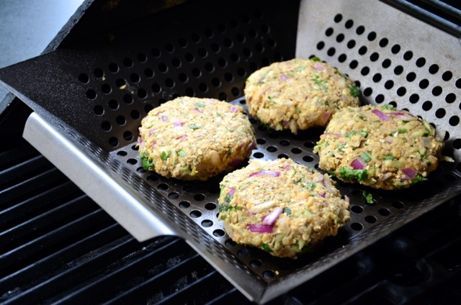Save

Easy and Flavourful
In addition to being full of flavour, these patties only take about 10 minutes to prep and you probably have most of the ingredients already! Feel free to switch up the spices and flavours as needed but I love the tangy red wine vinegar with the peanut butter, Sirracha and cilantro. It doesn’t quite sound like it should work but it really does, I swear!
Save

Spicy Chickpea Veggie Burgers
In the end I ate this patty on a toasted whole-wheat bun topped with avocado, salsa and lettuce but I had to take a few fancy, pretty pictures first! Tomorrow I’ll eat a few patties over salad for lunch. They will even work as a healthy and filling grab-n-go snack since they actually hold together!
Print

Chickpea Veggie Burgers
★★★★★
4.8 from 67 reviews
These easy to make veggie burgers are bursting with flavour and make an excellent alternative to store-bought versions. Try them on the BBQ for a delicious meal perfect for a summer afternoon.
- Author: Deryn Macey
- Prep Time: 10 mins
- Cook Time: 10 mins
- Total Time: 20 minutes
- Yield: 6-8

Ingredients
- 1 can chickpeas, drained, well-rinsed,and mashed
- 1/2 red onion, finely diced
- 1 small zuchinni, grated
- 3 tbsp finely chopped cilantro
- 3 tbsp red wine vinegar
- 1 tbsp sriracha sauce
- 2 tbsp natural peanut butter
- 1 tsp cumin
- 1 tsp garlic powder
- 2 tsp black pepper
- 1/2 tsp sea salt
- 1 cup quick oats (gluten-free if needed)
- 2 tbsp olive oil

Instructions
- After draining and rinsing the chickpeas, place them in a bowl and mash them with a fork.
- Add all the other ingredients to the bowl.
- Use your hands to mix very well.
- Form into 6-8 patties.
- Cook on the BBQ around 400 F for approximately 10 minutes each side.
- You can also fry these in a pan with some oil for 3-5 minutes a side.

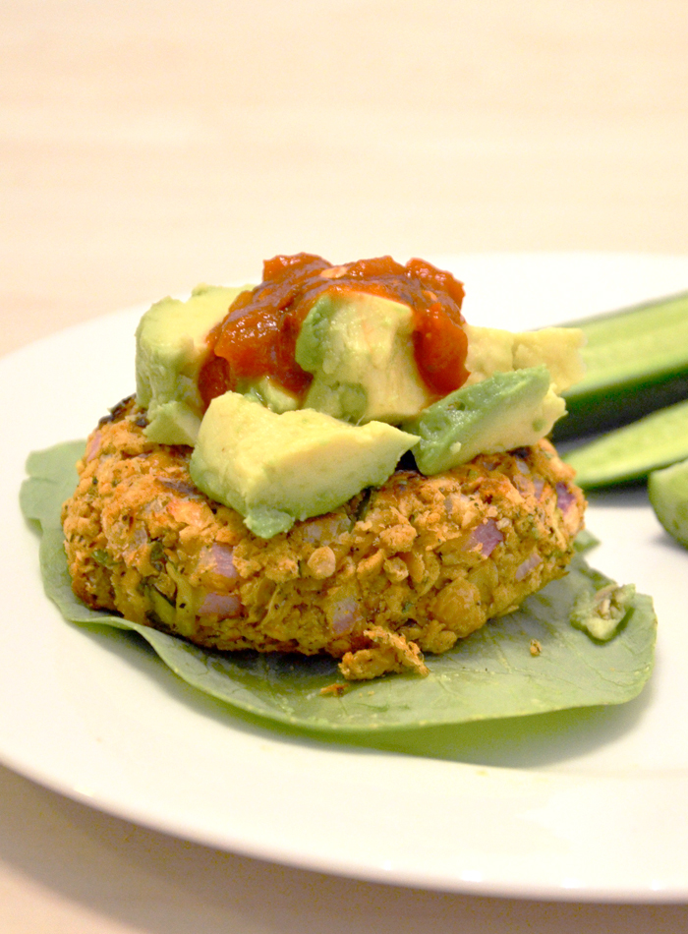Save

Related Posts
__immering some garlic, ginger, and dried mushrooms with your chicken broth makes for a great quickie “stock”. A good while in the pot will get some nice flavors going soon to be soaked up by those noodles. And by good while, I mean 19 minutes, because the whole thing takes 20.
Truth: I dislike when bloggers use the word rambling to describe themselves. BUT I AM DOING THAT. It’s late. I’ve had another long day (parent teacher conferences – they get me every time) and here I am writing this absurd post about what I eat when I’m being regular.
Please still like me.
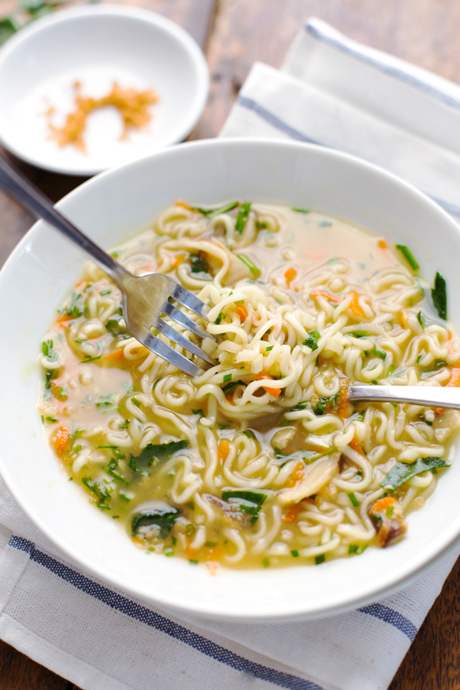
Truth: at the end of the day, bright veggies + flavorful broth + golden panko crumbs + chewy noodles in a bowl eaten at your own table in your own house with your own regular people is the best way.
print recipe pin recipe for later
4.5 from 35 reviews
Quick Homemade Ramen
Serves: makes 6 heaping 1-cup servings

Ingredients
- 1 tablespoon sesame oil
- 3 teaspoons grated ginger
- 4 teaspoons grated garlic
- 4 cups broth (I used chicken, but vegetable would also work)
- 4 cups water
- 1 ounce dried shiitake mushrooms
- 2 packages instant ramen (noodles only!)
- ½ cup chopped scallions or chives
- 2 cup chopped kale
- 1 cups shredded carrots
- Sriracha to taste
- crunchy golden panko crumbs for topping (see notes)
Instructions
- Heat the sesame oil in a large skillet over medium low heat. Add the garlic and ginger; stir fry for 2 minutes or until soft and fragrant. Add the broth and the water. Bring to a simmer; add the mushrooms and simmer for 10 minutes or until the mushrooms have softened and the broth is flavorful.
- Add the instant noodles to the hot liquid and simmer for an additional 5 minutes or until the noodles have softened. Add the scallions and stir to combine. Remove from heat, stir in the kale and carrots, and top with crunchy panko crumbs (see notes) and hot sauce to taste.
Notes
To make crunchy golden panko crumbs, heat a few tablespoons of oil in a large skillet over medium heat. Add the panko, stir for one minute or less, or until golden brown. Remove and place on paper towels to drain. You can also toss the panko with a little oil and toast them in the oven to get them golden and crispy.
Endurance Crackers
by Angela Liddon
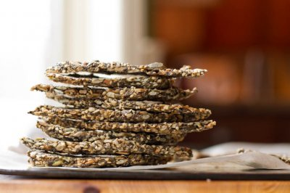
  PREP: 5 MINS
  COOK: 60 MINS
  Keywords: bake appetizer breakfast lunch snack dairy free gluten-free low sugar low-carb nut-free oil free soy-free vegan vegetarian
whose butt do you want to kick today? These Endurance Crackers are extremely light and crispy while providing long-lasting energy. They are also vegan, gluten-free, soy-free, nut-free, sugar-free, and oil-free to boot! Feel free to change up the seasonings and spices as you wish! Nutritional info follows. Inspired by Chocolatree Cafe in Sedona, AZ.
Instructions
- 1. Preheat the oven to 325F and line a large baking sheet with parchment paper.
- 2. In a large bowl, mix the seeds together. In a small bowl, mix the water, grated garlic, and grated onion. Whisk well. Pour the water mixture onto the seeds and stir until thick and combined. Season with salt, and optional Herbamare and Kelp granules, to taste. Add spices or fresh herbs if you wish.
- 3. Spread the mixture onto the prepared baking sheet with the back of a spoon until it’s less than 1/4 inch thick. Not to worry if a couple parts become too thin, you can just patch them up.
- 4. Bake at 325F for 30 minutes. Remove from oven, slice into crackers, carefully flip onto other side with a spatula. Bake for another 30 minutes, watching closely after about 25 minutes. The bottoms will be lightly golden in colour. Allow to cool completely on the pan. Store in a container or plastic baggy.
- Nutritional Info: (per cracker, makes 22 large crackers): 77 kcals, 6 grams fat, 4 grams carbs, 0 grams sugar, 3 grams fibre, 3 gram protein.
Ingredients
- 1/2 cup chia seeds
- 1/2 cup sunflower seeds
- 1/2 cup pepita seeds (or pumpkin seeds)
- 1/2 cup sesame seeds
- 1 cup water
- 1 large garlic clove, finely grated
- 1 tsp grated sweet onion
- 1/4 tsp kosher salt, or to taste
- Herbamare & kelp granules, to taste (optional)
_________________________________________
_______ Stuffed Mushroom Phyllo Roll & Mango Kale Salad
by Angela Liddon
Ingredients
- 7 sheets Phyllo dough, thaw according to package directions
- 16 oz/7 cups sliced fresh Crimini mushrooms (or mushrooms of choice)
- 1 tsp olive oil
- 1 cup chopped sweet onion
- 2 finely chopped garlic cloves
- 1-2 tbsp fresh Thyme (or use 1/2 tbsp dried)
- Kosher salt, Herbamare, and freshly ground black pepper, to taste
- 1 cup kale leaves, roughly torn and stems discarded
- 1/2 cup shredded Daiya Cheese
- ~1/2 cup melted Earth Balance, olive oil, OR cooking spray
Mango Kale Salad
- 1 bunch kale, stalks removed and leaves roughly torn
- 1 lemon juiced
- 1 tbsp + 1-2 tsp olive oil, to taste
- Kosher salt or Herbamare & freshly ground black pepper, to taste
- 1-1.5 tbsp pure maple syrup
- 1.25 cup diced mango (I just thawed frozen mango chunks)
- 2 tbsp pepita seeds, or other seed of choice

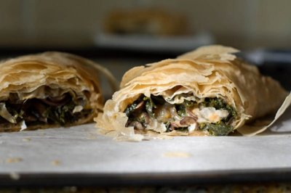
  FULL POST PRINT EMAIL TEXT
  PREP: 30 MINS
  COOK: 25-35 MINS
  Keywords: bake raw appetizer entree salad vegetarian vegan soy-free nut-free
Perfect for a fancy meal to impress. Hands down, one of the best savoury vegan foods I’ve made. This mushroom pastry is buttery, flaky, cheezy and will have you ohhing and awwing with every sinful bite. The Mango Kale Salad is quite nice too, but we still prefer the Weekend Glow Kale Salad

Raw Vegan Berry Tarts with Chocolate Mousse
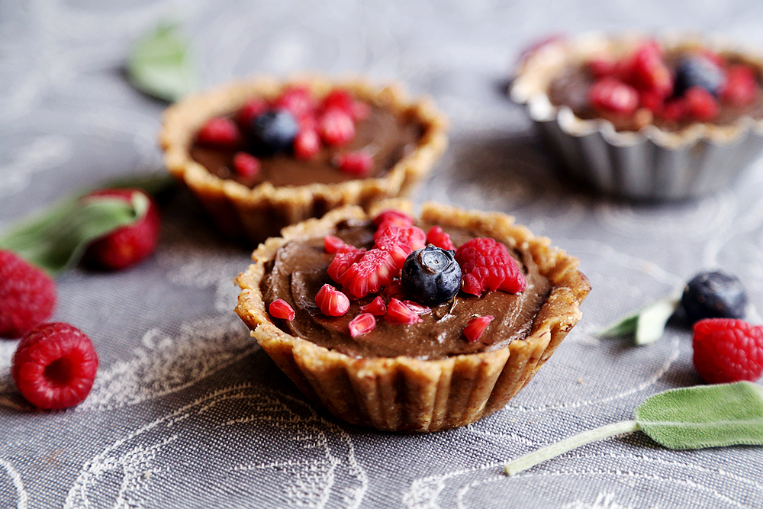
For a long time, I’ve been too scared of using the mini tartlet pans because I can never get the bloody things out! >_<;
You can just picture me scrapping the crust off, breaking it, cursing and thinking how on earth do I fix that, well, until I discovered this amazing way you can use it without all of that happening…
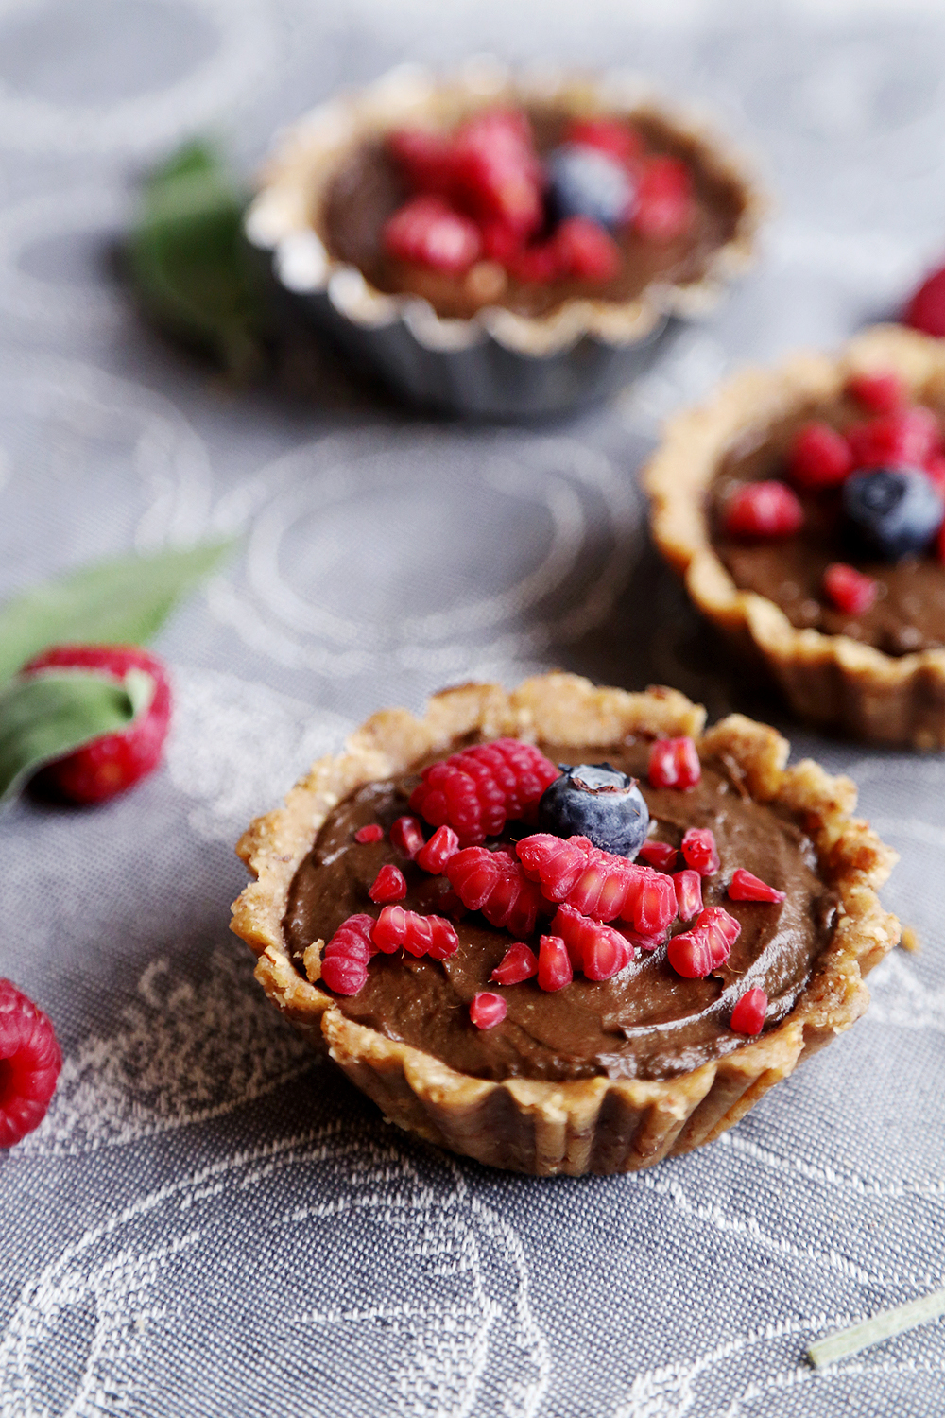
Use those little white circle muffin parchment cup things! Even though the muffin parchment paper cups are NOT the shape of the tart pans, when you press it on the pan, the paper will take the shape of the pan. YAY!
So this totally solved a big problem of mine, I can make TARTS again!
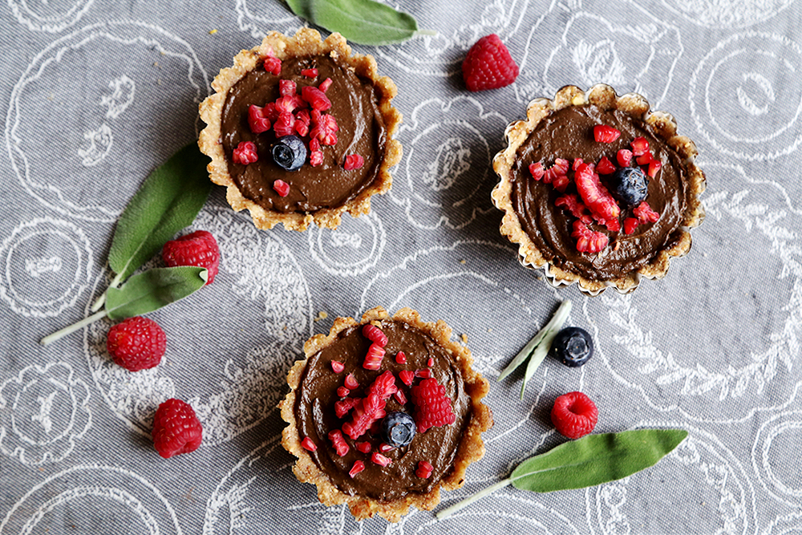
What is the sage doing in the pics, you may ask? Well, absolutely no reason, just to sit there looking pretty. Of course, if you dare to try a different flavour, you can always add some sage leaves, but I do not guarantee any result as I didn’t actually do that.
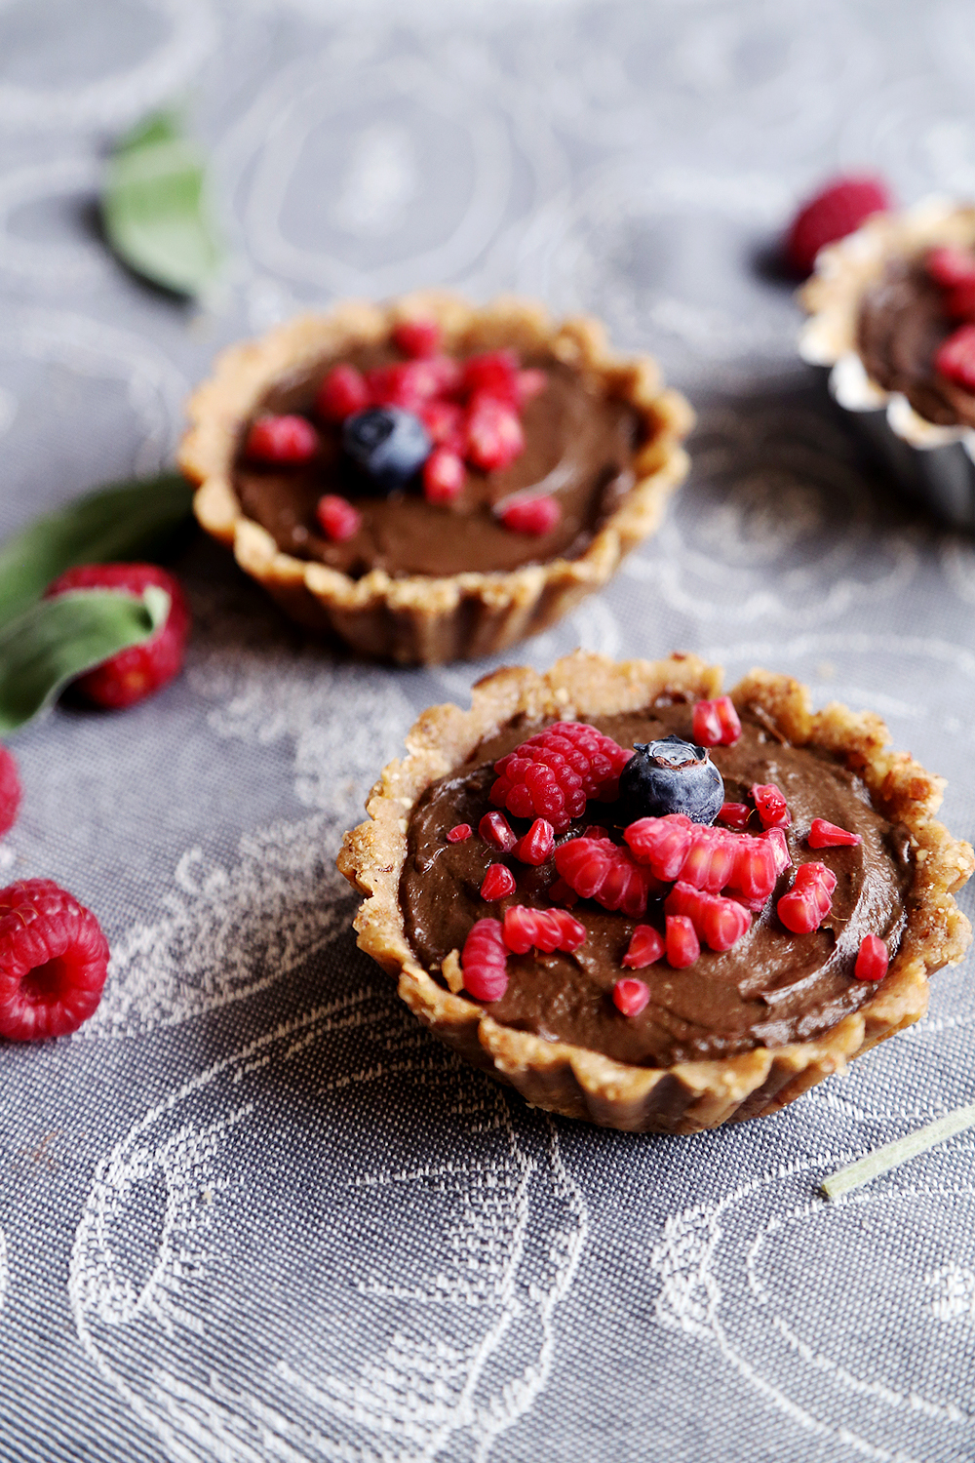
Anyway, I’m so happy I finally made use of the leftover berries I was using for a smoothie earlier this week. They always make such PRETTY desserts. OMG, the avocado this time turned out extra thick, which was really great. I think it has to do with that this avocado was not overripe, I tend to sometimes leave it in the fridge for too long.
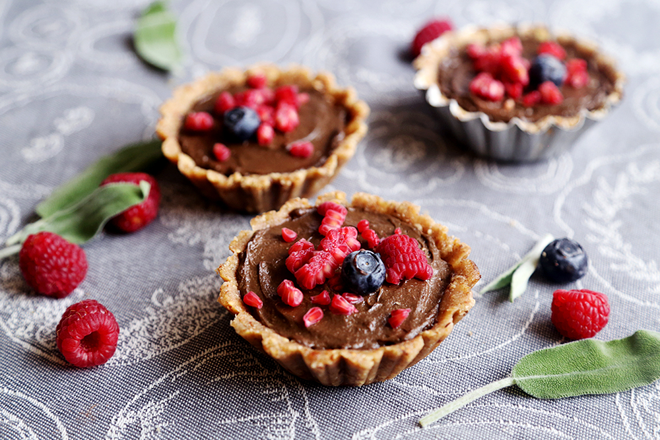
Raw Vegan Berry Tarts with Chocolate Mousse
Crust
1/2 cup oat flour
1/4 cup walnuts
2 tablespoons almonds
2 dried figs
1 tablespoon unsweetened almond milk
1 tablespoon walnut oil (or other preferred oil)
1 teaspoon pure vanilla extract
Filling
1 avocado
2 tablespoons pure maple syrup
1 tablespoon extra virgin coconut oil
1 tablespoon lucuma
1 tablespoon cacao power
1 tablespoon dark cocoa powder (eg Hershey’s Special Dark)
1 teaspoon pure vanilla extract
Topping
A small handful frozen raspberries and blueberries
Be sure that you’ve frozen a small handful of raspberries and blueberries. The raspberries will not break properly if they aren’t frozen, so this step is important.
Add all the ingredients for the crust into the blender. Blend on full speed until the mixture is crumbly and somewhat sticky. You may need to open the blender, spoon it around a little and blend again.
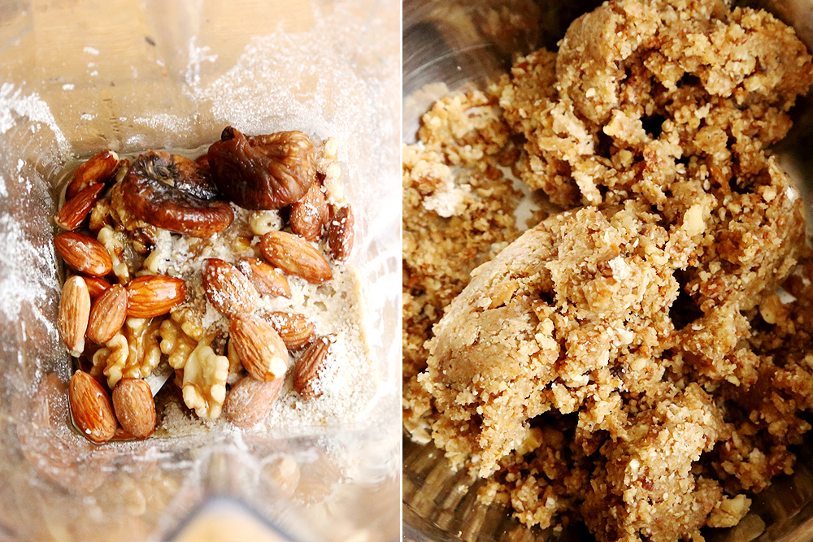
Spoon the mixture into a bowl and set it aside for now, then clean out the blender.
Remove the skin and pit from the avocado and add it to the blender, then add the rest of the filling ingredients in. Blend on full speed again until everything is completely smooth and well mixed. Again, use a spoon to mix it after a while, then put it back to be blended on high speed again.
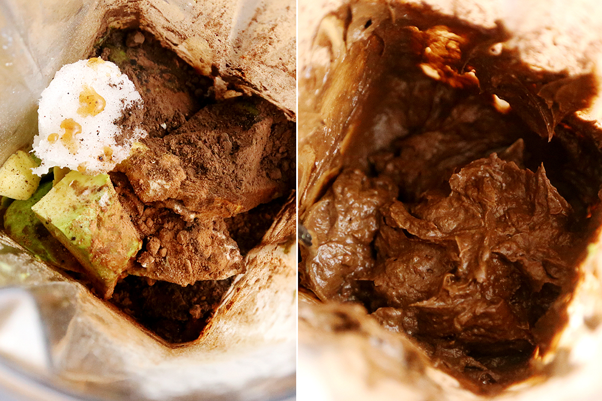
Leave the avocado chocolate mousse in the blender for now.
Prepare 3 mini tartlet pans and three muffin parchment paper (believe me, you will find the parchment paper useful, as it helps get the crust OUT of the pans easily).
Put the muffin parchment paper on the tartlet pans.
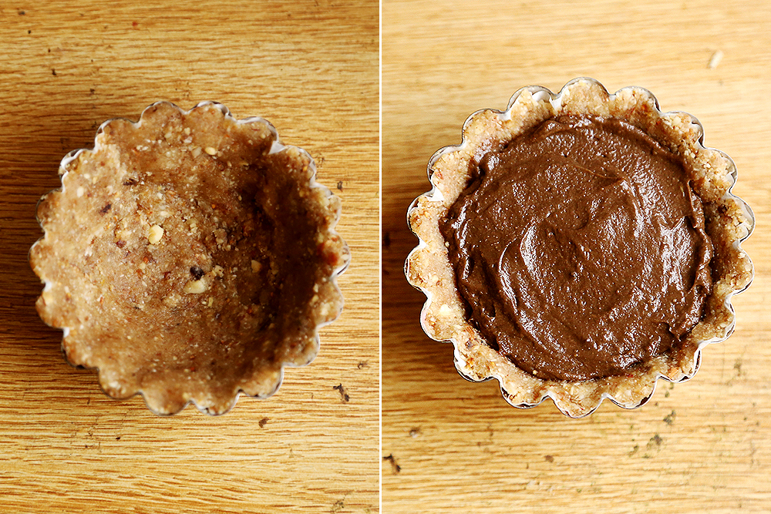
Spoon 1/3 of the filling onto the muffin parchment paper sitting on the tartlet pan and press it around to form a crust. Then, add a couple of spoonfuls of avocado mousse in the middle and use a spoon to even out the top.
Finally, get a frozen raspberry or two and break it into small pieces and spread it on top of the tart. Add a blueberry as well.
Repeat for the other two tarts and eat any remaining avocado mousse filling.
put it in the freezer for about 20-30 minutes, then carefully take the tarts with the parchment paper out of the tartlet pan, and peel the parchment paper off. (If you didn’t use it, you may end up furiously scraping the crust off the pan, with little or no success, resulting in broken tarts.)
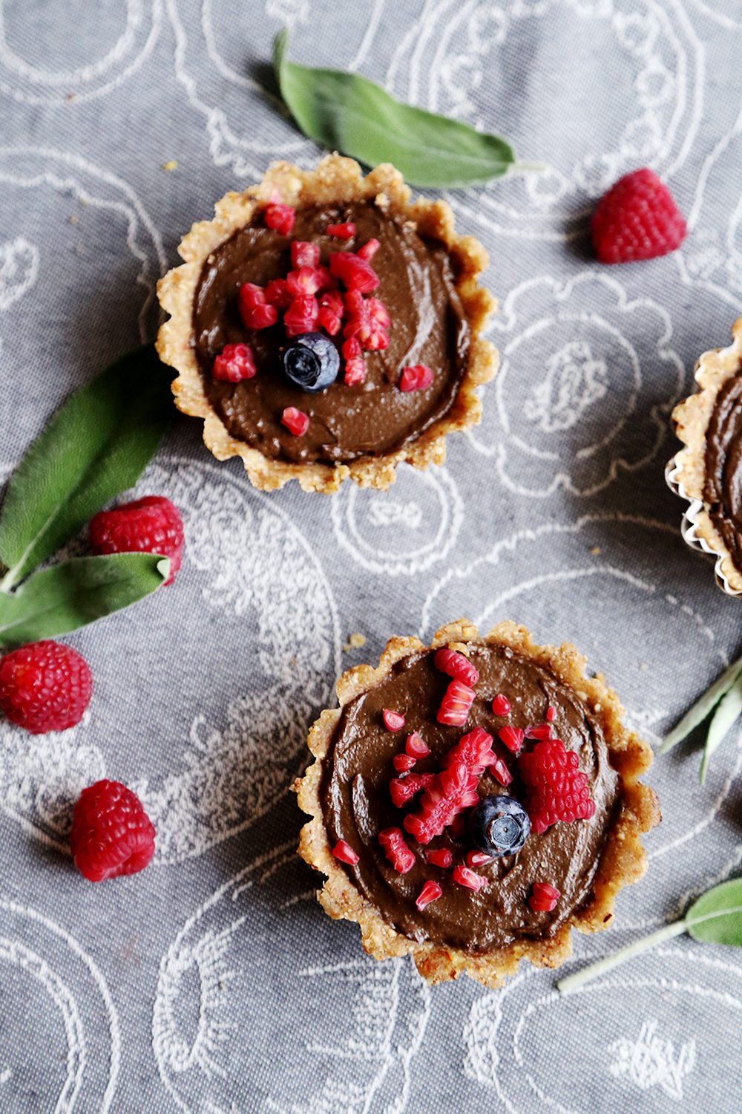
Print
Raw Vegan Berry Tarts with Chocolate Mousse
Serves: 3

Ingredients
Crust
- ½ cup oat flour
- ¼ cup walnuts
- 2 tablespoons almonds
- 2 dried figs
- 1 tablespoon unsweetened almond milk
- 1 tablespoon walnut oil (or other preferred oil)
- 1 teaspoon pure vanilla extract
Filling
- 1 avocado
- 2 tablespoons pure maple syrup
- 1 tablespoon extra virgin coconut oil
- 1 tablespoon lucuma
- 1 tablespoon cacao power
- 1 tablespoon dark cocoa powder (eg Hershey’s Special Dark)
- 1 teaspoon pure vanilla extract
Topping
- A small handful frozen raspberries and blueberries
Instructions
- Be sure that you’ve frozen a small handful of raspberries and blueberries. The raspberries will not break properly if they aren’t frozen, so this step is important.
- Add all the ingredients for the crust into the blender. Blend on full speed until the mixture is crumbly and somewhat sticky. You may need to open the blender, spoon it around a little and blend again.
- Spoon the mixture into a bowl and set it aside for now, then clean out the blender.
- Remove the skin and pit from the avocado and add it to the blender, then add the rest of the filling ingredients in. Blend on full speed again until everything is completely smooth and well mixed. Again, use a spoon to mix it after a while, then put it back to be blended on high speed again.
- Leave the avocado chocolate mousse in the blender for now.
- Prepare 3 mini tartlet pans and three muffin parchment paper (believe me, you will find the parchment paper useful, as it helps get the crust OUT of the pans easily).
- Put the muffin parchment paper on the tartlet pans.
- Spoon ⅓ of the filling onto the muffin parchment paper sitting on the tartlet pan and press it around to form a crust. Then, add a couple of spoonfuls of avocado mousse in the middle and use a spoon to even out the top.
- Finally, get a frozen raspberry or two and break it into small pieces and spread it on top of the tart. Add a blueberry as well.
- Repeat for the other two tarts and eat any remaining avocado mousse filling.
- put it in the freezer for about 20-30 minutes, then carefully take the tarts with the parchment paper out of the tartlet pan, and peel the parchment paper off. (If you didn’t use it, you may end up furiously scraping the crust off the pan, with little or no success, resulting in broken tarts.)




 
 

