[Via realfarmacy.com and hometalk.com]
James Bryan had a bright idea that resulted in something brilliant. Gardeners and repurposing fanatics behold, keyhole garden, meets tomato cage, meets drip irrigation. The setup is obviously simple yet highly functional and effective. You can whip one of these up for next to nothing, especially if you salvage the fencing.

Bryan says:
I started may 28th planting 4 tomatoes around a garbage can with holes drilled in the bottom rim and a second row up about 10 inches… buried the can to where the top holes just barely were above the ground… put in two shovels full of compost… then I fill the can up with water every 2 days and try not to water the leaves… these four plants are now 5 ft 4 inches in less that a month and a half and loaded with green tomatoes and about a hundred sets of tomato blossoms…
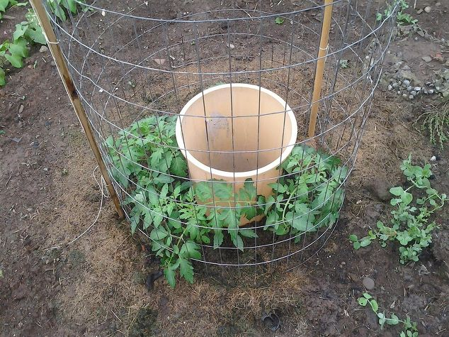

May 28th

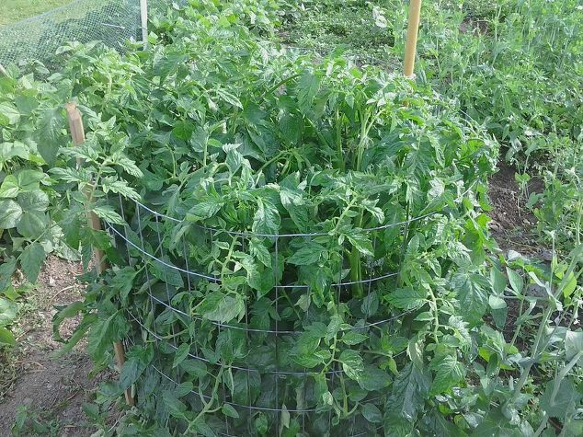

End of June, 3 ft cage

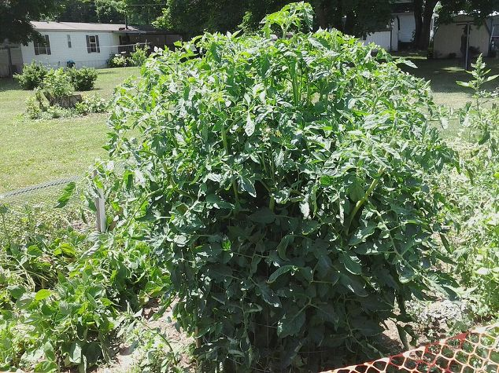

July 9

“July 9th after a week of record high temps and very little rain…the plants here are loaded with tomatoes inside the cage and full of blooms too!” -James Bryan via Hometalk
Bryan used a 13 gallon kitchen garbage can to grow the tomato plants above but has since switched to using 5 gallon buckets because they’re a lot cheaper and easier to find in quantities.
You could even use a larger can as long as you provide each plant with 5 gallons of water per week. For instance if you use a 5 gallon bucket and plant 2 tomato plants around it you fill the 5 gallon bucket 2 times per week. Or a 13 gallon can filled twice yields 26 gallons, so you could plant up to 5 plants around it.
“I grow tomatoes now for market, and I have a higher yield per plant than most other growers,” Bryan says.
Editors note: Click here to Find a Local Farmer

