FacebookTwitterGoogle+Share14k

Multiple recent reports exposed conventional foods manufactured in China as fake and even toxic: scams involving rice that contains plastic, fake eggs made from chemicals and many food items containing high levels of arsenic.
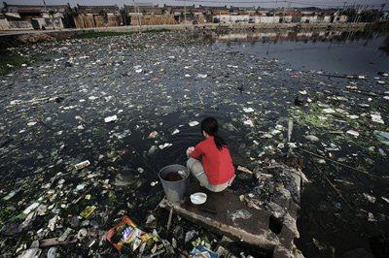Polluted water is a growing problem in China, where it may be used to water crops.

Now that country-of-origin labeling has been removed by Congress (for meat), and companies are struggling to find new sources of food to meet the growing demand for organics in the United States, it’s becoming more likely that your organic food could come from China or other countries rather than U.S. farmers.
Considering the country’s overall level of pollution and shocking lack of standards compared with the U.S., that could be a serious problem. Here are six reasons why:
1.Organic Products from China Can Contain an Unlimited Amount of Heavy Metals
While certified organic does mean that the producer cannot add pesticides, herbicides, heavy metals and other toxins when growing the produce, there are no rules about the outside environmental factors such as pollution.
A farmer in China can use water with mercury or chemicals on the crops and keep the organic label. Since many parts of China have been experiencing extreme pollution (to the point that some have been buying canned air out of desperation), a lot of its water is heavily polluted. But the lack of traceability in comparison to U.S. organic farms means you’ll have a hard time finding out any more information on how it was grown.
2. China Has Almost No Environmental Regulations
China is on a verge of a complete environmental disaster. Lack of regulation has caused the country to experience record air pollution in Beijing, and studies have shown that at least 40% of rivers are polluted, as well as 90% of groundwater, reported The Guardian. According to another report in the paper, about 1/5 of the country’s farmland is polluted.
This is the same water that may be used to water the “organic” crops.
While there are companies that are honest and wise when it comes to growing organic produce, it is nearly impossible to know who to trust.
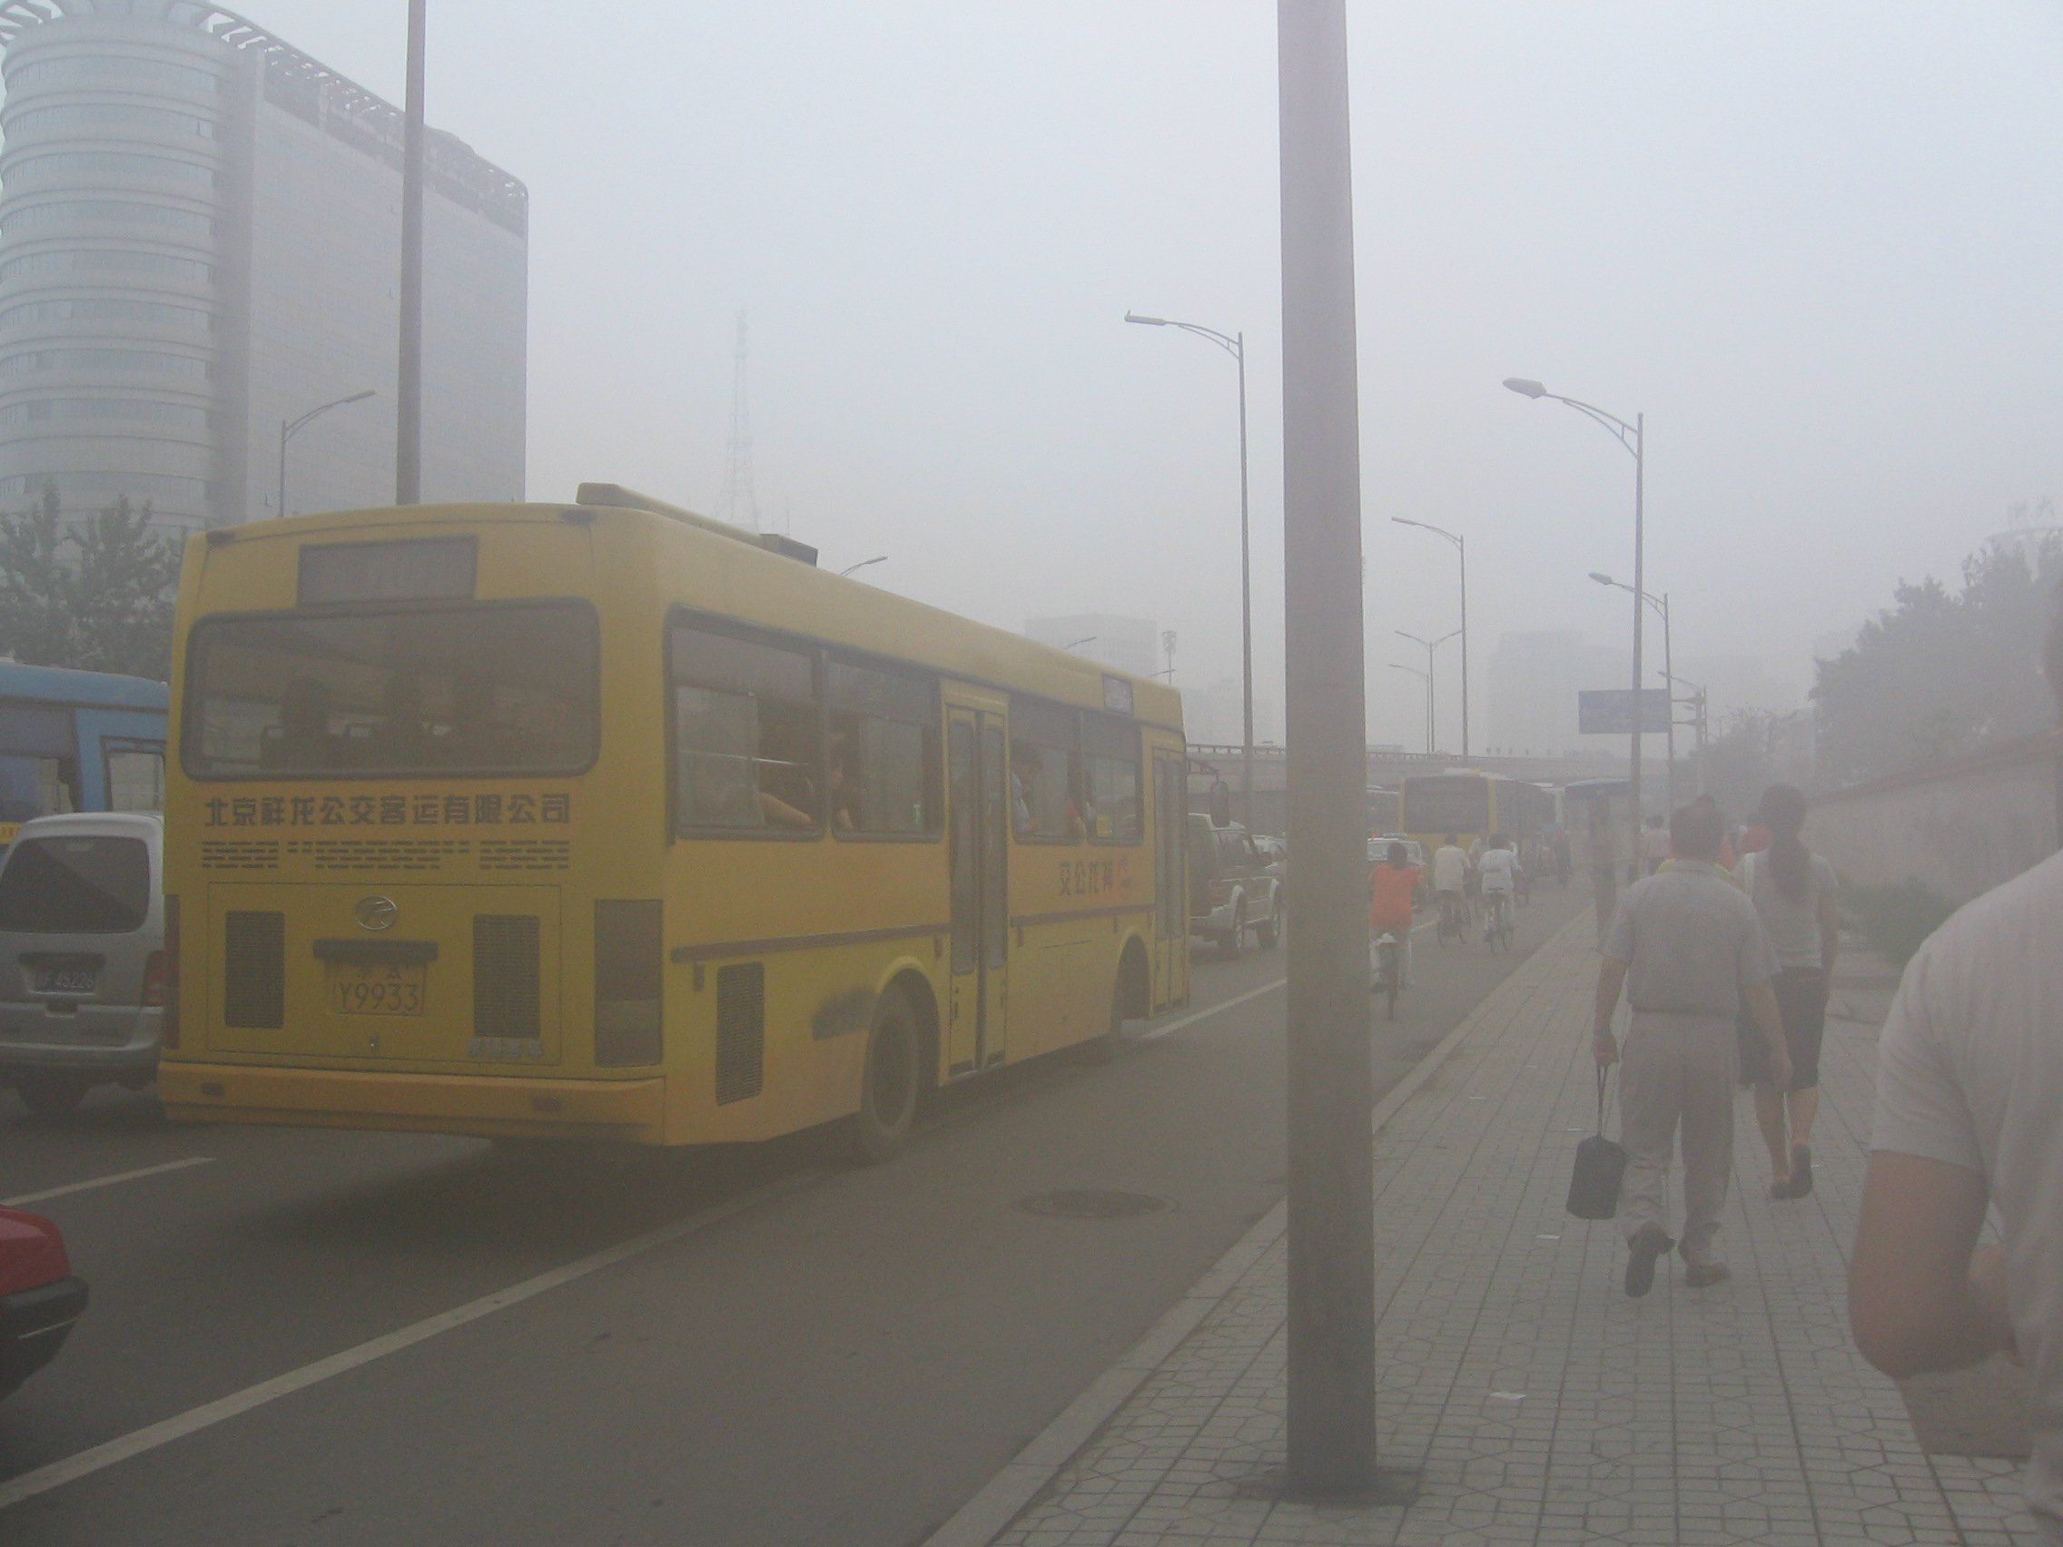Environmental problems such as smog and polluted waterways are becoming rampant through much of China. Photo: Wikipedia Commons.

3. Agencies and Government Departments in China are Not Operating Properly
Guangzhou Daily reported that when one consumer wanted to inform someone about fake organic produce, they were bounced between four government departments before finding out that none of them had the authority to deal with this problem, according to The Epoch Times, an independent source of news from China.
At the same time the USDA is trying to keep track of all the shipments coming from China (though the agency has fraud allegations of its own), but they have reported that several shipments of organic beans and berries were full of unsafe pesticides. Whichever agency on the Chinese side approved the shipment was not following regulations.
Reports have also stated that numerous Chinese food growers simply buy organic certification paperwork illegally and then grow foods in a non-organic way.
4. Supplements and Herbs from China Are Often Contaminated with Lead
Because many herbs have detoxifying properties, they absorb heavy metals easily. It has been tested, for example, that chlorella from China was most contaminated with aluminum, and also contained arsenic, cadmium and lead.
Although not organic, many conventional green tea companies have illegally used banned chemicals, as reported by Greenpeace. Can it happen to organic tea? – It might, because organic certification in China cannot be trusted.
5. Corruption: China Has Forged Organic Certification Label and Other Documents
Rumors about companies in China forging documents have been around for years. And in 2011 USDA released evidence of a fraudulent organic certificate made by a non-certified company. The firm used this fake certification to pass non-organic soy, millet and buckwheat as organic, according to the Cornucopia, the nation’s farming watchdog.
6. Organic Products in China are Often Certified by Third-Party Agencies
The agency in charge of certifying organics in China is The Chinese Organic Certification Center (COFCC). However it has been reported that they only inspect 30% of products, the rest are inspected by private third-party firms.
Though organic products imported to the US are supposed to be certified by a USDA certifier, there are not enough certifiers to meet the need, and the USDA relies on hiring third party certifiers in China. On at least one occasion the certifier from China provided the paperwork but did not physically confirm that the organic food complied with the organic regulations.
Until better regulations are enforced in China, and the country resolves its pollution problem, it might be wise to avoid food from China altogether, even if it has the “organic” stamp on it. Because even if it was not forged, it might not mean a whole lot considering the country’s dire environmental situation.
According to a 2008 investigation by a news station in Washington, D.C., Whole Foods in particular sells a ton of organic products from China. The company’s organic “California Blend” even came from the country, before this investigation came out and forced Whole Foods to change. Whole Foods said in 2010 that it stopped sourcing frozen veggies from China in its own line of products, except for edamame.
Learn more in the video player below:

If you enjoyed this article or learned something new, please don’t forget to share it with others so they have a chance to enjoy this free information. This article is open source and free to reblog or use if you give a direct link back to the original article URL. Thanks for taking the time to support an open source initiative. We believe all information should be free and available to everyone. Have a good day and we hope to see you soon!

