Top 8 “immunity builders” that actually contain insanely dangerous ingredients
Monday, November 27, 2017 by: S.D. Wells
Tags: bad vaccines, circovirus, flu shot scam, health hazard, influenza vaccine dangerous, rotateq toxic, small pox, toxic flu shot, toxic ingredients, vaccine scams, vaccine toxins
2,970Views
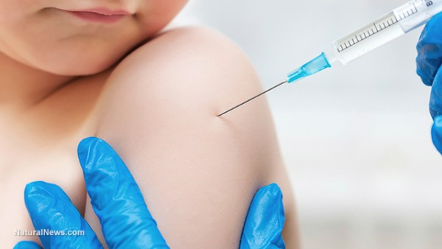
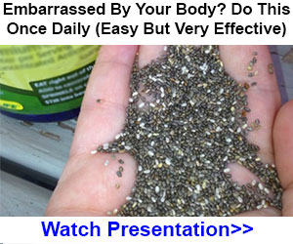
(Natural News) What if your doctor told you that taking out a small chunk of your brain will help you build immunity against infectious diseases – would you let the surgeon get to work on you and your children? The dire risk versus the inflated benefit would certainly need to be weighed and considered quite carefully. Why? You might lose your ability to socialize in a normal fashion, or lose some basic coordination skills, such as the ability to write with a pen or ever play sports again. The upside would be that you might have better immunity against some rather benign diseases, like rotavirus, chicken pox, measles and human papillomavirus (HPV). Then again, you might not. Most vaccines are just a “shot in the dark.”
What if you found out today that vaccines aren’t just “equipped” with random strains of genetically modified versions of LIVE viruses, but also pathogens that are often combined dangerously into one vial and loaded with preservatives that cause central nervous system disorders, severe (and deadly) allergies and sometimes death? Then what?
Every doctor in the U.S. is well-trained to tell you that all of the dangerous neurotoxins, excitotoxins and chemical “adjuvants” in vaccines are included in such minuscule amounts that they pose no danger, but what they ALL fail to mention is that the toxic vaccine industry has already paid out $3,000,000,000 (yes, that’s $3 billion) in damages for maiming and killing young and old patients alike. The doctors also fail to mention that it’s MORE dangerous to inject these “minuscule” amounts than it is to eat them because they bypass your normal filtration defenses, like saliva, digestive enzymes, lungs and skin.
The bottom line is that humans are NOT born “immuno-compromised” as the sick care industry would have us all believe. If we eat lots of organic fruits and veggies and take some quality vitamin and mineral supplementation, we’re good to go for fighting off all kinds of infectious diseases, without any side effects, brain damage or CNS complications.
Plus, many vaccines still contain trace amounts (that often aren’t even listed on the vaccine insert) from peanut oil, dairy derivatives, foreign proteins, yeast, and eggs – hence all those severe childhood allergies that the doctors just can’t seem to figure out. The worst part is that the sick care industry now wants YOUR children to get 60 of these hazardous vaccines before age five.
Here is a list of the most dangerous vaccines that the medical community claim offer immunity.

#1. Rotateq Rotavirus Vaccine
This insane jab literally contains two strains of circovirus – a deadly disease (that has “mysteriously” spread to America) that kills pigs. This porcine virus has NEVER been tested for safety on human babies and is proven to cause intussusception, which is the twisting and contorting of your intestines that blocks them and can cause death. Pigs in China are dying by the thousands from circovirus, but no human baby has ever been tested for it nor for the effects of the deadly vaccine that contains it.

#2. Flu Shot (aka influenza vaccine)
Yes, the CDC outright lied to every American a decade ago and said mercury was removed from all childhood vaccines, while keeping it in high doses in most multi-dose vials of flu shots, and then recommending them for babies older than six months and pregnant mothers. High mercury content can cause brain damage and central nervous system damage. This is a scientific fact. Plus, no flu shot has ever been proven effective and it says so right on the vaccine insert sheet, that no doctor or nurse ever reads to the patients. The “Fluad” version contains squalene, an oil-based adjuvant linked to chronic inflammation (rheumatoid arthritis).

#3. Small Pox vaccine
Contains infected African Green monkey kidney cells. This insane vaccination also contains modified medium from an eagle, serum from a calf, embalming fluid for the dead and antibiotics. Got allergies?

#4. Meningococcal vaccine
Contains E. coli. Yes, if you’re afraid of eating tainted meat, be very afraid of getting injected with E. coli directly into your muscle tissue and bloodstream, causing your immune system to attack itself while trying to fight the invading deadly pathogens, yet to no avail. No medical doctor has ever or will ever discuss this vaccine danger with the parents of infants and children.

#5. Rabies Vaccine
Contains human albumin. That means you are engaging in cannibalism if you get injected with this vaccine, taking a chance of getting infected by another human’s blood – someone you’ve never met who could have suffered from AIDS, hepatitis B, STDs, and all the infectious diseases you’re trying to avoid by getting vaccinated in the first place. How ironic!

#6. Varicella (Chicken Pox Vaccine)
The most useless, unnecessary, experimental vaccine ever created. This nightmare concoction contains guinea pig cell cultures, human diploid cell cultures, monosodium glutamate (Yes, MSG that gives babies brain damage), fetal bovine serum and antibiotics to boot. Ask your doctor if injecting neurotoxins and blood cells from other babies directly into your baby’s muscle tissue is right for your family’s needs.

#7. Shingles Vaccine (Zoster)
Pay some freaks in white lab coats to mix together some hydrolyzed porcine gelatin (boiled pigs hooves), MRC-5 abortion cells, urea (yes, animal urine), MSG, and inject it into as many black babies as possible, then call it disease prevention. Welcome to America, home of ethnic “cleansing” (population control and reduction) via experimental inoculations.

#8. MMRV
Oh yes, the measles, mumps, rubella and varicella (chicken pox) combo jab contains human lung diploid fibroblasts – a fancy name for the cells taken from an aborted baby that was stolen from the mother and used for experimentation without her permission, or yours for that matter (aka WI-38). Add in some hydrolyzed gelatin, recombinant human albumin (that means genetically modified) and you’ve got a violent, expensive, deadly allergic reaction just waiting to happen.
Want some immunity help that’s not linked to $3 billion in Big Pharma damage payouts? Go get some natural immune building supplements like garlic, oil of oregano, vitamin C, vitamin D3 (especially in winter), colloidal silver, aloe, chlorella, spirulina, and of course, turmeric.
Check out NaturalPedia.com for other natural remedies you won’t find using the infamous and censored “Google” search scheme.
Sources for this article include:
TheDoctorWithin.com
CDC.gov
CDC.news
NCBI.nlm.nih.gov
qz.com

