Coconut Chia Seed Pudding
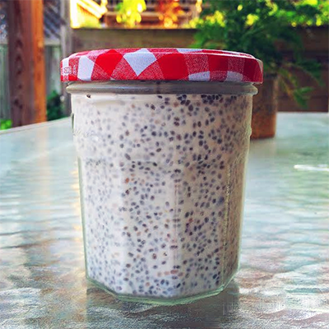

Recipe Courtesy of Meredith Dykstra
- 1/4 cup chia seeds
- 1/2 a can full-fat, organic coconut milk
- 1 tsp vanilla extract
- Pinch of sea salt
- 2 Tbs cacao nibs (optional)
- Optional Toppings: Walnuts and/or fresh or frozen berries
- In a small bowl or jar add chia seeds, coconut milk, nibs, vanilla, salt and mix well.
- Place in the refrigerator for at least two hours, but preferably overnight.
- Top with berries or nuts and enjoy!

