Antioxidants - Tocotrienols

Tocotrienols
Tocotrienols, which are members found in the Vitamin E family, are natural agents that, according to scientific research, have tremendous health benefits and may even affect how such illnesses as cardiovascular disease, diabetes, and certain kinds of cancer are treated in the future.

What Are Tocotrienols and Where Do They Come From?
Tocotrienols can be found in certain kinds of oil, rice, wheat, barley, rye, and oats. They are mainly found in the highest concentration in palm oil, which is derived from the palm nut that is commonly found in Africa and often used as a cooking oil. While their benefits are still being researched (tocotrienols account for less than 1% of research done on vitamin E), they are no doubt a point of interest for researchers throughout the world. While they are natural agents, they are generally found in low concentrations that do not have any appreciable benefits when consumed directly from the food source.

Molecular Makeup
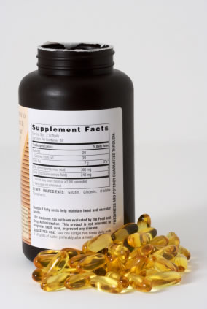
Vitamin E, from which tocotrienols are derived, is essentially divided into eight isomers: four tocopherols (alpha, beta, gamma, delta) and four tocotrienols (alpha, beta, gamma, delta). Both groups share common traits, such as the head, otherwise known as the Chroman Ring; the tail, phytyl tail (found mostly in tocopherols); and the hydoxy group, which is the active group head found at the head of the molecule.

History of Tocotrienols
Tocotrienols were discovered in 1964 by Drs. Pennock and Whittle, from the USDA and Liverpool respectively, who were able to isolate the molecules from rubber. But it wasn’t until the 1980s when their potential benefits were discovered by D
rs. Qureshi and Elson from the University of Wisconsin in Madison, who discovered that tocotrienols could lower cholesterol.
During the 1990s, scientists learned about their anti-cancer properties in their research. One man responsible for developing interest in this field of research was Dr. Barrie Tan, PhD. During the 1980s.

Tocotrienols, Raw Power Brand (16 oz, Raw Rice Bran Solubles) Premium Quality, 100% Raw, Pure, non-GMO
from Raw Power
4.7 out of 5 stars 21 customer reviews
| 12 answered questions

- 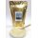
- 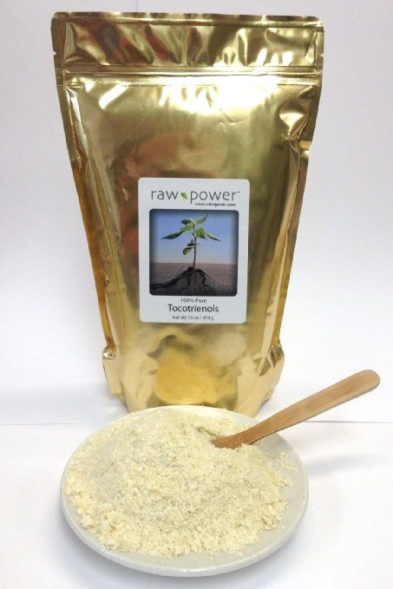

About the Product
- Tocotrienols belong to the Vitamin E family (tocopherals or tocols are the other group).
- Most of the Vitamin E supplements available at local grocery and even health food stores are made using a cheap, synthetic version of alpha-tocopheral.
- Tocotrienols, on the other hand, can be found in plant oils and cereal grains.
- Ours come from raw, rice bran solubles.
- Tocotrienols are valued for reducing cholesterol, heart health and protection, skin and hair luster and health, brain and nervous system health, and lowering blood pressure.

